**Analysis of data from project_dataset**

1. **Data plot:**

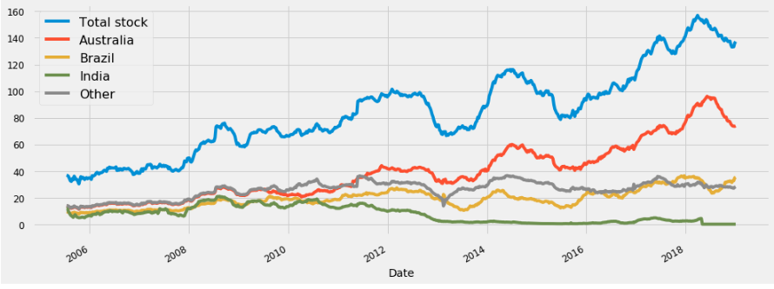

**2. Trend and Seasonal value:**

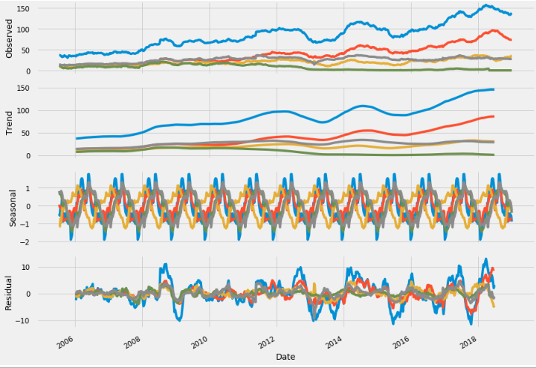

The given stock value is decomposed into three categories: Trend, Seasonal, and Residual, i.e. stock value given = Trend + Seasonal + Residual.

**2.1. Trend:**

The trend for stock is clearly upwards (for both total stock and individual countries). The company is doing well in terms of this. It may be said that this is obvious from the ‘Observed’ data; however, in some cases, some trend cannot easily be recognised from the ‘Observed’ data, especially when the data fluctuates significantly.

**2.2. Seasonal:**

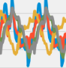We see this pattern repeats every year (the picture is seasonal value for a given year. The important thing to notice here is that the seasonal values fluctuate around the +- 2 mark, which constitutes almost nothing towards the ‘Observed’ data. This suggests that the stock amount doesn’t depend on seasons in the year. This is both an advantage and disadvantage:

i) The company stock is stable throughout the year, which is good.

ii) The company may not have utilised time when the demand for the given stock is increasing. For example, an improvement would be to only import high values of stock at certain periods of the year (when demand increases/price reduces/other reasons)

**2.3. Residual:**

Residual is just the remaining part of the real value. Minimal residual compared to the real value.

**3. Autocorrelation vs Lag of total stock:**

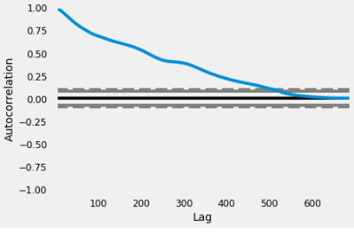

*Autocorrelation is the correlation coefficient, meaning a statistical relationship between two variables. The correlation coefficient is between -1 and 1. A correlation coefficient of 1 means that the two variables are positively correlated, i.e. if this one increases the other one should increase too! A correlation coefficient of -1 means that the two variables are negatively correlated, i.e. if this one increases the other one must be decrease (i.e. go the other direction)! The correlation is weaker when the coefficient is near 0.*

The horizontal shows the size of the lag between the values of the total stock. For example, the autocorrelation with lag 50 is the correlation between the given total stock and the corresponding total stock that were observed 50 time periods earlier. Since the data is recorded weekly, 52 time periods ~ 1 year. For example, the autocorrelation with lag 50 is about 0.75,

which means that if you see the total stock just increases this week, it is very likely that the total stock will be increasing in the following one year (‘0.75’, which is near to 1, means ‘very likely’.) That means if the company is doing the same as what they are doing now, total stock is very likely to increase.

You can see that as the time difference increases, autocorrelation reaches 0, which means that there is no correlation between today’s data and data from very long before.

4. **Prediction:**

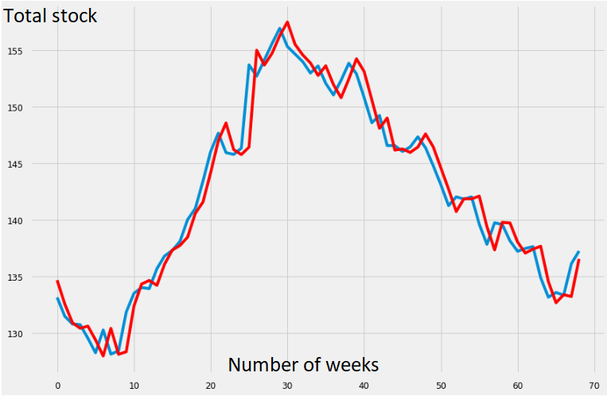

This is my attempt at predicting the total stock. Input is the first 90% of the given data (from 15-Jul-05 to ?), and output is prediction for the remaining last 10% of the data. The blue line is observed/given data, and the red line is the model prediction. It is possible to extend this to future prediction, which is much more important.