Challenged: Đinh Hoàng Sáng

ID: BEBEIU17022

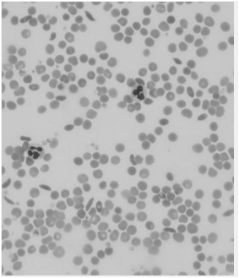Result:

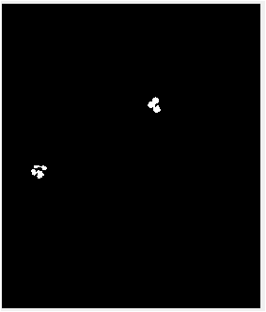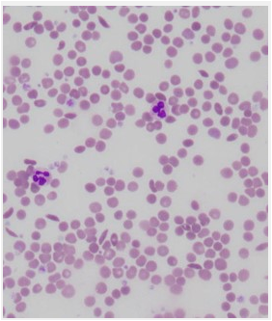

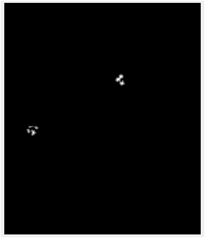

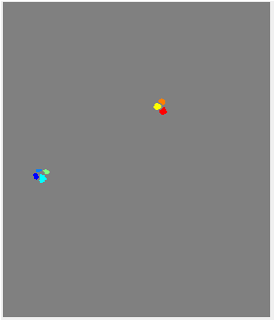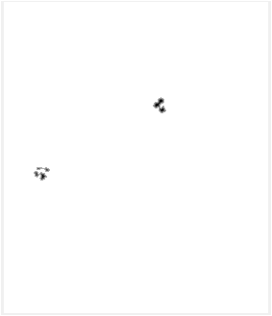

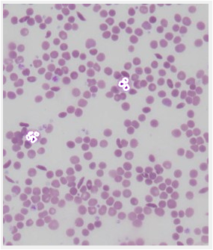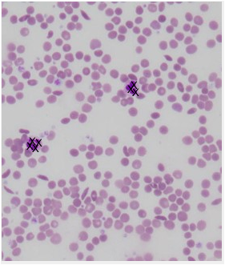

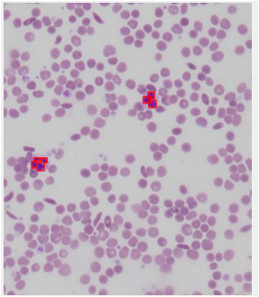

Code:

clc

close all

clear all

%%

I = imread('cancercell_challenge.jpg');

figure,imshow(I),impixelinfo

gray=rgb2gray(I);

%show "index"

figure,imshow(gray),impixelinfo

%I saw different from cell cancers, they have "index" < 100.

%%Scan pixels of image

[r c] =size(gray);

for i = 1:r

for j= 1:c

if gray(i,j) < 100

out(i,j) = 255;

else

out(i,j) = 0;

end

end

end

%%Separation of adherent cells, main: watershed()

figure,imshow(out)

%

D = bwdist(~out);

figure,imshow(D,[])

%

D = -D;

figure,imshow(D,[])

%

L = watershed(D);

L(~out) = 0;

%

rgb = label2rgb(L,'jet',[.5 .5 .5]);

figure,imshow(rgb)

%%

[B,Li] = bwboundaries(L,'noholes');

stats = regionprops(Li,'Area','Centroid');

%%stick "X"

figure,imshow(I);

for i = 1:length(stats)

text(stats(i).Centroid(1)-2.5,stats(i).Centroid(2),'X','FontSize',10)

end

%%draw cover

figure,imshow(I);

hold on;

for i = 1:length(B)

boundary =B{i};

plot(boundary(:,2), boundary(:,1),'w','LineWidth',2)

end

%%draw boundingBox

figure,imshow(I);

hold on;

statsB = regionprops(Li,'BoundingBox');

for k = 1 : length(statsB)

BB = statsB(k).BoundingBox;

rectangle('Position', [BB(1),BB(2),BB(3),BB(4)],...

'EdgeColor','r','LineWidth',1 )

end