**Đinh Hoàng Sáng**

**BEBEIU17022**

**HomeWork9**

Ex1:

Code:

clc

close all

clear all

%auto clear, ez to test

rgb = imread('coloredChips.png');

figure,imshow(rgb), impixelinfo

rgb_h = rgb2hsv(rgb);

figure,imshow(rgb_h)

red = rgb_h(:,:,1);

s = rgb_h(:,:,2);

v = rgb_h(:,:,3);

%change some chanel to find out differences between the color which you need dectect and other color.

%So, I saw the difference at rgb_h(:,:,1); figure(3)

%Red color had index>0.9, other color have index <0.9;

figure,imshow(red)

figure,imshow(s)

figure,imshow(v)

[r c] =size(red);

%scan all pixel of figure(3)

for i = 1:r

for j= 1:c

if red(i,j) >= 0.9

out(i,j) = 255; %index>0.9 replaced by white

else

out(i,j) = 0; %other replaced by black

end

end

end

figure,imshow(out)

%out = bwareaopen(out,100); %remove noises if u need, I didn’t need at my case.

figure,imshow(rgb)

[centers, radii] = imfindcircles(out,[20 25], 'ObjectPolarity','bright', ...

'Sensitivity',0.92,'Method','twostage'); %create table to save centroid and radius.

h = viscircles(centers,radii,'Color','k');%overlap circles on newest figure

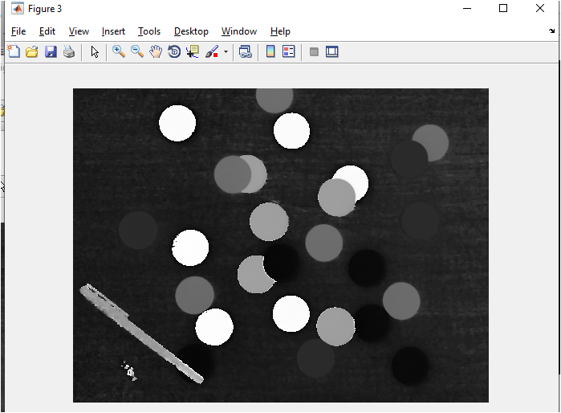

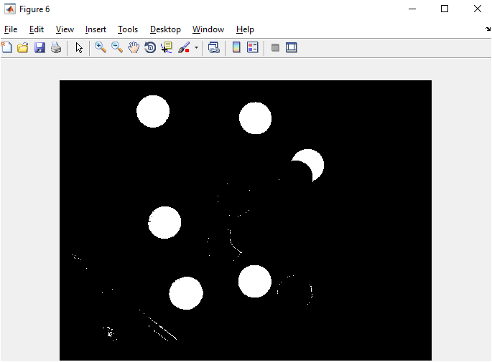

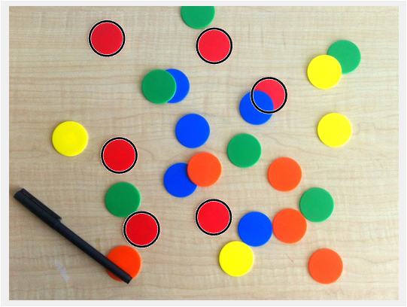

Ex1.

*Detect shapes by color

clc

close all

clear all

%%

[X,cmap] = imread('shapes.gif');

rgb = ind2rgb(X,cmap);

figure,imshow(rgb),impixelinfo

gray=rgb2gray(rgb); %show "index"

figure,imshow(gray),impixelinfo

%%Scan pixel of image RGB

[r c] =size(gray);

for i = 1:r

for j= 1:c

%% satify condition => white

if gray(i,j) > 0.49 && gray(i,j) < 0.5 %màu cam ??m,hình vuông

out_square(i,j) = 255;

%

elseif gray(i,j) > 0.72 && gray(i,j) < 0.74 %màu cam nh?t,elip

out_elip(i,j)= 255;

%

elseif gray(i,j) > 0.8 && gray(i,j) < 0.81 %màu h??ng,hexagon

out_hexagon(i,j)= 255;

%

elseif gray(i,j) > 0.47 && gray(i,j) < 0.48 %lá cây,hexagon

out_circle(i,j)= 255;

%

elseif gray(i,j) > 0.16 && gray(i,j) < 0.17 %blue,hexagon

out_rectangle(i,j)= 255;

%

elseif gray(i,j) > 0.88 && gray(i,j) < 0.89 %zang`,hexagon

out_triangle(i,j)= 255;

%

elseif gray(i,j) > 0.48 && gray(i,j) < 0.49 %rose,octagon

out_octagon(i,j) =255;

%%Other = Black

else

out_square(i,j) = 0;

out_elip(i,j) = 0;

out_hexagon(i,j)= 0;

out_circle(i,j)= 0;

out_rectangle(i,j)= 0;

out_triangle(i,j)= 0;

out_octagon(i,j) =0;

end

end

end

%%Get BoundingBox and Area vs Centroid

[B_square,L_square] = bwboundaries(out_square,'noholes');

[B_elip,L_elip] = bwboundaries(out_elip,'noholes');

[B_hexagon,L_hexagon] = bwboundaries(out_hexagon,'noholes');

[B_circle,L_circle] = bwboundaries(out_circle,'noholes');

[B_rectangle,L_rectangle] = bwboundaries(out_rectangle,'noholes');

[B_triangle,L_triangle] = bwboundaries(out_triangle,'noholes');

[B_octagon,L_octagon] = bwboundaries(out_octagon,'noholes');

%%

stats_square = regionprops(L_square,'Area','Centroid');

stats_elip = regionprops(L_elip,'Area','Centroid');

stats_hexagon = regionprops(L_hexagon,'Area','Centroid');

stats_circle = regionprops(L_circle,'Area','Centroid');

stats_rectangle = regionprops(L_rectangle,'Area','Centroid');

stats_triangle = regionprops(L_triangle,'Area','Centroid');

stats_octagon = regionprops(L_octagon,'Area','Centroid');

%%A empty Matrix M by 2

position=[];

%%Got T?a ?? c?a t?t c? centroid

%Square

for i = 1:length(stats_square)

position = vertcat(position,stats_square(i).Centroid);

end

%Elip

for i = 1:length(stats_elip)

position = vertcat(position,stats_elip(i).Centroid);

end

%Hexagon

for i = 1:length(stats_hexagon)

position = vertcat(position,stats_hexagon(i).Centroid);

end

%circle

for i = 1:length(stats_circle)

position = vertcat(position,stats_circle(i).Centroid);

end

%Hexagon

for i = 1:length(stats_rectangle)

position = vertcat(position,stats_rectangle(i).Centroid);

end

%Hexagon

for i = 1:length(stats_triangle)

position = vertcat(position,stats_triangle(i).Centroid);

end

%Octagon

for i = 1:length(stats_octagon)

position = vertcat(position,stats_octagon(i).Centroid);

end

%%overlap on orgiginal image vs Draw 'text' to regconize shapes

figure,imshow(rgb)

%Square

next_F=length(stats_square);

for i = 1:next_F

text(position(i,1)-5,position(i,2),'S')

end

%Elip

next_E=next_F+length(stats_elip);

for i = next_F+1:next_E

text(position(i,1)-5,position(i,2),'E')

end

next_F=next_E;

%Hexagon

next_E=next_F+length(stats_hexagon);

for i = next_F+1:next_E

text(position(i,1)-5,position(i,2),'H')

end

next_F=next_E;

%Circle

next_E=next_F+length(stats_circle);

for i = next_F+1:next_E

text(position(i,1)-5,position(i,2),'C')

end

next_F=next_E;

%Rectangle

next_E=next_F+length(stats_rectangle);

for i = next_F+1:next_E

text(position(i,1)-5,position(i,2),'R')

end

next_F=next_E;

%Triangle

next_E=next_F+length(stats_triangle);

for i = next_F+1:next_E

text(position(i,1)-5,position(i,2),'T')

end

next_F=next_E;

%Triangle

next_E=next_F+length(stats_octagon);

for i = next_F+1:next_E

text(position(i,1)-5,position(i,2),'0')

end

next_F=next_E;

