Name: Đinh Hoàng Sáng

ID: BEBEIU17022

Biosignal Processing

Question 1:

orig = imread ('convikhuan.jpg') ;

orig = immultiply(orig,1.2);

grayscale1 = rgb2gray ( orig ) ;

figure(1);

imshow (grayscale1);

k_v = [ -1 0 1; -2 0 2; -1 0 1];

k_h = [-1 -2 -1; 0 0 0; 1 2 1];

M1 = conv2 ( double ( grayscale1 ) , double ( k_v ) ) ;

M2 = conv2 ( double ( grayscale1 ) , double ( k_h ) ) ;

figure(2);

imshow (( M1 .^2+ M2 .^2) .^0.5 , []) ;

grayscale2 = ( M1 .^2+ M2 .^2) .^0.5

M1 = conv2 ( double ( grayscale2 ) , double ( k_v ) ) ;

M2 = conv2 ( double ( grayscale2 ) , double ( k_h ) ) ;

figure(3);

imshow (( M1 .^2+ M2 .^2) .^0.5 , []) ;

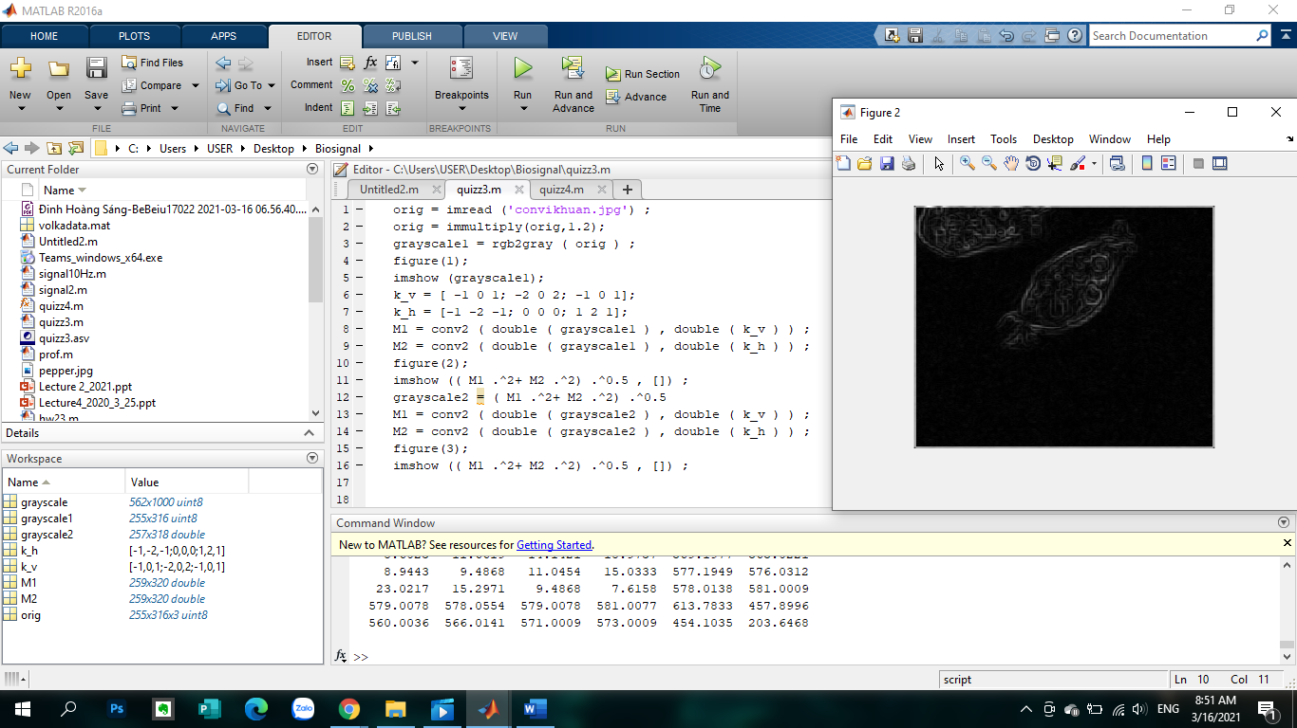

Question 2:

original = imread( 'pepper_noise.jpg' ) ;

grayscale = rgb2gray( original ) ;

figure (1) ;

imshow ( original ) ;

figure (2) ;

imshow ( grayscale ) ;

noisyImage = imnoise ( grayscale , 'salt & pepper' ) ;

figure (4) ;

imshow ( noisyImage ) ;

h = fspecial ( 'gaussian' , [24 24] , 3 ) ;

M = conv2 ( double( grayscale ) , double( h ) ) ;

figure (3) ;

imshow (( M .^2) .^0.5 , []) ;

