**Name: Đinh Hoàng Sáng**

**ID: BEBEIU17022**

**HomeWork 6**

**6.a**

function rbg2grayscale(image)

I = imread(image);

red = I(:,:,1);

green = I(:,:,2);

blue = I(:,:,3);

grayscale = 0.2989*red + 0.5870*green + 0.1140*blue;

imshowpair(I,grayscale, 'montage');

end

rbg2grayscale('PhuongLy_cute_hihi.jpg')

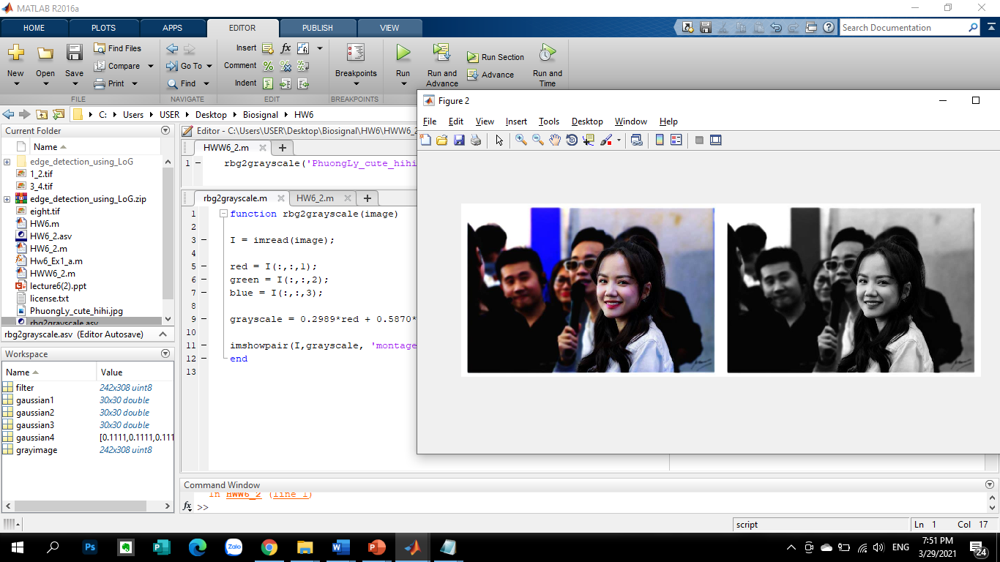

**6.b**

grayimage = imread('eight.tif');

figure(1);

subplot(2,3,2);

imshow(grayimage);

gaussian1 = fspecial('Gaussian',30,90);

filter = conv2(double(grayimage), gaussian1, 'same');

filter = uint8(filter);

subplot(2,3,4);

imshow(filter);

gaussian2 = fspecial('Gaussian', 30, 1);

filter = conv2(double(grayimage), gaussian2, 'same');

filter = uint8(filter);

subplot(2,3,5);

imshow(filter);

gaussian3 = gaussian1 - gaussian2;

filter = conv2(double(grayimage), gaussian3, 'same');

filter = uint8(filter);

subplot(2,3,6);

imshow(filter);

gaussian4 = fspecial('Average',3);

filter = conv2(double(grayimage), gaussian4, 'same');

filter = uint8(filter);

figure(2);

imshowpair(grayimage,filter,'montage');

