TWEET SENTIMENT PHRASE EXTRACTION USING ROBERTA-BASED QUESTION ANSWERING
¹ NGUYEN THI HIEN, ²DINH THI TU, ³ NGUYEN THANH PHUONG
Undergraduate student, Hanoi University, Km9, Nguyen Trai Street, Thanh Xuan, Hanoi, Vietnam
¹2101140025, ²2201140079, ²2201140067

ABSTRACT

Extracting sentiment-relevant phrases from text provides deeper interpretability than sentiment classification alone. Instead of only predicting sentiment polarity, sentiment phrase extraction aims to identify the exact text span that conveys sentiment. In this study, we address the Tweet Sentiment Phrase Extraction task by reformulating it as a span-based Question Answering (QA) problem. A RoBERTa-based transformer model is fine-tuned to predict the start and end positions of sentiment-bearing phrases within tweets, given sentiment labels. Experiments conducted on the Tweet Sentiment Extraction dataset demonstrate that the proposed approach achieves strong performance measured by word-level Jaccard similarity. The results confirm that treating sentiment extraction as a QA task enables accurate boundary detection and improves robustness, especially for positive and negative sentiments.

Keywords: Sentiment Analysis, Phrase Extraction, Question Answering, RoBERTa, Transformers.

I. INTRODUCTION
Sentiment analysis is a key task in NLP with applications in opinion mining, customer feedback analysis, and social media monitoring. Traditional methods classify text into positive, negative, or neutral, but they lack interpretability because they do not show which part of the text conveys sentiment.
Sentiment phrase extraction addresses this limitation by identifying the exact phrase that expresses sentiment. This is especially challenging in short, informal texts such as tweets, where cues may be subtle or noisy.
In this project, we reformulate the Tweet Sentiment Phrase Extraction problem as a span-based Question Answering (QA) task. Given a tweet and its sentiment label, the model predicts the start and end positions of the sentiment-bearing phrase. Our main contribution is demonstrating that this QA formulation, combined with a RoBERTa-based transformer, improves boundary detection and robustness compared to traditional sequence labeling approaches.
II. DATASET DESCRIPTION AND EXPLORATORY DATA ANALYSIS

2.1 Dataset Description

The Tweet Sentiment Extraction dataset contains 27,480 training samples and 3,534 test samples. Each training instance includes the tweet text, a sentiment label (positive, negative, or neutral), and the annotated sentiment phrase. The test set provides only text and sentiment labels, making it suitable for evaluating generalization.

2.2 Data Cleaning

To ensure data quality and consistency, several preprocessing steps were applied before model training. Samples with missing or empty tweet text were removed, as incomplete textual input could negatively impact model performance. Instances lacking a valid selected sentiment phrase were also eliminated from the training set. In addition, unnecessary whitespace was stripped from both tweet text and sentiment phrases, and invalid or empty strings were filtered out. After preprocessing, the dataset remained well-balanced across sentiment classes. This balance is important for reducing training bias and ensuring that the model learns representative patterns for all sentiment categories.

“Figure 1 shows the sentiment label distribution, with positive, negative, and neutral relatively balanced, and neutral slightly more frequent. This balance reduces bias and supports stratified cross-validation.”

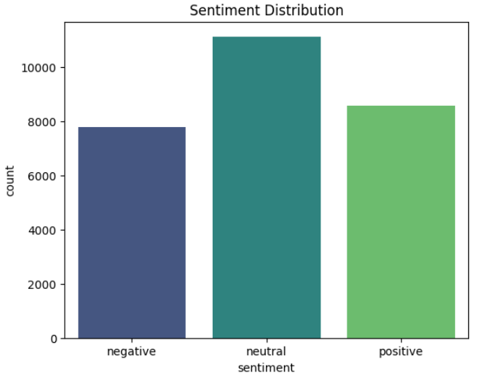
Figure 1: Distribution of sentiment labels in the dataset

2.3 Exploratory Data Analysis
Exploratory Data Analysis (EDA) was conducted to gain insights into the characteristics of the dataset and to validate its suitability for sentiment phrase extraction.

Neutral phrases are generally longer and more variable, often spanning the entire tweet, while positive and negative phrases are shorter and more focused. This observation motivated the heuristic of returning the full text for neutral cases and using span-based prediction for positive and negative sentiments. Boxplot comparisons confirmed that neutral phrases are significantly longer, reinforcing the need for differentiated handling during inference.

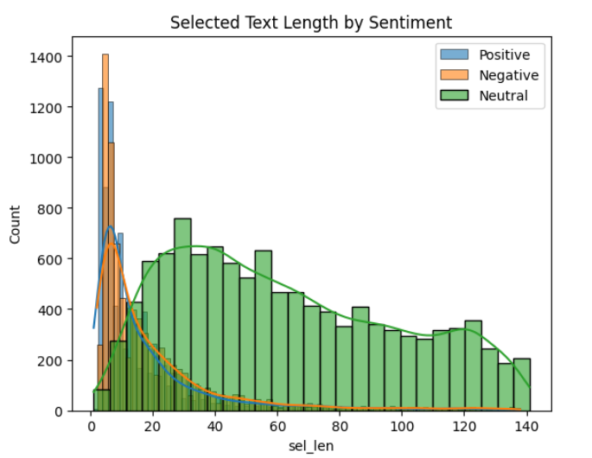
Figure 2: Histogram of selected text lengths by sentiment

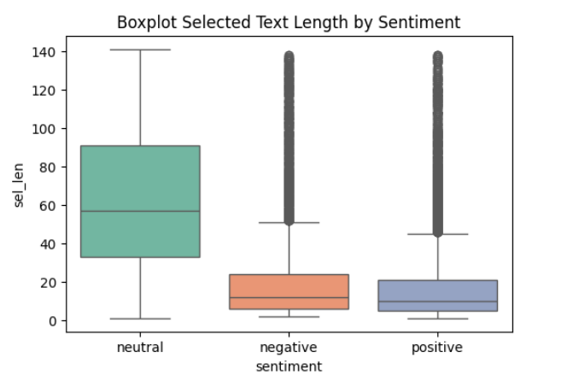
Figure 3: Boxplot of sentiment phrase lengths across classes

Word clouds further illustrated polarity-aligned keywords: positive phrases included terms such as “love” and “awesome,” negative phrases emphasized words like “sorry” and “bad,” and neutral phrases contained more generic or temporal expressions such as “now” and “today.” These visualizations validated the dataset’s reliability and informed key methodological choices: applying stratified cross-validation, adopting heuristic handling for neutral sentiment, and leveraging RoBERTa’s contextual embeddings to capture subtle emotional cues.

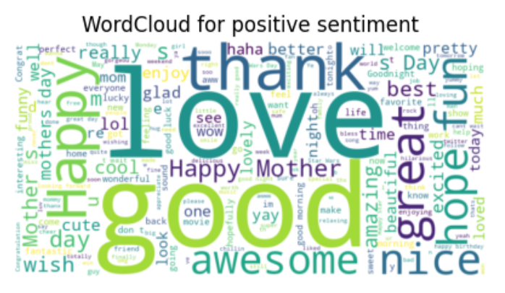
Figure 4: Word cloud for positive sentiment phrases

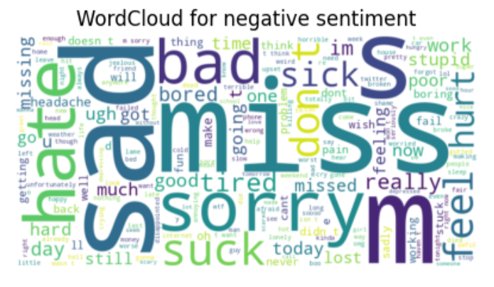
Figure 5: Word cloud for negative sentiment phrases
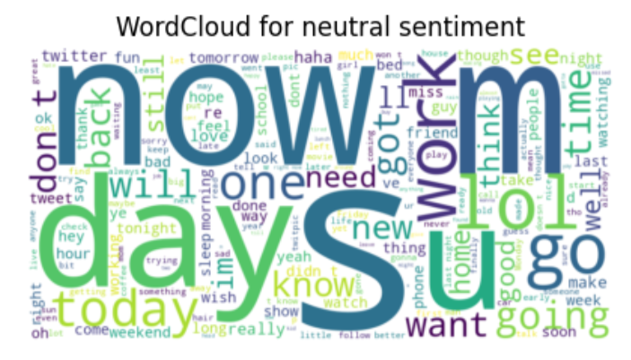
Figure 6: Word cloud for neutral sentiment phrases

III. METHODOLOGY

3.1 Reformulating Sentiment Extraction as Question Answering

Instead of sequence labeling, sentiment phrase extraction is reformulated as a Question Answering (QA) task. For each tweet, a question is generated based on the sentiment label (e.g., “Extract the positive phrase”), and the model predicts the start and end positions of the sentiment-bearing phrase. This formulation directs attention to sentiment-relevant information and improves boundary detection compared to token-level classification.

3.2 Model Architecture

The proposed model is built on RoBERTa-base, a transformer-based language model known for its strong contextual representation capabilities. The architecture consists of a RoBERTa encoder that generates contextual embeddings for each token in the input sequence, followed by a dropout layer to reduce overfitting.

On top of the encoder, a linear classification head is used to predict the start and end logits for each token. These logits are converted into probability distributions, allowing the model to identify the most probable start and end positions of the extracted sentiment phrase.

3.3 Training and Optimization

To improve training stability and generalization performance, several optimization strategies are applied. The model is trained using the AdamW optimizer with weight decay to mitigate overfitting. A linear learning rate decay schedule is employed to stabilize convergence, while gradient clipping is used to prevent exploding gradients. Label smoothing is incorporated to reduce model overconfidence, and early stopping is applied based on validation performance to avoid overtraining.

In addition, Stratified K-Fold Cross-Validation is used to maintain a balanced distribution of sentiment labels across training and validation splits. During inference, a top-K decoding strategy is employed to evaluate multiple candidate spans and select the most plausible sentiment phrase, further reducing boundary-related errors.

Loss Function and Span Prediction
The model is trained by minimizing the sum of two cross-entropy losses corresponding to the predicted start and end positions of the sentiment phrase. Let $y_s$ and $y_e$ denote the ground-truth start and end token indices, and $p_s$ and $p_e$ denote the predicted probability distributions. The training objective is defined as:
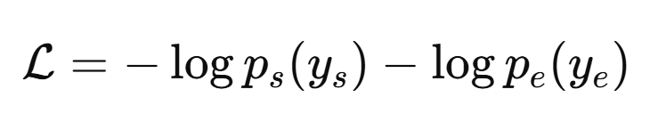
During inference, candidate spans are generated by combining the top-K most probable start and end positions, and the span with the highest joint probability and valid ordering is selected as the final prediction.
IV. EXPERIMENTS AND RESULTS

4.1 Training Setup

The model was trained using 5-fold Stratified Cross-Validation to ensure robust and reliable evaluation. Training was conducted on GPU with a batch size of 48 and a maximum sequence length of 160 tokens, providing a balance between computational efficiency and contextual coverage. Optimization techniques included AdamW optimizer, learning rate scheduling with warmup, gradient clipping, label smoothing, and early stopping.

4.2 Evaluation Metric

Model performance was evaluated using both word-level and character-level Jaccard similarity, which measure the overlap between predicted sentiment phrases and ground-truth annotations. These metrics are particularly suitable for span extraction tasks, as they directly reflect the quality of the extracted text boundaries.

4.3 Quantitative Results

Across validation folds, the model achieved an average word-level Jaccard score of 0.7863 ± 0.0027, indicating strong extraction performance. Neutral sentiment achieved near-perfect scores at 0.98, while positive and negative sentiments were more challenging, with scores ranging between 0.52 and 0.59. Performance remained stable across all validation folds, demonstrating the robustness of the proposed approach.

Compared to traditional sequence labeling approaches such as BIO tagging with conditional random fields or token-level classifiers, the QA-based framework offered improved flexibility in handling variable-length sentiment phrases. While sequence labeling models often struggled with ambiguous boundaries, the span-based prediction mechanism enabled more precise extraction, particularly for short and emotionally salient phrases. Empirically, this reformulation contributed to higher Jaccard similarity scores and more consistent predictions across folds.

4.4 Qualitative Analysis
Qualitative inspection of model predictions showed that the extracted phrases were concise, meaningful, and closely aligned with human annotations. The Top-K decoding strategy proved effective in handling ambiguous boundary cases, helping the model avoid unnecessary or incomplete extractions. Example predictions included “such a shame!” for negative tweets, “exciting” for positive tweets, and returning the full text for neutral tweets.
Compared to traditional sequence labeling approaches, the QA-based framework demonstrated greater flexibility in handling variable-length sentiment phrases. Sequence labeling models often struggled with ambiguous boundaries, whereas the span-based prediction mechanism allowed for more precise extraction, particularly for short and emotionally salient phrases. This difference was reflected in the improved Jaccard similarity scores and the consistency of results across validation folds.
V. INFERENCE AND SUBMISSION

For test inference, predictions from all folds were combined using majority voting. The neutral trick was applied consistently, and final outputs were saved in submission.csv. Sample predictions confirmed strong generalization to unseen tweets.

VI. CONCLUSION AND FUTURE WORK

This study proposes a RoBERTa-based framework for tweet sentiment phrase extraction by reformulating the task as a question answering problem. The proposed method effectively identifies sentiment-bearing text spans and achieves competitive performance on the Tweet Sentiment Extraction dataset, with an average Jaccard score of 0.786. By leveraging transformer-based contextual representations and robust optimization techniques, the model delivers accurate and interpretable results.

Future work may explore the use of domain-adapted transformer models for social media text, incorporate character-level or token-level supervision, and investigate sequence-to-sequence approaches for sentiment extraction. Overall, this work demonstrates that question answering formulations offer a powerful and flexible solution for fine-grained sentiment analysis tasks.

Despite its strong performance, the proposed approach has certain limitations. First, the model relies on the availability of sentiment labels at inference time, which may not always be feasible in real-world applications. Second, the handling of neutral sentiment through heuristic full-text selection may limit adaptability to more complex neutral expressions. Finally, the experiments are conducted on English-language tweets only, and generalization to other languages or domains remains an open challenge.

