Đề bài:

Load ảnh tĩnh

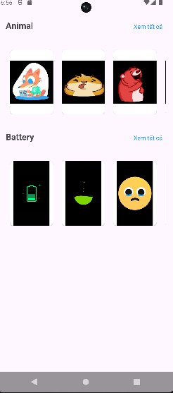

Ấn vào xem tất cả:

Load danh sách (ảnh tĩnh)

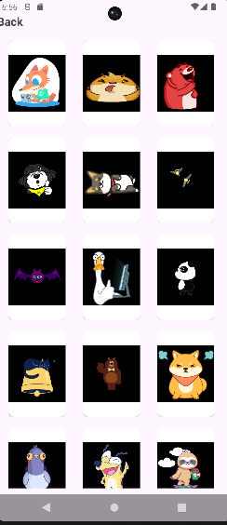

Ấn vào từng item:

Load ảnh động tương ứng

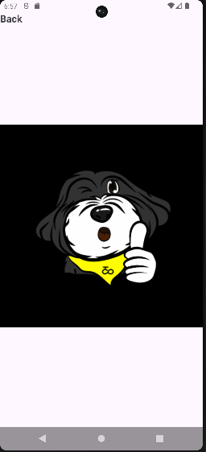

Json yêu cầu:

{

"Animal": {

"Index": 0,

"List": [

{

"static": [

"https://www.dropbox.com/scl/fi/yxio6e6p25zbmgwmj64qb/a1.jpg?rlkey=v2l4bglor03uiugl50wa34jqn&dl=1",

"https://www.dropbox.com/scl/fi/hu1gd5weeunvawg0w75d1/a2.jpg?rlkey=levs2n3d9d9wmxt7k01vnjtr6&dl=1",

"https://www.dropbox.com/scl/fi/72ifdymrkeug5hk3zhhnp/a3.jpg?rlkey=4zow3evtx4fwpnfub49zb8jww&dl=1",

"https://www.dropbox.com/scl/fi/zrkhhwmcg1zi62sodj3va/a4.jpg?rlkey=tk4a11kf2iomuwb0qo7tprof3&dl=1",

"https://www.dropbox.com/scl/fi/4h97rk5cc2nc8mjd8fk3v/a5.jpg?rlkey=dj6v48ep144bwussymjyr0p1z&dl=1"

],

"gif": [

"https://www.dropbox.com/scl/fi/0lt1y33gzcrccin2ja7uk/a1.gif?rlkey=rmnd5pt798163k2j5w3mb2wew&dl=1",

"https://www.dropbox.com/scl/fi/idmik4e49kfqlirmg67hr/a2.gif?rlkey=0vu1nbyb22ltxrlnjxcsqh77s&dl=1",

"https://www.dropbox.com/scl/fi/mciqnah5phdewcsy66vr6/a3.gif?rlkey=g6hn5vnuglsx2v72vzwni5cbb&dl=1",

"https://www.dropbox.com/scl/fi/n1oem4fhdfcktkdrubdju/a4.gif?rlkey=411oolsukohfk1omlusdewa8e&dl=1",

"https://www.dropbox.com/scl/fi/tx5wt7d8fr1nxdo830r0n/a5.gif?rlkey=7cnr7sqismopj6egyn66xktj7&dl=1"

]

},

{

"static": [

"https://www.dropbox.com/scl/fi/fildse8h8hz0ynnm4nu0m/a6.jpg?rlkey=mbg412pi1q6wtkjjpmadozcos&dl=1",

"https://www.dropbox.com/scl/fi/2pdsk4n6eb40x8v9ehgnb/a7.jpg?rlkey=nkh1i419zzj21g4nhxd4cexl7&dl=1",

"https://www.dropbox.com/scl/fi/ltww6rvwn1gydieku5pws/a8.jpg?rlkey=yel6vefguvbyndiw4u72z5xbp&dl=1",

"https://www.dropbox.com/scl/fi/mhczgrurszvs3omiwpvn2/a9.jpg?rlkey=wbc013c12u75oti0nts24ye3i&dl=1",

"https://www.dropbox.com/scl/fi/zryy4mcifk317fz5ajs8h/a10.jpg?rlkey=3nof8k2xlfpylszaszwnakcqg&dl=1"

],

"gif": [

"https://www.dropbox.com/scl/fi/vjdzn8nph28o08sj7w1ds/a6.gif?rlkey=fmef124czqmy0r4357q4xuqty&dl=1",

"https://www.dropbox.com/scl/fi/nbuo165fh0fts298s6h9i/a7.gif?rlkey=88gsnuni4hvli55cvj8p5ff59&dl=1",

"https://www.dropbox.com/scl/fi/jssfqkpd7uwbasl0jzfpc/a8.gif?rlkey=zm3vsfk0y9r76m74gh9ovm4dx&dl=1",

"https://www.dropbox.com/scl/fi/6r47dgj7ol4s2wz007cv6/a9.gif?rlkey=0ccsvekp045txbyhtsm5mynei&dl=1",

"https://www.dropbox.com/scl/fi/pcrwcsf6doi8gf11oybmi/a10.gif?rlkey=o8bodwnp8s4ltp6rha9iwfp7x&dl=1"

]

},

{

"static": [

"https://www.dropbox.com/scl/fi/vspf8d32c5hnpidtev0uu/a11.jpg?rlkey=wt3ynec1u5rs45lo5v0hsz0le&dl=1",

"https://www.dropbox.com/scl/fi/01d60fwt2thmxdqzkekn9/a12.jpg?rlkey=qbin74j5h7w25vwqcxrwm9xg5&dl=1",

"https://www.dropbox.com/scl/fi/hyigxg5z1mc0qipptstdo/a13.jpg?rlkey=6woxkge59e8i9r2zosugunwv2&dl=1",

"https://www.dropbox.com/scl/fi/0on6rgg8x07plv29ixmrp/a14.jpg?rlkey=0cgtrhz73bcwrpod3n4hqo2s0&dl=1",

"https://www.dropbox.com/scl/fi/76fio79045ya1rid3t816/a15.jpg?rlkey=iut9mbwuxyyf0k79b6kc5j1uv&dl=1"

],

"gif": [

"https://www.dropbox.com/scl/fi/2khp1p5vp20gudria42w7/a11.gif?rlkey=zr3j1w2l903iqs37kvjrktu8l&dl=1",

"https://www.dropbox.com/scl/fi/b74ri1hcu59xk4rpvc0c8/a12.gif?rlkey=28erq4qskeirspwcob4y6zzok&dl=1",

"https://www.dropbox.com/scl/fi/d9gu2kg9g6sbd86j9dzpq/a13.gif?rlkey=ij2gg2vedwz2q2iklxe5xvpev&dl=1",

"https://www.dropbox.com/scl/fi/pkh9pcld13g0mp4fb4bec/a14.gif?rlkey=llo19gpjk49spjiyi5czd6qn5&dl=1",

"https://www.dropbox.com/scl/fi/oo3qrm5s76z8emo4bkafl/a15.gif?rlkey=nqt463d4cfmpyflnqvduml984&dl=1"

]

},

{

"static": [

"https://www.dropbox.com/scl/fi/xlcidcdzbqha7ogwxobl0/a16.jpg?rlkey=rb5zfpwuli34dmu6pome7wlyy&dl=1",

"https://www.dropbox.com/scl/fi/aknt8gkyot82j1ci1llu8/a17.jpg?rlkey=ldphsozr50exuq8bs6n6nl10g&dl=1"

],

"gif": [

"https://www.dropbox.com/scl/fi/n9266jeug0m9b9ul73pvl/a16.gif?rlkey=4zn2gjnix0xat2oaqggrzihnq&dl=1",

"https://www.dropbox.com/scl/fi/wlb8drgyrd3epsovzmfcr/a17.gif?rlkey=f57s1wg1qirlg3w8e7hb8bxf0&dl=1"

]

}

]

},

"Battery": {

"Index": 1,

"List": [

{

"static": [

"https://www.dropbox.com/scl/fi/e05ep2yi7t7i5ackqjcu7/b1.jpg?rlkey=kjartjl2gz8p6vl1upg90bfb8&dl=1",

"https://www.dropbox.com/scl/fi/lhsqdtrzp7oqdewvk05xb/b2.jpg?rlkey=zzqc9cjf38ij7ovxqs9r6h1mm&dl=1",

"https://www.dropbox.com/scl/fi/c4etexfuvi1307xub5dip/b3.jpg?rlkey=yshyoxyne0zd54xx7jhmzgpgt&dl=1",

"https://www.dropbox.com/scl/fi/r5a5q4wcxnsablrlm4usi/b4.jpg?rlkey=pdbfyrsja8jg5inzrro0mf34q&dl=1",

"https://www.dropbox.com/scl/fi/mkx864ukyc9k1bnwemeyx/b5.jpg?rlkey=ro8dfu3zxhkucrmoalwxclceb&dl=1"

],

"gif": [

"https://www.dropbox.com/scl/fi/i4ppuf8fzqsrspstkndk2/b1.gif?rlkey=eato9vrp0ah7vuuoymebpgl8y&dl=1",

"https://www.dropbox.com/scl/fi/mje8v40cz1xxxt5ebdnjz/b2.gif?rlkey=j9t982c4uzelx2xv4l6qnv1vr&dl=1",

"https://www.dropbox.com/scl/fi/uir1hynurmxen6fb6pops/b3.gif?rlkey=e1a0gyacngyir21yeu6o0ipfn&dl=1",

"https://www.dropbox.com/scl/fi/1ihw01q8se2sjnv8hb19a/b4.gif?rlkey=5k992qto1j9v487wwle4mhfrn&dl=1",

"https://www.dropbox.com/scl/fi/tq391e1b462iotqbfq9ac/b5.gif?rlkey=aqy5cj3xhto5ozwx9ticvaq9t&dl=1"

]

},

{

"static": [

"https://www.dropbox.com/scl/fi/jogttl0pxkyxuwa7qz8ta/b6.jpg?rlkey=fprh6gemb0p7uakfffyh4zvpv&dl=1",

"https://www.dropbox.com/scl/fi/rpi1bvqvq44cd4woug7d2/b7.jpg?rlkey=xi5k7fujg108y0b1j5c174o8f&dl=1",

"https://www.dropbox.com/scl/fi/qs0shiwesqtmn9uw939ll/b8.jpg?rlkey=2wtw6rmga44mac2zvx6sx24bw&dl=1",

"https://www.dropbox.com/scl/fi/9uajrsmqwajo30dbb5oem/b9.jpg?rlkey=eiaww08nth2jnzx60fhq790g2&dl=1",

"https://www.dropbox.com/scl/fi/btk9a17d8ojsr9mmeatcq/b10.jpg?rlkey=r1dr9pxmovi4yw5f2wh9m7ze3&dl=1"

],

"gif": [

"https://www.dropbox.com/scl/fi/qtr6wmo1mqjynzg64f7ky/b6.gif?rlkey=aqfmrfagriy0kint9vad2bcmk&dl=1",

"https://www.dropbox.com/scl/fi/xhoriirtnidt4kouiz8an/b7.gif?rlkey=recw3bqkkswmc65zy0pa4f5l5&dl=1",

"https://www.dropbox.com/scl/fi/vpvjj4bnkxqvrj6eass6z/b8.gif?rlkey=2ertgvnlexpzm6vqy3d20ws0f&dl=1",

"https://www.dropbox.com/scl/fi/duh59tjqt9661thuw9ajm/b9.gif?rlkey=rsw4ut44rxzfscur99le3i5h4&dl=1",

"https://www.dropbox.com/scl/fi/um7esq87rfrb1x49fsizy/b10.gif?rlkey=69nk2cr8q98cs3hdnl9mvbmwt&dl=1"

]

},

{

"static": [

"https://www.dropbox.com/scl/fi/iselfgs3az98byncp7whm/b11.jpg?rlkey=u25jzd0igbjedfij844njehoq&dl=1"

],

"gif": [

"https://www.dropbox.com/scl/fi/aix4802o4huextzwod3bo/b11.gif?rlkey=mb79gksera073ux7f2azqjd23&dl=1"

]

}

]

}

}