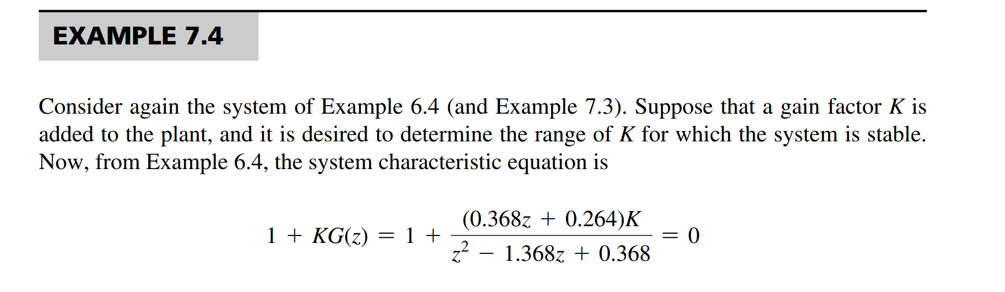

Characteristic equation is:

$$z^{2}-1.368z+0.369+\left(0.368z+0.264\right)K=0$$

* *Rearrange the components…*

*Use the stability judgement criteria. In this case Jury’s test*

*2024.04.08*

The reason why we would like to use July stability test instead of Routh Hurwitz is explained at the introduction.

Watching <https://www.youtube.com/watch?v=NRbGPgcLhU0&list=PLUMWjy5jgHK0MLv6Ksf-NHi7Ur8NRNU4Z&index=6&ab_channel=BrianDouglas>

**Discrete control #6: z-plane warping and the bilinear transform**

Giao trinh dieu khien so. Digital control system in Vietnamese

[*https://www.slideshare.net/man2017/gio-trnh-iu-khin-spdf*](https://www.slideshare.net/man2017/gio-trnh-iu-khin-spdf)

[*https://www.youtube.com/watch?v=88tWmyBaKIQ&list=PLUMWjy5jgHK0MLv6Ksf-NHi7Ur8NRNU4Z&index=5&ab_channel=BrianDouglas*](https://www.youtube.com/watch?v=88tWmyBaKIQ&list=PLUMWjy5jgHK0MLv6Ksf-NHi7Ur8NRNU4Z&index=5&ab_channel=BrianDouglas)

*The derivation of the bilinear transform to convert from s domain to z domain.*

*Digital control system in Vietnamese by HUST.*

[*https://www.youtube.com/watch?v=OJHVl6Mykxk&list=PLpq_FLpqGnQKkP_uB32X7jB2HNtZntuD1&index=3&ab_channel=ph%C6%B0%C6%A1ngnamnguy%E1%BB%85n*](https://www.youtube.com/watch?v=OJHVl6Mykxk&list=PLpq_FLpqGnQKkP_uB32X7jB2HNtZntuD1&index=3&ab_channel=ph%C6%B0%C6%A1ngnamnguy%E1%BB%85n)

Another course with describe those idea in math forms nicely.

[*https://www.youtube.com/watch?v=nWb52PkYHDI*](https://www.youtube.com/watch?v=nWb52PkYHDI)

Let’s recap what I understood so far:

* Z transform definition
* Why z transform is necessary and where it’s used. -> digital computer
* How to derive the relationship between s and z transform using math. -> Tustin method
* Stability in the z domain. Definition and how to test it.

It’s not only for control engineering but for signal and system in general. It’s great to truly understand how they generalize the control problem and filtering problem and view them as the same math problem.

Next steps:

ROC

Review and do exercise… maybe from Youtube.

## EXECERSISE

2024.04.09

<https://www.youtube.com/watch?v=alQkPsVXlY4&list=PLuUNUe8EVqln_5CpejcNFtK3Y9hQyf4Ge>



First the question is how many ways that we can use to solve these type of problems

Because it’s closed loop so we can take the characteristics equation right away, what is D(z). following the Jury stability criteria -> determine if the system is stable.

And we can verify the result with matlab by building the system on Simulink, discre-time



Method 1. First solve for the poles aka the solutions to characteristic equation.

Important notes when designing controller in z domain with Matlab Simulink.

## Reference link about topics

OneDrive -> tailieu_khac -> Thư viện bài giảng Điện – Điện tử - HE THONG DIEU KHIEN SO

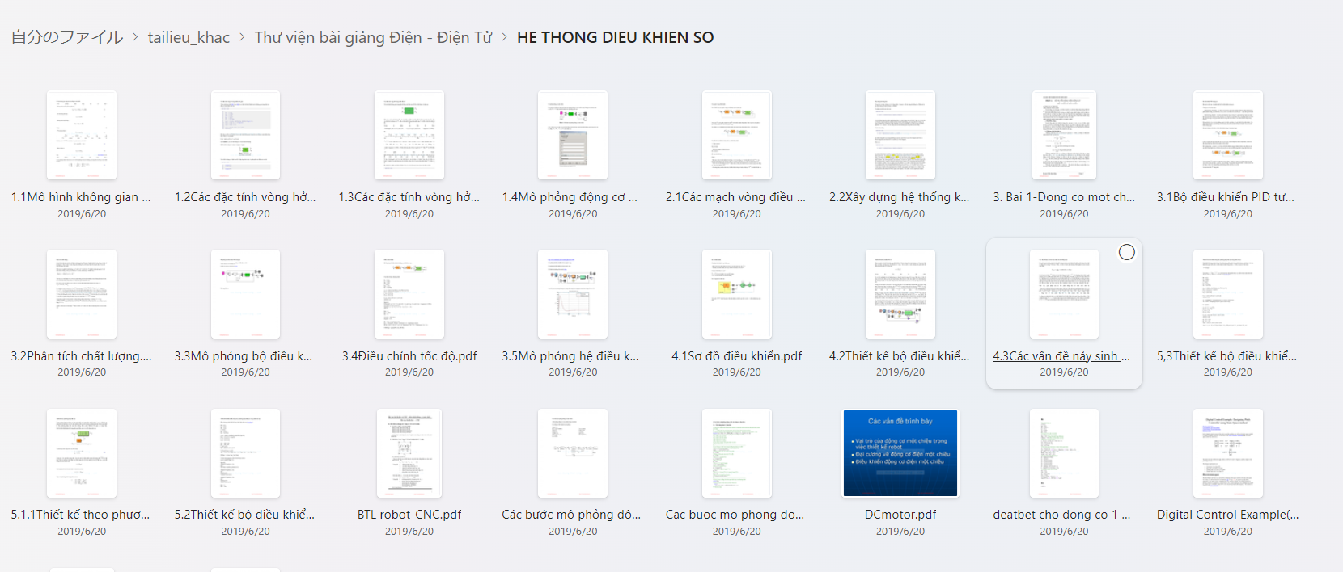

Digital Control Course material – HUST



[White paper] from-continuous-time-domain-to-microcontroller-code.pdf

https://www.qorvo.com/resources/d/from-continuous-time-domain-to-microcontroller-code

## QUESTIONS

1. Why do they need to explain the mapping between z domain and s domain in a graphical way, is it because of the root locus, how to determine the quality of the system or something?
2. What is the meaning of ROC, it’s the collection of values of z that make the series, or z transform convergence to a specific determined value. How to find ROC: find the z transform -> function of z, find the poles of function. How to use that value of ROC of z transform?? (2024.03.04)

What happens if the H(z) doesn’t converge?? It means that if that is the transfer function, or maybe a input signal, or an output signal, the signal goes to infinity?? Or maybe the original signal cannot be determined definitely. Anyway, I know that for every z transform result, there will be a ROC. It makes the z sequence determined.

2024.04.13: If the z transform function doesn’t converge, if that function is your system – transfer function in z domain, then it means that your system isn’t stable, with some bounded input can cause your output to blow up to infinity.

1. How to find z transform by using math knowledge and using z transform properties table, how to find ROC.