Nguyễn Đình Tiến – C4E20

Question1: What is Boolean? Write down 3 different expression that results a Boolean type (i.e. 5 == 6)

A Boolean value is either true or false. It is named after the British mathematician, George Boole, who first formulated Boolean algebra — some rules for reasoning about and combining these values. This is the basis of all modern computer logic.

A **Boolean expression** is an expression that evaluates to produce a result which is a Boolean value.

Ex:

1. **>>>** 12 == (6 * 2)   
   True
2. **>>>** yob == 1998

**>>>** age == 20

True

1. **>>>** x == 12

**>>>** y == 13

**>>>** x < y

True

Question2: What is a flow chart? Draw flow chart for the following code snippet: (you can draw on a paper, take a picture of it)

if name == “Anh Quan":

   print(“Hand some")

elif name == “Minh Duc":

   even_more_handsome = True

else:

   webbrowser.open(“<https://www.youtube.com/watch?v=04854XqcfCY>”)

A flow chart is graphical representation of the sequence of operations in an information system or program.

Flow chart:

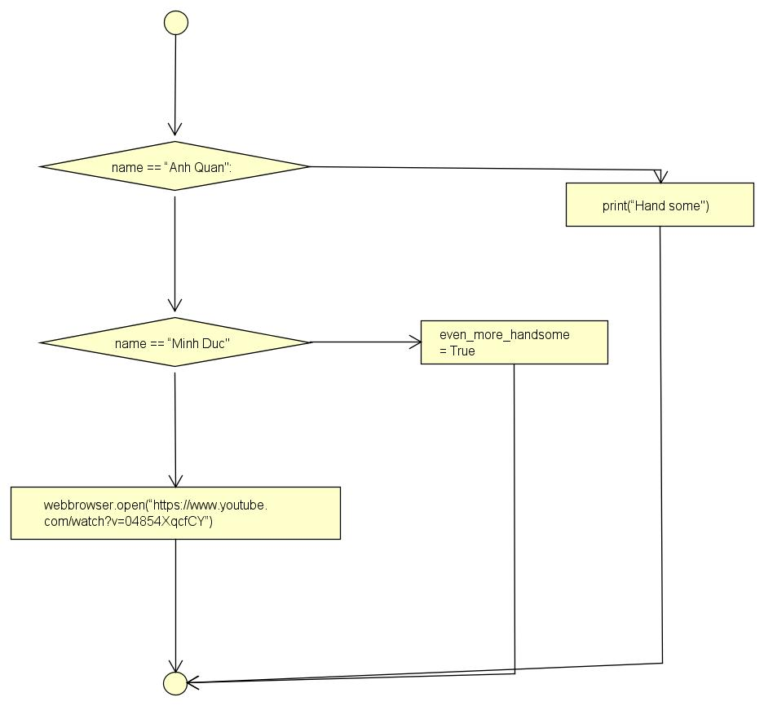

Question3: What is nested conditionals? Write a piece of code that uses nested conditionals

One conditional can also be **nested** within another

Ex: The outer conditional contains two branches. The second branch contains another if statement, which has two branches of its own. Those two branches could contain conditional statements as well

1 **if** x < y:  
2 STATEMENTS_A  
3 **else**:  
4 **if** x > y:  
5 STATEMENTS_B  
6 **else**:  
7 STATEMENTS_C