Submission Guideline

# Introduction

Final result of all participants in Cinnamon AI Marathon will be submitted to Cinnamon’s repository in Docker Hub. This guideline will introduce step by step to make Docker image and submit the image to Cinnamon’s Docker Hub.

## Docker

* What is **Docker**: is a computer program that performs operating-system-level virtualization, also known as "containerization". It was first released in 2013 and is developed by Docker, Inc. Docker is used to run software packages called "containers". [Wikipedia](https://en.wikipedia.org/wiki/Docker_(software))
* Installation:

<https://www.docker.com/get-started>

**NOTE**: to run GPU in Docker, need install Nvidia Docker

<https://github.com/NVIDIA/nvidia-docker>

## Docker Hub

* What is **Docker Hub**: is a cloud-based repository in which **Docker** users and partners create, test, store and distribute container images. **Docker Hub** is a cloud-hosted version of **Docker** Registry.

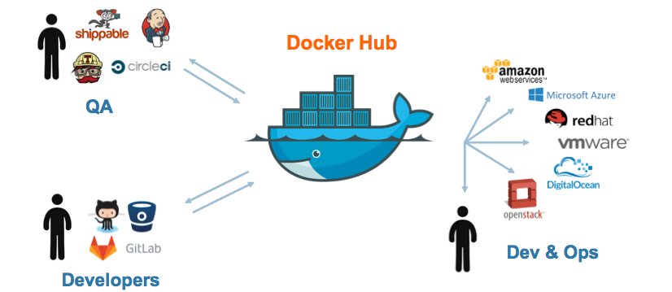

* Sign up to Docker Hub:

<https://hub.docker.com/>

**NOTE**: all participants **MUST** sign-up Docker Hub with registration email send to Cinnamon

In case of using other email, please send this email to [phelan@cinnamon.is](mailto:phelan@cinnamon.is) to register repository in Cinnamon’s Docker Hub

# Guideline of creating a Docker image

To create a Docker image, please follow below instructions:

## Preparation

* Install Docker: follow URL
* On Mac

<https://docs.docker.com/docker-for-mac/install/#install-and-run-docker-for-mac>

* On Ubuntu

<https://docs.docker.com/install/linux/docker-ce/ubuntu/#install-docker-ce-1>

* On Window

<https://docs.docker.com/docker-for-windows/install/>

* Prepare your your **submission folder**: include source code to run prediction and model (*recommendation*: you should also put source of training in here)

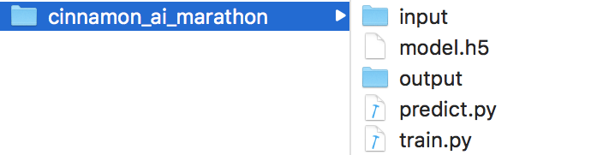

**NOTE**: file predict.py read all images in input folder and write result into output folder. Input folder now is empty, it will be mount into a folder which contains images when running Docker image

## Create a Docker image from scratch (or use your existing Docker image)

Example: create a Docker image from Ubuntu 16.04

* Make a file named **Dockerfile** with below content:

*# Download base image ubuntu 16.04*

*FROM ubuntu:16.04*

*# Update Ubuntu's package*

*RUN apt-get update -y*

* Open a terminal, go to folder contain **Dockerfile** and run below command

$ *cd {folder contain* ***Dockerfile****}*

$ *docker build -t cinnamon_ai_marathon:1.0 .*

Note: NEED the character “.” at end of command

* After finish, verify by command

$ *docker images*

Result will show “*cinnamon_ai_marathon”* on terminal ⇒ OK

## Run Docker container and copy submission folder into Docker container

* Run created or your existing Docker image

Example: run with above created Docker image and install dependencies to run your prediction program (install python, tensorflow and keras, ...)

Open a terminal and run below command

$ *docker run -it cinnamon_ai_marathon:1.0*

$ *apt-get install python3-pip python3-dev -y*

$ *pip3 install --upgrade --user tensorflow*

$ *pip3 install keras*

* Copy submission folder into Docker container

Open **another** terminal, and get Docker container ID by command, execute copy command and save all change to the Docker image

$ *docker ps*

* Output on the terminal contain

CONTAINER ID

**1eee6979a4a5** (different on your PC)

$ *docker cp {****submission folder****}* ***1eee6979a4a5:/***

$ *docker commit* ***1eee6979a4a5*** *cinnamon_ai_marathon:1.0*

* Verify run your prediction.py

$ docker run -w /*cinnamon_ai_marathon -v {input folder on PC}:/cinnamon_ai_marathon/input -v {output folder on PC}:/cinnamon_ai_marathon/output /usr/bin/python3 /cinnamon_ai_marathon/predict.py*

*Example:*

*docker run -w /cinnamon_ai_marathon -v ~/Desktop/input/:/cinnamon_ai_marathon/input -v ~/Desktop/output/:/cinnamon_ai_marathon/output cinnamon_ai_marathon:1.0 /usr/bin/python3 /cinnamon_ai_marathon/predict.py*

After run successfully, the prediction output will be write into *~/Desktop/output/* on your PC

**NOTE:** please change with your folder path and Docker image name when executing command.

# Guideline of submission to Docker Hub

After creating Docker image success and verified your Docker image, please push your Docker image into Cinnamon’ repository Docker Hub as below instructions.

## Create your account Docker Hub

If you already have Docker Hub account, please skip this step.

Otherwise, please go to below URL and sign up with registered email

<https://hub.docker.com/>

**NOTE**: If you sign up Docker Hub with other email (not email registered with Cinnamon AI Marathon), please inform to [phelan@cinnamon.is](mailto:phelan@cinnamon.is) with 2 information: Team name + Email using Docker Hub or Docker Hub ID

## Push Docker image to Cinnamon’s repository Docker Hub

* Each team enroll Cinnamon AI Marathon will be have a **Docker Hub’s repository** to upload Docker image with name as below:

*cinnamonmarathon/{Docker ID}*

Where:

Docker ID: your docker ID

Example: a team with Docker ID is phelan (to get docker ID, just login to Docker Hub and view profile) will have a repository:*cinnamonmarathon/phelan*

* Push Docker image to Docker Hub

$ *docker tag {docker_image}:{tag} {Docker Hub’s repository}:{challenge1|2|3}*

$ *docker push {Docker Hub’s repository}*

Example: above team enroll 2 challenge (1 and 2)

$ *docker tag cinnamon_ai_marathon:1.0 cinnamonmarathon/phelan:challenge1*

$ *docker push cinnamonmarathon/phelan*

$ *docker tag cinnamon_ai_marathon:1.0 cinnamonmarathon/phelan:challenge2*

$ *docker push cinnamonmarathon/phelan*

**NOTE**: Cinnamon’s Docker Hub only store latest version of each challenge, please no tag version of Docker image. The tag here is used to distinguished Docker image challenges.