HO CHI MINH CITY UNIVERSITY OF TECHNOLOGY

## FACULTY OF COMPUTER SCIENCE AND ENGINEERING



ASSIGNMENT 1 REPORT

DATABASE SYSTEMS

RESTAURANT MANAGEMENT

SYSTEM

Lecturer: Trần Minh Quang

*Group 9:*

**Vũ Lê Thiện Minh 1852590**

**Vũ Hoàng Anh Khôi 1811013**

**Đặng Gia Lệ 1812791**

**Dương Đình Trung 1814498**

**Contents**

1. Detailed requirement description
2. Conceptual DB design
   1. Conceptual DB design
   2. Tool for conceptual DB design
3. Logical DB design
4. Database management system
5. Physical DB design
6. Implement DB into Database management system
7. **Detailed requirement description**

The restaurant system is organized into **BRANCHs**. Each branch has a unique number, an address, and a particular employee who **<manages>** the branch. We keep track of the start date when that employee began managing the branch.

A branch must have one or more employees. An employee must **<works_for>** one and only one branch. The branch wants to keep track of the **EMPLOYEE’s** unique number, name, gender, address, phone, salary, shift.

A branch must **<control>** one and only one **MENU**, a menu must be controlled by one and only one branchs. A menu must **<contain>** one or more dishes, and a dish must be contained in one and only one menu. Attribute of dishes include a unique number, a name, description, price.

There are 3 different types of employees: **waiters, chefs, cashiers**. For waiters, the have rating attributes. About chefs, they have role attributes.

There are employees other than waiters, chefs, cashiers, admins, so an employee does not have to belong to any of these groups. A person can only belong to one of these groups.

A waiter may **<receives>** one or more **ORDERs** or may not receive any orders. An order must have one and only one waiter receive. Attribute of orders include a uniqure number and a datetime.

A chef may **<prepare>** one or more **ORDERs** or may not prepare any orders. An order may have any numbers of chefs prepare, and must have at least one chef prepare.

An order must **<include>** one or more **DISH** which be contained in menu. And, a dish may be included in one or more orders or may not contain in any orders. We keep track of the quantity that dish include in order.

An order must be **<made_by>** one and only one **CUSTOMER**, and a customer must make one or more orders. Each customer has a unique phone number, name, address.

We want to keep track of the **RESERVATIONs** of each customer, a customer may **<make>** many reservations or may not make any reservation. Attribute of reservations include date-time and number of seats.

One customer must **<pay>** one **BILL** and a bill must be paid by one customer. A bill must be taken by one and only one cashier, a cashier may **<take>** a number of bills or may not take any bills. Attribute of bill include an unique number, and a discount.

1. **Conceptual DB design**
   1. **Conceptual DB design**

Based on the requirement, we design ER model for Restaurant management system.

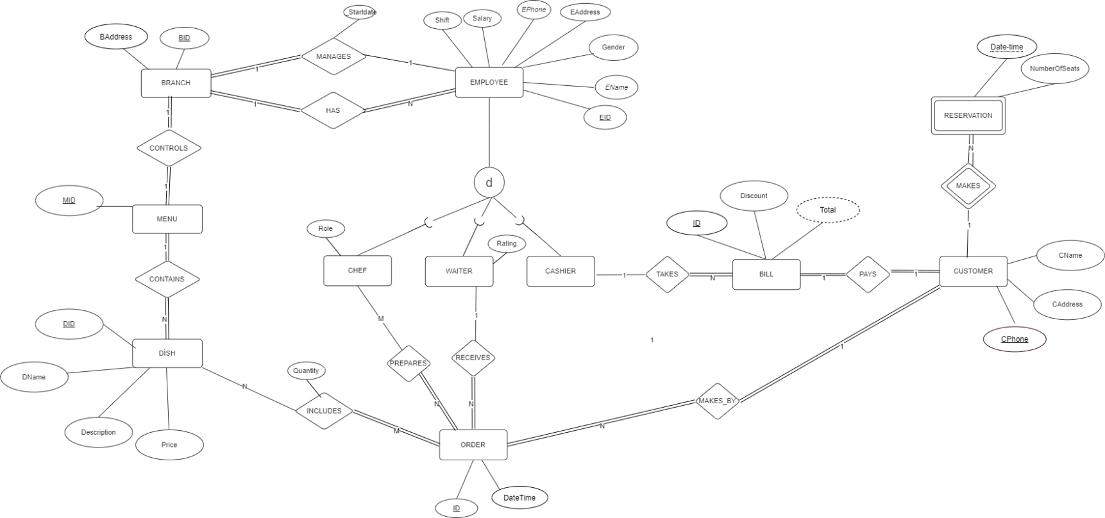

*Fig1. ER model for Restaurant Management System*

* 1. **Tool for conceptual design**

To design ER model we use **diagrams.net** (formerly **draw.io**)



*Fig2. diagrams.net (draw.io)*

diagrams.net (formerly **draw**.**io**) is free online diagram software. You can use it as a flowchart maker, network diagram software, to create UML online, as an ER diagram tool, to design database schema, to build BPMN online, as a circuit diagram maker, and more. **draw**.**io** can import .vsdx, Gliffy™ and Lucidchart™ files .

1. **Logical DB design**

We use ER model to relational mapping method in order to design logical DB.

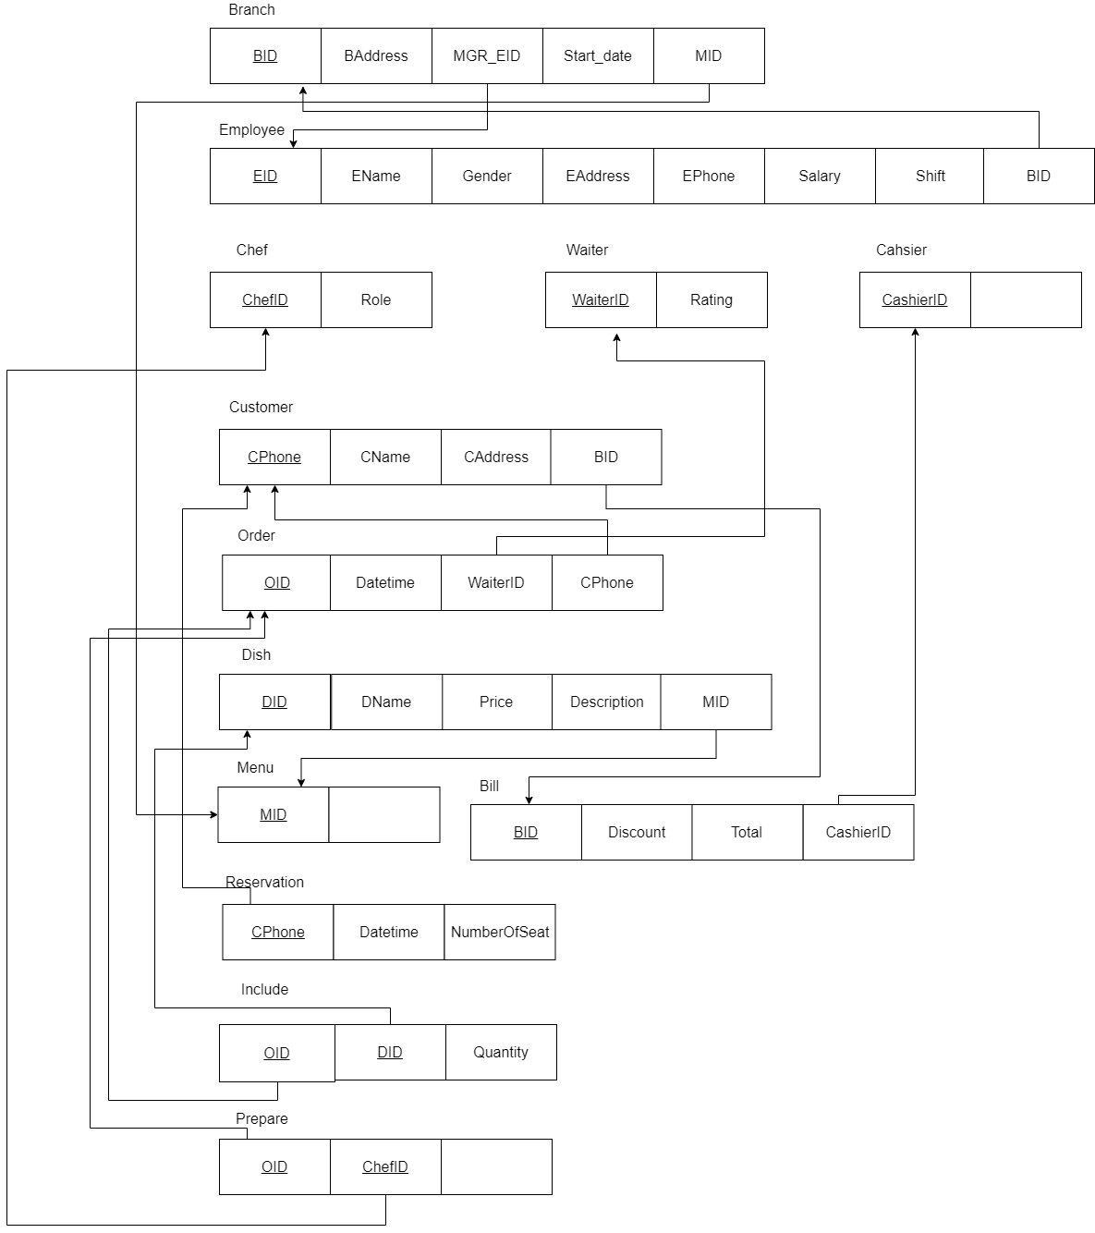

*Fig3. Relational mapping for Restaurant Management System*

1. **Database management system**

After discussing, we choose **MySQL** as our DBMS to manage DB.



*Fig4. MySQL*

MySQL is an open-source relational management system