I.Persona:

Trung, who is 19 years old is, in search of ways to improve his efficiency at work and studying in university by finding information easily. However he often gets distracted by information, which consumes an amount of his time. Therefore Trung is keen, on finding a tool that can assist him in locating information while saving time and enhancing productivity.

GOAL MODEL :

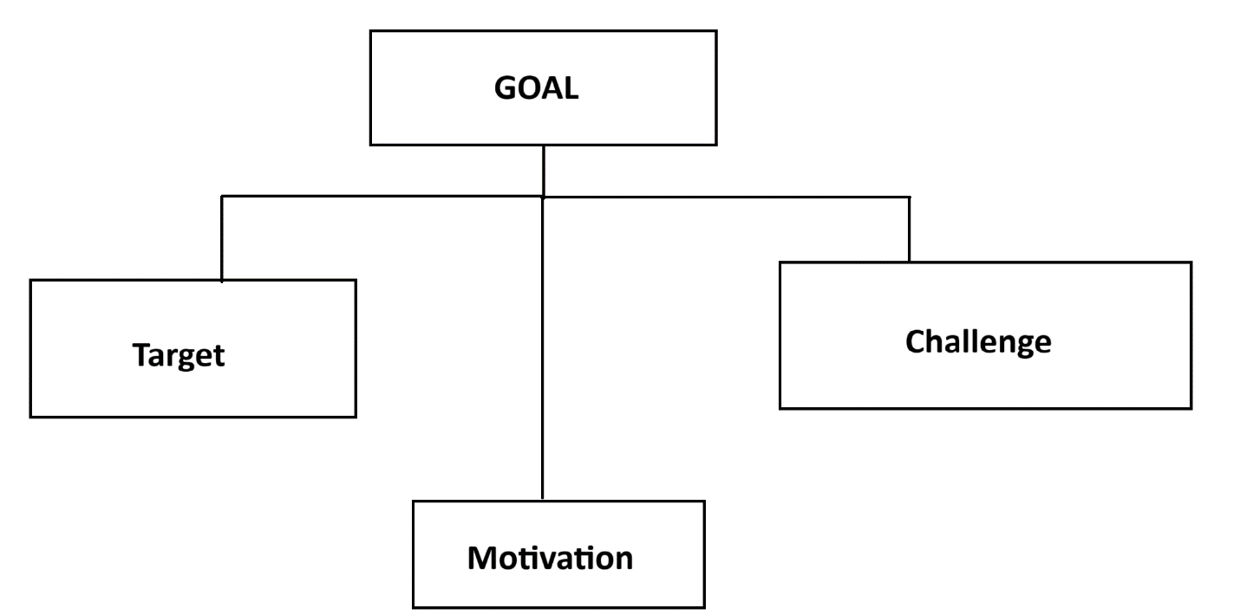

GOAL MODEL 1:

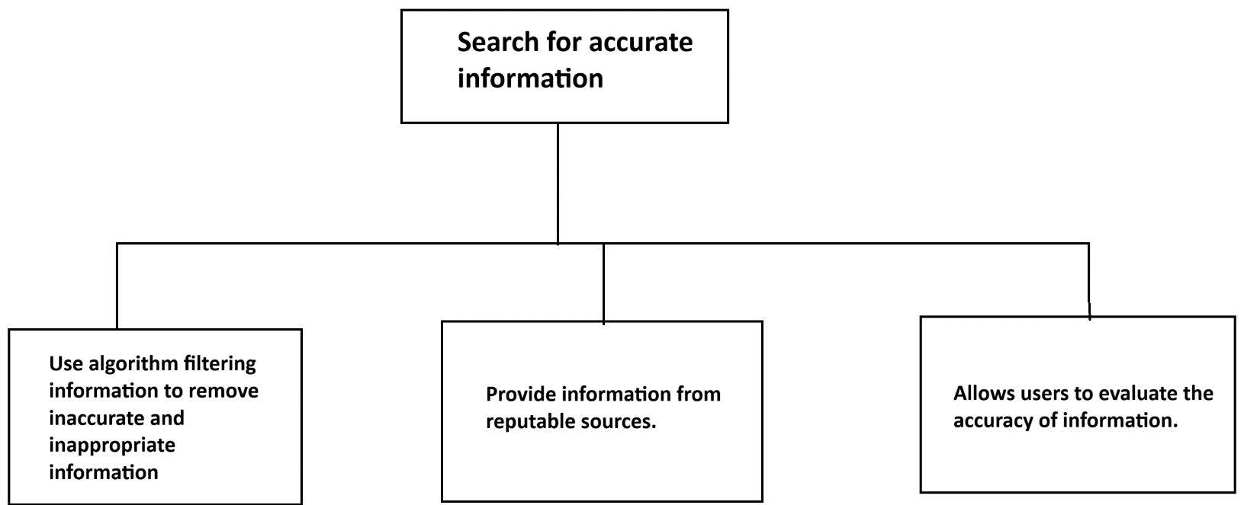

GOAL MODEL 2:

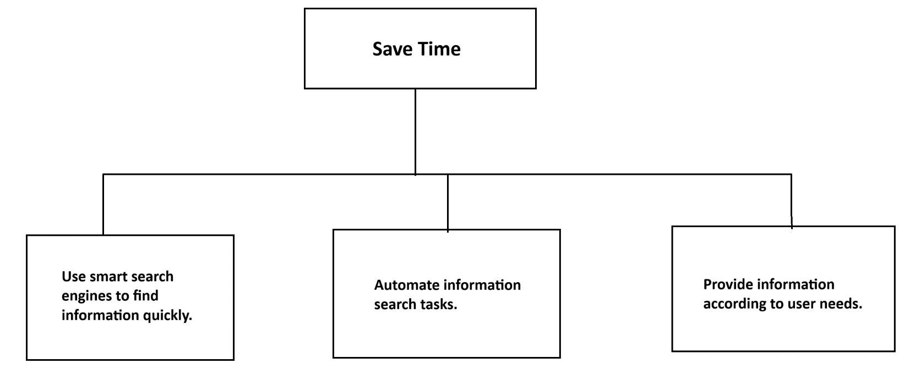

GOAL MODEL 3:

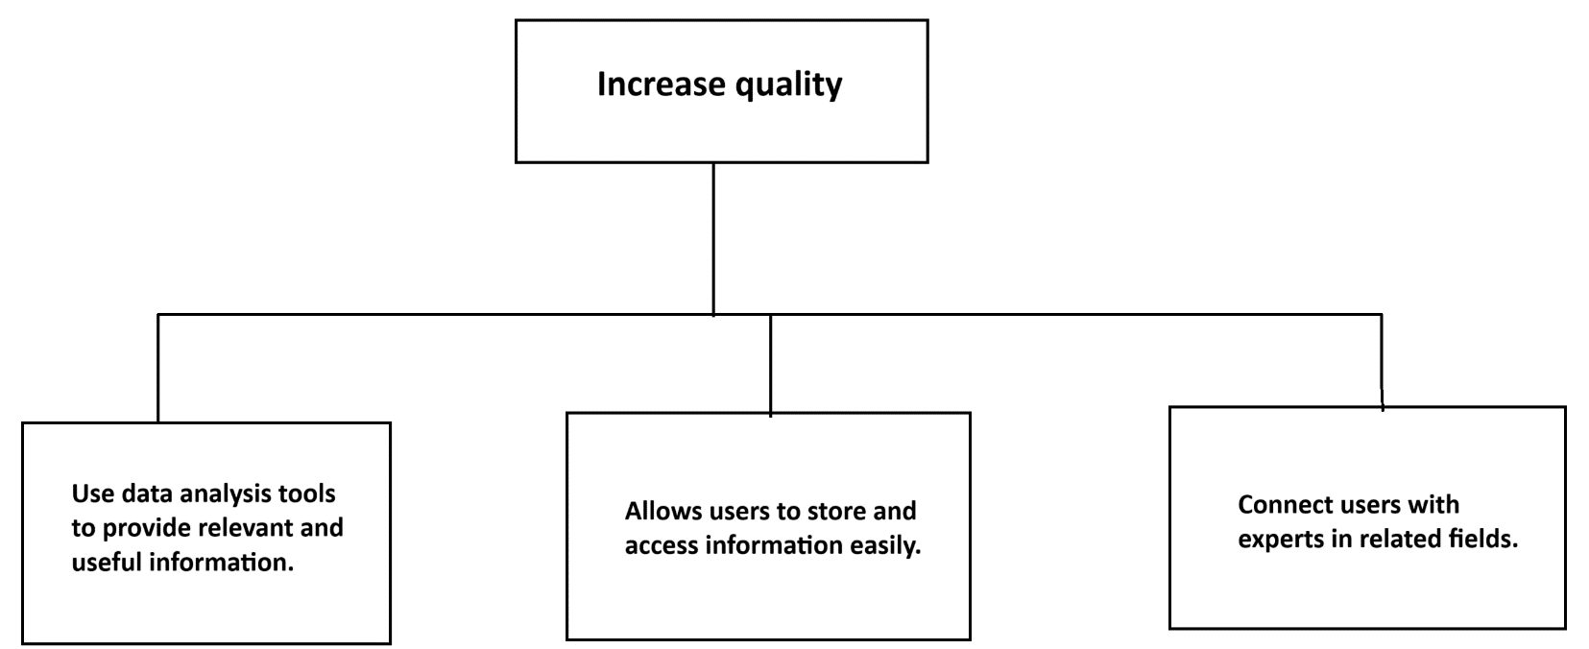

Use Case Diagram:

