1/

The actors of the system :

+ Officer of the Scientific Research Department

+ Students, researchers, lecturers

+ IT technician

+ Website visitors

2/

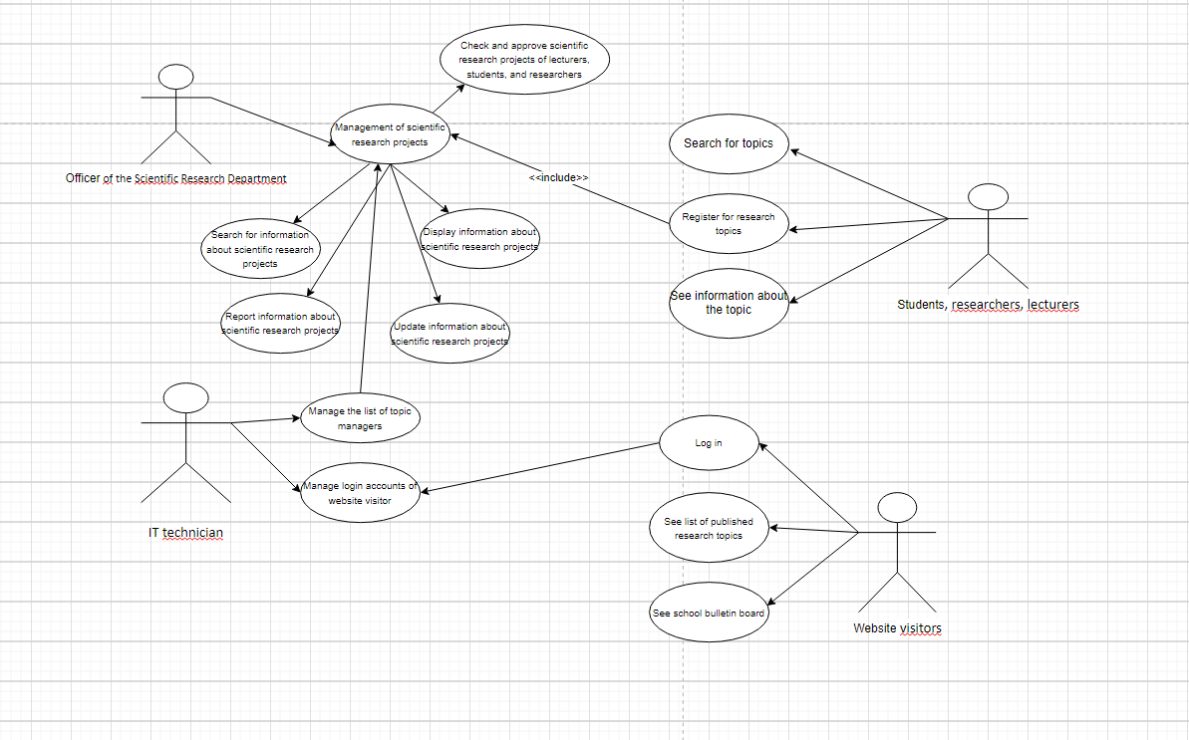

3/

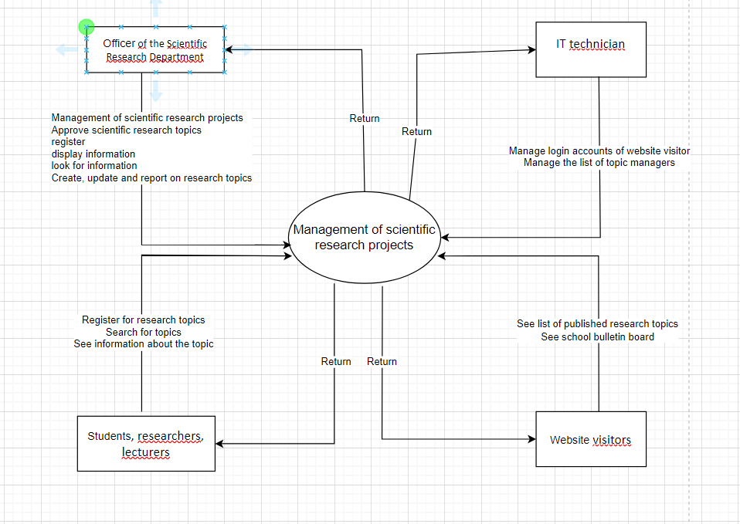

4/

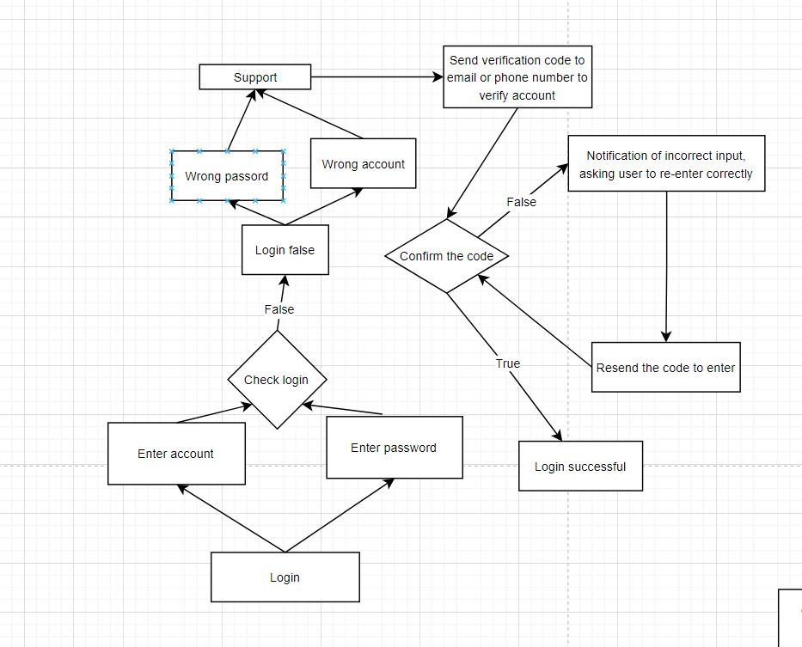

5/

