

**Table of Content**

1. Premms
2. Introduction
3. Customer Requirement Specifcaition
4. Site map
5. Database Spectification
6. Use cage and design system
7. **Premms**

In the process of implementing and completing my project, we had a lot of difficulties. And during that time, we' ve received a lot of help from many people.

First of all, we would like to thank Mr. Dai for helping us a lot. He outlined the roadmap, the way to help us from zero to the completion of the project. His enthusiasm and our receptivity made it an invaluable asset.

Beside, we would like to thank Softech Aptech for providing us with full documentation, knowledge and software to help us complete the project as quickly as possible.

Finally, we would like to thank our teammates. They enthusiastically helped me in difficult times to make us stronger. We had to face many difficulties, but with the synergy of the whole team, we turned those difficulties into momentum to prepare for the next steps.

During the implementation of the project, we also checked many times, but errors are inevitable. So we hope our project can be considered and recognized in the most equitable way. We would like to thank.

1. **Introduction**

Our project is a store management software that specializes in computer accessories.

Given the size of the project, we worked on a large amount of data. In addition, we also collect data for statistical purposes to control the store. Managing the operation of one or more stores entirely manually, requires a lot of manpower, time and cost, and is prone to errors.

Understanding the shortcomings in the management of the business, we have developed management software with additional features suitable for each business models of the business.

This software can help store managers control human resources, quantity of products, customers who have purchased products at the store... and many other features. Besides, the system also supports sales and print sales invoices. The application also has a search feature to help employees and customers easily find the necessary information quickly. Understanding the above difficulties of the Enterprise, we have developed software to manage more features suitable for many business models of businesses.

This software is used so that the store owner can control the number of employees, the number of products, the number of customers who have purchased the product at the store. It also allows employees to print invoices and sell. The use of the app makes it easy for them to control and find the necessary information.

Management software system includes:

* Management system for users with admin rights, managing all

* Login / Logout
* Order
* Account
* Product
* Statistics
* Customer
* My information

*Management system for employee

* Order
* Customer
* My infomation

1. **Customer Requirement Specification**
   1. **Client**

Computer store management software system was created to serve 2 types of customers:

* Customers who are the admin of the system can view all information related to sale, product import and export, employee information, statistics, change information and manage account
* Customers who are employees of the store: only view and manipulate with Order, Customer and Change Information.
  1. **Business Objective**

Management software functions of ComputerStoreManagement should be designed and developed to meet the following goals:

* Briefly introduce ComputerStoreManagement, typical features of the management system and the benefits of users when using the system to manage information about exporting, importing books, employee information and statistics.
* Manage intelligently, concisely and not much time, allowing users to manage the most concisely, the most correct data, and search quickly.
* Track detailed purchase orders, manage the number of product
* Easily find information about product.
* Helping users to statistic data, convenient for controlling revenue.
  1. **Software Requirements**
* Windows/Mac OS
* SQL Server Management Studio
* Java Development Kit
* NetBeans

1. **Site map**

**Management Software Diagram for Admin**

**Management Software Diagram for Employees**

1. **Database Spectification**

**1. Entities Relationship Diagram**

**2. Table Definition**

2.1. Bills

2.2. Bill Detail

2.3. Customer

2.4. Product

2.5. User Account

1. **Use cage and Design system**
2. **Use Cases**



**Admin/ Manage**



**Employee**

1. **Design of Specific Use Cases**
   1. Login

Login screen

Enter the username and password

Choose position: Admin or employee

Login button

Screen display

|  |  |
| --- | --- |
| User case name: Login  User: Admin / Employee | |
| **Input** | **Out put** |
| Username + password + is admin checkbox | * If position is admin: Can see all main menu. * If position is employee: Can see 4 main menu ( Logout, order, customer, my information ). |
| Note:   * If username and password is empty, show message error: Username or password is empty * If account does not exist, show message error: Account does not exist * While entering the password, you can click on the show password button to enter the password more easily | |

* 1. Product

1. Add product

Click add button

Enter product infomation

Click save button

|  |  |
| --- | --- |
| User case name: Add product  User: Admin | |
| **Input** | **Out put** |
| Information of the product | * New product in list product |
| Note:   * If some information has not been entered, show message error. * You can choose a photo for the product or not | |

1. Delete product

Select product to delete

Click delete button

|  |  |
| --- | --- |
| User case name: Delete product  User: Admin | |
| **Input** | **Out put** |
| Select product in table | * Delete product in list product |
| Note:   * If the product is not selected before clicking the delete button, a message will be displayed. * You can check the information before deleting | |

1. Edit product

Select product to edit and click edit button

Edit infomation

Click save button

|  |  |
| --- | --- |
| User case name: Edit product  User: Admin | |
| **Input** | **Out put** |
| Select product in table and edit information of product | * New information of product |
| Note:   * If the product is not selected before clicking the edit button, a message will be displayed. | |

* 1. Reset infomation

|  |  |
| --- | --- |
| User case name: Reset product infomation  User: Admin | |
| **Input** | **Out put** |
|  | * The input will be cleaned |
| Note:   * Any information entered after pressing the reset button will be cleaned. | |

* 1. My account

|  |  |
| --- | --- |
| User case name: My infomation  User: Admin/ Employee | |
| **Input** | **Out put** |
| Information of my account  Old password | * Information after edit * New password after change |
| Note:   * If the input is blank or not in the correct format, the input box will show a red background and the save button will be hidden. * in the change password section, if the old password entered doesn't match, the new password input box and the save button are also hidden. | |

* 1. Order

|  |  |
| --- | --- |
| **Use case name:** Order  **User:** Admin/Employee | |
| **Input** | **Output** |
| * Customer information * Product information * Amount paid by customer | * Information of the products is displayed in the table * Total amount to be paid * Return amount * Bill, Invoice |
| **Note:**   * Entering the customer’s ID or Phone number contained in the database will automatically fill in the remaining information. Or add customers quickly with the *Add new* button after filling in customer information. * Add a new product by Product ID, automatically fill in the Name and Price of the product (If the ID is wrong, a message dialog that the product does not exist will be displayed). * Entering the quantity of the product (if the message dialog is not available), after clicking the *Add product* button, the product will be displayed at the Product table and the total amount of the order. * Enteringthe amount paid by the customer, the excess amount will be displayed (if the message dialog is not available). * Clicking on *Add order* button to create an order and display the bill. * Clicking on *Print* button to print the payment bill. * Clicking on *Generate PDF* button to create the invoice. | |

* 1. Customer

|  |  |
| --- | --- |
| **Use case name:** Customer  **User:** Admin/Employee | |
| **Input** | **Output** |
| * Customer information | * Information of the customers is displayed in the table |
| **Note:**   * Entering the customer’s ID, Name, Contact, Address, click on *Add new* button to add a new customer. If you leave Customer ID and Name blank, a Message dialog will be displayed, can be left Contact and Address blank. * Select a customer in the Customer table, edit the information then click on *Edit* button to change the customer information. * Select a customer in the Customer table, edit the information then click on *Edit* button to change the customer information. * Click on *Add* button to clear all entered information. | |

2.7 Statistics

Enter ID product or name or supplier ID

Display result on the table

|  |  |
| --- | --- |
| **Use case name:** Statistics  **User:** Admin | |
| **Input** | **Output** |
| * ID product, name or supplier ID | * Information about product |
| **Note:** | |

* 1. My info

Enter new fullname, phone, address, gender, birthday

Click button

Change your information

|  |  |
| --- | --- |
| **Use case name:** My Account  **User:** Admin | |
| **Input** | **Output** |
| * Your new fullname, phone, address, gender, birthday | * Update your information |
| **Note:** | |

* 1. Change password

Enter your new password

Enter your old password

Check to see if the old password is correct.

Change your password

Check to see if the new password is valid

1. **The screen of software**

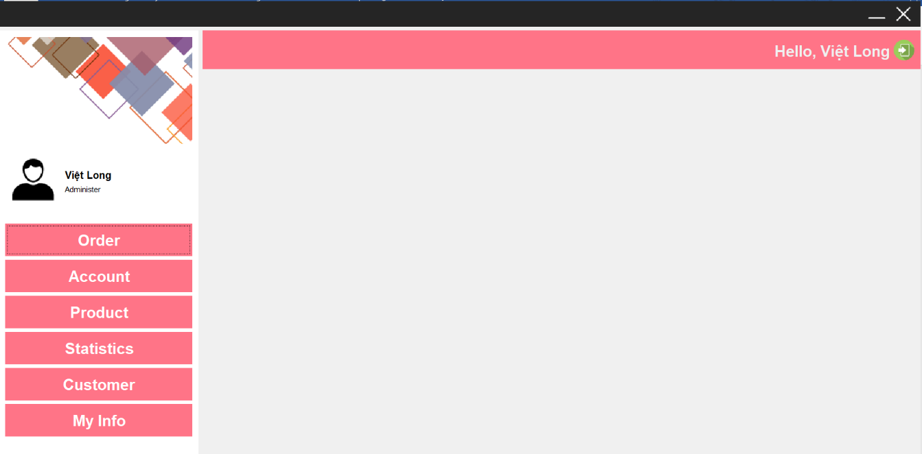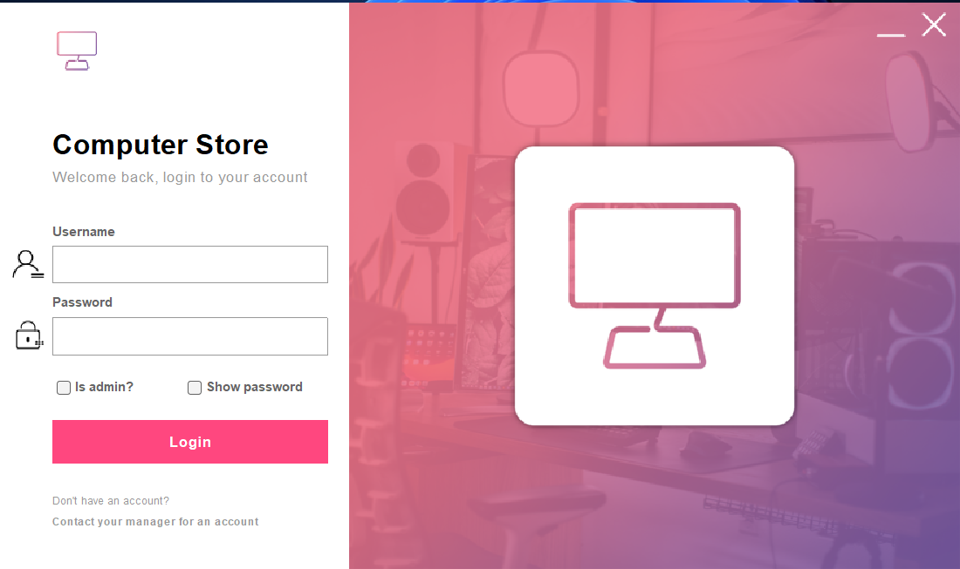

7.2 Admin screen

7.1 Login screen

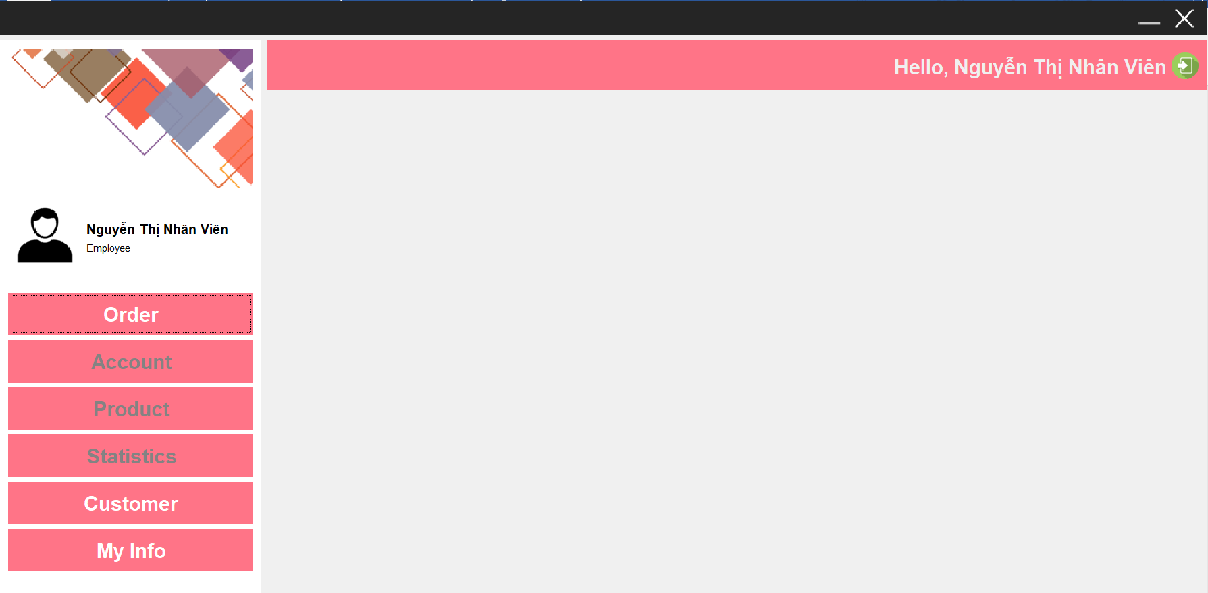

7.3 Employee screen

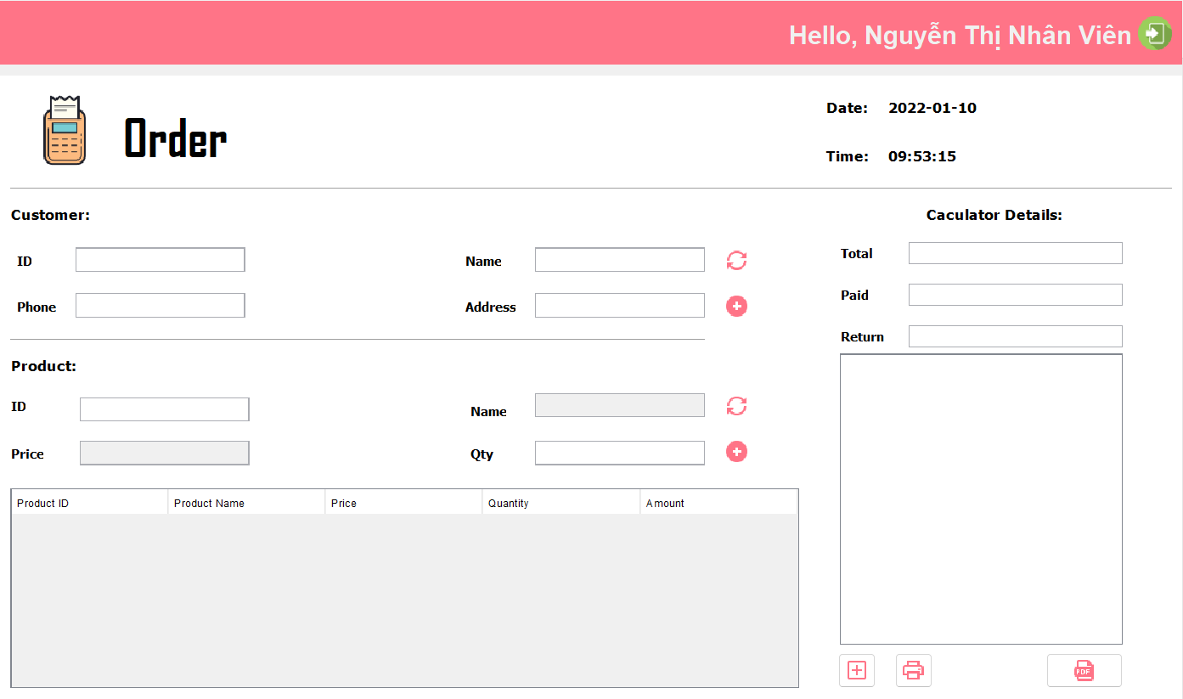

7.4 Order screen

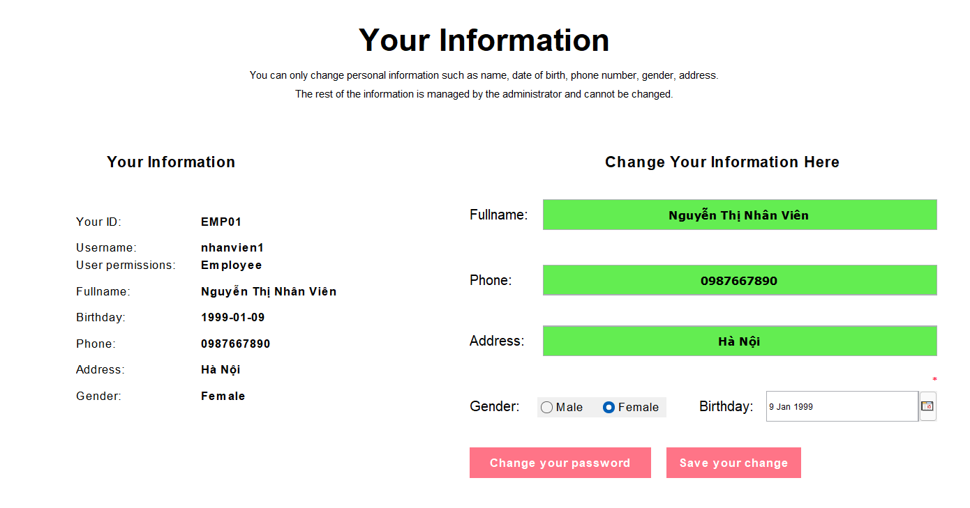

7.5 Change information screen

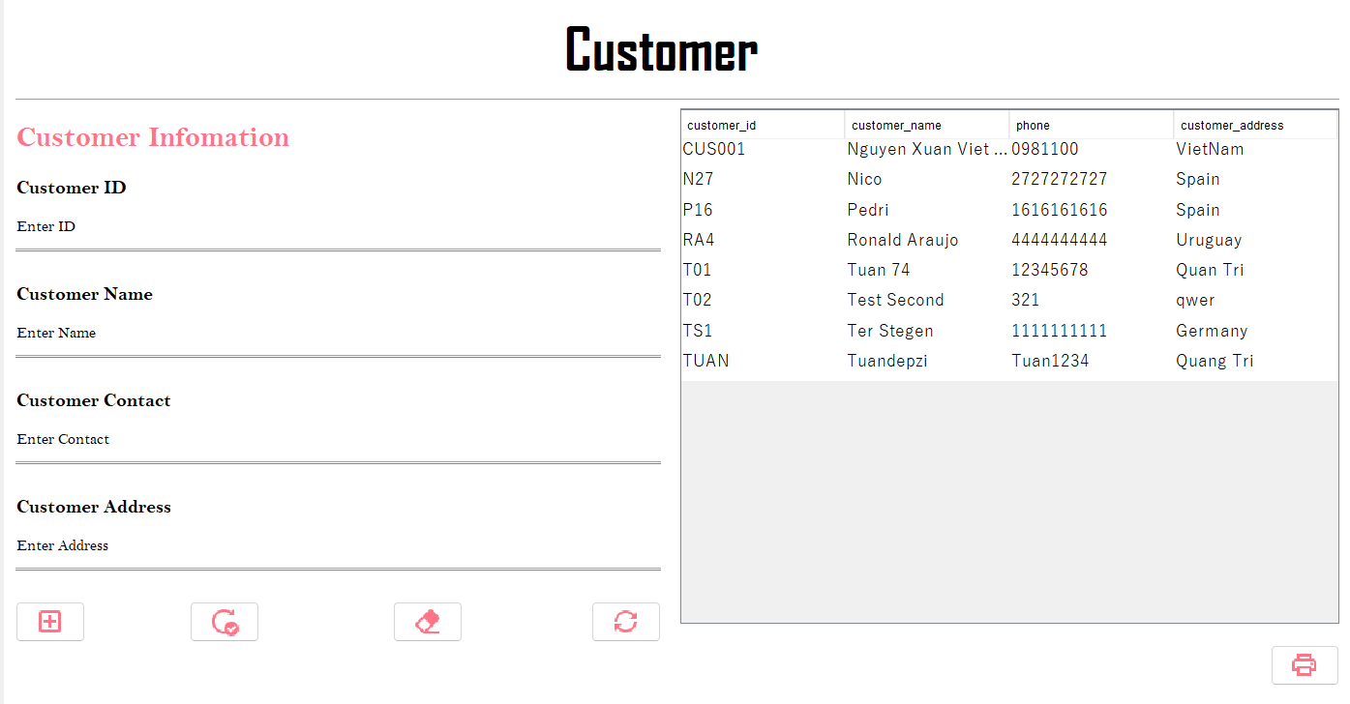

7.6 Customer screen

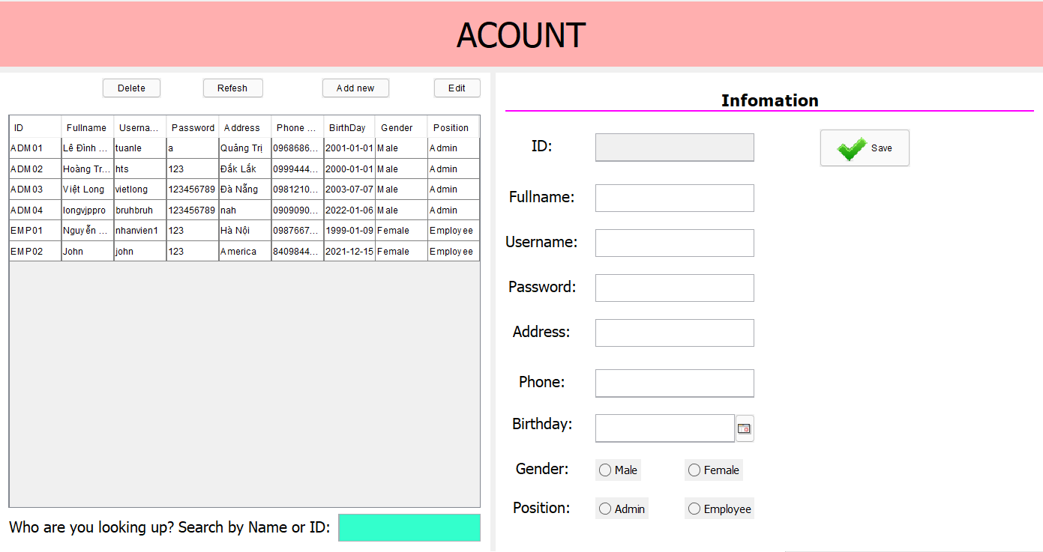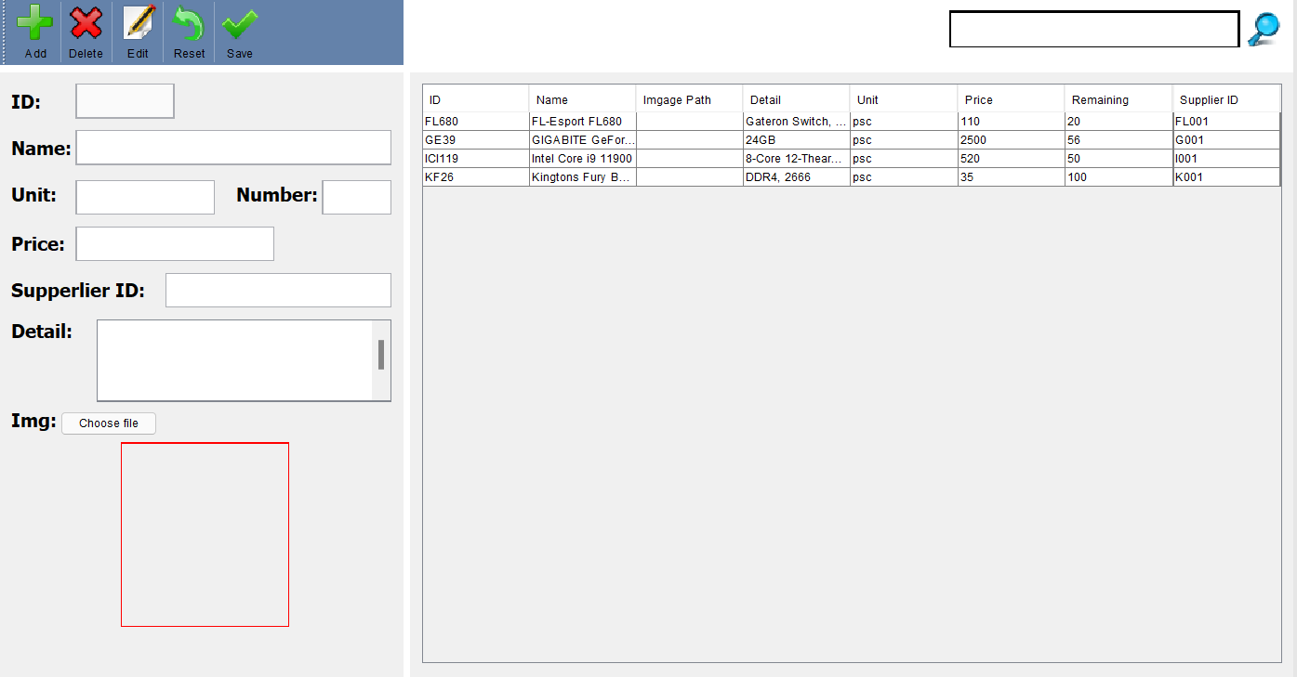

7.8 Manage product screen

7.7 Manage account screen

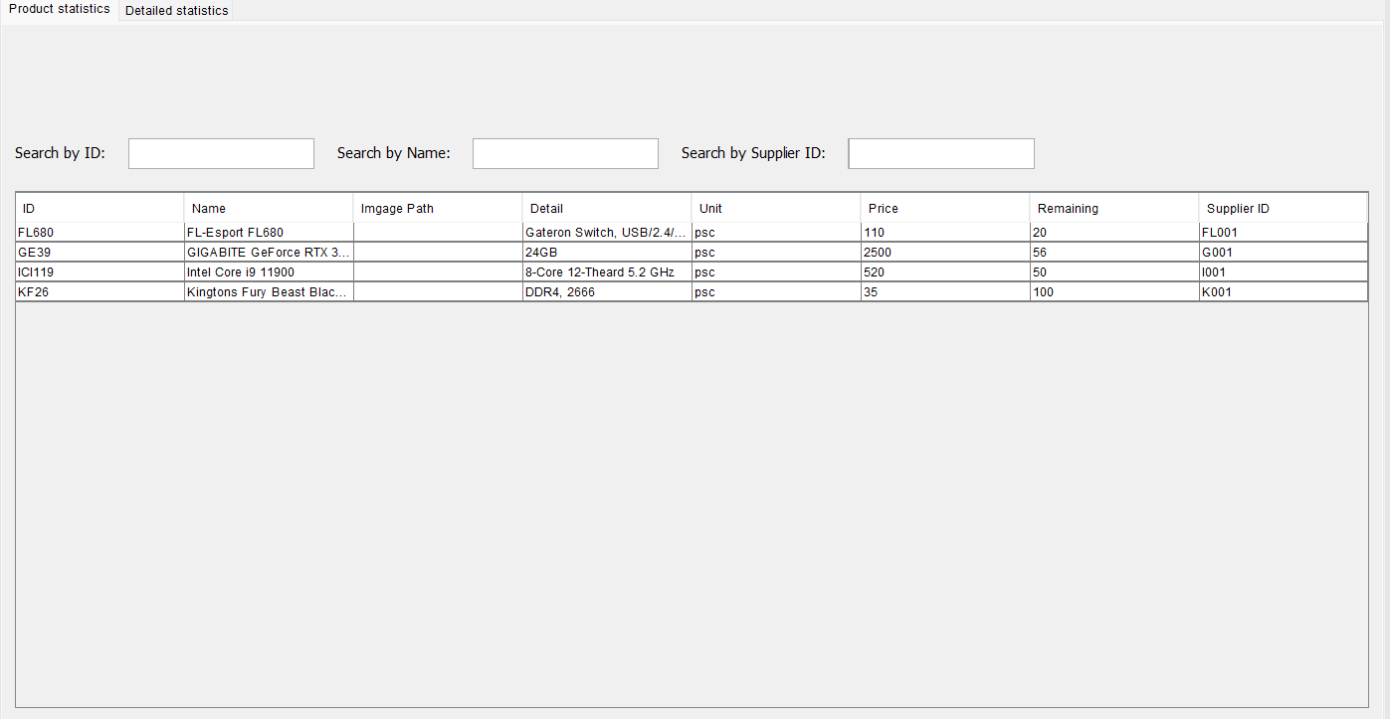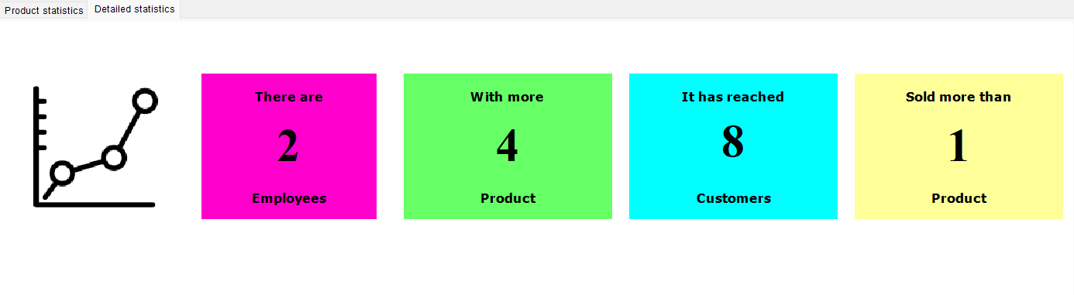

7.9 Stastics screen

1. **Tasksheet**

|  |  |
| --- | --- |
| **Task** | **Doers** |
| Login screen and panel | Le Dinh Tuan |
| Idea UX/UI, design icon, background | Nguyen Xuan Viet Long & Hoang Trong Son |
| Diagram | Nguyen Xuan Viet Long |
| Design database | All team |
| Statistics | Nguyen Xuan Viet Long |
| Product manage | Le Dinh Tuan |
| Order | Hoang Trong Son |
| My account | Le Dinh Tuan |
| Account manage | Hoang Trong Son |
| Customer manage | Hoang Trong Son |
| Doucument | All team |
| Slide | Nguyen Xuan Viet Long |
| Testing | All team |