[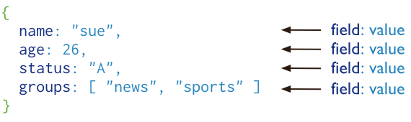](http://www.candra.web.id/wp-content/uploads/2014/02/crud-annotated-document.png)