Capstone Project Assignment: Data Storytelling

Dinisha Denuka
Trine University
Business Analytics Capstone
Thomas V. Smead

Data Storytelling
Business Problem
The business issue behind this project is that there is a need to access the safety and quality of water in various beaches. When the water quality changes and gets below the safe level, the relationship between tourism and the public health is directly impacted. The opinion and pressure on the beach management authorities is to monitor water conditions and in addition to that, to predict risks before they lead to any harm (City of Chicago, n.d.). In order to do it efficiently, they need to have a clear idea of what beaches are the most vulnerable, which processes contribute to shifts in the quality of water, and how seasonal or environmental conditions affect contamination. This issue is not only about making the number analysis but also presenting the insight in a manner easily understood and acted on by the decision-makers.
Interactive Storyboarding
The interactive storyboarding offered the ideal channel to integrate the various phases of the project, data preparation, visualization and design principles, into a unified story (City of Chicago, n.d.). The purpose of the storyboard was to guide users through the problem step-by-step, through the data, analysis and the solutions. The interactive components of the filters, highlight actions, and parameters instead of relying on a fixed chart enabled the stakeholders to view the data themselves. This allowed them to have some control of the way they perceived the insights, which made the story more interesting, individual, and effective.
Addressing Water Quality Variation Across Beaches
The initial question was how the water quality differed according to the beaches and places. The storyboard answered this question in a horizontal bar chart where the beaches were ranked in terms of average water quality scores (City of Chicago, n.d.). The color gradients also helped to make a distinction between cleaner and more problematic beaches. It was designed to be interactive through letting the user hover a beach to get detailed information, or by filtering to a specific time period. This rendered the visualization descriptive as well as exploratory to make the authorities know where to channel resources in a quick fashion (City of Chicago, n.d.).
Understanding Seasonal and Time-Based Trends
The second question was on the change in the water quality with time. The storyboard has a line chart that was meant to note the differences in the month and season. To render the story as an interactive one, the users were allowed to choose various time frames and compare several beaches at the same time. Safe thresholds were provided on the reference lines so that the users could instantly tell when and where the standards were violated. Such a scene in the storyboard permitted the patterns to be visible and actionable particularly when it comes to planning proactive checkups within the months that are high-risk.
Identifying Indicators Exceeding Safe Limits
The third issue was to examine what indicators were most frequently over safe standards. This was presented in interactive bar chart in the storyboard (City of Chicago, n.d.). The visual quickly attracted the attention to the indicators of the problem with the red color used in cases of exceedances and the gray color used in the safe level. The view could be filtered by location or time period and this provided more insightful analysis. This level of interactivity enabled decision-makers not only to determine the most problematic indicators in general but also to monitor whether there were beaches or times that increased the problem.
Measuring Frequency of Exceedances Across Beaches
The fourth question involved the interpretation of the frequency at which beaches were over limits of safety as well as most affected areas (City of Chicago, n.d.). A heatmap was added to the story board to tell this part of the story. The color scale moved beyond the light yellow and deep red and instantly signified the high risk beaches and seasons. The interactivity allowed users to enter a specific beach and see monthly performance. This visualization was an analytical tool because it provided a visual overview of the big picture and a deeper analysis that could be applied to inform decision-making on resource allocation (City of Chicago, n.d.).
Discovering Relationships in the Environment
The final question was about the impact of environmental conditions such as rain, tides and temperatures. The storyboard included a scatter plot with a temperature on the x-axis and water quality on the y-axis, the size of the markers measuring rainfall. Another color gradient made its way to give the status of the tide. Correlations were also better demonstrated by introducing a trendline. This visualization was based on interactivity and the user could filter by season or beach to see how the environment affected things differently in various situations (City of Chicago, n.d.). The management had a few predictions that were made out of this scene as they assisted them in anticipating the occurrence of unsafe conditions.
The Storytelling of the Business Problem
This interactive storyboard was not a group of charts, but a story. Each scene rested upon what had come before it, and the sequence was to find out which beaches had suffered most, to find out about seasonal information, to find out about problematic indicators, to quantify how often it had been surpassed, and finally but not least to explore the environmental drivers. Together, these pictures answered the five significant client-based questions of Week 1 and did not change in response to the business problem overall (City of Chicago, n.d.). The communication skills enabled the stakeholders to dig deeper into matters that were most relevant to their roles, and the knowledge gained was not only understood, but was put into action.
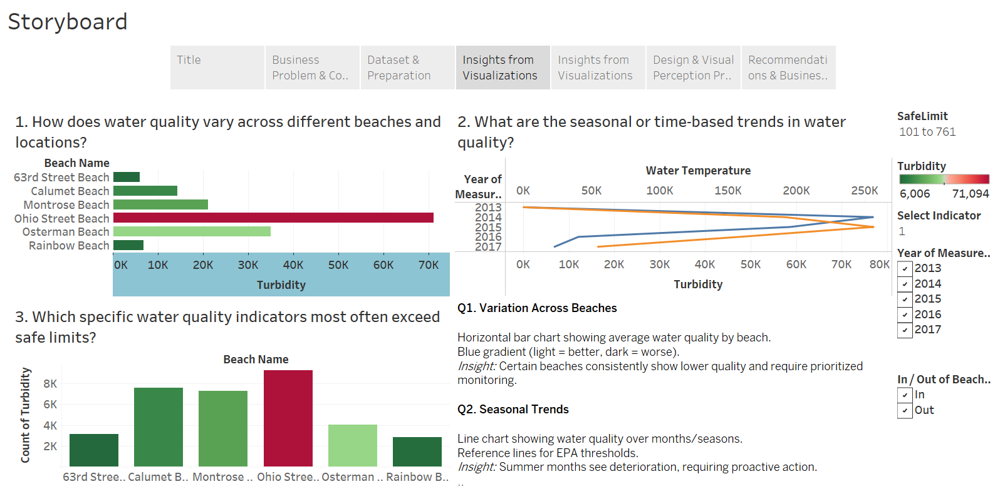
Conclusion
Finally, interactive storyboarding helped to transform raw data into the powerful story about water quality management. It responded to the questions raised by the client in a systematic and lively manner and emphasized the risks, trends, and solutions. The integration of data visualization best practice, design and interactivity resulted in the storyboard providing a solution that empowered authorities in charge of managing the beach with the knowledge that is required to safeguard the health of people, preserve their confidence and guarantee long term viability of their beaches. The business issue was not only narrated, but has been addressed through the strength of data storytelling (City of Chicago, n.d.).

References
City of Chicago. (n.d.). Beach water quality automated sensors. Data.World. Retrieved from https://data.world/cityofchicago/beach-water-quality-automated-sensors

