Capstone Project: Design Principles & Gestalt Principles

Dinisha Denuka
Trine University
Business Analytics Capstone
Thomas V. Smead

Design & Gestalt Principles
Introduction
In the Capstone Project, the main goal is to monitor water quality at various beaches and provide useful insights for city officials to ensure public safety. Clear data visualization is essential for turning complex datasets into understandable information. To achieve this, specific design principles and Gestalt concepts were used in the dashboard and charts to improve readability, highlight key patterns, and support decision-making. This section explains the design and Gestalt ideas integrated into the project and how they relate to the business problem identified in Week 1: identifying beaches with poor water quality, understanding trends, and prioritizing interventions (City of Chicago, n.d.).
Design Principle 1: Contrast
The principle of contrast focuses on using differences in color, size, or shape to make important elements stand out. Contrast was applied to the dashboard in several ways:
- Color Contrast: Exceedances in water quality indicators were highlighted with red tones, while safe measurements used lighter greens. This made high-risk areas easy to spot without complicated interpretation.
- Size and Shape: Bars for beaches with the highest exceedance percentages were slightly larger or bolded in the bar charts, helping viewers quickly identify priority locations.
Using contrast helps users distinguish between critical and non-critical data points quickly. For instance, when looking at seasonal water quality trends, different line colors let users follow specific beaches or indicators over time easily (City of Chicago, n.d.). By applying contrast, the dashboard directs attention to areas needing immediate action, supporting Week 1 questions like "Which beaches are most affected?" and "Which indicators often exceed safe limits?"
Design Principle 2: Alignment
Alignment ensures that elements are arranged in a structured way, creating visual order and reducing cognitive load. This principle was applied throughout the dashboard:
- Chart Layout: All charts were aligned along consistent horizontal and vertical axes, allowing viewers to move their eyes naturally from one visualization to another.
- Text and Labels: Titles, axis labels, and legends were aligned with their corresponding charts to prevent misunderstandings.
Alignment helps create a polished and visually coherent dashboard, ensuring that the viewer’s attention flows logically through the content. For example, placing bar charts next to each other allowed users to easily connect exceedance percentages with temporal trends. Proper alignment directly supports the business goal of helping city officials quickly analyze water quality data and make informed choices (City of Chicago, n.d.).
Gestalt Principle 1: Proximity
The proximity principle suggests that elements placed close together are seen as related. In the dashboard:
- Grouping Related Charts: Seasonal trends, exceedance counts, and environmental factor correlations were grouped closely. Charts displaying similar indicators or related metrics were positioned next to each other, creating visual units.
- Tooltips and Legends: Associated legends and explanatory notes were placed near relevant charts to strengthen contextual relationships.
This use of proximity allows viewers to quickly see connections between related datasets. For example, by grouping the heatmap showing exceedance frequency with the bar chart showing exceedance percentage, users can understand not only which beaches are at high risk but also when these exceedances happen (City of Chicago, n.d.). This principle improves pattern recognition and helps answer Week 1 questions like "How often do beaches exceed safety thresholds?"
Gestalt Principle 2: Similarity
Similarity is the principle where elements sharing visual traits—like color, shape, or size—are viewed as part of the same group. In this project:
- Color Coding: Exceedances across all indicators were consistently colored in shades of red, while safe readings were in blue or green. This consistency helped users quickly spot patterns of concern across different visualizations.
- Shape Consistency: Scatter plots and line charts used uniform shapes and line styles to represent data points or trend lines for the same category, maintaining visual harmony (City of Chicago, n.d.).
By applying similarity, users can intuitively group related data points, which enhances understanding of complex information. For instance, users can immediately identify which indicators repeatedly show problems across beaches, answering Week 1 questions like "Which water quality indicators often exceed safe limits?"
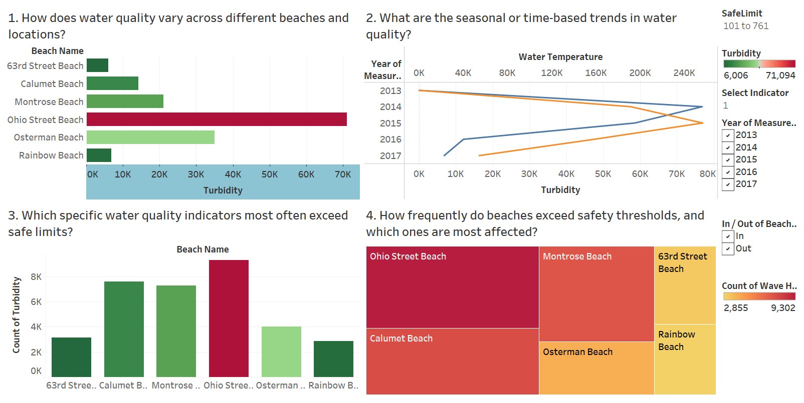
Summary of Application
Integrating these design principles and Gestalt concepts significantly improved the dashboard’s usability and effectiveness. Contrast highlighted high-risk data points, alignment ensured a clear flow of information, proximity allowed users to see relationships between related charts, and similarity reinforced consistent patterns across indicators. Together, these principles made it easier for stakeholders to analyze water quality trends, identify problem beaches, and prioritize interventions (City of Chicago, n.d.).
The careful application of visual perception techniques ensured that complex datasets became actionable information. Users can now interact with the dashboard confidently, understanding where and when water quality issues occur, which parameters are most problematic, and which beaches need immediate attention. Ultimately, these design choices support the Week 1 business problem by enabling city officials to make timely, informed decisions to protect public health and improve beach water quality management (City of Chicago, n.d.).

References
City of Chicago. (n.d.). Beach water quality automated sensors. Data.World. Retrieved from https://data.world/cityofchicago/beach-water-quality-automated-sensors

