TELCO AI Agent
A Multi-Agent Network Intelligence Platform for
Topology Awareness, Anomaly Detection, Fault Correlation, and QKD Link Health

Technical Design Paper — Version 0.1 (Draft)
July 2026
Components: Topology SubAgent (Go) · Anomaly SubAgent (Python) · Fault Correlation SubAgent (Go) · QKD Health Agent (Go) · Orchestrator (Go + NATS JetStream + gRPC) · GN (GenNets) Engine · Next.js / React Frontend

Table of Contents
1. Introduction
2. Background and Motivation
3. System Architecture Overview
4. Component Design
5. Communication Architecture
6. The GN (GenNets) Engine
7. Data Model
8. Simulator
9. Deployment and Operations
10. Evaluation Plan
11. Open Design Questions and Future Work
12. Conclusion
Appendix: References

1. Introduction
Modern telecom networks are no longer purely classical: fiber and microwave transport now sit alongside emerging quantum key distribution (QKD) links, cell sites, aggregation and core routing tiers, and a growing volume of streaming telemetry. Operating this environment reliably requires answering three questions continuously and in near real time: what does the network look like right now, what is behaving abnormally, and when several things go wrong at once, what is the actual root cause. The TELCO AI Agent project is a multi-agent system designed to answer exactly these three questions, built as a set of independently deployable microservices coordinated by an orchestrator over gRPC and NATS JetStream.
The system is organized around a simple separation of concerns. A Topology SubAgent is the single source of truth for what the network looks like. An Anomaly SubAgent, backed by a custom graph-learning engine, decides what looks wrong. A Fault Correlation SubAgent decides which wrong things belong together and why. A QKD Health Agent extends the same anomaly vocabulary to quantum links, so the rest of the system does not need quantum-specific logic. An Orchestrator ties these together, and a Next.js frontend renders the result as a live, explorable view of the network.
This document is a technical design paper for the project: it describes the architecture, the communication contracts between components, the design of the custom GN (GenNets) engine that powers anomaly inference and synthetic data generation, the data model, the simulator used for development and demos, and the open questions the team still needs to resolve. It is meant to be read alongside the accompanying repository scaffold, which implements the contracts described here as a starting skeleton.

2. Background and Motivation

2.1 Why a multi-agent architecture
Telecom operations software has historically been built as large, tightly coupled monoliths: a single fault-management system with modules for topology, alarms, and correlation compiled and deployed together. This has two structural costs. First, teams cannot iterate on anomaly detection without redeploying topology management, and vice versa. Second, a monolith concentrates failure: an unhandled exception in a correlation rule can take down alarm ingestion. A multi-agent architecture, where each responsibility is a separate microservice with its own deployment lifecycle and its own failure domain, trades some operational complexity, more services to run, a message bus to operate, for independent iteration speed and blast-radius containment. Given that the anomaly detection component is expected to change fastest, as models are retrained and improved, while topology and QKD health logic change more slowly, this trade favors separation.

2.2 Why graph learning for anomaly detection
Telecom network telemetry is not independent and identically distributed across nodes; a fault on a shared upstream link produces correlated symptoms on every downstream node and edge. Classical per-signal thresholding treats each series independently and cannot use this structure, which is exactly why fault correlation has historically been implemented as a separate rules engine bolted on afterward. Graph neural networks (GNNs) take the topology graph as an explicit input alongside the per-node and per-edge time series, so the anomaly model can learn which neighbors matter for a given node type and produce scores that are already structurally aware, rather than purely statistical. The design in this paper follows the general message-passing GNN formulation popularized by GraphSAGE (Hamilton et al., 2017) and graph attention networks (Velickovic et al., 2018), adapted here to a live, streaming operational graph rather than a static one.

2.3 Why QKD needs first-class treatment, not a bolt-on
Quantum key distribution links are physically and statistically different from classical links: their primary health signal is the quantum bit error rate (QBER), not utilization or packet loss, and QBER has a hard security-relevant threshold, approximately 11 percent under the standard BB84 protocol (Bennett and Brassard, 1984), above which the link must be treated as compromised or aborted, not merely degraded. Rather than writing QKD-specific logic into the general anomaly and correlation pipeline, this design treats a QKD channel as a typed edge in the same topology graph, and has the QKD Health Agent translate quantum-specific signals into the same anomaly-event vocabulary consumed by everything else. This keeps quantum expertise contained to one small service while letting a QKD fault participate fully in general fault correlation, for example when a QKD channel and a classical channel share the same physical fiber route.

2.4 Design goals
- Independent deployability: every subagent is a separately buildable, separately deployable microservice with its own repository module.
- A single communication contract: all cross-service interaction happens over versioned gRPC contracts or NATS JetStream subjects, never shared memory or a shared database written by multiple services.
- Explainability by construction: every anomaly event carries a feature-attribution summary and every fault ticket carries a rationale, not just a score.
- Simulator parity: the same synthetic data generator that trains the model also drives an end-to-end simulator, so the demo and development environment is never a separate code path from production.

3. System Architecture Overview
Figure 1 shows the high-level architecture. The Next.js frontend talks only to the Orchestrator, over a gRPC gateway exposed as gRPC-Web. The Orchestrator maintains a registry of subagent liveness and issues coordination commands, but it is deliberately kept thin: it does not implement topology, anomaly, correlation, or QKD logic itself. Each of the four subagents is an independent microservice, three in Go and one, Anomaly, in Python, and they communicate laterally through NATS JetStream rather than through the Orchestrator, so that the message bus, not the Orchestrator, is the throughput-critical path.
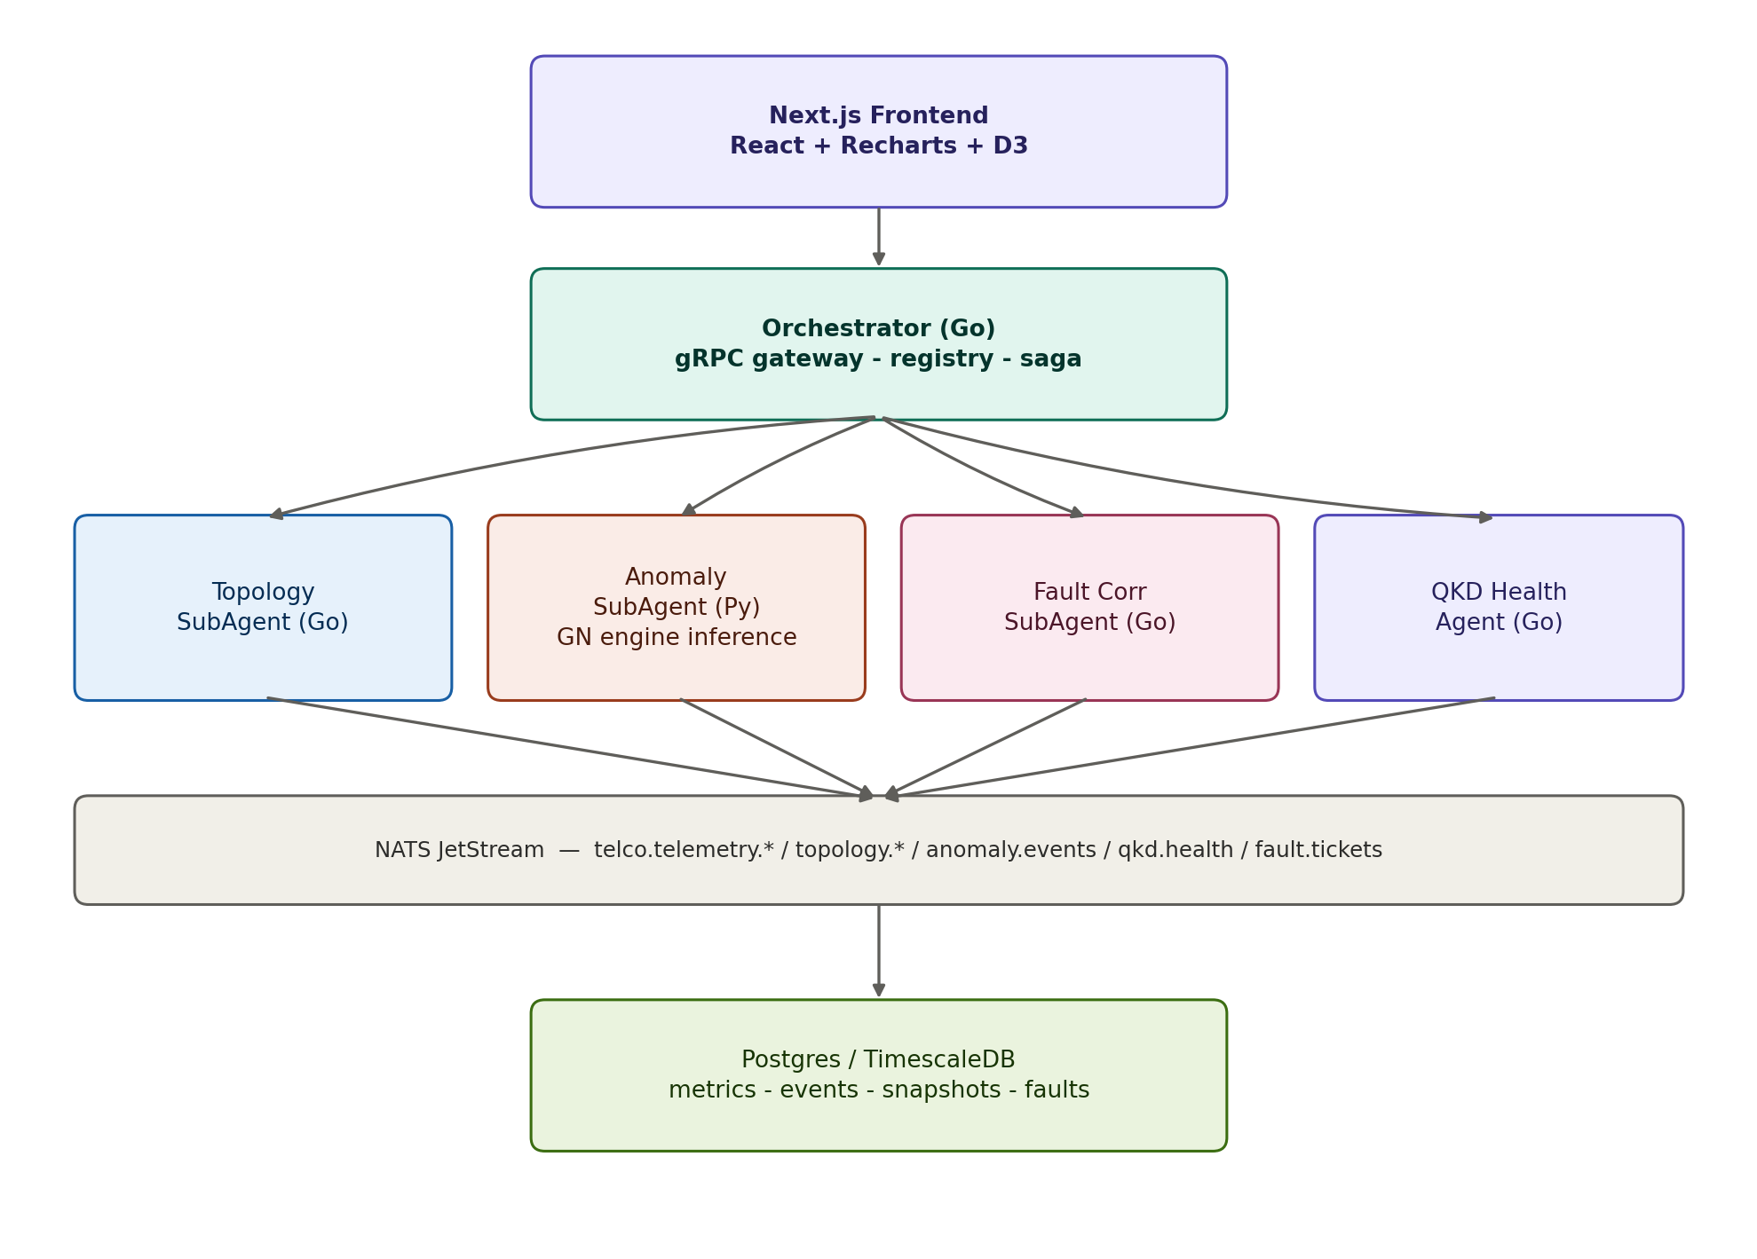
Figure 1. System architecture: frontend, orchestrator, four subagents, NATS JetStream bus, and TimescaleDB persistence.
Two properties of this layout are deliberate design choices rather than defaults. First, the Orchestrator is not on the data path for telemetry: telemetry flows from collectors, or the simulator, directly onto NATS subjects that the Topology and Anomaly subagents consume, so the Orchestrator's availability does not gate telemetry ingestion. Second, Postgres and TimescaleDB are written to by each subagent directly for its own domain tables, metrics, anomaly_events, faults, qkd_health, topology_snapshots, not through a shared data-access service, so there is no single write bottleneck and no cross-service schema coupling beyond the table boundaries themselves.

3.1 Component responsibilities at a glance
Component | Language | Primary responsibility | Owns
Orchestrator | Go | Frontend gateway, subagent registry, saga coordination | Session/registry state
Topology SubAgent | Go | Live network graph construction and versioning | Topology graph, snapshots
Anomaly SubAgent | Python | GN engine GNN inference over graph + telemetry window | Anomaly scoring
Fault Corr SubAgent | Go | Temporal + topological grouping of anomalies into faults | Fault tickets
QKD Health Agent | Go | QBER, key rate, drift monitoring for quantum links | QKD link health
Frontend | TypeScript | Topology map, timelines, fault board, QKD panel | UI state only

4. Component Design

4.1 Orchestrator
The Orchestrator is the only component with an externally reachable, frontend-facing endpoint besides the frontend server itself. It performs three jobs. It exposes a composed gRPC gateway so the frontend can query and subscribe to all four subagents through one endpoint rather than four. It maintains a registry of which subagents are alive, their last heartbeat, and the currently active topology version, so the frontend can display service health without polling each subagent directly. And it performs saga-style coordination: when the Anomaly SubAgent raises a score above a configured threshold, the Orchestrator is responsible for triggering the Fault Correlation SubAgent with a bounded time window and a correlation identifier, rather than leaving subagents to discover each other's events implicitly.
The Orchestrator also issues and rotates short-lived service tokens distributed over a dedicated NATS subject, so that subagents authenticate to each other and to NATS without static shared secrets baked into configuration. This is a deliberately small surface: the Orchestrator issues tokens, it does not proxy or inspect the payloads that flow over the data-plane subjects.

4.2 Topology SubAgent
The Topology SubAgent is the system's single source of truth for network structure. It ingests raw discovery and telemetry events, real streaming telemetry in production, or synthetic events from the simulator in development, and maintains an in-memory graph model where nodes represent network elements, routers, OLTs, ONTs, cell sites, QKD nodes, and edges represent physical or logical links, fiber, microwave, QKD channel, logical overlay, each carrying attributes such as bandwidth, latency, and loss.
Every mutation increments a monotonic graph version. The subagent publishes incremental deltas continuously to a NATS subject and a full snapshot periodically, and persists versioned snapshots to Postgres so that any consumer, including a subagent that restarts, can recover current state without replaying the entire event history. Its gRPC surface supports point queries, get the current graph, get a node's k-hop neighborhood, a server-streaming subscription for deltas, and a time-indexed query for replaying the graph as it existed at a past timestamp, which is used both for incident post-mortems and for generating training windows for the GN engine.

4.3 Anomaly SubAgent
The Anomaly SubAgent is the only Python service in the fleet, which is a deliberate exception rather than an inconsistency: it exists because the GN engine's GNN training and inference stack, PyTorch plus PyTorch Geometric, is materially more mature in Python than in Go, and isolating that dependency to one service behind a strict gRPC contract means the rest of the fleet never needs a Python runtime. It subscribes to enriched telemetry from the Topology SubAgent, maintains a rolling per-node and per-edge feature window, and periodically scores the current graph using the GN engine's GNN component, detailed in Section 6.
Every scored anomaly is published with a correlation identifier, a severity, the affected node and edge set, and a feature-attribution summary describing which input signals contributed most to the score. This attribution is not cosmetic: it is what lets the Fault Correlation SubAgent and the frontend explain why something was flagged, rather than presenting an opaque number, and it is what lets an operator distinguish a genuine link fault from, for example, a benign but unusual traffic pattern.

4.4 Fault Correlation SubAgent
Anomaly detection alone tends to over-report: a single upstream fault can cause a dozen downstream nodes to each independently cross their anomaly threshold. The Fault Correlation SubAgent's job is to turn a burst of individually true anomaly events into a small number of fault hypotheses that a human or downstream automation can act on. It subscribes to both anomaly events and topology deltas, and applies temporal and topological correlation: anomalies that occur within a configurable rolling window, five minutes by default, and that are close in the topology graph, are grouped into a single fault hypothesis. Grouping uses an interval tree keyed on topological distance rather than a fixed-size time bucket, since the right time window for a fiber cut and the right time window for a slow QKD channel drift are not the same.
Each fault hypothesis carries one or more ranked root-cause candidates, for example a shared upstream link, a common power domain, or a correlated QKD channel, each with a confidence score and a short rationale string. Fault tickets are persisted and exposed both as a point query for open faults and as a server-streaming subscription so the frontend fault board updates live.

4.5 QKD Health Agent
The QKD Health Agent is a specialized monitor scoped entirely to quantum link telemetry: quantum bit error rate, sifted and final key rate, sifting ratio, channel drift, and detector dead-time statistics. Rather than teaching the general anomaly and correlation pipeline about quantum-specific signals, this agent's only integration point with the rest of the system is that it treats QKD links as a typed edge in the topology graph, and it emits events onto the same anomaly-event subject that the GNN-based Anomaly SubAgent uses. This means a QKD channel degradation can be grouped by the Fault Correlation SubAgent with a correlated classical-channel fault on the same physical route with no QKD-specific code in that service at all.

4.6 Frontend
The frontend is a Next.js application using React for component structure, Recharts for time-series and gauge visualizations, and D3 for the force-directed and hierarchical topology graph. Its defining architectural constraint is that every view, the topology map, the anomaly timelines, the fault board, and the QKD panel, subscribes to the same delta-stream abstraction rather than each view polling its own subagent independently. This is what guarantees the UI never diverges from backend state: there is exactly one client-side source of truth per domain, refreshed by server-pushed deltas, not by client-initiated polling with its own cadence and its own staleness window.

5. Communication Architecture
Two transport mechanisms carry all cross-service communication, and the choice between them is deliberate rather than incidental. gRPC is used wherever a caller needs a typed, synchronous answer: point queries, control commands, and model inference calls. NATS JetStream is used wherever the interaction is a stream of events that may have multiple consumers, may need replay for a late-joining subscriber, or should not block the producer on the consumer's availability: telemetry ingestion, event fan-out, and token propagation.

5.1 NATS JetStream subjects
Each domain owns its own JetStream stream so that retention and replay policy can differ per domain: telemetry is high-volume and short-lived, fault tickets are low-volume and need long retention for audit purposes.
Subject | Producer | Primary consumers | Retention
telco.telemetry.raw.> | Collectors / simulator | Topology SubAgent | WorkQueue, 24h
telco.telemetry.metrics.> | Topology SubAgent | Anomaly SubAgent | Interest, 24h
telco.topology.delta | Topology SubAgent | Fault Corr, frontend bridge | Interest, 7d
telco.topology.snapshot | Topology SubAgent | All (cold start) | Interest, 30d
telco.anomaly.events | Anomaly SubAgent, QKD Health | Fault Corr, frontend bridge | Interest, 7d
telco.qkd.health | QKD Health Agent | Frontend bridge, Fault Corr | Interest, 7d
telco.fault.tickets | Fault Corr SubAgent | Frontend bridge, Orchestrator | Interest, 30d
telco.auth.tokens | Orchestrator | All subagents | Interest, short TTL

5.2 gRPC service contracts
Every subagent owns exactly one versioned protobuf package, telco.topology.v1, telco.anomaly.v1, telco.faultcorr.v1, and telco.qkd.v1, compiled from a single source of truth for both Go and Python so the two language implementations of the contract cannot silently drift. The Orchestrator's own gateway protobuf composes these into the single external-facing API surface the frontend depends on. Each service follows the same shape: a point-query RPC for current state, and a server-streaming RPC for live updates, so that every domain, topology, anomalies, faults, and QKD health, is consumable the same way from the frontend's perspective.

5.3 Delivery semantics
NATS JetStream provides at-least-once delivery by default, which means every consumer that creates side effects on message receipt, most notably fault-ticket creation, must be idempotent with respect to redelivery. The chosen approach is for the Fault Correlation SubAgent to key fault-ticket creation on the anomaly correlation identifier and perform an upsert rather than an insert, so a redelivered anomaly event updates an existing fault hypothesis instead of creating a duplicate. This is called out explicitly in Section 11 as one of the design decisions the team should validate with a concrete test before the correlation logic is considered production-ready.

6. The GN (GenNets) Engine
The GN engine is the most novel component of the system and is deliberately designed as a shared library rather than a service: it is imported by the Anomaly SubAgent for inference and used offline for training, and its synthetic-generation half is imported by the gn-sim command-line tool that drives the simulator. It has two halves that share data contracts but serve different purposes, shown in Figure 2.
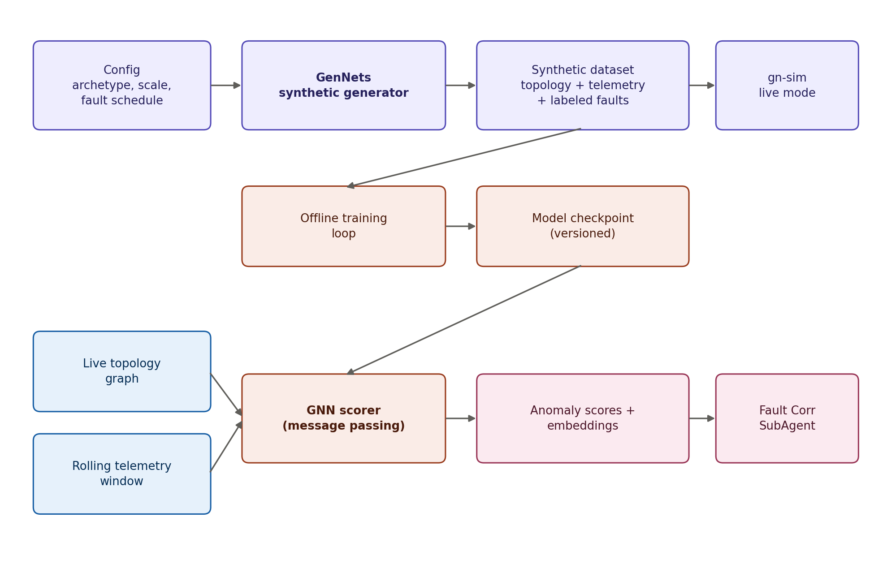
Figure 2. The GN engine: GenNets synthetic generator (top, offline/training path) and the GNN scorer (bottom, live inference path), sharing versioned model checkpoints.

6.1 The GNN inference core
The inference core takes two inputs: the current topology graph, with static node and edge attributes, and a rolling window of per-node and per-edge time series, utilization, error rate, latency, and QBER where applicable. It is implemented as a two-to-three-layer message-passing network with attention-weighted edge aggregation, so the model can learn which neighbors are informative for a given node type rather than treating all neighbors uniformly; a QKD node's relevant neighborhood is not the same as a core router's. The output is a per-node and per-edge anomaly score in the zero-to-one range, plus an embedding vector. The embedding is not discarded after scoring: it is passed downstream so the Fault Correlation SubAgent can group anomalies by embedding similarity even when their surface symptoms differ but their underlying cause is the same.
Training happens offline against versioned model checkpoints; the current design serves the model in-process inside the Anomaly SubAgent for v0.1 rather than standing up a separate model-serving hop, on the grounds that a second network call per scoring pass is not justified until a second consumer actually needs direct access to the GNN, a question raised explicitly as an open design question in Section 11.

6.2 The GenNets synthetic generator
The generator half of the GN engine, the part that gives the engine its name, is parametrized by network scale, a topology archetype, ring, mesh, hierarchical access/aggregation/core, or a hybrid archetype with a QKD overlay, a traffic profile, and a fault-injection schedule covering link degradation, node flapping, QKD channel drift, and correlated multi-fault scenarios. It runs in two modes. Batch mode writes a complete synthetic dataset, topology snapshot, time series, and labeled fault windows, for offline GNN training and evaluation. Live mode streams synthetic telemetry directly onto the real NATS subjects in real time, which is what allows the entire pipeline, Topology through Anomaly through Fault Correlation through QKD Health through the frontend, to run against generated data with no code path different from production.
Critically, the generator preserves ground truth alongside the synthetic stream: which nodes and edges are actually anomalous, and why, at every simulated tick. This is what makes it possible to score model quality and correlation accuracy automatically rather than relying on manual inspection, and it is the mechanism by which the simulator described in Section 8 doubles as a standing integration test.

6.3 Why one library, two languages
The Go gnn package in the shared library does not reimplement the trained model; it defines the shared inference contract, node and edge features in, scores and embeddings out, and ships a deliberately simple, dependency-free reference scorer, a z-score threshold over each series' recent window, so that gn-sim and early integration tests can exercise the full pipeline end to end before a trained model exists at all. The production GNN implementation lives in Python inside the Anomaly SubAgent. Keeping the contract defined once and implemented twice, rather than trying to share a single implementation across languages, is what lets the simulator run without a Python or GPU dependency while the real system uses the more capable Python stack for anything that actually needs it.

7. Data Model
Persistent state lives in Postgres with the TimescaleDB extension, chosen so that the high-volume, time-indexed tables, metrics and QKD health samples in particular, get automatic chunking and continuous aggregates without a separate time-series database to operate. Each subagent writes only to its own domain tables; there is no shared table written by more than one service.
Table | Type | Written by | Purpose
metrics | Hypertable | Topology SubAgent | Raw per-node/edge time-series values
anomaly_events | Hypertable | Anomaly SubAgent, QKD Health | Scored anomalies with attribution
faults | Standard table | Fault Corr SubAgent | Fault tickets and root-cause hypotheses
qkd_health | Hypertable | QKD Health Agent | QBER, key rate, drift samples per link
topology_snapshots | Standard table | Topology SubAgent | Versioned full-graph snapshots
The topology_snapshots table stores the graph as JSONB rather than as fully normalized nodes and edges tables in this version of the design, a deliberate choice to prioritize development velocity while query patterns are still being discovered; normalizing into dedicated tables is flagged in Section 11 as a change to make once real query patterns, for example range queries over a specific edge type, stabilize enough to justify the migration.
Continuous aggregates are defined over the metrics and qkd_health hypertables to serve the frontend's longer time ranges, hourly and daily anomaly rates, and QBER trend lines, without requiring the frontend or the Orchestrator to compute rollups on every request.

8. Simulator
The simulator is not a separate codebase from the production system; it is the GenNets generator's live mode wired directly onto the same NATS subjects the real telemetry pipeline uses, observed through the same frontend that would render production data. This is a deliberate architectural choice: because the dashboard code path is identical whether the data is synthetic or real, the simulator also functions as a standing integration test for the whole system, and a regression in, for example, the Fault Correlation SubAgent's grouping logic will show up in the simulator exactly as it would in production.

8.1 Two granularities
Two levels of simulation fidelity serve two different needs during development. A browser-only mock, generating synthetic topology, anomalies, and faults directly in the frontend with no backend dependency, is the fastest way to iterate on UI and UX and requires nothing running locally except the frontend itself. A full-stack simulation, the gn-sim Go command-line tool publishing onto real NATS subjects and consumed by the actual Go and Python subagents with real Postgres and TimescaleDB persistence, is integration-grade and is what continuous integration and live demos should run against.

8.2 What the simulator proves
- End-to-end wiring: that topology deltas, telemetry, anomaly events, fault tickets, and QKD health samples flow correctly across every NATS subject and gRPC contract in the system.
- Model quality against ground truth: because GenNets preserves which nodes and edges are actually anomalous at every tick, the Anomaly SubAgent's precision and recall can be measured automatically rather than by manual inspection.
- Correlation accuracy: whether the Fault Correlation SubAgent's grouping matches the generator's labeled multi-fault scenarios, including cases designed specifically to test whether a QKD channel fault and a co-routed classical fault are correctly grouped.
- UI resilience under load: the live-mode generator's tick rate and fault-injection rate are both configurable, so the frontend can be stress-tested against a much higher anomaly and fault rate than any real network is expected to produce.

9. Deployment and Operations
The initial deployment target is a single docker-compose stack for local development: NATS with JetStream enabled, Postgres with the TimescaleDB extension, every Go service, the Python Anomaly SubAgent, and the Next.js frontend, each with its own Dockerfile. The Orchestrator is the only service besides the frontend with an externally exposed port; every subagent is reachable only over the internal Docker network and NATS.
Kubernetes manifests are deliberately deferred rather than designed prematurely: pod topology, resource limits, and autoscaling policy are decisions that should follow from observed behavior of the proto contracts and NATS subject design under real load, not precede it. The recommended sequence is to prove the local docker-compose stack end to end with the full-stack simulator first, and only then design the production Kubernetes topology around the bottlenecks that sequence actually reveals.

10. Evaluation Plan
Because the GenNets generator preserves ground truth, model and pipeline quality can be evaluated quantitatively rather than only qualitatively, using the metrics below. These are proposed targets for the team to refine once a first trained model and a first full simulator run exist; they are not yet measured results.
Metric | Definition | Measured against
Anomaly precision/recall | Correctly flagged vs. ground-truth anomalous nodes/edges | GenNets labeled synthetic runs
Fault grouping accuracy | Correlator's groups vs. generator's labeled multi-fault scenarios | GenNets fault-injection schedule
Root-cause hit rate | Top-ranked candidate matches the injected fault target | GenNets ground truth
QKD detection latency | Time from QBER threshold breach to anomaly event | QKD Health Agent logs
End-to-end pipeline latency | Telemetry tick to fault ticket, p50/p95 | gn-sim full-stack run

11. Open Design Questions and Future Work

11.1 Model serving boundary
Should the GNN remain in-process with the Anomaly SubAgent, or should it move to a dedicated inference service once other consumers, most plausibly the Fault Correlation SubAgent wanting direct access to embeddings rather than only final scores, need it? The current design defers this until a second consumer actually exists.

11.2 Delivery idempotency
JetStream's at-least-once delivery means fault-ticket creation must be verified idempotent under redelivery. The proposed approach, upserting on the anomaly correlation identifier, needs a concrete redelivery test before the correlation path is considered production-ready.

11.3 QKD channel model fidelity
How detailed should the synthetic QKD channel model be: a full BB84-style QBER dynamics simulation, or a simpler stochastic degradation model? This directly affects both the realism of the generator's training data and how meaningful the QKD Health Agent's output is when evaluated against it.

11.4 Multi-tenancy
Is the system single-network from day one, or does it need to support multiple operators or network slices from the start? This affects NATS subject naming, which would need a tenant segment, and Postgres partitioning strategy, and is far cheaper to decide before the subject and schema conventions are frozen than after.

11.5 Topology data normalization
The topology_snapshots table currently stores the graph as JSONB for development velocity. Once real query patterns are observed, this should likely be normalized into dedicated nodes and edges tables with a topology_version column, but that migration should follow observed query patterns rather than precede them.

11.6 Future work beyond v0.1
- Kubernetes deployment topology, once local docker-compose behavior under the full-stack simulator has revealed real resource and scaling bottlenecks.
- A dedicated model-serving path for the GNN, if and when a second consumer needs direct embedding access.
- Expanded QKD channel modeling fidelity in the GenNets generator, informed by the answer to 11.3.
- Formal multi-tenancy support in the NATS subject hierarchy and Postgres schema, informed by the answer to 11.4.

12. Conclusion
The TELCO AI Agent design separates a telecom operations problem, know the network, spot what's wrong, explain why, into four independently deployable subagents coordinated over gRPC and NATS JetStream, with a custom GN engine providing both the graph-learning core for anomaly detection and the synthetic-data generator that trains it and drives its simulator. The central design commitment running through every section of this paper is that production and simulation should never be two different code paths: the same synthetic generator that trains the model also feeds the live system end to end, and the same dashboard renders both. That commitment is what turns the simulator from a demo convenience into a standing integration test, and it is the property most worth preserving as the system grows past this initial design.

Appendix: References
Hamilton, W., Ying, Z., and Leskovec, J. (2017). Inductive Representation Learning on Large Graphs (GraphSAGE). Advances in Neural Information Processing Systems (NeurIPS).
Velickovic, P., Cucurull, G., Casanova, A., Romero, A., Lio, P., and Bengio, Y. (2018). Graph Attention Networks. International Conference on Learning Representations (ICLR).
Bennett, C. H., and Brassard, G. (1984). Quantum Cryptography: Public Key Distribution and Coin Tossing. Proceedings of IEEE International Conference on Computers, Systems and Signal Processing.

