End-to-End Telecom Network Digital Twin
Architecture proposal covering RAN, transport/core, and fixed access domains

1. Executive summary
This document proposes an end-to-end digital twin covering all three major telecom infrastructure domains: radio access network (RAN), transport/core network, and fixed access. Rather than modeling each domain in isolation, the design correlates them into a single topology and state model so that an end-to-end service path — from a mobile handset or home router through to the core network — can be traced, monitored, and simulated as one continuous chain. The architecture is organized into five layers: domain data sources, an ingestion and integration layer, a digital twin core (topology graph plus live state), a simulation engine, and a visualization and interaction layer. This document also recommends a phased rollout starting from the transport/core domain, since it has the most direct precedent in prior network architecture work and the clearest data availability.

2. Objectives and scope
The digital twin is intended to:
- Provide a single, continuously updated model of network topology and state across RAN, transport/core, and fixed access domains.
- Support what-if simulation for fault impact, capacity planning, and maintenance change risk, before changes are made to the live network.
- Enable end-to-end service path tracing, so that a degradation experienced by a subscriber can be correlated back to a specific link, node, or cell site across domain boundaries.
- Present a unified visualization layer usable by network operations, capacity planning, and engineering teams without requiring each team to understand every domain's native tooling.
Scope excludes the underlying OSS/BSS and network management systems themselves, which are treated as data sources rather than components to be replaced; the digital twin integrates with them rather than substituting for them.

3. Layered architecture
Figure 1 shows the five-layer architecture. Data flows upward from domain-specific sources through ingestion into a unified twin core, which feeds both the simulation engine and the visualization layer.
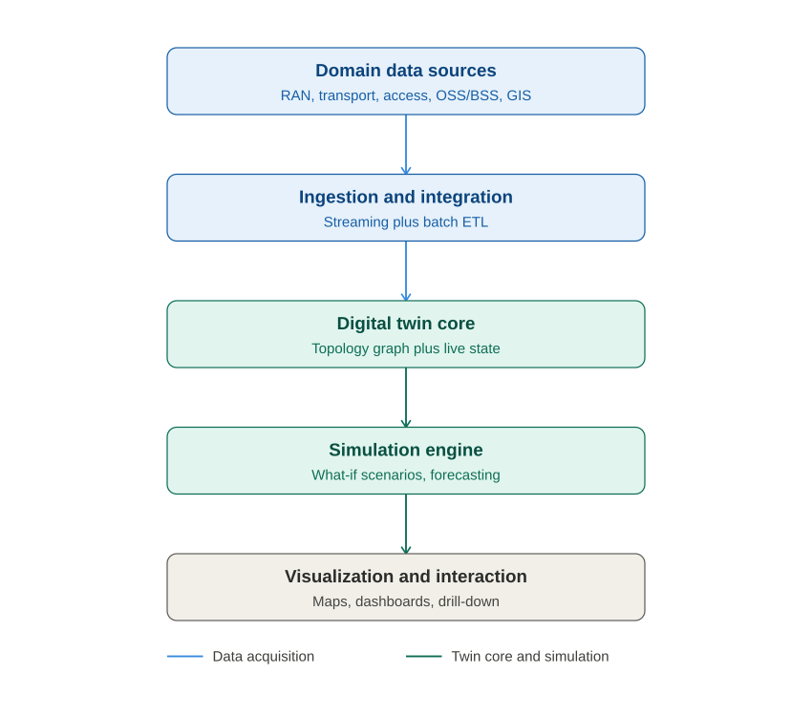
Figure 1. Five-layer end-to-end digital twin architecture.

4. Domain models

4.1 RAN domain model
The RAN model represents cell sites, sectors, spectrum bands, and coverage areas. Key state includes per-cell load, handover rates, and radio link quality indicators. RAN data typically arrives via OAM (operations, administration, and maintenance) interfaces from radio equipment vendors, often through a vendor-specific element management system (EMS) before reaching a multi-vendor network management layer.

4.2 Transport/core domain model
The transport/core model represents routers, switches, fiber links, and logical overlays (MPLS paths, VLANs, network slices). This domain has the most direct precedent from prior network architecture work: nodes, links, and capacity constraints map closely to the topology and capacity concepts used in metro network designs generally. Telemetry arrives via SNMP polling, streaming telemetry (gNMI or similar), or flow records, typically at higher update frequency and lower per-record latency than RAN or access domains.

4.3 Fixed access domain model
The fixed access model represents the last-mile network: passive optical network (PON) splitters, optical network terminals (ONTs), or cable plant, depending on access technology. Capacity here is often shared among subscribers on a common splitter or segment, so state must include both per-subscriber and per-segment utilization. Data typically arrives from access EMS platforms with lower update frequency than transport/core telemetry, since access-layer state changes more slowly.

4.4 Cross-domain correlation
The distinguishing feature of an end-to-end twin, versus three separate domain twins, is a correlation layer that stitches a subscriber's service path across all three domains: from a cell site or ONT, through access aggregation, into the transport/core network, and to the relevant service edge. This requires a consistent identifier scheme (subscriber ID, session ID, or circuit ID) that is preserved or mapped across domain boundaries, since each domain's native systems typically use different identifiers for the same underlying service.

5. Data ingestion and integration layer
Domain | Typical data sources | Update cadence
RAN | Vendor EMS, OAM interfaces, radio performance management feeds | Minutes (performance counters); near-real-time for alarms
Transport/core | SNMP, streaming telemetry (gNMI), flow records, NMS/SDN controllers | Seconds to sub-second for telemetry; real-time for alarms
Fixed access | Access EMS, PON management systems, DOCSIS/cable management systems | Minutes to tens of minutes
Cross-domain | OSS/BSS inventory and subscriber systems, GIS/geographic databases | Batch, typically daily or on change

Given the differing update cadences across domains, the ingestion layer should separate a low-latency streaming path (telemetry, alarms) from a batch/near-real-time path (inventory, subscriber data, GIS). A message bus pattern (publish/subscribe) decouples data producers from the twin core and allows each domain's ingestion pipeline to evolve independently.

6. Digital twin core
The core maintains two complementary representations: a topology graph (nodes, links, and their relationships, including cross-domain service paths) and a live state store (current utilization, alarms, and health per element). A graph-oriented data model is a natural fit for topology, since network relationships (which link connects which nodes, which service path traverses which links) are inherently graph-shaped rather than tabular. Live state is typically better served by a time-series-oriented store, since the dominant query pattern is “what has this metric looked like over time,” not relational lookups.
The core should expose a query interface that lets the simulation and visualization layers ask both topology questions (“what links carry traffic between site A and site B”) and state questions (“what is current utilization on this link”) without needing to know which underlying store answers which question.

6.1 Formal foundation: Generalized Nets
Rather than treating the topology graph and its transfer rules as an ad hoc combination of a graph database and bespoke application logic, the twin core's execution semantics are formalized using Generalized Nets (GNs), a mathematical apparatus introduced by Atanassov [1] that extends classical Petri nets in ways directly relevant to a telecom digital twin.
A Generalized Net consists of places, transitions, and tokens, with three extensions beyond a classical Petri net that matter here. First, tokens carry characteristics: a token is not an anonymous marker but carries a tuple of attribute values, for example volume, QoS class, latency budget, and accumulated path history, which update as the token moves. Second, each transition carries an index matrix: a matrix over the transition's input and output places specifying, for every place pair, the condition under which a token may transfer and a companion function describing how its characteristics change on transfer. Third, places and transitions can carry explicit time-moments and durations, so propagation delay, queueing delay, and holding time are part of the formal model rather than added separately in simulation code.
Table 4 gives the mapping from telecom digital twin concepts to Generalized Net elements used throughout the remainder of this document.
Digital twin concept | Generalized Net element
Network node, link, buffer, or port | Place, with an associated capacity
Router, switch, or other processing/routing point | Transition, governed by an index matrix
Routing, capacity, and fault conditions on a link | Index matrix entries for the corresponding transition
A traffic flow, session, or subscriber service instance | A token, carrying characteristics (volume, QoS class, latency budget, path history)
Propagation delay, queueing delay, holding time | Time-moments and durations attached to places and transitions
QoS priority classes competing for capacity | Priority relations over tokens at a place
Uncertain or partially trusted telemetry (link state) | Intuitionistic fuzzy index-matrix conditions (membership, non-membership, hesitancy) [2]

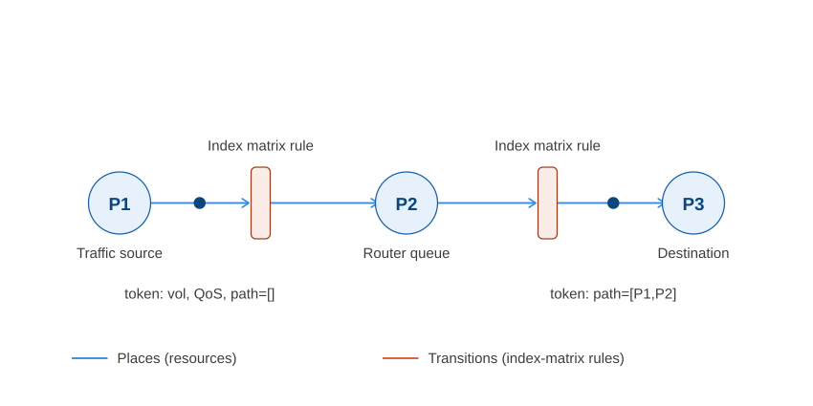
Figure 2. A Generalized Net fragment mapped onto a traffic path: places represent network resources, transitions carry index-matrix conditions, and a token accumulates path history as it transfers.
This formalization gives the twin core an executable mathematical semantics rather than an informal graph-plus-rules design: the same index matrix that defines normal operation can be directly modified to express a simulated fault, capacity change, or maintenance action, which is the basis for the simulation engine described in Section 7.

7. Simulation engine
Because the twin core is formalized as a Generalized Net, every simulation scenario reduces to a modification of the index matrix or place capacities, followed by running the token-transfer process forward, rather than requiring separate bespoke simulation logic for each scenario type.
- Fault impact simulation: zero out the index-matrix transfer condition for the affected transition or place, run the token-transfer process forward, and identify which tokens (service paths) cannot complete their journey and what reroutes, if any, remain available.
- Capacity planning simulation: increase the token generation rate at source places representing a region's projected subscriber or traffic growth, and observe which place capacities are exceeded first as the process runs forward.
- Maintenance change-risk simulation: temporarily restrict a transition's index-matrix condition to a reduced-capacity state for a bounded time-moment window, and measure the resulting characteristic changes, such as added latency or dropped QoS class, on affected tokens.
- Telemetry-uncertainty-aware simulation: where monitoring confidence in a link or node's state is itself uncertain, represent the relevant index-matrix condition using the intuitionistic fuzzy Generalized Net extension [2], so that simulated fault propagation reflects actual monitoring confidence (a membership, non-membership, and hesitancy triple) rather than assuming perfect ground truth.
Each simulation type consumes the same underlying Generalized Net model and differs only in which index-matrix entries or place capacities are perturbed and what token-level outcome is measured, which keeps the simulation engine's core execution logic shared across scenario types even as new scenarios are added over time.

8. Visualization and interaction layer
- A map-based view for domains with clear geography (RAN coverage, fixed access last-mile), and a graph/topology view for the transport/core domain where geography is less informative than logical connectivity.
- Drill-down navigation from region, to site, to device, to port, preserving context as the user moves between levels of detail.
- Scenario controls that let a user trigger a what-if simulation directly from the visualization (for example, clicking a link and selecting “simulate failure”) rather than requiring a separate simulation tool.
- Role-appropriate views: network operations teams likely need real-time health and alarms first, while capacity planning teams likely need the simulation and forecasting views first.

9. Technology considerations
Layer | Representative technology categories
Ingestion | Message bus / streaming platform (publish-subscribe pattern); batch ETL scheduler for inventory and OSS/BSS data
Twin core — topology | Graph-oriented database, chosen for native support of relationship queries across nodes and links
Twin core — live state | Time-series-oriented database, chosen for efficient storage and querying of metric history
Simulation engine | Discrete-event or graph-traversal simulation logic, run against a point-in-time snapshot of the twin core
Visualization | Web-based mapping and graph-visualization front end, with role-based views

This document intentionally names technology categories rather than specific vendor products, since product selection should follow from a more detailed requirements and procurement process; the categories above are sufficient to scope the prototype in the next phase of this project.

10. Security and access considerations
- The twin aggregates operationally sensitive data (topology, capacity, subscriber-adjacent identifiers) from multiple source systems; access control should be role-based and should not simply inherit the most permissive access level of any one source system.
- Read access to the twin should not imply write access to the underlying network; the twin is a model, and any action taken based on a simulation (for example, an actual maintenance change) should go through the same change-control process as it would without the twin.
- Cross-domain correlation using subscriber-adjacent identifiers should be reviewed against applicable data protection requirements before implementation, since correlating RAN, access, and core data for a given subscriber increases the sensitivity of the combined dataset relative to any single domain's data alone.

11. Phased rollout recommendation
Phase | Focus
Phase 1 | Transport/core domain only: topology graph, live state ingestion, and basic fault-impact simulation. Highest data availability and clearest precedent.
Phase 2 | Add fixed access domain and cross-domain correlation for access-to-core service paths.
Phase 3 | Add RAN domain and full end-to-end service path tracing across all three domains.
Phase 4 | Extend simulation engine to capacity planning and maintenance change-risk scenarios across the full end-to-end model.

Starting with the transport/core domain lets the prototype (next phase of this project) demonstrate value quickly using the domain with the most mature telemetry and the most direct architectural precedent, before taking on the additional integration complexity of RAN and access domains.

12. Conclusion
This architecture defines a five-layer digital twin spanning RAN, transport/core, and fixed access domains, correlated into a single end-to-end model rather than three independent domain twins. The twin core and simulation engine share a formal mathematical foundation in Generalized Nets, giving the same model both an executable topology-and-state representation and a direct, index-matrix-based mechanism for fault, capacity, and maintenance simulation, including an extension for representing genuine telemetry uncertainty. The phased rollout recommendation prioritizes the transport/core domain first, both for its data maturity and as the natural next step to prototype.

References
[1] K. Atanassov, “Generalized Nets,” World Scientific, Singapore (1991).
[2] K. Atanassov, “On Generalized Nets Theory,” Prof. M. Drinov Academic Publishing House, Sofia (2007).
[3] K. Atanassov, “Intuitionistic Fuzzy Sets,” Fuzzy Sets and Systems 20, 87–96 (1986).

