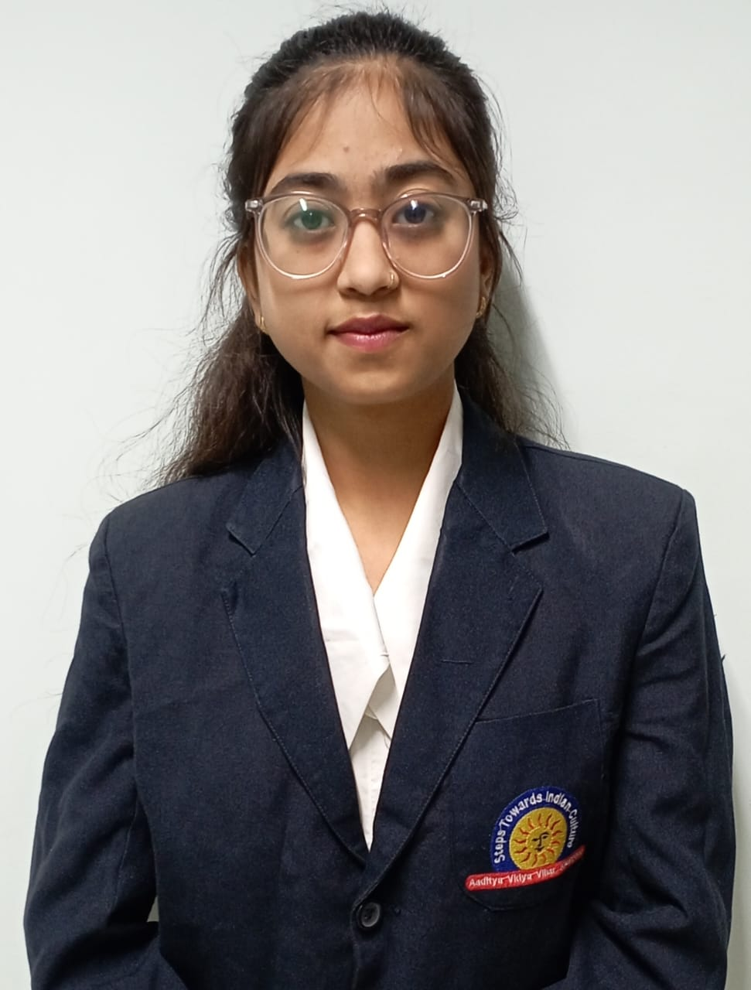
Amazon Clone
- clone of amazon shopping website
- Develop by using HTML,CSS
- Code: https://github.com/dinkal19/Amazon-clone.git

Personal Portfolio

- complete details about me and my educational background develop by using HTML,CSS,JAVASCRIPT

Traveling Website

- traveling website where we book our jounrey package in some beautifull places: develop by using html css and java script.

THE GUARDIAN | 20XX – 20XX

Contributor, Remote

Tasks:
      - Conducted interviews and covered key moments from theG20 Summit 2021 in Italy.
      - Produced in-depth and engaging online content in accordance with house style.

PROJECTS

DIPLOMAS Y HOBBIES

Formaciones : Diplomados, Congresos, xxxxxxxxxxxxxxxxxxxxxxxxxxxxxxxxxxxxxxxxxx
Hobbies:xxxxxxxxxxxxxxxxxxxxxxxxxxxxxx

DINKAL
BHAWSAR

Fresher

CAREER OBJECTIVE

My objective is to achieve a responsible position which will make me implement my technical
skills, educational background and my ability to adapt to any field with constant growth of
organization.

EDUCATION

Bachelor of Technology | Computer Science 2020-2024
Jawaharlal Institute of Technology ,Borawan
CGPA : 8.36/10(till 6th sem)

Higher Secondary School | CBSE June-2020
Aditya Vidhya Vihar , Higher Secondary School , Khargone(M.P.)
Score : 75.8%(Science)

High School | CBSE June-2018
Devi Rukmani , Higher Secondary School , Khargone(M.P.)
Score : 72.8%

TECHNICAL SKILLS

- CodeChef: https://www.codechef.com/users/dinkal19
- GitHub: https://github.com/dinkal19
- LinkedIn: https://www.linkedin.com/in/dinkal-bhawsar-ab5a75209
CONTACT
- C & C++
- Java
- DSA
- HTML/CSS
- DBMS

- Communication
- Team Work
- Multitasking
- Time Management

SOFT SKILLS
Mobile :+91 8959929529
Gmail : dinkalbhawsar@gmail.com
Location : Khargone, M.P.

PLATFORMS PROFILES
REWARDS & ACHIEVEMENTS
- 3 Certificates in CodeChef (C ,Java,Python)
- Core python Certificate(Infosys , July 2023)
- Placement Training of Full Stack (Java Professionals , 2021-2023)
- Awarded as a Student Of The Year by LIC.

©AZURIUS - My-resume-templates.com

