High Level Network Design – Project VI

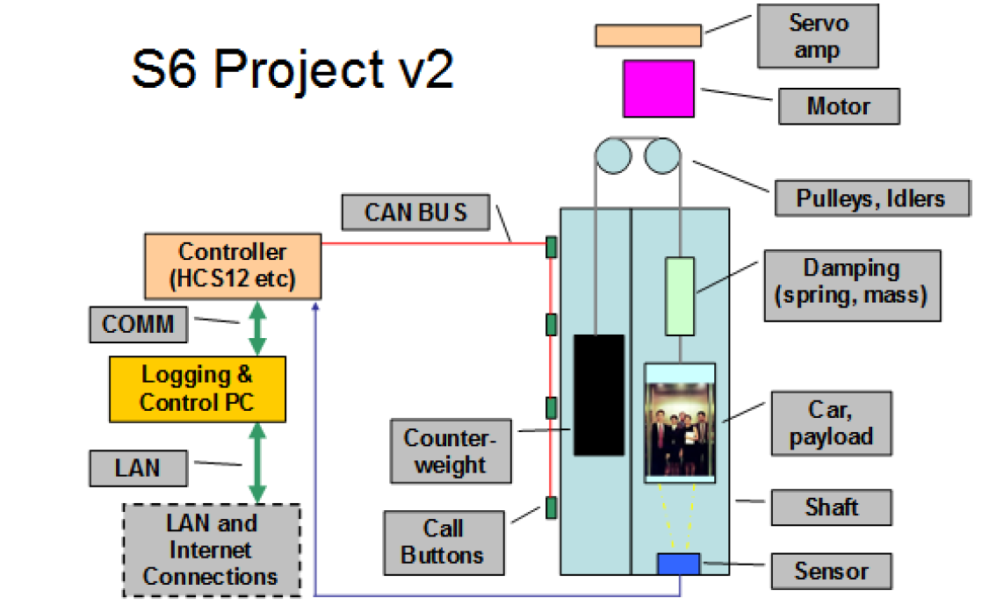

Figure Source S6 Project v2 Charter