**Program no-1**

**Program to recognize vowels.**

#include<stdio.h>

#include<conio.h>

#include<string.h>

void main()

{

charmystring[20];

inti,c=0,l;

clrscr();

printf("Welcome to the compiler design program.\n");

printf("\nEnter the String:-\n");

gets(mystring);

l=strlen(mystring);

printf("The vowels are:-\n");

for(i=0;i<l;i++)

{

if((mystring[i]=='a')||(mystring[i]=='e')||(mystring[i]=='i')||(mystring[i]=='o')||(mystring[i]=='u')||(mystring[i]=='A')||(mystring[i]=='E')||(mystring[i]=='I')||(mystring[i]=='O')||(mystring[i]=='U'))

{

printf(" %c",mystring[i]);

c++;

}

}

if(c==0)

printf("\nNo vowel found");

else

printf("\nTotal number of vowels are:- %d",c);

getch();

}

**Output:-**

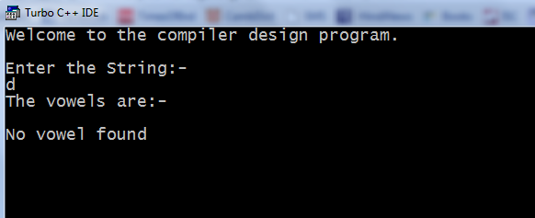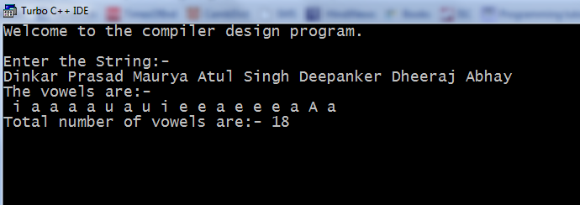

**Program no-2**

**Program to reverse the given string.**

#include<stdio.h>

#include<conio.h>

void main()

{

char string[100];

intlen=0,i;

clrscr();

printf("Welcome to the compiler Design program.\n");

printf("Enter the string.\n");

gets(string);

printf("The Input String is:-\n");

printf("%s\n",string);

for(i=0;string[i]!=NULL;i++)

len++;

printf("The Reverse string is:-\n");

for(i=len-1;i>=0;i--)

printf("%c",string[i]);

getch();

}

**Output:-**

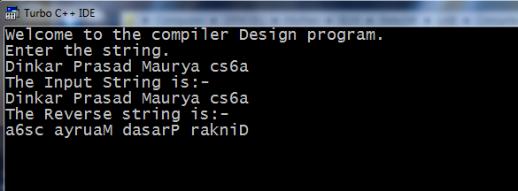

**Program no-3**

**To implement a scanner which identifies identifiers and constant.**

#include<stdio.h>

#include<conio.h>

#include<ctype.h>

#include<string.h>

void main()

{

char str[100],digit[100],alpha[100],other[100];

intlen=0,i,k=0,j=0,l=0;

clrscr();

printf("Welcome to the Compiler Design program.\n");

printf("Enter a string:-\n");

gets(str);

len=strlen(str);

for(i=0;i<len;i++)

{

if(isdigit(str[i]))

{

digit[j]=str[i];

j++;

}

else if(isalpha(str[i]))

{

alpha[k]=str[i];

k++;

}

else

{

other[l]=str[i];

l++;

}

}

printf("\nDgits are:-\n");

for(i=0;i<j;i++)

printf(" %c",digit[i]);

printf("\nAlphanumerics are:-\n");

for(i=0;i<k;i++)

printf(" %c",alpha[i]);

printf("\nSpecial Characters are :-\n");

for(i=0;i<l;i++)

printf(" %c",other[i]);

getch(); }

**Output:-**

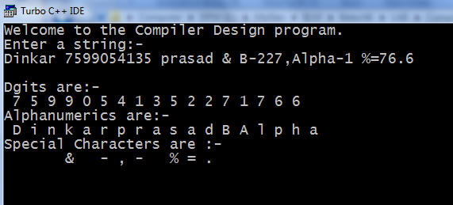

**Program no-4**

**To output text from a file.**

#include<stdio.h>

#include<conio.h>

void main()

{

FILE *f1,*f2;

charch;

int i=0;

clrscr();

printf("Welcome to the compiler Design program.\n");

f1=fopen("readfile.c","r+");

//fseek() sets the file pointer associated with a stream to a new position.

fseek(f1,0,strlen(f1));

do

{

ch=fgetc(f1);

putch(ch);

}while(ch!=EOF);

getch();

}

**Output:-**

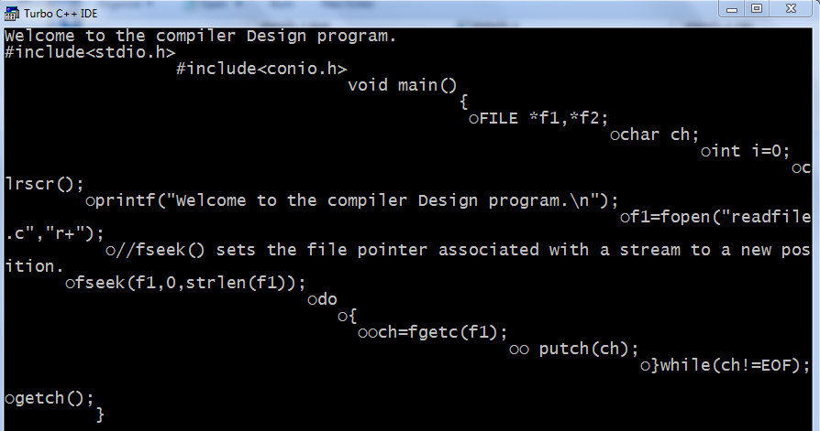

**Program no-5**

**To implement shift reduce parser for “id+id” where**

**productions are:-**

**E->id**

**E->E+E**

#include<stdio.h>

#include<conio.h>

#include<ctype.h>

void main()

{

charar[5]={'$','i','+','i','$'};

int top=0,i;

char stack[5];

clrscr();

printf("Welcome to the Compiler Design program.\n");

printf("The production are:-\n");

puts("E->id\nE->E+E\n");

puts("The input Symbole is:-\nid+id\n");

for(i=0;i<5;i++)

{

if(isalpha(ar[i]))

{

stack[top]='E';

top++;

}

else if(i==2)

{

stack[top]='+';

top++;

}

else

{

stack[top]='$';

top++;

}

}

printf("\nThe content of stack are:\n");

for(i=0;i<top;i++)

printf("%c ",stack[i]);

if(stack[top-1]=='$'&&stack[top-2]=='E'&&stack[top-3]=='+'&&stack[top-4]=='E'&&stack[top-5]=='$')

printf("The production is accepted.\n");

else

printf("Not accepted\n");

getch(); }

**Output:-**

