**Program no-1**

**Objective:-Program to perform Array operation.**

**Theory:-**

+ Plus.

X + Y adds matrices X and Y. X and Y must have the same dimensions unless one is a scalar (a 1-by-1 matrix).

A scalar can be added to anything.C = PLUS(A,B) is called for the syntax 'A + B' when A or B is an object.

- Minus.

X - Y subtracts matrix Y from X. X and Y must have the same dimensions unless one is a scalar. A scalar can be subtracted from anything.

C = MINUS(A,B) is called for the syntax 'A - B' when A or B is an object.

* Matrix multiply.

X*Y is the matrix product of X and Y. Any scalar (a 1-by-1 matrix) may multiply anything. Otherwise, the number of columns of X must equal the number of rows of Y.

C = MTIMES(A,B) is called for the syntax 'A * B' when A or B is an object.

**Program:-**

>> Clear all

>>Close all

>> clc

>> A=[1 2 3;4 5 6;7 8 9];

>> B=[9 8 7;6 5 4; 3 2 1];

>> C=A+B;

>> fprintf('%d',C);

101010101010101010>>

>> D=minus(A,B);

>> fprintf('%d',D);

-8-24-606-428>> A=[1 2 3;4 5 6;7 8 9];

>> B=[9 8 7;6 5 4; 3 2 1];

>> M=mtimes(A,B);

>> fprintf('%d',M);

30841382469114185490>>

**Program no-2**

**Objective:-Program to read and show image.**

**Theory:-**

IMREAD Read image from graphics file.

A = IMREAD(FILENAME,FMT) reads a grayscale or color image from the file specified by the string FILENAME, where the string FMT specifies the format of the file. See the reference page, or the output of the function IMFORMATS, for a list of supported formats. If the file is not in the current directory or in a directory in the MATLAB path, specify the full pathname of the location on your system. If IMREAD cannot find a file named FILENAME, it looks for a file named IMREAD returns the image data in the array A. If the file contains a grayscale image, A is a two-dimensional (M-by-N) array. If the file contains a color image, A is a three-dimensional (M-by-N-by-3) array. The class of the returned array depends on the data type used by the file format.

For most file formats, the color image data returned uses the RGB color space. For TIFF files, however, IMREAD can return color data that uses the RGB, CIELAB, ICCLAB, or CMYK color spaces. If the color image uses the CMYK color space, A is an M-by-N-by-4 array. See the reference page for more information about reading TIFF files that use these color spaces. FILENAME.FMT.

**Program:-**

>> Clear all

>>Close all

>> clc

>> image=imread('Dinkar111.jpg');

>> imshow('Dinkar111.jpg');

**Output:-**



**Program no-3**

**Objective:-Program to perform image variable addition.**

**Theory:-**

IMREAD Read image from graphics file.

A = IMREAD(FILENAME,FMT) reads a grayscale or color image from the file specified by the string FILENAME, where the string FMT specifies the format of the file. See the reference page, or the output of the function IMFORMATS, for a list of supported formats. If the file is not in the current directory or in a directory in the MATLAB path, specify the full pathname of the location on your system. If IMREAD cannot find a file named FILENAME, it looks for a file named

FILENAME.FMT.

IMREAD returns the image data in the array A. If the file contains a grayscale image, A is a two-dimensional (M-by-N) array. If the file contains a color image, A is a three-dimensional (M-by-N-by-3) array. The class of the returned array depends on the data type used by the file format.

For most file formats, the color image data returned uses the RGB color space. For TIFF files, however, IMREAD can return color data that uses the RGB, CIELAB, ICCLAB, or CMYK color spaces. If the color image uses the CMYK color space, A is an M-by-N-by-4 array. See the reference page for more information about reading TIFF files that use these color spaces.

IMADD Add two images, or add constant to image.

Z = IMADD(X,Y) adds each element in array X to the corresponding element in array Y and returns the sum in the corresponding element of the output array Z. X and Y are real, nonsparse, numeric arrays or logical arrays with the same size and class, or Y is a scalar double. Z has the same size and class as X unless X is logical, in which case Z is double.

Z = IMADD(X,Y,OUTPUT_CLASS) specifies the desired output class of Z. OUTPUT_CLASS must be one of the following strings: 'uint8', 'uint16', 'uint32', 'int8', 'int16', and 'int32', 'single, 'double'.

If Z is an integer array, then elements in the output that exceed the range of the integer type are truncated, and fractional values are rounded. If X and Y are double or logical arrays, you can use the expression X+Y instead of this function.

Notes -----

On Intel Architecture processors, IMADD can take advantage of the Intel Performance Primitives Library (IPPL), thus accelerating its execution time. IPPL is activated in two cases:

- arrays X, Y and Z are uint8, int16, or single and are of the same class - Y is a double scalar and arrays X and Z are uint8, int16 or single and are of the same class.

IMSHOW Display image.

IMSHOW(I,N) displays the intensity image I with N discrete levels of gray. If you omit N, IMSHOW uses 256 gray levels on 24-bit displays, or 64 gray levels on other systems.

IMSHOW(I,[LOW HIGH]) displays I as a grayscale intensity image, specifying the data range for I. The value LOW (and any value less than LOW) displays as black, the value HIGH (and any value greater than HIGH) displays as white, and values in between display as intermediate shades of

gray. IMSHOW uses the default number of gray levels. If you use an empty matrix ([]) for [LOW HIGH], IMSHOW uses [min(I(:)) max(I(:))]; the minimum value in I displays as black, and the maximum value displays as white.

IMSHOW(BW) displays the binary image BW. Values of 0 display as black, and values of 1 display as white.

IMSHOW(X,MAP) displays the indexed image X with the colormap MAP.

IMSHOW(RGB) displays the truecolor image RGB.

IMSHOW(...,DISPLAY_OPTION) displays the image, calling TRUESIZE if DISPLAY_OPTION is 'truesize', or suppressing the

call to TRUESIZE if DISPLAY_OPTION is 'notruesize'. Either option string can be abbreviated. If you do not supply this argument, IMSHOW determines whether to call TRUESIZE based on

the setting of the 'ImshowTruesize' preference.

IMSHOW(x,y,A,...) uses the 2-element vectors x and y to establish a nondefault spatial coordinate system, by specifying the image XData and YData. Note that x and y can have more than 2 elements, but only the first and last elements are actually used.

IMSHOW(FILENAME) displays the image stored in the graphics file FILENAME. IMSHOW calls IMREAD to read the image from the file, but the image data is not stored in the MATLAB

workspace. The file must be in the current directory or on the MATLAB path.

H = IMSHOW(...) returns the handle to the image object created by IMSHOW.

**Program:-**

>> Clear all

>>Close all

>> clc

>> img1=imread('Blue hills.jpg');

>> img2=imread('Sunset.jpg');

>> imgadd=imadd(img1,img2);

>> imshow(imgadd);

**Output:-**



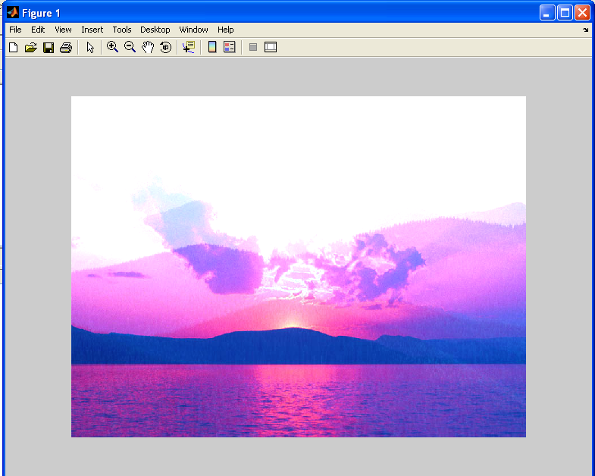

**Program no-4**

**Objective:-Program to design Histogram.**

**Theory:-**

RGB2GRAY Convert RGB image or colormap to grayscale.RGB2GRAY converts RGB images to grayscale by eliminating the hue and saturation information while retaining the luminance.

I = RGB2GRAY(RGB) converts the truecolor image RGB to the grayscale intensity image I.

NEWMAP = RGB2GRAY(MAP) returns a grayscale colormap equivalent to MAP.

Class Support

-------------

If the input is an RGB image, it can be of class uint8, uint16 or double; the output image I is of the same class as the input image. If the input is a colormap, the input and output colormaps are both of class double.

IMHIST Display histogram of image data. IMHIST(I) displays a histogram for the intensity image I whose number of bins are specified by the image type. If I is a grayscale image, IMHIST uses 256 bins as a default value. If I is a binary image, IMHIST uses only 2 bins.

IMHIST(I,N) displays a histogram with N bins for the intensity image I above a grayscale colorbar of length N. If I is a binary image then N can only be 2.

IMHIST(X,MAP) displays a histogram for the indexed image X. This histogram shows the distribution of pixel values above a colorbar of the colormap MAP. The colormap must be at least as long as the largest index in X. The histogram has one bin for each entry in the colormap.

[COUNTS,X] = imhist(...) returns the histogram counts in COUNTS and the bin locations in X so that stem(X,COUNTS) shows the histogram. For indexed images, it returns the histogram counts for each colormap entry; the length of COUNTS is the same as the length of the colormap.

Class Support -------------

The input image can be of class uint8, uint16, double, or logical.

**Program:-**

>> image=imread('Hist.bmp');

>> image_gray=rgb2gray(image);

>> imhist(image_gray);

**Output:-**

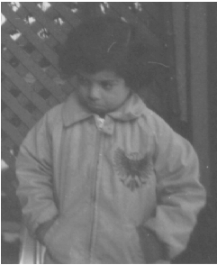

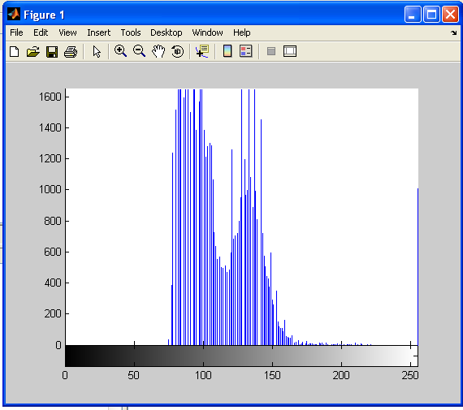s



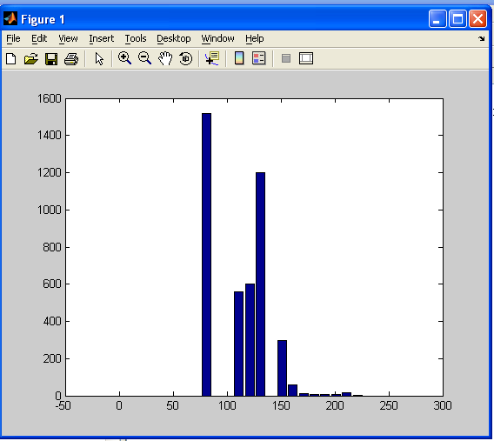

**Program no-5**

**Objective:-Program to perform equalization of histogram.**

**Theory:-**

HISTEQ Enhance contrast using histogram equalization. HISTEQ enhances the contrast of images by transforming the values in an intensity image, or the values in the colormap of an indexed image, so that the histogram of the output image approximately matches a specified histogram.

J = HISTEQ(I,HGRAM) transforms the intensity image I so that the histogram of the output image J with length(HGRAM) bins approximately matches HGRAM. The vector HGRAM should contain

integer counts for equally spaced bins with intensity values in the appropriate range: [0,1] for images of class double, [0,255] for images of class uint8, and [0,65535] for images

of class uint16. HISTEQ automatically scales HGRAM so that sum(HGRAM) = prod(size(I)). The histogram of J will better match HGRAM when length(HGRAM) is much smaller than the number of discrete levels in I. J = HISTEQ(I,N) transforms the intensity image I, returning in J an intensity image with N discrete levels. A roughly equal number of pixels is mapped to each of the N levels in

J, so that the histogram of J is approximately flat. (The histogram of J is flatter when N is much smaller than the number of discrete levels in I.) The default value for N is 64. [J,T] = HISTEQ(I) returns the gray scale transformation that maps gray levels in the intensity image I to gray levels in J. NEWMAP = HISTEQ(X,MAP,HGRAM) transforms the colormap associated with the indexed image X so that the histogram of the gray component of the indexed image (X,NEWMAP)

approximately matches HGRAM. HISTEQ returns the transformed colormap in NEWMAP. length(HGRAM) must be the same as size(MAP,1). NEWMAP = HISTEQ(X,MAP) transforms the values in the colormap so that the histogram of the gray component of the indexed image X is approximately flat. It returns the transformed colormap in NEWMAP.

[NEWMAP,T] = HISTEQ(X,...) returns the gray scale transformation T that maps the gray component of MAP to the gray component of NEWMAP.

Class Support

-------------

For syntaxes that include an intensity image I as input, can be of class uint8, uint16, or double, and the output image J has the same class as I. For syntaxes that include an indexed image X as input, X can be of class uint8 or double; the output colormap is always of class double. Also, the optional output T (the gray level transform) is always of class double.

**Program:-**

>> Clear all

>>Close all

>> clc

>> image=imread('n.bmp');

>> imagegray=rgb2gray(image);

>> figure,imshow(imagegray);

>> image_hist=histeq(imagegray);;

>> figure,imshow(image_hist);

**Output:-**

