## PROGRAM NO-1

## //Write a program to generate five random numbers.

import java.util.Random;

class abc

{

void myrandom()

{

System.out.println("The random numbers are:\n");

Random rd = new Random();

for (int i=1;i<= 5;i++)

{

int num = rd.nextInt(100);

System.out.print(num+"\t");

}

}

}

public class intrandom

{

public static void main(String args[])

{

abc ob=new abc();

ob.myrandom();

}

}

*OUTPUT:-*

The random numbers are:

14 26 45 1 17

## PROGRAM NO-2

## //Program for sum and product of digit of a given number.

class abc

{

void digitsum(int n)

{

int digit,s=0;

while(n>0)

{

digit=n%10;

n/=10;

s+=digit;

}

System.out.println("Sum of the digit is:-\t"+s);

}

void digitmul(int n)

{

int digit,m=1;

while(n>0)

{

digit=n%10;

n/=10;

m=m*digit;

}

System.out.println("Product of the digit is:-\t"+m);

}

}

class sp

{

public static void main(String arg[])

{

String num;

num=arg[0];

abc ob=new abc();

ob.digitsum(Integer.parseInt(num));

ob.digitmul(Integer.parseInt(num));

}

}

OUTPUT:-

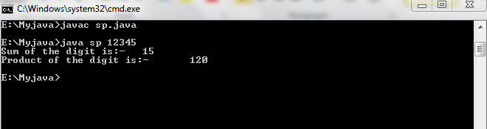

## PROGRAM NO-3

## //Write a program to reverse a number.

class a

{

int num;

a(int i)//Constructure.

{

num=i;

}

void rev()

{

int digit,rev=0;

System.out.print("The reverse number is:\t");

while(num!=0)

{

digit=num%10;

rev=(rev*10)+digit;

num/=10;

}

System.out.print(rev);

}

}

class reverse

{

public static void main(String args[])

{

int m;

m=Integer.parseInt(args[0]);//Command line argument.

a ob=new a(m);

ob.rev();

}

}

OUTPUT:- 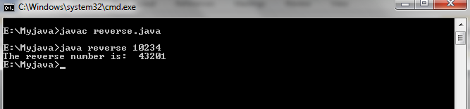

## PROGRAM NO-4

## //Program for concatenation of strings.

import java.lang.String;

class CONT

{

public static void main(String args[])

{

char ch1[]=new char[1000];

int i,j,l,ls,max=0;

l=args.length;

for(i=0;i<l;i++)

{

String s=args[i];

ls=s.length();

for(j=0;j<ls;j++)

{

char ch=s.charAt(j);

ch1[max++]=ch;

}

}

System.out.println("The string is:-\n");

for(i=0;i<max;i++)

System.out.print(ch1[i]);

}

}

OUTPUT:-

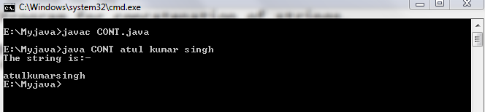

## PROGRAM NO-5

## //Program for calculation of number of months and days .

class abc

{

int days;

abc(int i)//Constructure.

{

days=i;

}

void md()

{

int m,d;

m=days/30;

d=days%30;

System.out.print(m+"months");

System.out.print(d+"days.");

}

}

class month

{

public static void main(String args[])

{

int p;

p=Integer.parseInt(args[0]);//Command line argument.

abc ob=new abc(p);

ob.md();

}

}

OUTPUT:-

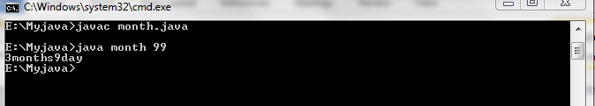

## PROGRAM NO-6

## //Program for checking a number prime or not.

class abc

{

int number;

abc(int i)//Constructure.

{

number=i;

}

int p()//Returning type method.

{

int i,c=0;

for(i=2;i<=number/2;i++)

{

if(number%i==0)

c++;

}

if(c==0)

{

if(number==1)

return 1;

else

return 0;

}

else

return 1;

}

}

class prime

{

public static void main(String args[])

{

int n,call;

n=Integer.parseInt(args[0]);//Command line argument.

abc ob=new abc(n);

call=ob.p();

if(call==0)

System.out.println("Prime");

else

System.out.println("Not Prime");

}

}

OUTPUT:-

