**Program no-1**

**Program to show the academic career of student.**

<!DOCTYPE HTML PUBLIC "-//W3C//DTD HTML 4.01 Transitional//EN">

<html>

<title>Education</title>

<p>

<body bgcolor="white"><br>

<table border="5">

<caption>Academic Career</caption>

<tr><td>Degree</td><td>Institution</td><td>Year of Passing</td></tr>

<tr><td>High School</td><td>UdaiPratap College</td><td>2006</td></tr>

<tr><td>Intermediate</td><td>UdaiPratap College</td><td>2008</td></tr>

<tr><td>B.Tech</td><td>CET IILM AHL</td><td>2012</td></tr>

</p>

</table>

</body>

</html>

**Output:-**

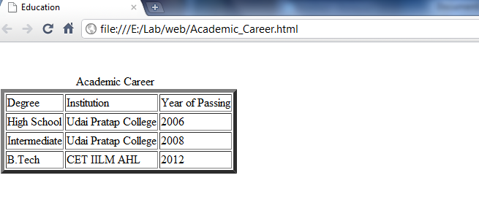

**Program no-2**

**Program to show the detail of manufacturing of the car.**

<!DOCTYPE HTML PUBLIC "-//W3C//DTD HTML 4.01 Transitional//EN">

<html>

<head><h1>Car details</h1>

<title>Car</title>

<meta http-equiv="Content-Type" content="text/html; charset=UTF-8">

</head>

<body>

<ul>

<li>Bajaj Auto

<li>Chinkara

<ul>

<li>Roadster

<li>Jeepster

</ul>

<li> Force

<ul>

<li>MUV

</ul>

<li> Hindustan

<ul>

<li> Ambassador

</ul>

<li>Hyundai (Subdivision of South Korean car brand Hyundai)

<ul>

<li>Santro

<li>Accent

<li>Sonata

<li>Getz

<li>i10

<li>i20

<li>Santafe

<li>Terracan

</ul>

<li>ICML

<ul>

<li>Rhino RX

</ul>

<li>Mahindra (c.1945-present)

<ul>

<li>Bolero

<li>Scorpio

<li>Jeep

<li>Xylo

<li>Axe

</ul>

<li>Maruti (1982-present)

<ul>

<li>800

<li>Omni

<li>Gypsy

<li>Alto

<li>Swift

<li>A-Star

<li>Ritz

<li>Dezire

<li>SX4

<li>Eeco

</ul>

<li>Pal<ul>

<li>Roadstar

<li>Sigma

<li>RiO

</ul>

<li>REVA Electric Car Company

<ul>

<li>REVA

</ul>

<li>San

<ul>

<li>Storm

</ul>

<li>Tata (1945-present)

<ul>

<li>Nano

<li>Indica

<li>Indigo

<li>Sumo

<li>Safari

<li>Xenon

<li>Aria

</ul>

</ul>

</body>

</html>

**Output:-**

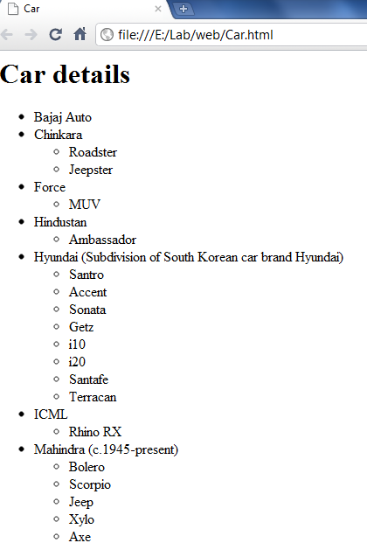

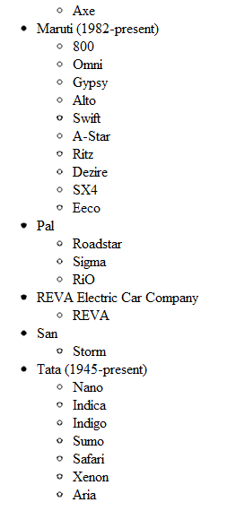

**Program no-3**

**Program to create ordered list.**

<!DOCTYPE HTML PUBLIC "-//W3C//DTD HTML 4.01 Transitional//EN">

<html>

<head>Ordered List Presentation

<title>Ordered List</title>

<meta http-equiv="Content-Type" content="text/html; charset=UTF-8">

</head>

<body>

<ol>Bank

<li>Bank Manager <li>Assistant Manager <li>Provision Officer

<li>Cashier <li>Clerk <li>Peon <li>Watch Man

</ol>

<ol>College

<li>College Name <li>Branches<li>Teachers <li>Books <li>Library <li>Labor</ol></body>

</html>

**Output:-**

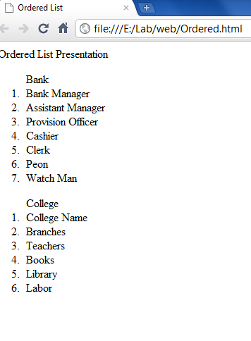

**Program no-4**

**Program to create unordered list.**

<!DOCTYPE HTML PUBLIC "-//W3C//DTD HTML 4.01 Transitional//EN">

<html>

<head>Unordered List representation

<title></title>

<meta http-equiv="Content-Type" content="text/html; charset=UTF-8">

</head>

<body>

<ul>Games

<li>Chess

<li>Cricket

<li>Football

<li>Volleyball

<li>Badminton

</ul>

<ul>Famous Player

<li>Sachin Tendulkar <li>SaniaMirja

<li>SainaNehwal<li>VirendraShehvag</ul>

</body>

</html>

**Output:-**

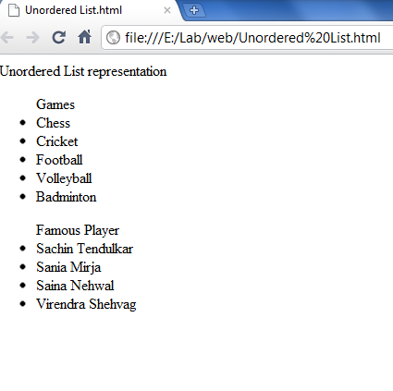

**Program no-5**

**Program to create nested list.**

<!DOCTYPE HTML PUBLIC "-//W3C//DTD HTML 4.01 Transitional//EN">

<html>

<head>Representation of Nested List

<title>Nested List</title>

<meta http-equiv="Content-Type" content="text/html; charset=UTF-8">

</head>

<body>

<ol>Student

<li>Name

<li>Branch

<ol>

<li>CSE

<li>IT

<li>ME

<li>EC

<li>EN

</ol>

<li>Address

<ul>

<li>Residential Address <li>correspondence address

</ul></ol></body>

</html>

**Output:-**

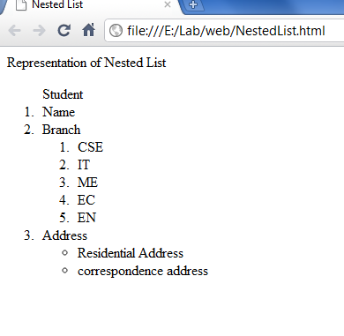

**Program no-6**

**Program to create menu and hyperlink in a web page.**

<!DOCTYPE HTML PUBLIC "-//W3C//DTD HTML 4.01 Transitional//EN">

<html>

<head>List Presentation

<title>Link</title>

<meta http-equiv="Content-Type" content="text/html; charset=UTF-8">

</head>

<body>

<menu>

<li><a href="index.html">This is a index page link</a></li><br>

<li><a href="NestedList.html">This is a nested list link</a></li><br>

<li><a href="Unordered List.html">This is a unordered list link</a></li>

</menu>

</body>

</html>

**Output:-**

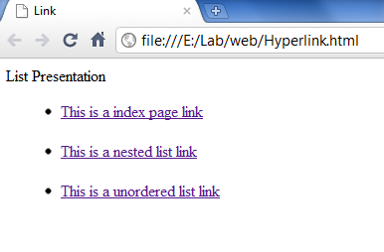

**Program no-7**

**Program to create an Image.**

<!DOCTYPE HTML PUBLIC "-//W3C//DTD HTML 4.01 Transitional//EN">

<html>

<head>Image Presentation

<title>My Image </title>

<meta http-equiv="Content-Type" content="text/html; charset=UTF-8">

</head>

<body>

<imgsrc="Dinkar.jpg" alt="This is my image" width="700" height="500" /></body></html>

**Output:-**

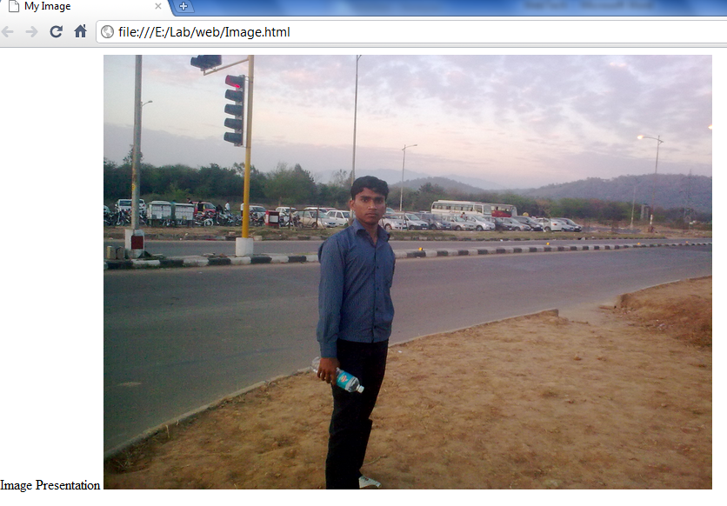

**Program no-8**

**Program to create a table.**

<!DOCTYPE HTML PUBLIC "-//W3C//DTD HTML 4.01 Transitional//EN">

<html>

<head>My table

<title>CET IILM AHL</title>

<meta http-equiv="Content-Type" content="text/html; charset=UTF-8">

</head>

<body>

<body bgcolor="white"><br>

<p>

<caption>Student</caption>

<table border="2">

<trbgcolor="white" bordercolor="yellow"><th>name</th><th>Branch</th><th>Age</th></tr>

<tr><td>Dinkar</td><td align="center">CS6A</td><td>19</td></tr>

<tr><td>Atul</td><td align="center">CS6A</td><td>20</td></tr>

<tr><td>Deepanker</td><td align="center">CS6A</td><td>20</td></tr>

</p>

</body>

</html>

**Output:-**

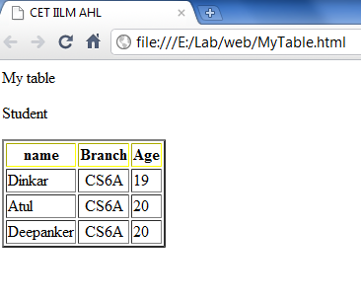

**Program no-9**

**Program for alert text prompt.**

<!DOCTYPE HTML PUBLIC "-//W3C//DTD HTML 4.01 Transitional//EN">

<html>

<title>Alert Prompt</title>

<head>

<script type="text/javascript">

functionMyalert()

{

alert("Welcome! This is alert box.");

}

</script>

</head>

<body>

<input type="button" onclick="Myalert()" value="Click to see alert Box" />

</body>

</html>

**Output:-**

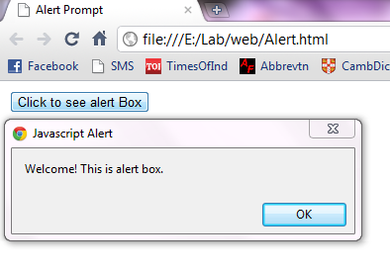

**Program no-10**

**Program to create a form.**

<!DOCTYPE HTML PUBLIC "-//W3C//DTD HTML 4.01 Transitional//EN">

<html>

<head>

<title>Myform</title>

<meta http-equiv="Content-Type" content="text/html; charset=UTF-8">

</head>

<fieldset>

<body>

<imgsrc="iilm.gif">

<h>Student</h><br><hr>

<form>

Student Id<Input type=Text name=t1><br>

Password<Input type=Password name=p1><br>

Your Description<TextArea cols="50" rows="4" name="Comment"></TextArea>

<br>Your Section<Input type=radio name= r>CS

<Input type=radio name=r>ME

<Input type=radio name=r value=EC>EC

<p>

Books You Want to issue please tick

<Input type=checkbox name=c1>COMPILER DESIGN<br>

<Input type=checkbox name=c1>SOFTWARE ENGINEERING<br>

<Input type=checkbox name=c1>CYBER LAW<br>

<Input type=checkbox name=c1>WEB TECH<br>

<Input type=checkbox name=c1>INDUSTRIAL MANAGEMANET<br>

<Input type=checkbox name=c1>COMPUTER NETWORK<br>

</p>

<p>

Companies<select name="dinkar" size="1">

<option>Inphosis</option>

<option>Tcs</option>

<option>Microsoft</option>

<option>Acenture</option>

<option>Wipro</option>

</p>

<p>

<Input type=Submit name=s>

<Input type=Reset name=r>

</p>

</select>

</fieldset>>

</form>

<a href="Image.html">NEXTPAGE</a>

</body>

</html>

**Output:-**

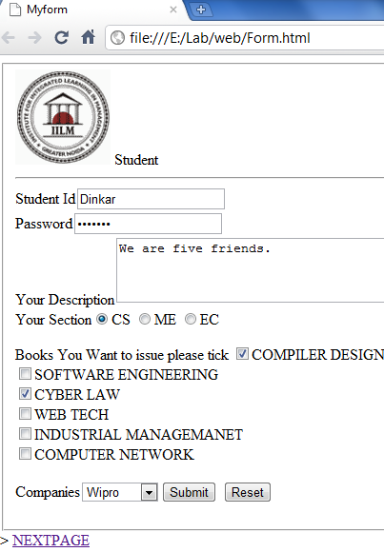

**Program no-11**

**Program to create frame.**

<!DOCTYPE HTML PUBLIC "-//W3C//DTD HTML 4.01 Transitional//EN">

<html>

<frameset cols="25%,*,25%">

<frame src="Form.html" />

<frame src="Image.html" />

<frame src="MyTable.html" />

</frameset>

</html>

**Output:-**

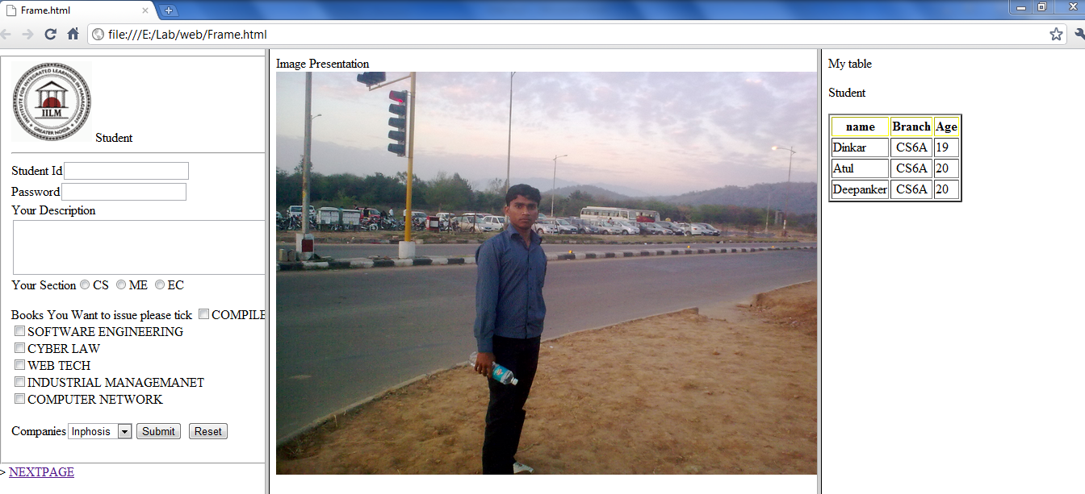

**Program no-12**

**Program to calculate GCD(greatest common divisor).**

<!DOCTYPE HTML PUBLIC "-//W3C//DTD HTML 4.01 Transitional//EN">

<html>

<head>

<script type="text/javascript">

function GCD()

{

var x1=prompt("Please enter your name","number x1");

var x2=prompt("Please enter your name","number x2");

if(x1<0 || x2<0)

{

alert("Cannot compute the GCD "+

"if one integer is negative.");

exit();

}

vara,b,g,z;

if(x1>x2) {

a = x1;

b = x2;

} else {

a = x2;

b = x1;

}

if(b==0)

{

document.write("The Greates Common Divisor is "+a);

}

g = b;

while (g!=0)

{

z= a%g;

a = g;

g = z;

}

document.write("The Greatest Common Divisor is "+a);

}

</script>

</head>

<body>

<input type="button" onclick="GCD()" value="Click here to Enter your numbers" />

</body>

</html>

**Output:-**

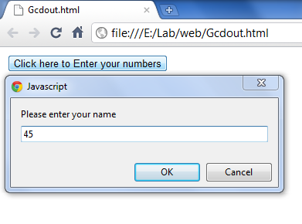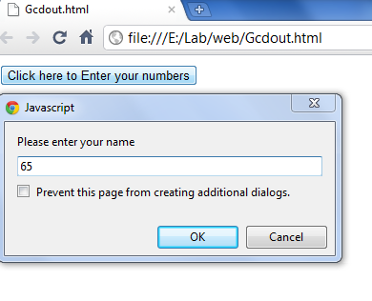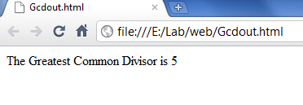

**Program no-13**

**Program to show prime numbers.**

<!DOCTYPE HTML PUBLIC "-//W3C//DTD HTML 4.01 Transitional//EN">

<html>

<head>

<script type="text/javascript">

function Prime()

{

varnum=prompt("Please enter your name","number");

var i;

document.write("<br>"+"The prime numbers are:-"+"</br>"+"<hr>");

for (i=1; i <num; i++ )

{

var j;

for (j=2; j<i; j++)

{

var n = i%j;

if (n==0)

break;

}

if(i == j)

{

document.write(" "+i);

}

}

}

</script>

</head>

<body>

<input type="button" onclick="Prime()" value="Click here to Enter your numbers" />

</body>

</html>

**Output:-**

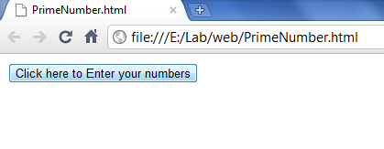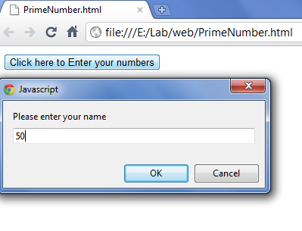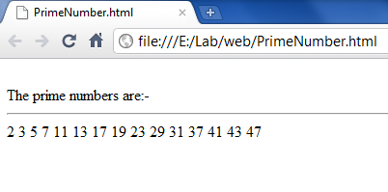

**Program no-14**

**Program to for validation of login page.**

*LoginValidation.html*

<!DOCTYPE HTML PUBLIC "-//W3C//DTD HTML 4.01 Transitional//EN">

<html>

<head>

<script>

functionLoginfunction()

{

if(document.getElementById('userid').value.length==0&&document.getElementById('password').value.length==0)

alert("Sorry! You have not filled any field.");

else if(document.getElementById('userid').value.length==0)

alert("Sorry!UserId can't be blank.");

else if(document.getElementById('password').value.length==0)

alert("Sorry!Password can't be blank.");

else

{

alert("Congress!You have Successfully logged in.");

window.open("LoginV.html");

}

}

</script>

</head>

<body>

UserId<input type="text" id="userid">

<br/>

Passowrd<input type="password" id="password">

<br /><br/>

<input type ="button" onclick="Loginfunction()" value ="LogIn">

</body>

</html>

*LoginV.html*

<!DOCTYPE HTML PUBLIC "-//W3C//DTD HTML 4.01 Transitional//EN">

<html>

<head>

<title>Welcome</title>

</head>

<body>

<P><h1><i>Welome to your Home Page </i></h1>

<b>My name is Dinkar Prasad Maurya.

<hr>I am pursing B.tech(Computer Science) in Greater Noida.

<hr>My home town is Sarnath.

</P>

</body>

</html>

**Output:-**

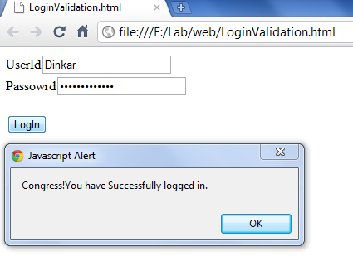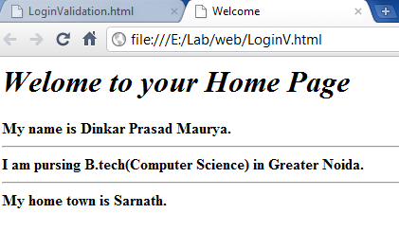

**Program no-15**

**Program to show Employee detail in XML.**

<?xml version="1.0" encoding="UTF-8"?>

<Employees>

<Employee>

<Emp_id>6249752</Emp_id>

<Emp_name>Deepak Kumar Swain</Emp_name>

<Emp_dept>Computer Science</Emp_dept>

<Role>Teacher</Role>

</Employee>

<Employee>

<Emp_id>6249753</Emp_id>

<Emp_name>Ravindra Kumar Bharti</Emp_name>

<Emp_dept>Computer Science</Emp_dept>

<Role>Teacher</Role></Employee>

<Employee>

<Emp_id>6249754</Emp_id>

<Emp_name>Pradeep</Emp_name>

<Emp_dept>Computer Science</Emp_dept>

<Role>Teacher</Role>

</Employee></Employees>

**Output:-**

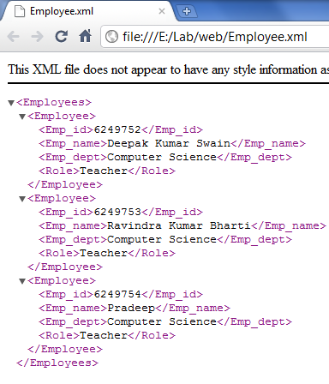

**Program no-16**

**Program to calculate factorial of the given number.**

*fact.jsp*

<%--

Document : fact

Created on : 1 May, 2011, 5:01:57 PM

Author : Maurya

--%>

<%@ page contentType="text/html; charset=iso-8859-1" language="java" %>

<html>

<title>Factorial</title>

<body>

<form name="frm" method="get" action="FactCal.jsp">

Enter the number

<input type="text" name="number">

<input type="submit" name="submit" value="Submit">

</form>

</body>

</html>

*FactCal.jsp*

<%--

Document : input

Created on : 1 May, 2011, 5:00:01 PM

Author : Maurya

--%>

<%@ page contentType="text/html; charset=iso-8859-1" language="java" %>

<%

int n, fact = 1;

String num = request.getParameter("number");

n = Integer.parseInt(num);

try {

while (n > 0) {

fact = fact * n;

n = n - 1;

}

} catch (Exception e) {

out.println(e);

}

%>

<html>

<body>

The factorial of the number in JSP :<%=fact%>

</body>

</html>

**Output:-**

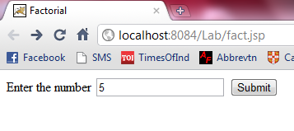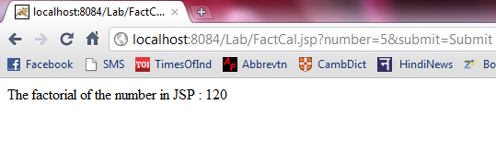

**Program no-17**

**Program to solve the Quadratic equation in JSP.**

<%--

Document : Qinput

Created on : 2 May, 2011, 12:43:01 AM

Author : Maurya

--%>

<%@ page contentType="text/html; charset=iso-8859-1" language="java" %>

<html>

<body>

<form name="frm" method="get" action="QuardCal.jsp">

Enter the the value of a:-

<input type="text" name="a1"><br>

Enter the the value of b:-

<input type="text" name="b1"><br>

Enter the the value of c:-

<input type="text" name="c1"><br>

<input type="submit" name="submit" value="Submit">

</form>

</body>

</html>

QuardCal.jsp

<%--

Document : QuardCal

Created on : 9 May, 2011, 3:21:23 PM

Author : Maurya

--%>

<%@ page contentType="text/html; charset=iso-8859-1" language="java" %>

<%

double x1 = 0, x2 = 0,disc=0, a, b, c;

String x, y, z;

x = request.getParameter("a1");

a = Double.parseDouble(x);

y = request.getParameter("b1");

b = Double.parseDouble(y);

z = request.getParameter("c1");

c = Double.parseDouble(z);

disc=b*b-4*a*c;

x1=(-b+Math.sqrt(disc))/2;

x2=(-b-Math.sqrt(disc))/2;

%>

<html>

<body>

The both solution of the Quadratic equation in JSP are:-<%=x1+" and "+x2%>

</body>

</html>

**Output:-**

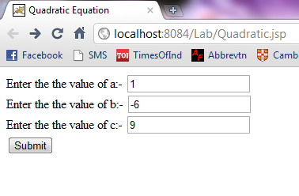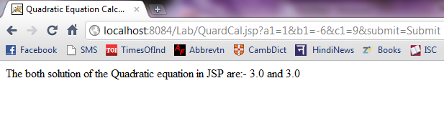

**Program no-18**

**Program to show Data Base Connectivity in JSP using MySql.**

<%--

Document : DBconnection

Created on : 9 May, 2011, 4:59:26 PM

Author : Maurya

--%>

<%@ page import="java.sql.*"%>

<%

response.setContentType("text/html");

try

{

Class.forName("com.mysql.jdbc.Driver");

Connection con = DriverManager.getConnection("jdbc:mysql://localhost:3306/Dinkar_Database", "admin", "tiger");

Statement stmt = con.createStatement();

PreparedStatementps = con.prepareStatement("select * from Student");

ResultSetrs = ps.executeQuery();

out.print("The Data Base connectivity program execution in jsp page."+"<br>");

out.println("Name"+"\t\t\t\t"+"Roll Number"+"\t\t\t\t"+"Age"+"<br>");

while (rs.next())

{

out.println(rs.getString(1));

out.println("\t\t\t\t\t" +rs.getString(2));

out.println("\t\t\t\t\t" + rs.getString(3));

out.println("<br>");

}

out.println("<hr>");

}

catch (SQLException e)

{

out.println(e + "Sql Error!");

}

catch (Exception e)

{

out.println(e + "defalt Error");

}

%>

***Data Base Content:-***

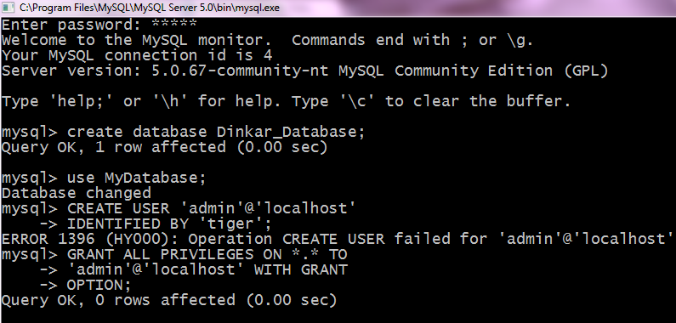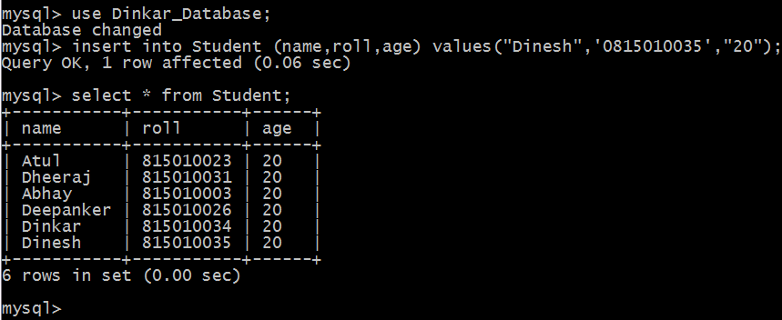

**Output:-**

