ThermalMapper - Report
Partner 3: Faculty of Electrical Engineering Sarajevo

The main task of Faculty of Electrical Engineering in this project is to develop a software for reconstructing the 3D model of indoor environment from Riegl VZ – 400 laser scans. These laser scans also incorporates thermal imaging results, so temperature scalar field can be visualized.
We chose an open source Visualization Toolkit to work with since it provides good framework for working with 3D and image data.
The work done within this project can be divided into several parts:
- 3D Model reconstruction,
- Thermal field mapping,
- Model improvements,
- Heat source/leak detection,
- Simple application for inspection of the 3D model.

3D Model Reconstruction
For the reconstruction of the 3D model we chose to implement a Marching cubes algorithm (MCA) for generating a 3D mesh from point cloud acquired by Riegl laser scanner. In order to employ MCA we applied Gaussian estimation of iso – values in order to precisely generate 3D model.
Several known techniques of model reduction we applied to enhance interactivity of the model in the means of model inspection. Simple model decimation (eliminating excessive faces from the model without changing the visual perception of the model) proved to be enough to optimize the performance of model inspection.
The results considering the model reconstruction are published in [1] and [3].

Thermal field mapping
After obtaining the 3D model in the form of mesh it was required to enrich this model with thermal data acquired from Optris PI 160 thermal camera.
We chose to implement this by mapping a thermal scalar field onto reconstructed 3D model. This has an advantage over texture mapping techniques using thermal information as a digital image in a sense that all the thermal information will be accessible for each coordinate of space. Although this enlarges the model considerably, we think that this enables better future inspection.
The mapping was implemented by finding corresponding points from the original point cloud with added thermal information to the points in the reconstructed model. These points will have the same thermal information as the original points. Since there are more points in the reconstructed model than in original point cloud some points in the 3D model will not have thermal information added. To deal with this, simple linear interpolation of scalar field was implemented to solve this problem. Sample image of the reconstruction with added thermal information is given in Figure 1.
The results considering Thermal field mapping are published in [1] and [3].
Model improvements
At first, some parts of the model had some major problems with precision. We identified that density of the points in those parts was much smaller than in other parts of the model. The main cause of this was the data recorded contains semi – transparent surfaces (e.g. windows). We implemented a clustering method based on K – nearest neighbour to exclude these points from 3D model reconstruction.
We observed major improvement in precision with this method applied.
Also, Fuzzy C Means based method was tested with similar results.
Results considering model improvements is published in [2]

Heat source/leak detection
We identified this as a main objective after model reconstruction – what constitutes as heat source of a leak. We automated this process in order to help the end user in identification of these points of interests.
We implemented the similar clustering procedure to detect heat sources/leaks, but this one is done in two stages since we need to exclude the points that are artefacts of model reconstruction.

Simple application for inspection of the 3D model
We developed a simple proof-of-concept application for the inspection of the 3D model with added thermal information.
It includes basing interaction with the model – walk-through, fly-by, rotating, zooming. The model is presented with colour coded thermal information for each point in space. Several colour codes (colour maps) are offered to user.
Also, selecting the points in the model in order to acquire its thermal information is implemented.
Interaction requires keyboard, mouse or a joystick to inspect the model. The screenshot of this application is given in Figure 2.
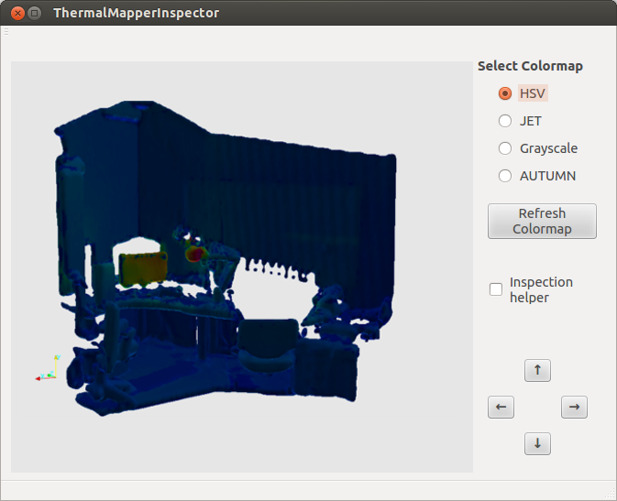Figure 2: Screenshot of the ThermalMapperInspector viewing the model from Figure 1
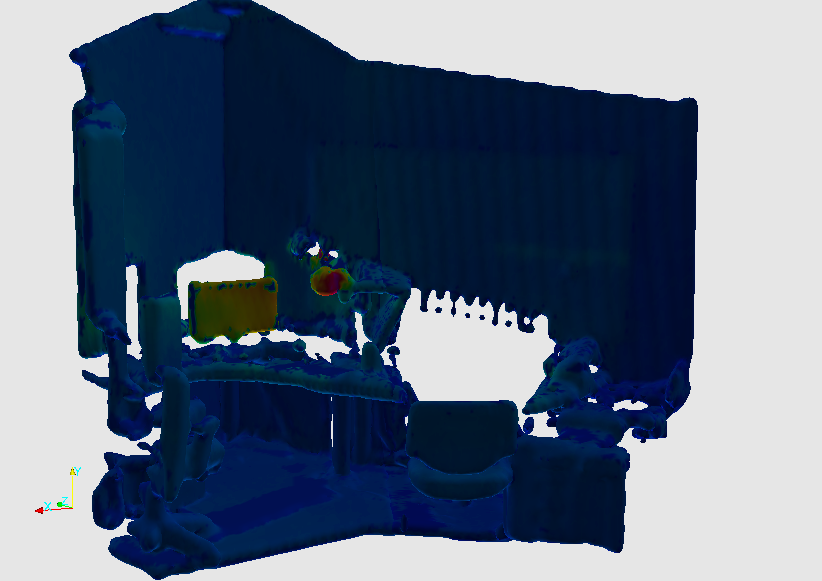
Figure 1: Image of the part of the reconstructed 3D model
References:

- Dorit Borrmann, Andreas Nüchter, Marija Ðakulović, Ivan Maurović, Ivan Petrović, Dinko Osmanković, Jasmin Velagić, “The Project ThermalMapper – Thermal 3D Mapping of Indoor Environments for Saving Energy”, IFAC SYROCO 2012, Dubrovnik, Croatia

- Osmanković D., Velagić J., “Increasing the precision of reconstructed 3D model of indoor robot environment by elimination of problematic points”, IFAC SYROCO 2012, Dubrovnik, Croatia
- Osmanković D., Velagić J., “Reconstructing the 3D thermal model of indoor environment from unorganized data set acquired by 3D laser scans and thermal imaging camera”, IEEE MSC 2012, Dubrovnik, Croatia

