PDFPreview

Purpose
This project use mupdf library to generate preview and printout of pdf documents.
The reason for this is I need to port my old application to Linux and I use external Sumatra pdf viewer for preview and printing of pdf documents. Sumatra does not exists on linux, so...
Also sumatra use libmupdf 1.6 and I want 1.8.
The purpose of the document is to explain how to build libmupdf.dll (32 and 64 bit) for windows and Linux, how to link it in FPC (lazarus or codetyphon) application.
Example project show the use of library with common preview functions. You are encourage to extend this project.
Initial idea for this FPC project is done by Blestan Tabakov. His version use one of first version of libmupdf library.
Problems:
There are lot of changes in cdecl function calls between versions. Big change is between version 1.6 and 1.7. Almost every call in version 1.7 is changed in way that first param is CONTEXT variable. Some functions are changed in way that they have different params or param types.

Layout of final application
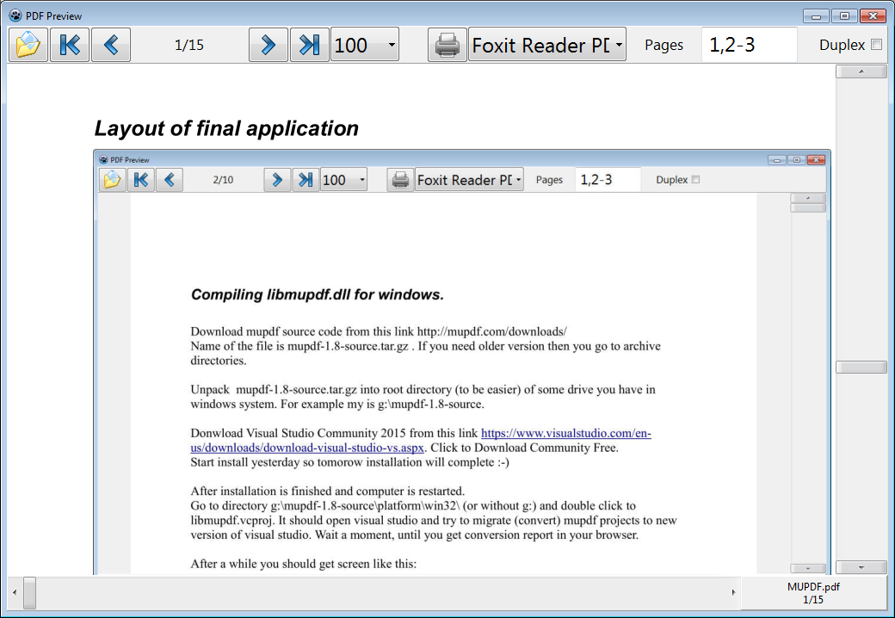

History

My first approach was to use ver 1.6 of libmudpf. I did not found any precompiled version of it. According to Blestan, Sumatra project always have libmudpf.dll if you use installer and install sumatra. So I did, but guys from Sumatra did not export all function needed by Blestan example. So it was dead end for me. Then I used Sumatra source code and recompile libmupdf.dll but included missing function. This was good. Then I tried to precomile for Linux. But Fedora19 did not have 1.6 and latest version was 1.5. So I decided to go again from start. Use plain mupdf source (latest was 1.8) and recompile for win32 and win64. Almost all calls are changed between 1.6 and 1.8. Some of the functions are renamed.

Compiling libmupdf.dll for windows (Dynamic Library - dll)

Download mupdf source code from this link http://mupdf.com/downloads/
Name of the file is mupdf-1.8-source.tar.gz . If you need older version then you go to archive directories.

Unpack mupdf-1.8-source.tar.gz into root directory (to be easier) of some drive you have in windows system. For example my is g:\mupdf-1.8-source.

Donwload Visual Studio Community 2015 from this link https://www.visualstudio.com/en-us/downloads/download-visual-studio-vs.aspx. Click to Download Community Free.
Start install yesterday so tomorow installation will complete :-)

After installation is finished and computer is restarted.
Go to directory g:\mupdf-1.8-source\platform\win32\ (or without g:) and double click to libmupdf.vcproj. It should open visual studio and try to migrate (convert) mupdf projects to new version of visual studio. Wait a moment, until you get conversion report in your browser.

After a while you should get screen like this:
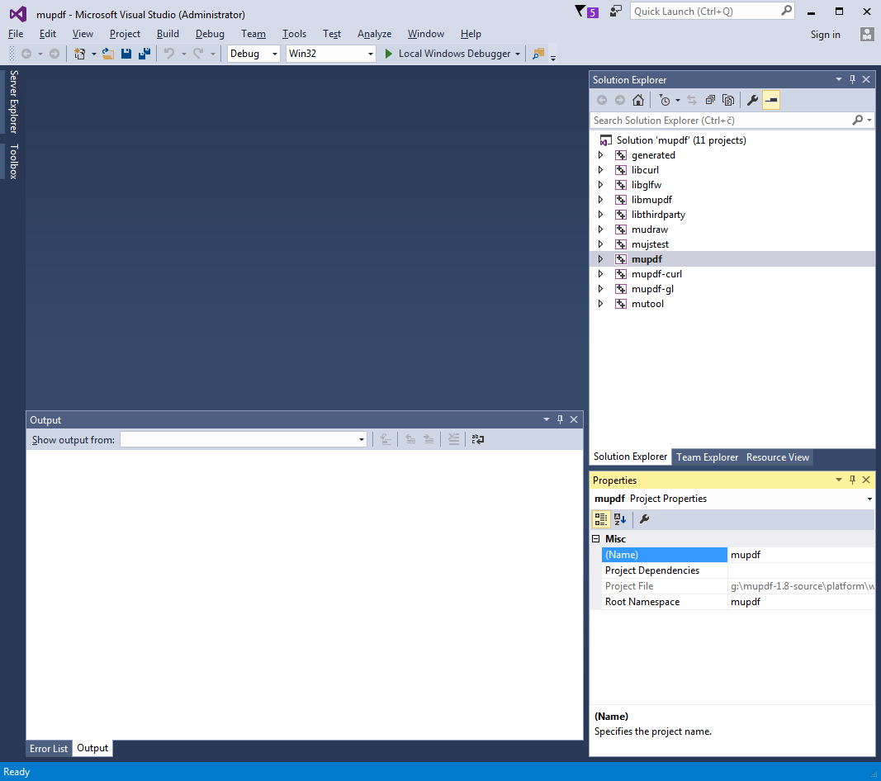
Right click to libmupdf third party and chose properties, after that choose Configuration Manager.
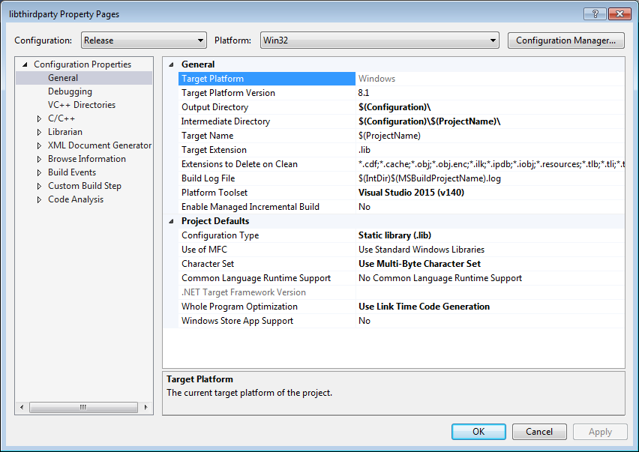
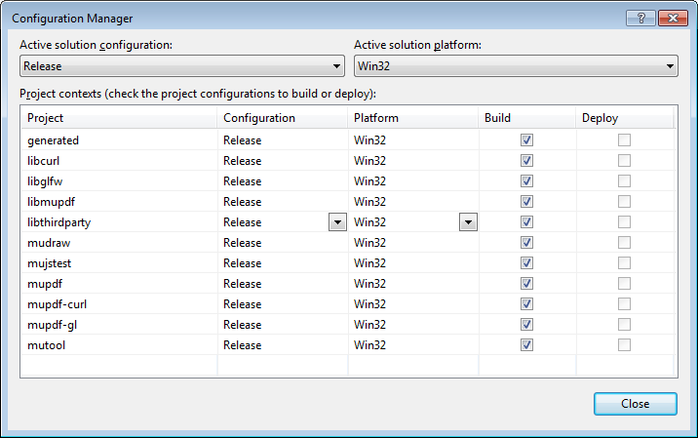

Chose Acive Soultion = Release (original is Debug)
Close both windows, right click again to libthirdparty and choose Build. Wait until this lib is built, and you get message like this

1>------ Build started: Project: libthirdparty, Configuration: Release Win32 ------
1> libthirdparty.vcxproj -> g:\mupdf-1.8-source\platform\win32\Release\libthirdparty.lib
========== Build: 1 succeeded, 0 failed, 0 up-to-date, 0 skipped ==========

So, first lib is created and it is located in
g:\mupdf-1.8\source\platform\win32\Release\libthirdparty.lib

Now me must make libmupdf.dll.
Right Click to libmupdf and chose Properties. This library depends on libthirdparty.lib so we have to make a link to it. But first we need to change project configuration type to dll.

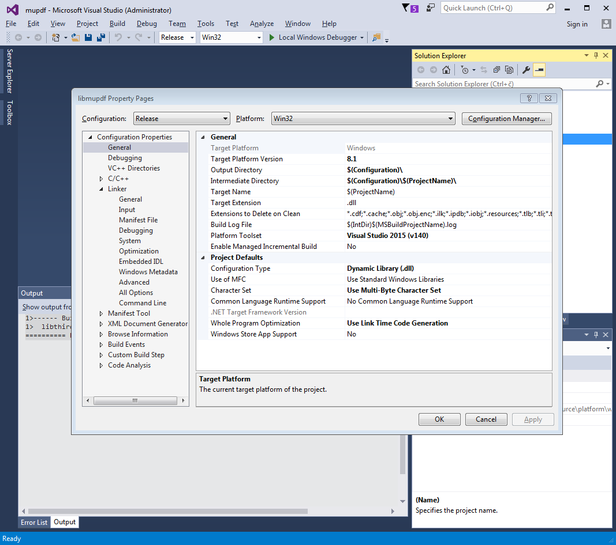

After that open Linker options:

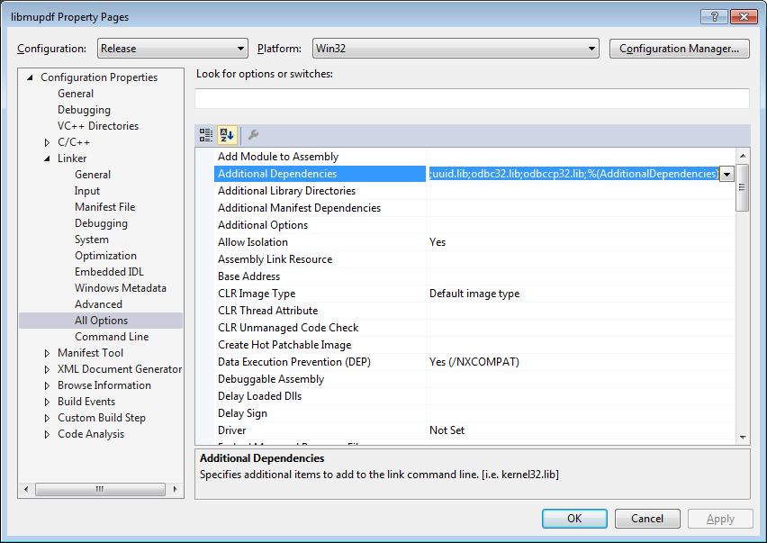
Add new library into Additional Dependencies so the value look like:

kernel32.lib;user32.lib;gdi32.lib;winspool.lib;comdlg32.lib;advapi32.lib;shell32.lib;ole32.lib;oleaut32.lib;uuid.lib;odbc32.lib;odbccp32.lib;g:\mupdf-1.8-source\platform\win32\Release\libthirdparty.lib;%(AdditionalDependencies)

Now we need list of function which dll have to export and that are needed for our project.
File is /DEF:g:\mupdf-1.8-source\libmupdf.def %(AdditionalOptions)
Only functions that are listed here will be visible in libmupdf.dll by some other consumer program.
Example of libmupdf.def file:

; Fitz exports

fz_new_context_imp
pdf_document_handler

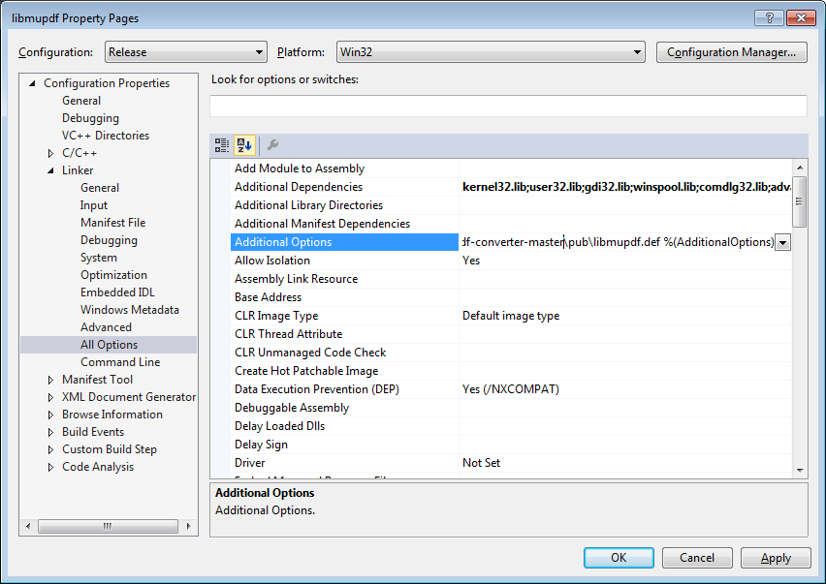

Close all other windows, right click to libmupdf and choose Build.
Afer some time you should see something like this:

2> Generating Code...
2> Creating library Release\libmupdf.lib and object Release\libmupdf.exp
2> Generating code
2> All 2655 functions were compiled because no usable IPDB/IOBJ from previous compilation was found.
2> Finished generating code
2> libmupdf.vcxproj -> g:\mupdf-1.8-source\platform\win32\Release\libmupdf.dll
2> libmupdf.vcxproj -> Release\libmupdf.pdb (Full PDB)
========== Build: 2 succeeded, 0 failed, 0 up-to-date, 0 skipped ==========

The final file is located in g:\mupdf-1.8-source\platform\win32\Release\libmupdf.dll
Now take this file and rename it too libmupdf18-32.dll

Lets build win64 dll.

Right Click to properties of libmupdf and then chose configuration manager.
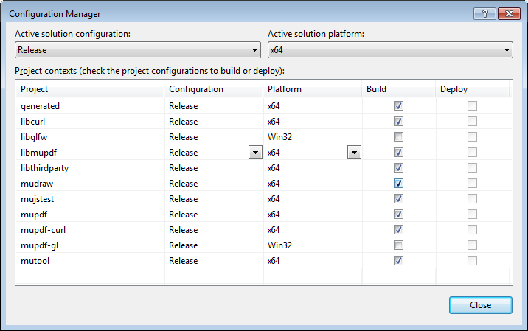
Change to Release and x64.

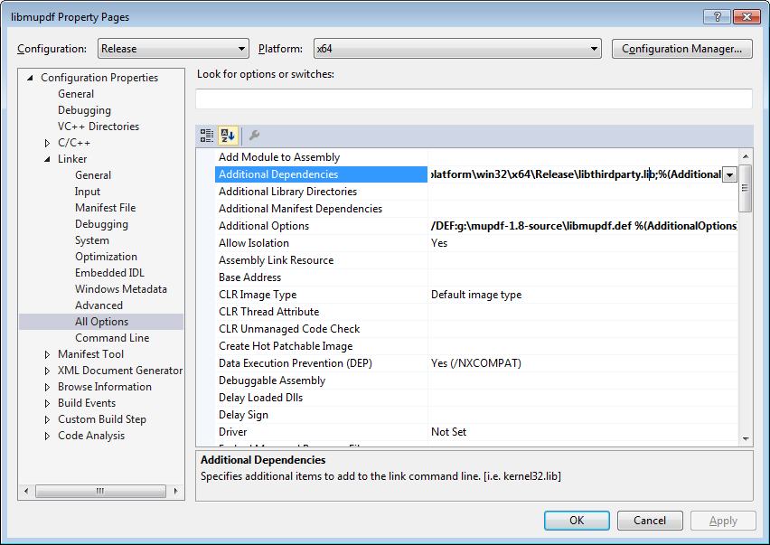

kernel32.lib;user32.lib;gdi32.lib;winspool.lib;comdlg32.lib;advapi32.lib;shell32.lib;ole32.lib;oleautChange everything like you did for 32 version. Be carefull. Release of library in now in different directory:

32.lib;uuid.lib;odbc32.lib;odbccp32.lib;g:\mupdf-1.8-source\platform\win32\x64\Release\libthirdparty.lib;%(AdditionalDependencies)

Change Additional options like we did in 32 version.
/DEF:g:\mupdf-1.8-source\libmupdf.def %(AdditionalOptions)

Windows and static linking did not workout for me. I always got the error while linking. Something like Wrong COFF magic number. This error is the same no matter I compile with mingw or visual studio 2015.

Compilation of mupdf 1.7 did not workout for me because Visual Studio 2010 i required, or Platform Tools 2010 for Visual Studio 2015. I was not able to find Platform Tools.

Content of file libmupdf.def (function names)

LIBRARY libmupdf
EXPORTS

; Fitz exports variables

pdf_document_handler
xps_document_handler
cbz_document_handler
img_document_handler
tiff_document_handler
html_document_handler
epub_document_handler

; Fitz exports functions

fz_new_context_imp
fz_register_document_handler
fz_register_document_handlers
fz_new_document_handler_context
fz_drop_document_handler_context

; fz_free_context is changed to fz_drop_context
; fz_close_document is changed to fz_drop_document
; fz_free_device is changed to fz_drop_device
; fz_free_page is changed to fz_drop_page

fz_open_document
fz_drop_document
fz_drop_context
fz_drop_device
fz_count_pages
fz_load_page
fz_drop_page
fz_load_page
fz_bound_page
fz_run_page
fz_new_draw_device
fz_rotate
fz_pre_scale
fz_lookup_device_colorspace
fz_pixmap_bbox
fz_pixmap_width
fz_pixmap_height
fz_new_pixmap
fz_new_pixmap_with_bbox
fz_new_pixmap_with_data
fz_new_pixmap_with_bbox_and_data
fz_keep_pixmap
fz_drop_pixmap
fz_pixmap_colorspace
fz_pixmap_components
fz_pixmap_samples
fz_clear_pixmap_with_value
fz_clear_pixmap
fz_new_trace_device
fz_new_bbox_device
fz_new_draw_device_with_bbox
fz_needs_password
fz_authenticate_password
fz_transform_rect

Now Linux

If you think that windows was hard then Linux is dll hell (or linking hell)

I tried Fedora 22 (64 bit) on vmware 12 (widnows host), and I tried Fedora 23 (32 bit) on vmware 12 (windows host). Fedora 22-64 was succesfull with static linking of mupdf-1.7a, but then I lost network card which I was unable to recreate. So I did not test mupdf 1.8. Cross compile on windows machine was also ok. Printer paper must be A4 on linux, otherwise application prints out empty paper ???.
When you cross compile for Linux it is important to order linuking libraries in correct order.
Chek out:
Project Inspector/ Compiler Options/Path/Libraries
For Linux 32:
externallibs\$(TargetCPU)_$(TargetOS);c:\codetyphon\binLibraries\i386-linux\;C:\codetyphon\binLibraries\i386-linux-qt4\
For Linux 64:
externallibs\$(TargetCPU)_$(TargetOS);C:\codetyphon\binLibraries\x86_64-linux-qt4\;C:\codetyphon\binLibraries\x86_64-linux\

Following screenshot is from Fedora22-64bit. Application is written with mupdf 1.8. It is crosscompiled on windows host. So everything is possible.
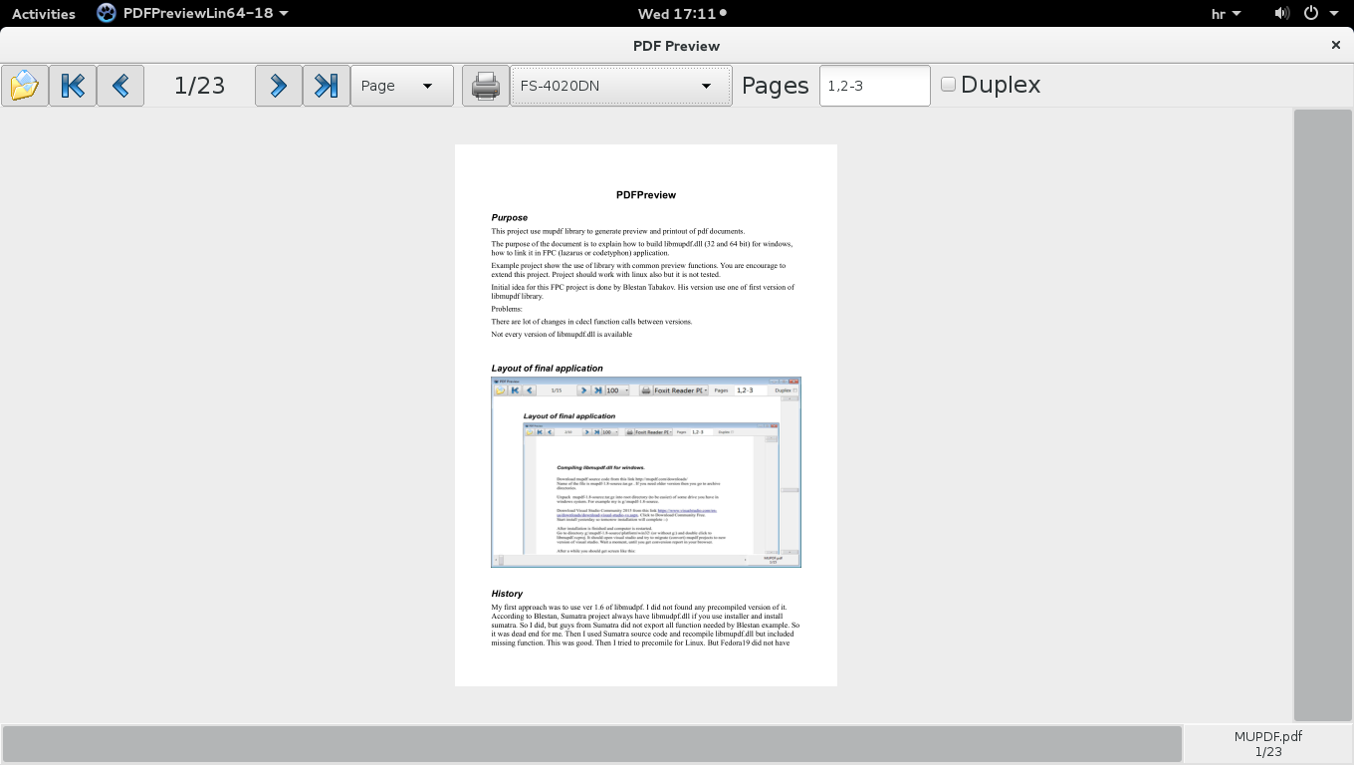

Following is my notest about Fedora 22

Install Fedora22 (I use 64 bit) on virtual machine. You will need latest vmware (12) virtual machine. After installation you will need to uninstall open-vmware-tools and install regular vmware tools. This is because you want to share drives between windows host and linux virtual machine. I installed codetyphon 5.40. Download it and unpack in user home directory (user can not be root). Run install.sh script, and choose option 0. This option will install all prerequisites needed by typhon64. Then you choose option 8 (Remove and Build All)

http://www.linuxfromscratch.org/blfs/view/svn/pst/mupdf.html
build win32
make OS=MINGW build=release

make build=release install

https://fedoraproject.org/wiki/Common_F22_bugs#No_network_connection_in_VM_when_both_host_and_guest_installed_from_a_Live_image
sudo virsh net-destroy default
sudo virsh net-undefine default

Following is my notest about Fedora 23 (64 bit)

After installing Fedora23(64 bit) – clean without CodeTyphon
For Fedora23-64bit to be able compile mupdf 1.8 following must be:
dnf install libX11-devel xorg-x11-proto-devel libXau-devel
dnf install libXext-devel.x86_64
dnf groupinstall 'Development Tools'
dnf install freeglut-devel.x86_64
dnf install libXcursor-devel.x86_64
dnf install glfw-devel.x86_64

This part was not finished – it seems to me that for 64bit version of Fedora23 we need to use gt2 widgetset
To install qt4 on fedora23-64bit you need to download package from
http://rpm.pbone.net/index.php3/stat/4/idpl/31960309/dir/fedora_23/com/qt-4.8.7-5.fc23.x86_64.rpm.html
and
http://rpm.pbone.net/index.php3/stat/3/srodzaj/1/search/libcrypto.so.10(libcrypto.so.10)
then copy in local fedora folder and type
dnf install openssl-libs-1.0.2e-3.fc23.i686.rpm
dnf install qt-4.8.7-5.fc23.x86_64.rpm

Installing Fedora23 – 32 on VMWare12.

Installation procedure:

Choose installation image and install.
After installation
Put shared disk on: G and D in vmware Settings/Options/Shared Folders
Check amount of memory you put to virtual machine. My is about 3 GB.
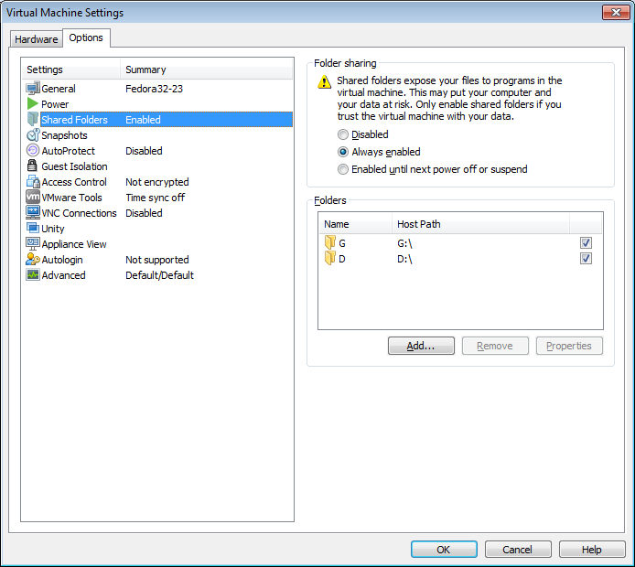

If Fedora chose Activity and type Privacy. Choose Screen Lock = Off
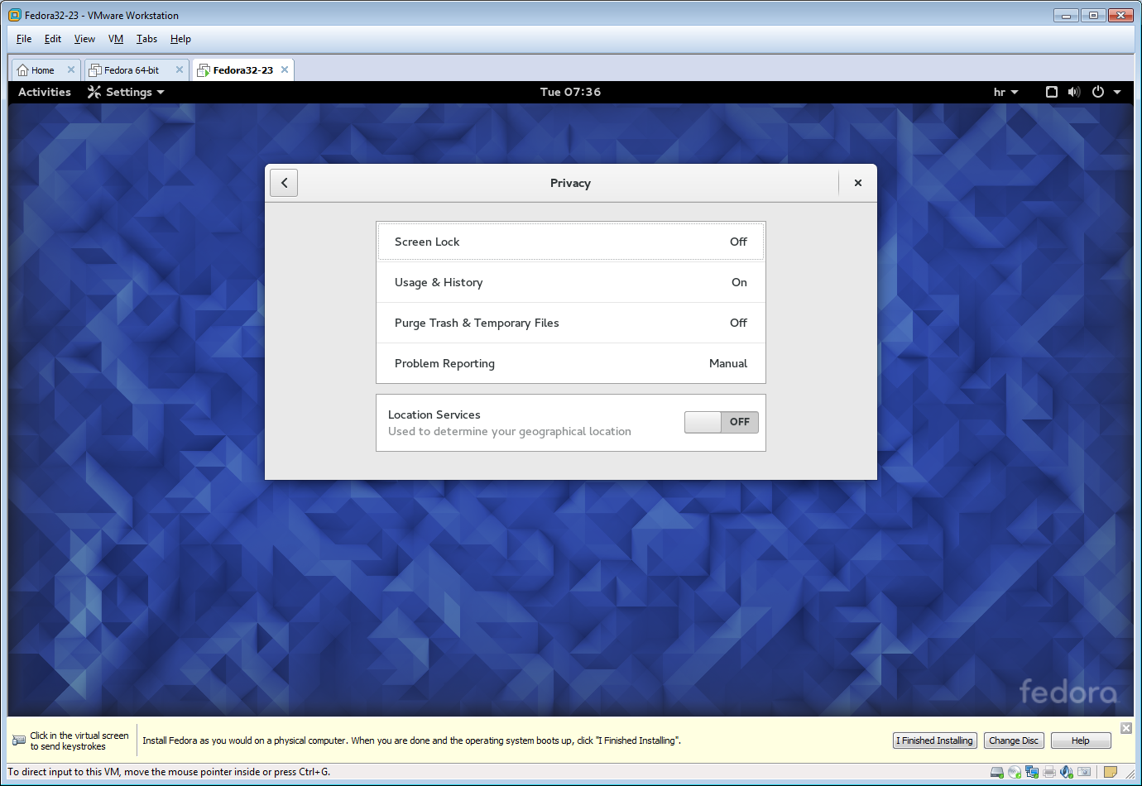
Choose Activities/Power and Screen Lock = 0.
Choos Activity and type Printers. Click Unlock and type password.
Install printer by typing ip address 192.168.88.10
Choose Jet Direct-Printer – Choose FS4000
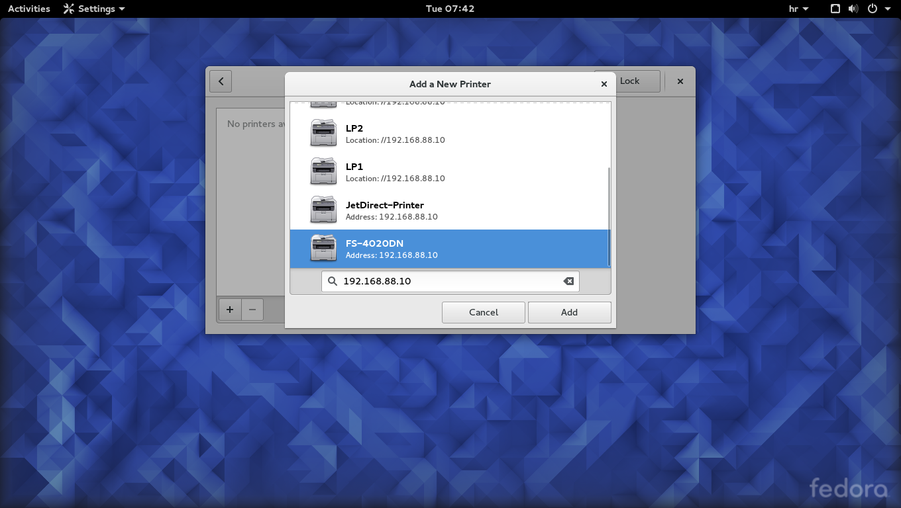
Choose FS-4020DN as driver

Install mc
Open Terminal. Activity type terminal.
Type:
su and password
dnf install mc

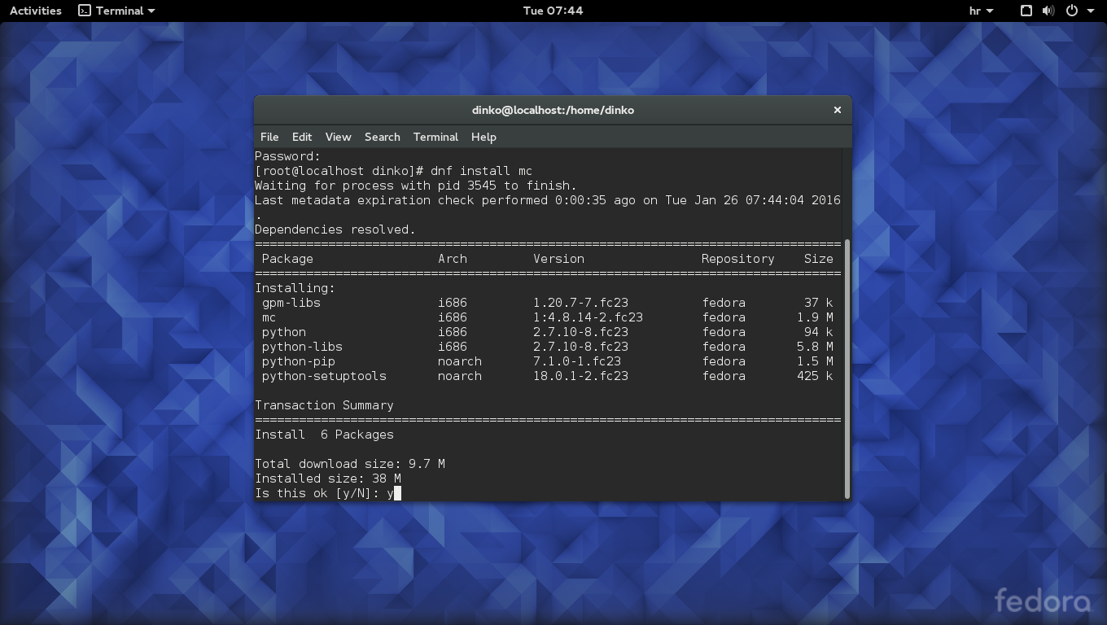

Enabling vmware shares:
uninstal open-vmware-tools
Type:
su and password
dnf remove open-vm-tools

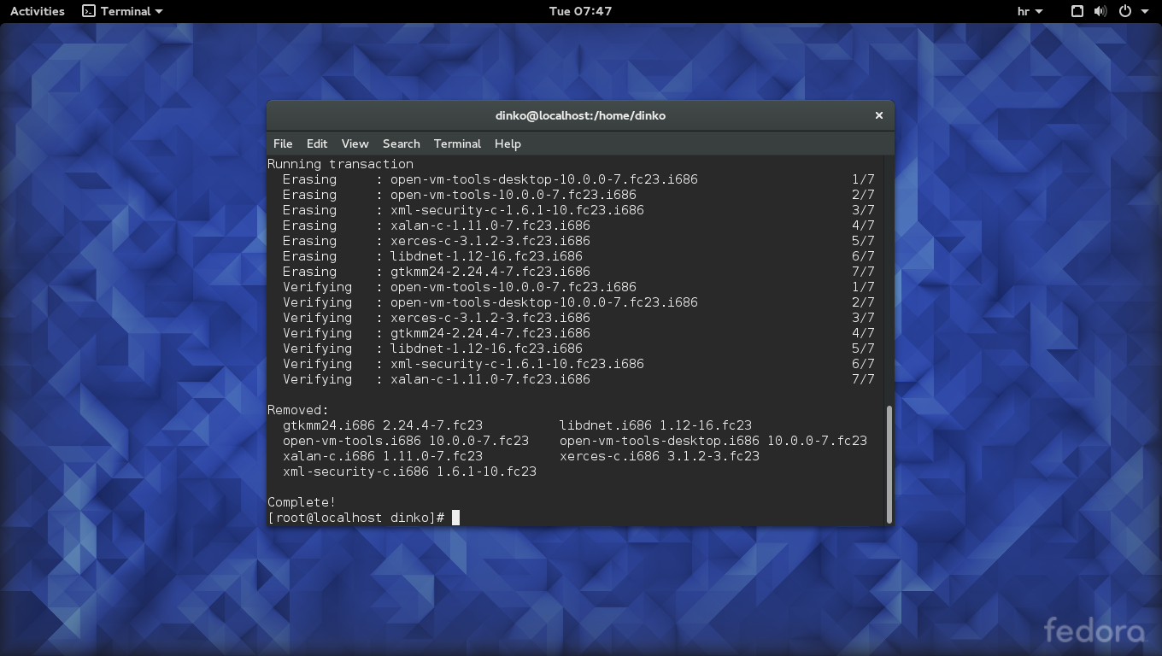
Go to vmware VM menu of host application and chose VM/Install VMWare Tools. Wait until tools are mounted in Fedora 23 file system.
Goto Fedora22 and open mc in terminal. Goto /run/media/dinko directory.
If not succesfull (not exists) then restart Fedora23 and try again the same procedure.
Inside directory should be VMWare Tools disk with VMWare-Tools 10.0.5-3228523 tar gzip file.
Unzip this file in your home directory by using mc. Just enter into tar gzip by pressing Enter.
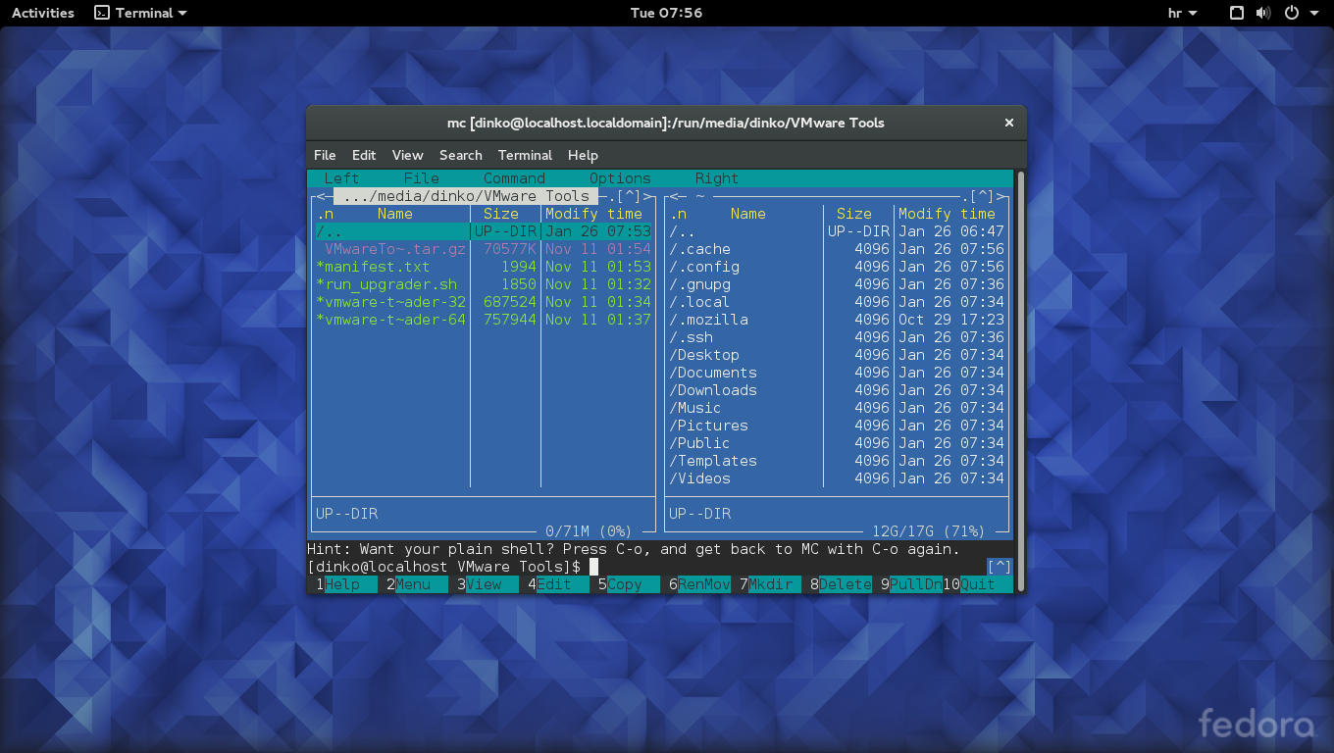
Open another terminal
type:
su and password
cd vm and press tab then enter
ls -al
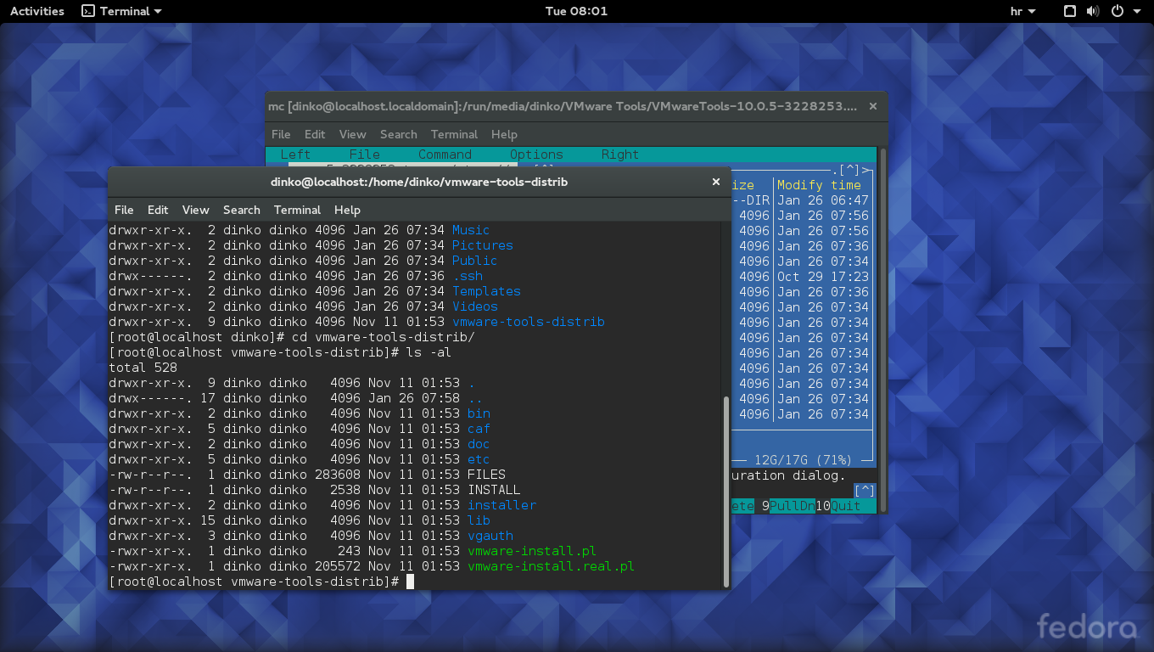
type to start installation
./vmware-install.pl
Type yes on firs question
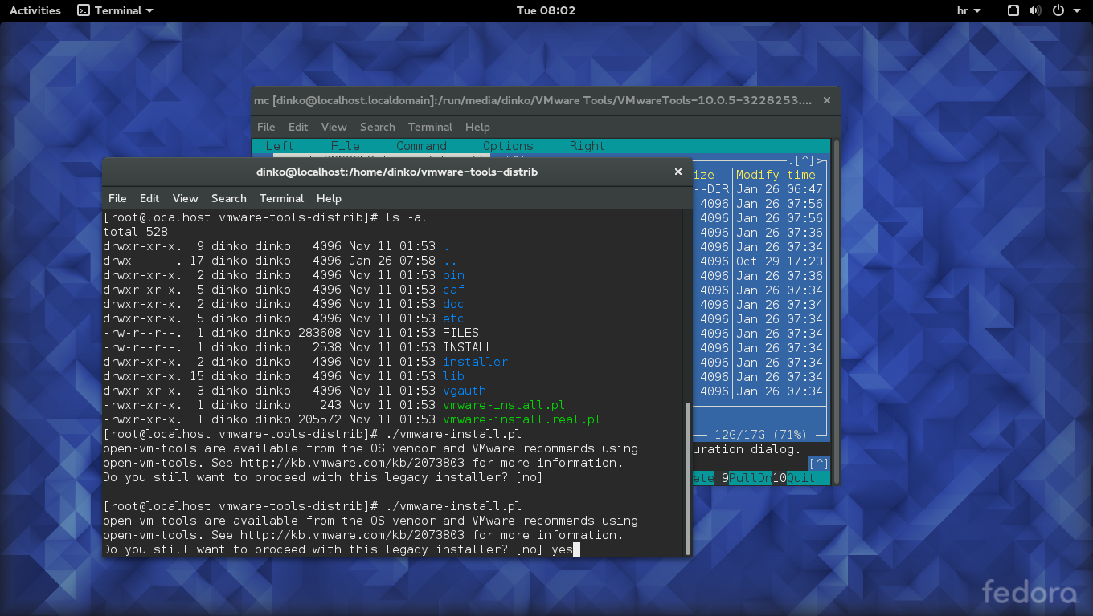
Confirm every question with default by pressing enter. Wait until installation is finished

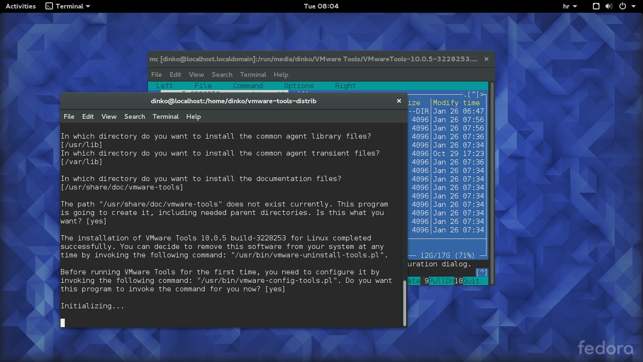

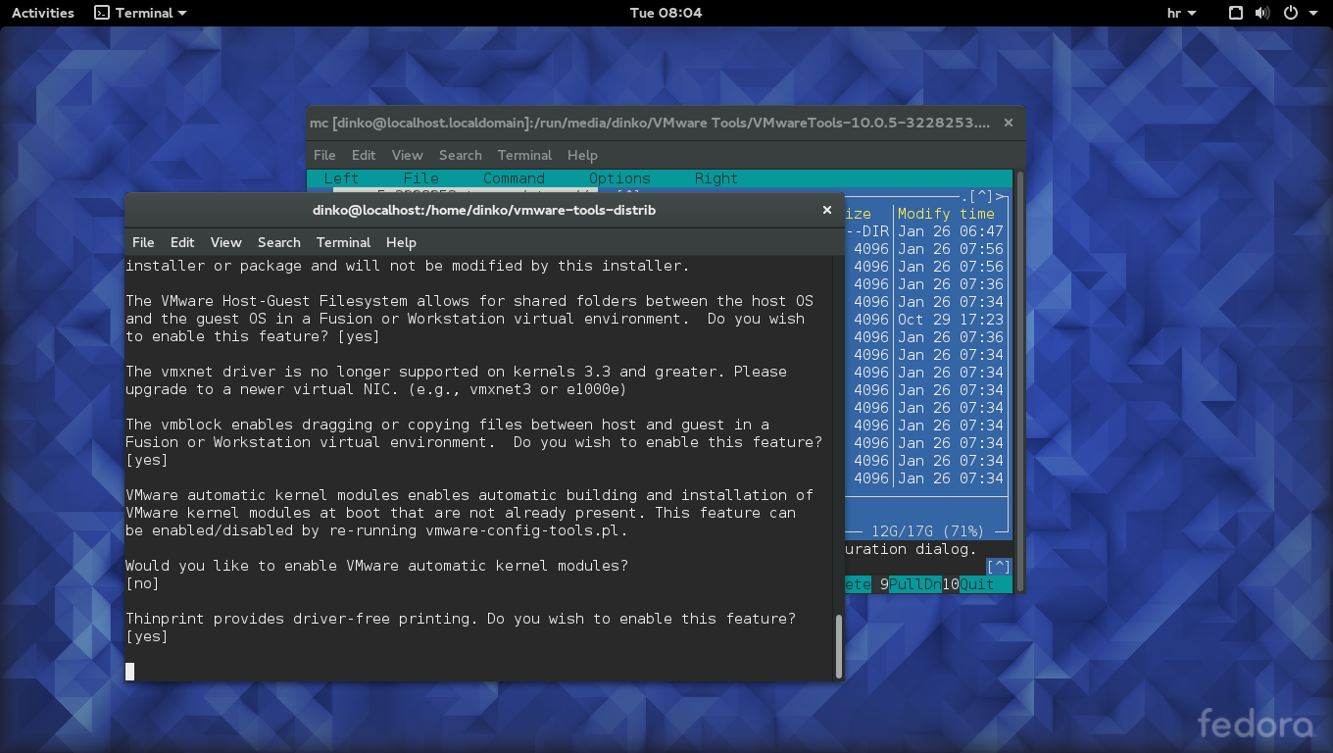

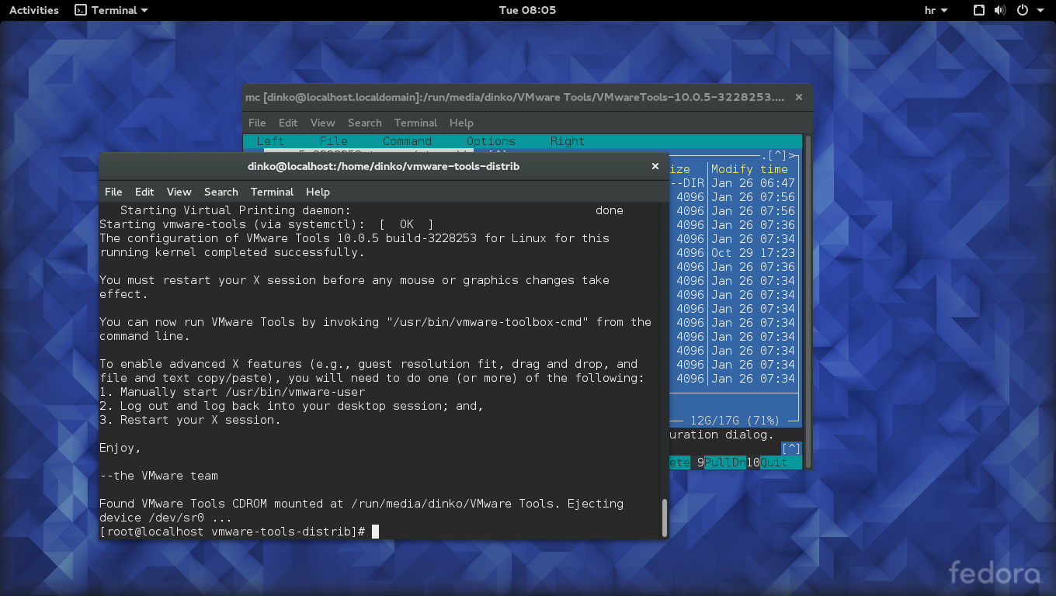
Restart Fedora 23

Now you should have shared directories from host. Open terminal and find /mnt/hgfs/G and /mnt/hgfs/D directory. If you find it then you are ready to install codetyphon. I install CodeTyphon540
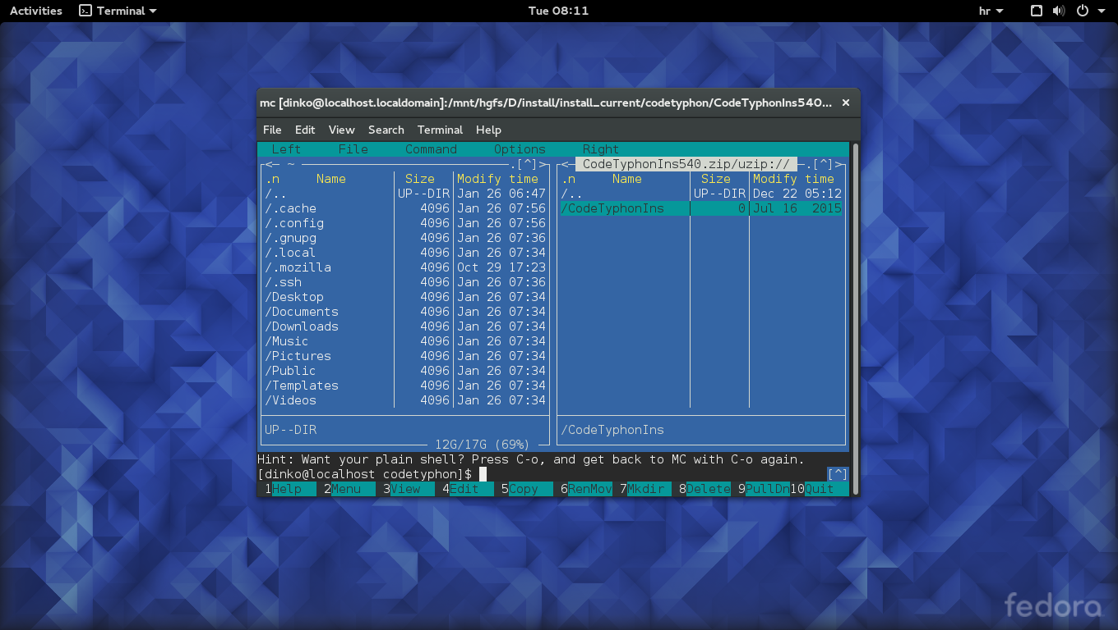

Find you codetyphon installation on host disks and unzip CodeTyphonIns folder in your home directory. Check this link

1)-Copy, Unzip CodeTyphonIns.zip
2)-Install "nano" text editor
su and password
dnf install nano
3)-Give full "sudo" permissions to current user.
su
sudo nano /etc/sudoers
add in the end of /etc/sudoers the line
username ALL=(ALL) NOPASSWD: ALL
and comment out the following line in /etc/sudoers:
#Defaults requiretty – this part I did not found in Fedora 23
4)-Install CodeTyphon
5)-Install "System Libraries" from CT setup script. Option 0
6)-Build ALL (Freepascal and Typhon IDE).
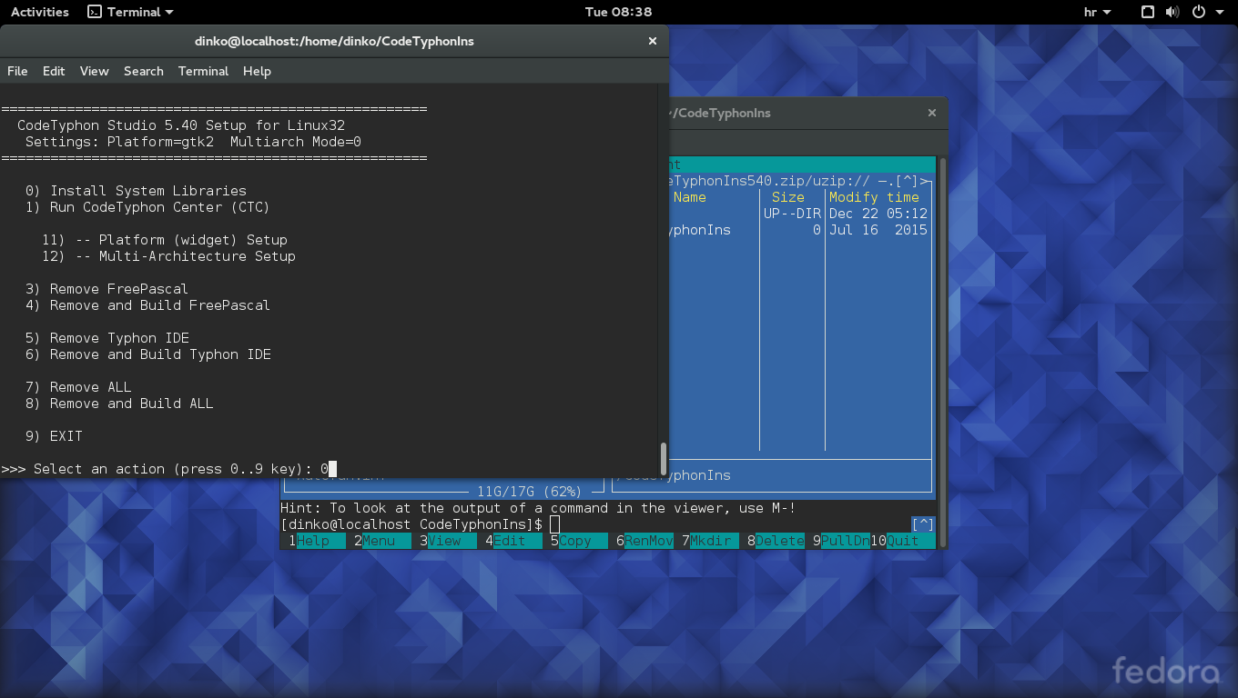

Installation sometimes fail. Check amount of memory you put to virtual machine. My is about 3 GB.

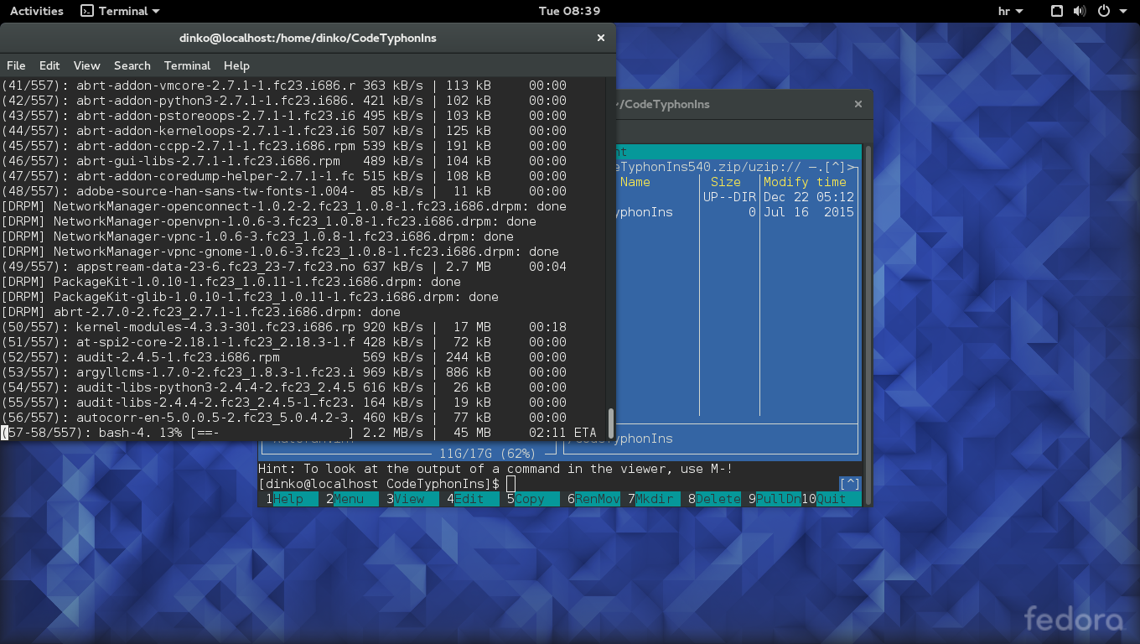

After installation is finished type
dnf install qt4pas-devel-2.5-7.fc23.i686

Do not install dnf install mupdf-devel-1.7a-4.fc23.i686
Do not install dnf install mupdf-1.7a-4.fc23.i686

Duplex Printing of Windows
This was really big problem. I was unable to set duplex printing on windows for 2 days. Now I have solution, but this solution change global DUPLEX print variable on printer driver (and after print it puts it back to original settings). I think that it will be better solution that I installed one driver with SIMPLEX setting and other one with DUPLEX settings, but this is not good solution for me because I have many terminals and I have to go to each and every one and set printers.
Windows solution is in file WinPrinterUtils.pas
Linux duplex printing is not set at all.
Reference:
https://support.microsoft.com/en-us/kb/167345
Also I found some printersettings.zip on lazarus forum.
http://forum.lazarus.freepascal.org/index.php/topic,15444.msg83670.html#msg83670

Setting CodeTyphon for cross compiling

This is easy with CodeTyphon, but it is long process.
Install CodeTyphon for windows as usual. I have 64 bit machine, so afer installation i start CodeTyphon64.
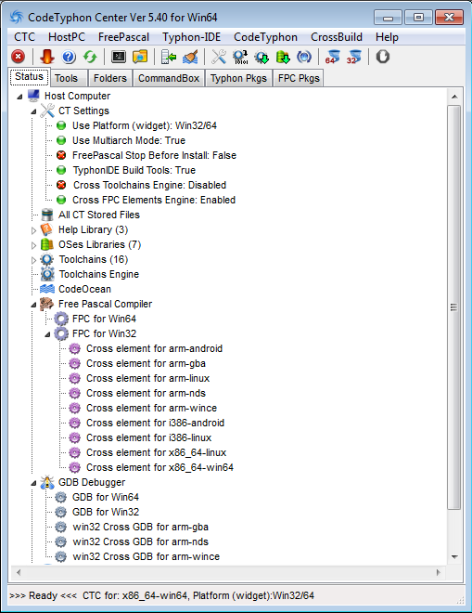
Next step is to setup Typhon32 cross compilers.
Goto Menu/Cross Build/FreePascal 32bits/FPC32 Build Cross Element All and wait for program to finish (1 to 2 hours)

Next is to download neccessery libraries. Goto to Menu/Cross Build/Download Libraries. Then refresh button and choose i386-linux, i386-linuxqt4, x86_64-linux,x86_64-linux-qt4. After program finish you get your libraries in directories under c:\codetyphon\binLibraries\.
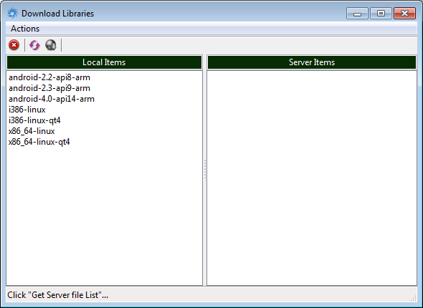
Now we need toolchain. Goto to Menu/Cross Build/Download Toolchains
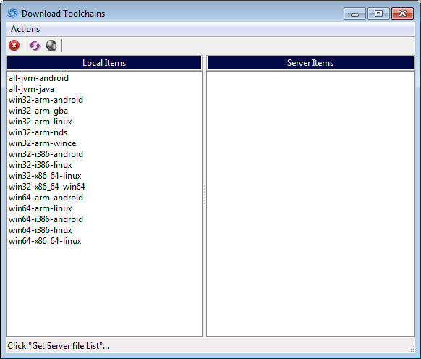
After that you need to build toolchains.Goto to Menu/Cross Build/Toolchain Builder
and choose your build configuration
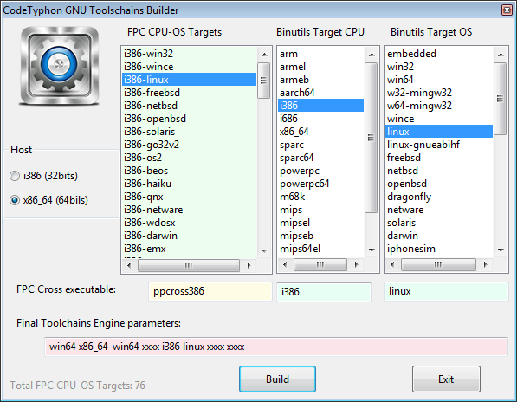
We need "i386-linux and i386 and linux" and "x86_64-linux and x86_64 and linux"
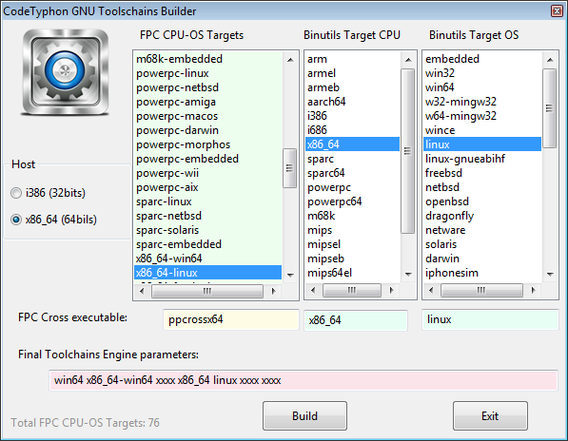
Click to build selected configuration one by one.
That is it. Now you can cross compile project, but for every project you have to create build configuration. Go to Project properties and duplicate default configuration and set operating system, processor type, put location to libraries, add location to mupdf extra libraries, choose widget (for linux is gtk2 or qt4). Check the pictures for linux 32. Turn off deugging to produce smaller executables.
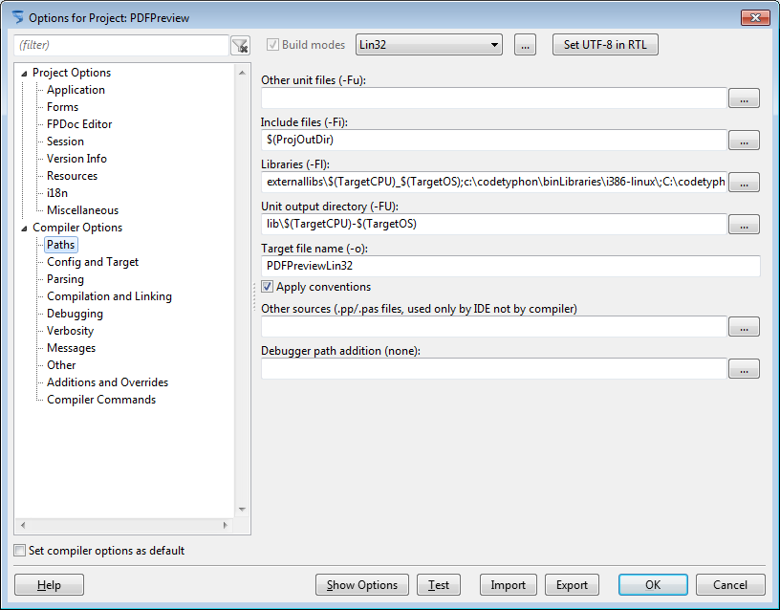
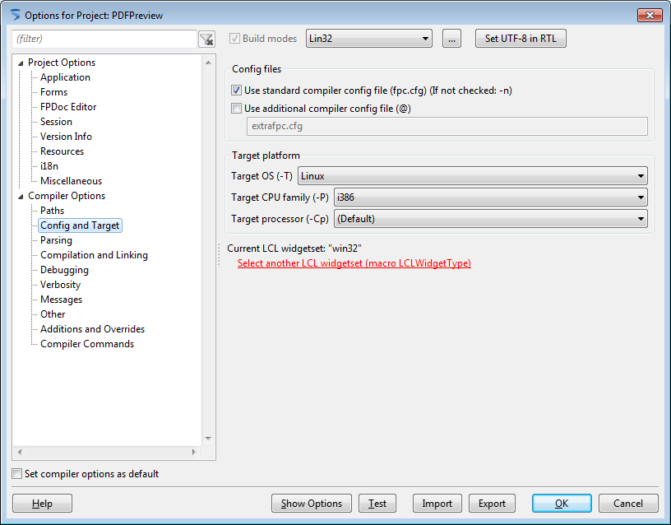
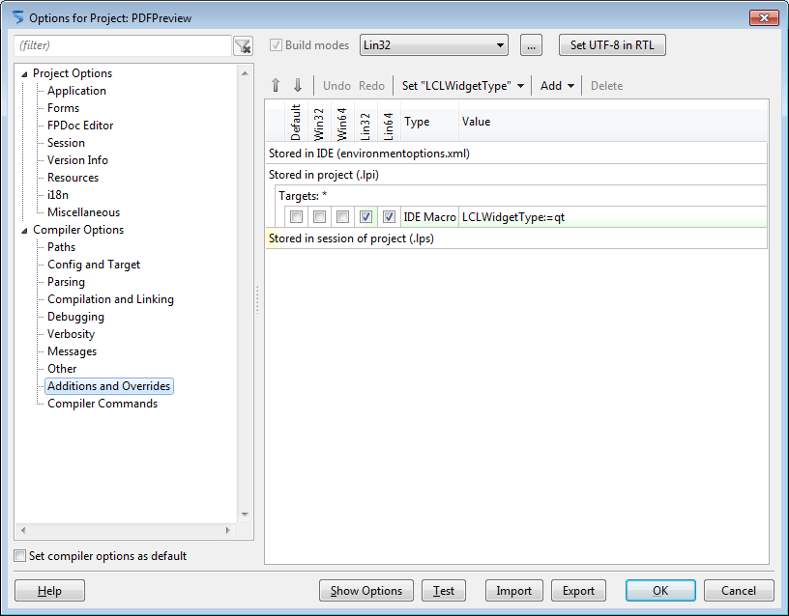
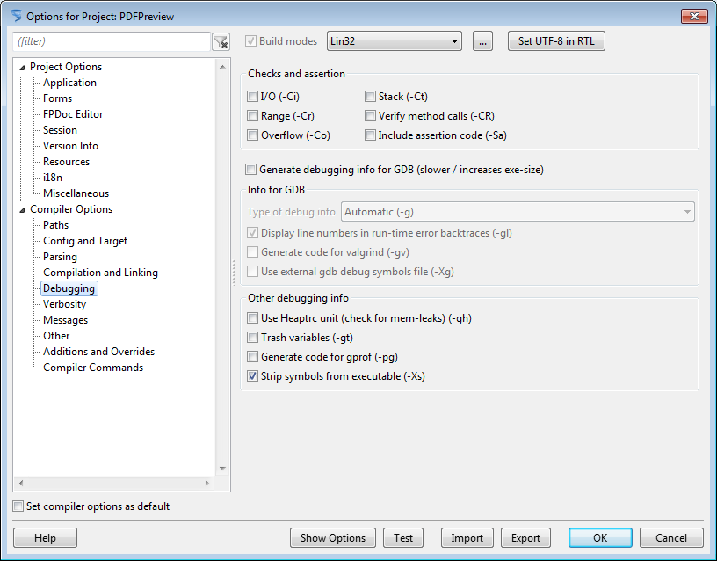
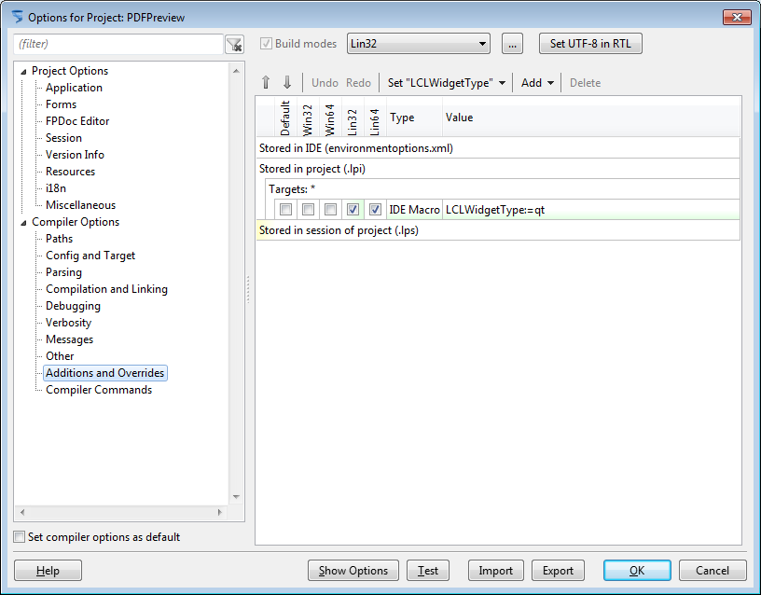
Note linking order is important. So this library path is important
externallibs\$(TargetCPU)_$(TargetOS);c:\codetyphon\binLibraries\i386-linux\;C:\codetyphon\binLibraries\i386-linux-qt4\
Also compiler comands like
{$linklib m}, {$linklib libcurl.a} and {$L g:\dev\mupdf\PDFPreview/externallibs/i386_linux/libgcc_s-5.3.1-20151207.so.1}
have different meaning.
Meanings:
{$linklib m} means libm standard linux library
{$linklib libcurl.a} means find library in libcurl.a in current library path (externallibs\$(TargetCPU)_$(TargetOS) defined by library path in Path options or Project Properties
{$L g:\dev\mupdf\PDFPreview/externallibs/i386_linux/libgcc_s-5.3.1-20151207.so.1} means that compiler must link static library function from exact path location.
Good refrence for linking is this url:
http://www.math.uni-leipzig.de/pool/tuts/FreePascal/prog/node6.html

About

Author: Dinko Miljak
email: dinmil@gmail.com
Verison: 0.0.0.1
Date: 2016-01-22

