SIMATS ENGINEERING
Department of Computer Science and Engineering
COURSE NAME: | Cloud Computing and Big Data Analytics – Model Practical Examination | COURSE CODE: | CSA1522

Name | Dinnepati Sindhu Prasad
Register Number | 192311271

MODEL PRACTICAL EXAMINATION – SET 2
Answer all questions. Each question carries equal marks (20). Total marks: 100
1. Create a simple cloud software application for Car Booking Reservation System using any Cloud Service Provider to demonstrate SaaS. Include the necessary fields such as Search for Cabs, From, To, Rental, Out Station, Package Type, Hours/Days, etc.
2. Create a simple cloud software application for Hospital Information System for SIMATS Hospital using any Cloud Service Provider to demonstrate SaaS. Include the fields of Patient Name, Age, Address, Phone, Email, Attender Name, Attender Phone, Doctor Name, Diseases, etc.
3. Change the hardware compatibility of a VM (either by clone/create a new one) which is already created and configured, and run simple UNIX commands.
4. Create a Virtual Machine with 1 CPU, 2GB RAM and 15GB storage disk using a Type 2 Virtualization Software.

- Create a simple cloud software application for Car Booking Reservation System using any Cloud Service Provider to demonstrate SaaS. Include the necessary fields such as Search for Cabs, From, To, Rental, Out Station, Package Type, Hours/Days, etc.

AIM:
To create a simple cloud software application for Car Booking Reservation System using any Cloud Service Provider to demonstrate SaaS.

PROCEDURE:
STEP 1: Log into zoho.com.
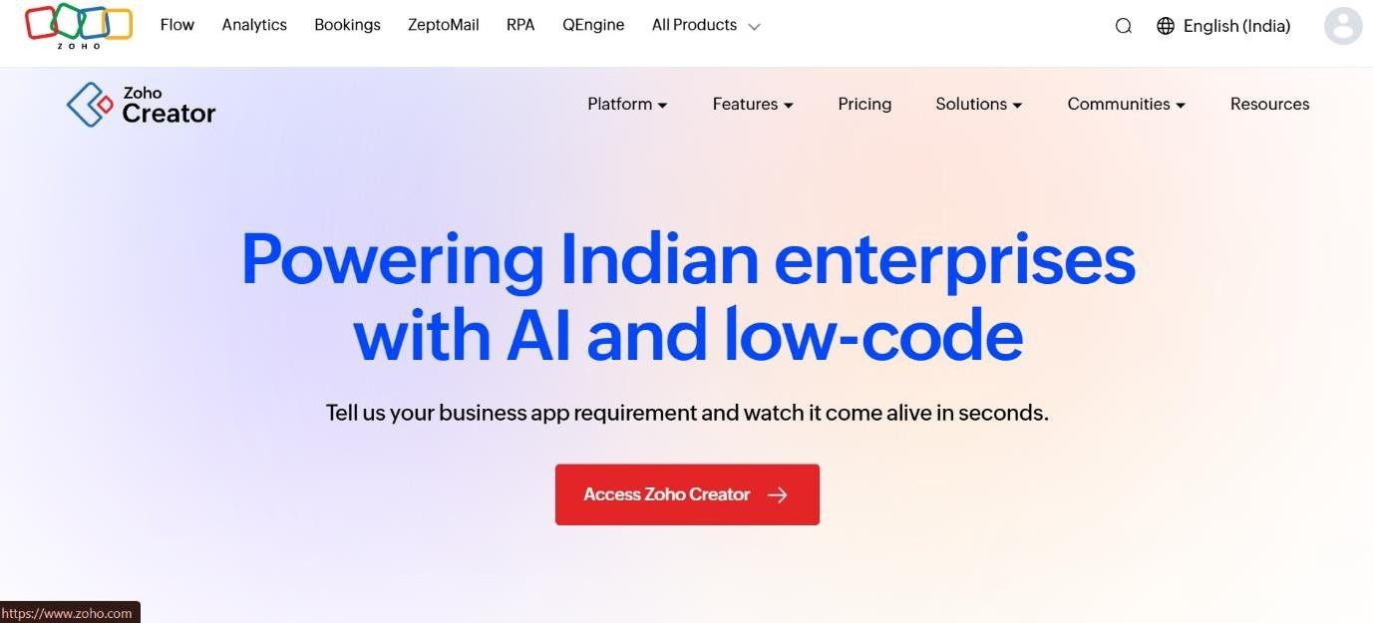
STEP 2: Create a new application from scratch in Zoho Creator.
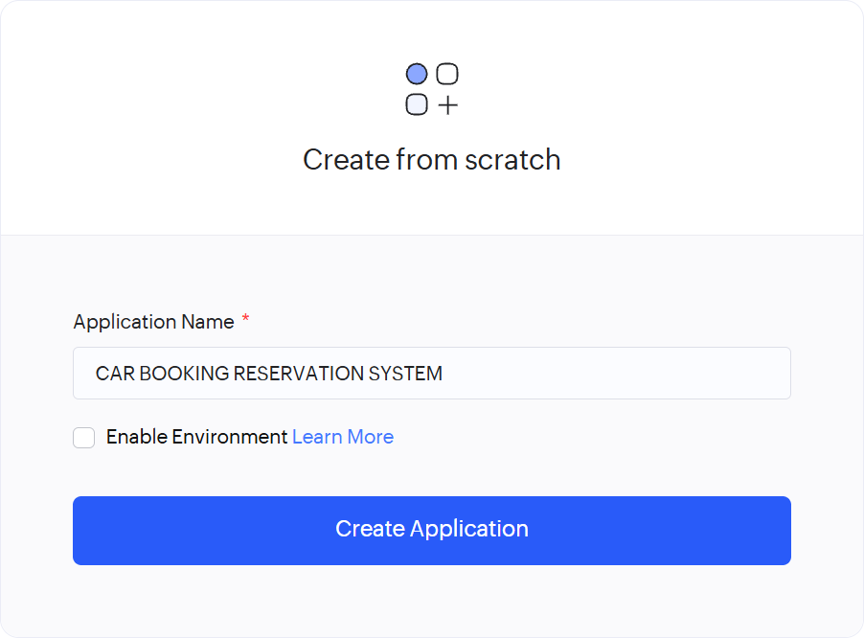

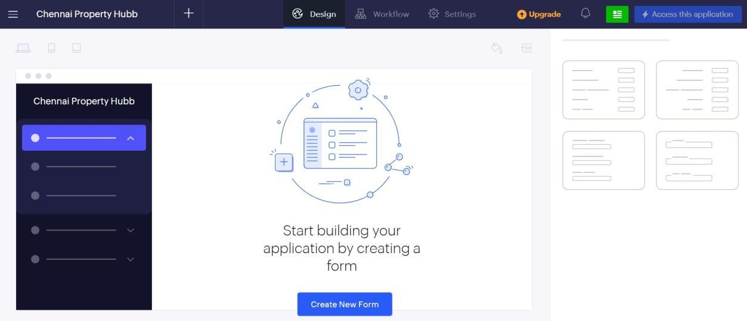

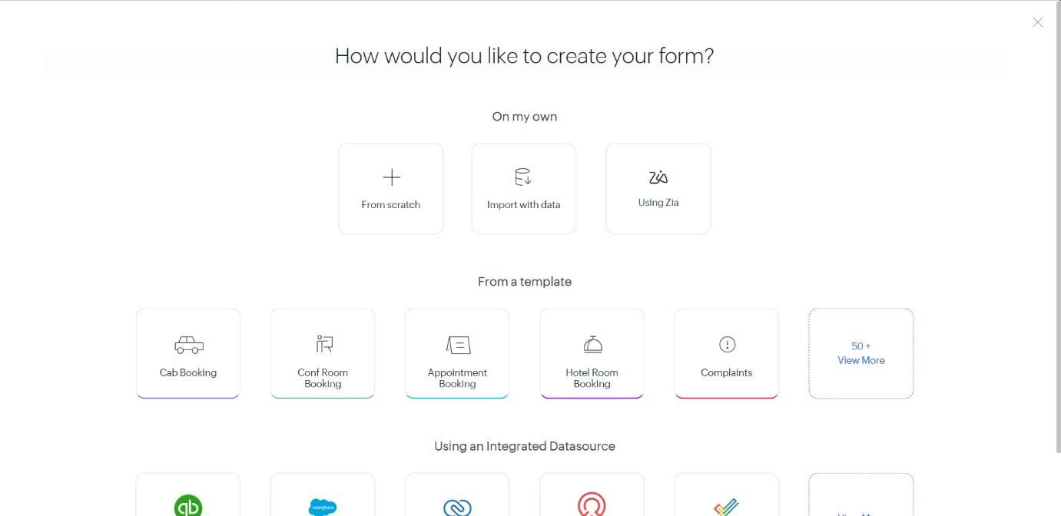
STEP 4: Create cars form
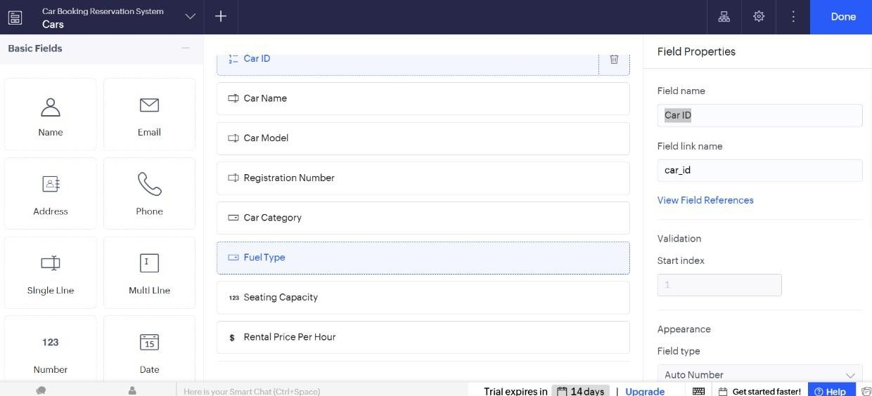

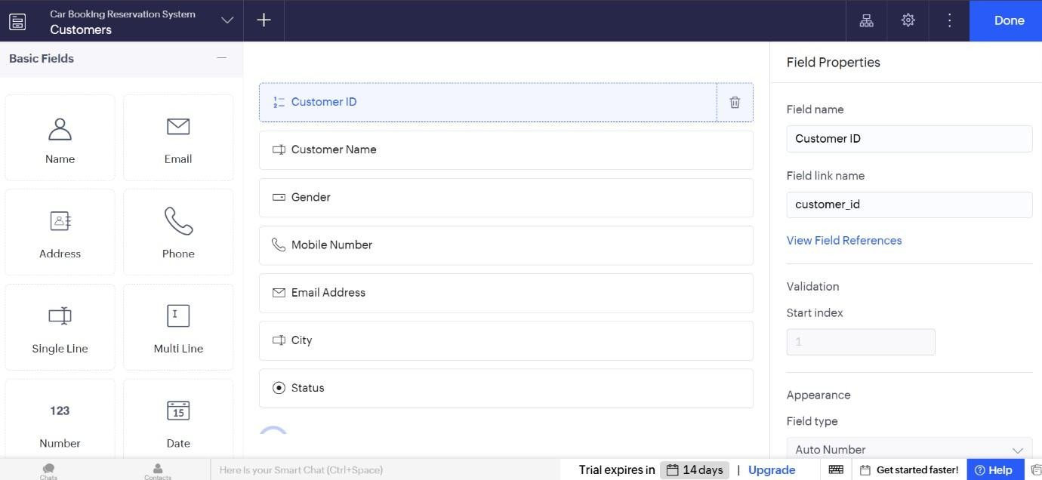
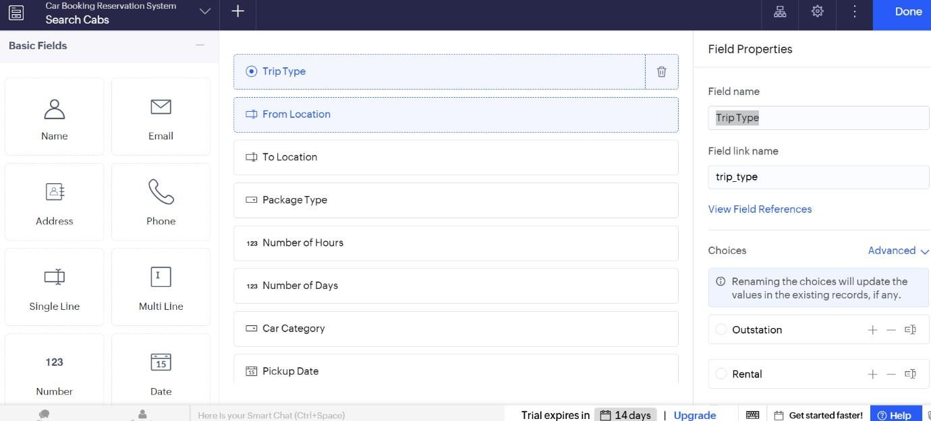
STEP 6: Create Bookings form
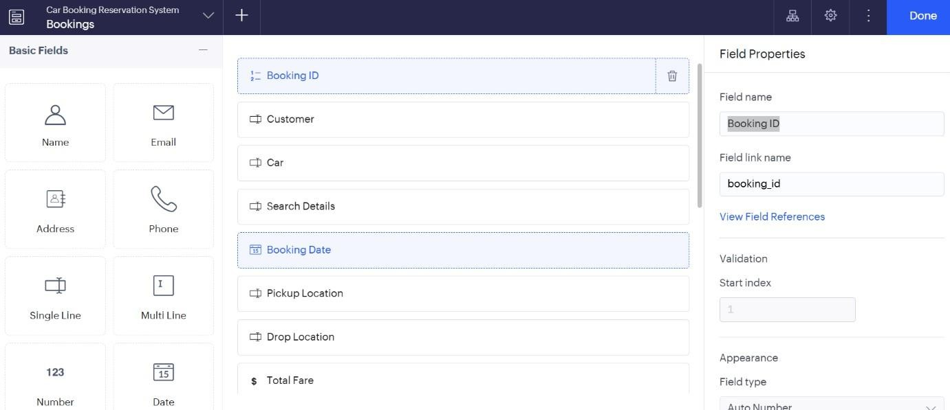
STEP 7: Create Search Cabs forms

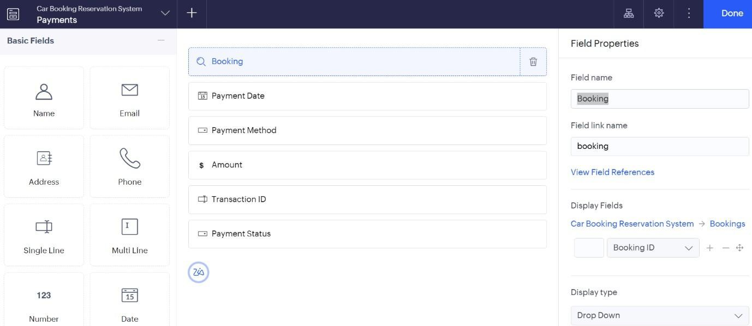
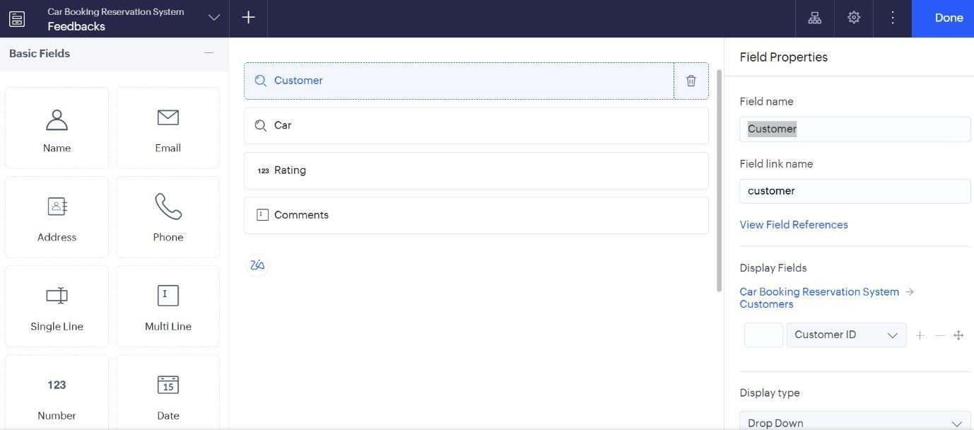
STEP 9: Create Feedback Form

STEP 10: Add sample data to all the created forms.
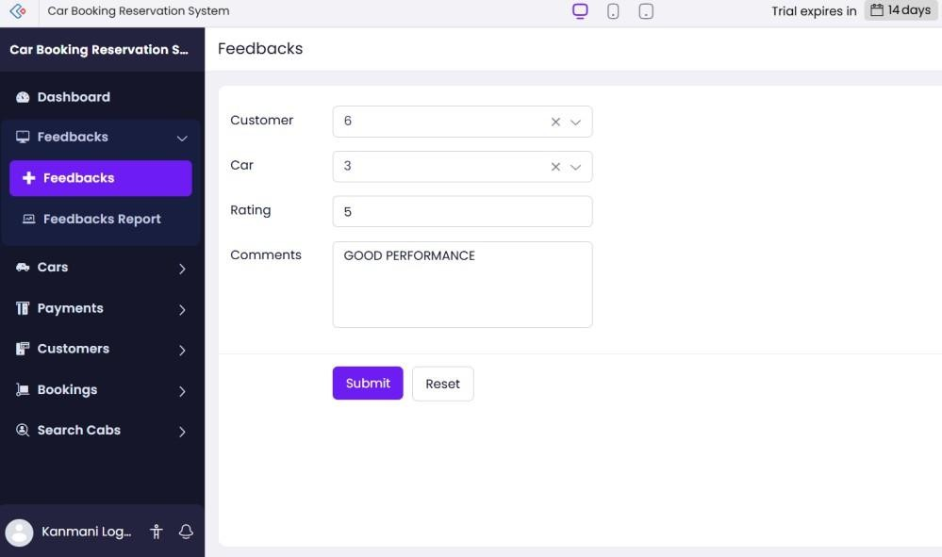

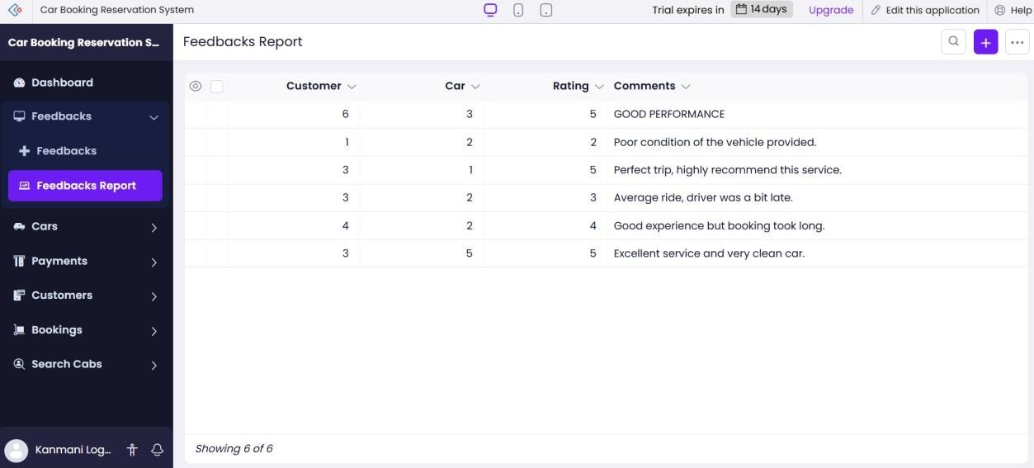
STEP 12: Create and display the Dashboard with cab bookings, rental bookings, outstation trips, package bookings, and other important information.
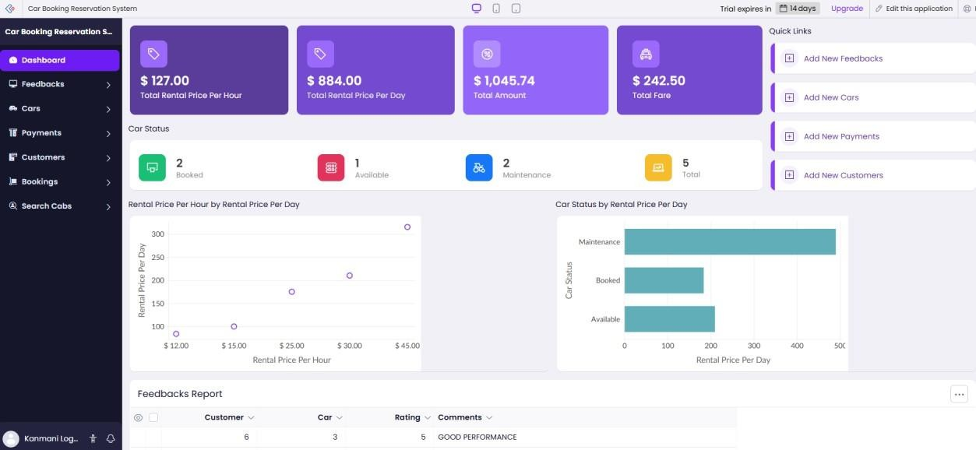

https://creatorapp.zohopublic.in/dinnepatiprasad56/simats-hospital-cloud-information-system/page-perma/DashBoard/4npHdgOO1RTP8h4UjPjbsGRymbArpZVdh3BXpSZWesX8GePJOCbFJjNjqp2Rn62U9K1weMJMf4vfRGZQfe79mVzfSJJ59JCNSkD8
2. Create a simple cloud software application for Hospital Information System for SIMATS Hospital using any Cloud Service Provider to demonstrate SaaS. Include the fields of Patient Name, Age, Address, Phone, Email, Attender Name, Attender Phone, Doctor Name, Diseases, etc

AIM:
To create a simple cloud software application for Hospital Information System for SIMATS Hospital using any Cloud Service Provider to demonstrate SaaS.

PROCEDURE:
STEP 1: Log into zoho.com.

STEP 2: Create a new application from scratch in Zoho Creator.
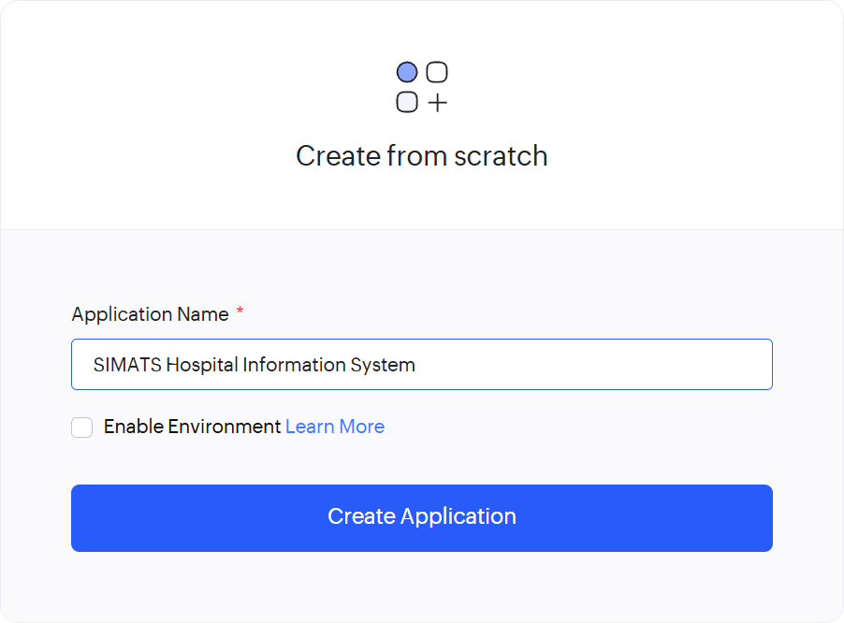

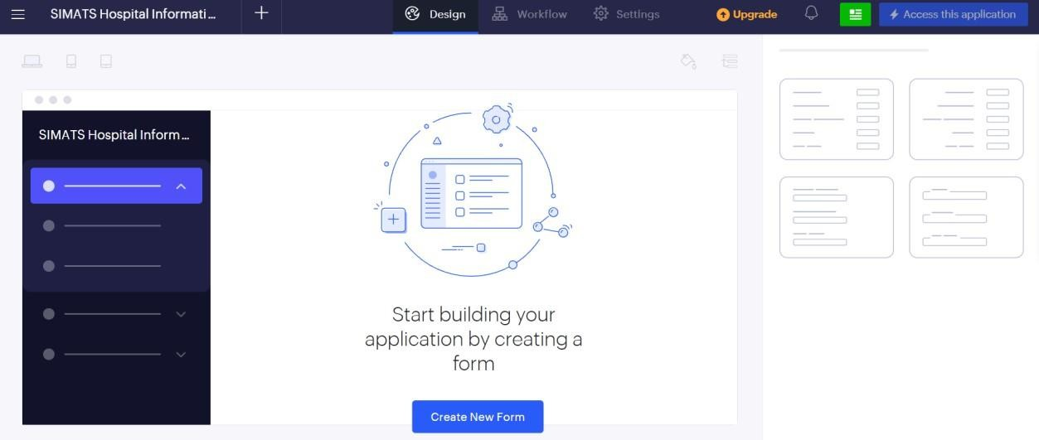


STEP 4: Create Patient Details Form.
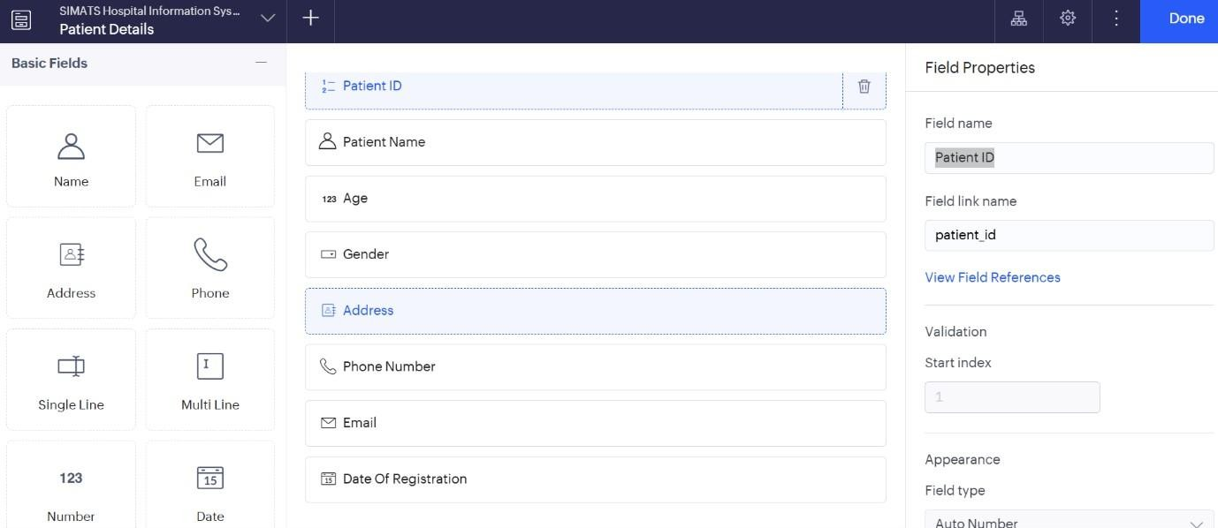
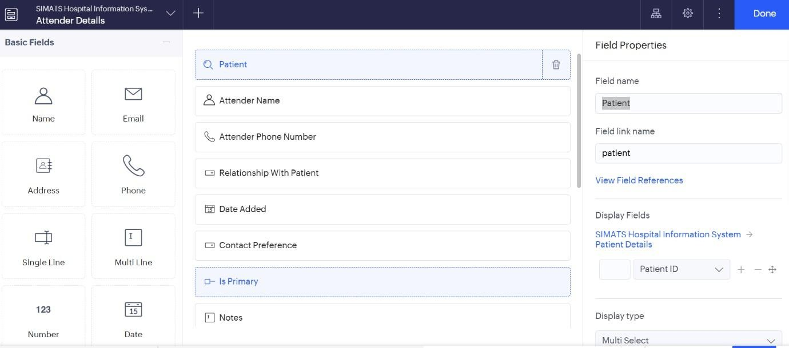
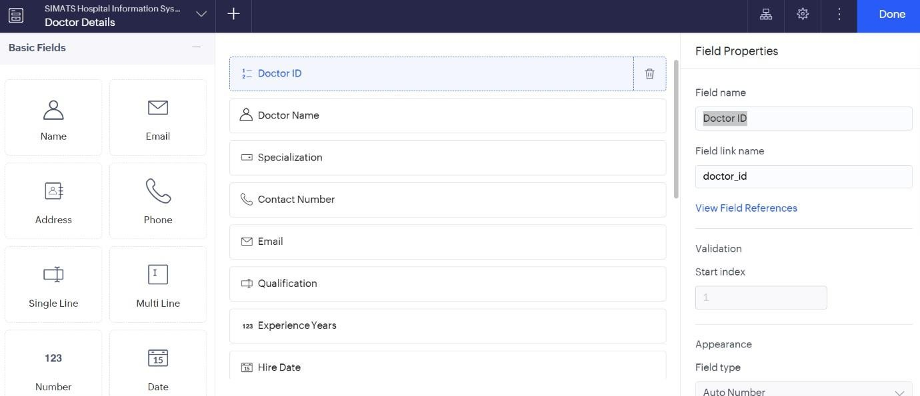
STEP 6: Create Doctor Details Form
.
STEP 7: Create Appointment Details Form.
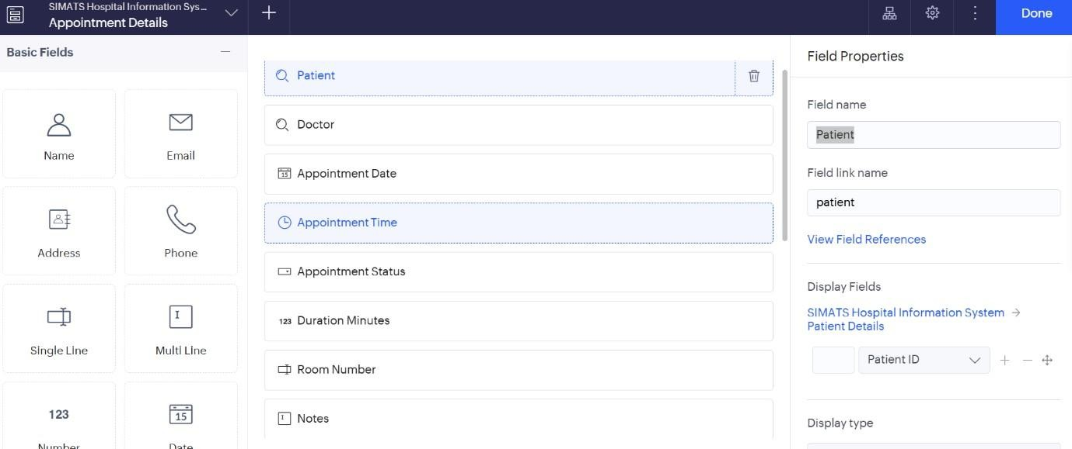

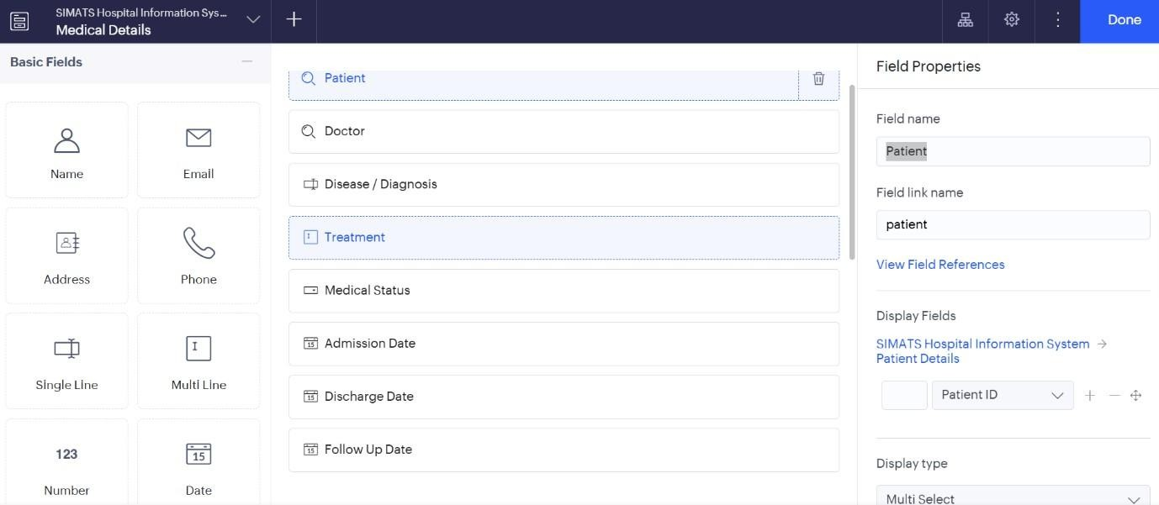
STEP 9: Add sample data to all the created forms.
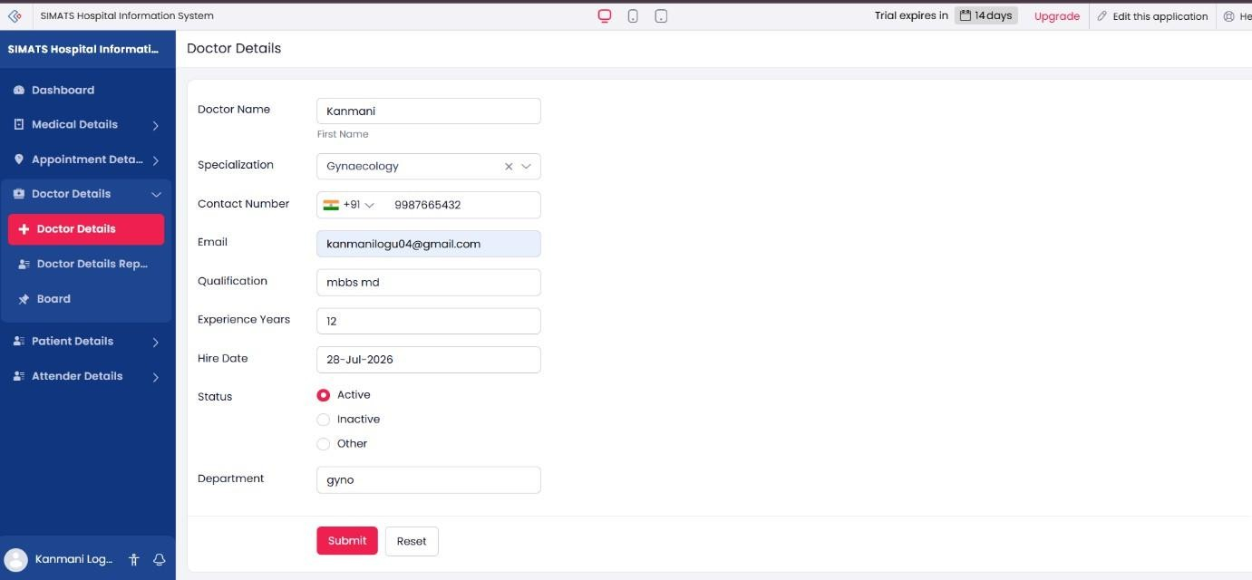
STEP 10: Create reports to display the data entered in the respective forms.
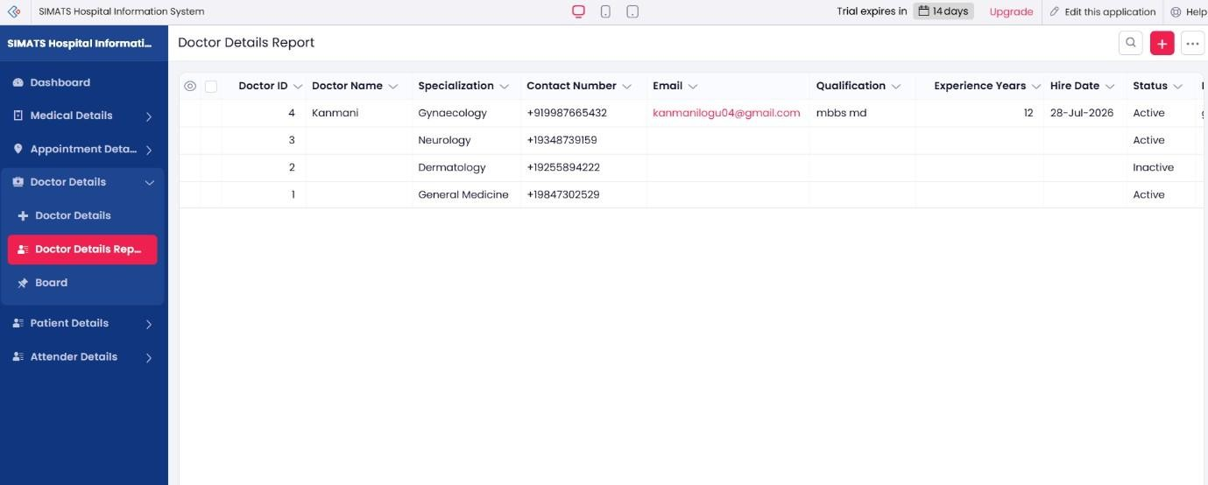

Step 11: create and display the dashboard withbthe patient detailsappointments, medical
records, and other important hospital information.

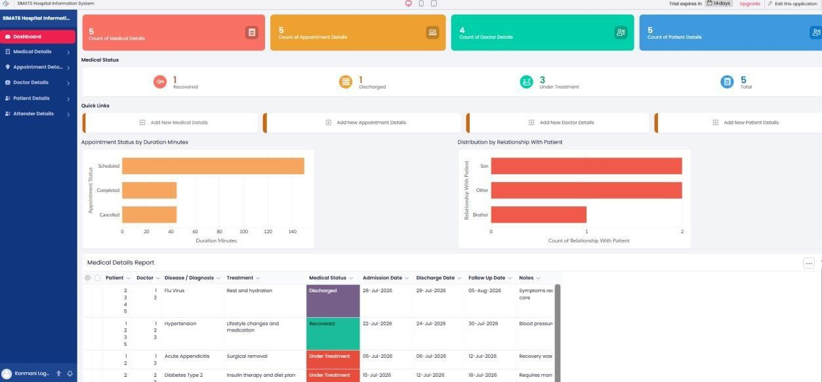

https://creatorapp.zohopublic.in/dinnepatiprasad56/cloud-cab-booking-reservation-system/page-perma/DashBoard/TBCQ81twTtjPyZKPM3y3DzCu4EQq1uj0kbZhJVzxGXn6PhPpYKxuKfTuzJjZPAa9fMVVTGPnXCM6NGmGSmj9PfWfEHsWFBNt8YG2

3. Change the hardware compatibility of a VM (either by clone/create a new one) which is already created and configured, and run simple UNIX commands.
Sol)

AIM:
To Change Hardware compatibility of a VM (Either by clone/create new one) which is already created and configured.

PROCEDURE:
Step 1:Goto Vm Ware Workstation.
Step2: Right Click The Vm And Goto The Settings.
Step 3: Add Hardware Wizard And Select Scsi And Click Next.
Step 4: Create New Virtual Disk.
Step 5: Selct The Disk Size As 2.0. And Selct Split Virtual Disk Intomultifiles.
Step 6: Give Name And Click The Finish.

IMPLEMENTATION:

STEP 1:GOTO VM WARE WORKSTATION
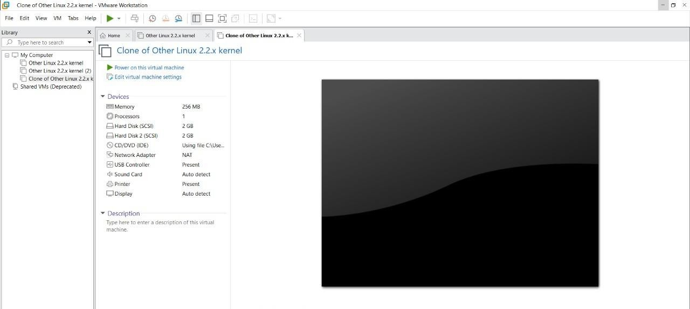

STEP2: RIGHT CLICK THE VM AND GOTO THE SETTINGS
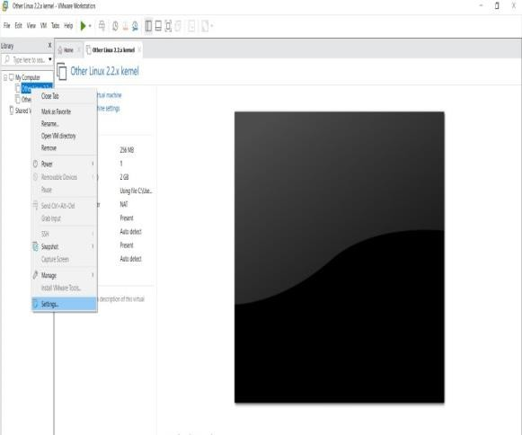

STEP 3: ADD HARDWARE WIZARD AND SELECT SCSI AND CLICK NEXT
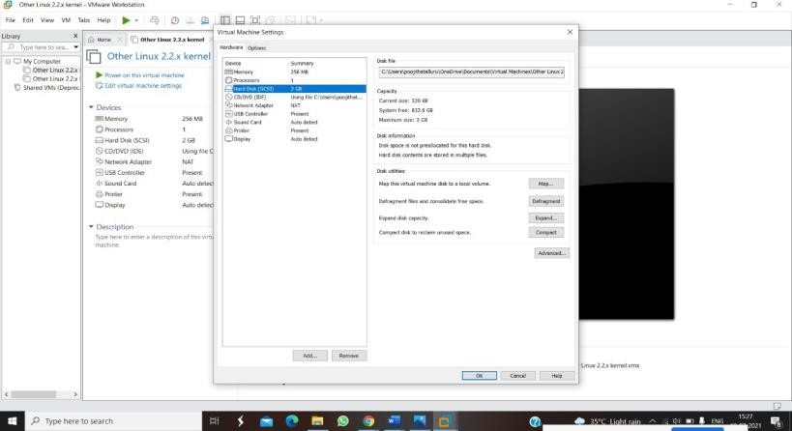

STEP 4: CREATE NEW VIRTUAL DISK
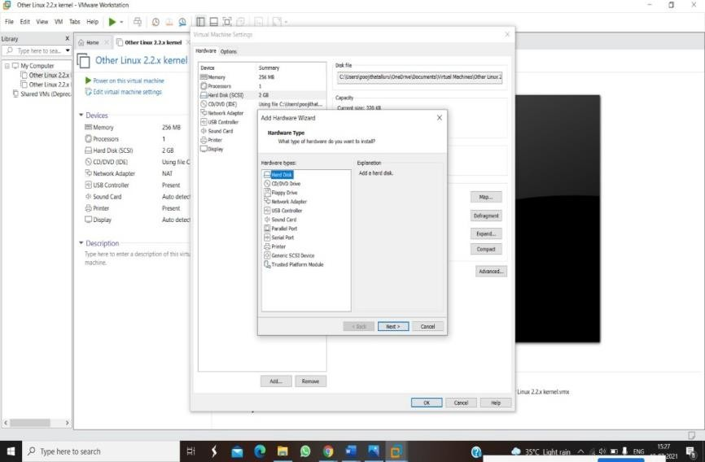

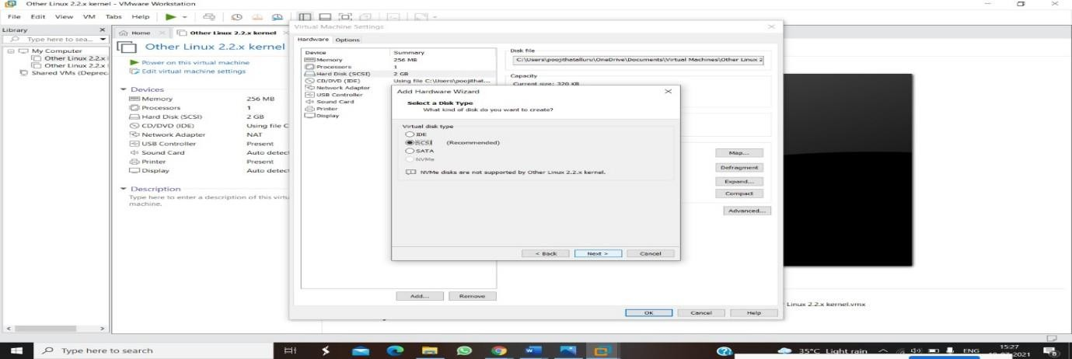

STEP 5: SELCT THE DISK SIZE AS 2.0. AND SELCT SPLIT VIRTUAL DISK INTOMULTIFILES.
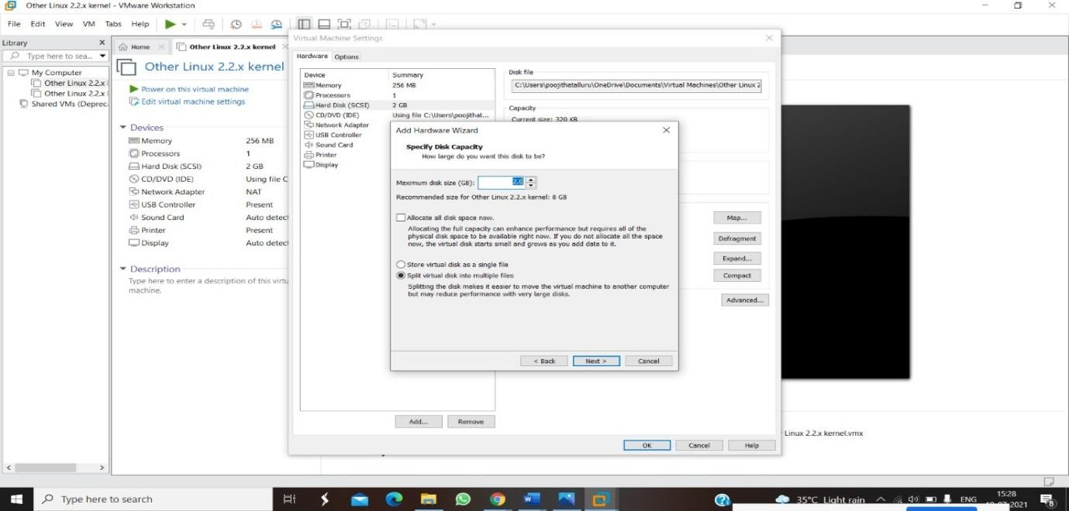

STEP 6: GIVE NAME AND CLICK THE FINISH
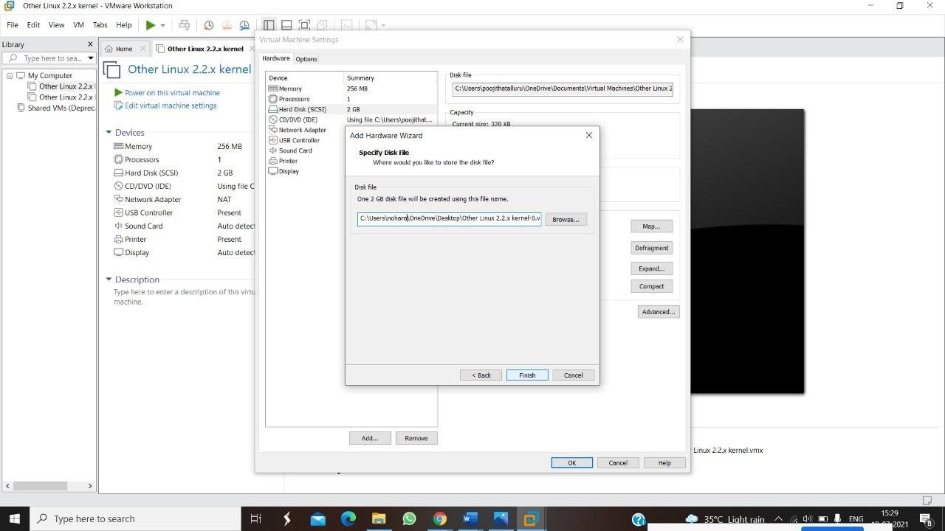

4)Create a Virtual Machine with 1 CPU, 2GB RAM and 15GB storage disk using a Type 2 Virtualization Software.

AIM:
To create a virtual machine with 1 cpu, 2gb ram and 15gbstorage disk using a type 2 virtualization software.
PROCEDURE:
STEP 1:Dowload VMware workstation and installed as type 2hypervisor.
STEP2:Dowload ubuntu or tiny OS as iso image file.
STEP 3: In VMware workstation->create new VM.
STEP 4: Do the basic configuration settings.
STEP 5: Created tiny OS virtual machine.
STEP 6: Launch the VM. IMPLEMENTATION:

STEP 1:DOWLOAD VMWARE WORKSTATION AND INSTALLED AS TYPE 2HYPERVISOR
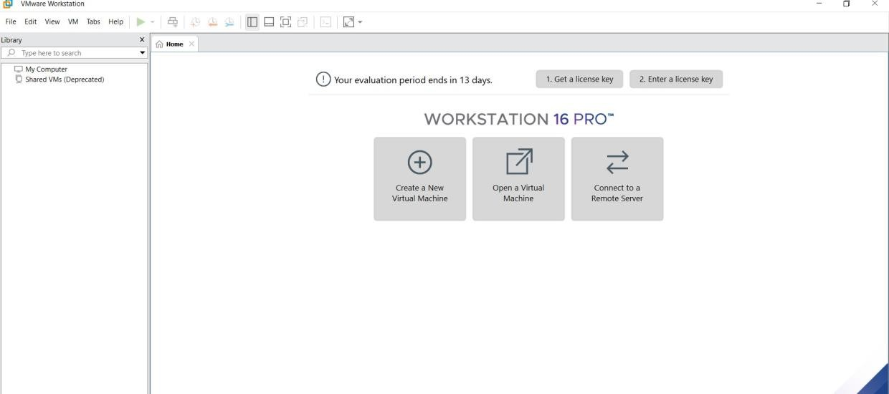

STEP 3: IN VMWARE WORKSTATION->CREATE NEW VM


STEP 4: DO THE BASIC CONFIGURATION SETTINGS.
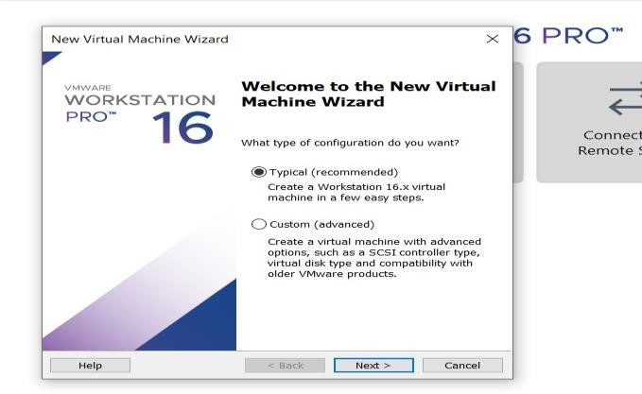

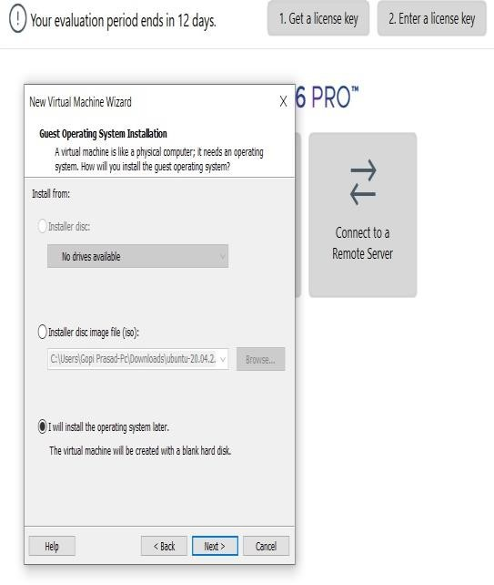
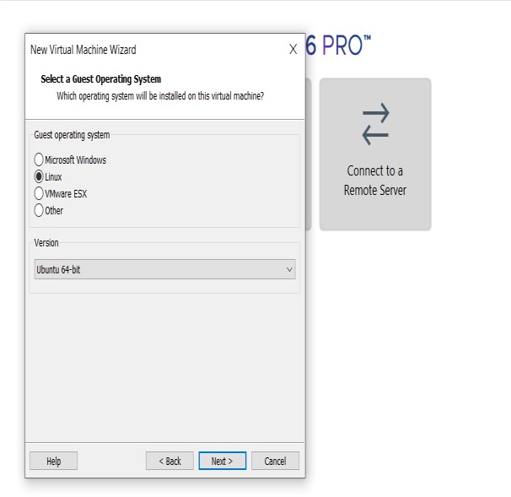
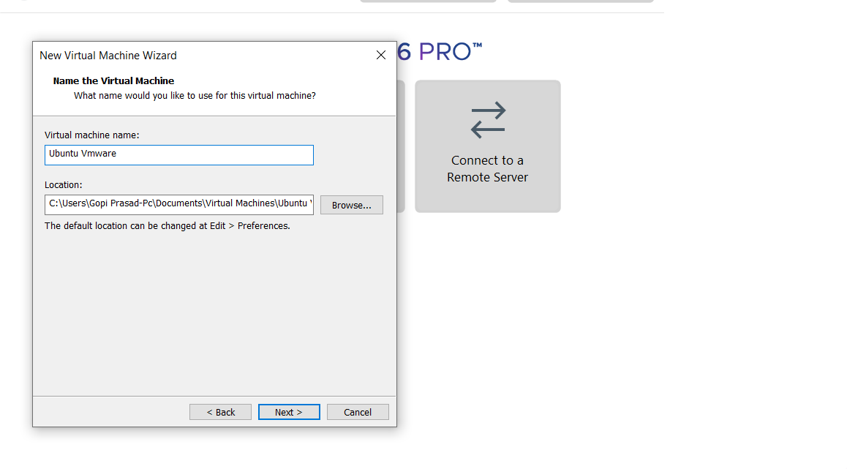

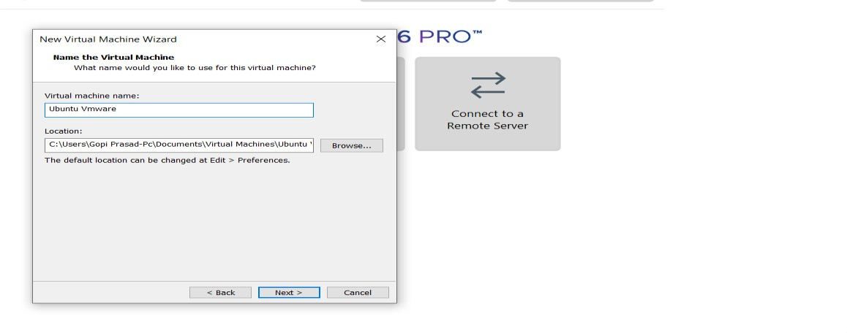
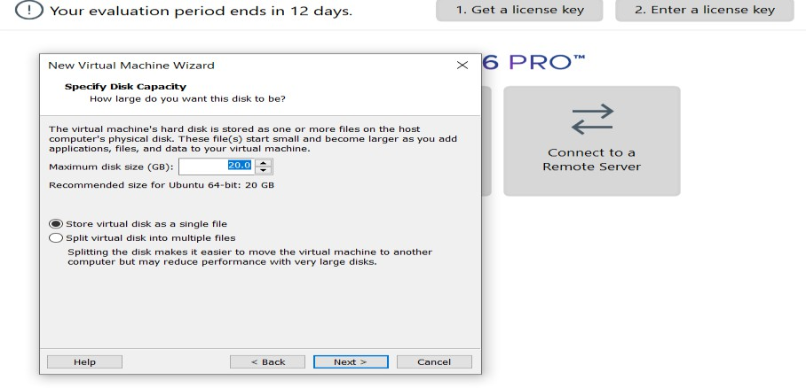
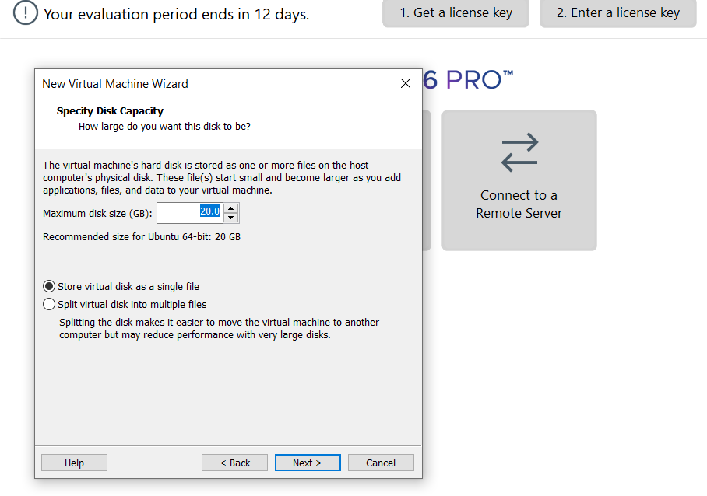

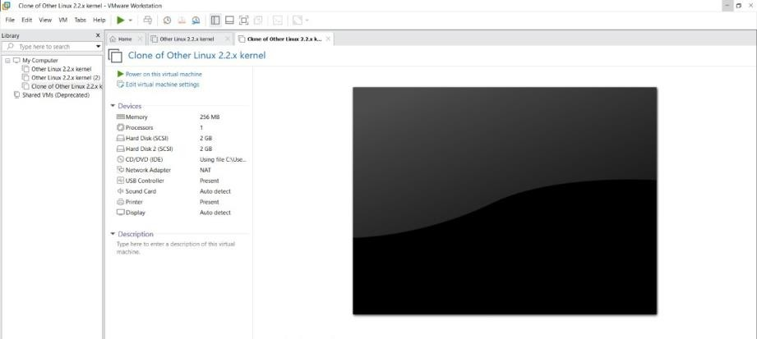
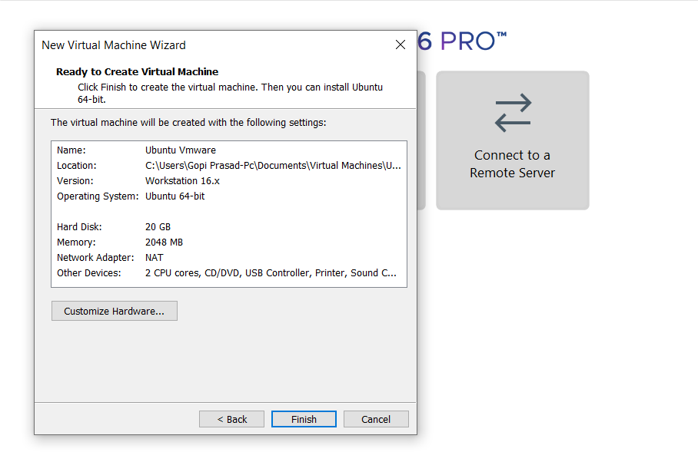

STEP 5: CREATED TINYOS VIRTUAL MACHINE

