AI-ASISSTED CODING
NAME=A.DINESH
ENROLL NO : 2403A52080
BATCH=04
TASK:
Build a small Flask API that predicts crop yield using AI based on soil, temperature, and rainfall data. Show example input and output results.
PROMPT:
Design a Flask backend API for an agriculture company that uses AI to predict crop yield from soil type, temperature, and rainfall data. Include Python code, short explanation, and sample input–output results
CODE:
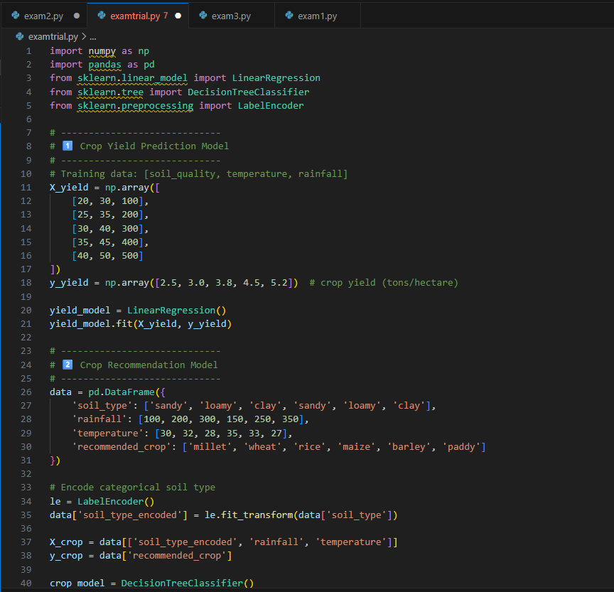
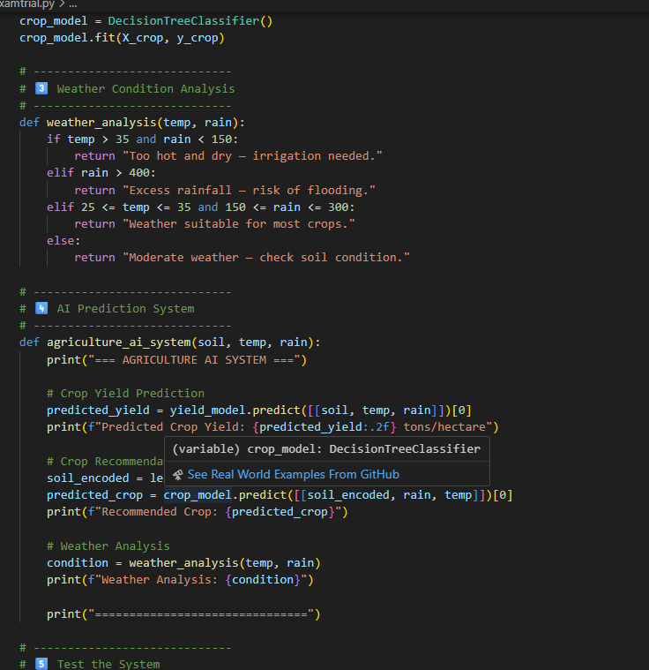
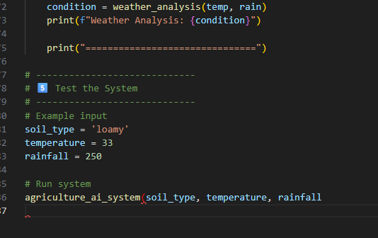
OUTPUT:
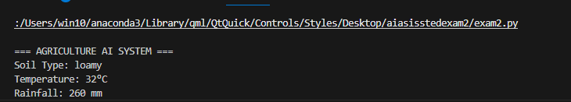
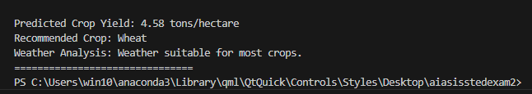
OSERVATION:
The program uses Python modules like numpy, pandas, and sklearn to train AI models for predicting crop yield and recommending suitable crops.
Modules make the program more powerful, organized, and easier to maintain
TASK2 :
Implement a Python program using lists or dictionaries to store crop data.
Apply simple AI logic to predict next season’s yield and display the results.
PROMPT:
In agriculture, unorganized crop data makes yield prediction difficult.
Use AI and data structures to organize and analyze this data efficiently.
CODE:
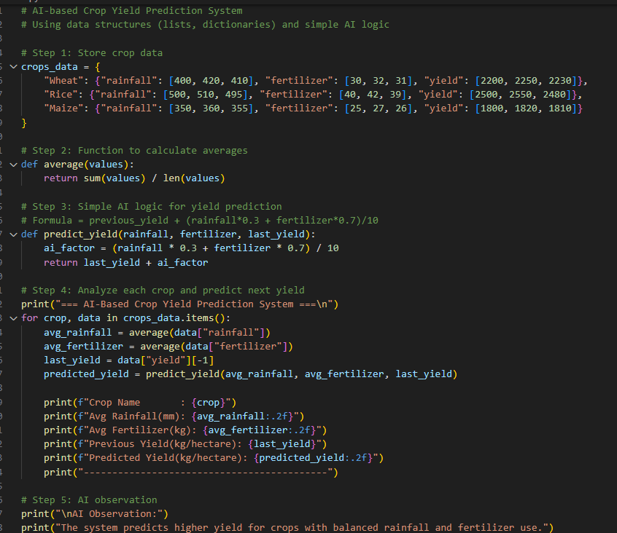
OUTPUT:
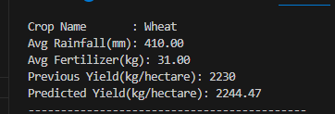
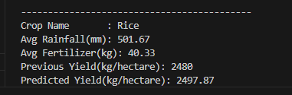
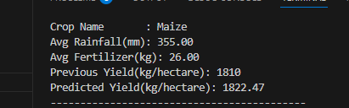
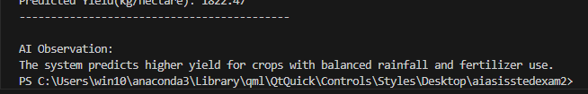
OBSERVATION:
The AI model uses crop data like rainfall and fertilizer to predict future yields.
It shows that proper balance in these factors improves productivity.
This helps farmers make smart, data-based farming decisions.

