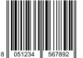 |  |  | 
8051234567890 | 8051234567891 | 8051234567892 | 8051234567893
ART0001 | ART0001 | ART0002 | ART0002

