Answers
Q1:
1.1 Identification of Major Operational Systems
ABC Hub operates several interconnected operational systems to manage its digital streaming services and physical media rental services. These systems generate large amounts of transactional data through daily business activities.
The major operational systems are identified below.
No. | Operational System | Main Responsibilities | Data Generated
1 | Customer Management System | Manages customer registration, login, profiles and account details. | Customer ID, name, email, address, registration date, account status.
2 | Content Management System | Manages digital and physical content, including movies, books, music and games. | Content ID, title, category, genre, release date, content type.
3 | Subscription Management System | Handles streaming plans, subscriptions, renewals and cancellations. | Subscription ID, customer ID, plan type, start date, end date, subscription status.
4 | Rental Management System | Manages physical item rentals, rental periods and returns. | Rental ID, customer ID, item ID, rental date, return date, rental status.
5 | Inventory Management System | Tracks the availability and quantity of physical items. | Item ID, stock quantity, availability, item condition, inventory location.
6 | Payment Processing System | Processes payments for subscriptions, rentals and other services. | Transaction ID, customer ID, payment amount, payment method, payment status.
7 | Delivery Management System | Manages the delivery and collection of rented physical items. | Delivery ID, rental ID, delivery address, dispatch date, delivery status.
8 | Customer Support System | Handles customer complaints, inquiries and service-related issues. | Ticket ID, customer ID, issue category, complaint date, resolution status.

1.2 How Operational Systems Interact
These operational systems interact with one another to support ABC Hub's business operations.
For example, when a customer rents a physical movie:
- The Customer Management System verifies the customer's account.
- The Content Management System provides information about the selected movie.
- The Inventory Management System checks whether the physical movie is available.
- The Rental Management System creates a rental transaction.
- The Payment Processing System processes the rental payment.
- The Delivery Management System arranges delivery to the customer's address.
- The Customer Support System handles any issues related to the rental or delivery.
Similarly, when a customer subscribes to a streaming plan, the Subscription Management System communicates with the Customer Management System and Payment Processing System to activate the subscription.
1.3 High-Level Operational Systems Architecture Diagram
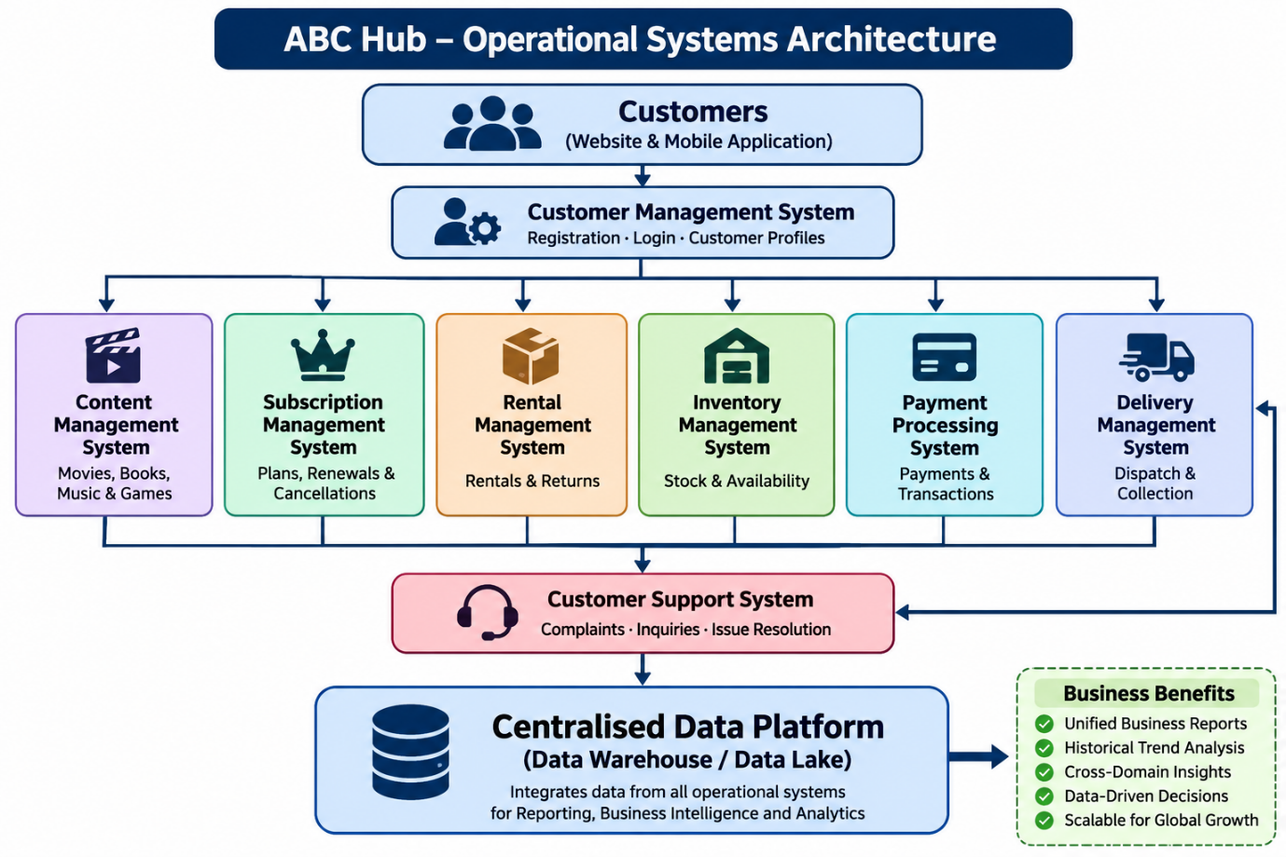

1.4 Importance of Operational Systems for Data Engineering
Each operational system generates different types of business data. However, analysing data separately from these systems creates challenges such as inconsistent reports, delayed reporting and difficulties in understanding overall customer behaviour.
Therefore, ABC Hub needs to integrate data from all eight operational systems into a centralised data platform.
This integration will provide the following benefits:
- Centralised reporting: Combines data from different departments into a single source of truth.
- Historical analysis: Stores historical data to identify business trends over time.
- Customer behaviour analysis: Combines streaming activities, subscriptions and physical rental activities to understand customer preferences.
- Improved decision-making: Enables management to make data-driven business decisions.
- Scalability: Supports increasing customers and data volumes as ABC Hub expands internationally.
Conclusion: The eight operational systems are essential for ABC Hub's daily business activities. Integrating their data through a modern data engineering platform will help overcome existing reporting challenges and support future business growth.
2.1 Analysis of Existing Business Challenges
ABC Hub currently operates multiple independent operational systems. Although these systems support daily business transactions, they create several challenges when management needs to analyse business performance.
Identified challenge | Analysis | Recommended solution
Slow report preparation | Data is distributed across multiple operational systems, requiring manual extraction and processing. | Implement automated ETL/ELT pipelines.
Inconsistent business figures | Different departments may use different definitions, calculations and data sources. | Establish a centralised Data Warehouse with standardised business definitions.
Difficult historical analysis | Operational databases mainly focus on current transactions rather than long-term analytical requirements. | Maintain historical data using a Data Warehouse and Slowly Changing Dimensions.
Cannot analyse customer behaviour together | Streaming and physical rental information are stored in separate systems. | Integrate both datasets using common customer and content dimensions.
Heavy dependency on IT teams | Business users lack direct access to integrated analytical datasets. | Develop subject-oriented Data Marts and self-service BI dashboards.

2.2 Recommended Solution – Modern Data Warehouse Architecture
The proposed solution is to implement a centralized Data Warehouse using an automated ETL/ELT pipeline.
The architecture consists of the following layers:
1. Data Sources Layer
Collect data from the eight operational systems identified in Question 1.
Examples:
- Customer Management
- Content Management
- Subscription Management
- Rental Management
- Inventory Management
- Payment Processing
- Delivery Management
- Customer Support
Data can be extracted using APIs, database connectors, scheduled batch processing or Change Data Capture (CDC).
2. Staging Layer (Raw Data Layer)
This layer stores extracted data from source systems before performing transformations.
Responsibilities:
- Store raw data without changing its original structure.
- Maintain source-system information.
- Keep extraction timestamps.
- Support data recovery and reprocessing.
- Temporarily store data from multiple operational systems.
3. Data Cleaning and Integration Layer
This layer prepares the extracted data for analytical processing.
Responsibilities:
- Remove duplicate records.
- Handle missing and invalid values.
- Standardise date formats and data types.
- Resolve inconsistent customer and content identifiers.
- Validate data quality.
- Integrate data from different operational systems.
For example, the same customer may have streaming activity and physical rental transactions. This layer ensures that both datasets can be associated with the correct customer.
4. Enterprise Data Warehouse Layer
Recommended modelling approach: Kimball
This is the central analytical storage layer.
I recommend using Kimball Dimensional Modelling, particularly Star Schema modelling.
Why Kimball?
- It is designed specifically for reporting and business intelligence.
- It supports fast analytical queries.
- It allows data from different business processes to be analysed together.
- Conformed dimensions enable consistent reporting across departments.
- It makes it easier to create separate Data Marts.
The warehouse will contain fact tables and dimension tables.
Recommended Data Warehouse data model
Instead of creating one massive table, use a Fact Constellation (Galaxy Schema) consisting of multiple fact tables sharing common dimension tables.
This is particularly suitable for ABC Hub because it has several independent business processes.

5. Data Marts Layer
Data Marts are created for specific business departments or analytical objectives.
I recommend the following:
Data Mart | Main analytical objectives
Customer Analytics Mart | Customer behaviour, churn, lifetime value and segmentation.
Streaming Analytics Mart | Most-watched content, viewing patterns and popular genres.
Rental Analytics Mart | Rental trends, return patterns and inventory availability.
Financial Analytics Mart | Revenue, subscription income, rental income and refunds.
Operations Analytics Mart | Delivery performance, inventory and customer support performance.
These Data Marts can use dimensional tables, aggregated tables or materialised views depending on reporting requirements.
6. BI and Reporting Layer
Business users can access the Data Marts through BI tools such as:
- Power BI
- Tableau
- Looker
Management can use dashboards to monitor KPIs, analyse historical trends and make business decisions without depending heavily on IT teams.
2.3 Architecture Diagram
This is the architecture I recommend presenting in your assignment.
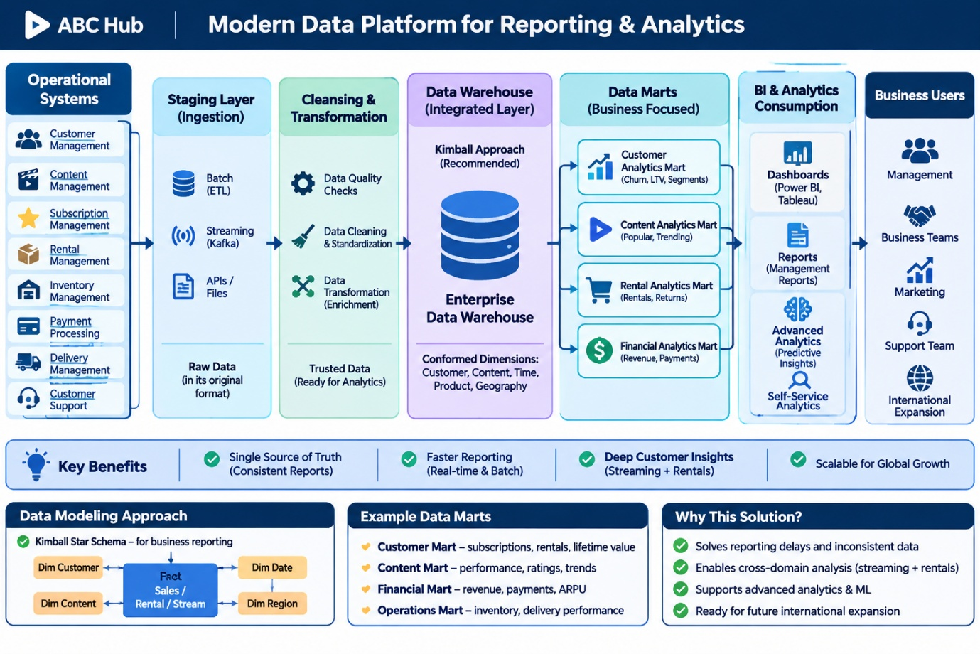

2.4 Why Kimball instead of Inmon, OBT or other approaches?
Approach | Description | Suitability
Kimball | Dimensional modelling using fact and dimension tables. | Recommended  Excellent for BI and reporting.
Inmon | Enterprise Data Warehouse initially designed using normalised structures (3NF), with downstream Data Marts. | Suitable for enterprise integration but more complex.
OBT (One Big Table) | Combines multiple datasets into a denormalised wide table. | Useful for particular analytical workloads, but not ideal as the main enterprise warehouse model.
My recommendation: Use Kimball's dimensional modelling with conformed dimensions and multiple fact tables. This provides an integrated analytical environment while keeping reporting simple and efficient.
2.5 Expected Benefits
The proposed architecture will address the challenges identified in the business scenario:
- Faster reporting: Automated ETL/ELT pipelines eliminate repetitive manual data preparation.
- Single source of truth: Centralised and standardised data ensures consistent business figures across departments.
- Historical analysis: Historical records enable trend analysis and forecasting.
- Unified customer insights: Streaming and rental activities can be analysed together.
- Self-service BI: Business users can independently access dashboards and reports.
- Scalability: The architecture supports increasing data volumes and international business expansion.
Conclusion: By implementing a layered modern data platform with a Kimball-based Enterprise Data Warehouse and subject-oriented Data Marts, ABC Hub can transform its disconnected operational data into reliable business intelligence. This will improve reporting efficiency, analytical capabilities and long-term decision-making.

Question 3 – Gathering Analytical Requirements
1. Customer Activity
A. Questions to ask stakeholders
- Should customer activity include both streaming activities and physical rentals?
- Do you need to analyse daily, weekly, monthly or yearly customer activity?
- Should customers be segmented by country, city, age group or subscription plan?
- What KPIs are important: active customers, streaming sessions, watch duration, rental frequency or subscription renewals?
- Should inactive and cancelled customers be included in the analysis?
- How many years of historical customer activity data should be retained?
- Do you need to identify customers who use both streaming and physical rental services?
B. Assumptions and justifications
Assumption | Justification
Customer activity includes streaming sessions, physical rentals and subscription activities. | These represent the main customer interactions with ABC Hub.
Reports will support daily, weekly, monthly and yearly analysis. | Enables management to analyse customer engagement over different periods.
Customer activity will be analysed by country, city, subscription plan and customer segment. | Supports customer segmentation and international business analysis.
KPIs include active customers, streaming sessions, watch duration, rental frequency and subscription renewals. | These measures provide a comprehensive view of customer engagement.
Both active and inactive customers will be included. | Helps identify customer retention and churn patterns.
Five years of historical data will be retained, subject to privacy and retention policies. | Supports long-term behavioural analysis and machine learning.

C. Refined Analytical Requirements
Category | Requirement
Business objective | Understand customer engagement across streaming and physical rental services.
KPIs | Active customers, streaming sessions, watch duration, rental frequency, subscription renewals and churn rate.
Dimensions | Customer, Date, Location, Subscription Plan and Device.
Time granularity | Individual activity/event level, with daily, weekly, monthly and yearly aggregations.
Reporting frequency | Daily and monthly.
Historical data | Five years of detailed customer activity.
Primary users | Customer Management and Marketing teams.
2. Streaming Performance
A. Questions to ask stakeholders
- Do you need to analyse total views, unique viewers or streaming sessions?
- Should streaming duration and content completion rates be measured?
- Do you need to identify peak streaming hours?
- Should streaming performance be analysed by genre, content type and release year?
- Do you need to compare streaming performance across countries and devices?
- How frequently should streaming reports be refreshed?
- How many years of historical streaming activity should be stored?
B. Assumptions and justifications
Assumption | Justification
Streaming performance includes total views, unique viewers and watch duration. | These KPIs measure digital content engagement.
Content completion rate will be measured. | Helps identify whether customers finish watching content.
Streaming activity will be analysed by genre, content type, device and country. | Helps identify customer viewing preferences.
Hourly and daily analysis will be supported. | Helps identify peak streaming periods and usage trends.
Reports will be refreshed daily. | Daily updates are sufficient for most management reports.
Five years of detailed streaming events will be retained, subject to applicable policies. | Supports historical analysis and recommendation models.
C. Refined Analytical Requirements
Category | Requirement
Business objective | Evaluate streaming service performance and customer viewing behaviour.
KPIs | Total views, unique viewers, watch duration, average watch duration and completion rate.
Dimensions | Content, Customer, Date, Genre, Device, Platform and Country.
Time granularity | Individual streaming session/event, hourly and daily.
Reporting frequency | Daily, with hourly analysis.
Historical data | Five years of detailed streaming activity.
Primary users | Content Management and Streaming Operations teams.
3. Physical Rental Trends
A. Questions to ask stakeholders
- Do you need to analyse total rentals, rental revenue and return rates?
- Should overdue rentals and late returns be included?
- Do you need to analyse rental trends by content category and physical item type?
- Should rental activity be analysed by customer location?
- Do you need to identify frequently rented and rarely rented items?
- How frequently should rental reports be generated?
- How much historical rental transaction data should be retained?
B. Assumptions and justifications
Assumption | Justification
Rental analytics will include total rentals, rental revenue, return rates and overdue rentals. | These measures evaluate rental business performance.
Rental trends will be analysed by content type, genre and location. | Helps identify popular rental categories and geographical demand.
Frequently and rarely rented items will be identified. | Helps improve rental planning and stock management.
Reports will support daily and monthly analysis. | Supports operational monitoring and long-term comparisons.
Five years of historical rental transactions will be retained. | Enables historical trend analysis.
C. Refined Analytical Requirements
Category | Requirement
Business objective | Understand rental trends and improve physical rental operations.
KPIs | Total rentals, rental revenue, return rate, overdue rentals and average rental duration.
Dimensions | Customer, Content, Physical Item, Date and Location.
Time granularity | Individual rental transaction, daily and monthly.
Reporting frequency | Daily and monthly.
Historical data | Five years of rental transactions.
Primary users | Rental Management team.
4. Revenue
A. Questions to ask stakeholders
- Should revenue be analysed separately for streaming subscriptions and physical rentals?
- Do you need to include refunds, discounts and failed payments?
- Should revenue be analysed by country, payment method and subscription plan?
- Do you need daily, monthly, quarterly and yearly revenue reports?
- Should different currencies be converted into a standard reporting currency?
- Do you need to calculate KPIs such as Average Revenue Per User (ARPU)?
- How much historical financial data should be retained?
B. Assumptions and justifications
Assumption | Justification
Revenue will be separated into subscription revenue and rental revenue. | Provides clear financial visibility across business services.
Successful payments, refunds and discounts will be tracked separately. | Ensures accurate revenue calculations.
Revenue will be analysed by country, date, payment method and subscription plan. | Supports financial comparisons.
Multiple currencies will be supported. | ABC Hub plans international expansion.
ARPU and revenue growth will be calculated. | These KPIs help evaluate financial performance.
Five years of historical financial data will be retained, subject to legal requirements. | Supports financial trend analysis.
C. Refined Analytical Requirements
Category | Requirement
Business objective | Monitor and evaluate financial performance.
KPIs | Total revenue, subscription revenue, rental revenue, refunds, ARPU and revenue growth.
Dimensions | Date, Customer, Subscription Plan, Payment Method, Location and Revenue Category.
Time granularity | Individual payment transaction, daily, monthly, quarterly and yearly.
Reporting frequency | Daily and monthly.
Historical data | Five years of financial data, subject to applicable retention requirements.
Primary users | Finance and Senior Management teams.
5. Content Popularity
A. Questions to ask stakeholders
- How should content popularity be measured: views, rentals, ratings or reviews?
- Should streaming and physical rental popularity be analysed together?
- Do you need to compare content by genre, category and release year?
- Should popularity be analysed by country or customer segment?
- Do you need to identify trending content over different time periods?
- Should customer ratings and reviews be included?
- How much historical content usage data should be retained for recommendation models?
B. Assumptions and justifications
Assumption | Justification
Popularity will be measured using views, rentals, ratings and reviews. | Provides multiple indicators of content performance.
Streaming and rental activities will be analysed together. | Identifies popularity across both business services.
Content will be analysed by genre, category and release year. | Helps identify customer preferences.
Popularity trends will be analysed daily and monthly. | Helps identify trending content.
Historical usage and rating data will be retained for five years. | Supports recommendation systems and predictive analytics.
C. Refined Analytical Requirements
Category | Requirement
Business objective | Identify popular content and understand customer preferences.
KPIs | Total views, unique viewers, rental frequency, average ratings and review counts.
Dimensions | Content, Genre, Category, Release Year, Date and Content Type.
Time granularity | Individual viewing/rental events, daily and monthly.
Reporting frequency | Daily and monthly.
Historical data | Five years of content usage and rating history.
Primary users | Content Management and Marketing teams.
6. Inventory Utilisation
A. Questions to ask stakeholders
- Do you need to analyse available stock, rented stock and total stock quantity?
- How should inventory utilisation be calculated?
- Should inventory be analysed by physical item, content category and warehouse location?
- Do you need to identify frequently unavailable items?
- Should overdue rentals be included in inventory utilisation reports?
- How frequently should inventory availability be updated?
- Do you need historical stock availability and movement records?
B. Assumptions and justifications
Assumption | Justification
Inventory utilisation will be calculated using rented stock against total usable stock. | Measures how effectively physical inventory is being used.
Inventory will be analysed by item, content category and location. | Helps identify stock distribution and demand.
Overdue and unavailable items will be tracked separately. | Helps identify inventory management issues.
Inventory availability will be updated hourly or near real-time. | Stock availability changes frequently due to rentals and returns.
Daily inventory snapshots and transaction history will be retained for five years, subject to applicable policies. | Supports historical inventory trend analysis.
C. Refined Analytical Requirements
Category | Requirement
Business objective | Monitor inventory utilisation and improve stock availability.
KPIs | Total stock, available stock, rented stock, inventory utilisation rate and overdue item count.
Dimensions | Physical Item, Content, Location and Date.
Time granularity | Inventory transaction level and daily snapshots.
Reporting frequency | Hourly or near real-time availability; daily management reports.
Historical data | Five years of inventory movements and snapshots.
Primary users | Inventory and Rental Management teams.
7. Machine Learning and Recommendation Analytics
A. Questions to ask stakeholders
- What types of machine learning and recommendation models are planned?
- Do you need individual customer streaming and rental activity?
- Should customer ratings, reviews and content preferences be included?
- How much historical data is required for model training?
- Do you need to track customer interactions with recommended content?
- Should datasets be refreshed daily or more frequently?
- What privacy and security restrictions apply to customer information?
B. Assumptions and justifications
Assumption | Justification
Detailed customer activity and content interaction events will be available. | Recommendation models require behavioural information.
Streaming, rentals, ratings and reviews will be integrated. | These provide useful signals for customer preferences.
Five years of historical behavioural data will be retained, subject to applicable policies. | Provides sufficient historical information for model development and evaluation.
Customer identifiers will be pseudonymised in ML datasets where possible. | Protects customer privacy.
Data Scientists will have controlled access to analytical datasets. | Enables machine learning development while maintaining security.
C. Refined Analytical Requirements
Category | Requirement
Business objective | Support machine learning and personalised recommendation systems.
KPIs / features | Watch frequency, watch duration, genre preferences, rental frequency, ratings and customer engagement.
Dimensions | Customer, Content, Date, Genre, Device and Subscription Plan.
Time granularity | Individual customer activity and content interaction events.
Reporting frequency | Daily dataset updates, with more frequent updates if required by future models.
Historical data | Five years of detailed behavioural data.
Primary users | Data Science and Machine Learning teams.

4 Recommended Data Modelling Approach
For ABC Hub, I recommend Data Vault 2.0 Modelling as the primary data modelling approach for the Enterprise Data Warehouse.
Data Vault 2.0 is particularly suitable because ABC Hub requires complete historical information, data traceability and support for auditing and regulatory requirements.
Unlike traditional approaches that may update existing records, Data Vault maintains historical changes by storing new records rather than overwriting previous information.
Data Vault 2.0 consists of three main components:
1. Hubs
Hubs store unique business keys representing important business entities.
Examples in ABC Hub:
- HubCustomer – Customer information.
- HubContent – Movies, books, music and games.
- HubSubscription – Subscription identifiers.
- HubPayment – Payment identifiers.
- HubRental – Rental identifiers.
Hubs contain business keys and technical metadata such as load timestamps and record sources.
2. Links
Links represent relationships between different business entities.
Examples:
- LinkCustomerSubscription – Connects customers with their subscriptions.
- LinkCustomerRental – Connects customers with rental transactions.
- LinkCustomerPayment – Connects customers with payments.
- LinkCustomerContent – Connects customers with content interactions.
Links allow ABC Hub to track relationships between different operational entities.
3. Satellites
Satellites store descriptive attributes and historical changes associated with Hubs and Links.
Examples:
- SatCustomerDetails – Customer name, email and address.
- SatContentDetails – Content title, genre and category.
- SatSubscriptionDetails – Subscription plan and status.
- SatPaymentDetails – Payment amount and payment status.
- SatRentalDetails – Rental dates and return status.
Whenever information changes, a new satellite record is inserted instead of overwriting the previous record.
This preserves historical information.
4.2 How Data Vault 2.0 Maintains Historical Information
Consider a customer who changes their subscription plan.
Initially, the customer has a Basic subscription.
Later, the customer upgrades to Premium.
Instead of updating the existing record, Data Vault inserts a new historical record.
Example: SatSubscriptionDetails

Customer Key | Subscription Plan | Load Date | Record Source
C001 | Basic | 2026-01-01 | Subscription System
C001 | Premium | 2026-06-01 | Subscription System
C001 | Enterprise | 2026-10-01 | Subscription System
This allows ABC Hub to identify:
- The customer's original subscription plan.
- When the subscription changed.
- The customer's current subscription plan.
- The source system that provided the information.
Data Vault can also maintain technical metadata such as:
- LOAD_DATE: When the record entered the warehouse.
- RECORD_SOURCE: Which operational system provided the data.
- HASHDIFF: Used to detect changes in descriptive attributes.
- EFFECTIVE_FROM and EFFECTIVE_TO: Business validity periods, where applicable.

4.3 High-Level Data Vault 2.0 Architecture Diagram
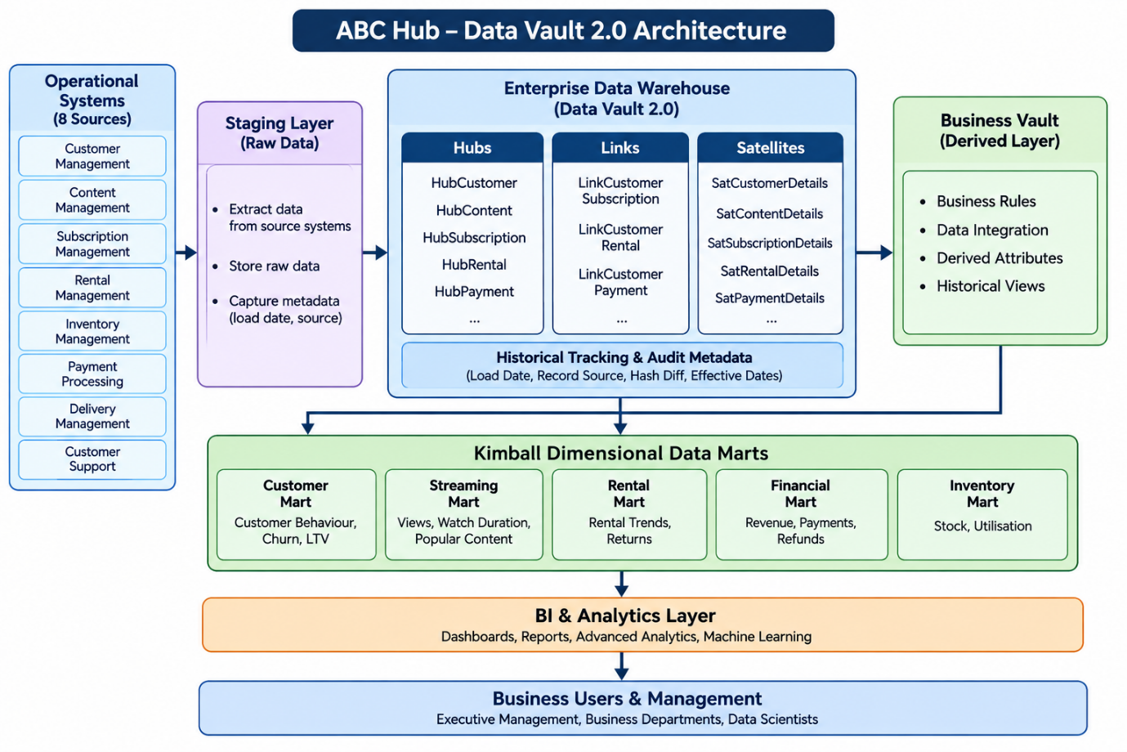
4.4 Justification for Choosing Data Vault 2.0
Reason | Justification
Historical data preservation | Stores historical changes without overwriting previous records.
Data traceability | Maintains source information and load timestamps for auditing.
Audit and compliance | Supports investigation of when data was received and where it originated.
Scalability | Supports increasing data volumes and additional operational systems.
Flexibility | New business entities and data sources can be integrated without redesigning the entire warehouse.
Data integration | Combines information from multiple operational systems while preserving source-level information.
Machine learning support | Preserves detailed historical information for future analytical and predictive workloads.
4.5 Integration with Kimball Dimensional Modelling
An important consideration is that Data Vault 2.0 and Kimball are not competing approaches that must be used independently.
ABC Hub can use a hybrid architecture:
- Data Vault 2.0 for the central Enterprise Data Warehouse, focusing on historical preservation, integration and auditability.
- Kimball dimensional modelling for downstream Data Marts, focusing on reporting, business intelligence and analytical queries.
This approach provides both historical traceability and efficient reporting.
Conclusion: Data Vault 2.0 is the recommended modelling approach for ABC Hub because it provides a scalable and auditable environment while preserving historical changes. By combining Data Vault 2.0 with Kimball dimensional Data Marts, ABC Hub can maintain complete historical information and deliver efficient business reporting to management.
5. One Big Table (OBT) Approach for Simplifying Analytical Data Access
1. Recommended Approach – One Big Table (OBT)
One Big Table (OBT) is a denormalised data modelling approach where data from multiple related tables is combined into a single, wide table.
Instead of requiring analysts to join several fact and dimension tables whenever they prepare reports, the data engineering team creates a pre-joined table containing commonly required business information.
For ABC Hub, an OBT could combine customer, streaming, rental, subscription, payment and content information.
Example structure:
Customer | Content | Activity Type | Plan | Date | Revenue
John Smith | Avengers | Streaming | Premium | 2026-01-10 | 0
John Smith | Batman | Rental | Premium | 2026-01-12 | 1,500
Sarah Wilson | Inception | Streaming | Basic | 2026-01-15 | 0
Sarah Wilson | Interstellar | Rental | Basic | 2026-01-18 | 1,200
This allows analysts to access commonly required information from one table without repeatedly joining multiple tables.
2. How OBT Improves Analytical Performance
- Reduces complex joins: Analysts do not need to join multiple fact and dimension tables for every report.
- Faster query execution: Pre-joined data reduces runtime join operations, particularly for frequently used analytical queries.
- Simplifies reporting: Analysts can write simpler SQL queries to calculate KPIs such as total revenue, rental frequency and streaming activity.
- Improves accessibility: Business analysts can access business-friendly columns without needing detailed knowledge of the underlying database structure.
3. Advantages of OBT
- Simplicity: Provides a single access point for commonly required analytical data.
- Improved performance: Reduces repeated joins and can improve report response times.
- Business-friendly structure: Uses understandable business attributes and measures.
- Analyst productivity: Reduces dependency on technical teams when preparing reports.
- Consistent reporting: Centralised transformation logic helps different departments use consistent business definitions.
4. Potential Limitations and Trade-offs
- Data duplication: The same customer or content information may be repeated across many rows, increasing storage requirements.
- Data maintenance: When source data changes, the OBT must be refreshed or updated to maintain accuracy.
- Limited flexibility: A single wide table may not efficiently support every analytical requirement.
- Complex data relationships: Combining multiple fact tables with different levels of detail can create duplicated records and incorrect calculations.
- Scalability challenges: As ABC Hub expands its streaming, rental and subscription services, the OBT may become very large and difficult to maintain.

6. Modern End-to-End Data Platform Architecture

6.1 Proposed Architecture
1. Operational Data Sources
These are the systems that generate day-to-day business data. ABC Hub collects information from customer management, streaming, rental, subscription, payment and inventory systems.
2. Data Ingestion Layer
This layer collects data from operational systems and transfers it to the data platform.
- Batch ingestion: Collect data at scheduled intervals.
- Change Data Capture (CDC): Capture changes made in operational databases.
- Streaming ingestion: Capture real-time events such as streaming activities and payment transactions.
3. Bronze Layer – Raw Data
The Bronze Layer stores the original data received from operational systems with minimal transformation. It preserves source information and ingestion metadata, allowing historical recovery and reprocessing when necessary.
4. Silver Layer – Cleaned and Integrated Data
The Silver Layer improves data quality by removing duplicates, handling missing values, standardising formats and integrating information from different operational systems. This ensures that the data is consistent and reliable before analytical modelling.
5. Gold Layer – Business-Ready Data
The Gold Layer contains structured analytical data using Kimball dimensional modelling.
- Fact tables: Store measurable business activities, such as streaming events, rentals and payments.
- Dimension tables: Store descriptive information about customers, content, dates, locations and subscription plans.
- Data Marts: Provide business-specific datasets for Customer Analytics, Streaming Analytics, Rental Analytics, Financial Analytics and Inventory Analytics.
This layer simplifies analytical queries and provides consistent business metrics.
6. BI and Analytics Layer
Business Intelligence tools use the Gold Layer to generate dashboards, reports and visualisations. Advanced analytics and machine learning can also use these datasets to identify customer behaviour, predict churn and generate content recommendations.
7. Business Users
The final output is delivered to executive management, business analysts, finance teams, marketing teams and data scientists to support informed business decisions.
6.3 Supporting Platform Components
In addition to the main data layers, the platform should include:
Component | Purpose
Data Orchestration | Schedule and manage data pipelines.
Data Quality | Validate accuracy, completeness and consistency.
Data Governance | Manage access control, security and data ownership.
Metadata and Data Lineage | Track data origins and transformations.
Monitoring and Logging | Identify pipeline failures and performance issues.
These components support the entire architecture rather than operating as separate Medallion layers.
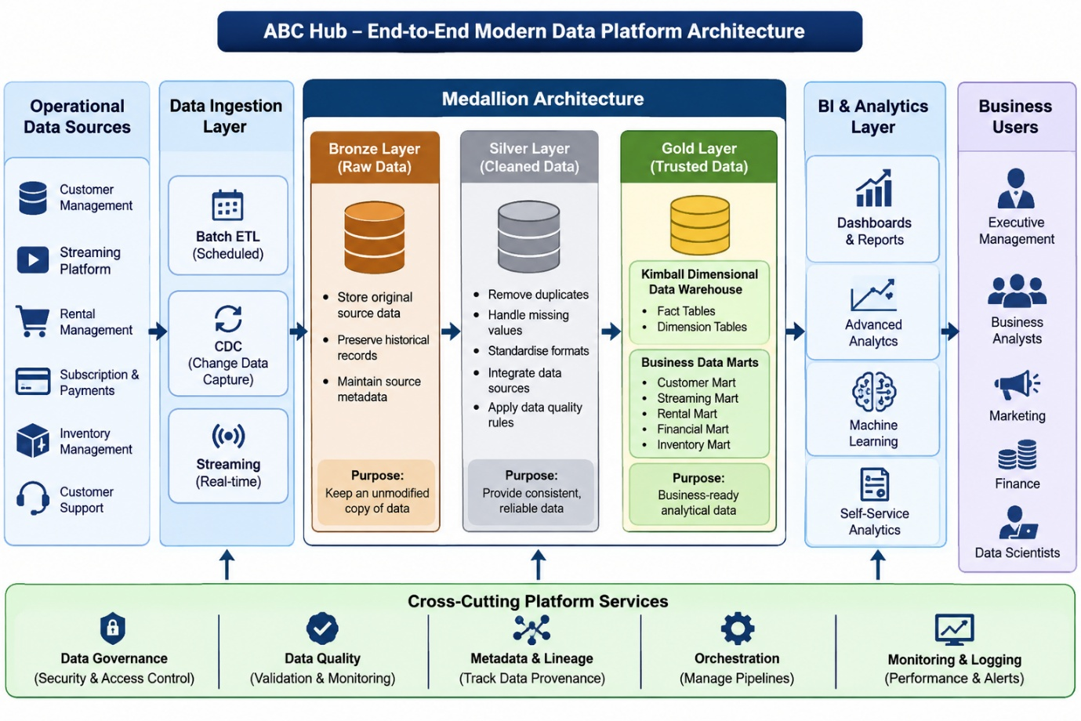

Question: 7
Scenario A – Customer Daily Activity
1. Identify the grain
Grain: One record per customer per calendar day.
Each row represents the total daily activity of one customer.
2. Fact Table – FactCustomerDailyActivity
Column | Key | Description
Customer_Key | PK, FK | References DimCustomer
Date_Key | PK, FK | References DimDate
Total_Streaming_Sessions | Measure | Number of streaming sessions
Total_Streaming_Duration | Measure | Total streaming duration
Total_Physical_Rentals | Measure | Number of physical rentals
Total_Returned_Items | Measure | Number of returned items
Total_Amount_Spent | Measure | Total customer spending
Total_Support_Tickets | Measure | Number of support tickets
Primary key: Composite key (Customer_Key, Date_Key).
3. Dimension Tables
DimCustomer
Column | Key
Customer_Key | PK
Customer_ID | Operational ID
Customer_Name | Attribute
Gender | Attribute
City | Attribute
Country | Attribute
Customer_Segment | Attribute
DimDate
Column | Key
Date_Key | PK
Full_Date | Attribute
Day | Attribute
Month | Attribute
Quarter | Attribute
Year | Attribute
4. Business Measures and Justification
Measure | Why it belongs in the Fact table
Total_Streaming_Sessions | Quantifies daily streaming activity.
Total_Streaming_Duration | Measures customer engagement time.
Total_Physical_Rentals | Measures rental activity.
Total_Returned_Items | Tracks returned rental items.
Total_Amount_Spent | Measures customer spending and revenue.
Total_Support_Tickets | Measures customer support activity.
These are numerical business events or aggregations that management needs to analyse over time.
5. Star Schema Diagram
Scenario B – Content Monthly Performance
1. Identify the grain
Grain: One record per content item per calendar month.
Each row represents the monthly performance of a particular movie or series.
2. Fact Table – FactContentMonthlyPerformance
Column | Key | Description
Content_Key | PK, FK | References DimContent
Date_Key | PK, FK | References DimDate
Total_Streams | Measure | Total streaming sessions
Total_Rental_Count | Measure | Total physical rentals
Total_Revenue | Measure | Revenue attributed to content
Average_Customer_Rating | Measure | Average customer rating
Total_Wishlist_Additions | Measure | Number of wishlist additions
Primary key: Composite key (Content_Key, Date_Key).
3. Dimension Tables
DimContent
Column | Key
Content_Key | PK
Content_ID | Operational ID
Content_Title | Attribute
Content_Type | Attribute
Genre | Attribute
Release_Date | Attribute
Language | Attribute
Age_Rating | Attribute
Note: Your operational schema supports multiple genres per content item. For a simple star schema, you can use a content-genre bridge or define a primary genre rather than duplicating fact rows.
DimDate
Reuse the same DimDate from Scenario A.
For this monthly model, use the first day of each month as the date reference, e.g. 20260101 for January 2026.
4. Business Measures and Justification
Measure | Why it belongs in the Fact table
Total_Streams | Measures content viewing popularity.
Total_Rental_Count | Measures physical rental demand.
Total_Revenue | Measures financial performance attributed to content.
Average_Customer_Rating | Measures customer satisfaction.
Total_Wishlist_Additions | Measures customer interest in content.
These measures allow management to compare content performance across different months, genres and content types.
5. Star Schema Diagram
Scenario C – Inventory Utilisation
1. Identify the grain
Grain: One record per physical inventory item per calendar day.
Each row represents the daily rental and availability status of an individual physical inventory item.
2. Fact Table – FactInventoryDailyUtilisation
Column | Key | Description
Inventory_Key | PK, FK | References DimInventoryItem
Date_Key | PK, FK | References DimDate
Total_Rentals | Measure | Number of rentals
Total_Returns | Measure | Number of returned items
Available_Day_Count | Measure | Number of eligible available days (0 or 1)
Rented_Day_Count | Measure | Number of days rented (0 or 1)
Inventory_Utilisation_Percentage | Measure | Percentage of eligible time utilised
Primary key: Composite key (Inventory_Key, Date_Key).
3. Dimension Tables
DimInventoryItem
Column | Key
Inventory_Key | PK
Inventory_ID | Operational ID
Content_ID | Related content
Barcode | Attribute
Purchase_Date | Attribute
Item_Condition | Attribute
Warehouse_ID | Attribute
Warehouse_Name | Attribute
Status | Attribute
DimDate
Reuse the same DimDate from Scenarios A and B.
4. Business Measures and Justification
Measure | Why it belongs in the Fact table
Total_Rentals | Measures how frequently inventory items are rented.
Total_Returns | Tracks the number of returned items.
Available_Day_Count | Measures the number of days an item was available for rental.
Rented_Day_Count | Measures how long an item was being utilised.
Inventory_Utilisation_Percentage | Measures how effectively inventory is being used.
Utilisation can be calculated as:
\[ \text{Utilisation \%} = \frac{\text{Rented Day Count}}{\text{Eligible Day Count}}\times100 \]
Here, eligible days are days when the item is available for use, excluding periods when it is inactive, damaged or otherwise unavailable.
5. Star Schema Diagram

Final comparison of all three analytical models
Requirement | Scenario A | Scenario B | Scenario C
Grain | Customer + Day | Content + Month | Inventory Item + Day
Dimension 1 | DimCustomer | DimContent | DimInventoryItem
Dimension 2 | DimDate | DimDate | DimDate
Fact table | FactCustomerDailyActivity | FactContentMonthlyPerformance | FactInventoryDailyUtilisation
Model type | Periodic Snapshot | Periodic Snapshot | Periodic Snapshot

