**Pandemic and its impact on Society**

**stress related issues**

**__________________________________________**

**Introduction: -**

A pandemic of unknown causes was first reported in China on 31 December 2019 by World Health Organization. The official outbreak was declared a Public Health Emergency of International Concern on 30 January 2020. It was given a name by WHO of Coronavirus Disease: COVID-19 on 11 February 2020.

In this paper, I attempt to summarize the changes in mental health, social behavior, and some other concerns.

**____________________________________________________**

**As I had conducted a survey, it recorded a lot of responses and here I am going to share some of the results of that survey.**

**\*\***

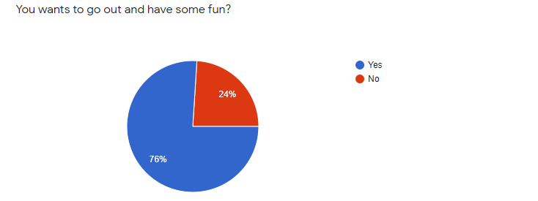

As we can see in this chart, most people want to go out and have some fun which means that this pandemic has made them so lifeless that they want to go out and relieve their stress. It's not a strange outcome to be seen due to this pandemic. All of us are just tolerating this problem.

**\*\***

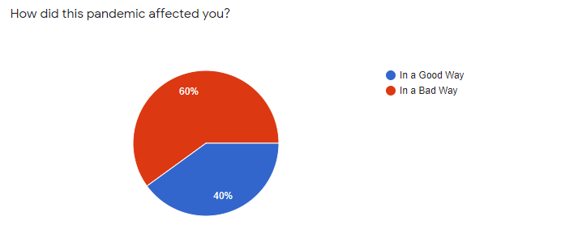

This Chart shows that most people are affected badly by this pandemic there's not much they can do even though it's causing them a lot but what can they do. The main problem stays intact that whatever they do doesn't matter, in the end, they have to face it and somehow overcome it.

**\*\***

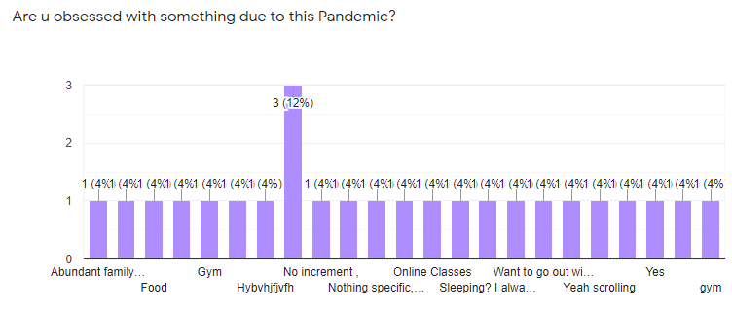

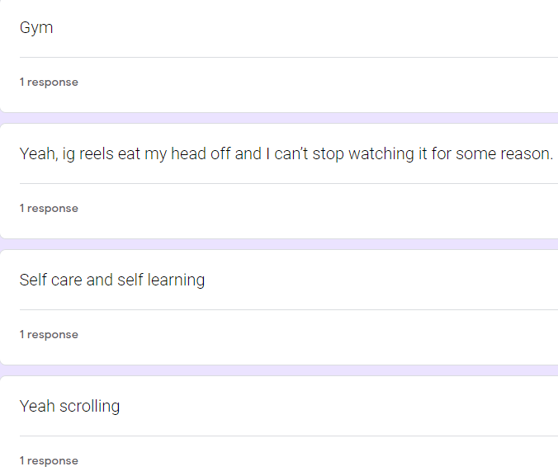 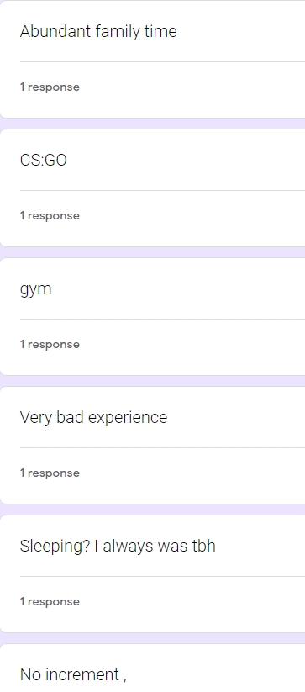

These 2 Q/A screenshots show that most people are obsessed with some sluggish activity, we all know that before this pandemic people used to go out and have fun with their playmates but nowadays, they have just become self-centered.

Not only this some people have become so much lazy that now they just enjoy sleeping only.

**\*\***

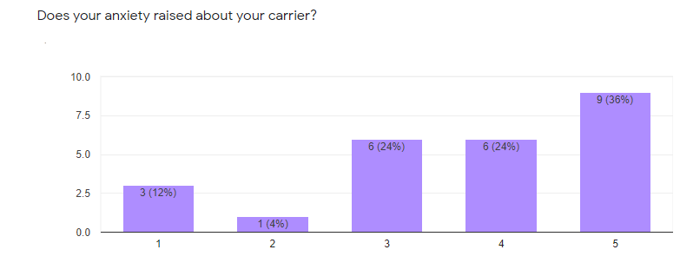

As we all know that this pandemic has made us attend our classes Online which has ruined our carrier and so our anxiety has been raised due to this, every one of us is worried about our future and it makes us so stressed that no one can a single thing even though we all know that now our carrier is like a Titanic.

**\*\***

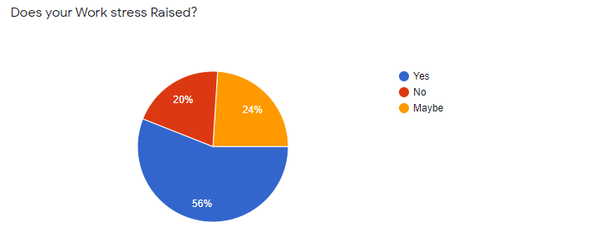

When this pandemic has just started, we all thought that it will make our work easier but now it feels like we are in a prison. And it won’t get changed until this lockdown ends. We are just pressured day by day to perform well when our mental health isn’t well.

**\*\***

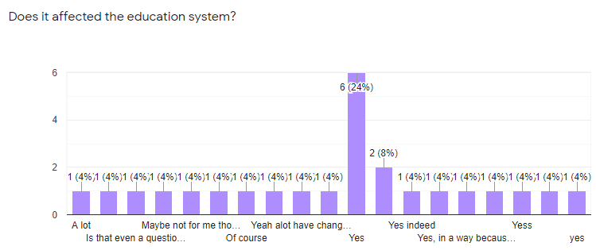

It has affected the education system a lot. As we can see in this chart every single person replied with yes, it shows that our education system is affected the most.

**\*\***

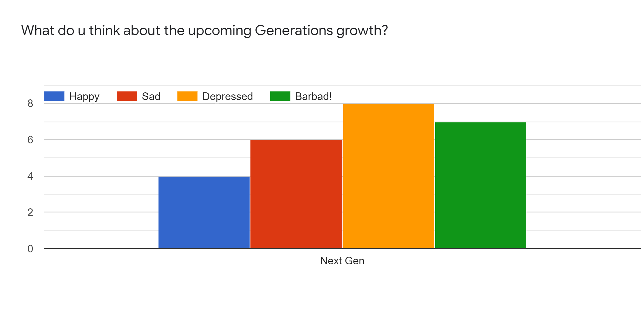

Now, more than 80% of people think that our upcoming generation is the one affected the most. And they are affected not in a good way but the exact opposite.

**\*\***

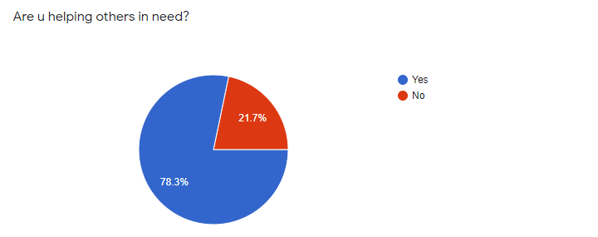

Last but not the least, I also asked that whether people are helping others or not after this much trouble they are facing themselves and the answer is Yes, they are.

**SUMMARY OF THIS SURVEY: -**

**As I have shared the result of the survey with you all. Now I am going to give you all a summary of this survey and my opinions towards this pandemic.**

We all were living our healthy day-to-day life until December 2019 when a virus of size approx. 80-120 nm not just distorted our life but ruined it.

It's 20 April 2021, and its cure hasn't been found we all are wearing masks and sanitizing ourselves whenever we come in contact with some other person to protect ourselves from this virus.

**We are imprisoned in our homes.**

Nowadays, People have become lazy and either doing work from home, attending online classes from home, or fired from the job due to lockdown or just sitting at home.

From this survey, I confirmed that people are suffocating and feeling sick at home, they have nowhere to go to do something exciting or to go and have some fun. I can say with 100% surety that this pandemic has affected them only in a bad way, we can assume it financially, physiologically, or physically.

People have become obsessed with indoor activities like scrolling on social media, playing games, or just sleeping. Their anxiety level has risen so much that now they are frustrated, stressed, and feeling depressed. All of their daily life activities stressed have just risen whether it's online classes, preparing for competitive exams, or job pressure. The government has postponed the date of the competitive exams and no one knows that when will it be, in private sector company are firing their staff to increase their profit and things like these.

This has affected our education system too and everyone is worried about their future as well as of their upcoming generation because a lot of banks have gone bankrupt, and it's estimated that millions of people can go below the poverty line.

People are recovering from this pandemic and helping others in need, all we can say that we are trying our level best but no one can do a thing individually. Only we all together can bring change.

**-BY DEV DHAMA**

**________________________________________________________________________________________________________**

REFERENCES: -

<https://wchh.onlinelibrary.wiley.com/doi/full/10.1002/pnp.666>