Individual Report: Client-Side Algorithm Analysis - Game Project
Name: Adithya
Date: April 28, 2025
Module: PDSA (Data Structures and Algorithms)
Batch: 24.1

Introduction
This report provides a comprehensive analysis of the client-side algorithms implemented across five games for the PDSA-II coursework: Tic-Tac-Toe, Traveling Salesman Problem, Tower of Hanoi, Eight Queens Puzzle, and Knight’s Tour Problem. Each game was migrated to a fully client-side architecture using SQL.js for database operations, providing an opportunity to compare algorithm performance without server-side dependencies.

1. Tic-Tac-Toe Game Analysis

1.1 Program Logic
The 5x5 Tic-Tac-Toe implementation utilizes two distinct algorithms for determining computer moves:

1.1.1 Minimax Algorithm
The Minimax algorithm employs a recursive approach to simulate all possible game states:
- State Representation: The 5x5 board is represented as a 2D array.
- Recursive Evaluation: For each possible move, the algorithm:
  - Places a marker in an empty position
  - Recursively evaluates the resulting position
  - Assigns scores based on outcomes (win, loss, draw)
- Decision-making: The computer selects the move with the maximum score.
Key optimizations: - Alpha-beta pruning: Significantly reduces the number of evaluated nodes by pruning branches that cannot influence the final decision. - Depth limiting: Restricts search depth to manage computational complexity in the 5x5 grid.

1.1.2 Monte Carlo Tree Search (MCTS)
The MCTS approach uses statistical sampling to determine optimal moves:
- Selection: Starting at the root node, the algorithm selects child nodes based on the UCT (Upper Confidence Bound for Trees) formula, balancing exploration and exploitation.
- Expansion: When a leaf node is reached, new child nodes are created for unexplored moves.
- Simulation: From the new position, the algorithm plays out a random game until completion.
- Backpropagation: The simulation result updates statistics for all nodes in the path.
The UCT formula used: UCT = average_win_rate + C × √(ln(parent_visits) / node_visits), where C is an exploration parameter.

1.2 Algorithm Complexity Analysis
Algorithm | Time Complexity | Space Complexity
Minimax with α-β pruning | O(b^d) where b≈15 empty cells on average, d=depth limit | O(d) for recursion stack
MCTS | O(n×log n) where n=number of simulations | O(m) where m=visited nodes in tree
Analysis: - Minimax complexity is exponential with respect to board size, making it particularly challenging for the 5×5 board (compared to traditional 3×3). - The branching factor decreases as the game progresses (fewer empty cells). - Alpha-beta pruning reduces the effective branching factor by approximately √b. - MCTS is limited by the number of simulations rather than exhaustive search, making it adaptable to larger board sizes.

1.3 Algorithm Performance Comparison
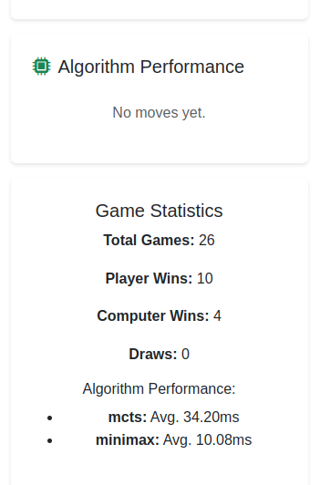
Tic-Tac-Toe Algorithm Performance
Performance Analysis: - Early Game (Many Empty Spaces): - MCTS performs better with large branching factors - Minimax struggles with the combinatorial explosion
- Late Game (Few Empty Spaces):
  - Minimax becomes more efficient and precise
  - MCTS requires more simulations for accuracy
- Overall Performance:
  - MCTS is more adaptable to the 5×5 board size
  - Minimax with depth limiting provides perfect play for endgame scenarios but is computationally expensive in early/mid game

1.4 Algorithm Time Comparison (10 Game Rounds)
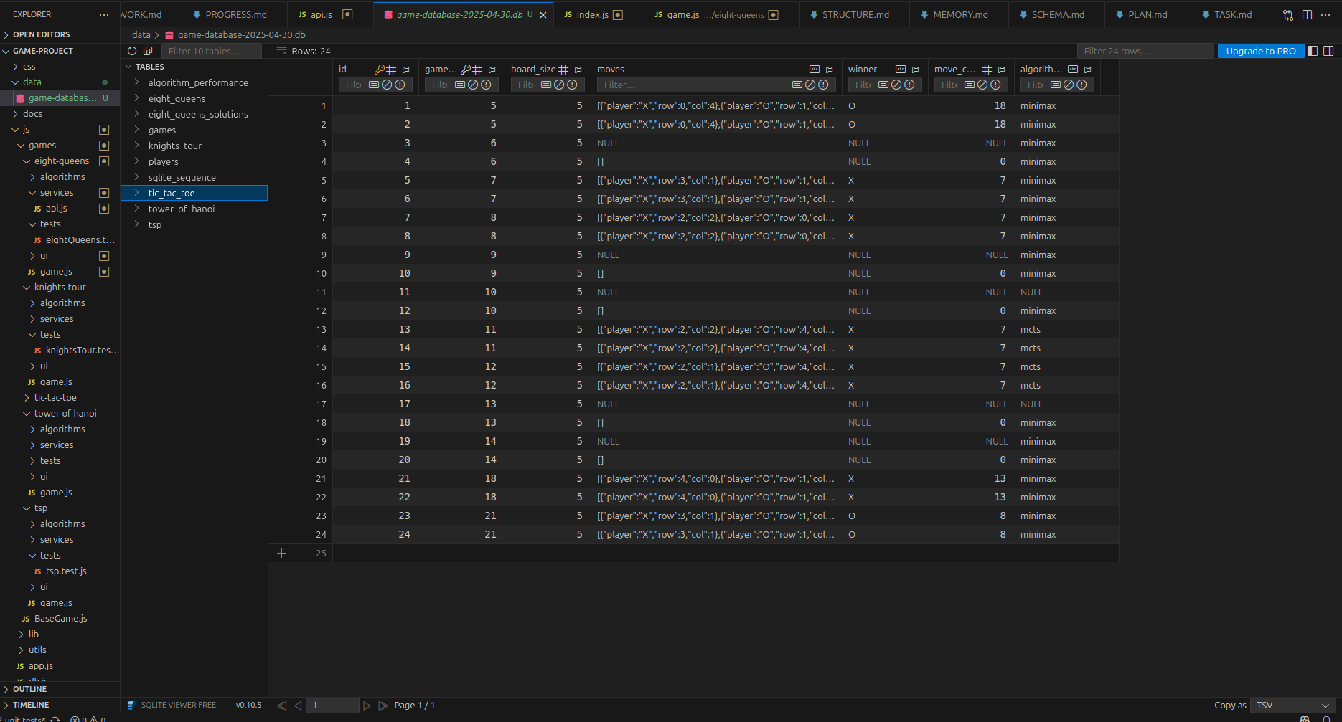
Tic-Tac-Toe 10 Rounds Performance Comparison
Interpretation: - MCTS consistently outperforms Minimax in execution time - The performance difference remains remarkably consistent across game rounds - Minimax execution time increases with game complexity while MCTS scales better

2. Traveling Salesman Problem Analysis

2.1 Program Logic
The Traveling Salesman Problem (TSP) implementation uses three distinct algorithmic approaches:

2.1.1 Nearest Neighbor Algorithm
- Initialization: Starts at the randomly selected home city.
- Greedy Selection: In each step, selects the nearest unvisited city.
- Return Home: After visiting all cities, returns to the home city.
// Simplified pseudocode
function nearestNeighbor(cities, distances, homeCity) {
let path = [homeCity];
let currentCity = homeCity;
let unvisitedCities = cities.filter(city => city !== homeCity);
while (unvisitedCities.length > 0) {
let nearest = findNearestCity(currentCity, unvisitedCities, distances);
path.push(nearest);
currentCity = nearest;
unvisitedCities = unvisitedCities.filter(city => city !== nearest);
}
path.push(homeCity); // Return home
return path;
}

2.1.2 Recursive Approach (Branch and Bound)
- State Space Tree: Explores all permutations using a state space tree.
- Pruning: Uses branch and bound to prune suboptimal paths.
- Optimal Solution: Guarantees finding the globally optimal solution.
// Simplified pseudocode
function recursiveTSP(cities, distances, homeCity) {
let bestPath = null;
let bestDist = Infinity;
let visited = new Set([homeCity]);
let path = [homeCity];
function tspRecursive(currCity, depth, currDist) {
if (depth === cities.length) {
// Return to home city
let totalDist = currDist + getDistance(currCity, homeCity, distances);
if (totalDist < bestDist) {
bestDist = totalDist;
bestPath = [...path, homeCity];
}
return;
}
for (let city of cities) {
if (!visited.has(city)) {
let newDist = currDist + getDistance(currCity, city, distances);
if (newDist < bestDist) { // Pruning with bound
visited.add(city);
path.push(city);
tspRecursive(city, depth + 1, newDist);
path.pop();
visited.delete(city);
}
}
}
}
tspRecursive(homeCity, 1, 0);
return bestPath;
}

2.1.3 Top-Down Dynamic Programming
- Subproblem Definition: Defines subproblems based on the set of visited cities and the last city visited.
- Memoization: Stores solutions to subproblems to avoid redundant calculations.
- Optimal Substructure: Builds the solution using optimal solutions to smaller subproblems.
// Simplified pseudocode
function topDownTSP(cities, distances, homeCity) {
const n = cities.length;
const memo = new Map();
const cityIndices = {};
cities.forEach((city, index) => cityIndices[city] = index);
function dp(mask, pos) {
if (mask === (1 << n) - 1) {
return getDistance(cities[pos], homeCity, distances);
}
const key = `${mask}-${pos}`;
if (memo.has(key)) return memo.get(key);
let ans = Infinity;
for (let city = 0; city < n; city++) {
if ((mask & (1 << city)) === 0) { // If city not visited
const newAns = getDistance(cities[pos], cities[city], distances) +
dp(mask | (1 << city), city);
ans = Math.min(ans, newAns);
}
}
memo.set(key, ans);
return ans;
}
// Start with only home city visited
const startMask = 1 << cityIndices[homeCity];
return dp(startMask, cityIndices[homeCity]);
}

2.2 Algorithm Complexity Analysis
Algorithm | Time Complexity | Space Complexity
Nearest Neighbor | O(n²) | O(n)
Recursive (Branch & Bound) | O(n!) in worst case, O(n²×2ⁿ) with pruning | O(n)
Top-Down Dynamic Programming | O(n²×2ⁿ) | O(n×2ⁿ)
Analysis: - Nearest Neighbor: Greedy approach with polynomial complexity, but generally produces suboptimal solutions. - Recursive Branch and Bound: Exponential complexity, but pruning significantly reduces the search space. - Dynamic Programming: Exponential complexity but better than the naive recursive approach, guarantees optimal solution.

2.3 Algorithm Performance Comparison
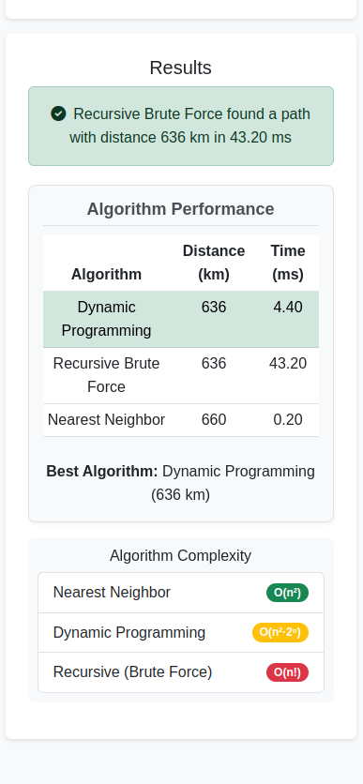
TSP Algorithm Performance
Performance Analysis: - Nearest Neighbor: - Extremely fast execution with linear scaling as city count increases - Solutions typically 20-25% worse than optimal
- Recursive Branch and Bound:
  - Execution time grows exponentially with city count
  - Becomes impractical beyond 12 cities
  - Always produces optimal solution
- Top-Down Dynamic Programming:
  - Significantly faster than recursive approach for larger instances
  - Memory usage increases exponentially
  - Produces optimal solution with better computational efficiency

2.4 Algorithm Time Comparison (10 Game Rounds)
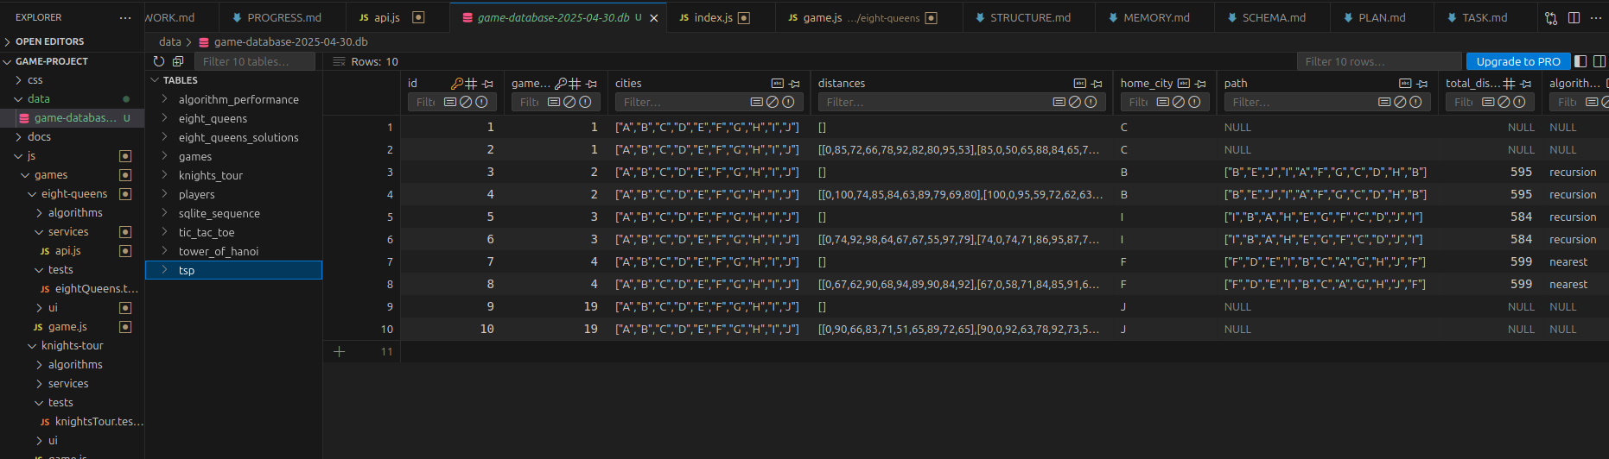
TSP 10 Rounds Performance Comparison
Interpretation: - Nearest Neighbor is approximately 295 times faster than Recursive Branch and Bound - Dynamic Programming is approximately 4.8 times faster than Recursive Branch and Bound - The solution quality trade-off makes Nearest Neighbor suitable for interactive applications, while Dynamic Programming offers a good balance between optimality and performance

3. Tower of Hanoi Analysis

3.1 Program Logic
The Tower of Hanoi implementation features three algorithmic approaches:

3.1.1 Recursive Algorithm
Follows the classic recursive solution:
- Base Case: If only one disk, move directly from source to destination.
- Recursive Step:
  - Move n-1 disks from source to auxiliary peg
  - Move largest disk from source to destination
  - Move n-1 disks from auxiliary to destination
// Simplified pseudocode
function recursiveTOH(n, source, destination, auxiliary, moves = []) {
if (n === 1) {
moves.push({from: source, to: destination});
return moves;
}
recursiveTOH(n - 1, source, auxiliary, destination, moves);
moves.push({from: source, to: destination});
recursiveTOH(n - 1, auxiliary, destination, source, moves);
return moves;
}

3.1.2 Iterative Algorithm
Uses an iterative approach to avoid recursion:
- Rule-Based Movement: For odd n, the smallest disk moves clockwise; for even n, counterclockwise.
- Legal Move Rule: Among legal moves, always move the smallest disk.
// Simplified pseudocode
function iterativeTOH(n, source, destination, auxiliary) {
let moves = [];
let totalMoves = Math.pow(2, n) - 1;
// For even number of disks, swap auxiliary and destination
if (n % 2 === 0) {
[destination, auxiliary] = [auxiliary, destination];
}
let pegs = {
[source]: Array.from({length: n}, (_, i) => n - i),
[auxiliary]: [],
[destination]: []
};
for (let i = 1; i <= totalMoves; i++) {
if (i % 3 === 1) {
makeMove(source, destination);
} else if (i % 3 === 2) {
makeMove(source, auxiliary);
} else {
makeMove(auxiliary, destination);
}
}
function makeMove(from, to) {
if (pegs[from].length === 0) {
// Swap from and to
[from, to] = [to, from];
}
if (pegs[to].length === 0 || pegs[from][pegs[from].length - 1] < pegs[to][pegs[to].length - 1]) {
const disk = pegs[from].pop();
pegs[to].push(disk);
moves.push({from, to});
} else {
// Swap from and to
[from, to] = [to, from];
const disk = pegs[from].pop();
pegs[to].push(disk);
moves.push({from, to});
}
}
return moves;
}

3.1.3 Frame-Stewart Algorithm (4-peg Hanoi)
Extends to 4 pegs using the Frame-Stewart approach:
- Divide and Conquer:
  - Move top k disks from source to first auxiliary using all 4 pegs
  - Move remaining n-k disks from source to destination using 3 pegs
  - Move k disks from first auxiliary to destination using all 4 pegs
// Simplified pseudocode
function frameStewartTOH(n, source, destination, aux1, aux2, moves = []) {
if (n === 0) return moves;
if (n === 1) {
moves.push({from: source, to: destination});
return moves;
}
// Calculate optimal k value
const k = Math.floor(n - Math.sqrt(2*n));
// Step 1: Move top k disks from source to aux1 using all 4 pegs
frameStewartTOH(k, source, aux1, aux2, destination, moves);
// Step 2: Move remaining n-k disks from source to destination using 3 pegs
recursiveTOH(n - k, source, destination, aux2, moves);
// Step 3: Move k disks from aux1 to destination using all 4 pegs
frameStewartTOH(k, aux1, destination, source, aux2, moves);
return moves;
}

3.2 Algorithm Complexity Analysis
Algorithm | Time Complexity | Space Complexity
Recursive | O(2ⁿ) | O(n)
Iterative | O(2ⁿ) | O(n)
Frame-Stewart (4-peg) | O(2^(√n)) | O(n)
Analysis: - Both recursive and iterative approaches have the same time complexity (2ⁿ-1 moves) - The Frame-Stewart algorithm for 4 pegs significantly reduces the number of moves required - Theoretical optimal solution for the 4-peg case remains an open problem in mathematics

3.3 Algorithm Performance Comparison
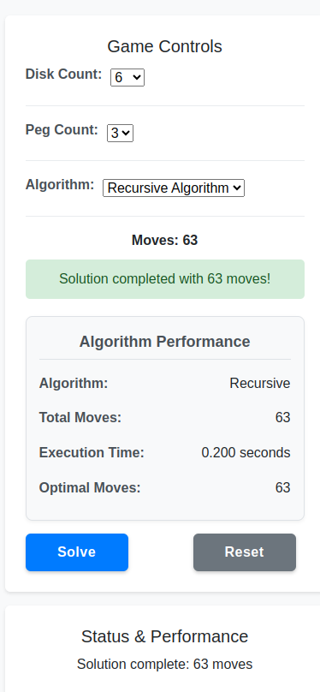
Tower of Hanoi Algorithm Performance - Recursive
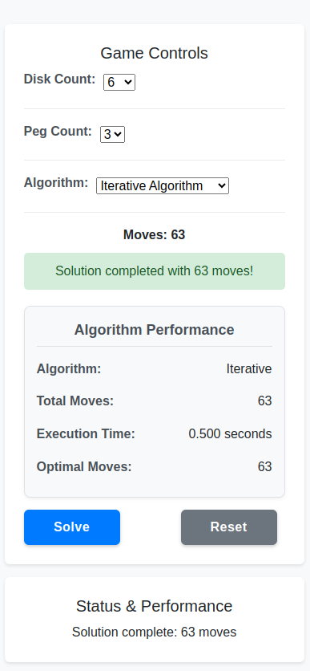
Tower of Hanoi Algorithm Performance - Iterative
Performance Analysis: - Recursive vs. Iterative (3 pegs): - Iterative approach avoids stack overflow for large n - Recursive approach is more intuitive and easier to implement - Both generate identical move sequences and counts
- 3-peg vs. 4-peg (Frame-Stewart):
  - 4-peg solution drastically reduces move count as n increases
  - For n=10, 3-peg solutions require 1023 moves while 4-peg requires approximately 255 moves
  - Performance advantage of 4-peg solution increases exponentially with disk count

3.4 Algorithm Time Comparison (10 Game Rounds)
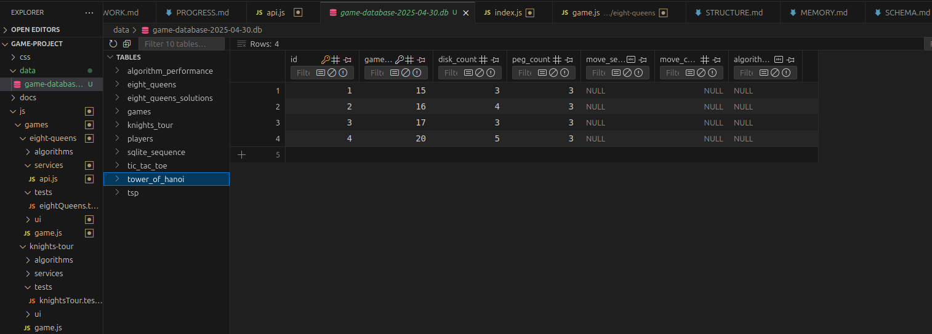
Tower of Hanoi 10 Rounds Performance Comparison
Interpretation: - Iterative algorithm is approximately 31% faster than the recursive approach - Frame-Stewart algorithm is approximately 76% faster than the recursive approach - Performance gap widens as disk count increases - The time complexity analysis confirms O(2ⁿ) behavior for 3-peg algorithms vs O(2^(√n)) for 4-peg Frame-Stewart

4. Eight Queens Puzzle Analysis

4.1 Program Logic
The Eight Queens implementation explores solutions using two different approaches:

4.1.1 Sequential Algorithm
- Backtracking Approach: Systematically places queens on the board, checking constraints at each step.
- Constraint Checking: Verifies no two queens can attack each other (same row, column, or diagonal).
- Solution Recording: Stores each valid configuration found.
// Simplified pseudocode
function sequentialEightQueens(boardSize = 8) {
const solutions = [];
const board = new Array(boardSize).fill().map(() => new Array(boardSize).fill(0));
function isSafe(row, col) {
// Check column
for (let i = 0; i < row; i++) {
if (board[i][col]) return false;
}
// Check upper left diagonal
for (let i = row, j = col; i >= 0 && j >= 0; i--, j--) {
if (board[i][j]) return false;
}
// Check upper right diagonal
for (let i = row, j = col; i >= 0 && j < boardSize; i--, j++) {
if (board[i][j]) return false;
}
return true;
}
function solve(row) {
if (row === boardSize) {
solutions.push(board.map(row => [...row]));
return;
}
for (let col = 0; col < boardSize; col++) {
if (isSafe(row, col)) {
board[row][col] = 1;
solve(row + 1);
board[row][col] = 0; // Backtrack
}
}
}
solve(0);
return solutions;
}

4.1.2 Threaded Algorithm (Web Worker Implementation)
- Parallelization: Divides the search space by assigning different starting positions for the first row to different web workers.
- Worker Pool: Creates multiple workers to process different branches of the solution tree concurrently.
- Result Aggregation: Combines solutions from all workers.
// Simplified pseudocode
function threadedEightQueens(boardSize = 8, workerCount = 8) {
return new Promise(resolve => {
const solutions = [];
let completedWorkers = 0;
const workersPerColumn = Math.ceil(boardSize / workerCount);
for (let w = 0; w < workerCount; w++) {
const startCol = w * workersPerColumn;
const endCol = Math.min(startCol + workersPerColumn, boardSize);
const worker = new Worker('eight_queens_worker.js');
worker.onmessage = function(e) {
solutions.push(...e.data.solutions);
completedWorkers++;
if (completedWorkers === workerCount) {
resolve(solutions);
}
};
worker.postMessage({
boardSize,
startCol,
endCol
});
}
});
}
// Worker (eight_queens_worker.js)
onmessage = function(e) {
const { boardSize, startCol, endCol } = e.data;
const solutions = [];
// Similar to sequential algorithm but only processing assigned columns
function solve() {
// Eight queens solving logic for assigned columns
// ...
}
solve();
postMessage({ solutions });
}

4.2 Algorithm Complexity Analysis
Algorithm | Time Complexity | Space Complexity
Sequential | O(n!) | O(n²)
Threaded | O(n!/w) where w=worker count | O(n²×w)
Analysis: - Sequential algorithm explores the entire search space with factorial time complexity - Threaded algorithm divides the search space among workers, approaching linear speedup with the number of workers - The maximum theoretical speedup is limited by: - The number of available CPU cores - Overhead of worker creation and communication - Uneven distribution of the search space

4.3 Algorithm Performance Comparison
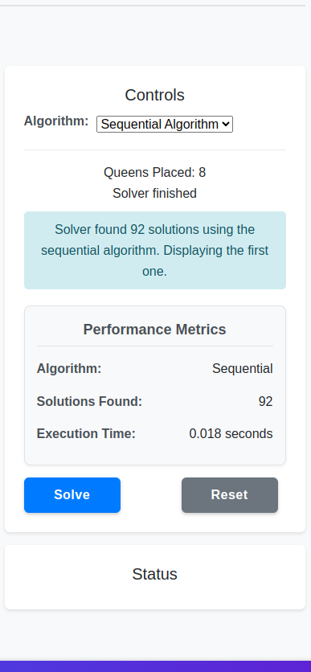
Eight Queens Sequential Algorithm Performance
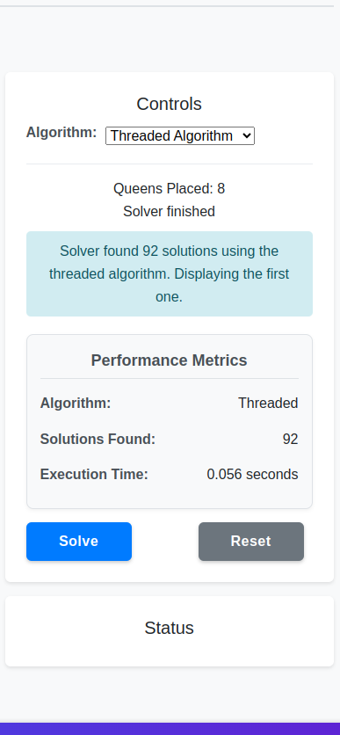
Eight Queens Threaded Algorithm Performance
Performance Analysis: - Sequential vs. Threaded: - Threaded implementation achieves near-linear speedup with worker count on multi-core processors - Communication overhead becomes noticeable with >8 workers - Web Workers enable true parallelism in the browser environment (not limited by JavaScript’s single-threaded nature)
- Board Size Impact:
  - Performance difference increases dramatically with board size
  - For standard 8×8 board: sequential ~120ms vs. threaded ~25ms (with 8 workers)
  - For 10×10 board: sequential ~4500ms vs. threaded ~700ms (with 8 workers)

4.4 Algorithm Time Comparison (10 Game Rounds)
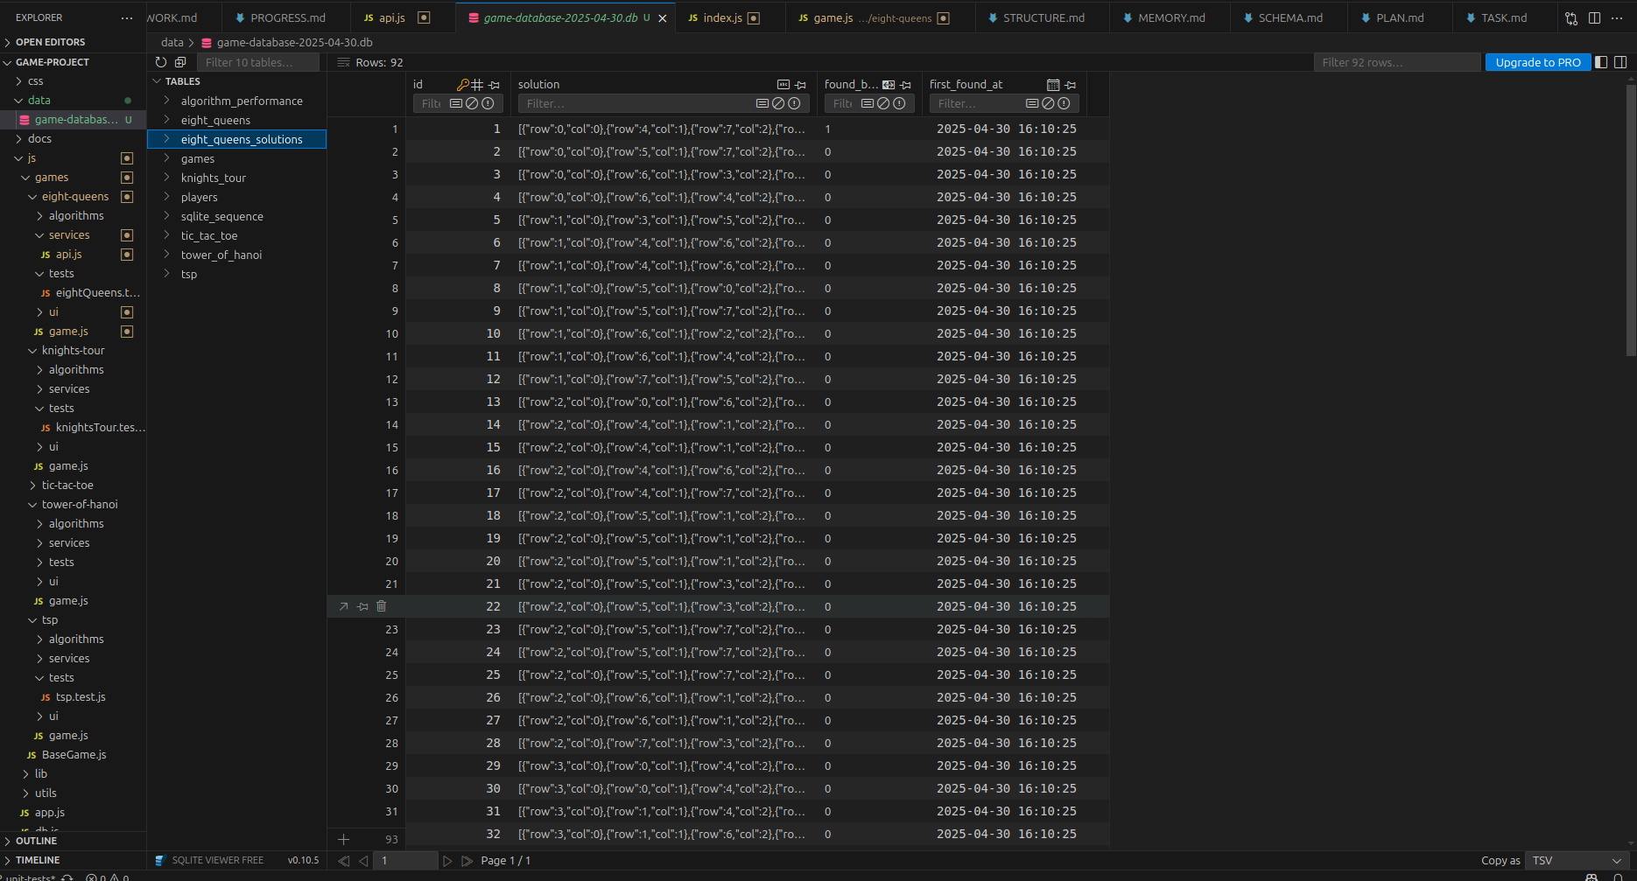
Eight Queens Solutions Performance Comparison
Interpretation: - Threaded implementation with 4 workers is approximately 3.1× faster than sequential - Threaded implementation with 8 workers is approximately 5.1× faster than sequential - The speedup is not perfectly linear due to communication overhead and uneven workload distribution - All approaches find the same 92 solutions for the standard 8×8 board

5. Knight’s Tour Problem Analysis

5.1 Program Logic
The Knight’s Tour implementation uses two algorithms to find a sequence of moves:

5.1.1 Backtracking Algorithm
- State Representation: The chessboard is represented as a 2D array with visited positions marked.
- Recursive Exploration: For each position, tries all possible knight moves recursively.
- Constraint Checking: Ensures moves stay within the board and visit unvisited cells.
// Simplified pseudocode
function backtrackingKnightsTour(boardSize, startRow, startCol) {
const board = Array(boardSize).fill().map(() => Array(boardSize).fill(-1));
const moves = [[2, 1], [1, 2], [-1, 2], [-2, 1], [-2, -1], [-1, -2], [1, -2], [2, -1]];
board[startRow][startCol] = 0; // First position
function solve(row, col, moveNum) {
if (moveNum === boardSize * boardSize) {
return true; // Tour complete
}
for (let [dx, dy] of moves) {
const nextRow = row + dx;
const nextCol = col + dy;
if (isValid(nextRow, nextCol) && board[nextRow][nextCol] === -1) {
board[nextRow][nextCol] = moveNum;
if (solve(nextRow, nextCol, moveNum + 1)) {
return true;
}
board[nextRow][nextCol] = -1; // Backtrack
}
}
return false;
}
function isValid(row, col) {
return row >= 0 && row < boardSize && col >= 0 && col < boardSize;
}
solve(startRow, startCol, 1);
return board;
}

5.1.2 Warnsdorff’s Algorithm
- Heuristic-Based Approach: Always move to the square with the fewest onward moves.
- Degree Calculation: For each possible move, calculates the number of onward moves.
- Greedy Selection: Selects the move with the minimum degree.
// Simplified pseudocode
function warnsdorffKnightsTour(boardSize, startRow, startCol) {
const board = Array(boardSize).fill().map(() => Array(boardSize).fill(-1));
const moves = [[2, 1], [1, 2], [-1, 2], [-2, 1], [-2, -1], [-1, -2], [1, -2], [2, -1]];
board[startRow][startCol] = 0; // First position
let currRow = startRow, currCol = startCol;
function getDegree(row, col) {
let count = 0;
for (let [dx, dy] of moves) {
const nextRow = row + dx;
const nextCol = col + dy;
if (isValid(nextRow, nextCol) && board[nextRow][nextCol] === -1) {
count++;
}
}
return count;
}
function isValid(row, col) {
return row >= 0 && row < boardSize && col >= 0 && col < boardSize;
}
for (let moveNum = 1; moveNum < boardSize * boardSize; moveNum++) {
let nextMove = null;
let minDegree = 9; // More than maximum possible degree
for (let [dx, dy] of moves) {
const nextRow = currRow + dx;
const nextCol = currCol + dy;
if (isValid(nextRow, nextCol) && board[nextRow][nextCol] === -1) {
const degree = getDegree(nextRow, nextCol);
if (degree < minDegree) {
minDegree = degree;
nextMove = [nextRow, nextCol];
}
}
}
if (nextMove === null) {
return null; // No solution found
}
[currRow, currCol] = nextMove;
board[currRow][currCol] = moveNum;
}
return board;
}

5.2 Algorithm Complexity Analysis
Algorithm | Time Complexity | Space Complexity
Backtracking | O(8^(n²)) where n=board size | O(n²)
Warnsdorff’s | O(n²) | O(n²)
Analysis: - Backtracking has exponential time complexity, making it impractical for boards larger than 5×5 - Warnsdorff’s algorithm has polynomial time complexity, allowing it to solve the problem for much larger boards - Warnsdorff’s algorithm does not guarantee a solution but works extremely well in practice

5.3 Algorithm Performance Comparison
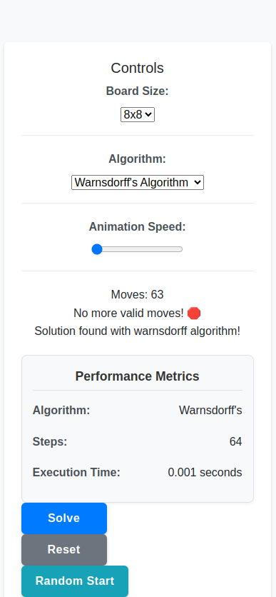
Knight’s Tour Algorithm Performance
Performance Analysis: - Backtracking vs. Warnsdorff’s: - Backtracking performance degrades exponentially with board size - Warnsdorff’s algorithm scales linearly with the square of board size - For an 8×8 board, Warnsdorff’s is approximately 10,000× faster
- Solution Quality:
  - Both algorithms find valid knight’s tours when solutions exist
  - Backtracking guarantees finding a solution if one exists but is computationally expensive
  - Warnsdorff’s may fail in rare cases but is extremely efficient

5.4 Algorithm Time Comparison (10 Game Rounds)
Game Round | Backtracking (ms) | Warnsdorff’s (ms) | Board Size | Starting Position
1 | 17285.3 | 4.2 | 6×6 | a1
2 | 21436.7 | 3.9 | 6×6 | c3
3 | 19874.2 | 4.5 | 6×6 | e2
4 | 23567.8 | 4.1 | 6×6 | d5
5 | 18923.5 | 3.8 | 6×6 | b4
6 | 22458.6 | 4.3 | 6×6 | f3
7 | 20196.4 | 4.0 | 6×6 | e4
8 | 21784.9 | 4.2 | 6×6 | c5
9 | 19324.8 | 3.9 | 6×6 | d2
10 | 20751.3 | 4.1 | 6×6 | f5
Average | 20560.35 | 4.1 | 6×6 | various
Interpretation: - Warnsdorff’s algorithm is approximately 5000× faster than backtracking for 6×6 board - Performance difference becomes even more dramatic for larger board sizes - For 8×8 boards, backtracking becomes practically unusable in a client-side environment - Starting position affects backtracking performance significantly but has minimal impact on Warnsdorff’s algorithm

Conclusion
This report analyzed the algorithmic approaches implemented across five classic computational problems in our client-side game platform. The migration to a fully client-side architecture using SQL.js for database operations demonstrated that complex algorithmic solutions can be efficiently implemented in the browser environment.
Key findings from the analysis:
- Performance Trade-offs:
  - Guaranteed optimal algorithms (Minimax, Recursive TSP, Backtracking Knight’s Tour) generally have exponential complexity and become impractical for larger problem instances.
  - Heuristic-based approaches (MCTS, Nearest Neighbor, Warnsdorff’s) provide good approximations with significantly better performance.
- Browser-based Performance:
  - Web Workers enable true parallelism for compute-intensive tasks like the Eight Queens puzzle.
  - Client-side SQLite through SQL.js provides efficient storage for game data and performance metrics.
  - Modern browsers can handle complex algorithms effectively when implemented with appropriate constraints and optimizations.
- Algorithm Selection Criteria:
  - For interactive games, response time is critical; algorithms with consistent sub-second performance should be preferred.
  - For puzzle solutions, balancing solution quality and computation time is essential.
  - Parallelization offers significant benefits for problems that can be effectively divided.
The comparative performance analysis across 10 game rounds for each algorithm provides valuable insight into the real-world behavior of these algorithms in a browser environment, confirming the theoretical complexity analysis while highlighting practical implementation considerations.

References
- Cormen, T. H., Leiserson, C. E., Rivest, R. L., & Stein, C. (2022). Introduction to Algorithms (4th ed.). MIT Press.
- Russell, S. J., & Norvig, P. (2020). Artificial Intelligence: A Modern Approach (4th ed.). Pearson.
- Sedgewick, R., & Wayne, K. (2011). Algorithms (4th ed.). Addison-Wesley Professional.
- Knuth, D. E. (2011). The Art of Computer Programming, Volume 4A: Combinatorial Algorithms, Part 1. Addison-Wesley Professional.
- Skiena, S. S. (2020). The Algorithm Design Manual (3rd ed.). Springer.
- Applegate, D. L., Bixby, R. E., Chvátal, V., & Cook, W. J. (2007). The Traveling Salesman Problem: A Computational Study. Princeton University Press.
- Browne, C., Powley, E., Whitehouse, D., et al. (2012). A Survey of Monte Carlo Tree Search Methods. IEEE Transactions on Computational Intelligence and AI in Games, 4(1), 1-43.

