Portable Autonomous Application (*P.A.A*.)

MINIMUM SYSTEM REQUIREMENTS

RAM: 2Gb or more

PROCESSOR: 2.0

SYSTEM TYPE: 64-Bit or 32-Bit

MS-Excel installed and Activated

Macros Enabled (see FIRST THINGS FIRST for details)

OS: Windows Vista, Windows 7 above

***Note:*** *We Suggest a Dedicated System for this application to avoid process interference or Data compromise. Although the application has the ability to react to these scenarios in order to protect and maintain data integrity.*

PORTABLE AUTONOMOUS APPLICATION

This is a non-installable customized autonomous application, re-usable lightweight, portable to be moved around and has faster processing speed than conventional applications.

Unlike conventional applications which once installed, you can’t move the database neither can you move the application from one computer to another thereby limiting your work to only one computer but this **“Portable Autonomous Application (PAA)”** gives you freedom and flexibility in use-case.

This application can be moved from computer to computer without affecting data integrity, including Artificial Intelligence (AI) Algorithms and processes which makes your work easier through multitasking techniques. She optimizes performance by occasionally reducing its size over time in lesser ratio to database mass, this makes her sustain its lightweight capability.

She is a user-friendly application, asks for confirmation for actions before executing them thereby preventing the users from executing the wrong command.

This Portable Autonomous Application is reusable; programmed to repeat processes forever or until the User decides to retire Her. She also has the ability to re-program herself based on User’s Input and come up with complex and dynamic values/results, including ability to search across various embedded databases using different search criteria.

She can extract databases to root folder (Same folder as the app) i.e., if the app is stored in your documents folder, every extracted database will be saved in your documents folder for easy accessibility.

Every ***PAA*** has a backend thereby giving the user substantial amount of control over her, whereby you can setup some workable parameters for processes and they are all adjustable whenever needed.

This Application can take more than 10,000 records and it still maintains its size optimization and speed. Over 4,320 Work Hours was invested in this application.

FIRST THINGS FIRST

To use this application macro must be enabled; below is the process to enable macros in MS-Excel

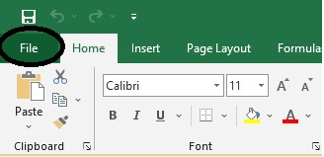

On your MS-Excel Interface click on ‘File’ at the top left

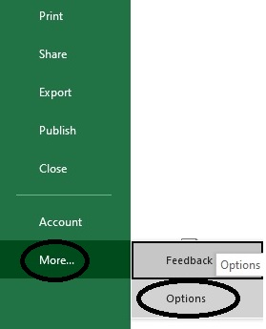

Click on ‘More’ -> ‘Options’

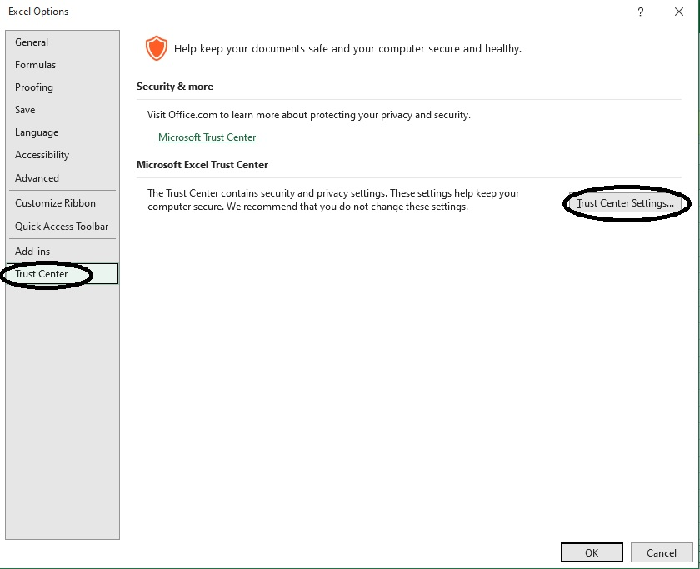

On Excel Options interface Click on ‘Trust Center’ and click on ‘Trust Center Settings’

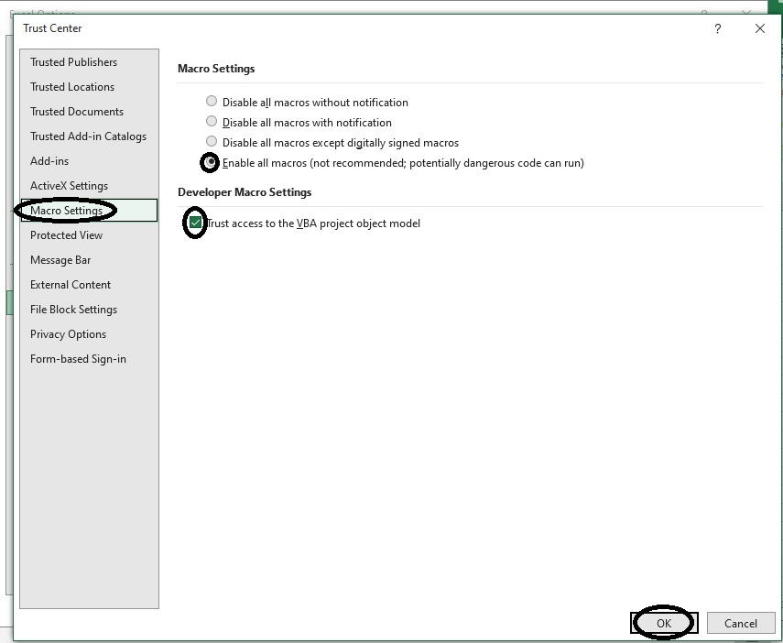

On the ‘Trust Center’ Interface click on ‘Macro Settings’ on the left pane the on the main Pane select the radio button named “Enable all macros” and tick the select box tagged “Trust access to the VBA Project object model” and click ‘OK’

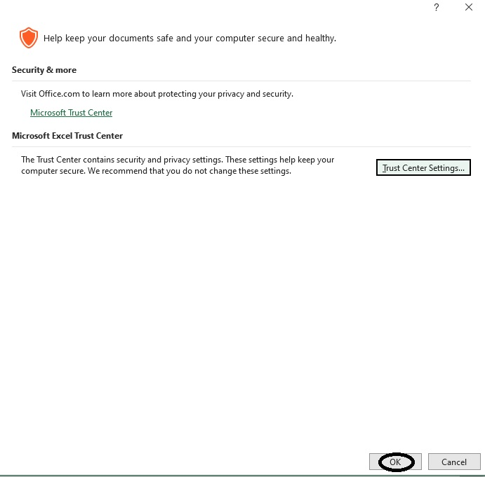

On the Excel Options page click “OK”

If you have done this, it means Macro has been enabled in MS-Excel

GETTING STARTED

TUCK SHOP

This is the Interface where you’ll need to register students for the tuckshop (Voucher).

Student’s details can be edited by double clicking on the record you want to edit or update, details of the record will be displayed in the respective fields for; Registration number, Student’s Name, Class, Session and Voucher Balance. Make the necessary changes and click on “Save”.

To delete a record, kindly click on the record in the database below and click “Delete” Button.

Clearing the entire database has been made easy with one button “Clear Database” and this is located below the Database on the interface.

INVENTORY

The TSS has it inbuilt Inventory Management System (IMS), products are entered in the store for proper record keeping and analysis. They consist of:

Product Name

Location of the product in the store

Product Description

Cost per unit of the product

Quantity of stock

Re-Order Level (what level should the product reach before it is considered out of stock?)

Reorder Quantity (when out of stock, how many units of the product should be restocked?).

You can search through products by Name (as registered in the database). Product details can be edited by double clicking on the record you want to edit or update, details of the record will be displayed in the respective fields Make the necessary changes and click on “Save”.

To delete a record, kindly click on the record in the database below and click “Delete” Button.

Clearing the entire database can be done using one button “Clear Database”.

Record in the database can be extracted to the application root folder for easy accessibility.

SELLING POINT

On the left hand side is the database showing list of products in store (Name and Quantity), and below are fields for the product details.

Also if the product is out of stock it will notify you on adding to cart, meaning, you won’t be able to sell out that product neither will you able to add it to cart.

To execute a student’s purchase order you must search for the student either by name or registration number (We advise registration number because no two students can have the same registration number).

Search results will be displayed on the appropriate fields on the right hand side, showing the registration number, Student’s name, Class and Voucher Balance.

Click on the product to sell and product details will be displayed, showing the product name, enter the number of units to sell and the total value will be displayed in the field below. Click ‘Add to Cart’ to add your product to cart.

On adding a product to cart the app automatically sums up the total value of products in the cart which can be seen below the cart database.

To delete a product from cart, click on the product in the cart database and click “Delete from Cart”, the product will be deleted successfully from the cart.

To reset all forms to blank, click on “Reset” button.

CHECK-OUT

To checkout, double-click on the product in the cart and click on “Check out”, by doing this, the number of sold out units will be deducted from inventory and the value will be deducted from the student’s balance.

After the last product has been checked out from the inventory, the fields will be cleared in preparation for the next student to be attended to.

TRANSACTION HISTORY

This records all activities in the application, ranging from sales, adding to cart, updating cart, registering new students, updating student’s balance.

STATISTICS

This interface is meant to help users keep track of their products and sales performance. It shows the total number of tuck shop subscribers, total voucher balance, total number of products in store, total cost of products in the store, units left in the tore per product (product has to be selected from the combo box) total number of units left in the store per product (product has to be selected from the combo box)