ZETDC WIND ASSESSMENT SYSTEM  System overview and architecture | 
1 SYSTEM DESCRIPTION

A single view of Zimbabwe’s wind assessment information
The ZETDC Wind Assessment System is a browser-based decision-support tool that brings wind-resource information into one clear operational view. The current prototype consolidates measurements from eight ZETDC wind assessment points and can also display a separately labelled Open-Meteo feed for comparison. It enables managers, analysts and renewable-energy teams to see where each point is located, review recent conditions, compare sites and regions, and follow changes over time without working directly with raw files.
The system turns wind speed, wind direction, temperature, humidity and pressure records into practical indicators such as air density, data quality, availability and estimated wind-energy potential. It supports standard reporting, site comparison, historical review and short- to medium-term planning forecasts. Users can filter the information, save report views and export selected results for further review. Access is role-based, with administration functions reserved for authorised users.
Important: Power, energy and revenue are engineering estimates based on configured assumptions; they are not actual turbine SCADA generation. Forecasts are provisional planning indicators and include uncertainty ranges.

Main functions
Monitor | Shows eight wind assessment points on a Zimbabwe map with current status and key measurements.
Analyse | Summarises wind speed, direction, temperature, humidity, pressure, air density, availability and data quality.
Estimate | Calculates indicative power, energy and revenue from measured wind using configurable engineering assumptions.
Compare | Filters and compares results by source, ZETDC region, province, point and time window.
Forecast | Provides 7-, 30-, 90- or 180-day planning views with upper and lower wind ranges.
Report | Provides standard reports, advanced analytics, historical trends, saved views, printing and CSV/JSON export.
Administer | Allows authorised administrators to review data coverage, manage users and maintain calculation settings.

2 SYSTEM ARCHITECTURE

How the system works — in plain language
The architecture is a simple information journey: measurements enter the system, are checked and organised, converted into useful indicators, and then presented to authorised users.
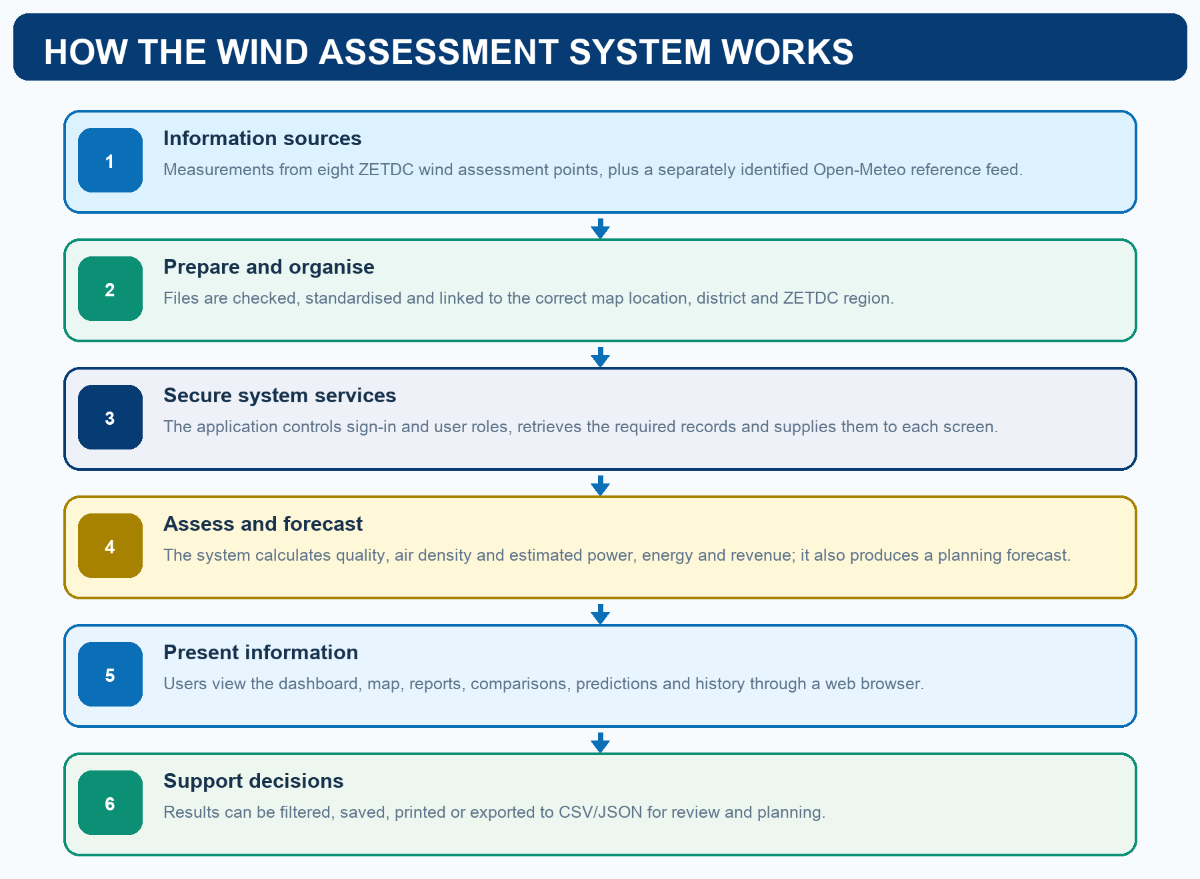

What this means for a user
What happens | Plain-language meaning
Data is collected | The system uses readings from the eight assessment points; external live data remains clearly identified as a separate source.
Information is prepared | Different files are converted into one consistent format and attached to the correct geographic area.
Calculations are applied | The system converts measurements into summaries and indicative energy results using documented settings.
Results are delivered | A secure web portal shows maps, charts, reports, forecasts and history appropriate to the user’s role.
Decisions are supported | Users can compare locations, identify promising wind conditions, inspect data quality and export evidence for planning.

Current prototype boundaries
- ZETDC mast readings are currently imported from supplied data files rather than streamed directly from field instruments.
- The sign-in service currently uses prototype accounts; connection to ZETDC Single Sign-On is the intended production step.
- A production database is included in the deployment design, while the current prototype reads its normalised wind dataset from application files.

