WIND TURBINE MONITORING, ANALYTICS &  PREDICTIVE INTELLIGENCE PLATFORM  System Overview & Technical Architecture | 
Document | Repository implementation | Version | Date | Status
Technical architecture | ZETDC Wind Assessment System v0.1.0 | 1.0 | 18 Sep 2026 | Prototype / design baseline
1 System Overview
Purpose. The implemented application is a browser-based wind-resource assessment and planning prototype for eight geographically distributed ZETDC measurement points. It centralises 75,224 imported mast observations from 563 CSV files, enriches them with geographic context and engineering calculations, and gives managers and technical teams one place to review wind conditions, data coverage, comparative site potential, history and forecasts.
Scope accuracy: The repository does not yet ingest turbine SCADA or condition-monitoring data. “Power”, “energy”, “capacity factor” and “revenue” are calculated estimates from mast wind and configured assumptions—not metered turbine generation. Predictive maintenance, alarm workflows and failure-risk models are future capabilities.
1.1 Implemented functions
Module | What the current system provides
Overview dashboard | Fleet wind points, estimated energy, average wind, logger availability, regional status, site ranking and interactive Zimbabwe map.
Point monitoring | Latest and daily mast measurements: wind speed/min/max, direction, temperature, humidity and air pressure; calculated air density and point status.
Analysis & comparison | 1/7/30/90-day filters; point, province and ZETDC-region scope; mast, Open-Meteo and difference views; rankings, trends, tables and descriptive variance findings.
Forecasting | Transparent daily baseline for wind, air density and estimated power/energy over 7, 30, 90 or 180 days, with planning ranges and holdout MAE.
Reports & history | Measured-wind, environmental, derived-assessment and data-governance reports; monthly/daily drill-down; CSV, JSON, Excel-compatible, print, copy, email and share actions.
GIS & grid context | Leaflet/OpenStreetMap, local ZETDC region/district polygons, site markers, optional grid infrastructure overlay and nearest station/transformer distances.
Administration | Source provenance, wind-point register, forecast provenance, formula settings and administrator-only user creation.
1.2 Business and operational use
Operations & engineers  Review site measurements, logger coverage, environmental conditions and indicative energy potential. | Analysts & planners  Compare sites/regions, explore historical patterns and use six-month baseline scenarios for planning. | Management & administrators  Consume concise KPIs and reports; govern access, source provenance and calculation assumptions.
Overall value: The system converts fragmented measurement files into traceable wind-resource intelligence for monitoring, comparison, forecasting, reporting and investment or site-planning decisions, while clearly labelling derived estimates and prototype limitations.

2 High-Level System Architecture
Information flows through six implemented layers, from mast and external reference data to a secured web experience. Dashed components show the intended production evolution and are not active runtime services.
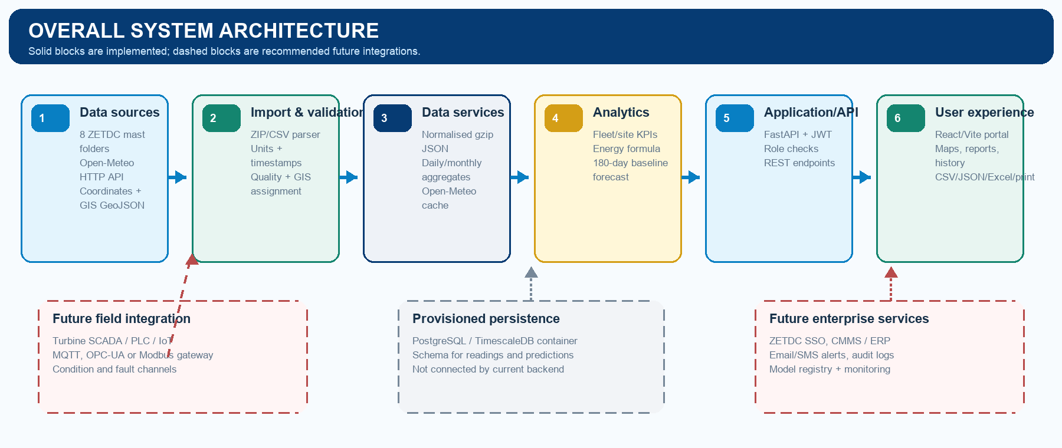
2.1 Turbine and data-acquisition layer
Source | Status | Acquisition behaviour
ZETDC mast archive | Implemented | ZIP containing exactly eight site folders and 563 CSV files; timestamped source readings are normally 10-minute samples.
Open-Meteo | Implemented | HTTPS REST request for 10 m wind, direction, temperature, humidity and pressure; one-day hourly data cached and refreshed daily.
GIS sources | Implemented | Supplied site coordinates plus local region, district and electricity-infrastructure GeoJSON; OpenStreetMap supplies base tiles.
SCADA / PLC / IoT | Future | No MQTT, OPC-UA, Modbus, WebSocket or turbine-controller connector exists in the repository.
2.2 Backend and application services
Area | Current implementation
Technology | Python 3.12 container; FastAPI 0.115.6, Uvicorn, Pydantic and PyJWT. Frontend calls JSON REST endpoints through Vite’s /api proxy.
Data processing | Archive validation, unit conversion (cm/s to m/s), duplicate-timestamp replacement, moist-air density, energy enrichment, per-point daily and monthly aggregation.
Business logic | Fleet/region/province KPIs, data completeness, capacity factor, revenue estimate, sudden derived-power-drop count, history and forecasts.
Scheduled service | An asynchronous startup task attempts one Open-Meteo refresh every 24 hours and falls back to a stale cache if the provider fails.
Service limits | There is no message broker, background job queue, notification service, audit service, model server or SCADA ingestion API.
2.3 REST API surface
Public health: GET /health. Authenticated data: /turbines, /live-wind, /metrics, /readings, /analytics/daily, /history and /predictions. Report configurations: GET/POST /reports. Administrator-only: GET/POST /admin/users and GET/PUT /admin/wind-energy.

3 Data, Integration and Frontend Architecture
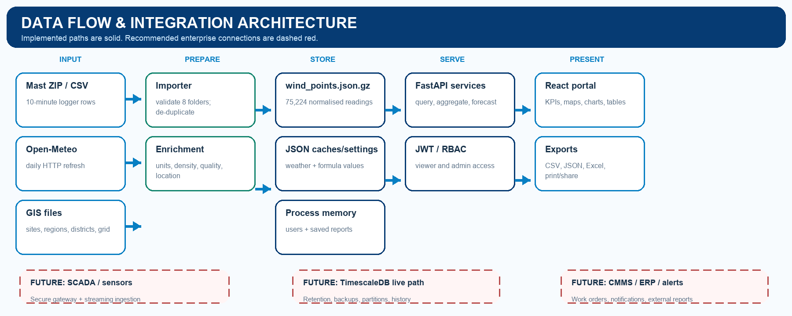
3.1 Operational and historical data architecture
Domain | Design and current behaviour
Wind-point master | 8 point identities, folders/logger IDs, coordinates, province/locality, assumed 2.5 MW assessment capacity, record coverage and status.
Telemetry | Wind speed/min/max/direction, temperature, humidity and pressure; derived density, power, energy, revenue, availability, capacity factor and quality.
Runtime storage | wind_points.json.gz is loaded into process memory at API startup; Open-Meteo and formula settings are JSON files. User additions and saved reports exist only in memory.
Historical access | Cached daily summaries serve up to 90 latest days per point; monthly history covers the full imported archive with point and day drill-down.
Provisioned database | Docker Compose starts PostgreSQL/TimescaleDB. Migration 001 defines provinces, turbines, readings hypertable, predictions, users and reports.
Critical distinction | No database client/ORM is installed and the FastAPI runtime does not use DATABASE_URL; the provisioned schema is a target, not active persistence.
3.2 Frontend, reporting and mapping
Frontend architecture  - React 18 + TypeScript + Vite 6; React Router routes overview, point detail, reports, analytics, compare, predictions, history and admin.  - Recharts renders line, area, bar and comparison visualisations; the data client caches identical GET requests for 60 seconds.  - Reports filter by data source, ZETDC region, province, wind point and latest 1/7/30/90 days; source and derived measures are labelled. | Geographic architecture  - Leaflet renders OpenStreetMap tiles and local ZETDC region boundaries; markers join directly to point IDs and coordinates.  - Server-side point-in-polygon logic assigns each site to authoritative region and district GeoJSON features.  - A local grid GeoJSON overlay shows stations, transformers, overhead lines and cables and calculates nearest-asset distances in the browser.
3.3 Reports and outputs
Implemented report groups are Measured Wind Summary, Environmental Summary, Derived Assessment Measures and Analysis Library. Advanced analytics adds wind/resource ranking, wind-to-power assessment, environmental conditions, estimated energy/revenue, data quality and source coverage. The comparison workspace supports point-versus-point and region-versus-region. History provides month and day registers. Exports include CSV and JSON forecasts, CSV analytics/comparisons, Excel-compatible historical workbooks, browser print/PDF, clipboard, email and operating-system share actions.

4 AI, Machine Learning and Predictive Architecture
Implementation status: The runtime contains a deterministic statistical forecast—not a trained AI/ML library. There is no Prophet, ARIMA/SARIMA, Random Forest, XGBoost, LSTM, anomaly model, LLM service, failure-probability model or remaining-useful-life model wired into the application.
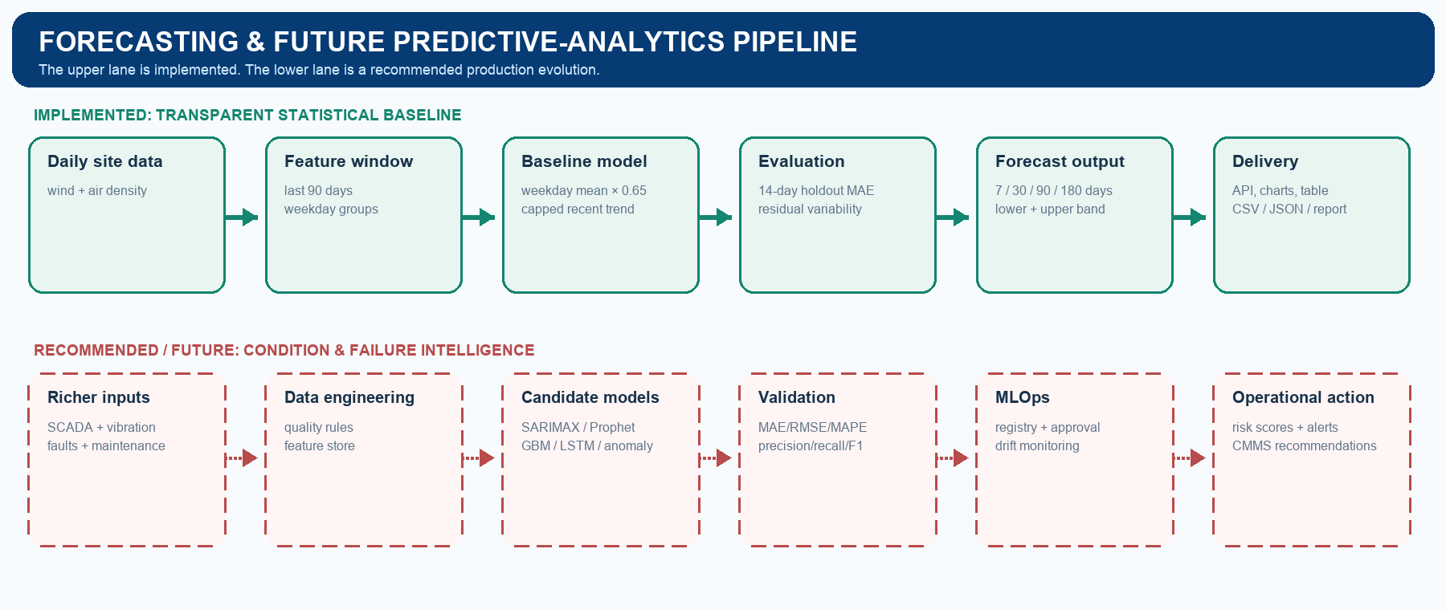
4.1 Implemented prediction pipeline
Stage | Technical behaviour
Inputs | Per-point historical wind and calculated air density. No rotor, vibration, gearbox, generator, fault or maintenance features exist.
Model | measured-weekday-baseline-1.0: daily averages; most recent 90 days; weekday means; 65% weekday adjustment; capped recent trend.
Outputs | Daily wind, air density, estimated power and energy for fleet and each point; API/UI limit is 1–180 days (six months).
Uncertainty | Planning half-width is the maximum of 0.25 m/s, validation MAE and 55% of recent standard deviation, multiplied by 1.64. It is not a calibrated probabilistic interval.
Validation | Last 14 daily observations are held out and compared with training weekday means; the displayed metric is wind-speed MAE. RMSE, MAPE and R² are not implemented.
Energy model | P = 0.5 × air density × rotor area × wind speed³ × Cp × efficiency, capped to assumed point capacity; energy = kW × interval hours / 1,000.
4.2 Forecast horizons and predictive-maintenance roadmap
Short term  7–30 days  Operational wind and indicative power planning; most defensible current use. | Medium / long term  90–180 days  Scenario/trend view only; uncertainty should widen and accuracy must be independently validated. | Predictive maintenance  Future  Requires validated SCADA condition signals, fault labels and work-order history before RUL, failure risk or anomaly alerts can be claimed.
Recommended production ML path: ingest SCADA/weather/maintenance history → establish data-quality and feature pipelines → train forecast and condition models → validate by time-based backtests → store versioned predictions → monitor drift → expose approved risk scores to dashboards, alerts and CMMS. Use MAE/RMSE/MAPE/R² for regression and precision/recall/F1 for labelled failure or anomaly classification.

5 Integration, Security and Deployment Architecture
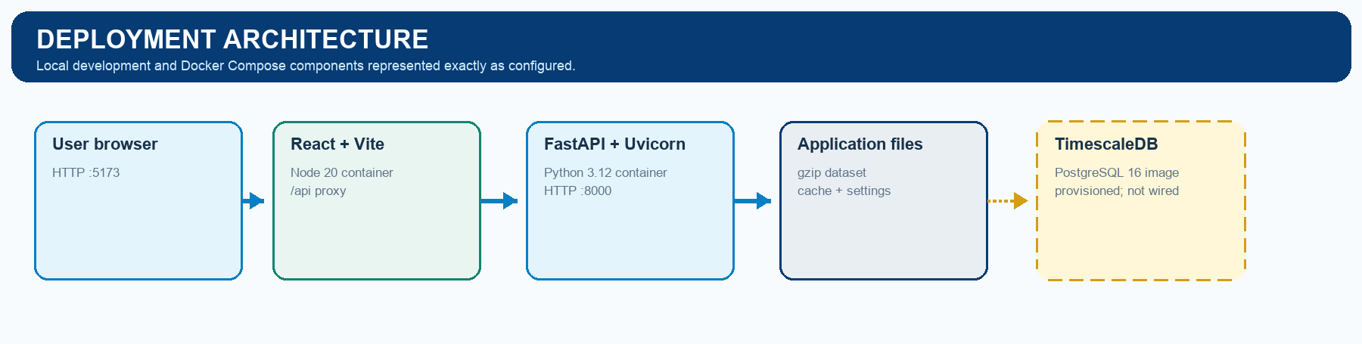
Local execution uses start-system.sh to create a Python virtual environment, install dependencies and launch Uvicorn plus Vite. Docker Compose defines frontend, backend and TimescaleDB containers. The frontend Dockerfile still runs the Vite development server; no reverse proxy, TLS termination, cloud configuration or CI/CD workflow is present.
5.1 Integration register
Integration | Status | Technical note
Mast ZIP/CSV import | Implemented | Offline/manual import into normalised runtime dataset
Open-Meteo weather | Implemented | HTTPS REST; daily cached one-day hourly response
OpenStreetMap / Leaflet | Implemented | Internet tile service; local boundaries and grid layers
PostgreSQL/TimescaleDB | Provisioned | Container and schema exist; application connection is not implemented
ZETDC SSO | Future | Documented replacement point is authenticate_ec_number()
SCADA / IoT gateways | Future | Define secure MQTT/OPC-UA/Modbus or REST ingestion after source assessment
CMMS, ERP, email/SMS | Future | No work-order, enterprise, alert or notification connector exists
5.2 Security architecture and production actions
Control area | Assessment
Implemented | Eight-hour HS256 JWT bearer tokens; authentication dependency on protected APIs; admin authorization guard; Pydantic request validation; localhost-only CORS; constrained numeric formula settings.
Prototype limitations | Hard-coded mock users/passwords; development JWT fallback; browser localStorage token; HTTP development servers; no password hashing, refresh/revocation, audit trail, rate limiting, secrets manager or backup policy.
Required for production | Integrate ZETDC SSO, rotate managed signing keys, enforce HTTPS, define viewer/admin permissions centrally, add audit logging and rate limits, connect durable database storage, encrypt backups and test recovery.
5.3 End-to-end system data flow
Example: A mast logger row is read from a site CSV → the importer parses its Africa/Harare timestamp, converts wind from cm/s to m/s, calculates completeness and attaches the site coordinates → the normalised record is stored in the compressed dataset → at API startup, air density and configured power/energy/revenue estimates are applied → daily/monthly aggregations and fleet/site KPIs are produced → JWT-protected REST endpoints return the selected source and scope → React renders maps, cards, charts, tables and exports. The current flow does not evaluate turbine faults or issue maintenance alerts.
5.4 Technical summary
The repository is a coherent, transparent wind-assessment prototype with strong source labelling, useful GIS/reporting workflows and an explainable six-month baseline. Production readiness depends on replacing file/in-memory persistence and mock identity, hardening deployment/security, and acquiring real turbine condition, fault and maintenance data before positioning the product as a real-time turbine-monitoring or predictive-maintenance platform.

