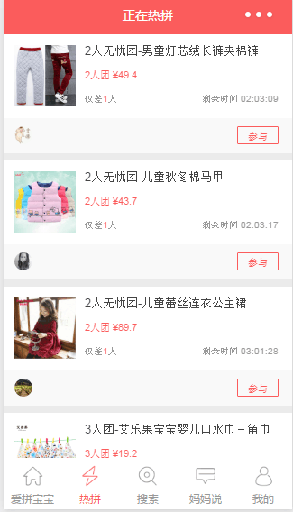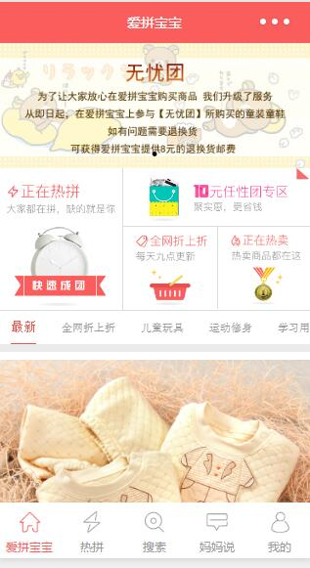

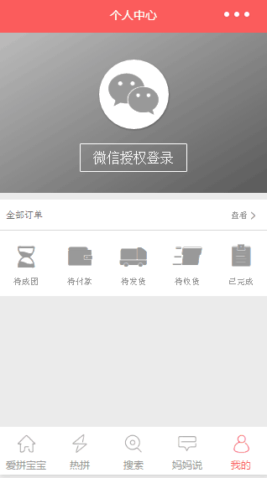



四个模块链接：

http://m.ipinbb.com/ipbb/static/images/home-01.png,

http://m.ipinbb.com/ipbb/static/images/home-02.png,

http://m.ipinbb.com/ipbb/static/images/home-03.png,

<http://m.ipinbb.com/ipbb/static/images/home-04.png>

后端数据接口：

全部数据:<http://m.ipinbb.com/ipbb/home/load?ti=-1&ft=Home>

导航栏：<http://service.ipinbb.com:8080/goodsService/getHomeTabs>

首页轮播图:http://service.ipinbb.com:8080/goodsService/getHomeBanner

http://m.ipinbb.com/ipbb/home/load