DOHK7CCB:

==========

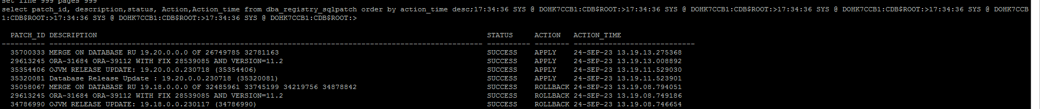

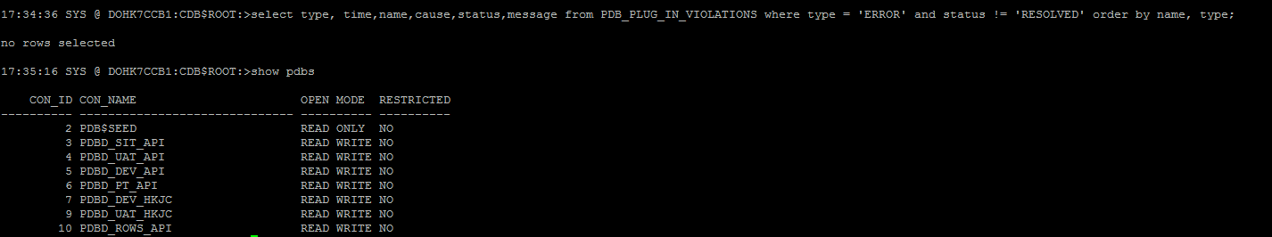

DOHk1RND:

=========

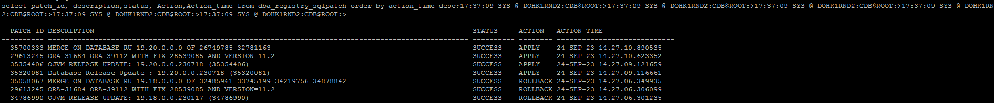

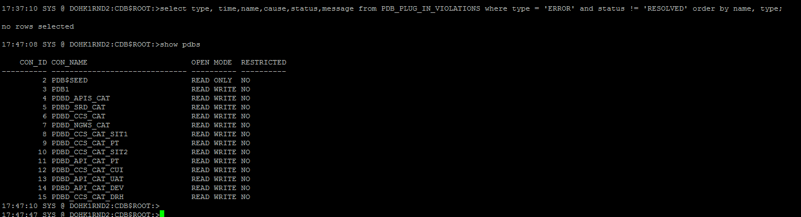

DOHK3S2B

=========

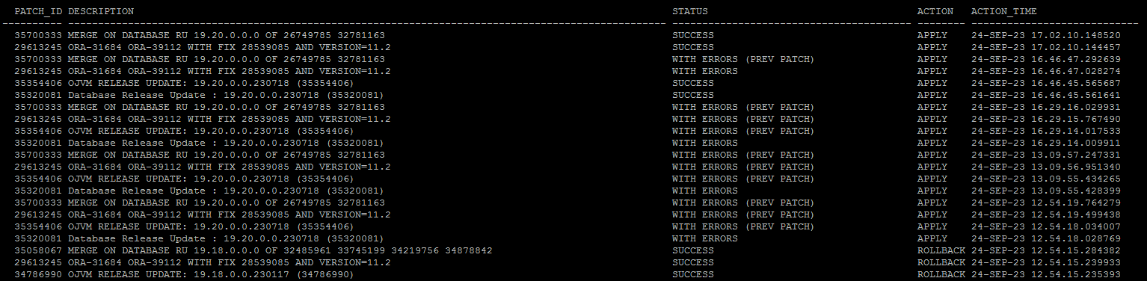

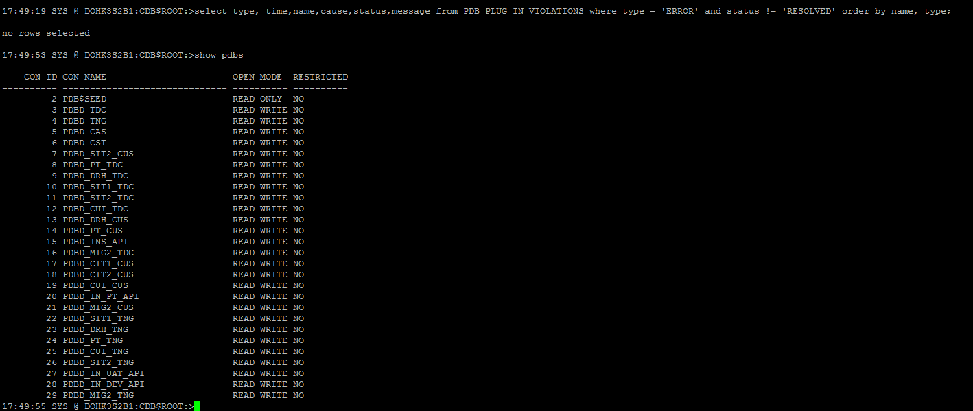

DOHK2S2B

==========

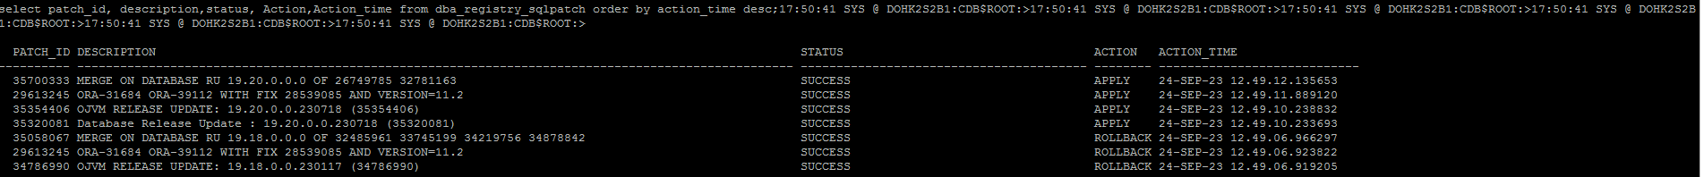

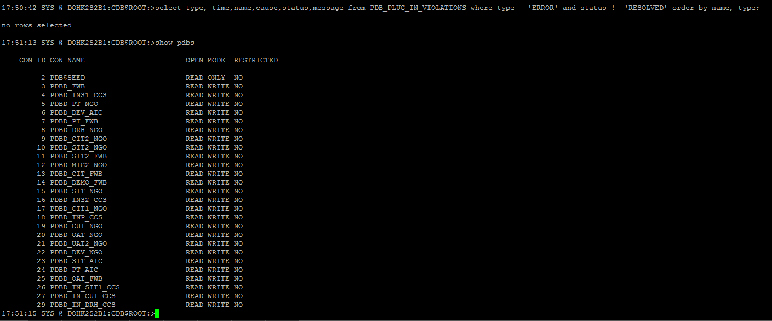

DOHK1SSC

=========

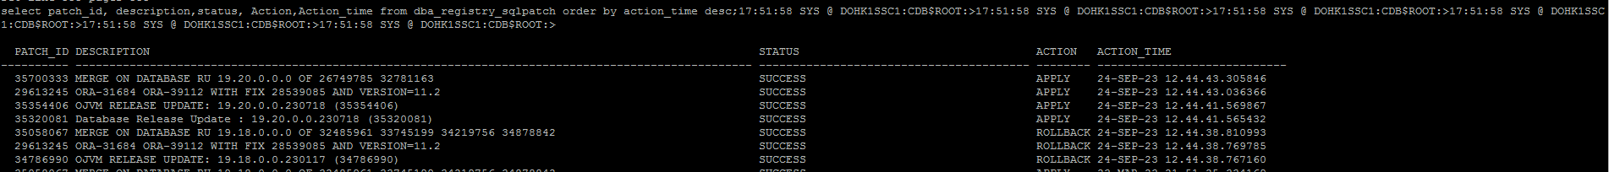

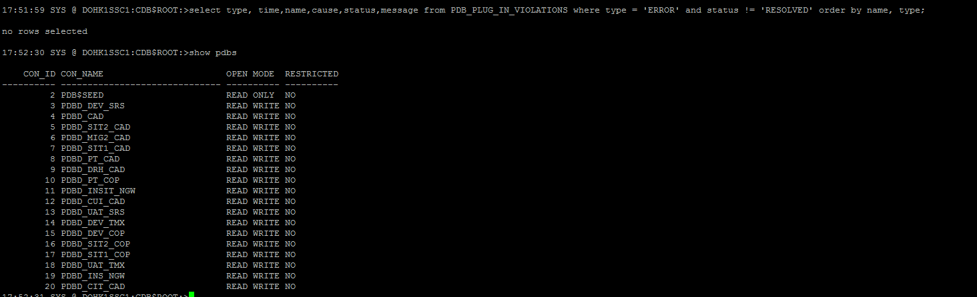

DOHK1RND

==========

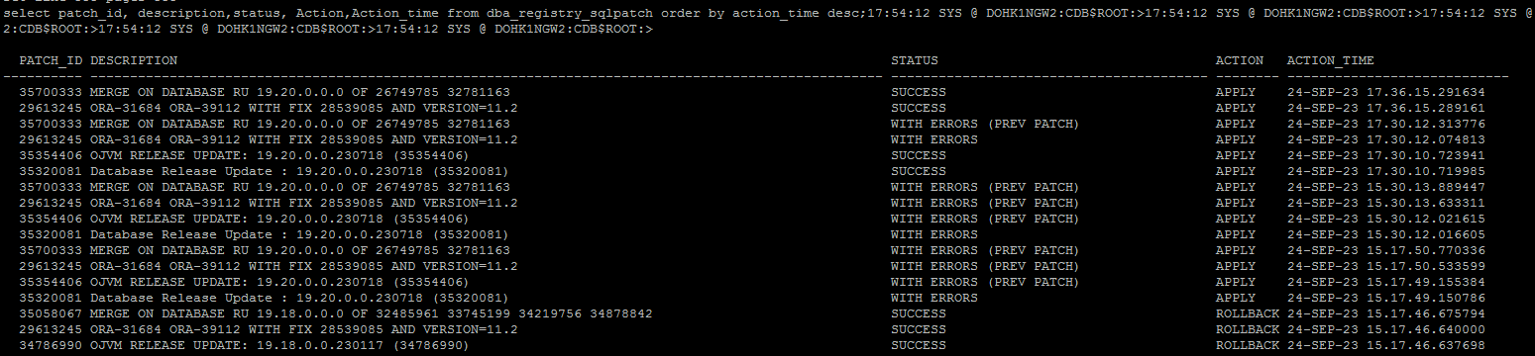

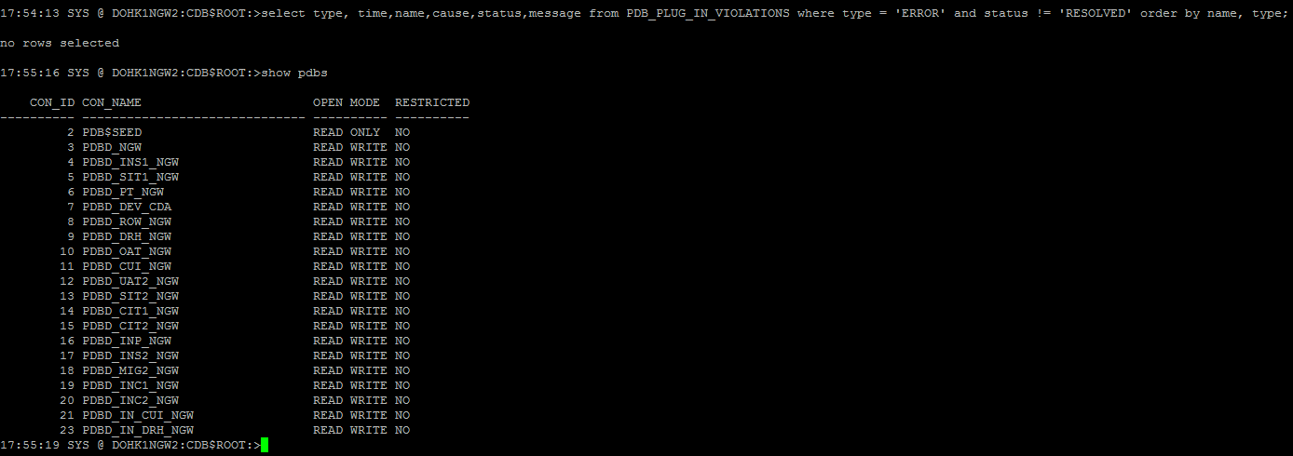

DOHK1S2B

==========

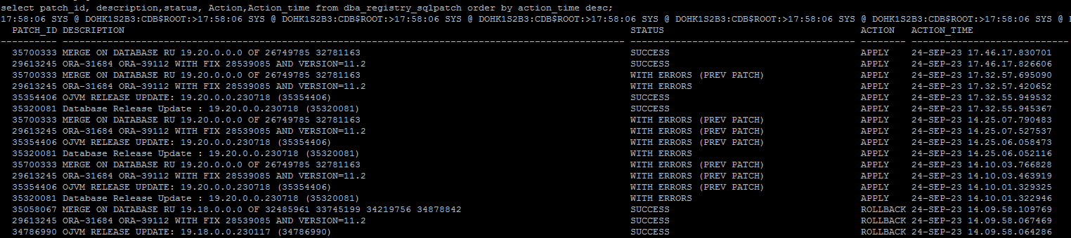

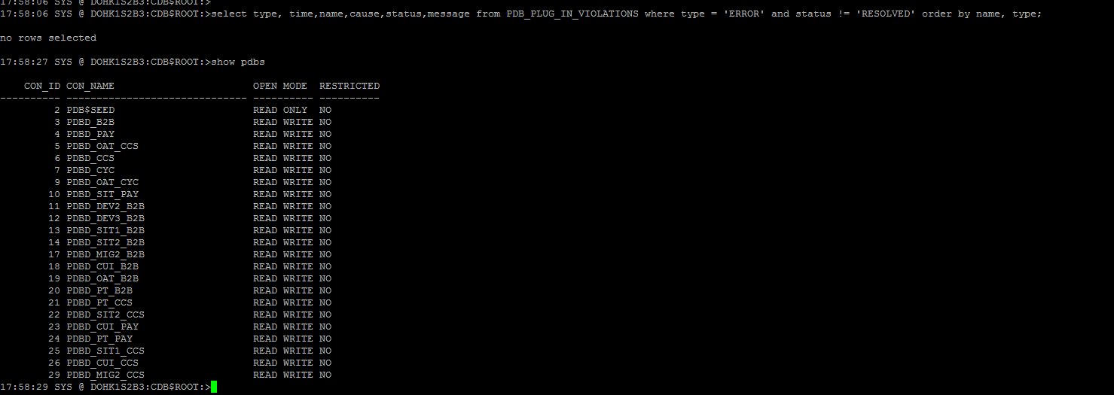

DB status

========

