To create PDB on existing CDB

cd /u01/app/oracle/global/scb_utils/PDBAdmin

./OracleDaaS_PDBAdmin.sh -o createPDB -c POHK4CCD3 -a COP

where POHK4CCD3 is CDB and COP is PDP name. it will create PDBP_COP

OUTPUT:

========

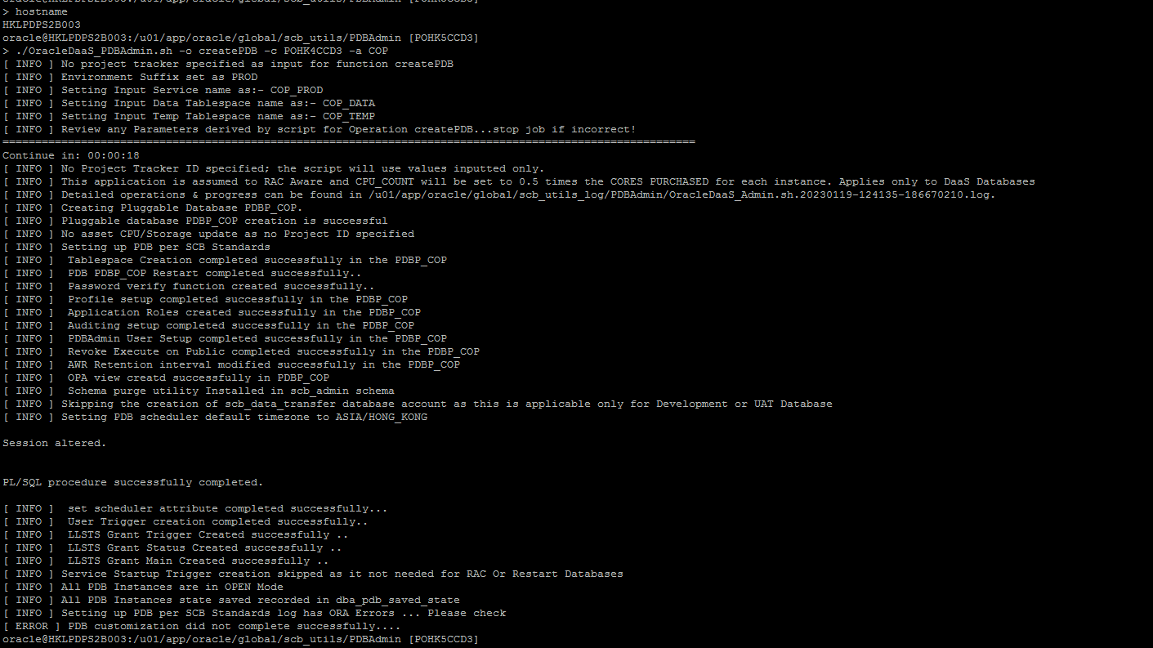

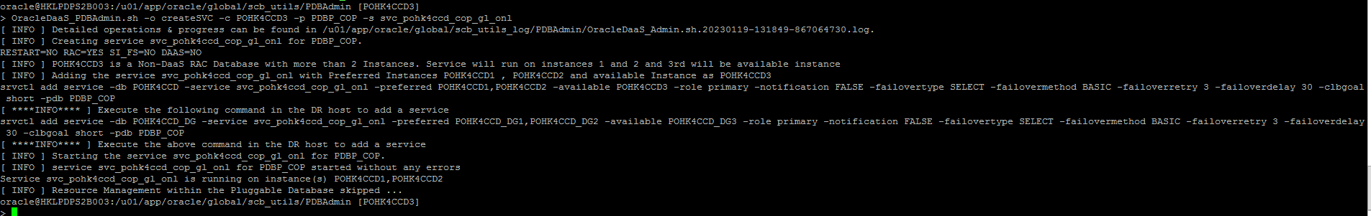

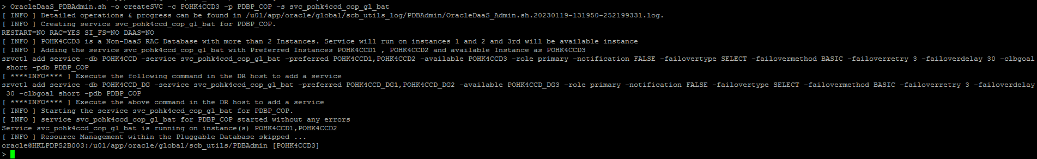



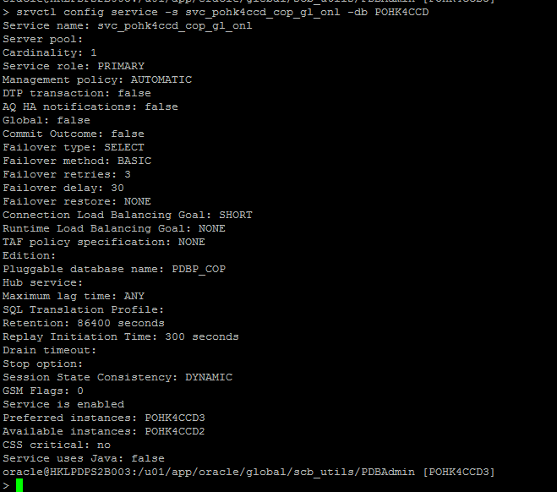

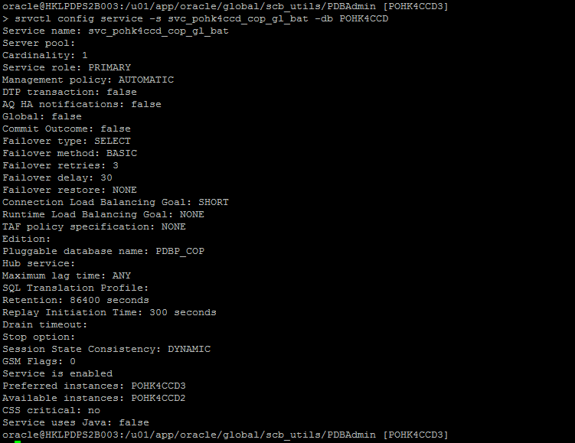

DR:

===

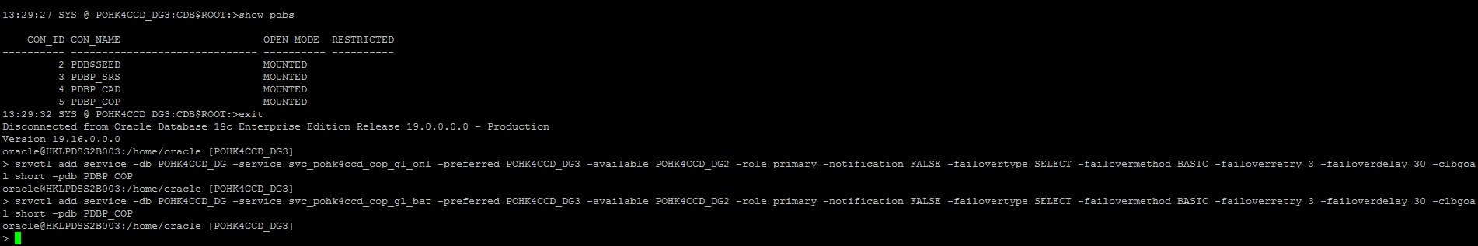

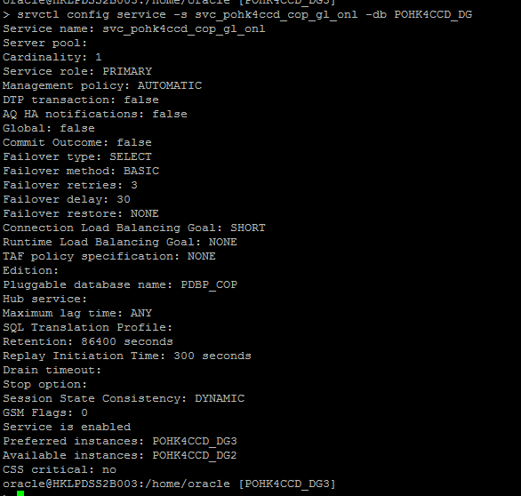

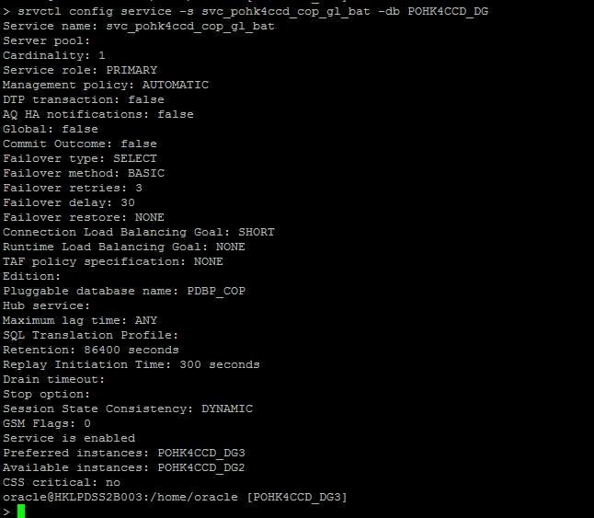

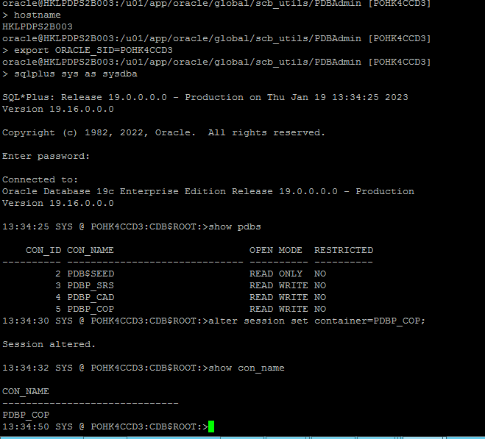

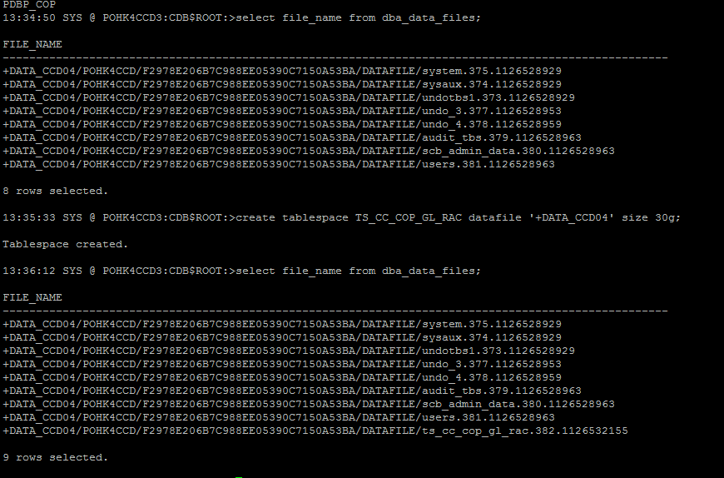

DML:

