Nama : Mochammad Fahrudin
Npm : 4513210024
Matakuliah : Pemrograman 4
Langkah-Langkah Membuat Java web dengan maven dengan menggunakan Netbeans
- Membuat New Project → pilihMaven → pilih Web Application
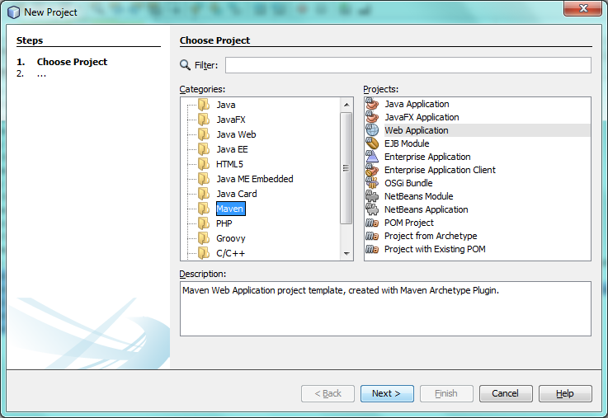

- Setelah File nya jadi lalu klik kanan Web Pages → New →Pilih HTML
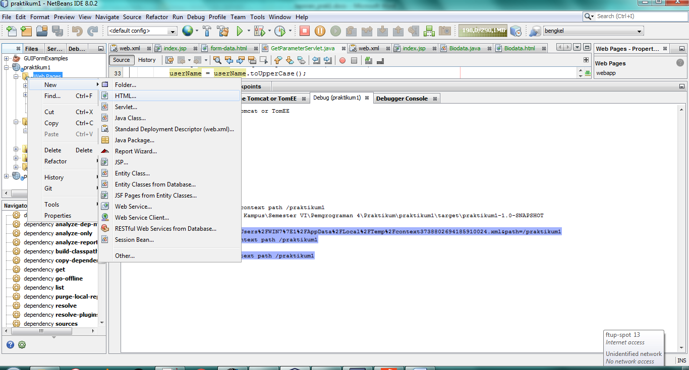

- Setelah File nya jadi lalu klik kanan Package → New →Pilih Servlet
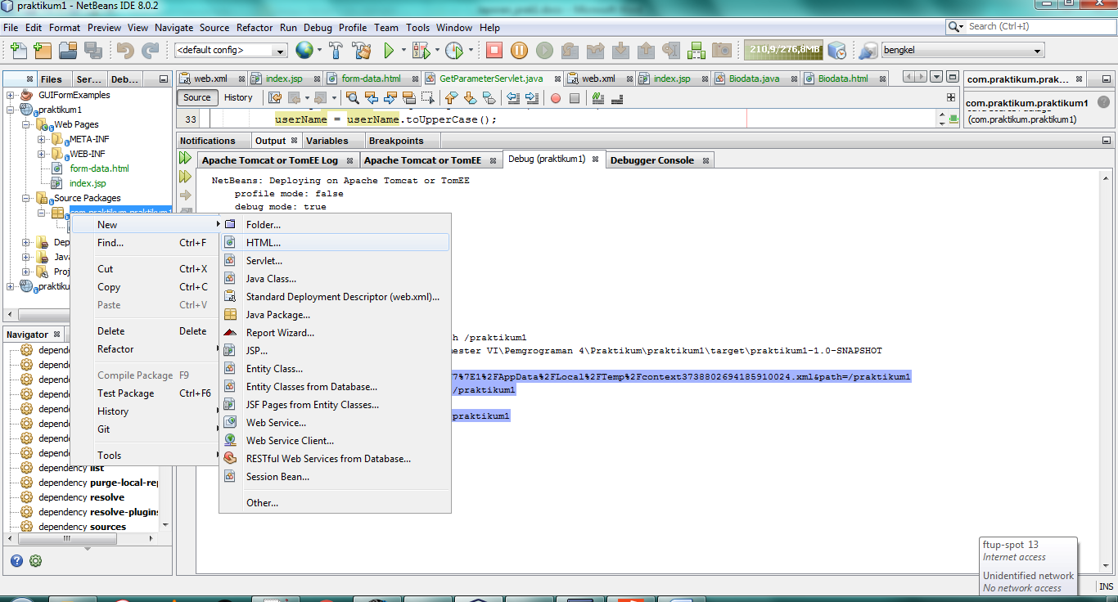
- Screenshoot Halaman pertama
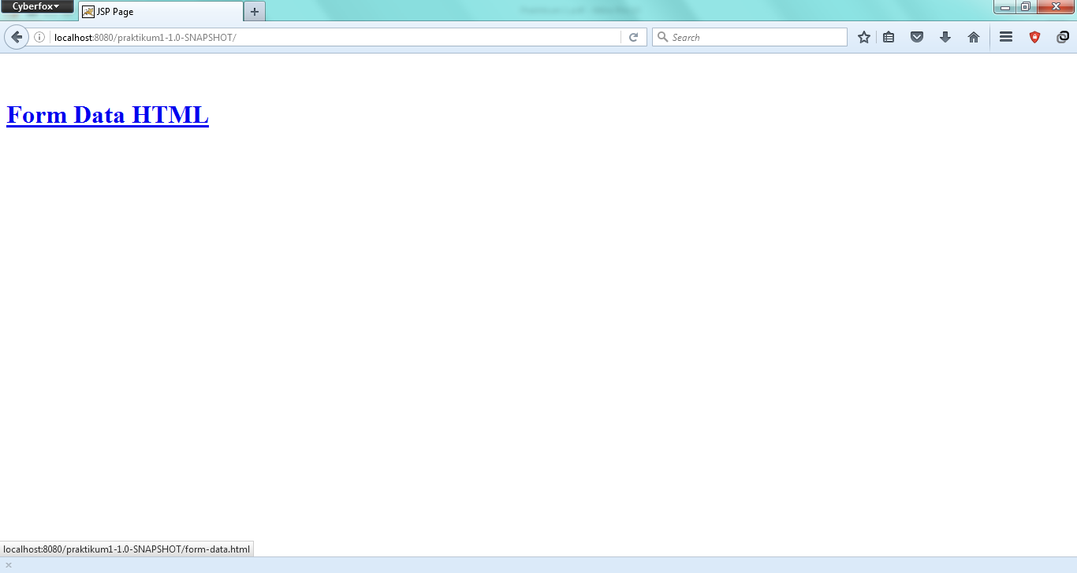

- Screenshoot Halaman kedua
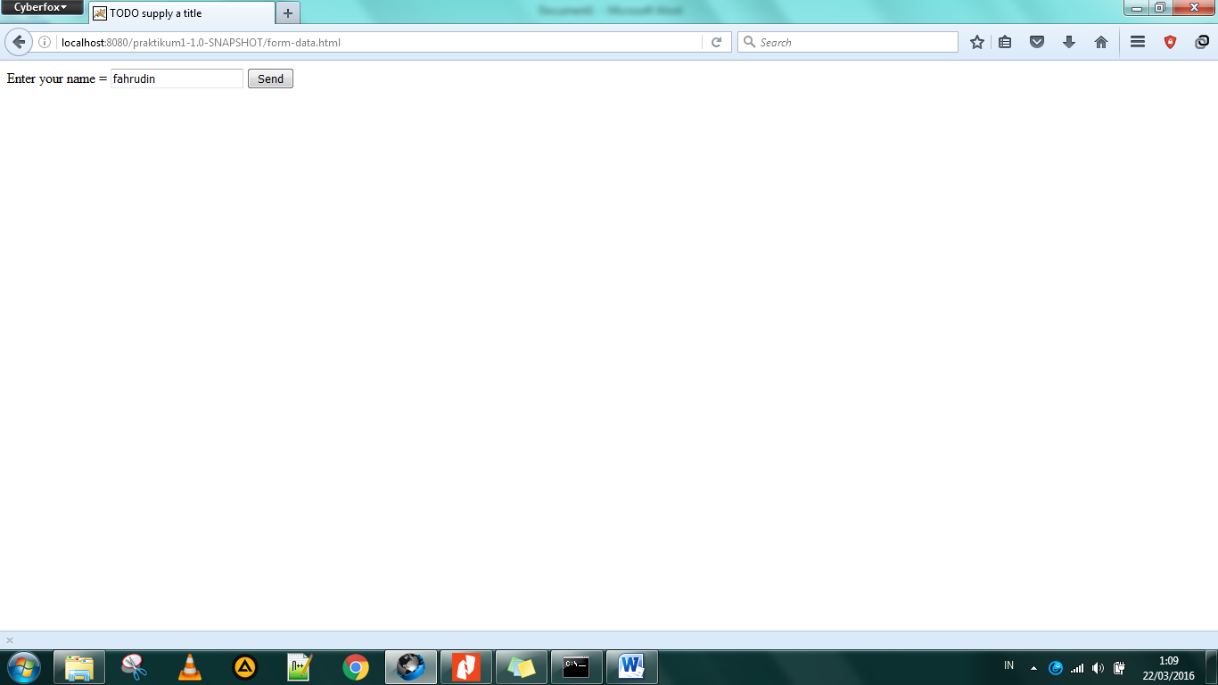

- Screenshoot Halaman ketiga
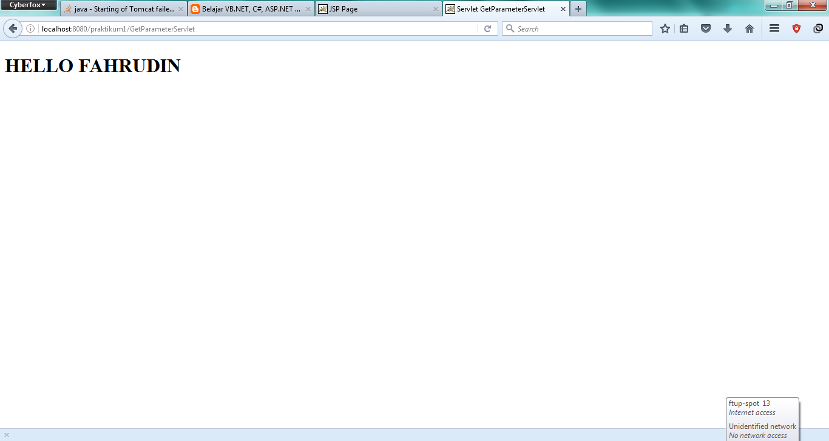

FILE LOG

File Deploy
Deployment is in progress...
deploy?config=file%3A%2FC%3A%2FUsers%2FWIN7%7E1%2FAppData%2FLocal%2FTemp%2Fcontext3738802694185910024.xml&path=/praktikum1
OK - Deployed application at context path /praktikum1
start?path=/praktikum1
OK - Started application at context path /praktikum1
File Undeploy
Tomcat server started.
Undeploying ...
undeploy?path=/praktikum1
OK - Undeployed application at context path /praktikum1In-place deployment at D:\Tugas Kampus\Semester VI\Pemgrograman 4\Praktikum\praktikum1\target\praktikum1-1.0-SNAPSHOT

