Visualization

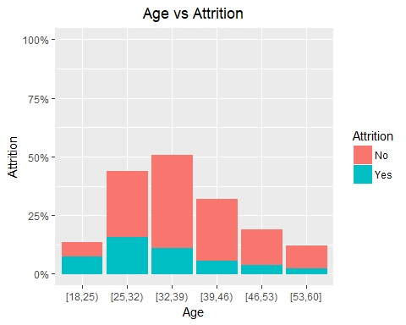

[1] "Attrition rate stabilises after the age of 31 and the age group of 18-24 has highest attrition rate"

Cell Contents  
|-------------------------|  
| N |  
| N / Row Total |  
|-------------------------|  
  
   
Total Observations in Table: 1470   
  
   
 | df$Attrition   
 bins | No | Yes | Row Total |   
-------------|-----------|-----------|-----------|  
 [18,25) | 59 | 38 | 97 |   
 | 0.608 | 0.392 | 0.066 |   
-------------|-----------|-----------|-----------|  
 [25,32) | 278 | 80 | 358 |   
 | 0.777 | 0.223 | 0.244 |   
-------------|-----------|-----------|-----------|  
 [32,39) | 395 | 56 | 451 |   
 | 0.876 | 0.124 | 0.307 |   
-------------|-----------|-----------|-----------|  
 [39,46) | 262 | 29 | 291 |   
 | 0.900 | 0.100 | 0.198 |   
-------------|-----------|-----------|-----------|  
 [46,53) | 146 | 21 | 167 |   
 | 0.874 | 0.126 | 0.114 |   
-------------|-----------|-----------|-----------|  
 [53,60] | 93 | 13 | 106 |   
 | 0.877 | 0.123 | 0.072 |   
-------------|-----------|-----------|-----------|  
Column Total | 1233 | 237 | 1470 |   
-------------|-----------|-----------|-----------|

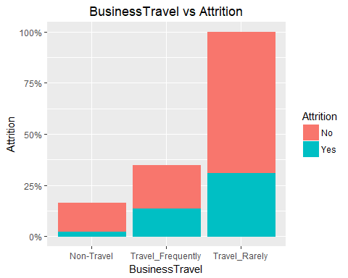

[1] "Attrition rate stabilises after the age of 31 and the age group of 18-24 has highest attrition rate"

Cell Contents  
|-------------------------|  
| N |  
| N / Row Total |  
|-------------------------|  
  
   
Total Observations in Table: 1470   
  
   
 | df$Attrition   
df$BusinessTravel | No | Yes | Row Total |   
------------------|-----------|-----------|-----------|  
 Non-Travel | 138 | 12 | 150 |   
 | 0.920 | 0.080 | 0.102 |   
------------------|-----------|-----------|-----------|  
Travel_Frequently | 208 | 69 | 277 |   
 | 0.751 | 0.249 | 0.188 |   
------------------|-----------|-----------|-----------|  
 Travel_Rarely | 887 | 156 | 1043 |   
 | 0.850 | 0.150 | 0.710 |   
------------------|-----------|-----------|-----------|  
 Column Total | 1233 | 237 | 1470 |   
------------------|-----------|-----------|-----------|

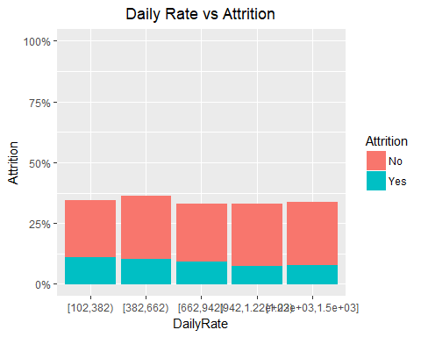

[1] "Attrition gradually decreases with daily rate"

Cell Contents  
|-------------------------|  
| N |  
| N / Row Total |  
|-------------------------|  
  
   
Total Observations in Table: 1470   
  
   
 | df$Attrition   
 bins | No | Yes | Row Total |   
-------------------|-----------|-----------|-----------|  
 [102,382) | 230 | 57 | 287 |   
 | 0.801 | 0.199 | 0.195 |   
-------------------|-----------|-----------|-----------|  
 [382,662) | 255 | 54 | 309 |   
 | 0.825 | 0.175 | 0.210 |   
-------------------|-----------|-----------|-----------|  
 [662,942) | 237 | 47 | 284 |   
 | 0.835 | 0.165 | 0.193 |   
-------------------|-----------|-----------|-----------|  
 [942,1.22e+03) | 252 | 39 | 291 |   
 | 0.866 | 0.134 | 0.198 |   
-------------------|-----------|-----------|-----------|  
[1.22e+03,1.5e+03] | 259 | 40 | 299 |   
 | 0.866 | 0.134 | 0.203 |   
-------------------|-----------|-----------|-----------|  
 Column Total | 1233 | 237 | 1470 |   
-------------------|-----------|-----------|-----------|

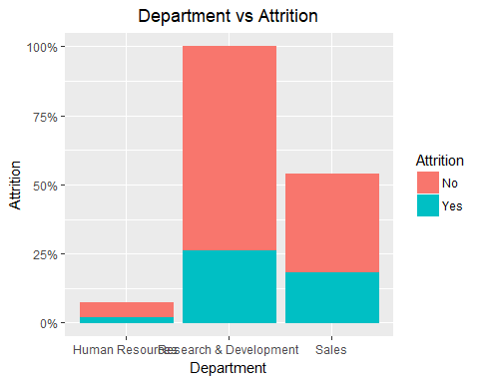

[1] "Research and Development team has the lowest attrition rate"

Cell Contents  
|-------------------------|  
| N |  
| N / Row Total |  
|-------------------------|  
  
   
Total Observations in Table: 1470   
  
   
 | df$Attrition   
 df$Department | No | Yes | Row Total |   
-----------------------|-----------|-----------|-----------|  
 Human Resources | 51 | 12 | 63 |   
 | 0.810 | 0.190 | 0.043 |   
-----------------------|-----------|-----------|-----------|  
Research & Development | 828 | 133 | 961 |   
 | 0.862 | 0.138 | 0.654 |   
-----------------------|-----------|-----------|-----------|  
 Sales | 354 | 92 | 446 |   
 | 0.794 | 0.206 | 0.303 |   
-----------------------|-----------|-----------|-----------|  
 Column Total | 1233 | 237 | 1470 |   
-----------------------|-----------|-----------|-----------|

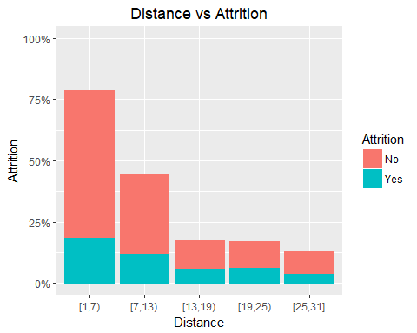

[1] "The distance from home ranging 1-6 has lowest attrition rate"

Cell Contents  
|-------------------------|  
| N |  
| N / Row Total |  
|-------------------------|  
  
   
Total Observations in Table: 1470   
  
   
 | df$Attrition   
 bins | No | Yes | Row Total |   
-------------|-----------|-----------|-----------|  
 [1,7) | 597 | 94 | 691 |   
 | 0.864 | 0.136 | 0.470 |   
-------------|-----------|-----------|-----------|  
 [7,13) | 324 | 60 | 384 |   
 | 0.844 | 0.156 | 0.261 |   
-------------|-----------|-----------|-----------|  
 [13,19) | 113 | 31 | 144 |   
 | 0.785 | 0.215 | 0.098 |   
-------------|-----------|-----------|-----------|  
 [19,25) | 106 | 33 | 139 |   
 | 0.763 | 0.237 | 0.095 |   
-------------|-----------|-----------|-----------|  
 [25,31] | 93 | 19 | 112 |   
 | 0.830 | 0.170 | 0.076 |   
-------------|-----------|-----------|-----------|  
Column Total | 1233 | 237 | 1470 |   
-------------|-----------|-----------|-----------|

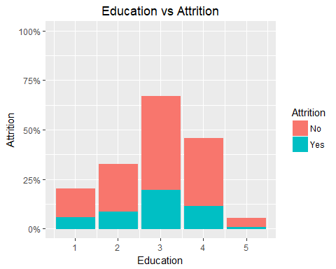

[1] "There is not very significant effect on the attrition and it remains nearly same for all education divisions"

Cell Contents  
|-------------------------|  
| N |  
| N / Row Total |  
|-------------------------|  
  
   
Total Observations in Table: 1470   
  
   
 | df$Attrition   
df$Education | No | Yes | Row Total |   
-------------|-----------|-----------|-----------|  
 1 | 139 | 31 | 170 |   
 | 0.818 | 0.182 | 0.116 |   
-------------|-----------|-----------|-----------|  
 2 | 238 | 44 | 282 |   
 | 0.844 | 0.156 | 0.192 |   
-------------|-----------|-----------|-----------|  
 3 | 473 | 99 | 572 |   
 | 0.827 | 0.173 | 0.389 |   
-------------|-----------|-----------|-----------|  
 4 | 340 | 58 | 398 |   
 | 0.854 | 0.146 | 0.271 |   
-------------|-----------|-----------|-----------|  
 5 | 43 | 5 | 48 |   
 | 0.896 | 0.104 | 0.033 |   
-------------|-----------|-----------|-----------|  
Column Total | 1233 | 237 | 1470 |   
-------------|-----------|-----------|-----------|

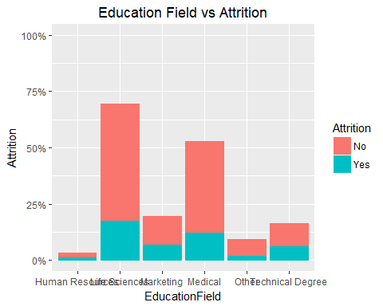

[1] "The highest attrition is in the field of human resources"

Cell Contents  
|-------------------------|  
| N |  
| N / Row Total |  
|-------------------------|  
  
   
Total Observations in Table: 1470   
  
   
 | df$Attrition   
df$EducationField | No | Yes | Row Total |   
------------------|-----------|-----------|-----------|  
 Human Resources | 20 | 7 | 27 |   
 | 0.741 | 0.259 | 0.018 |   
------------------|-----------|-----------|-----------|  
 Life Sciences | 517 | 89 | 606 |   
 | 0.853 | 0.147 | 0.412 |   
------------------|-----------|-----------|-----------|  
 Marketing | 124 | 35 | 159 |   
 | 0.780 | 0.220 | 0.108 |   
------------------|-----------|-----------|-----------|  
 Medical | 401 | 63 | 464 |   
 | 0.864 | 0.136 | 0.316 |   
------------------|-----------|-----------|-----------|  
 Other | 71 | 11 | 82 |   
 | 0.866 | 0.134 | 0.056 |   
------------------|-----------|-----------|-----------|  
 Technical Degree | 100 | 32 | 132 |   
 | 0.758 | 0.242 | 0.090 |   
------------------|-----------|-----------|-----------|  
 Column Total | 1233 | 237 | 1470 |   
------------------|-----------|-----------|-----------|

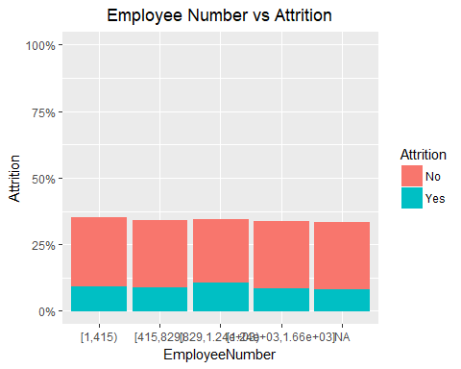

[1] "Employee number does not signifies attrition"

Cell Contents  
|-------------------------|  
| N |  
| N / Row Total |  
|-------------------------|  
  
   
Total Observations in Table: 1179   
  
   
 | df$Attrition   
 bins | No | Yes | Row Total |   
--------------------|-----------|-----------|-----------|  
 [1,415) | 255 | 48 | 303 |   
 | 0.842 | 0.158 | 0.257 |   
--------------------|-----------|-----------|-----------|  
 [415,829) | 250 | 46 | 296 |   
 | 0.845 | 0.155 | 0.251 |   
--------------------|-----------|-----------|-----------|  
 [829,1.24e+03) | 234 | 55 | 289 |   
 | 0.810 | 0.190 | 0.245 |   
--------------------|-----------|-----------|-----------|  
[1.24e+03,1.66e+03] | 246 | 45 | 291 |   
 | 0.845 | 0.155 | 0.247 |   
--------------------|-----------|-----------|-----------|  
 Column Total | 985 | 194 | 1179 |   
--------------------|-----------|-----------|-----------|

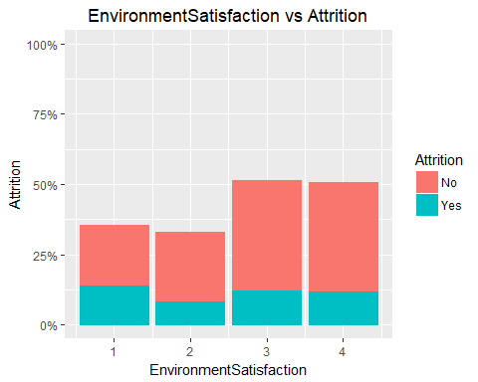

[1] "As satisfaction increases, attrition decreases"

Cell Contents  
|-------------------------|  
| N |  
| N / Row Total |  
|-------------------------|  
  
   
Total Observations in Table: 1470   
  
   
 | df$Attrition   
df$EnvironmentSatisfaction | No | Yes | Row Total |   
---------------------------|-----------|-----------|-----------|  
 1 | 212 | 72 | 284 |   
 | 0.746 | 0.254 | 0.193 |   
---------------------------|-----------|-----------|-----------|  
 2 | 244 | 43 | 287 |   
 | 0.850 | 0.150 | 0.195 |   
---------------------------|-----------|-----------|-----------|  
 3 | 391 | 62 | 453 |   
 | 0.863 | 0.137 | 0.308 |   
---------------------------|-----------|-----------|-----------|  
 4 | 386 | 60 | 446 |   
 | 0.865 | 0.135 | 0.303 |   
---------------------------|-----------|-----------|-----------|  
 Column Total | 1233 | 237 | 1470 |   
---------------------------|-----------|-----------|-----------|

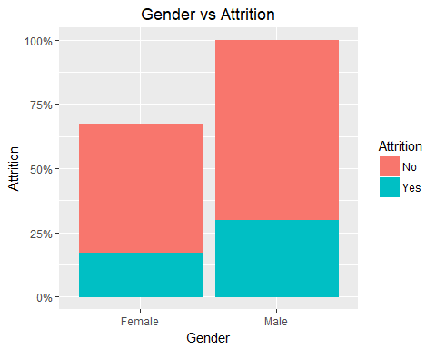

[1] "The attrition rate for females is less as compared to males"

Cell Contents  
|-------------------------|  
| N |  
| N / Row Total |  
|-------------------------|  
  
   
Total Observations in Table: 1470   
  
   
 | df$Attrition   
 df$Gender | No | Yes | Row Total |   
-------------|-----------|-----------|-----------|  
 Female | 501 | 87 | 588 |   
 | 0.852 | 0.148 | 0.400 |   
-------------|-----------|-----------|-----------|  
 Male | 732 | 150 | 882 |   
 | 0.830 | 0.170 | 0.600 |   
-------------|-----------|-----------|-----------|  
Column Total | 1233 | 237 | 1470 |   
-------------|-----------|-----------|-----------|

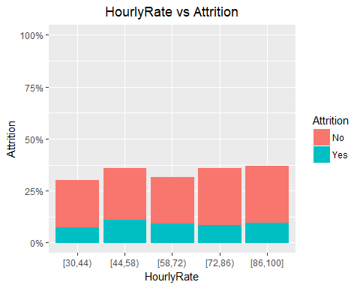

[1] "There is not that much significant effect on attrition"

Cell Contents  
|-------------------------|  
| N |  
| N / Row Total |  
|-------------------------|  
  
   
Total Observations in Table: 1470   
  
   
 | df$Attrition   
 bins | No | Yes | Row Total |   
-------------|-----------|-----------|-----------|  
 [30,44) | 225 | 39 | 264 |   
 | 0.852 | 0.148 | 0.180 |   
-------------|-----------|-----------|-----------|  
 [44,58) | 246 | 56 | 302 |   
 | 0.815 | 0.185 | 0.205 |   
-------------|-----------|-----------|-----------|  
 [58,72) | 221 | 48 | 269 |   
 | 0.822 | 0.178 | 0.183 |   
-------------|-----------|-----------|-----------|  
 [72,86) | 268 | 45 | 313 |   
 | 0.856 | 0.144 | 0.213 |   
-------------|-----------|-----------|-----------|  
 [86,100] | 273 | 49 | 322 |   
 | 0.848 | 0.152 | 0.219 |   
-------------|-----------|-----------|-----------|  
Column Total | 1233 | 237 | 1470 |   
-------------|-----------|-----------|-----------|

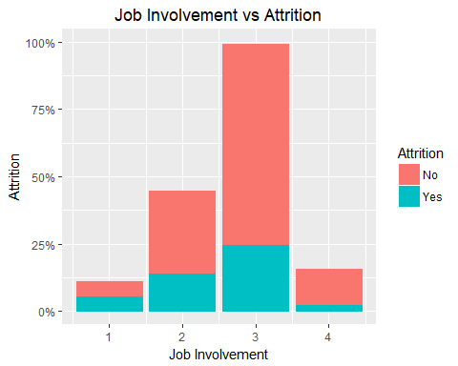

[1] "As job involvement increases, attrition goes down"

Cell Contents  
|-------------------------|  
| N |  
| N / Row Total |  
|-------------------------|  
  
   
Total Observations in Table: 1470   
  
   
 | df$Attrition   
df$JobInvolvement | No | Yes | Row Total |   
------------------|-----------|-----------|-----------|  
 1 | 55 | 28 | 83 |   
 | 0.663 | 0.337 | 0.056 |   
------------------|-----------|-----------|-----------|  
 2 | 304 | 71 | 375 |   
 | 0.811 | 0.189 | 0.255 |   
------------------|-----------|-----------|-----------|  
 3 | 743 | 125 | 868 |   
 | 0.856 | 0.144 | 0.590 |   
------------------|-----------|-----------|-----------|  
 4 | 131 | 13 | 144 |   
 | 0.910 | 0.090 | 0.098 |   
------------------|-----------|-----------|-----------|  
 Column Total | 1233 | 237 | 1470 |   
------------------|-----------|-----------|-----------|

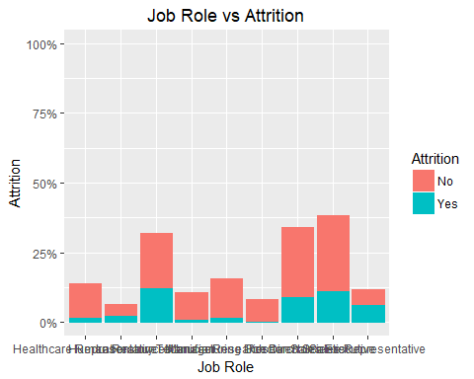

[1] "Attrition rate is highest for Sales Representative as compared to others"

Cell Contents  
|-------------------------|  
| N |  
| N / Row Total |  
|-------------------------|  
  
   
Total Observations in Table: 1470   
  
   
 | df$Attrition   
 df$JobRole | No | Yes | Row Total |   
--------------------------|-----------|-----------|-----------|  
Healthcare Representative | 122 | 9 | 131 |   
 | 0.931 | 0.069 | 0.089 |   
--------------------------|-----------|-----------|-----------|  
 Human Resources | 40 | 12 | 52 |   
 | 0.769 | 0.231 | 0.035 |   
--------------------------|-----------|-----------|-----------|  
 Laboratory Technician | 197 | 62 | 259 |   
 | 0.761 | 0.239 | 0.176 |   
--------------------------|-----------|-----------|-----------|  
 Manager | 97 | 5 | 102 |   
 | 0.951 | 0.049 | 0.069 |   
--------------------------|-----------|-----------|-----------|  
 Manufacturing Director | 135 | 10 | 145 |   
 | 0.931 | 0.069 | 0.099 |   
--------------------------|-----------|-----------|-----------|  
 Research Director | 78 | 2 | 80 |   
 | 0.975 | 0.025 | 0.054 |   
--------------------------|-----------|-----------|-----------|  
 Research Scientist | 245 | 47 | 292 |   
 | 0.839 | 0.161 | 0.199 |   
--------------------------|-----------|-----------|-----------|  
 Sales Executive | 269 | 57 | 326 |   
 | 0.825 | 0.175 | 0.222 |   
--------------------------|-----------|-----------|-----------|  
 Sales Representative | 50 | 33 | 83 |   
 | 0.602 | 0.398 | 0.056 |   
--------------------------|-----------|-----------|-----------|  
 Column Total | 1233 | 237 | 1470 |   
--------------------------|-----------|-----------|-----------|

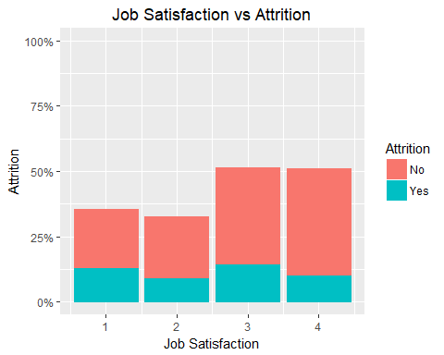

[1] "The attrition rate is lowest for job satisfaction level 4"

Cell Contents  
|-------------------------|  
| N |  
| N / Row Total |  
|-------------------------|  
  
   
Total Observations in Table: 1470   
  
   
 | df$Attrition   
df$JobSatisfaction | No | Yes | Row Total |   
-------------------|-----------|-----------|-----------|  
 1 | 223 | 66 | 289 |   
 | 0.772 | 0.228 | 0.197 |   
-------------------|-----------|-----------|-----------|  
 2 | 234 | 46 | 280 |   
 | 0.836 | 0.164 | 0.190 |   
-------------------|-----------|-----------|-----------|  
 3 | 369 | 73 | 442 |   
 | 0.835 | 0.165 | 0.301 |   
-------------------|-----------|-----------|-----------|  
 4 | 407 | 52 | 459 |   
 | 0.887 | 0.113 | 0.312 |   
-------------------|-----------|-----------|-----------|  
 Column Total | 1233 | 237 | 1470 |   
-------------------|-----------|-----------|-----------|

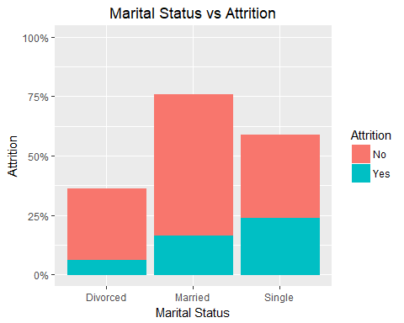

[1] "People with marital status as single have highest attrition rate"

Cell Contents  
|-------------------------|  
| N |  
| N / Row Total |  
|-------------------------|  
  
   
Total Observations in Table: 1470   
  
   
 | df$Attrition   
df$MaritalStatus | No | Yes | Row Total |   
-----------------|-----------|-----------|-----------|  
 Divorced | 294 | 33 | 327 |   
 | 0.899 | 0.101 | 0.222 |   
-----------------|-----------|-----------|-----------|  
 Married | 589 | 84 | 673 |   
 | 0.875 | 0.125 | 0.458 |   
-----------------|-----------|-----------|-----------|  
 Single | 350 | 120 | 470 |   
 | 0.745 | 0.255 | 0.320 |   
-----------------|-----------|-----------|-----------|  
 Column Total | 1233 | 237 | 1470 |   
-----------------|-----------|-----------|-----------|

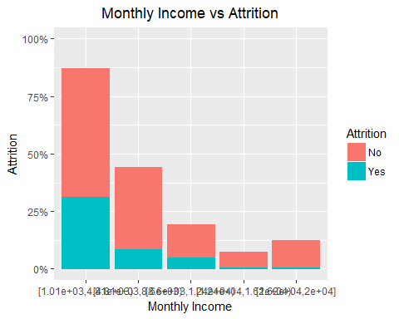

[1] "As monthly incomes increases, attrition rate goes down"

Cell Contents  
|-------------------------|  
| N |  
| N / Row Total |  
|-------------------------|  
  
   
Total Observations in Table: 1470   
  
   
 | df$Attrition   
 bins | No | Yes | Row Total |   
--------------------|-----------|-----------|-----------|  
[1.01e+03,4.81e+03) | 557 | 157 | 714 |   
 | 0.780 | 0.220 | 0.486 |   
--------------------|-----------|-----------|-----------|  
 [4.81e+03,8.6e+03) | 355 | 44 | 399 |   
 | 0.890 | 0.110 | 0.271 |   
--------------------|-----------|-----------|-----------|  
 [8.6e+03,1.24e+04) | 140 | 26 | 166 |   
 | 0.843 | 0.157 | 0.113 |   
--------------------|-----------|-----------|-----------|  
[1.24e+04,1.62e+04) | 65 | 5 | 70 |   
 | 0.929 | 0.071 | 0.048 |   
--------------------|-----------|-----------|-----------|  
 [1.62e+04,2e+04] | 116 | 5 | 121 |   
 | 0.959 | 0.041 | 0.082 |   
--------------------|-----------|-----------|-----------|  
 Column Total | 1233 | 237 | 1470 |   
--------------------|-----------|-----------|-----------|

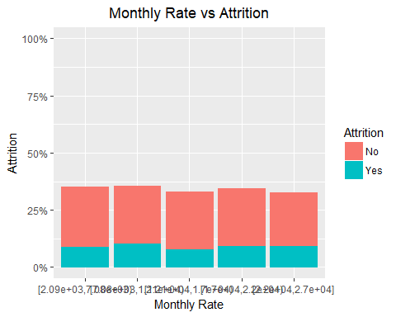

[1] "There is not that much significant effect on attrition"

Cell Contents  
|-------------------------|  
| N |  
| N / Row Total |  
|-------------------------|  
  
   
Total Observations in Table: 1470   
  
   
 | df$Attrition   
 bins | No | Yes | Row Total |   
--------------------|-----------|-----------|-----------|  
[2.09e+03,7.08e+03) | 260 | 46 | 306 |   
 | 0.850 | 0.150 | 0.208 |   
--------------------|-----------|-----------|-----------|  
[7.08e+03,1.21e+04) | 246 | 54 | 300 |   
 | 0.820 | 0.180 | 0.204 |   
--------------------|-----------|-----------|-----------|  
 [1.21e+04,1.7e+04) | 249 | 41 | 290 |   
 | 0.859 | 0.141 | 0.197 |   
--------------------|-----------|-----------|-----------|  
 [1.7e+04,2.2e+04) | 248 | 48 | 296 |   
 | 0.838 | 0.162 | 0.201 |   
--------------------|-----------|-----------|-----------|  
 [2.2e+04,2.7e+04] | 230 | 48 | 278 |   
 | 0.827 | 0.173 | 0.189 |   
--------------------|-----------|-----------|-----------|  
 Column Total | 1233 | 237 | 1470 |   
--------------------|-----------|-----------|-----------|

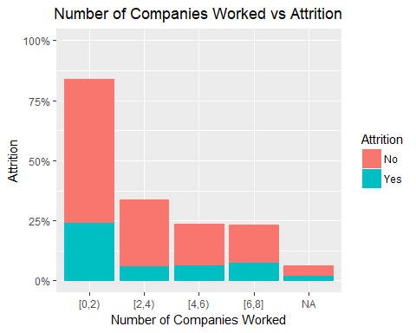

[1] "The attrition level is lowest with people who have worked in 2 or 3 companies"

Cell Contents  
|-------------------------|  
| N |  
| N / Row Total |  
|-------------------------|  
  
   
Total Observations in Table: 1418   
  
   
 | df$Attrition   
 bins | No | Yes | Row Total |   
-------------|-----------|-----------|-----------|  
 [0,2) | 597 | 121 | 718 |   
 | 0.831 | 0.169 | 0.506 |   
-------------|-----------|-----------|-----------|  
 [2,4) | 273 | 32 | 305 |   
 | 0.895 | 0.105 | 0.215 |   
-------------|-----------|-----------|-----------|  
 [4,6) | 169 | 33 | 202 |   
 | 0.837 | 0.163 | 0.142 |   
-------------|-----------|-----------|-----------|  
 [6,8] | 154 | 39 | 193 |   
 | 0.798 | 0.202 | 0.136 |   
-------------|-----------|-----------|-----------|  
Column Total | 1193 | 225 | 1418 |   
-------------|-----------|-----------|-----------|

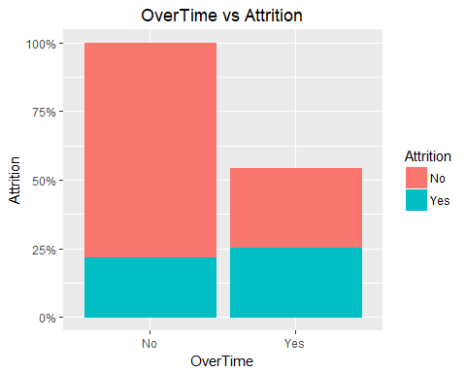

[1] "The people who are not doing overtime has low attrition level"

Cell Contents  
|-------------------------|  
| N |  
| N / Row Total |  
|-------------------------|  
  
   
Total Observations in Table: 1470   
  
   
 | df$Attrition   
 df$OverTime | No | Yes | Row Total |   
-------------|-----------|-----------|-----------|  
 No | 944 | 110 | 1054 |   
 | 0.896 | 0.104 | 0.717 |   
-------------|-----------|-----------|-----------|  
 Yes | 289 | 127 | 416 |   
 | 0.695 | 0.305 | 0.283 |   
-------------|-----------|-----------|-----------|  
Column Total | 1233 | 237 | 1470 |   
-------------|-----------|-----------|-----------|

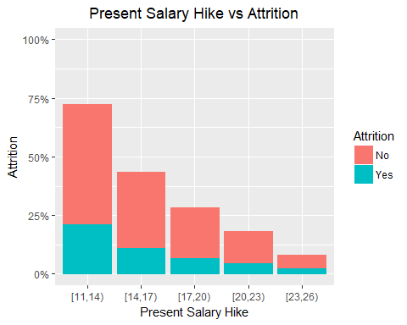

[1] "The attrition level for Percent Salary Hikes does not has significant effect"

Cell Contents  
|-------------------------|  
| N |  
| N / Row Total |  
|-------------------------|  
  
   
Total Observations in Table: 1470   
  
   
 | df$Attrition   
 bins | No | Yes | Row Total |   
-------------|-----------|-----------|-----------|  
 [11,14) | 509 | 108 | 617 |   
 | 0.825 | 0.175 | 0.420 |   
-------------|-----------|-----------|-----------|  
 [14,17) | 324 | 56 | 380 |   
 | 0.853 | 0.147 | 0.259 |   
-------------|-----------|-----------|-----------|  
 [17,20) | 211 | 36 | 247 |   
 | 0.854 | 0.146 | 0.168 |   
-------------|-----------|-----------|-----------|  
 [20,23) | 135 | 24 | 159 |   
 | 0.849 | 0.151 | 0.108 |   
-------------|-----------|-----------|-----------|  
 [23,26) | 54 | 13 | 67 |   
 | 0.806 | 0.194 | 0.046 |   
-------------|-----------|-----------|-----------|  
Column Total | 1233 | 237 | 1470 |   
-------------|-----------|-----------|-----------|

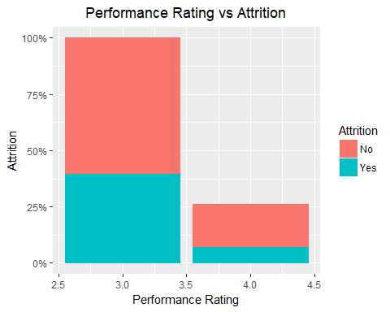

[1] "Both performance rating has nearly same effect on attrition"

Cell Contents  
|-------------------------|  
| N |  
| N / Row Total |  
|-------------------------|  
  
   
Total Observations in Table: 1470   
  
   
 | df$Attrition   
df$PerformanceRating | No | Yes | Row Total |   
---------------------|-----------|-----------|-----------|  
 3 | 1044 | 200 | 1244 |   
 | 0.839 | 0.161 | 0.846 |   
---------------------|-----------|-----------|-----------|  
 4 | 189 | 37 | 226 |   
 | 0.836 | 0.164 | 0.154 |   
---------------------|-----------|-----------|-----------|  
 Column Total | 1233 | 237 | 1470 |   
---------------------|-----------|-----------|-----------|

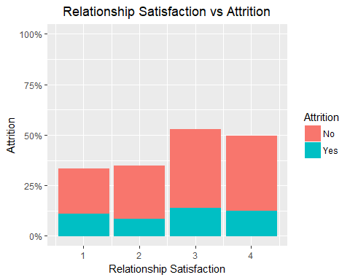

[1] "There is no significant effect on attrition"

Cell Contents  
|-------------------------|  
| N |  
| N / Row Total |  
|-------------------------|  
  
   
Total Observations in Table: 1470   
  
   
 | df$Attrition   
df$RelationshipSatisfaction | No | Yes | Row Total |   
----------------------------|-----------|-----------|-----------|  
 1 | 219 | 57 | 276 |   
 | 0.793 | 0.207 | 0.188 |   
----------------------------|-----------|-----------|-----------|  
 2 | 258 | 45 | 303 |   
 | 0.851 | 0.149 | 0.206 |   
----------------------------|-----------|-----------|-----------|  
 3 | 388 | 71 | 459 |   
 | 0.845 | 0.155 | 0.312 |   
----------------------------|-----------|-----------|-----------|  
 4 | 368 | 64 | 432 |   
 | 0.852 | 0.148 | 0.294 |   
----------------------------|-----------|-----------|-----------|  
 Column Total | 1233 | 237 | 1470 |   
----------------------------|-----------|-----------|-----------|

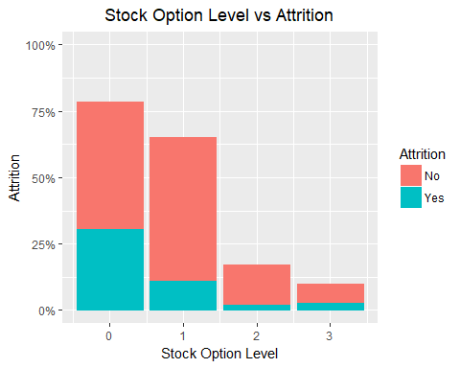

[1] "The attrition is lowest at stock option level 2"

Cell Contents  
|-------------------------|  
| N |  
| N / Row Total |  
|-------------------------|  
  
   
Total Observations in Table: 1470   
  
   
 | df$Attrition   
df$StockOptionLevel | No | Yes | Row Total |   
--------------------|-----------|-----------|-----------|  
 0 | 477 | 154 | 631 |   
 | 0.756 | 0.244 | 0.429 |   
--------------------|-----------|-----------|-----------|  
 1 | 540 | 56 | 596 |   
 | 0.906 | 0.094 | 0.405 |   
--------------------|-----------|-----------|-----------|  
 2 | 146 | 12 | 158 |   
 | 0.924 | 0.076 | 0.107 |   
--------------------|-----------|-----------|-----------|  
 3 | 70 | 15 | 85 |   
 | 0.824 | 0.176 | 0.058 |   
--------------------|-----------|-----------|-----------|  
 Column Total | 1233 | 237 | 1470 |   
--------------------|-----------|-----------|-----------|

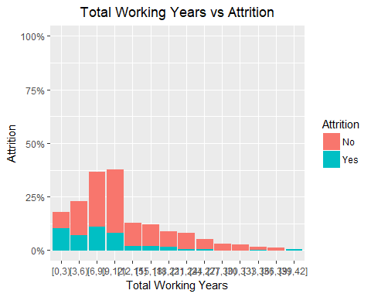

[1] "Attrtion rate is decreasing with increase in total working years"

Cell Contents  
|-------------------------|  
| N |  
| N / Row Total |  
|-------------------------|  
  
   
Total Observations in Table: 1470   
  
   
 | df$Attrition   
 bins | No | Yes | Row Total |   
-------------|-----------|-----------|-----------|  
 [0,3) | 69 | 54 | 123 |   
 | 0.561 | 0.439 | 0.084 |   
-------------|-----------|-----------|-----------|  
 [3,6) | 156 | 37 | 193 |   
 | 0.808 | 0.192 | 0.131 |   
-------------|-----------|-----------|-----------|  
 [6,9) | 253 | 56 | 309 |   
 | 0.819 | 0.181 | 0.210 |   
-------------|-----------|-----------|-----------|  
 [9,12) | 292 | 42 | 334 |   
 | 0.874 | 0.126 | 0.227 |   
-------------|-----------|-----------|-----------|  
 [12,15) | 103 | 12 | 115 |   
 | 0.896 | 0.104 | 0.078 |   
-------------|-----------|-----------|-----------|  
 [15,18) | 99 | 11 | 110 |   
 | 0.900 | 0.100 | 0.075 |   
-------------|-----------|-----------|-----------|  
 [18,21) | 70 | 9 | 79 |   
 | 0.886 | 0.114 | 0.054 |   
-------------|-----------|-----------|-----------|  
 [21,24) | 72 | 5 | 77 |   
 | 0.935 | 0.065 | 0.052 |   
-------------|-----------|-----------|-----------|  
 [24,27) | 41 | 5 | 46 |   
 | 0.891 | 0.109 | 0.031 |   
-------------|-----------|-----------|-----------|  
 [27,30) | 30 | 1 | 31 |   
 | 0.968 | 0.032 | 0.021 |   
-------------|-----------|-----------|-----------|  
 [30,33) | 24 | 1 | 25 |   
 | 0.960 | 0.040 | 0.017 |   
-------------|-----------|-----------|-----------|  
 [33,36) | 13 | 2 | 15 |   
 | 0.867 | 0.133 | 0.010 |   
-------------|-----------|-----------|-----------|  
 [36,39) | 11 | 0 | 11 |   
 | 1.000 | 0.000 | 0.007 |   
-------------|-----------|-----------|-----------|  
 [39,42] | 0 | 2 | 2 |   
 | 0.000 | 1.000 | 0.001 |   
-------------|-----------|-----------|-----------|  
Column Total | 1233 | 237 | 1470 |   
-------------|-----------|-----------|-----------|

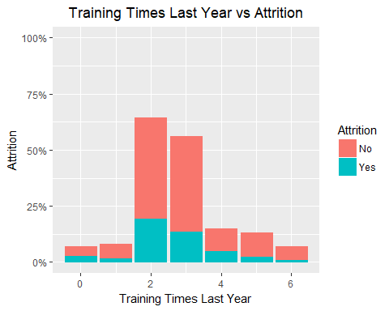

Cell Contents  
|-------------------------|  
| N |  
| N / Row Total |  
|-------------------------|  
  
   
Total Observations in Table: 1470   
  
   
 | df$Attrition   
df$TrainingTimesLastYear | No | Yes | Row Total |   
-------------------------|-----------|-----------|-----------|  
 0 | 39 | 15 | 54 |   
 | 0.722 | 0.278 | 0.037 |   
-------------------------|-----------|-----------|-----------|  
 1 | 62 | 9 | 71 |   
 | 0.873 | 0.127 | 0.048 |   
-------------------------|-----------|-----------|-----------|  
 2 | 449 | 98 | 547 |   
 | 0.821 | 0.179 | 0.372 |   
-------------------------|-----------|-----------|-----------|  
 3 | 422 | 69 | 491 |   
 | 0.859 | 0.141 | 0.334 |   
-------------------------|-----------|-----------|-----------|  
 4 | 97 | 26 | 123 |   
 | 0.789 | 0.211 | 0.084 |   
-------------------------|-----------|-----------|-----------|  
 5 | 105 | 14 | 119 |   
 | 0.882 | 0.118 | 0.081 |   
-------------------------|-----------|-----------|-----------|  
 6 | 59 | 6 | 65 |   
 | 0.908 | 0.092 | 0.044 |   
-------------------------|-----------|-----------|-----------|  
 Column Total | 1233 | 237 | 1470 |   
-------------------------|-----------|-----------|-----------|

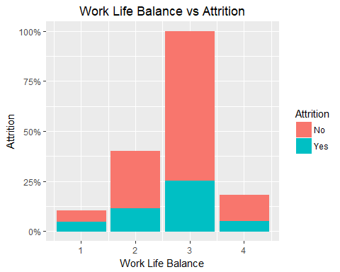

[1] "There is an significant decrease in attrition rate after Work life balance of level 1"

Cell Contents  
|-------------------------|  
| N |  
| N / Row Total |  
|-------------------------|  
  
   
Total Observations in Table: 1470   
  
   
 | df$Attrition   
df$WorkLifeBalance | No | Yes | Row Total |   
-------------------|-----------|-----------|-----------|  
 1 | 55 | 25 | 80 |   
 | 0.688 | 0.312 | 0.054 |   
-------------------|-----------|-----------|-----------|  
 2 | 286 | 58 | 344 |   
 | 0.831 | 0.169 | 0.234 |   
-------------------|-----------|-----------|-----------|  
 3 | 766 | 127 | 893 |   
 | 0.858 | 0.142 | 0.607 |   
-------------------|-----------|-----------|-----------|  
 4 | 126 | 27 | 153 |   
 | 0.824 | 0.176 | 0.104 |   
-------------------|-----------|-----------|-----------|  
 Column Total | 1233 | 237 | 1470 |   
-------------------|-----------|-----------|-----------|

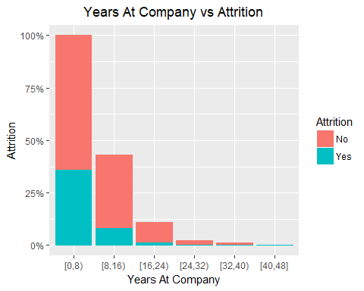

[1] "People who have spent 0-8 years at a company has highest attrition rate"

Cell Contents  
|-------------------------|  
| N |  
| N / Row Total |  
|-------------------------|  
  
   
Total Observations in Table: 1470   
  
   
 | df$Attrition   
 bins | No | Yes | Row Total |   
-------------|-----------|-----------|-----------|  
 [0,8) | 760 | 182 | 942 |   
 | 0.807 | 0.193 | 0.641 |   
-------------|-----------|-----------|-----------|  
 [8,16) | 348 | 42 | 390 |   
 | 0.892 | 0.108 | 0.265 |   
-------------|-----------|-----------|-----------|  
 [16,24) | 95 | 8 | 103 |   
 | 0.922 | 0.078 | 0.070 |   
-------------|-----------|-----------|-----------|  
 [24,32) | 20 | 2 | 22 |   
 | 0.909 | 0.091 | 0.015 |   
-------------|-----------|-----------|-----------|  
 [32,40) | 10 | 2 | 12 |   
 | 0.833 | 0.167 | 0.008 |   
-------------|-----------|-----------|-----------|  
 [40,48] | 0 | 1 | 1 |   
 | 0.000 | 1.000 | 0.001 |   
-------------|-----------|-----------|-----------|  
Column Total | 1233 | 237 | 1470 |   
-------------|-----------|-----------|-----------|

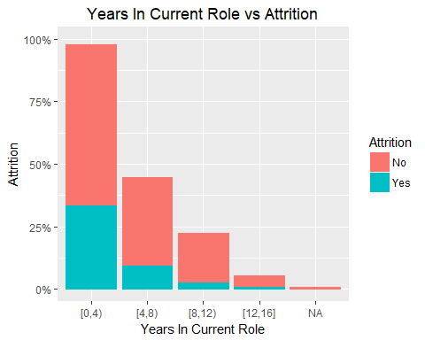

[1] "Years ranging from 0-4 in current role has highest attrition rate"

Cell Contents  
|-------------------------|  
| N |  
| N / Row Total |  
|-------------------------|  
  
   
Total Observations in Table: 1464   
  
   
 | df$Attrition   
 bins | No | Yes | Row Total |   
-------------|-----------|-----------|-----------|  
 [0,4) | 640 | 168 | 808 |   
 | 0.792 | 0.208 | 0.552 |   
-------------|-----------|-----------|-----------|  
 [4,8) | 350 | 49 | 399 |   
 | 0.877 | 0.123 | 0.273 |   
-------------|-----------|-----------|-----------|  
 [8,12) | 192 | 15 | 207 |   
 | 0.928 | 0.072 | 0.141 |   
-------------|-----------|-----------|-----------|  
 [12,16] | 45 | 5 | 50 |   
 | 0.900 | 0.100 | 0.034 |   
-------------|-----------|-----------|-----------|  
Column Total | 1227 | 237 | 1464 |   
-------------|-----------|-----------|-----------|

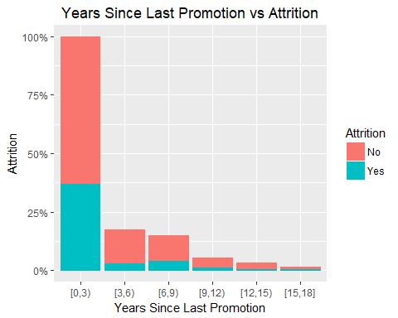

[1] "Years ranging from 0-3 since last promotion has highest attrition rate"

Cell Contents  
|-------------------------|  
| N |  
| N / Row Total |  
|-------------------------|  
  
   
Total Observations in Table: 1470   
  
   
 | df$Attrition   
 bins | No | Yes | Row Total |   
-------------|-----------|-----------|-----------|  
 [0,3) | 911 | 186 | 1097 |   
 | 0.830 | 0.170 | 0.746 |   
-------------|-----------|-----------|-----------|  
 [3,6) | 142 | 16 | 158 |   
 | 0.899 | 0.101 | 0.107 |   
-------------|-----------|-----------|-----------|  
 [6,9) | 104 | 22 | 126 |   
 | 0.825 | 0.175 | 0.086 |   
-------------|-----------|-----------|-----------|  
 [9,12) | 40 | 7 | 47 |   
 | 0.851 | 0.149 | 0.032 |   
-------------|-----------|-----------|-----------|  
 [12,15) | 26 | 3 | 29 |   
 | 0.897 | 0.103 | 0.020 |   
-------------|-----------|-----------|-----------|  
 [15,18] | 10 | 3 | 13 |   
 | 0.769 | 0.231 | 0.009 |   
-------------|-----------|-----------|-----------|  
Column Total | 1233 | 237 | 1470 |   
-------------|-----------|-----------|-----------|

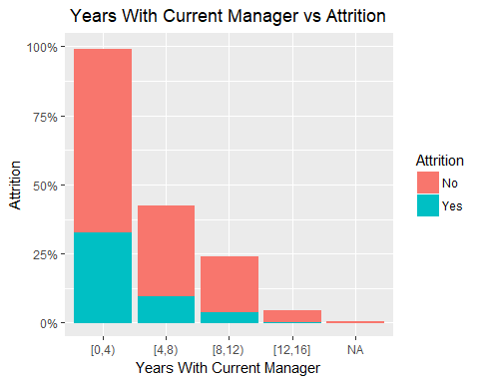

[1] "Years ranging from 0-4 for a current manager has highest attrition rate"

Cell Contents  
|-------------------------|  
| N |  
| N / Row Total |  
|-------------------------|  
  
   
Total Observations in Table: 1463   
  
   
 | df$Attrition   
 bins | No | Yes | Row Total |   
-------------|-----------|-----------|-----------|  
 [0,4) | 660 | 165 | 825 |   
 | 0.800 | 0.200 | 0.564 |   
-------------|-----------|-----------|-----------|  
 [4,8) | 324 | 50 | 374 |   
 | 0.866 | 0.134 | 0.256 |   
-------------|-----------|-----------|-----------|  
 [8,12) | 200 | 20 | 220 |   
 | 0.909 | 0.091 | 0.150 |   
-------------|-----------|-----------|-----------|  
 [12,16] | 42 | 2 | 44 |   
 | 0.955 | 0.045 | 0.030 |   
-------------|-----------|-----------|-----------|  
Column Total | 1226 | 237 | 1463 |   
-------------|-----------|-----------|-----------|