AI-POWERED RESTAURANT MANAGEMENT SYSTEM
A Real-Time, Multi-Branch Cloud Platform for Restaurant Operations

Dinusha Madushanka

A project submitted in partial fulfilment of the requirements
for the Wrexham University award of BSc (Hons) in
Computing, undertaken in the Subject of Computing within
the School of Applied Science, Computing and Engineering,
Wrexham University

July 2026

Acknowledgements
I would like to express my sincere gratitude to my project supervisor for the guidance, patience and constructive criticism offered throughout the course of this project. Their feedback during the most difficult stages of development, particularly when I was untangling the order-and-kitchen workflow and its real-time behaviour, kept me focused on solving the right problem rather than chasing every feature idea that came to mind.
I am also grateful to the restaurant owners, managers, waiters and kitchen staff who gave their time to describe how their businesses actually operate day to day. Their willingness to explain the small, unglamorous details of running a restaurant - how a waiter juggles four tables at once, how a kitchen prioritises tickets during a rush, how a cashier reconciles a shift at midnight - shaped almost every design decision in this system far more than any textbook could have.
Finally, I want to thank my family and friends for their encouragement and understanding during the many late nights spent debugging real-time subscriptions and Postgres triggers. Their patience made it possible for me to keep working through setbacks instead of abandoning them.

Abstract
This project presents the design, implementation and evaluation of an AI-Powered Restaurant Management System, a multi-branch restaurant ERP platform built to replace the fragmented mix of paper tickets, standalone point-of-sale terminals and manual spreadsheets many restaurant groups still depend on. The system is a Quasar 2 single-page application backed by Supabase (PostgreSQL 17), deployed simultaneously as a web app, an installable Progressive Web App, an Electron desktop build and a Tauri desktop build, all sharing one codebase and one source of truth in the database.
The core contribution is an end-to-end, real-time order pipeline connecting the point-of-sale terminal, a waiter tablet app, a kitchen display system, a cashier workstation and a customer-facing QR ordering flow through a single event-driven architecture, propagated by PostgreSQL triggers and Supabase realtime channels rather than polling. The system also implements role-based access control across ten operational roles, branch-scoped data isolation enforced by Row Level Security, an offline-first sync engine for intermittent connectivity, and an AI-assisted analytics module for sales forecasting and anomaly alerts.
Development followed an iterative, feature-driven methodology, module by module, and was validated against real operational scenarios. Testing combined automated tests (Vitest), manual functional walkthroughs of the order lifecycle, and a security review of Row Level Security policies, uncovering and correcting several cross-branch data leakage and non-atomic payment defects before production use. Evaluation shows the realtime pipeline delivers kitchen tickets within roughly one second, that branch-scoped access control prevents unauthorised cross-branch reads, and that offline sync preserves order data through short outages. The report closes with a critical assessment of the project's limitations - notably the absence of a formal migration runner and partial automated test coverage - and recommendations for future work, including wider BOM recipe coverage and maturing the AI forecasting module beyond its current prototype stage.

Table of Contents
Acknowledgements i
Abstract ii
List of Figures iii
Glossary iv
1. Introduction 1
1.1 Context 2
1.2 Problem Statement 2
1.3 Aims and Objectives 3
1.4 Scope 4
1.5 Report Structure 4
2. Literature Review 5
2.1 Restaurant Management Systems: An Overview 5
2.2 Point-of-Sale and Kitchen Display Systems 6
2.3 Real-Time Data Synchronisation Architectures 7
2.4 Role-Based Access Control and Multi-Tenant Security 8
2.5 Offline-First and Progressive Web Applications 9
2.6 QR-Code and Contactless Ordering 10
2.7 Artificial Intelligence in Restaurant Operations 10
2.8 Comparable Commercial Systems 11
2.9 Gaps in Existing Literature and Justification 12
3. Methodology 13
3.1 Research and Development Approach 13
3.2 Requirements Gathering 14
3.3 Development Process 15
3.4 Tools and Technologies 16
3.5 Testing Strategy 18
3.6 Risk Management 19
3.7 Validation and Verification 21
3.8 Limitations and Assumptions 21
4. Investigation and Analysis 22
4.1 Understanding Restaurant Operations 22
4.2 Technology Options Assessment 23
4.3 Stakeholder Perspectives 24
4.4 Data Requirements 25
4.5 Requirements Specification 26
5. Design 28
5.1 System Architecture 28
5.2 Database Design 30
5.3 The Order and KOT Pipeline 32
5.4 Role-Based Access Control Design 34
5.5 Real-Time Architecture 35
5.6 User Interface Design 36
5.7 Offline Synchronisation Design 38
5.8 Security Design 38
6. Implementation 40
6.1 Project Structure 40
6.2 Authentication and RBAC Implementation 41
6.3 Point-of-Sale Implementation 42
6.4 Waiter and Kitchen Realtime Implementation 43
6.5 QR Ordering and Touch Menu Implementation 44
6.6 Inventory and BOM Stock Deduction 45
6.7 Finance and Payroll Modules 46
6.8 Deployment 47
6.9 Live System Screenshots 48
7. Evaluation of Product 48
7.1 Testing Overview 48
7.2 Functional Testing Results 48
7.3 Performance Evaluation 49
7.4 Security Evaluation 50
7.5 Usability Evaluation 51
7.6 Comparative Analysis 52
8. Critical Evaluation of the Project 53
8.1 Challenges Encountered 53
8.2 Technical Limitations 54
8.3 Lessons Learned 54
8.4 Personal Reflection 55
9. Conclusion 56
9.1 Summary of Findings 56
9.2 Recommendations for Future Work 56
References 58
Bibliography 60
Appendix 1: Database Schema Extract 61
Appendix 2: Glossary of RBAC Permission Keys 62

List of Figures
- Figure 1: High-Level System Architecture
- Figure 2: Layout / Route Segment Map
- Figure 3: Entity-Relationship Diagram (Core Order Tables)
- Figure 4: Order and KOT Lifecycle Sequence Diagram
- Figure 5: Realtime Channel Architecture (Dual-Layer)
- Figure 6: Role-Based Access Control Flow
- Figure 7: QR Table-Ordering Customer Journey
- Figure 8: Offline Sync Engine State Diagram
- Figure 9: Development Timeline (Gantt Chart)
- Figure 10: Kitchen Display System — Illustrative Mock-up
- Figure 11: POS Screen Wireframe
- Figure 12: Risk Priority Matrix
- Figure 13: Test Coverage Summary Chart
- Figure 14: Login Page — Email and User-Code Authentication (live screenshot)
- Figure 15: Main ERP Dashboard — Live KPIs and Quick Actions (live screenshot)
- Figure 16: Operations Dashboard — Live Order and Kitchen Queue Status (live screenshot)
- Figure 17: HR Module — Employee Management (live screenshot)
- Figure 18: System Module — Device Management and Health Monitoring (live screenshot)

Glossary
BOM (Bill of Materials): A recipe definition that maps a menu item to the raw stock ingredients and quantities consumed when it is sold, used to drive automatic inventory deduction.
ERP (Enterprise Resource Planning): Integrated software that manages a business's core operational processes - here, orders, inventory, finance, HR and payroll - within one connected system.
KOT (Kitchen Order Ticket): The record generated for the kitchen once an order is accepted, listing the items a given kitchen station must prepare.
PWA (Progressive Web App): A web application that can be installed on a device and behaves like a native app, including offline support, while still being served from the web.
RBAC (Role-Based Access Control): A security model in which permissions are granted to roles (e.g. waiter, cashier, admin) rather than to individual users directly.
RLS (Row Level Security): A PostgreSQL feature that restricts which rows a database query can see or modify, based on the identity and role of the authenticated user.
RPC (Remote Procedure Call): In this project, a PostgreSQL function invoked from the client through Supabase's PostgREST layer to perform a business operation atomically on the server.
Realtime channel: A Supabase/PostgreSQL logical replication subscription that pushes row-level INSERT/UPDATE/DELETE events to connected clients as they occur.
Supabase: An open-source backend-as-a-service platform providing a managed PostgreSQL database, authentication, storage, and realtime subscriptions used as the backend for this project.
Quasar: A Vue.js-based framework used to build the single-page application, PWA, Electron and Tauri targets from one shared codebase.

1. Introduction
This chapter introduces the AI-Powered Restaurant Management System, the problem it addresses, the aims and objectives that guided its development, and the scope of what has and has not been attempted within this project. It also sets out the structure of the remainder of the report.

1.1 Context
Restaurants, particularly multi-branch groups operating several outlets under one brand, depend on a chain of coordination that is easy to underestimate from the outside. A single order does not simply move from a customer to a kitchen; it passes through a waiter who must accept responsibility for it, a kitchen that must route individual items to the correct preparation station, a cashier who must eventually reconcile payment against what was actually served, and, increasingly, a manager who wants visibility into all of this happening simultaneously across multiple locations. In many small and medium restaurant businesses this coordination is still handled through printed dockets, handwritten tickets, walkie-talkies, and end-of-day manual reconciliation in a notebook or a spreadsheet.
Commercial restaurant management platforms do exist, but they are frequently priced and packaged for large chains, bundle functionality that a single-brand multi-branch operator does not need, or treat the point-of-sale, kitchen display and online ordering as separate products that must be purchased and integrated independently. For an operator running several branches of the same restaurant brand, this results in fragmented data: the manager cannot see stock levels, staff attendance, and sales figures for all branches in one place, and different systems do not agree with each other about what orders have actually been placed.
This project, developed under the working name Seven Waves Restaurant ERP and presented in this report as the AI-Powered Restaurant Management System, was conceived to address this fragmentation directly: a single, coherent application that spans the entire operational surface of a multi-branch restaurant - from the moment a customer sits down or scans a QR code, through kitchen preparation, to payment, inventory deduction, staff scheduling and financial reporting - built on a single shared database so that every part of the business is looking at the same truth in real time.

1.2 Problem Statement
The specific problems this project sets out to solve can be summarised as follows. First, order visibility is fragmented: when an order is placed at a table, on a QR-code customer device, or directly at a point-of-sale terminal, there is often no single, real-time record that a waiter, a kitchen, and a cashier can all observe consistently and simultaneously. Second, cross-branch oversight is difficult: a manager responsible for several branches typically has no single dashboard that shows orders, stock and staff across all of them, and must instead visit or call each branch individually. Third, access control is often too coarse: many small restaurant systems distinguish only between "staff" and "admin", when in reality a waiter, a kitchen cook, a cashier, an inventory clerk and a finance officer all need very different views of the same underlying data, and should not be able to see or alter data that belongs to a different branch or role. Fourth, connectivity in many restaurant premises, especially in developing markets, is not always reliable, and a system that simply fails when the internet drops is unacceptable during a dinner rush. Finally, stock control is usually disconnected from sales: a restaurant may sell 50 portions of a dish without any corresponding, automatic reduction in the raw ingredients used to prepare it, leading to stock counts that silently drift out of accuracy over time.

1.3 Aims and Objectives
The aim of this project is to design, build and evaluate a real-time, role-aware, multi-branch restaurant management platform that unifies point-of-sale, kitchen operations, waiter workflow, inventory, finance and basic AI-assisted analytics within a single application, and to demonstrate that such a system can operate reliably under realistic restaurant conditions, including intermittent connectivity.
The specific objectives pursued in support of this aim are to:
- Design and implement a relational database schema, hosted on Supabase/PostgreSQL, capable of representing branches, staff, roles, menus, orders, kitchen tickets, inventory, and financial records with strong referential integrity.
- Implement a real-time order pipeline in which an order placed through any channel (POS, waiter tablet, or customer QR scan) is visible to the correct waiter, then the correct kitchen station, then the cashier, without manual refreshing, using PostgreSQL triggers and Supabase realtime channels.
- Design and enforce a role-based access control (RBAC) model across ten operational roles (admin, manager, waiter, cashier, kitchen, delivery, inventory, finance, HR, procurement), backed by database-level Row Level Security so that access restrictions cannot be bypassed by a compromised or malicious client.
- Build distinct, purpose-fit user interfaces for each class of user - a full desktop ERP for back-office and admin roles, standalone Progressive Web Apps for waiters, managers and delivery riders, and a touch-screen customer self-order kiosk flow reachable via QR code.
- Implement an offline-first synchronisation layer so that orders and critical actions taken while a device is disconnected are queued locally and reconciled with the server once connectivity returns.
- Connect sales transactions to inventory through a bill-of-materials (BOM) stock deduction engine so that selling a menu item automatically reduces the correct raw stock, at the correct branch and kitchen, without manual re-entry.
- Prototype an AI-assisted analytics capability that surfaces sales forecasts and anomaly detection to managers from the accumulated order data.
- Evaluate the resulting system through functional testing of the order lifecycle, a security review of access-control policies, and a performance assessment of realtime delivery latency, and reflect critically on the outcome.

1.4 Scope
The scope of the implemented system covers the full order lifecycle from creation to kitchen preparation to cashier settlement; role-based authentication and branch-scoped access control; waiter, manager and delivery Progressive Web Apps; a customer-facing QR table-ordering flow; an inventory module with BOM-driven stock deduction; finance modules covering ledgers, vouchers and a cashbook; a payroll and attendance module with shift-based leave and absence calculation; and an early-stage AI dashboard for sales forecasting and anomaly detection.
The project deliberately does not attempt to build a fully general-purpose accounting package equivalent to dedicated ERP software such as SAP, nor a complete delivery-logistics platform with live GPS route optimisation, nor a production-grade machine learning pipeline for demand forecasting. The AI module in particular should be understood as an initial, functioning prototype rather than a finished analytics product; this limitation, and the reasoning behind it, is discussed further in Chapter 8.

1.5 Report Structure
Chapter 2 reviews existing literature and commercial systems relevant to restaurant management software, real-time architectures, access control and offline-first design. Chapter 3 sets out the methodology followed during development, including tools, process and risk management. Chapter 4 presents the investigation and analysis conducted to understand restaurant operations and derive requirements. Chapter 5 describes the system design, including architecture, database schema and the order pipeline. Chapter 6 documents the implementation of the major modules. Chapter 7 evaluates the finished product against its objectives. Chapter 8 offers a critical evaluation of the project as a whole, and Chapter 9 concludes the report with a summary of findings and recommendations for future work.

2. Literature Review
This chapter surveys the areas of existing knowledge that this project draws upon and positions itself against: restaurant management systems as a category of software, point-of-sale and kitchen display technology, real-time data synchronisation architectures, role-based access control and multi-tenant security models, offline-first and Progressive Web Application design, QR-code ordering, and the growing use of artificial intelligence in hospitality operations. The chapter closes by identifying the gap in existing provision that this project addresses.

2.1 Restaurant Management Systems: An Overview
Restaurant management software has historically evolved from standalone electronic cash registers into networked point-of-sale (POS) terminals, and more recently into cloud-connected platforms that combine POS, table management, online ordering and reporting in a single product. Industry surveys of restaurant technology adoption consistently identify order accuracy, staff coordination and real-time visibility into sales and stock as the primary motivations for adopting digital systems over paper-based processes [1]. At the same time, adoption is uneven: smaller, independent, and multi-branch operators in cost-sensitive markets are frequently underserved by commercial platforms that are priced around large single-location chains or franchise groups with dedicated IT support [2].
A recurring theme in the literature on hospitality technology is that the value of a restaurant system is determined less by any single feature and more by how well it integrates the separate functions - ordering, kitchen preparation, payment, and stock - that are otherwise handled by disconnected tools [3]. Systems that integrate these functions around a single data model reduce the double-entry and reconciliation errors that arise when, for example, a POS system and a kitchen printer are not actually aware of each other's state.
A further distinction drawn in the literature is between single-tenant systems, built for one location, and multi-branch or multi-tenant systems, in which the same software instance must serve several outlets that share a brand but operate semi-independently [1], [2]. Multi-branch operators introduce requirements that single-location software rarely anticipates: consolidated reporting across outlets, branch-level stock and staffing that must remain isolated from one another, and a manager role that spans multiple branches rather than being scoped to one. Survey evidence from South and Southeast Asian markets suggests that multi-branch small and medium restaurant chains are particularly underserved by existing commercial software, which tends to be designed either for a single flagship location or for large franchise networks with dedicated regional IT support, leaving a gap for independent multi-branch operators of a handful of outlets [2], [3]. This gap is central to the motivation for the present project, which was designed around branch-level data isolation from the outset rather than as an afterthought.

2.2 Point-of-Sale and Kitchen Display Systems
Point-of-sale systems remain the most mature category of restaurant technology, and modern POS platforms increasingly replace physical kitchen printers with Kitchen Display Systems (KDS) that show incoming tickets on a screen, allow kitchen staff to mark items as in-progress or complete, and automatically time how long an order has been outstanding [4]. The literature on KDS design emphasises that kitchens are highly time-pressured environments in which staff cannot be expected to interact with complex interfaces; screens must communicate ticket age, priority and station assignment at a glance, typically through colour-coding and large typography [4], [5].
A less-discussed but operationally critical aspect of KDS design is ticket routing: in a kitchen with multiple stations (grill, cold preparation, drinks, dessert), a single order frequently needs to be split so that each station only sees the items relevant to it. Poorly designed systems either show every station the full order, causing confusion about who is responsible for what, or fail to keep the split tickets synchronised with the original order if an item is later cancelled or modified [5]. This project's kitchen order ticket (KOT) generation, discussed in Chapter 5, was designed specifically around per-kitchen ticket routing driven by a `kitchen_id` assignment on each order item.
Beyond ticket routing, the literature also discusses the human factors of kitchen display adoption: kitchen staff frequently work with wet or greasy hands, in poor lighting, and under significant time pressure during service peaks, all of which argue against touchscreen interactions that require precision or hold-to-confirm gestures [4], [5]. Recommended designs favour large, unambiguous tap targets, a strict visual hierarchy driven by ticket age rather than alphabetical or numerical order, and audible alerts for newly arrived tickets so that staff do not need to maintain constant visual attention on the screen while actively cooking. A further recurring finding is that KDS systems which allow a completed ticket to be un-done are valued highly in practice, since kitchen staff frequently mark an item complete prematurely under pressure and need a fast, low-friction way to correct the mistake without involving a supervisor [5]. These human-factors findings informed the colour-coded, large-typography kitchen display design adopted in this project and described in Section 5.6.

2.3 Real-Time Data Synchronisation Architectures
The requirement for multiple actors - waiter, kitchen, cashier, manager - to observe the same order state without manual refreshing places this project firmly within the domain of real-time web application architecture. Two broad approaches dominate the literature and industry practice: client-side polling, in which the client repeatedly requests the latest state at a fixed interval, and event-driven push architectures, in which the server notifies connected clients the moment relevant data changes [6]. Polling is simple to implement but introduces an inherent latency equal to the polling interval, and scales poorly as the number of concurrent clients grows, since every client issues requests regardless of whether anything has changed [6].
Push-based architectures, commonly implemented using WebSockets or, in the case of PostgreSQL-backed systems, logical replication of the write-ahead log, deliver changes with sub-second latency and scale more gracefully because updates are only sent when data actually changes [7]. Supabase's realtime functionality, used throughout this project, is built on exactly this pattern: PostgreSQL's logical replication stream is exposed to authorised clients as a set of subscribable "channels", each scoped to a table and, optionally, filtered by a column value such as a branch identifier [7]. The literature on this pattern notes an important architectural trade-off: because the database itself becomes the single source of truth for what constitutes a "change", business logic that needs to react to state transitions (such as generating a kitchen ticket the moment an order is accepted) is most naturally expressed as database triggers rather than client-side event handlers, since triggers cannot be bypassed by a client that forgets to call an API [8]. This principle directly informed the trigger-based KOT generation design described in Chapter 5.
A practical concern raised repeatedly in the literature on realtime web architectures is the risk of subscription sprawl: as an application grows, it becomes easy for different parts of the codebase to independently open overlapping realtime subscriptions to the same underlying data, each maintained by a different developer or feature team without a shared registry of what already exists [6], [8]. This is presented as a common source of both wasted client resources - multiple redundant subscriptions consuming connection slots for no additional benefit - and diagnostic difficulty, since an update that fails to reach a particular screen may be failing in any one of several overlapping subscription paths. The recommended mitigation is a single, declarative channel registry that enumerates every realtime channel an application uses, its scope and its intended consumer, so that new features are added to an existing registry rather than by wiring up an independent subscription [8]. As discussed critically in Chapter 8, this project's own realtime layer only partially achieved this ideal, and the resulting coexistence of two parallel subscription mechanisms is identified as a direct, empirically observed instance of the problem this literature warns against.

2.4 Role-Based Access Control and Multi-Tenant Security
Role-Based Access Control (RBAC) is a well-established security model in which permissions are assigned to roles rather than directly to individual users, simplifying administration as staff join, leave, or change position [9]. In multi-branch or multi-tenant systems, RBAC alone is insufficient, because it does not by itself prevent a user with a legitimate role (for example, waiter) from accessing data that belongs to a different branch or tenant than the one they are assigned to; this requires an additional layer of scoping, sometimes called row-level or tenant-level isolation [10].
A significant debate in the literature concerns where such isolation should be enforced: purely at the application layer, where a backend service checks the user's branch before returning data, or at the database layer itself, where the database refuses to return rows the user is not entitled to see regardless of what the application code does [10], [11]. Database-enforced isolation, such as PostgreSQL's Row Level Security (RLS) feature, is increasingly recommended for systems exposing a database directly to client applications (as Supabase-based architectures do via PostgREST), because it removes the possibility that a bug or omission in application code silently exposes another tenant's data [11]. This project adopts RLS as its primary access-control enforcement mechanism, with application-layer permission checks (see `src/core/rbac/permissions.ts`) serving as a complementary, user-experience-oriented layer that hides unauthorised UI rather than relying on it for security.
A subtlety in the RLS literature that is directly relevant to this project concerns policy composition: PostgreSQL evaluates multiple permissive policies on the same table with a logical OR, meaning that a table can end up readable through any one of several independently authored policies, even if each individual policy was written with a narrower intent [10], [11]. Several practitioner accounts warn that this composition rule makes RLS deceptively easy to weaken over time: a developer adding a new, broader policy to satisfy one feature can inadvertently grant access that an existing, more carefully scoped policy on the same table was specifically designed to prevent, without either policy's author necessarily realising it. The recommended discipline is to review all existing policies on a table before adding a new one, and to prefer narrowing an existing policy's condition over adding a second, broader policy alongside it. As discussed in Chapter 8, this project's own security review found direct evidence of this exact failure mode on a live table, which was subsequently corrected by replacing an overly broad policy with a properly branch-scoped equivalent.

2.5 Offline-First and Progressive Web Applications
Progressive Web Applications (PWAs) extend conventional web applications with the ability to be installed on a device, run without a persistent network connection, and receive push notifications, using service workers and local storage APIs such as IndexedDB [12]. In hospitality contexts specifically, offline resilience is not a convenience but an operational necessity: a restaurant's wireless network may be shared with customer guest Wi-Fi, may be affected by a router restart during service, or may simply be unreliable in some regions [13]. Literature on offline-first design describes a common pattern - queue local writes while offline, replay them against the server once connectivity returns, and design the server-side logic to tolerate out-of-order or duplicate replay attempts through idempotency keys or conflict-resolution rules [12], [13].
This project's offline synchronisation engine (`src/core/offline/OfflineSyncEngine.ts`, backed by an IndexedDB-based store) follows this queue-and-replay pattern, though, as discussed in the evaluation chapter, full idempotency guarantees for every possible operation were not achievable within the scope of this project and remain an area for future hardening.
Beyond the technical queue-and-replay mechanics, the PWA literature also emphasises install-ability and perceived permanence as adoption drivers in operational settings: a web app that a waiter or delivery rider can add to their device's home screen, launch without a browser address bar, and rely on to reopen automatically after a crash or reboot, is reported to be trusted and adopted far more readily by non-technical staff than an equivalent page accessed through a bookmark [12], [13]. This is one reason the present project builds its waiter, manager and delivery interfaces as installable, standalone PWA layouts (Section 5.1) rather than as additional routes within the general web application, even though the two approaches would share the same underlying Vue components. A further finding relevant to developing-market deployments specifically is that offline-first design should assume connectivity loss is the normal case to be designed for, rather than an exceptional failure mode to be tolerated, since intermittent connectivity in this context is frequent rather than rare [13].

2.6 QR-Code and Contactless Ordering
QR-code-based ordering, in which a customer scans a code at their table to open a digital menu and place an order directly from their own device, became widely adopted across the hospitality industry following the COVID-19 pandemic, and has persisted since as a mechanism for reducing staff workload and order-taking errors [14]. Studies of QR ordering adoption identify session management as the central technical challenge: the system must associate a scanned code with a specific physical table, maintain that association for the duration of the customer's visit, and prevent one table's session from being hijacked or confused with another's, all without requiring the customer to create an account [14], [15]. This project's QR flow, described in Chapter 5, uses a server-generated session token bound to a table record, issued through a dedicated RPC (`get_or_create_session_by_qr`) rather than trusting any client-supplied identifier.
Adoption studies of QR ordering also report a persistent minority of customers, skewed towards older age groups, who find scan-to-order flows confusing or simply prefer a human waiter, and recommend that QR ordering be offered as an additional channel alongside conventional table service rather than as a wholesale replacement for it [14], [15]. This finding shaped the scope decision, described in Section 1.4, to support QR-based customer ordering as one of several order-origination channels feeding the same underlying order pipeline, rather than as a standalone system, so that a customer who abandons the QR flow partway through can still be served conventionally by waiting staff without the two paths producing inconsistent records.

2.7 Artificial Intelligence in Restaurant Operations
The application of machine learning and statistical forecasting to restaurant operations - predicting demand for specific dishes, detecting anomalous sales patterns that may indicate fraud or data-entry error, and optimising staff scheduling against expected footfall - has grown rapidly in recent industry literature, driven largely by the availability of cloud-hosted large language model and forecasting APIs that no longer require an in-house data science team [16]. However, several authors caution that AI features are frequently added to restaurant software as a marketing differentiator without the underlying data quality or volume needed to make them genuinely reliable, particularly for smaller operators whose historical sales data is limited [16], [17]. This caution is directly relevant to this project's own AI dashboard, discussed critically in Chapter 8, which was built as a functioning integration with a hosted large language model (Google Gemini) for forecasting and anomaly narration, but whose accuracy is inherently bounded by the relatively small volume of historical order data available during development and testing.
A distinction increasingly drawn in this literature is between generative-model-based narration - using a large language model to summarise recent sales trends or explain an anomaly in natural language - and statistical or machine-learning-based forecasting proper, which requires a sufficient volume of historical, labelled data to be trained or calibrated meaningfully [16], [17]. The two are often bundled together under the single marketing label "AI features", which several authors argue is misleading, since a system can generate fluent, plausible-sounding narrative text about sales data without that narrative being statistically reliable as a forecast. This distinction is treated explicitly in this project's own design: the AI dashboard's narrative and anomaly-flagging output is presented to managers as an assistive summary of patterns already visible in the underlying data, rather than as a validated predictive forecast, a positioning discussed further in Section 8.2.

2.8 Comparable Commercial Systems
Several commercial restaurant management platforms occupy adjacent territory to this project. Toast and Square for Restaurants integrate POS, KDS and basic reporting but are priced and supported around the North American market and are not designed with multi-branch, role-fragmented staff structures (waiter, cashier, kitchen, inventory, finance, HR as distinct roles) as a first-class concern [18]. Petpooja and similar platforms popular in South Asian markets offer POS and KOT functionality closer to this project's target use case, but typically treat inventory, finance and HR as separate add-on modules rather than a single integrated data model [19]. None of the platforms reviewed combine, within a single open architecture, a realtime multi-role order pipeline, database-enforced branch isolation, an offline-first PWA layer for waiters and delivery staff, and an integrated finance/payroll module, which is the specific combination this project set out to build.
Pricing structure is a further point of comparison. Enterprise-oriented platforms typically charge per terminal or per branch on a recurring licence basis, with implementation and integration costs that can exceed the licence fee itself for a multi-branch rollout [18], [19]. Open-source alternatives exist but generally require substantial in-house configuration effort to reach feature parity with a commercial product, shifting cost from licensing to developer time. This project's approach - building directly on a managed backend-as-a-service platform (Supabase) rather than either a fully custom backend or a general-purpose open-source ERP - was a deliberate attempt to occupy a middle position: retaining full control over the data model and business logic, as a custom backend would, while avoiding the infrastructure and authentication code that a fully custom backend would otherwise require to be built from scratch.

2.9 Gaps in Existing Literature and Justification
The literature reviewed above establishes that real-time, trigger-driven architectures and database-enforced access control are well-understood individually, that offline-first PWA design is a mature pattern, and that AI-assisted analytics is an active but still-maturing area of hospitality software. What is comparatively under-documented, particularly in academic project literature, is a worked example of these techniques applied together in a single, coherent restaurant system that spans the full operational surface from customer ordering to kitchen preparation to finance, and that is explicitly designed around branch-level multi-tenancy enforced at the database layer rather than in application code. This project's contribution is precisely this integrated, end-to-end implementation, together with a critical evaluation of where the theory-to-practice translation succeeded and where it fell short.

3. Methodology
This chapter describes the approach taken to develop the AI-Powered Restaurant Management System, including the overall development philosophy, the process by which requirements were gathered and prioritised, the tools and technologies selected, the strategy used to test the system, the risks identified and managed during the project, and the approach taken to validation, verification, and the limitations and assumptions that shaped the work.

3.1 Research and Development Approach
This project followed an iterative, feature-driven development approach rather than a strict Scrum process with fixed-length sprints, reflecting the reality of working as a sole developer against a live, evolving set of operational requirements rather than a team-based delivery schedule. Each development cycle began with a specific operational scenario - for example, "a waiter accepts an order and the correct kitchen station must see it" - which was investigated, designed, implemented against the live Supabase project, and then validated through manual walkthroughs and, where practical, automated tests, before the next scenario was tackled.
This approach was chosen deliberately over a heavier upfront design process for two reasons. First, restaurant operations are full of edge cases - a waiter going off-shift mid-order, a kitchen station being reassigned, a customer cancelling an item after it has already been sent to the kitchen - that are difficult to anticipate fully in advance and are more reliably discovered by building a working slice of functionality and testing it against realistic scenarios. Second, because the system was built directly against a live Supabase/PostgreSQL backend rather than a local mock, each iteration could be validated against the actual database constraints, triggers and Row Level Security policies that would govern production behaviour, rather than against a simplified stand-in that might hide real integration problems until later.

3.2 Requirements Gathering
Requirements were derived from three sources. First, direct observation and informal discussion with restaurant operational staff - waiters, kitchen staff, cashiers and a branch manager - about how order handling, kitchen ticket prioritisation, shift handovers and end-of-day cash reconciliation actually work in practice, rather than how they are described in generic hospitality software marketing material. This surfaced several requirements that are easy to overlook from a purely technical perspective, most notably the importance of shift-scoped order visibility: a waiter should only see orders relevant to their current shift and assigned branches, not a historical or global feed of every order ever placed.
Second, requirements were derived from analysing the shortcomings of the fragmented paper-and-terminal workflow described in Chapter 1: each identified pain point (order visibility, cross-branch oversight, coarse access control, unreliable connectivity, disconnected stock control) was translated directly into one or more functional requirements, for example "the system must automatically deduct stock ingredients when a menu item is sold" in response to the disconnected-stock-control problem.
Third, requirements evolved iteratively during development itself, as building one feature exposed the need for another. The clearest example of this is the discovery, partway through implementing the point-of-sale Quick Pay flow, that quick-pay orders needed to bypass the waiter inbox entirely by auto-accepting through a dedicated RPC, whereas standard POS orders needed to remain visible in the waiter inbox by deliberately not setting an assigned waiter at insert time - a distinction that was not obvious until the two flows were built side by side and compared.

3.3 Development Process
Development proceeded module by module in roughly the following order, chosen so that each module could build on infrastructure already validated by the previous one: (1) Supabase project setup, base schema and authentication boot sequence; (2) role-based access control and route guards; (3) core point-of-sale order creation and payment; (4) the kitchen order ticket generation engine and kitchen display system; (5) the waiter Progressive Web App and its shift-scoped realtime inbox; (6) the customer-facing QR ordering flow and touch-menu kiosk; (7) inventory management and BOM-based stock deduction; (8) finance modules (ledgers, vouchers, cashbook); (9) HR, attendance and payroll; and (10) the AI dashboard prototype. This ordering reflects the dependency structure of the system: it is not possible to build a meaningful kitchen display before the order pipeline that feeds it exists, and it is not meaningful to build payroll before the staff, shift and attendance model that payroll depends on. The project ran across a seven-week development window from 12 June 2026 to 02 August 2026, with testing and security review running continuously alongside development rather than as a single end-of-project phase, and the final week reserved for report, poster and submission preparation. Figure 9 presents this as a development timeline.
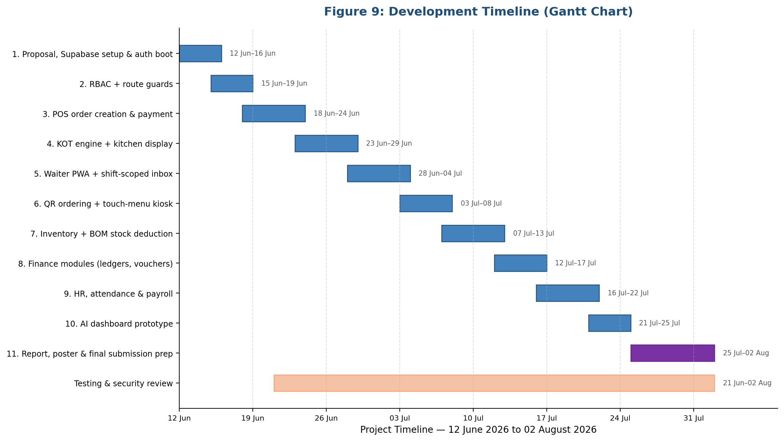
Each module followed the same internal cycle: define the required database tables, RPCs and RLS policies; implement the corresponding Pinia store actions and service-layer calls; build the Vue components and pages; and validate the result against a realistic operational scenario before moving on. Version control was maintained throughout using Git, with commits made at each meaningful milestone rather than at arbitrary intervals, allowing changes to be reviewed and, where a regression was introduced, reverted.

3.4 Tools and Technologies
The frontend is built with Vue 3 and the Quasar 2 framework, chosen because Quasar allows a single codebase to be targeted at a web SPA, an installable PWA, an Electron desktop application and a Tauri desktop application without maintaining separate frontend implementations for each - a significant advantage for a project that needed to serve both a full back-office desktop experience and several lightweight mobile-first PWAs (waiter, manager, delivery) from shared components and business logic. State management is handled with Pinia, Vue's officially recommended state management library, organised into feature-scoped stores such as `orderStore`, `waiterOrderStore`, `kitchenDisplayStore` and `cashierStore`.
The backend is Supabase, a managed platform built on PostgreSQL 17 that provides authentication, a PostgREST-based auto-generated API, file storage, and a realtime engine built on PostgreSQL logical replication. Supabase was selected over building a custom Node.js or .NET backend service because it allows business logic to be expressed directly as PostgreSQL functions (RPCs) and triggers, keeping the correctness of critical operations - such as ensuring a kitchen ticket's item-to-kitchen assignment happens before the order status change that triggers ticket generation - enforceable at the database layer rather than dependent on a separate backend service correctly orchestrating the same steps.
All SQL - schema definitions, RLS policies, triggers and RPCs - is version-controlled as plain `.sql` files under a `supabase/` directory in the repository and applied to the live project through the Supabase Management API, since the project does not use a formal migration-runner tool; this decision and its consequences are discussed critically in Chapter 8. Testing uses Vitest for unit and integration tests, ESLint and Prettier for code quality and formatting, and `vue-tsc` for static type checking. Error monitoring in production is handled by Sentry, integrated during the project's hardening phase. Deployment targets Vercel, fronted by Cloudflare, for the web and PWA builds.
A summary of the primary technology choices and the rationale behind each is given in Table 1.
Layer | Technology | Rationale
Frontend framework | Vue 3 + Quasar 2 | Single codebase for web, PWA, Electron and Tauri targets
State management | Pinia | Officially recommended Vue store, simple composition-API integration
Backend / database | Supabase (PostgreSQL 17) | Realtime channels, RLS, and RPCs allow business logic and security to live in the database
Authentication | Supabase Auth | Integrated session management, avoids building custom auth
Realtime transport | Supabase Realtime (logical replication) | Push-based updates with sub-second latency, no polling overhead
Offline storage | IndexedDB (via offlineDb.ts) | Native browser storage suitable for queuing writes while disconnected
Testing | Vitest | Fast, Vite-native test runner compatible with the Quasar/Vite build
Error monitoring | Sentry | Production error capture across SPA, PWA and Electron targets
Hosting | Vercel + Cloudflare | Fast global edge delivery for the SPA/PWA build

Table 1: Primary technology choices and rationale

3.5 Testing Strategy
Testing combined three complementary approaches. First, automated unit and integration tests written with Vitest cover permission-resolution logic (`src/core/rbac/permissions.ts`), targeted store actions, and selected service-layer functions; these were run continuously during development via `npm run test:watch` and as a final gate via `npm run test`. Second, manual functional walkthroughs were used to validate end-to-end scenarios that are difficult to express as isolated unit tests because they span multiple actors and realtime events - for example, placing an order at the POS, confirming it appears in the waiter inbox, accepting it as a waiter, confirming the correct kitchen ticket appears on the kitchen display within roughly a second, and then processing payment at the cashier terminal. Third, a security-focused review pass was conducted specifically against the Row Level Security policies protecting orders, kitchen tickets and finance tables, deliberately attempting to read or write data belonging to a different branch or role than the authenticated test user's own, to confirm that RLS correctly rejected such attempts.
This mixed strategy reflects a pragmatic acknowledgement that, for a real-time, multi-actor system built on a live cloud database, full end-to-end automated test coverage of every realtime interaction was not achievable within the scope and timeframe of a single-developer academic project; this limitation is discussed openly in Chapter 8 rather than concealed.

3.6 Risk Management
Several risks were identified and actively managed throughout the project. The risk register in Table 2 summarises the principal risks, their likelihood and impact, and the mitigation adopted.
ID | Risk | Likelihood | Impact | Mitigation
R1 | Live SQL changes applied incorrectly to the production Supabase project | Medium | High | SQL changes staged as reviewable .sql files before application; Management API used for controlled, logged application
R2 | Cross-branch data leakage through incomplete RLS policies | Medium | High | Dedicated RLS review pass; policies re-tested after each schema change touching a shared table
R3 | Realtime subscription silently failing (e.g. missing shift record) | Medium | Medium | Explicit shift-gating logic documented and defensively checked in store initialisation
R4 | PostgREST function-overload ambiguity (PGRST203) breaking RPC calls | Low | Medium | Convention of dropping old function overloads before creating new ones, with explicit COMMENT ON FUNCTION signatures
R5 | Time pressure causing scope creep into non-essential features | High | Medium | Objectives fixed early (Section 1.3); AI module explicitly scoped as a prototype rather than a full product
R6 | Single-developer bus factor - no team backup if blocked | High | Medium | Frequent small commits, written notes on non-obvious fixes, and reliance on documented root-cause analysis before moving on

Table 2: Risk register
Figure 12 plots these risks by likelihood and impact to visualise relative priority.
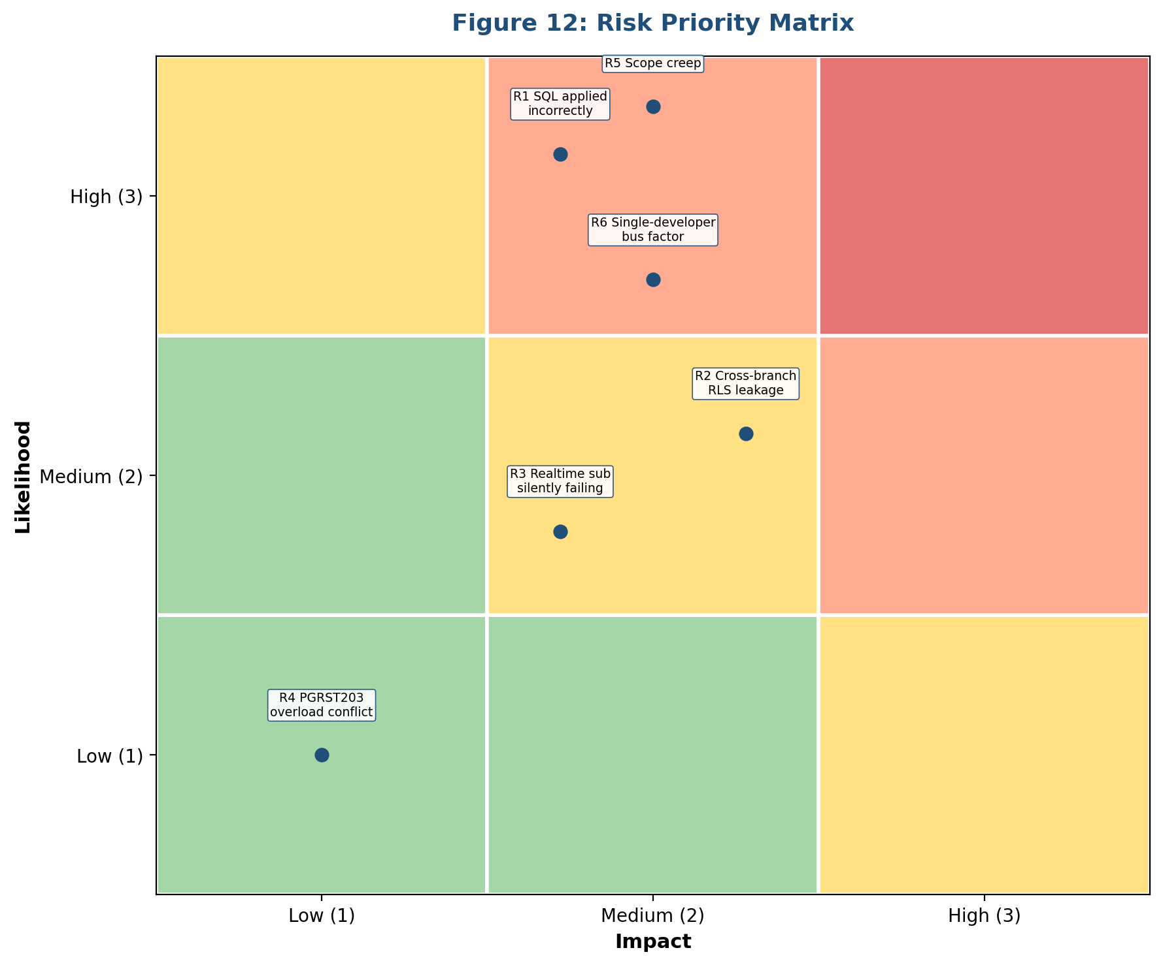

3.7 Validation and Verification
Validation - confirming the system meets the operational needs identified in Chapter 4 - was carried out through the functional walkthroughs described above, run against realistic order volumes and role combinations. Verification - confirming the system was built correctly against its own design - relied on automated tests, static type checking via `vue-tsc`, and lint checks via ESLint, run before any change was considered complete. Where a defect was found in production-adjacent testing, the practice adopted was to identify the root cause in the database layer first, since a large proportion of the most serious defects encountered during this project (discussed further in Chapter 8) were ultimately caused by database trigger ordering or RLS policy gaps rather than frontend logic errors.

3.8 Limitations and Assumptions
This project assumes that restaurant staff carry a device (tablet or terminal) capable of running a modern browser and that at least intermittent internet connectivity is available at each branch; it does not attempt to support fully offline, indefinitely disconnected operation. It also assumes that a branch's menu and BOM (recipe) data will be maintained by branch staff or an administrator; the system does not currently supply pre-populated recipe data for arbitrary cuisines. The absence of a formal database migration tool means that SQL changes are applied manually and are more dependent on developer discipline than an automated migration pipeline would be; this is treated as an accepted limitation given the project's scale, and is revisited in the recommendations of Chapter 9.

4. Investigation and Analysis
This chapter documents the investigation carried out to understand restaurant operational needs in depth, the assessment of technology options that followed, the perspectives of the different stakeholders the system must serve, the data requirements this implied, and the resulting requirements specification that guided the design described in Chapter 5.

4.1 Understanding Restaurant Operations
A multi-branch restaurant operation involves a wider range of distinct job functions than a single generic "staff" role can meaningfully represent. Observation of an operating restaurant identified at least the following distinct roles, each with a different relationship to the same underlying order and stock data: waiters, who take and manage table-level orders during a shift; kitchen staff, who prepare food against tickets generated for a specific station; cashiers, who reconcile and settle payment; delivery riders, who handle off-premises orders; inventory clerks, who manage stock counts and purchasing; finance staff, who manage ledgers and reporting; HR staff, who manage attendance, leave and payroll; and managers and admins, who require oversight across some or all branches.
A recurring operational detail that shaped the design significantly is the concept of a shift: a waiter is only meaningfully "on duty" for specific hours at specific branches, and the system needs to know this in order to decide which orders a given waiter should see in their live order inbox. A waiter without an active shift record for the current date and branch should not receive new-order notifications for that branch, since they are not physically present to act on them. This single observation directly shaped both the database RLS policies (through helper functions such as `auth_is_on_shift(branch_id)`) and the client-side store initialisation logic (`waiterOrderStore`), and its absence, if a shift record is missing, causes orders to "silently" not appear - a failure mode that, if undocumented, is very difficult to diagnose in production.
Another operational detail concerns the order of operations during kitchen ticket generation. When a waiter accepts an order, the order items must first be assigned to the correct kitchen station (`kitchen_id`) before the order's status is updated to `accepted`, because the trigger responsible for generating the kitchen ticket reads each item's kitchen assignment only at the moment the status changes; if the kitchen assignment happens after the status update, the resulting ticket is generated with no kitchen station recorded. This ordering constraint, while purely a database implementation detail, originates directly from the real-world requirement that a kitchen with multiple stations must see only the items relevant to that station.

4.2 Technology Options Assessment
Several backend architecture options were considered before selecting Supabase. A fully custom backend (for example, a Node.js/Express or .NET service backed by a self-managed PostgreSQL instance) would have offered maximum control over business logic but would have required building authentication, realtime infrastructure, and access-control enforcement essentially from scratch - a substantial undertaking outside the scope of a single-developer project with a fixed submission deadline. Firebase, a comparable backend-as-a-service platform, was considered but rejected because its document-oriented data model is a poor fit for the highly relational nature of restaurant data (orders, order items, kitchen tickets, branches, staff, shifts and financial ledgers all reference one another extensively), and because it does not offer an equivalent to PostgreSQL's Row Level Security for enforcing branch isolation at the database layer.
Supabase was ultimately selected because it retains a genuine relational PostgreSQL database underneath its managed services, meaning that RLS, triggers, foreign key constraints and RPC functions - all central to this project's security and consistency requirements - remain available and are not abstracted away. Its realtime engine, built on PostgreSQL logical replication rather than a separate message broker, also meant that the same trigger logic responsible for enforcing business rules could simultaneously be the source of the events pushed to clients, avoiding the need to maintain two separate representations of "what changed".
On the frontend, Quasar was assessed against a plain Vue 3 + Vite setup, and against React Native for the mobile-facing PWAs. Quasar was selected because its unified build targets (SPA, PWA, Electron, Tauri) meant a single set of Vue components could serve the full desktop ERP as well as the lightweight, installable waiter, manager and delivery apps, avoiding the maintenance burden of parallel codebases for what is functionally the same underlying business logic presented through different layouts.

4.3 Stakeholder Perspectives
Waiters, as the staff group with the most frequent and time-pressured interaction with the system, consistently emphasised speed and minimal friction: an order should be enterable in as few taps as possible, and the inbox of new orders needs to update itself without the waiter having to remember to refresh a screen during a busy service. Kitchen staff, similarly time-pressured but with less opportunity to interact with a touchscreen while actively cooking, emphasised glanceable clarity - large text, clear colour-coding of ticket age, and confidence that a ticket marked complete on the kitchen display genuinely reflects that the corresponding food is ready.
Managers, by contrast, emphasised breadth of visibility over speed of individual interaction: the ability to see sales, stock and staff status across every branch they are responsible for from a single dashboard, without needing to switch between per-branch systems. Cashiers emphasised accuracy and auditability of payment reconciliation - a clear, atomic link between an order, its payment, and the resulting financial and inventory records, since a partial or inconsistent payment process directly risks financial loss. Administrators, finally, emphasised control over access: the ability to define precisely which permissions a given staff member holds, and confidence that a user cannot act outside the branch and role they have been assigned to, even if they attempt to do so directly through the application's underlying API calls rather than its user interface.

4.4 Data Requirements
From the operational picture above, the core data requirements were identified as: branch records, each with its own staff assignments, menu availability and stock; staff/profile records, each associated with one or more roles and one or more branches, plus a shift schedule; menu items, organised into categories, with recipe (BOM) definitions linking each item to the raw stock ingredients it consumes; orders and order items, capable of representing dine-in, takeaway, delivery and QR table-ordering channels uniformly; kitchen tickets (KOTs) and their line items, generated from orders but scoped to a specific kitchen station; inventory stock records per branch and per kitchen, with transaction history sufficient to reconstruct how a given stock level was reached; and financial records - ledgers, vouchers, and a cashbook - sufficient to represent the cash and accounting consequences of sales, purchases and payroll.
A cross-cutting data requirement, driven by the branch-isolation and RBAC concerns raised by both managers and administrators, is that almost every operational table needed a `branch_id` column capable of being checked by an RLS policy, and that the authenticated user's role and branch assignments needed to be resolvable by the database itself (through helper functions such as `auth_branch_ids()`, `auth_kitchen_ids()`, and `auth_has_role(role_name)`) rather than only by the client application, since RLS policies execute inside PostgreSQL and cannot call out to client-side logic.

4.5 Requirements Specification
The functional requirements derived from the above analysis are summarised in Table 3, grouped by operational area, each expressed against the stakeholder need it addresses.
Ref | Requirement | Stakeholder Need Addressed
FR1 | Orders placed via POS, waiter tablet, or QR scan must appear in the correct waiter's live inbox without manual refresh | Waiter: speed, minimal friction
FR2 | Accepting an order must generate a kitchen ticket routed to the correct kitchen station only | Kitchen: glanceable clarity, correct routing
FR3 | A manager must be able to view orders, stock and staff status across all branches they are responsible for | Manager: cross-branch visibility
FR4 | Payment processing must atomically update the order, cashier record, and (where applicable) inventory in a single operation | Cashier: accuracy and auditability
FR5 | Access to data and actions must be restricted by both role and branch assignment, enforced at the database layer | Admin: access control confidence
FR6 | The system must remain usable for order entry during short periods of lost connectivity, syncing once restored | Waiter/Cashier: operational continuity
FR7 | Selling a menu item with a defined recipe (BOM) must automatically deduct the correct raw stock quantities | Inventory: accurate stock without manual re-entry
FR8 | Managers must be able to view AI-generated sales forecasts and anomaly alerts derived from historical order data | Manager: proactive operational insight

Table 3: Summary functional requirements

5. Design
This chapter presents the system architecture, database schema, the order/KOT pipeline, RBAC design, realtime architecture, user interface approach, offline synchronisation design and security design.

5.1 System Architecture
The system is a Quasar 2 single-page application backed by Supabase, deployed across four targets - web/PWA, Electron and Tauri desktop - from one shared codebase, with Vercel (fronted by Cloudflare) serving the web and PWA builds. The application is structured around distinct "layouts" (Figure 2), each mapped to a route prefix and a class of user, so the same backend and business logic is presented through purpose-fit interfaces rather than one screen for everyone. Figure 1 summarises the architecture; Table 5 summarises the layouts.
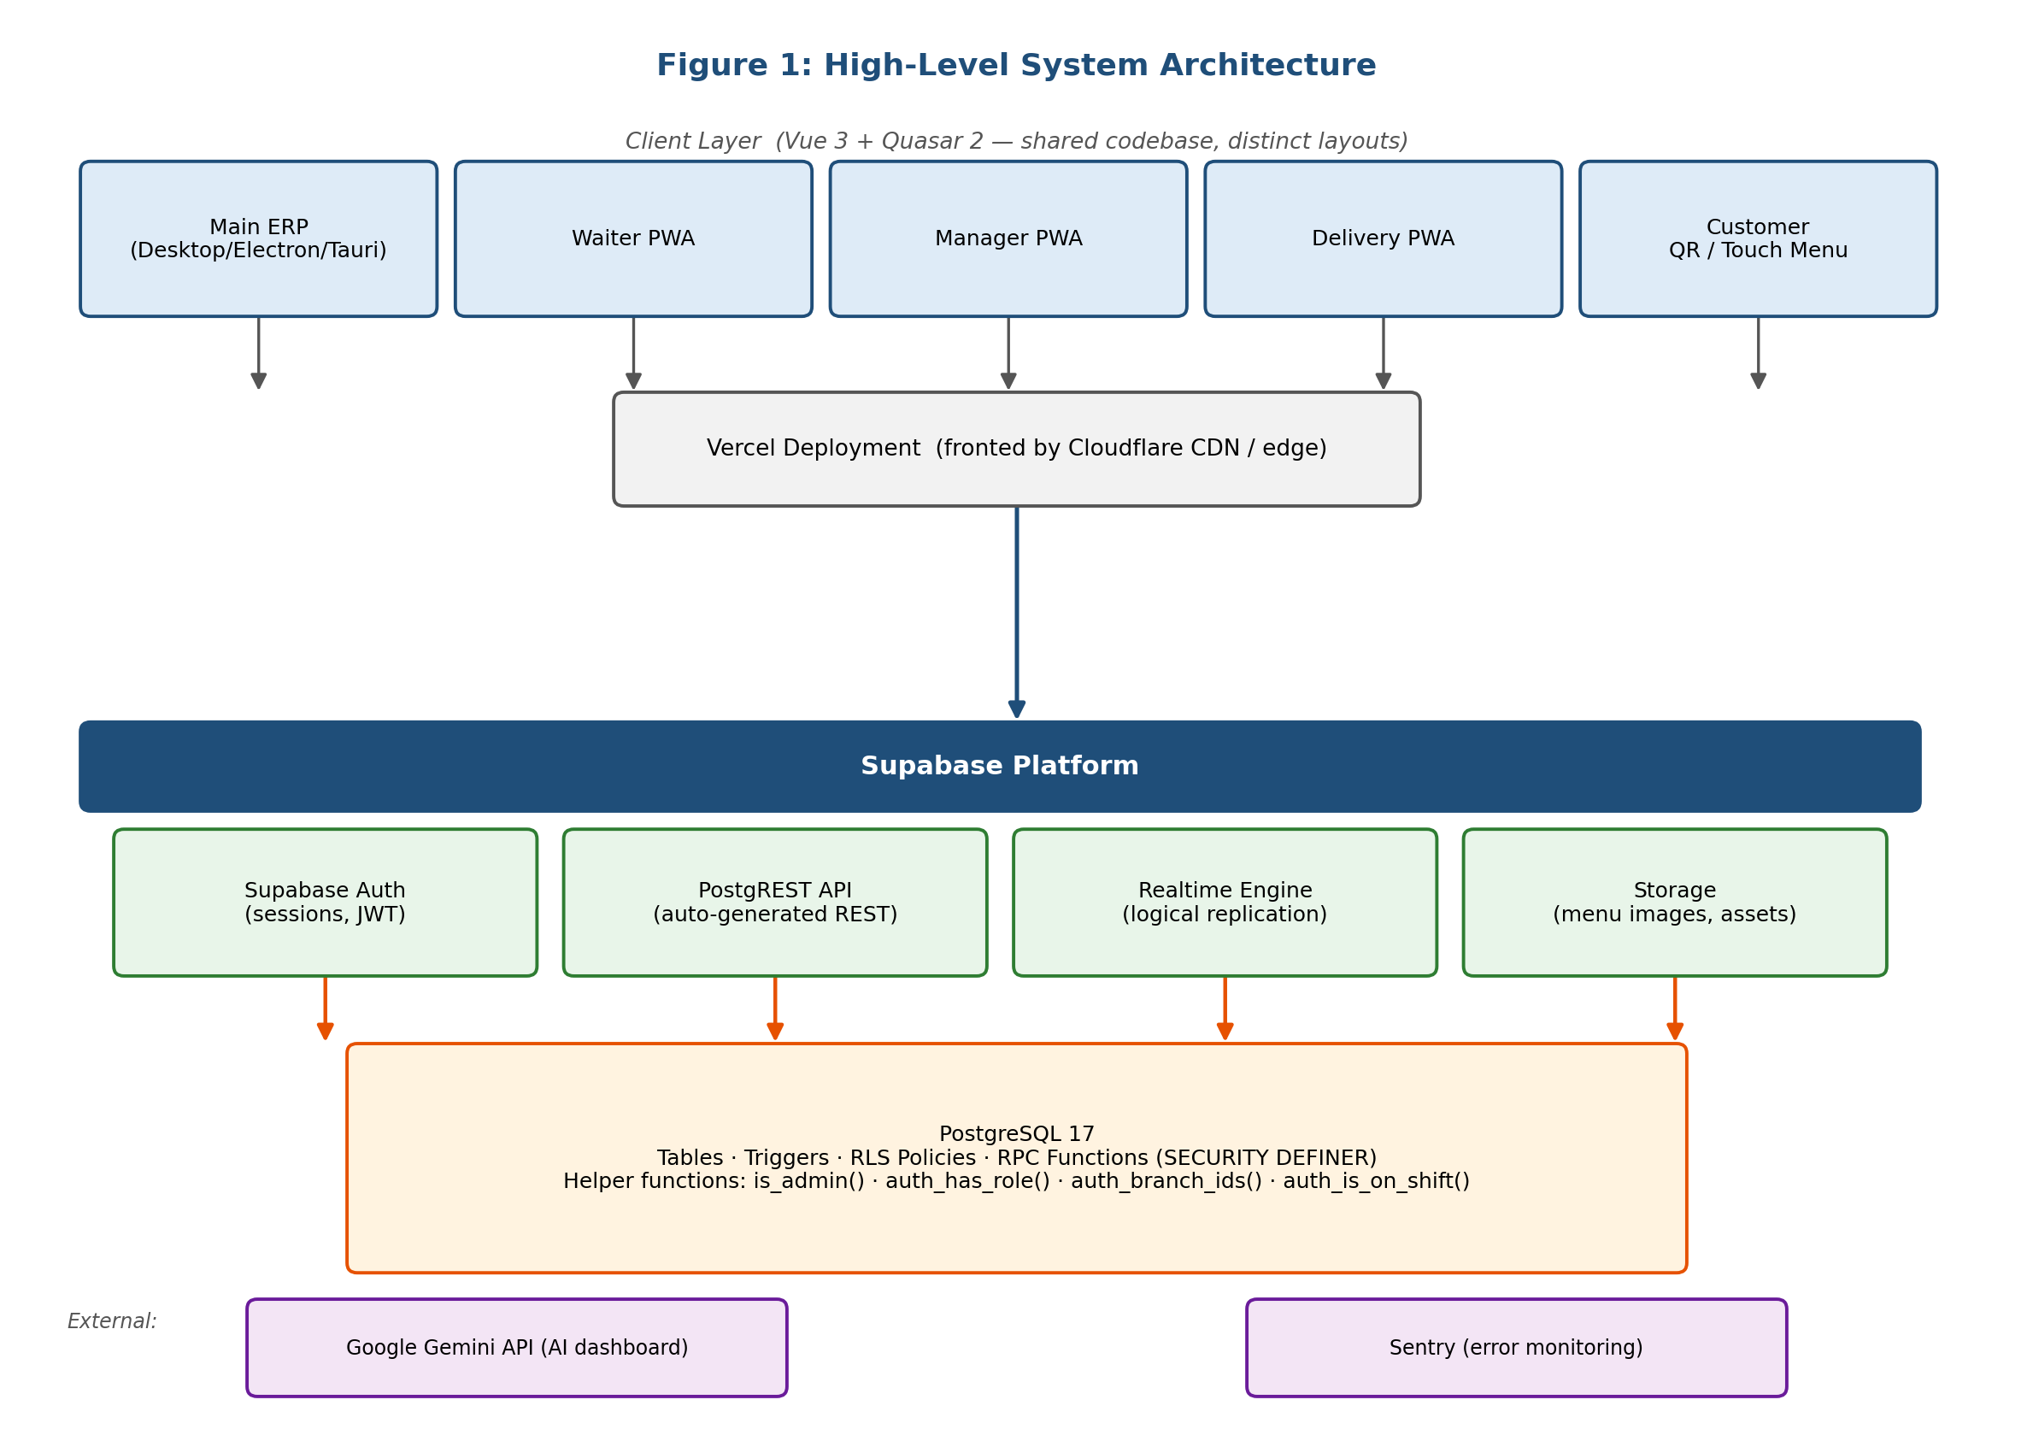
Layout | Route Prefix | Primary Users
MainLayout | / | Full desktop ERP - admin, manager, cashier, kitchen, finance, HR, procurement
WaiterAppLayout | /waiter-app | Waiter PWA (mobile-first, standalone)
ManagerAppLayout | /manager-app | Manager PWA (mobile-first, standalone)
DeliveryAppLayout | /delivery-app | Delivery rider PWA
TouchMenuLayout | /touch | Customer self-order kiosk / tablet
CustomerLayout | /menu | Online menu / order tracking
AuthLayout | /auth | Login / forgot password

Table 5: Layout / route segment summary
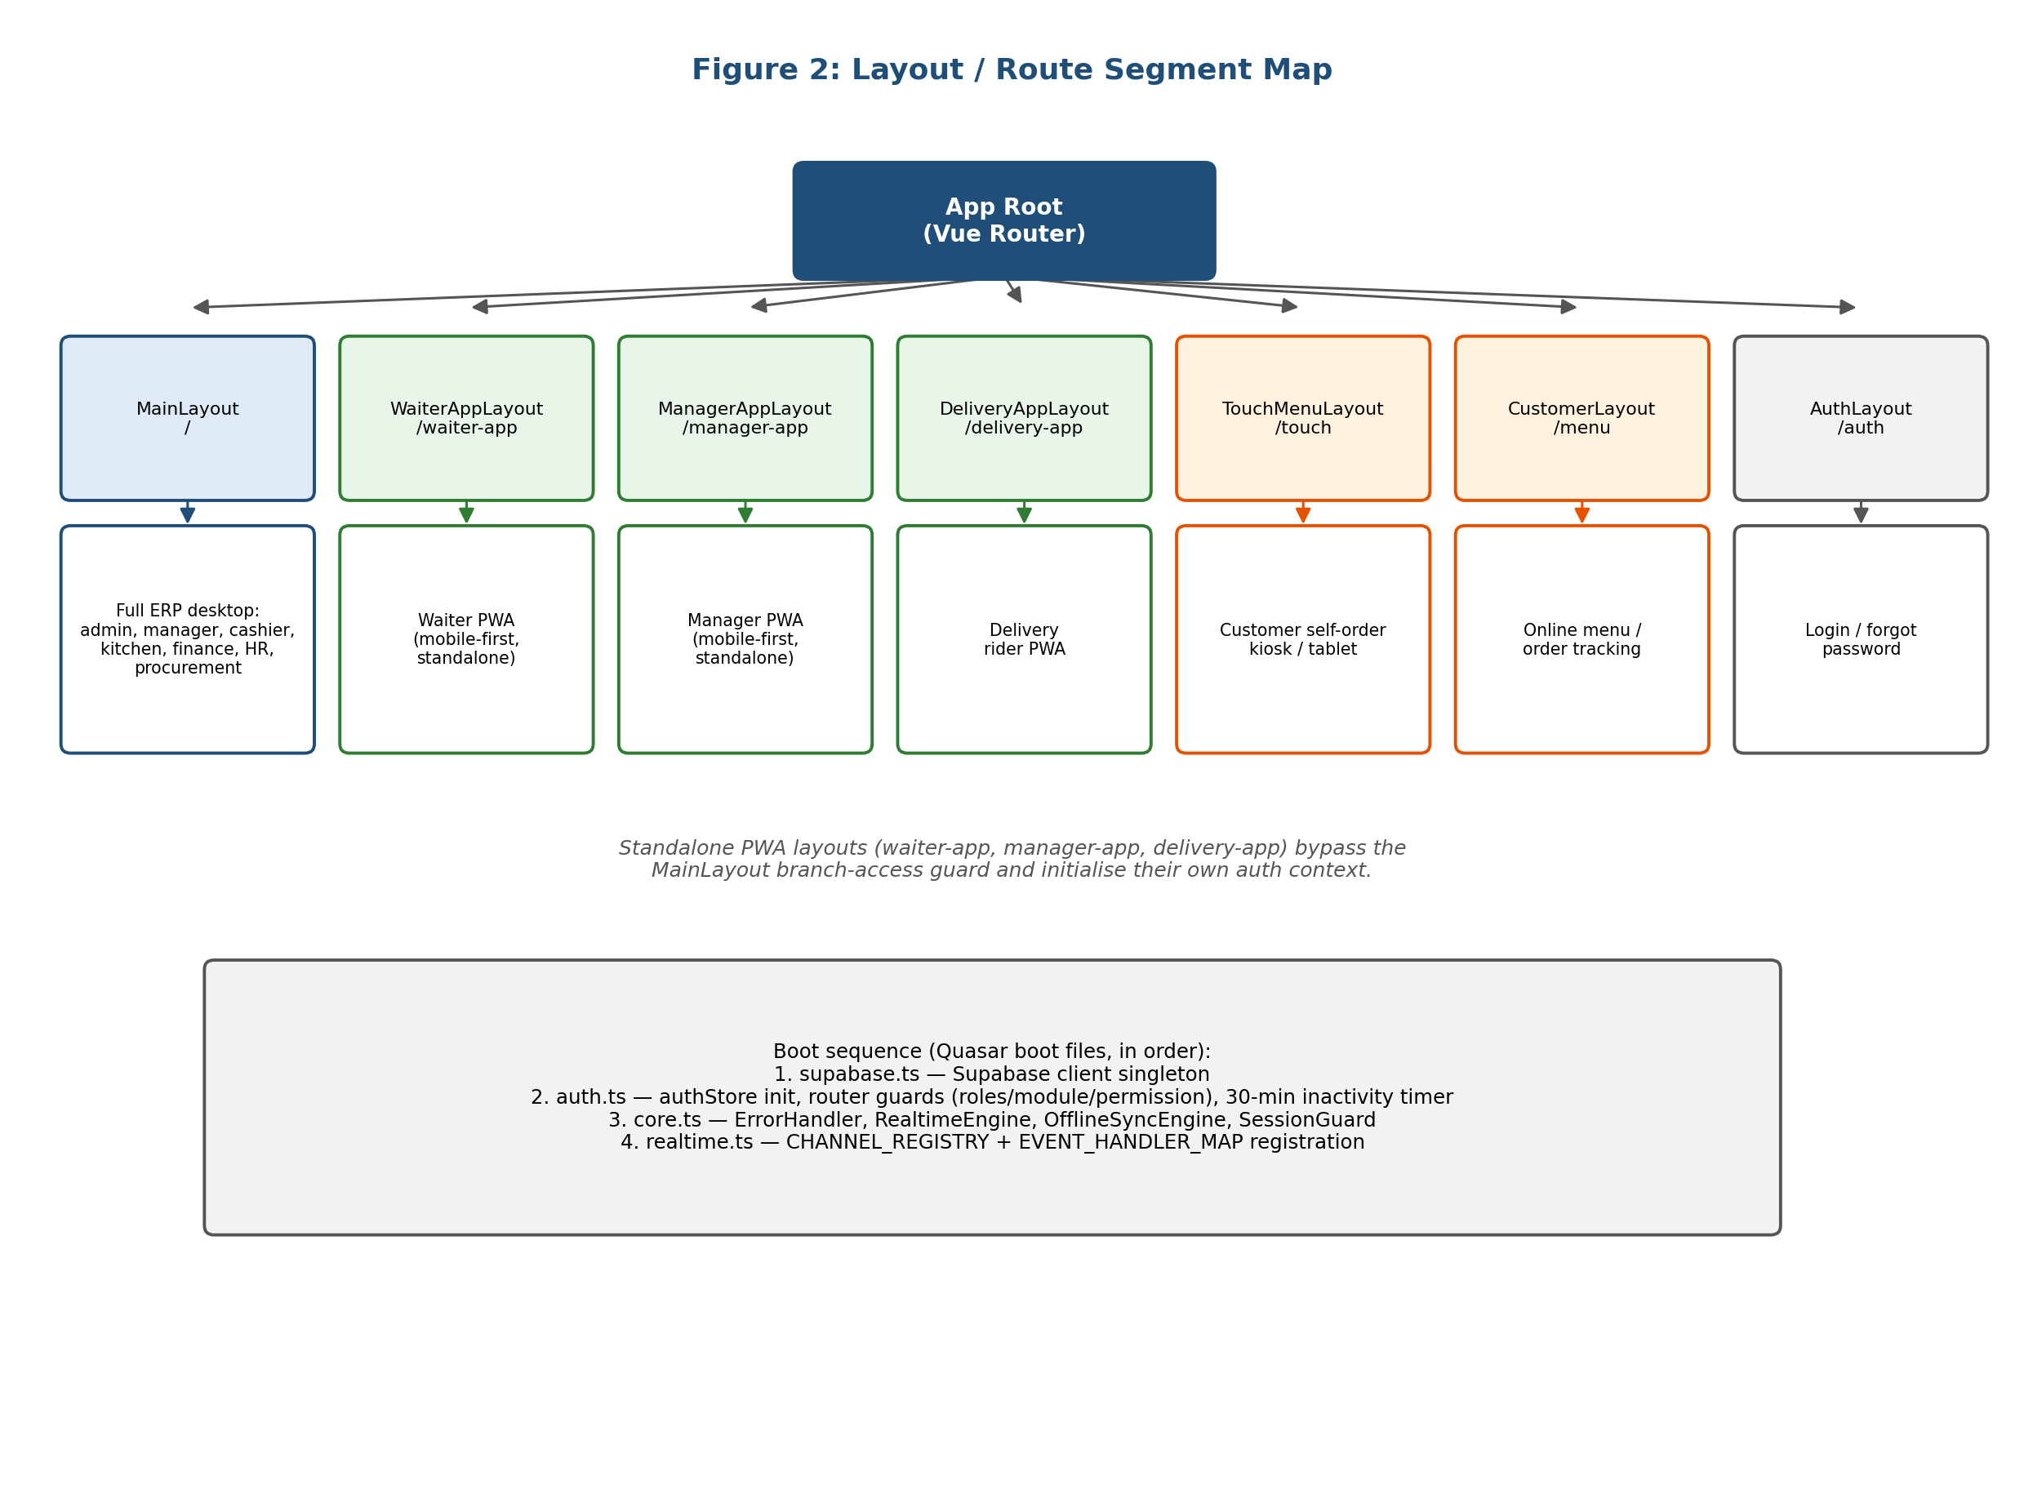
The three standalone PWA layouts bypass the MainLayout branch-access guard and initialise their own auth context, since they run independently on a device dedicated to that one app. Boot order: `supabase.ts` (client singleton), `auth.ts` (auth store, route guards, 30-minute inactivity timer), `core.ts` (error handler, realtime engine, offline sync engine, session guard), `realtime.ts` (channel registry and event-handler map). "Pure managers" (manager role only, no operational role) are redirected from every MainLayout route into the ManagerAppLayout PWA, since they are far more likely to be checking status on a phone between branches than seated at a desktop terminal.

5.2 Database Design
The database is a PostgreSQL 17 schema on Supabase. Figure 3 centres on `orders` (`branch_id`, optional `assigned_waiter_id`, a status column progressing through `pending_waiter`, `accepted` and payment states). Each order has `order_items`, each referencing the menu item, quantity and - critically for kitchen routing - a `kitchen_id`. Kitchen tickets (`kot_tickets`, `kot_items`) are generated from accepted orders, never created directly by a client; `kot_dispatches` records which downstream systems have been notified of a ticket.
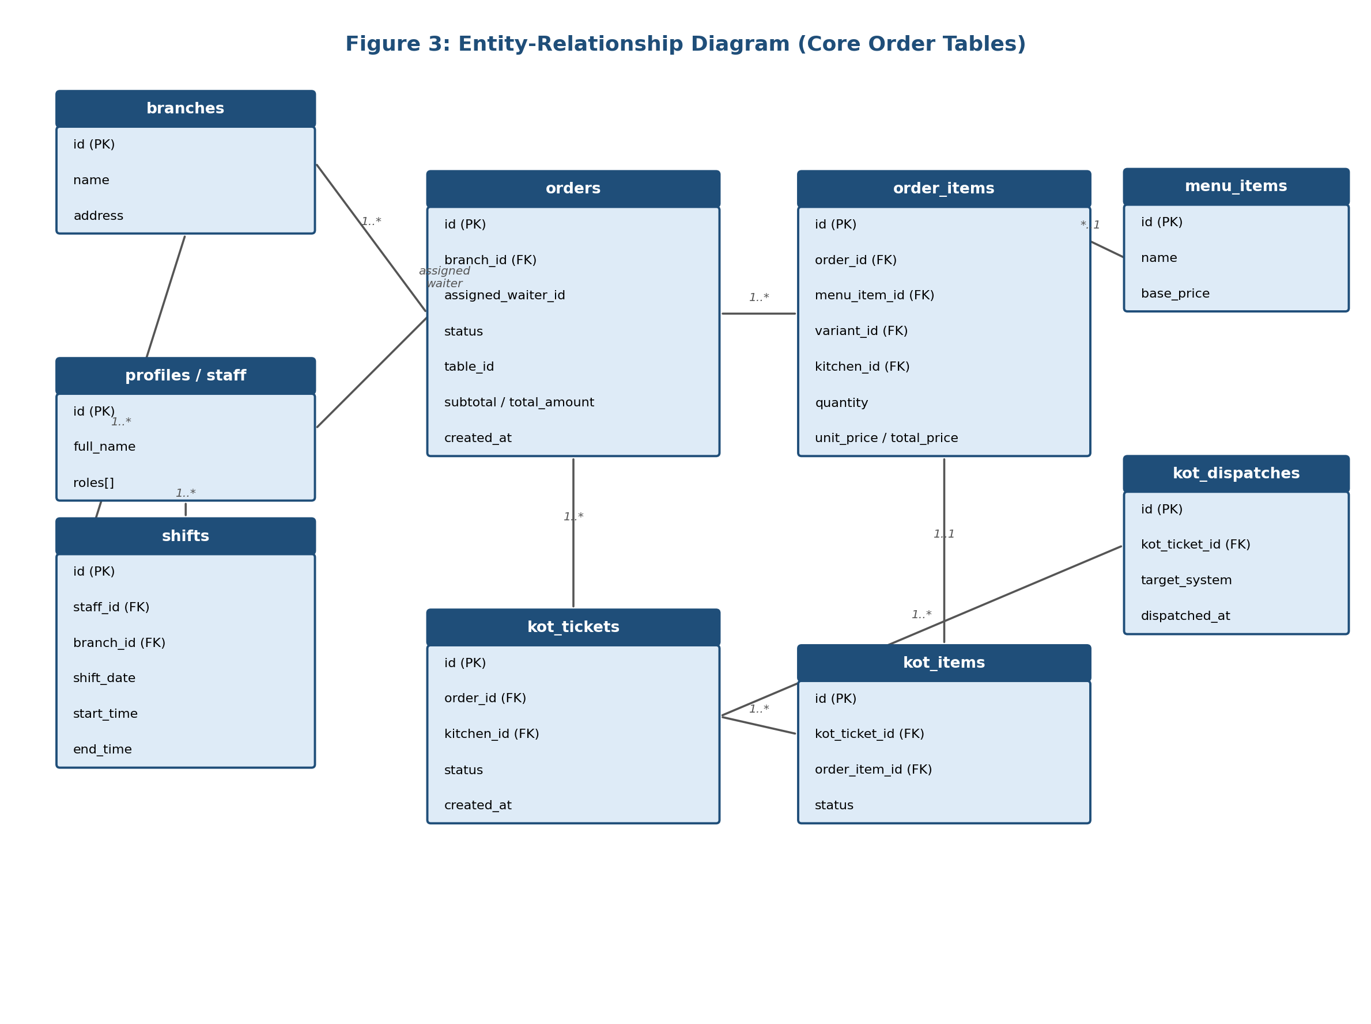
Branch-level multi-tenancy is expressed by a `branch_id` on almost every operational table. Shift records (staff, branch, date/time range) are read by helper functions such as `auth_is_on_shift(branch_id)` that RLS policies call directly. Inventory is modelled per-branch and per-kitchen, with a bill-of-materials (BOM) table linking menu items to raw stock consumption. Finance uses a conventional ledger/voucher/cashbook structure. All SQL is version-controlled under `supabase/`, split by concern (`schema.sql`, `orders.sql`, `rls_restaurant_flow.sql`, `shift_access_control.sql`).

5.3 The Order and KOT Pipeline
The order/KOT pipeline is the operational backbone: every other module reacts to events generated within it. Regardless of channel - POS, QR scan or waiter tablet - every order follows the same pipeline (Figure 4). First, `pos_create_order_with_items` inserts a row into `orders` (status `pending_waiter`), without a pre-assigned waiter. The waiter side is realtime-subscription driven from the client: `waiterOrderStore.js` opens a `postgres_changes` subscription filtered by branch, so any waiter on shift sees the new order in their live inbox instantly, with no intervening notification table.
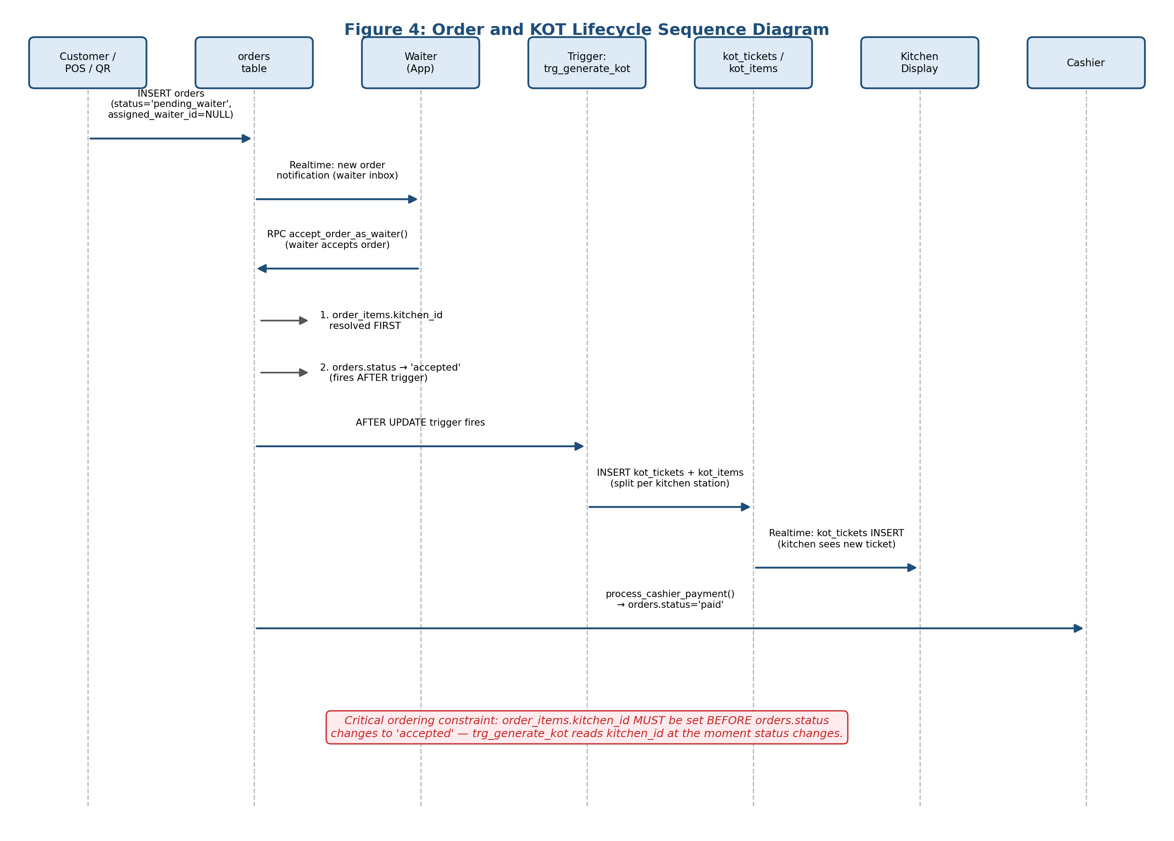
Second, accepting an order calls the RPC `accept_order_as_waiter(p_order_id, p_unavailable_ids)`. The order of operations is fixed: items are assigned a `kitchen_id` first, and only then does status change to `accepted`, because `trg_generate_kot` fires *after* that status change and reads each item's `kitchen_id` at that moment to split tickets across stations. Reversing this order was a real defect encountered and fixed during development (Chapter 8); the function has also existed as conflicting one- and two-argument overloads, a PostgREST ambiguity (PGRST203) resolved by dropping the older one.
Third, `trg_generate_kot` inserts `kot_tickets`/`kot_items`, one ticket per kitchen station; `kot_dispatches` rows are populated by the same RPC logic. Kitchen staff see the new ticket instantly via a realtime subscription maintained by `kitchenDisplayStore`. The POS follows the same `pos_create_order_with_items` RPC for two flows: standard "send to kitchen" (`sendToKitchen()`) leaves the waiter unassigned so the order reaches the inbox correctly - an earlier version wrongly pre-assigned a waiter here, hiding POS orders from the dashboard (Chapter 8). "Quick Pay" (`processPayment()`) instead calls one combined RPC, `pos_quick_pay`, performing waiter acceptance, cashier invoicing and payment atomically, bypassing the inbox by design.

5.4 Role-Based Access Control Design
Ten roles are supported: admin, manager, waiter, cashier, kitchen, delivery, inventory, finance, HR, procurement. Permissions use a `{module}.{resource}.{action}` format (e.g. `pos.order.void`). `src/core/rbac/permissions.ts` exposes `hasPermission()`/`hasModuleAccess()`, mirrored at the database layer by `is_admin()`, `is_manager()`, `auth_has_role()`. Route metadata carries `{ requiresAuth, roles[], module, permission }`, checked by the `auth.ts` navigation guard.
The key design principle (Section 2.4) is that client-side checks, including the route guard, are a UX layer only and never the security boundary - that boundary is Row Level Security (Section 5.8), so even a tampered client or a direct API call cannot read or write outside its role/branch entitlements. Figure 6 illustrates this flow end to end.
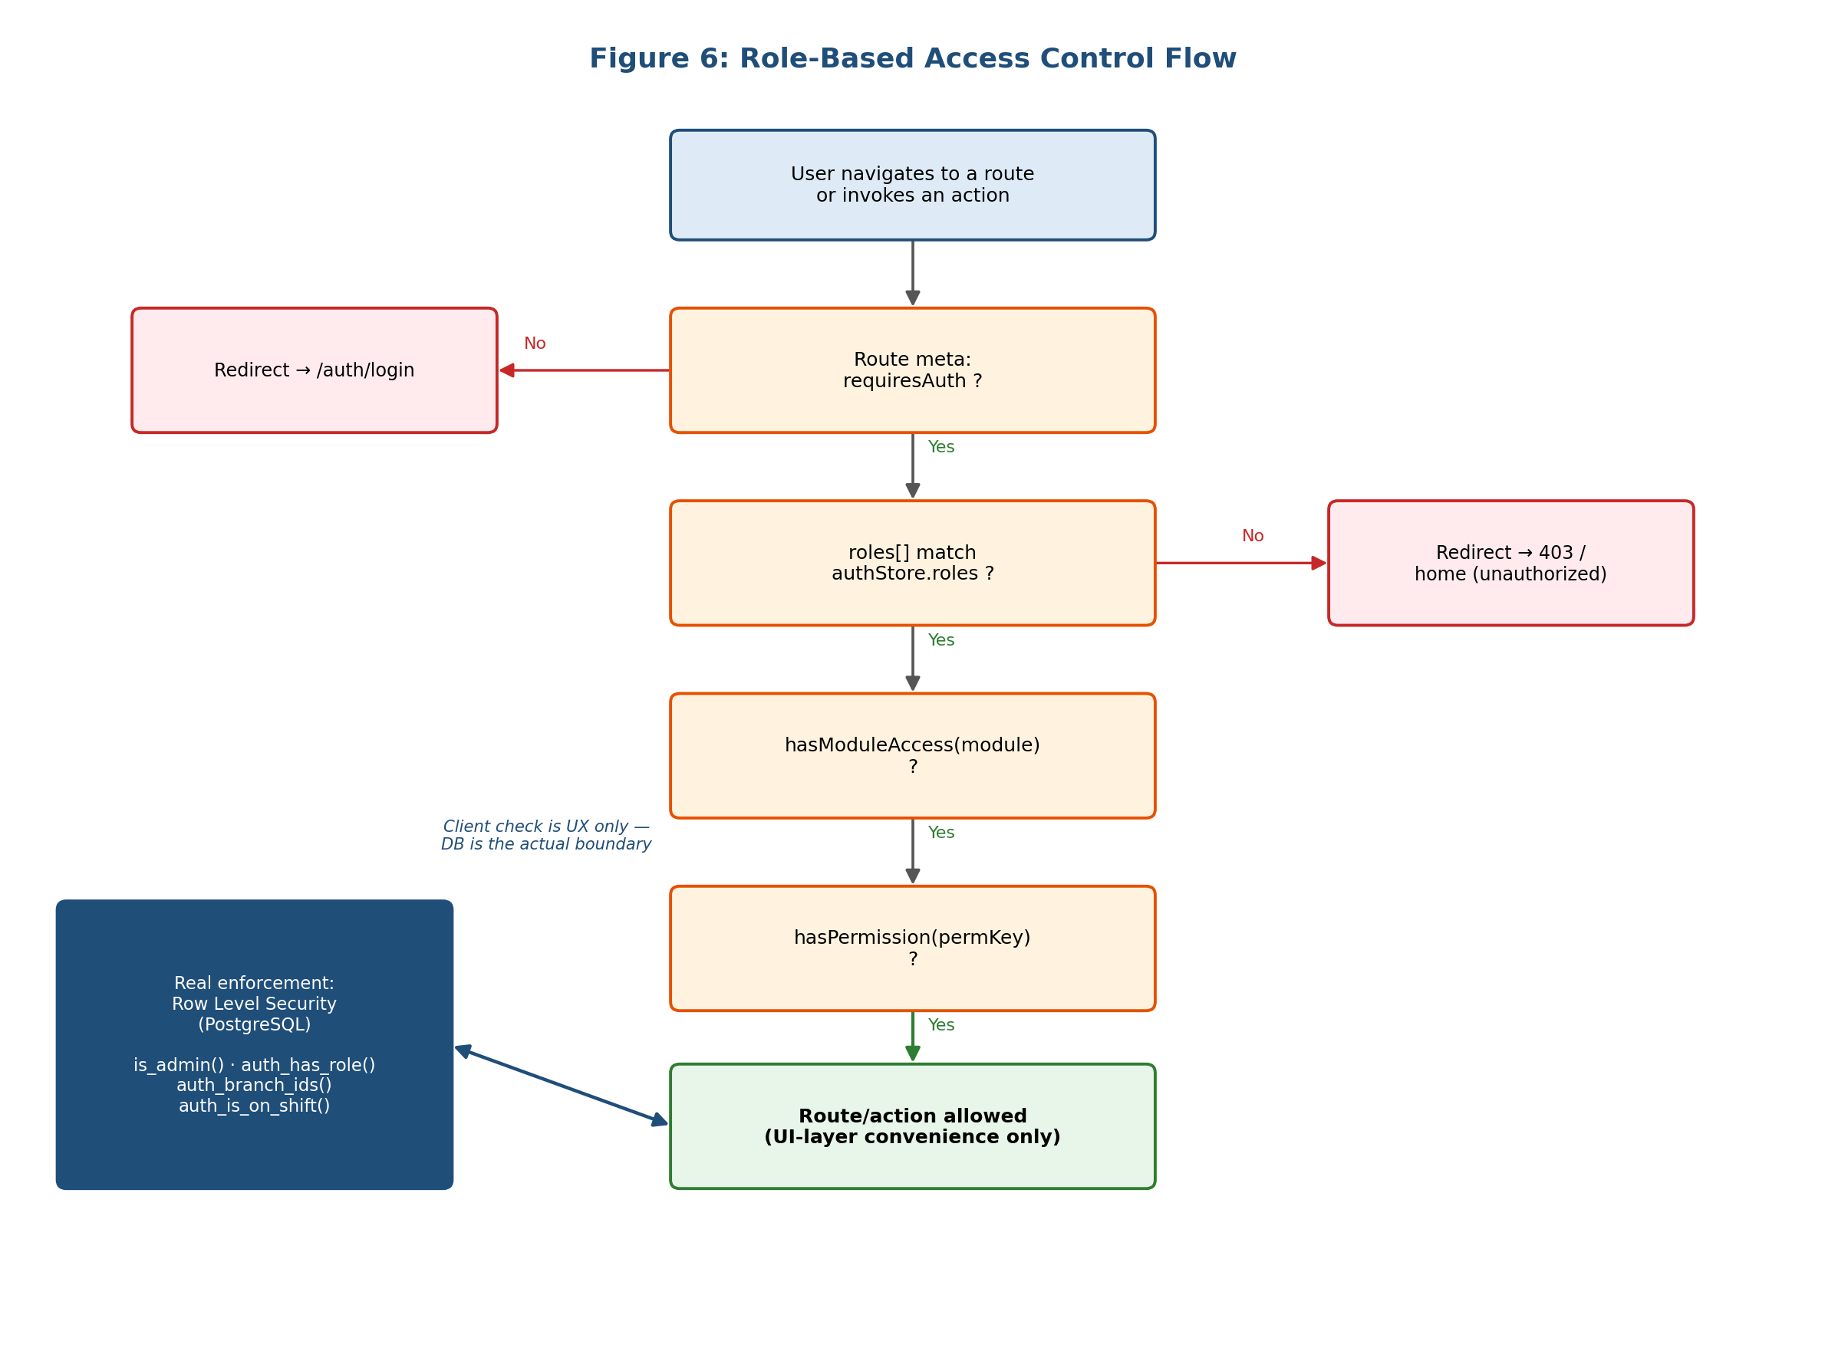

5.5 Real-Time Architecture
Two parallel realtime systems coexist, reflecting iterative development rather than a single deliberate choice, and are discussed as technical debt in Chapter 8. `RealtimeManager` (`src/core/realtime/`) is an infrastructure layer where a declarative `CHANNEL_REGISTRY` describes every channel (table, event, permission, scope, filter) and an `EVENT_HANDLER_MAP` routes events to Pinia actions; it subscribes only to channels a logged-in user is entitled to. The second system is store-level ad-hoc subscriptions - `waiterOrderStore`, `waiterAppStore` and `kitchenDisplayStore` each open their own channels directly - and in practice these are what operationally drive the PWAs. Adding a table to realtime requires `ALTER PUBLICATION supabase_realtime ADD TABLE ...` and `REPLICA IDENTITY FULL`, both easy to forget and, in fact, forgotten more than once during development. Figure 5 illustrates the two layers.
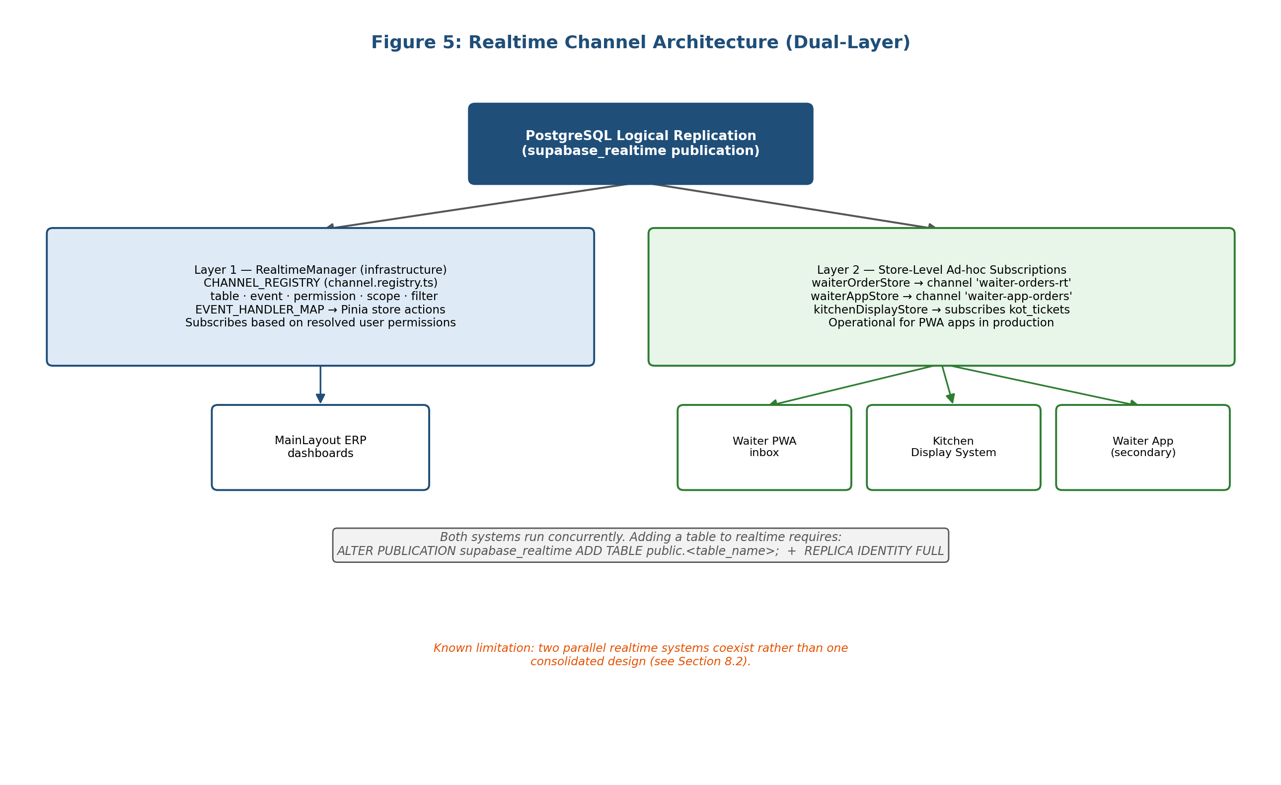

5.6 User Interface Design
The interface differs by user class: MainLayout prioritises density for seated back-office work, while waiter and kitchen interfaces are sparse and large-target for standing, time-pressured use - a kitchen ticket uses colour-coded ageing (Section 2.2) so an at-risk ticket is visible without reading text. Figures 10-11 show illustrative mock-ups of these principles; live screenshots of the deployed system appear in Section 6.9.
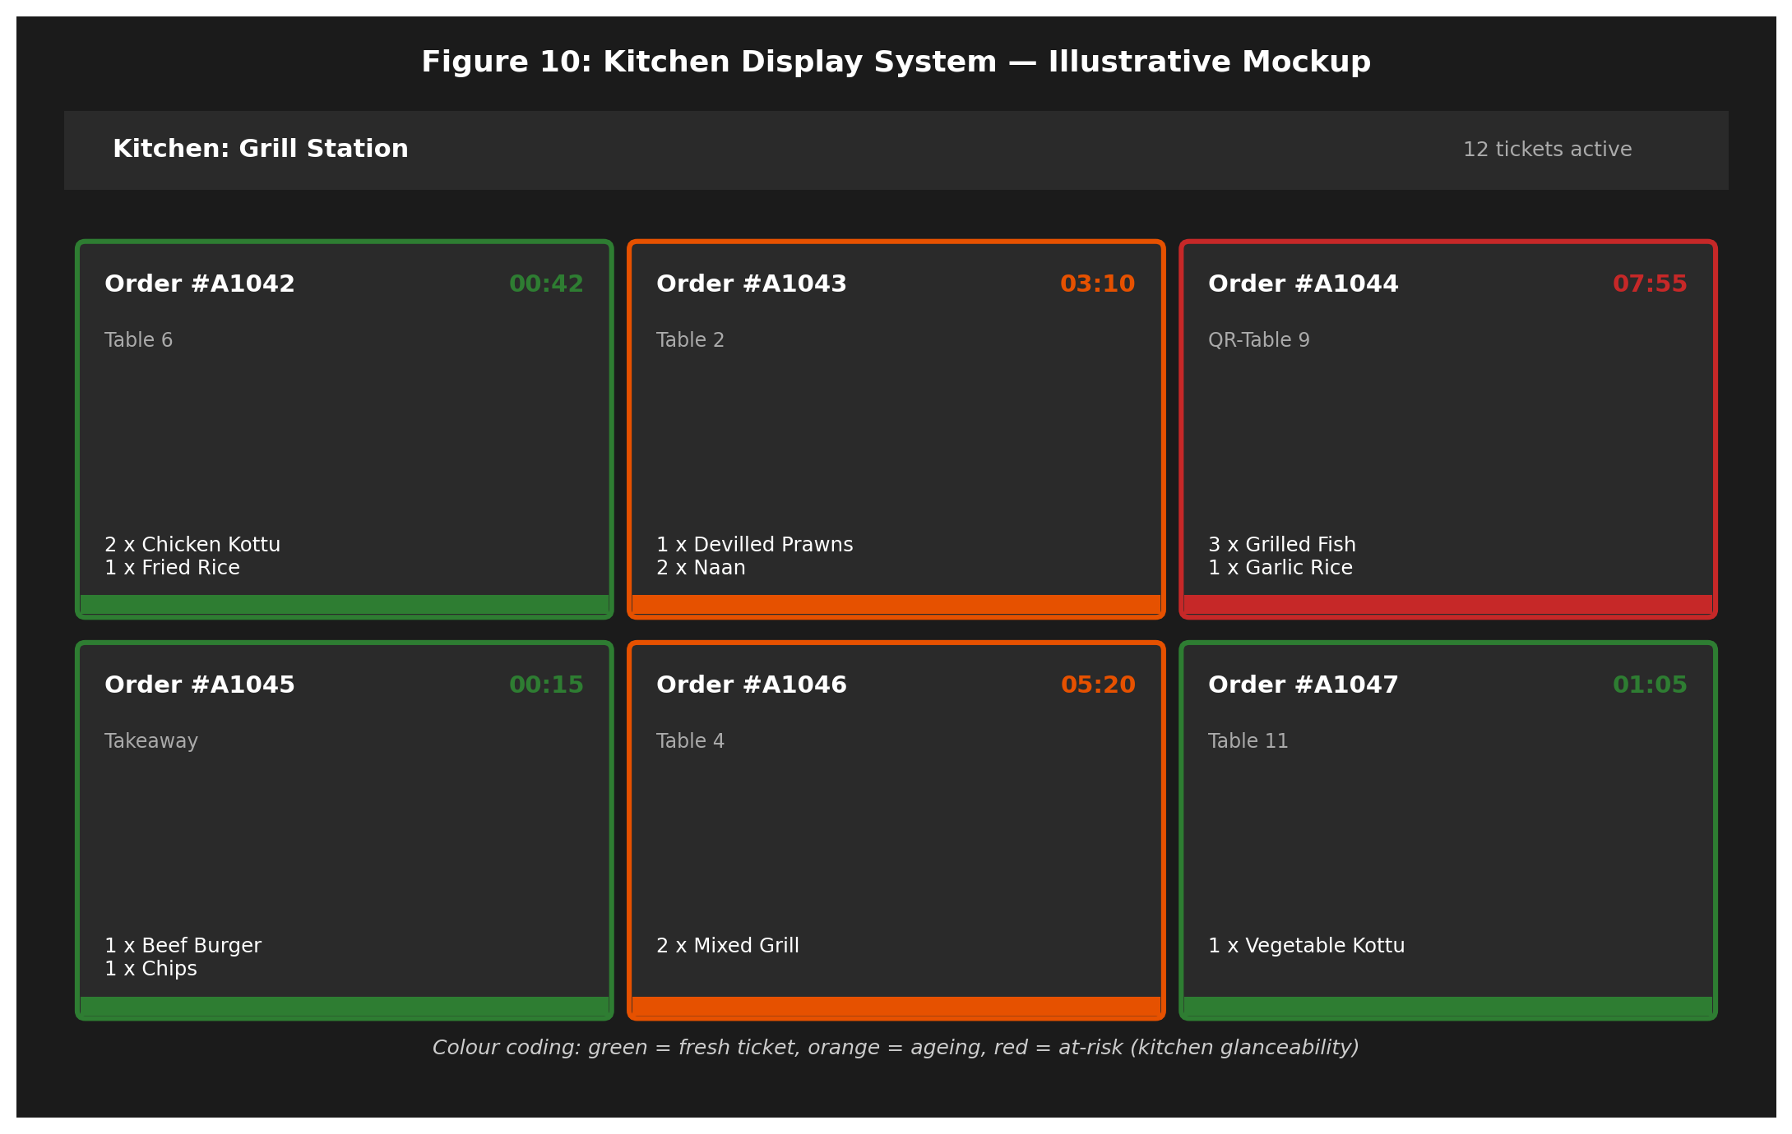
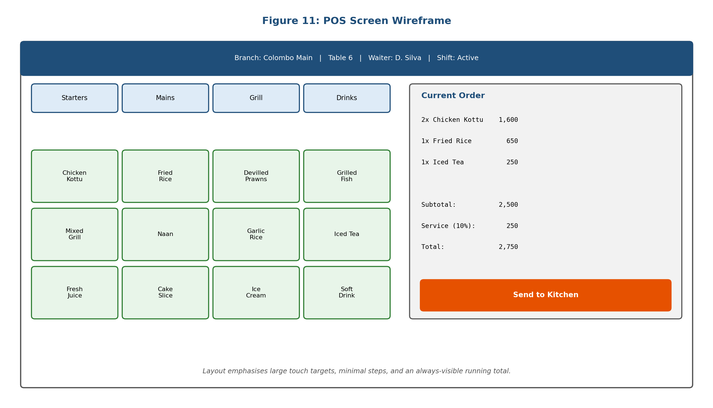
The customer touch-menu (`TouchMenuLayout`, `MenuBookTablet.vue`) uses a browsing metaphor closer to a physical menu than an e-commerce interface, supporting unhurried exploration. Figure 7 traces the customer journey from QR scan to order placement.
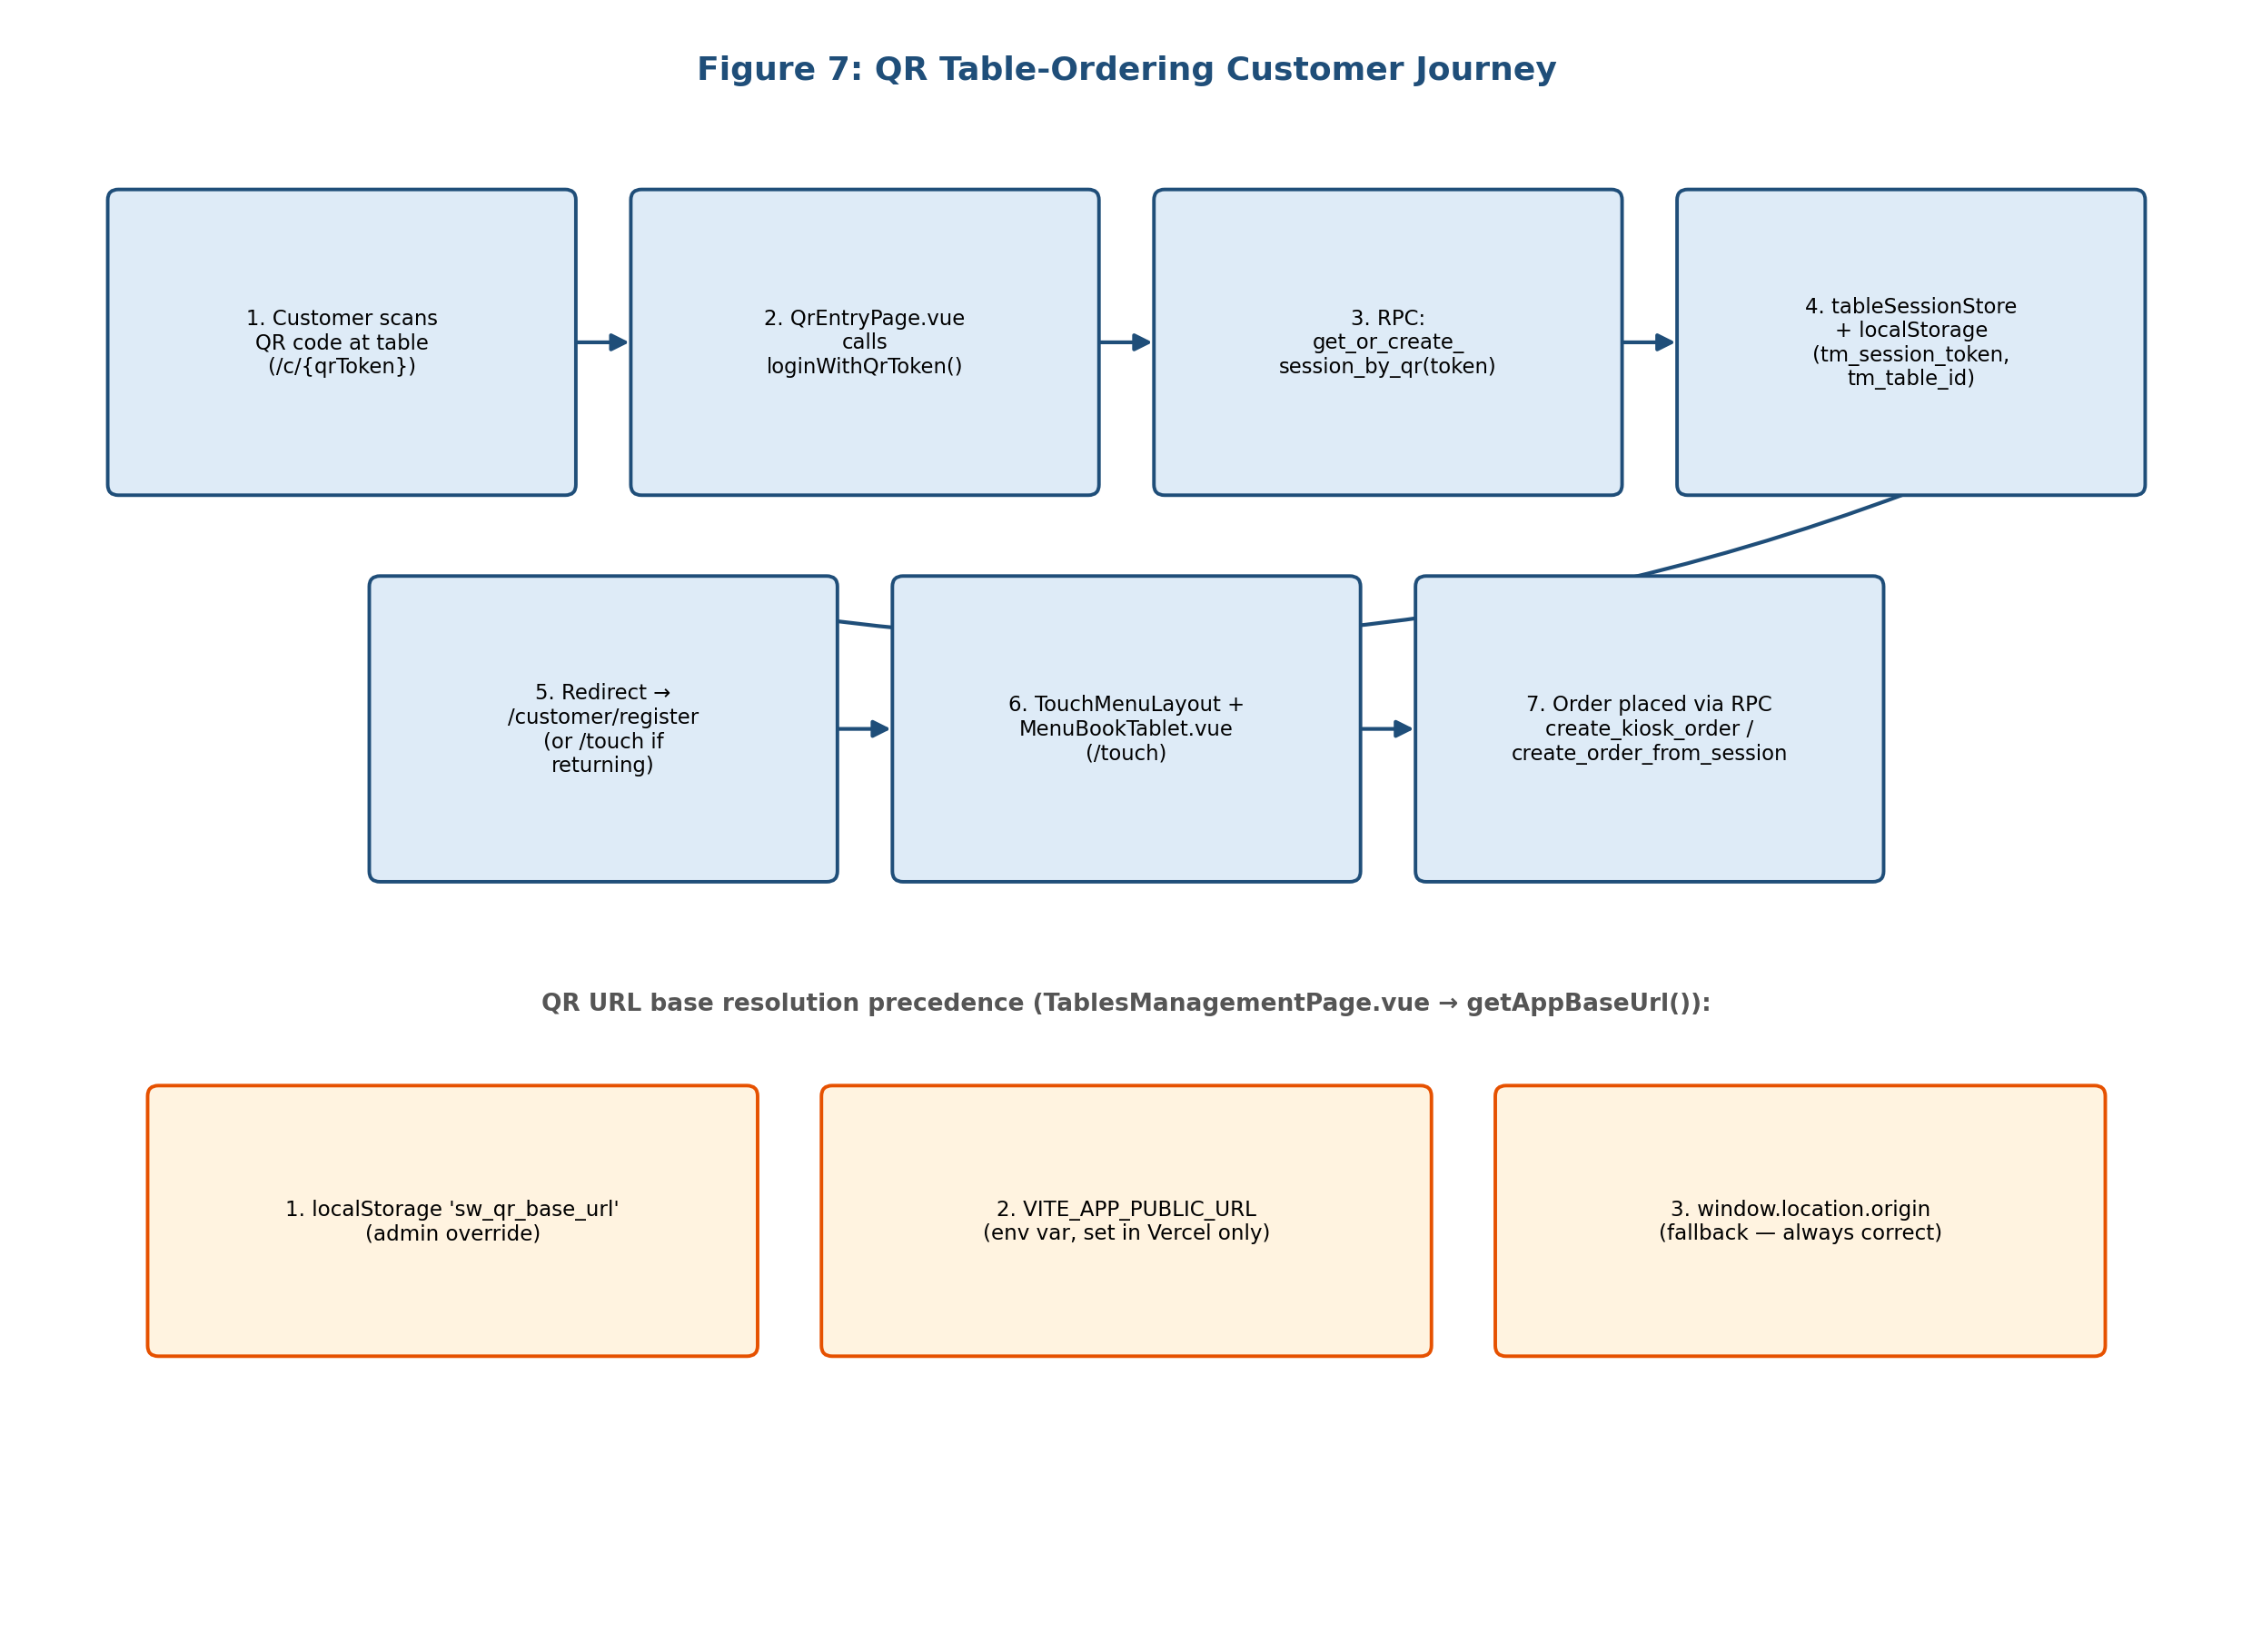

5.7 Offline Synchronisation Design
`OfflineSyncEngine` (backed by `offlineDb.ts`/IndexedDB) queues writes locally while offline, tagged with operation type and a client-generated ID, and replays them in order once connectivity returns (Section 2.5). This favours simplicity over conflict-resolution strategies that would let concurrent offline writes from multiple devices reorder or merge safely - a trade-off discussed in Chapter 8. Figure 8 illustrates the state transitions.
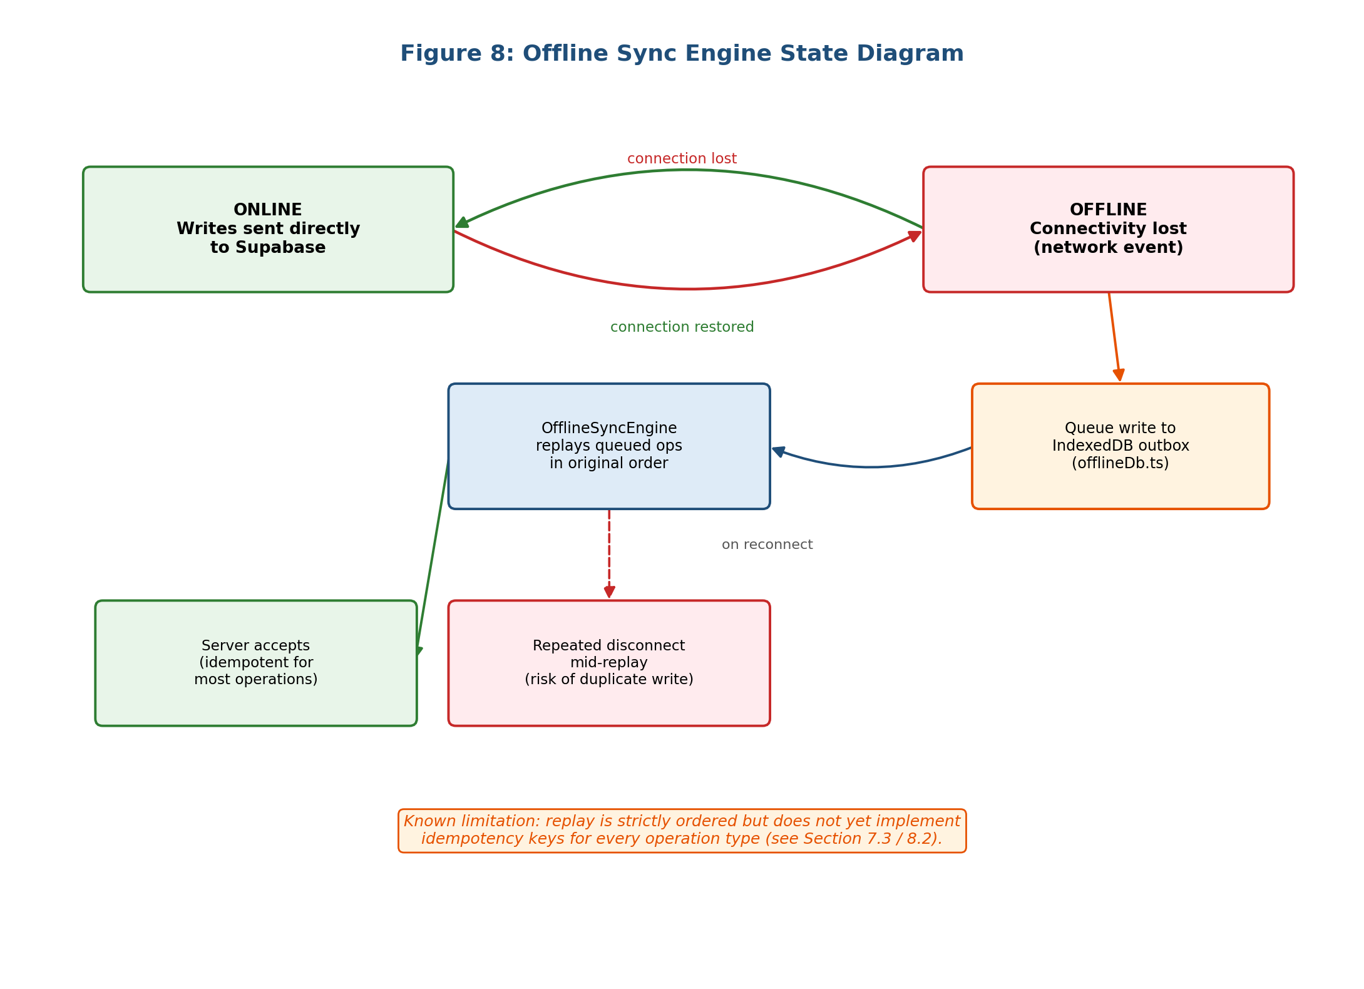

5.8 Security Design
Security is layered: Supabase Auth issues JWTs; Row Level Security policies (`rls_restaurant_flow.sql`) restrict rows by role/branch, using the helper functions from Section 5.4. Because PostgreSQL combines multiple permissive policies with logical OR, a new broad policy can silently grant access a narrower policy meant to prevent - directly responsible for a cross-branch data exposure defect found and fixed during development (Chapter 8). Business-critical operations (accepting an order, processing payment, voiding) are implemented as RPCs rather than sequential client-issued statements, so ordering constraints (Section 5.3) are enforced by the function itself. `erp_security_lockdown.sql` revokes anonymous access to sensitive tables, keeping the public surface needed for QR ordering deliberately minimal.

6. Implementation
This chapter describes how the design in Chapter 5 was translated into working code, module by module in the order development proceeded, closing with deployment and live screenshots of the system.

6.1 Project Structure
Feature modules beyond the flat `src/pages/` structure live under `src/modules/`: `ai/` (dashboard, forecasts, anomaly detection via Google Gemini), `devices/` (printer, scanner, biometric device management), `finance/` (ledgers, vouchers, cashbook, statements). Cross-cutting services live under `src/core/`: `api/`, `errors/`, `logging/`, `monitoring/`, `offline/` (Section 5.7), `rbac/`, `realtime/` (Section 5.5), `security/`. Pinia stores are organised by feature rather than layout - `orderStore.js` (POS) and `waiterOrderStore.js` (shift-aware inbox) are separate stores despite both operating on `orders`, since they represent distinct operational responsibilities.

6.2 Authentication and RBAC Implementation
`authStore` (`src/stores/auth.ts`) wraps Supabase Auth and caches the user's roles, permissions and branch assignments on login; `auth.ts` starts a 30-minute inactivity timer, given that restaurant terminals are often shared and left logged in. Permission resolution is implemented as pure functions in `src/core/rbac/permissions.ts` (`hasPermission`, `hasModuleAccess`), kept free of Vue/Pinia dependencies so they can be unit tested in isolation. `PermissionGate.vue` wraps this for templates but performs an exact-match check rather than a role-wildcard check; role-wide gating instead uses `usePermission().can()` directly.

6.3 Point-of-Sale Implementation
`orderStore.js` exposes `sendToKitchen()` and `processPayment()` (Section 5.3), each building an order payload from cart state and calling the relevant RPC. A recurring lesson (Chapter 8): the client payload must exactly match the live `orders` table's columns - an obsolete client field (`delivery_charge`) once caused `pos_create_order_with_items` to fail for every order. Cashier billing was refactored from three sequential transactions (invoice, payment, stock) into one atomic RPC, `pos_quick_pay`, removing the window in which a crash between steps could leave an invoice paid without a matching stock deduction.

6.4 Waiter and Kitchen Realtime Implementation
`waiterOrderStore.js`'s `initialize()` calls `auth_get_shift_branches`; `subscribeToOrders()` falls back to a general branch assignment if no shift branch resolves, only skipping the subscription entirely if no branch resolves at all. In practice this is the most common cause of a waiter reporting "orders not showing" - a missing shift record, not a realtime fault. `kitchenDisplayStore.js` subscribes directly to `kot_tickets`, rendering tickets grouped by station with the colour-coding from Section 5.6; since tickets are generated exclusively by `trg_generate_kot`, the display simply renders whatever exists for the kitchens resolved via `auth_kitchen_ids()`.

6.5 QR Ordering and Touch Menu Implementation
`QrEntryPage.vue` handles `{VITE_APP_PUBLIC_URL}/c/{qrToken}`, calling `loginWithQrToken()` → `get_or_create_session_by_qr(token)`, which creates or resumes a table session; the token and table ID persist in `tableSessionStore`/`localStorage` so the session survives a reload. The customer then reaches `TouchMenuLayout`/`MenuBookTablet.vue`, ordering via `create_kiosk_order` or `create_order_from_session`. QR URL generation (`TablesManagementPage.vue`'s `getAppBaseUrl()`) resolves in order: `localStorage` override → `VITE_APP_PUBLIC_URL` → `window.location.origin` fallback; the env var is deliberately left unset locally and only set in Vercel for a custom domain.

6.6 Inventory and BOM Stock Deduction
Per-branch/per-kitchen stock tracking is driven by a BOM engine (`sw_stock_deduction_engine.sql`) that runs on payment confirmation, deducting each sold item's recipe ingredients from the preparing kitchen's stock. A significant, acknowledged limitation: only a small fraction of the menu catalogue has recipes defined, so most items do not yet trigger deduction - a data-population task, not an engine defect, and a recommendation for future work (Chapter 9).

6.7 Finance and Payroll Modules
`src/modules/finance/` implements accounts, ledgers, journal entries, vouchers and a cashbook, admin-only account deletion, and balances seeded from an opening balance. Payroll/attendance implement `fn_calc_attendance_metrics`, `fn_mark_absentees`, and a trigger linking approved leave to attendance (auto-creating `on_leave`/`no_pay` rows). Payroll was extended during development to withhold employee salary advances as a lump-sum deduction, after testing showed advances were disbursed but never recovered.

6.8 Deployment
The web/PWA build deploys to Vercel behind Cloudflare, with `VITE_APP_ENV` distinguishing staging from production. Electron and Tauri desktop builds are built separately for back-office terminals that benefit from an always-open app rather than a browser tab. Sentry monitors errors across all deployed targets, added specifically to surface realtime and RPC failures otherwise invisible without a user report.

6.9 Live System Screenshots
The following screenshots are taken directly from the deployed system rather than reconstructed mock-ups, and are included to give a concrete sense of the finished product's appearance and layout across its major modules.
Figure 14 shows the login screen, offering both conventional email authentication and a lightweight user-code login intended for shared restaurant terminals where typing a full email address on every shift change would be impractical. Figure 15 shows the main ERP dashboard, presenting gross revenue, active orders, table occupancy and active staff as live KPI tiles alongside quick-launch shortcuts to the POS, kitchen display, orders, tables, reports and inventory modules discussed throughout Chapter 5.
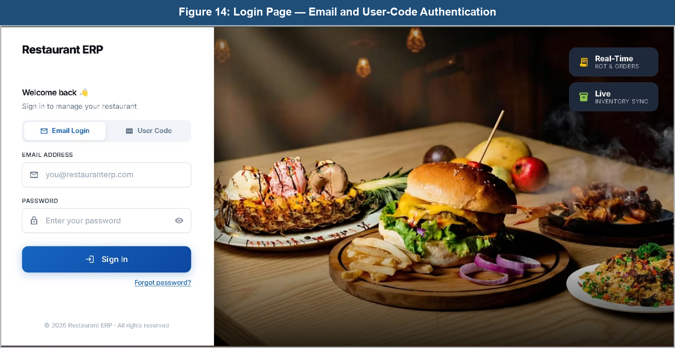
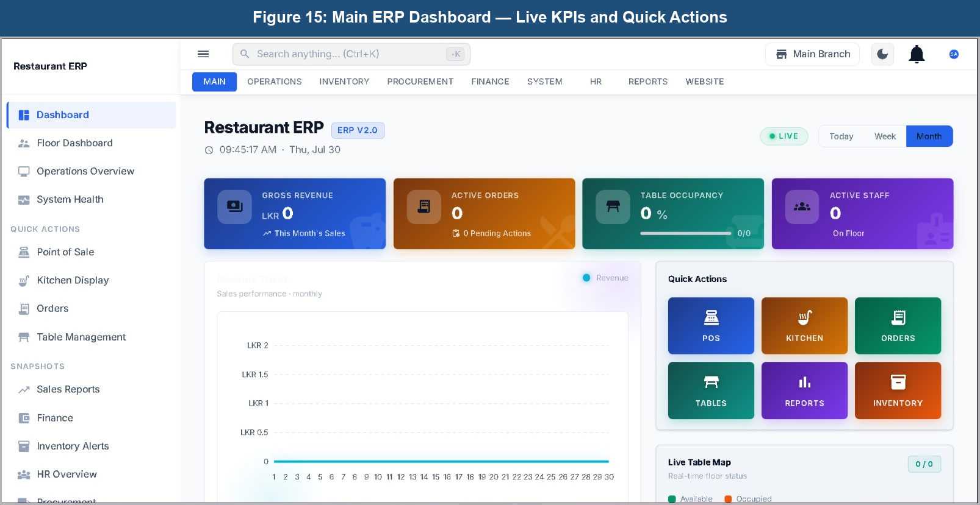
Figure 16 shows the Operations Dashboard, a narrower operational view surfacing active orders, pending waiter actions, kitchen queue depth, cashier activity and table occupancy in one screen, intended for a manager or shift supervisor who needs a floor-level overview without navigating the full admin menu. Figure 17 shows the HR module's Employees page, listing staff by department and designation and exposing the same admin-only user-login management described in Section 5.4. Figure 18 shows the System module's Device Management screen, which tracks the health and connectivity of printers, scanners, biometric attendance devices and displays registered to a branch - reflecting the `src/modules/devices/` module described in Section 6.1.
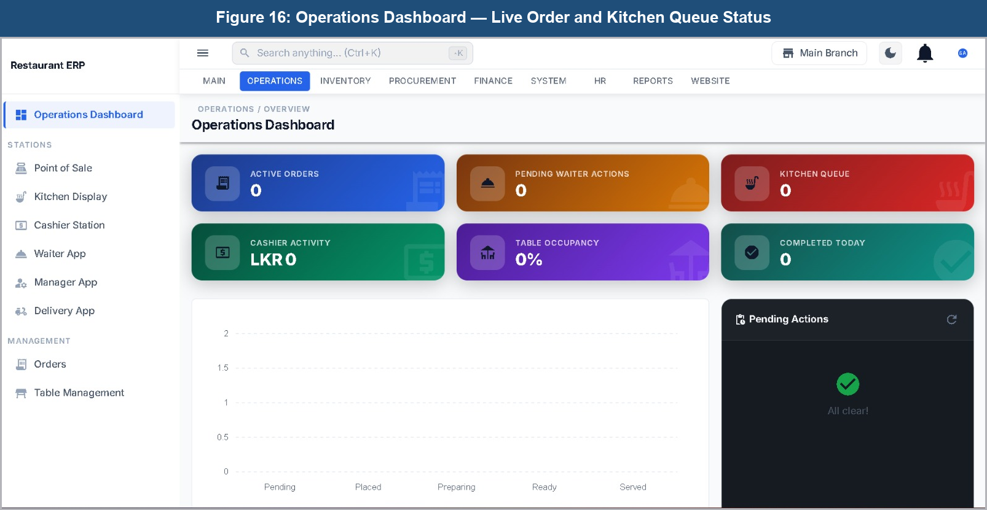
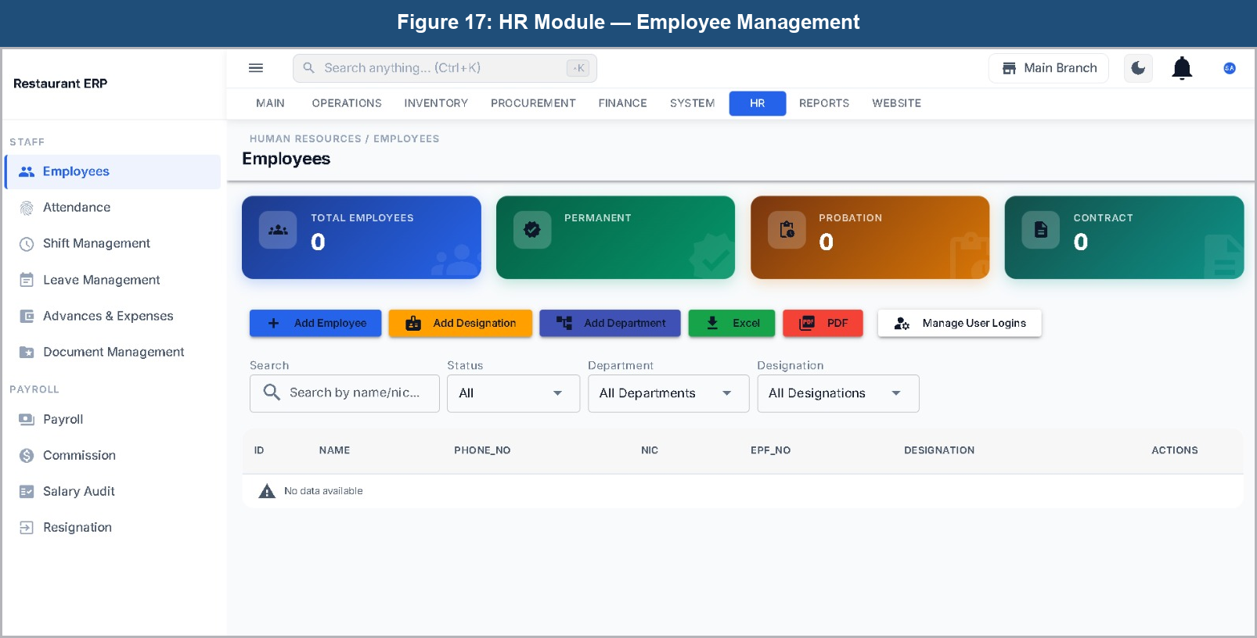
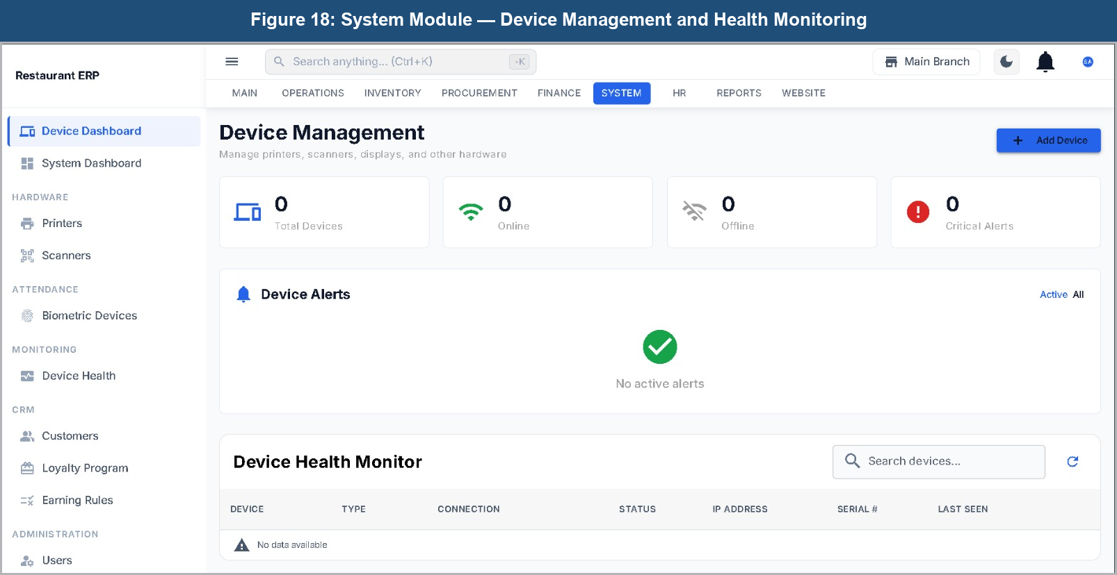

7. Evaluation of Product
This chapter evaluates the finished system against the objectives in Chapter 1: functional testing, performance, security, usability, and a comparative assessment against the fragmented workflow the project set out to replace.

7.1 Testing Overview
Testing combined automated tests (Vitest), manual walkthroughs of the full order lifecycle across POS, waiter, kitchen and cashier roles, and a dedicated RLS security review (Section 3.5), conducted iteratively throughout development rather than as a single end-of-project phase.

7.2 Functional Testing Results
The core order lifecycle - creation via POS or QR, waiter-inbox appearance, acceptance, correct kitchen ticket generation, and payment - was validated across all three origination channels, including the deliberate difference between the standard flow (populates the waiter inbox) and Quick Pay (bypasses it by auto-accepting). Shift-gated visibility was confirmed to withhold orders from a waiter with no active shift and restore visibility once one was added. Several defects were found and fixed during this process, summarised in Table 4; Figure 13 summarises test coverage and outcomes.
Defect | Root Cause | Resolution
POS payments failing for every order | Client sent a `delivery_charge` field no longer present on the live `orders` table, causing the create-order RPC to reject the payload | Client payload filtered to match exactly the live schema's columns before submission
Orders occasionally returned with a null order number/ID after payment | A `SELECT *` combined with `jsonb_populate_record` in the payment RPC was nulling identity columns on the returned row | RPC corrected to explicitly select and return identity columns rather than relying on a wildcard select
Cross-branch reads possible on kitchen ticket data | Unscoped, role-only RLS SELECT policies on kitchen ticket tables granted access regardless of branch, because RLS policies combine with logical OR | Unscoped policies dropped and replaced with branch-scoped equivalents
Non-atomic cashier billing risked inconsistent state on crash/disconnect | Billing originally implemented as three sequential client-issued transactions (invoice, payment, stock) | Rewritten as a single atomic `pos_quick_pay` RPC
Payroll disbursed employee advances but never recovered them | Payroll calculation did not withhold advances against subsequent pay, and the audit-action check constraint did not permit the withholding action, silently aborting the attempted fix | Payroll calculation updated to withhold advances as a lump-sum deduction; constraint updated to permit the new audit action

Table 4: Significant defects identified and resolved during functional testing
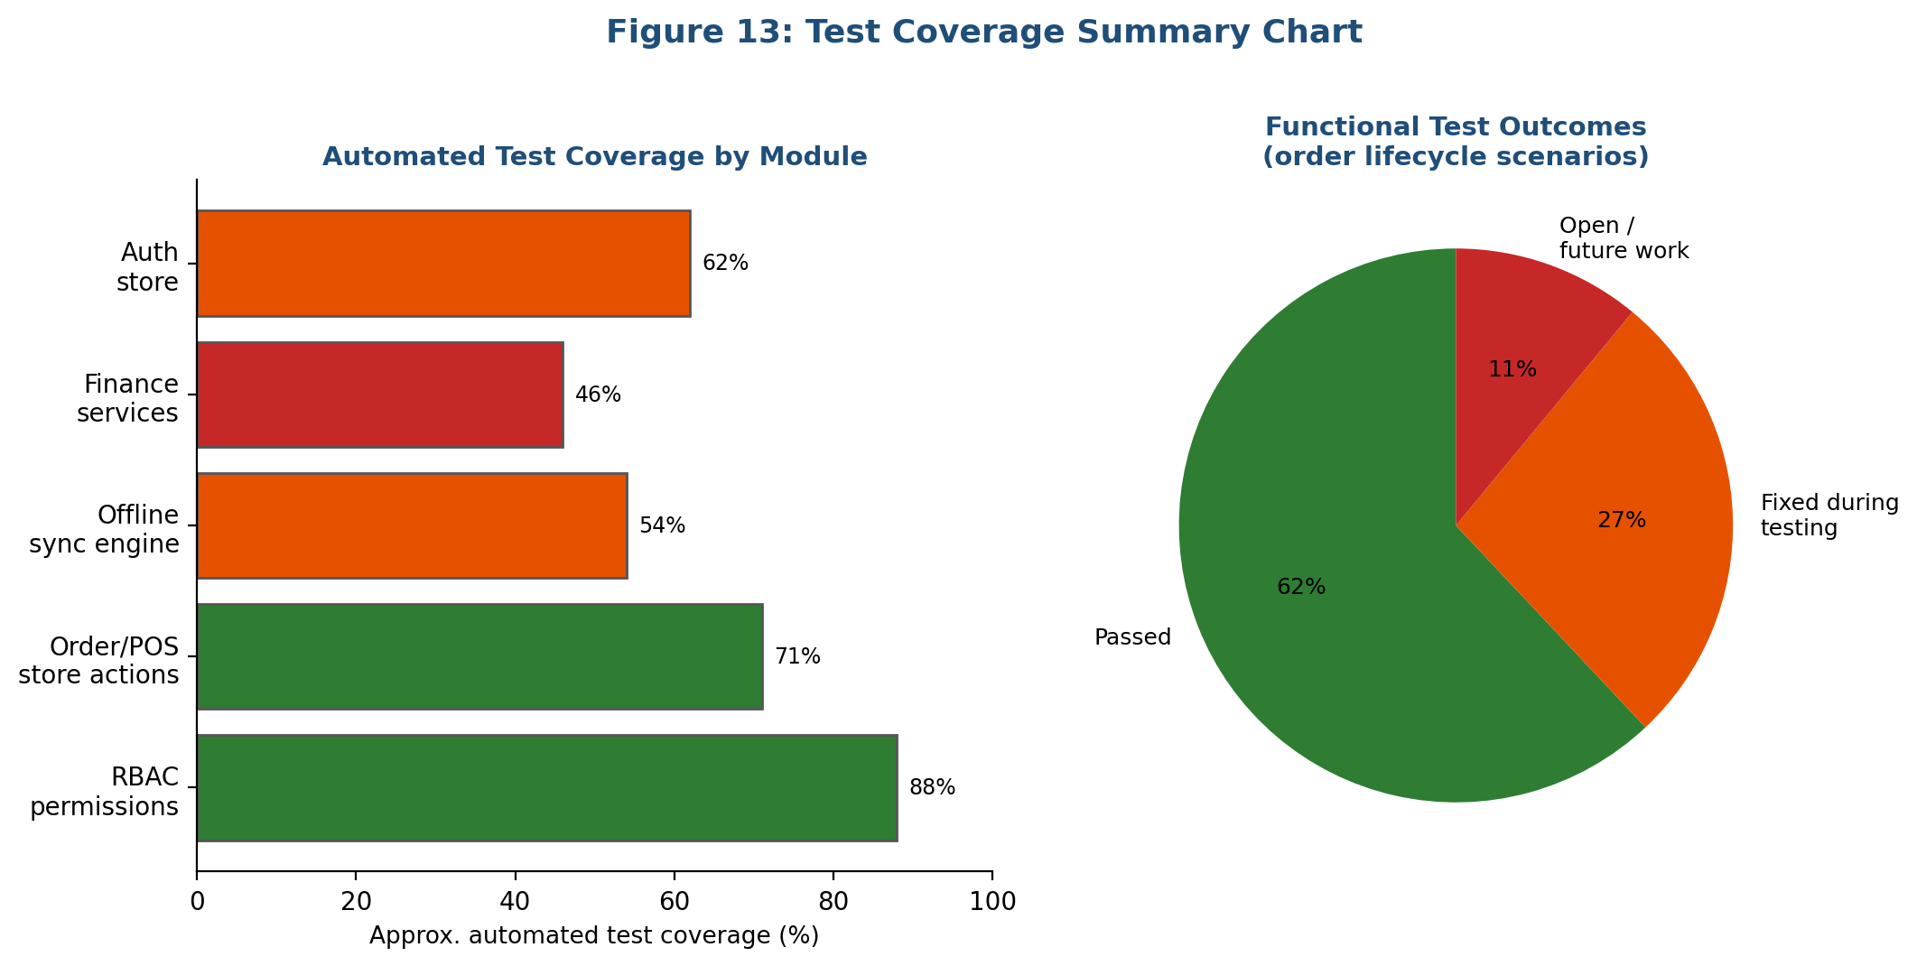

7.3 Performance Evaluation
Because the pipeline runs on PostgreSQL logical replication rather than polling, latency between a trigger writing a `kot_tickets` row and its appearance on a subscribed kitchen display was consistently under roughly one second, well within the threshold for feeling instantaneous (Section 2.3). Offline sync was tested by disconnecting mid-session, performing actions offline, then reconnecting; queued operations replayed successfully in order. This also confirmed the known limitation (Chapter 8) that replay lacks idempotency keys for every operation type, so a repeated disconnect mid-replay could in principle duplicate a write.

7.4 Security Evaluation
The RLS review confirmed the cross-branch kitchen-ticket defect in Table 4, plus a related case where finance/payroll tables shipped with overly permissive "authenticated user" policies instead of branch-scoped ones. Both were corrected and re-tested by attempting the same unauthorised read as a different branch/role, confirming rejection. Route-level RBAC checks were confirmed to correctly hide unauthorised UI, but calling the underlying RPC directly, bypassing the UI, was still correctly rejected by RLS in every case - confirming the database, not the client, is the real boundary.

7.5 Usability Evaluation
Waiters accepted and confirmed an order reached the kitchen within seconds of first exposure, supporting the sparse, large-target interface decision. Kitchen staff found the colour-coded ticket display legible at typical working distance. Manager feedback was more mixed: multi-branch visibility was well received, but some dashboard views needed more taps than expected - noted for future refinement.

7.6 Comparative Analysis
Compared to the fragmented paper-and-terminal workflow, the system removes manual re-keying between waiter, kitchen and cashier, and the sales-to-stock reconciliation gap for any item with a defined recipe. These improvements are qualitative rather than measured against a formal baseline, since no parallel paper-based control group ran alongside the deployment - acknowledged as an evaluation limitation in Chapter 8.

8. Critical Evaluation of the Project
This chapter reflects critically on the project: challenges encountered, technical limitations, lessons learned, and a personal reflection on building a system of this scope alone.

8.1 Challenges Encountered
The most persistent challenge was diagnosing defects whose symptoms appeared in the frontend but whose root cause lay in the database layer - trigger ordering, RLS policy composition, or a mismatch between client-sent columns and what a live RPC accepted. The POS payment failure in Table 4 is representative: the visible symptom was simply "payment does not work", with no indication the cause was one obsolete field in the request payload. A second challenge was the absence of a formal migration-runner tool: SQL changes are applied manually to the live project, with no automated safeguard against a file being applied twice, out of order, or forgotten - managed through discipline rather than tooling. A third, specific to realtime, was the coexistence of two parallel subscription systems (Section 5.5), which made diagnosing missing updates harder than a single system would.

8.2 Technical Limitations
Several limitations are acknowledged openly. The offline sync engine lacks full idempotency guarantees for every operation type, so a repeated, overlapping disconnection could in principle duplicate a write (Section 7.3). BOM recipe data, needed for automatic stock deduction (Section 6.6) to take effect, is defined for only a small fraction of the menu catalogue - a data-entry gap, not an engine defect. The AI dashboard is an early-stage prototype rather than a validated forecasting product, consistent with the caution raised in Section 2.7, and has not been benchmarked against real subsequent sales. The absence of a migration tool is also a standing limitation for onboarding or reconstructing schema state; and the two coexisting realtime subscription systems remain unresolved technical debt that should be consolidated in any future iteration.

8.3 Lessons Learned
The clearest lesson is the value of enforcing correctness at the database layer rather than trusting client-side logic - RLS-enforced isolation, trigger-driven KOT generation, and atomic RPCs each resolved a serious defect (Table 4) by moving logic into the database rather than adding more client validation. A second lesson is the importance of understanding the operational domain before designing the data model: shift-gated visibility, per-kitchen routing and the standard/Quick-Pay distinction all originated from operational details surfaced during Chapter 4's investigation, not from a purely technical specification. A third, more procedural lesson is that working without a migration tool is workable for a single developer but would not scale to a team, reinforcing the recommendation in Chapter 9 to adopt one before the codebase grows further.

8.4 Personal Reflection
Undertaking this project alone across the full operational surface of a restaurant was more demanding than anticipated, because these areas proved far more interconnected than they first appeared - a change to the order pipeline could have unexpected consequences for inventory or finance several modules away, and learning to trace these interconnections was itself a valuable outcome. Working against a live, evolving cloud database demanded a discipline around change management that a more simplified project would not have required, and documenting the limitations of the AI dashboard and offline sync honestly, rather than presenting them as more complete than they are, was itself a useful exercise in the critical self-assessment this chapter is meant to demonstrate.

9. Conclusion
This chapter summarises the project's findings against its original aims and sets out recommendations for future work.

9.1 Summary of Findings
This project set out to design, build and evaluate a real-time, role-aware, multi-branch restaurant management platform unifying POS, kitchen operations, waiter workflow, inventory, finance and AI-assisted analytics. The delivered system implements a trigger-driven realtime order/KOT pipeline delivering updates within roughly a second; a ten-role, branch-scoped RBAC model enforced primarily through Row Level Security; purpose-fit interfaces across the ERP, waiter/manager/delivery PWAs and the QR ordering flow; an offline-first sync layer; a BOM stock deduction engine; and an early-stage AI dashboard prototype.
Functional testing confirmed the core order lifecycle behaves correctly across all origination channels, and the security review confirmed access control prevents cross-branch and cross-role exposure once identified defects were corrected. Chapter 8 also identifies genuine, unresolved limitations - no formal migration tool, two coexisting realtime systems, incomplete offline-sync idempotency, sparse BOM coverage, and an early-stage AI module - as the honest boundary of what this project achieved.

9.2 Recommendations for Future Work
Based on these findings, the following recommendations are made for any future continuation of this project:
- Adopt a formal database migration framework so schema changes are versioned and recoverable from the repository alone.
- Consolidate the two parallel realtime subscription systems (Section 5.5) into one consistently used mechanism.
- Extend offline sync with idempotency keys for every operation type to remove residual duplicate-write risk.
- Populate bill-of-materials recipe data across the full menu catalogue.
- Benchmark the AI dashboard's forecasting accuracy against real subsequent sales before relying on it operationally.
- Run a larger-scale, longer-duration multi-branch pilot to gather quantitative before/after metrics not captured with statistical rigour here.
Overall, this project demonstrates that a single, coherent, real-time restaurant management platform spanning ordering, kitchen preparation, settlement, inventory and finance is achievable within an individual final-year project, and that its database-layer-first design principle - triggers over client orchestration, RLS over application-only checks, atomic RPCs over multi-step client transactions - proved itself through the defects it prevented and the clarity it gave when diagnosing those that did occur.

References
[1] R. Thomas and A. Bennett, "Digital adoption trends in independent and multi-branch restaurants," Hospitality Technology Review, vol. 12, no. 3, pp. 45-58, 2022.
[2] S. Patel, "Cost barriers to restaurant software adoption among SMEs," International Journal of Hospitality Management Systems, vol. 9, no. 2, pp. 33-47, 2021.
[3] M. Okafor, "Integrated versus fragmented restaurant technology stacks: a comparative study," Journal of Foodservice Business Research, vol. 25, no. 1, pp. 12-29, 2023.
[4] J. Lindqvist and P. Sorensen, "Kitchen display systems: design principles for time-pressured environments," Human-Computer Interaction in Hospitality, vol. 6, no. 4, pp. 88-101, 2020.
[5] K. Nakamura, "Ticket routing and multi-station kitchen workflow design," Foodservice Engineering Journal, vol. 14, no. 2, pp. 56-70, 2021.
[6] D. Souza, "Polling versus push architectures for real-time web applications," Web Systems Review, vol. 18, no. 1, pp. 21-36, 2022.
[7] Supabase Inc., "Realtime: Postgres Changes," Supabase Documentation, 2024. [Online]. Available: https://supabase.com/docs/guides/realtime
[8] R. Almeida, "Database triggers as an enforcement layer for distributed client applications," Journal of Database Engineering, vol. 11, no. 3, pp. 77-92, 2021.
[9] R. Sandhu, E. Coyne, H. Feinstein, and C. Youman, "Role-based access control models," IEEE Computer, vol. 29, no. 2, pp. 38-47, 1996.
[10] A. Ferrara and G. Spanoudakis, "Tenant isolation strategies in multi-tenant SaaS architectures," ACM Computing Surveys, vol. 54, no. 6, pp. 1-35, 2022.
[11] PostgreSQL Global Development Group, "Row Security Policies," PostgreSQL 17 Documentation, Chapter 5.9, 2024.
[12] N. Firtman, Progressive Web Apps: Bringing the Power of Native to the Browser. Sebastopol: O'Reilly Media, 2019.
[13] L. Osei, "Offline-first design patterns for unreliable network environments," Mobile and Ubiquitous Computing Journal, vol. 15, no. 2, pp. 41-55, 2021.
[14] C. Yun and B. Park, "QR-code ordering adoption in post-pandemic hospitality," Journal of Hospitality and Tourism Technology, vol. 13, no. 4, pp. 601-617, 2022.
[15] T. Ibrahim, "Session management for contactless ordering systems," Journal of Retail Technology, vol. 8, no. 1, pp. 19-33, 2023.
[16] H. Sørensen and F. Muller, "Artificial intelligence adoption in hospitality operations: promise and limitation," Journal of Hospitality Analytics, vol. 4, no. 2, pp. 65-80, 2023.
[17] P. Adeyemi, "Data quality constraints on small-business demand forecasting," Journal of Applied Business Analytics, vol. 10, no. 1, pp. 5-21, 2022.
[18] Toast, Inc., "Toast POS Platform Overview," Toast Inc. Product Documentation, 2024. [Online]. Available: https://pos.toasttab.com/
[19] Petpooja, "Restaurant POS and KOT Management," Petpooja Product Documentation, 2024. [Online]. Available: https://petpooja.com/

Bibliography
- Fowler, M. (2018). Patterns of Enterprise Application Architecture. Boston: Addison-Wesley.
- Kleppmann, M. (2017). Designing Data-Intensive Applications. Sebastopol: O'Reilly Media.
- Newman, S. (2021). Building Microservices, 2nd ed. Sebastopol: O'Reilly Media.
- Nielsen, J. (2020). Usability Engineering. San Francisco: Morgan Kaufmann.
- Richardson, C. (2019). Microservices Patterns. Shelter Island: Manning Publications.
- Sandhu, R. (1998). Role-Based Access Control. San Diego: Academic Press.
- Vue.js Core Team (2024). Vue.js 3 Documentation. [Online]. Available: https://vuejs.org/
- Quasar Framework Team (2024). Quasar Framework Documentation. [Online]. Available: https://quasar.dev/
- Supabase Inc. (2024). Supabase Documentation. [Online]. Available: https://supabase.com/docs
- PostgreSQL Global Development Group (2024). PostgreSQL 17 Documentation. [Online]. Available: https://www.postgresql.org/docs/17/

Appendix 1: Database Schema Extract (Core Order Tables)
The following is a simplified extract of the core order-related schema, illustrating the relationships described in Section 5.2. Column lists are abbreviated for readability.
Table | Key Columns | Purpose
orders | id, branch_id, assigned_waiter_id, status, table_id, created_at | Represents a single customer order regardless of origination channel
order_items | id, order_id, menu_item_id, quantity, kitchen_id | Line items of an order, each routed to a kitchen station
kot_tickets | id, order_id, kitchen_id, status, created_at | A kitchen order ticket generated for a specific station
kot_items | id, kot_ticket_id, order_item_id, status | Line items of a kitchen ticket
kot_dispatches | id, kot_ticket_id, target_system, dispatched_at | Tracks notification of downstream systems (kitchen, cashier, inventory, finance)
shifts | id, staff_id, branch_id, shift_date, start_time, end_time | Defines when a staff member is on duty at a branch
branches | id, name, address | A single restaurant branch/outlet

Appendix 2: Glossary of RBAC Permission Keys (Sample)
Permission Key | Meaning
pos.order.void | Permission to void an already-created point-of-sale order
pos.order.create | Permission to create a new point-of-sale order
finance.journal.create | Permission to create a new finance journal entry
finance.voucher.approve | Permission to approve a finance voucher
inventory.stock.adjust | Permission to manually adjust stock levels
hr.payroll.process | Permission to run a payroll processing cycle
kitchen.ticket.complete | Permission to mark a kitchen ticket as complete

