1)Create a database called person & create collection called details
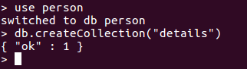

2)Create the above 6 person’s details documents.
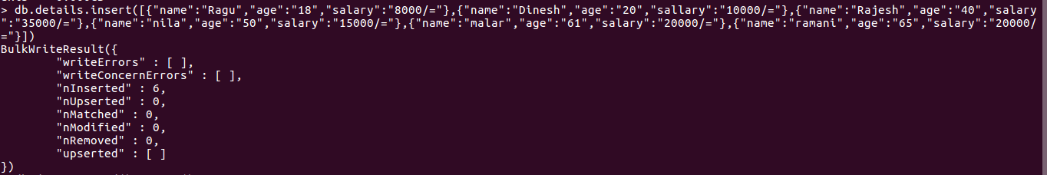
3)Find the persons following this conditions
1)Age > 50
2)Age < 50
3)Salary=20000/=
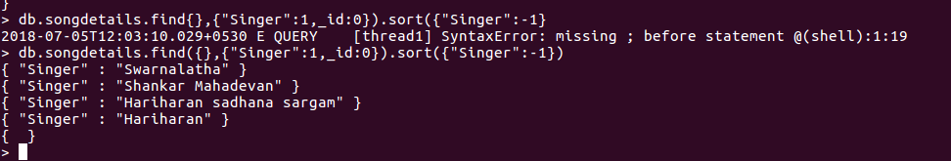
4)Salary < = 20000/=
5)Salary < 20000/=
6)Salary > 20000/=
7)Age < 50 & Salary > 20000/=
8)Age < 50 or Salary > 20000/=
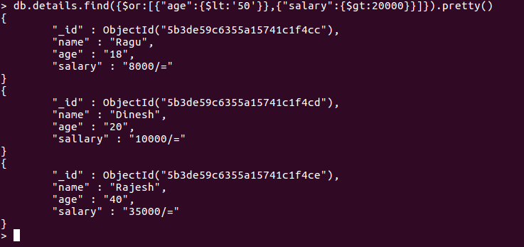

9)Age < 20 or Salary >= 10000/=
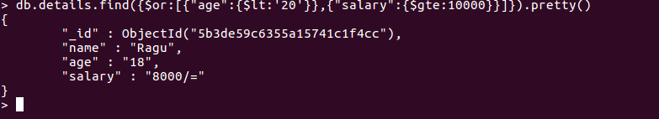
10)Age < = 20 and Salary >= 10000/=
