Comp1804 Report: Predicting the severity of road accidents in the UK
STUDENT ID: 001273076
12.04.2023
Word count: 2934

Executive summary
The report contains the supervised learning approach to predict the accident severity by modelling the data of reported accidents occurred in UK around 2019. These data can be used to detect patterns and trends, determine areas of concern, and establish safety measures in place to reduce the frequency and severity of future accidents. The performance of the traditional machine learning algorithms namely, RF, SVM, Decision tree and KNN were compared with a deep neural network and feedforward neural network (MLP) to compare the performance of traditional machine learning algorithms vs neural networks. Best accuracy of 80.65% was given by the deep neural network.

1. Exploratory data analysis
Before feeding the dataset into a model, it should be evaluated to understand the variables, their distributions, and correlations with the target variable (accident_severity). In addition to determining whether the data contains any missing values, outliers, or imbalances, this enables the identification of the factors that are most crucial for predicting the target variable.

1.1 Overview
Figure 1.1: Head of the dataset containing the first three records

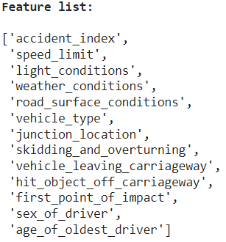
Figure 1.2: Fourteen columns of the dataset Figure 1.3: Data types of each feature

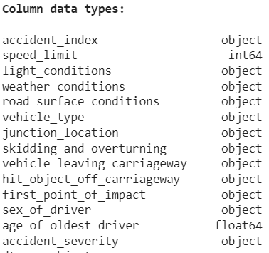
The dataset has 31647 records and 14 features (figure 2). All the features are object data type except speed_limit and age_of _oldest driver as in figure 3. The target variable is defined as ‘accident_severity’.

1.2 Missing values
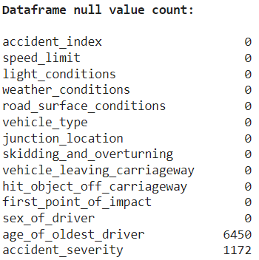
As given in the figure 4, there are 1172 missing values in the target and 6450 missing values in age_of_oldest_driver. All the missing values of the categorical variable are replaced as ‘data missing or out of range’.
Figure 1.4: Count of missing values

Some general insights of the categorical features are obtained using the value_counts and listed in the table below.
Table 1.1: Feature overview
Feature name | Data missing or out of range | Major category
speed_limit | 0 | True zero, max speed= 70, min speed = -1
light_conditions | 0 | daylight
weather_conditions | 970 | fine
road_surface_conditions | 365 | dry
vehicle_type | 63 | Only cars
junction_location | 1470 | at or within 20 metres of junction
skidding_and_overturning | 2034 | no skidding or overturning
vehicle_leaving_carriageway | 1967 | none leaving carriageway
first_point_of_impact | 1304 | at least one vehicle with frontal impact
sex_of_driver | 5122 | all males
age_of_oldest_driver | 6450 | min age = 6, max age = 101
accident_severity | 1172

1.3 The impact of numerical features to the target
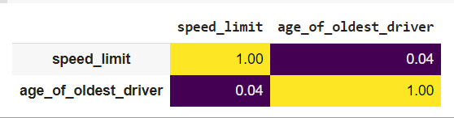

Figure 1.5: Correlation heatmap

The two numerical features do not have any strong relationships with each other. However, considering the boxplot of figure 1.6, the data range of the feature, age_of_oldest_driver with respect to the three classes Slight, Fatal and Serious does not have variation. All are in the same range. The age_of_the_oldest_driver does not have any significant impact with the target.

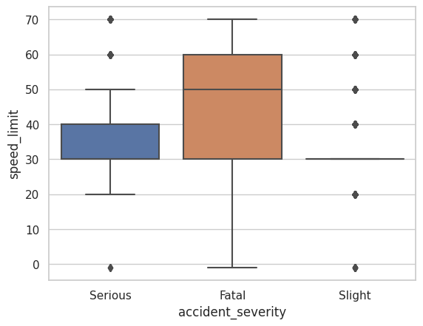
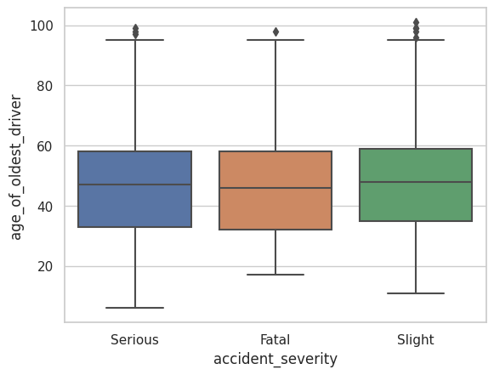
Figure 1.6: Boxplot representation of age_of_oldest_driver with target
Figure 1.6: Boxplot representation of speed_limit with target
However, as in the figure 1.6, it is interesting to observe that the Serious damages are caused by low speeds having the interquartile range of 30 to 40 units while Fata damages are caused by high speed range with the interquartile range of 30 to 60 units. There exists some outliers that were omitted during the analysis.

1.4 Outliers
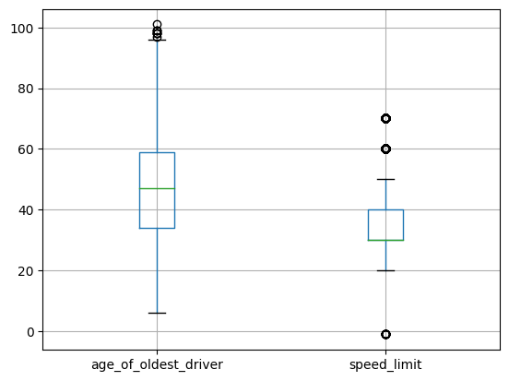
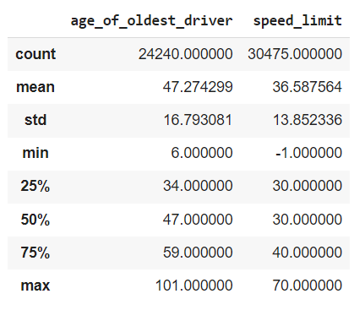
Figure 1.7: Data distribution of the two features
Figure 1.8: Descriptive statistics of the two features

There exist some outliers for the age of the oldest driver, minimum as 6 years old and negative values for minimum speed limit which is unrealistic.

1.4 Imbalances

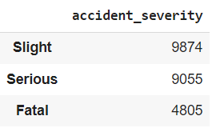
The imbalance of the target across classes was tested using the training labels. The classes are imbalanced.

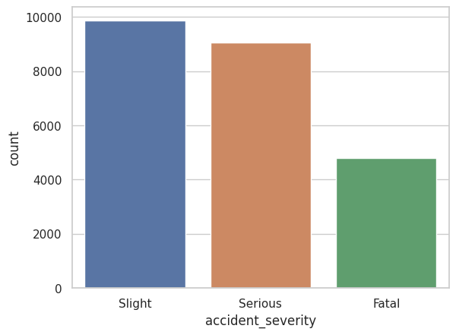
Figure 1.9: Class imbalance visualisation

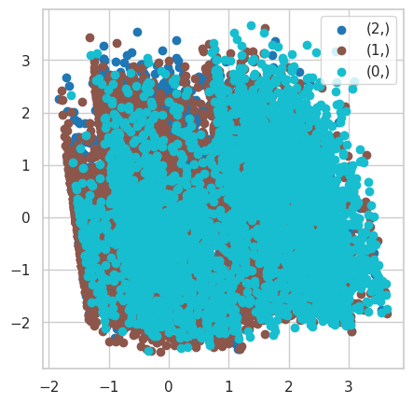
1.5 Visualisation of the dataset using dimentionality reduction technique

Figure: Scatter plot to visualize the dataset with respect to their classes, Fatal, Serious, Slight

The scatter plot generated by PCA visualisation indicates that there is no visible linear separation between the classes since all of the scatter points are grouped together. This may occur when there is a lack of obvious pattern in the data or when the classes in the dataset have a significant degree of overlap. As a solution, the data can be visualised using a different dimensionality reduction technique such as t-SNE, UMAP, or MDS or more advanced machine learning algorithms that can handle non-linear relationships between features.

2. Data preprocessing

2. 1 Duplicates in the accident_index

There were 1172 duplicated records, they were removed from the dataset. Since there are no duplicates in the accident_index column, it was assigned as the index column.

Handling redundancy categories

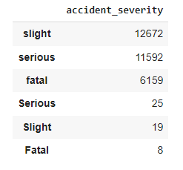
The target variable had redundant categories due to typos as given in the figure 2.1. It was corrected by setting the three categories as Slight, Serious and Fatal.

Figure 2.1: Target feature typos

Rename categories

‘fog or mist’ category in the feature weather_conditions was replaced as ‘mist’. 'wet or damp'
Category in the feature road_surface_conditions was replaced as wet as they carry the same meaning.

2.4 Reset the inconsistent values by setting a data limit
It is not interested in keeping outliers; hence the accepted minimum age limit was set as 16 because in UK, driving is allowed at the age of 16. Speed_limit has minus values which are unreliable. Therefore, the minimum value of the speed limit was set to 0.

2.5 Removing the null records of target accident_severity

The null values of the target cannot be replaced as it misleads the machine learning algorithms. Therefore, those records are removed from the dataset. All the null records in the target are replaced with the string, 'null value'. Then remove that particular records carrying the category name ‘null record’.

2.6 Dataset split into train and validation

The dataset is divided into training and testing, and validation sets based on the ratio of 8:1:1 Since the dataset is imbalanced, for being sure that the distributions of the target variable are similar, stratified sampling was used.
Up-sampling or Down-sampling techniques were not used because it can distort the original data, besides this application can be handled without it.
Data splitting is done prior to handling missing values. The missing values are replaced by either mean or mode of train data. Otherwise, data leakage happened across train, test and validation data.

2.7 Imputing missing values

When two collisions happen the age of the oldest driver is described from the feature age_of_oldest_driver. It contains 6450 missing values which is around ⅕ th as a proportion from all records. Therefore, it is decided not to remove 6450 records as it reduces the size of the dataset. As the dataset was small, losing any data will cause the important information to be lost, which could have a significant effect.
- The numerical missing values of train, test and validation datasets are replaced by the mean of that feature in train dataset.
- The categorical missing values (data missing or out of range) of train, test and validation datasets are replaced by the mode of the particular feature in train dataset.
The mean and mode are calculated from train dataset to avoid data leakage across train, test and validation sets.

2.8 Change data type
Speed limits are typically whole numbers. Rounding mistakes that can be introduced by floating-point numbers could be problematic. Therefore, integer data type which offers high precision is preferable.

2.9 Feature encoding
Training data was fit to learn the parameters of onehot encoding. Using the learned parameters, all training, testing and validation features were transformed. Unlike label encoding, onehot encoding does not add an order to the numerical represented values as such order misleads some machine learning algorithms. Onehot encoding introduces a new column for each sub category resulting in a new dataframe having 30 features.

2.10 Label encoding

Training data was fit to learn the parameters of label encoding. Using the learned parameters, all training, testing and validation features were transformed. A target should be a unique numerical value; therefore, target cannot be onehot encoded. It does not matter if an order such as 0, 1, 2 is assigned as labels.

2.11 Feature scaling

ML algorithms that calculate distance measurements (KNN), regularization techniques (logistics regression), gradient descent based (Naïve bayes) and neural networks need scaled features for accurate performance. OneHot encoded variables and labels do not need to be scaled. The distributions of the input features can be plotted using box plots as in the figure below.
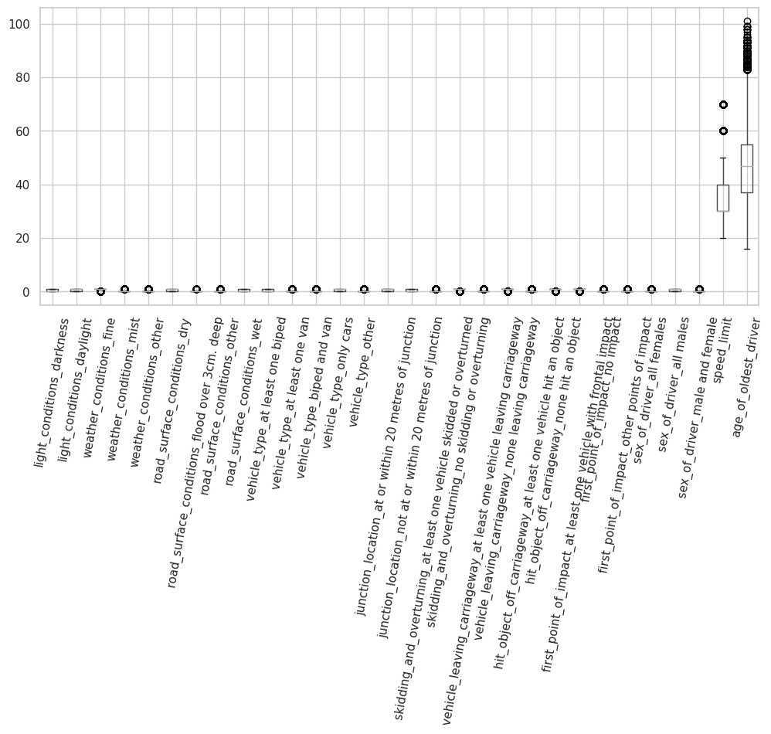
Figure 2.2: Encoded feature set before standardizing

Standard scaler was used where the z-score for 99% of data ranges from -3.00 to 3.00 It is used by assuming the input is normally distributed. Besides, cannot trust the minimum and maximum values of the feature values to use the min-max scaler.
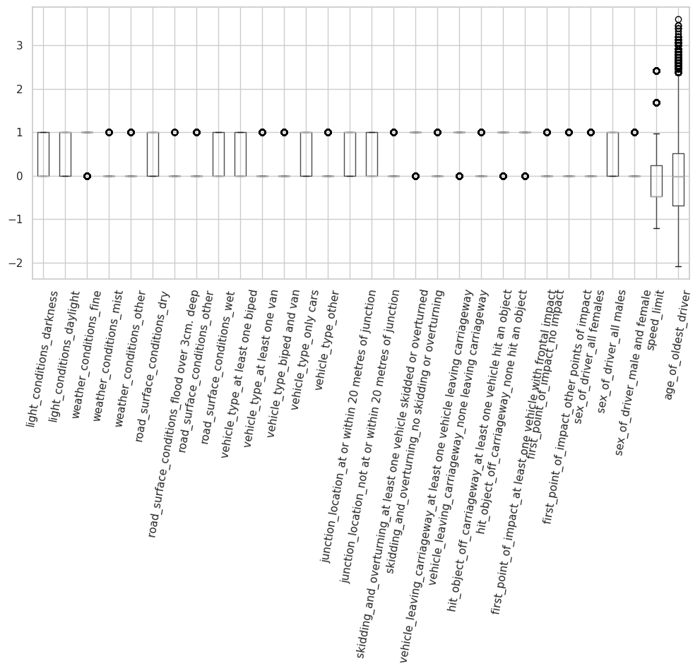
Figure 2.3: Encoded features after standardizing

3.11 Dimensionality reduction using PCA

Higher dimensions are computationally expensive. Therefore, it is useful to represent the dataset with the most important features less than the original feature set. The principal components are identified for the training features. According to the figure2.4, 90% variance of the dataset can be explained using at least 11 components.

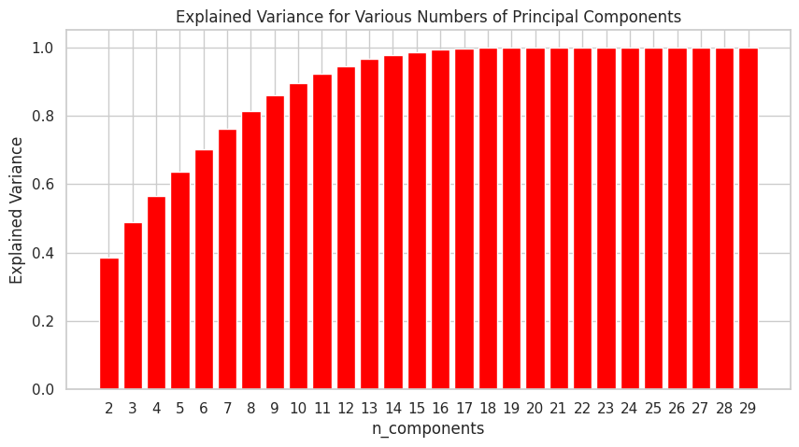
Figure: 2.4: Explained variance by each component of PCA

Training features ware used to fit to learn the parameters of pca which explains 90% of the variance of the original data. Using the learned parameters, testing and validation features were transformed. The reduced train, test, and validation features (now 11 features) were used to train the models.

3. Classification using traditional machine learning
3.1 Random Forest Classifier
Table 3.1: Summary of the best model hyperparameters
Model parameter | Value
n_estimators | 100
max_depth | 6
min_samples_split | 2
min_samples_leaf | 1
max_features | None
criterion | entropy

Random forest is an ensembled decision tree which means a group of randomized decision trees are used to build a RF model. N_estimators refers to the number of decision trees in the forest. The heigh of one tree (max_depth) is 6. It splits at least to 2 at each node. The minimum samples at leaf nodes are 1. Criterion used to split the data at each node when building the tree is ‘entropy’.

Process: The feature that offers the greatest information gain is chosen first by the entropy. Using this feature, the dataset can be divided into two or more subgroups according to their values. The method repeats the procedure of recursively separating each subset until max_depth = 6 or min_samples_leaf =1

Hyperparameter optimization:
Several other traditional machine learning algorithms were trained using randomized search and according to the optimal solution the model that gave the best-balanced accuracy was random forest.
Randomised search is used to select the optimal solution out of the given parameters in a random forest. 'criterion': ['entropy','gini'],'max_depth': [None,4,5,6], 'max_features': ['auto','sqrt', None]

Regression problems are handled using linear regression, whereas classification difficulties are handled using logistic regression. Therefore, logistics regression was selected. Following table shows the models and their balanced accuracy for the best hyperparameter values.
Table 3.2: Traditional ML models and balanced accuracies
Model | Balanced accuracy
Logistics regression | 75.78%
KNN | 72.57%
Decision Tree | 74.73%
SVM | 74.90%
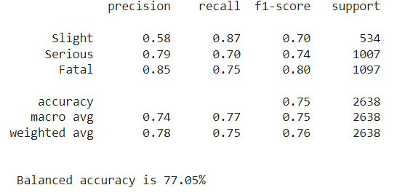
Model evaluation:
Figure 3.1: Classification report
According to the classification report, the model has correctly classified 75% classes. For Fatal, the model had a precision of 0.85, meaning that 85% of the time it correctly identified a Fatal accident. Similar to this, the recall of 0.75 for Fatal shows that 75% of the time, the model correctly classified the class Fatal. The F1-score, a harmonic mean of precision and recall of Fatal is 80%. The balanced accuracy which is the average of the recall was obtained as 77.05%

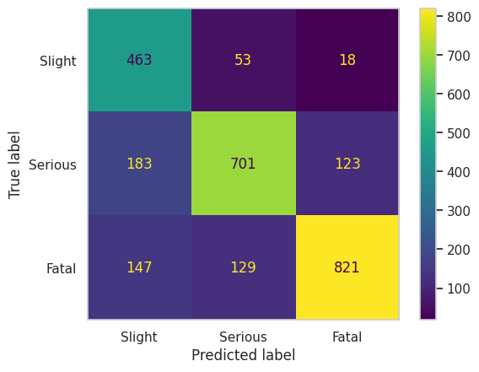
Figure 3.2: Confusion matrix
By observing the diagonal, it is obvious that most classes predicted well.

4. Classification using neural networks

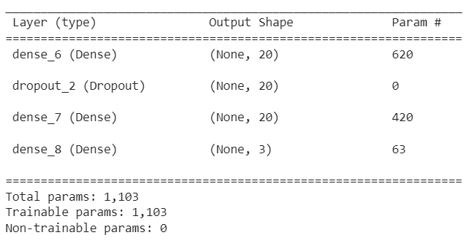
4.1 Deep Neural Network

Figure 4.1: Model summary

Table 4.1: Summary of the best model hyperparameters
Model parameter | Value
Number of hidden layers | 2 (Dropout layer, Dense layer)
Number of neurons per layer | 20
Activation functions | ReLu
Learning rate | 0.0005
Dropout | 0.2
Batch size | 60
Optimization algorithm | Adam
Loss function | Sparse Categorical Cross entropy

Input layer consists of 20 nodes and training data after dimensionality reduction was fed. The two hidden layers consists of 20 nodes each, while first hidden layer is a dropout layer with a drop out fraction of 0.2. It is used to avoid overfitting. Second hidden layer is a fully connected layer. The activation function for those layers is ReLu. As this is a multiclass (3 class) classification problem, the output layer, activation function and loss function are 3 nodes, softmax and Sparse categorical cross-entropy.

Process:
The input layer receives the 11 features from the dimensionality reduced output. Each neuron at input layer output a ReLu activation output. The next layer is a dropout layer where the probability of the presence of a node is 80%. The output signal is then passed on to the next layer and continues in this manner until the final output of the network is produced. Since the layers are fully connected, each hidden neuron gets and input from multiple neurons in the previous layer and applies weights before passing to the next layer. The weighted inputs are passed through the activation function which allows it to learn more complex relationships among inputs and outputs and adds non-linearity. The weights are adjusted to minimize the loss function. Loss function calculated the difference of the current output and the desired output which is called as backpropagation. This process continues iteratively until a satisfactory of accuracy is achieved. Afterword’s, the accuracy remains constant.

Hyperparameter optimization:
The model was trained for several learning rate. The final accuracies vs learning rates was given in the figure 4.2. The best accuracy was obtained for the learning rate 0.0005 A simple model with one hidden layer was chose first and it is improves by adding another hidden layer and drop out layer to reduce overfitting. MLP model was implemented to compare the balanced accuracy, but its accuracy remained as 75.24%. The training and validation accuracy variation for each epoch is given in figure 4.3 after 60, the accuracy maintains at a same level. Figure 4.4 depicts the train and validation loss with number of epochs. Using the features after PCA provided better accuracy.
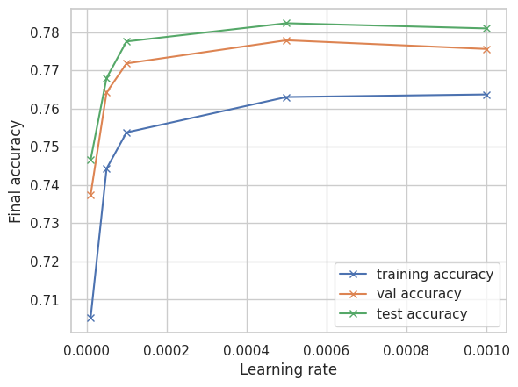
Figure 4.2: Training, testing and validation accuracy vs learning rate
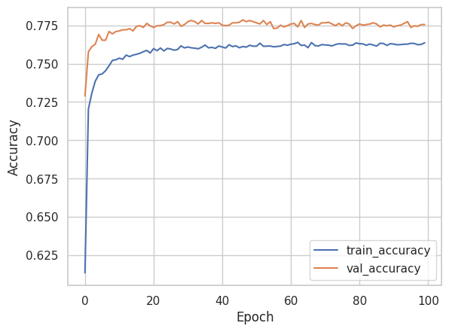
Figure 4.3: Training and validation accuracy vs number of epoch

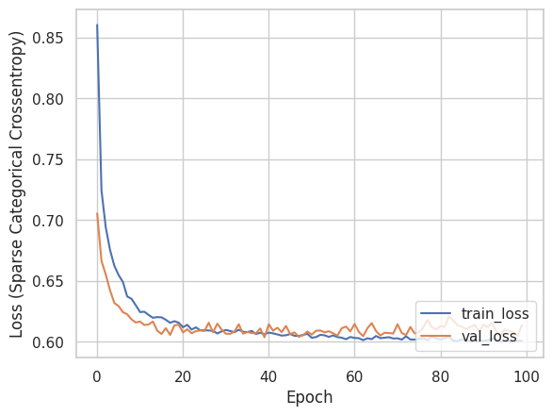
Figure 4.4: Train and validation loss vs number of epoch

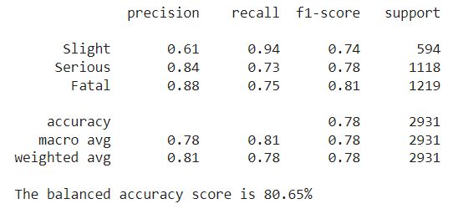
Model evaluation:

Figure 4.2: Classification report
According to the classification report, the model has correctly classified 78% classes. For Fatal, the model had a precision of 0.88, meaning that 88% of the time it correctly identified a Fatal accident. Similar to this, the recall of 0.75 for Fatal shows that 75% of the time, the model correctly classified the class Fatal. The F1-score, a harmonic mean of precision and recall of Fatal is 81%.
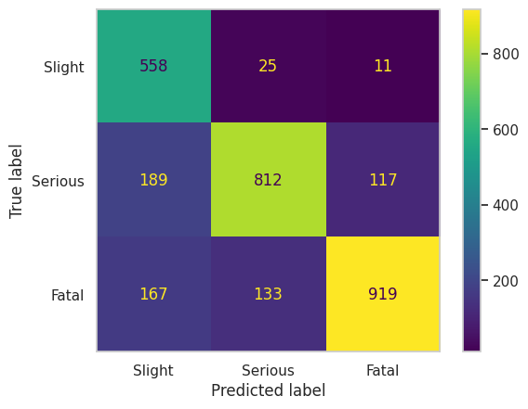
The balanced accuracy of 80.65% was considered to select the best model. The model is biased to predict the majority class, ‘Fatal’.

Figure 4.3: Confusion matrix
By observing the diagonal, it is obvious that most classes predicted well. But some are predicted incorrectly.

5. Ethical discussion

Ethical OS Toolkit can be used to identify the potential risks and advantages for various stakeholders in order to investigate the social and ethical implications of accident severity prediction.
- Accuracy: Incorrect predictions of the model can lead to inappropriate emergency response medical treatment, or legal consequences. Using only ML predictions can leave out key factors like road conditions or driver behaviour that have an impact on accident severity.
- Privacy: This data does not have any personal identifying information that raises privacy concerns.
- Bias: If the dataset used to train the model is biassed to a certain group or community that is unfair to others.
- Accountability: If a prediction goes wrong, the responsible body is questionable. The data was released under the Open Government Licence and this study was required by non-commercial entities.
Possible methods for reducing these hazards include transparency by making the data data collection and processing procedures visible to build stakeholder trust and identify any biases or flaws in the data. The dataset for model training should represent a diverse representative.

6. Recommendations
The best model to predict the accident severity is the deep neural network. Unlike traditional machine learning approaches, deep neural networks are able to extract the most relevant features and give more weight to them while learning, which is a black box training. That can capture complex, non-linear interactions that cannot be captured manually.
In practice, deep neural networks can bear complex (images, maps etc.) and huge amounts of data. Hence, this model can be reused for transfer learning to accurately predict the accident severity.
For future improvements, to acquire the transparency of the model as discussed in the section 5, visualization techniques can be used to create heat maps or other visual representations of the most important features for a given prediction. Furthermore, the model can be used as transfer learning, to feed more data and fine tune for better predictions.

7. Retrospective
The traditional machine learning algorithms (RF, Decision Tree, SVM KNN, LG) were compared with MLP and a deep neural network to predict the severity of the road accidents. Further investigations include, trying other types of NN such as CNN. Moreover, using a different dimensionality reduction technique to visualize the dataset.

8. References
Dataman, C.K.D. (2023) Dimension reduction techniques with python, Medium. Towards Data Science. Available at: https://towardsdatascience.com/dimension-reduction-techniques-with-python-f36ca7009e5c (Accessed: March 22, 2023).
PCA does not make sense after one hot encoding (2021) Andrew Wheeler. Available at: https://andrewpwheeler.com/2021/06/22/pca-does-not-make-sense-after-one-hot-encoding/ (Accessed: March 22, 2023).
Sklearn.ensemble.randomforestclassifier scikit. Available at: https://scikit-learn.org/stable/modules/generated/sklearn.ensemble.RandomForestClassifier.html (Accessed: April 14, 2023).

Abbreviations
CNN: Convolution Neural Network
KNN: K-nearest neighbors
MLP: Multi linear perceptron
NN: Neural networks
PCA: Principal Component Analysis
ReLu: Rectified Linear Unit
RF: Random Forest
SVM: Support Vector Machine

