OHDSI Australia — Home

Advancing Real-World Evidence Across Australia

OHDSI Australia is a collaborative network connecting researchers, data holders, national initiatives, and institutions to generate reliable, reproducible, and scalable real-world evidence. All methods, tools, and standards are open source.

Who Are We?
The Observational Health Data Sciences and Informatics (or OHDSI, pronounced “Odyssey”) community is a multi-stakeholder, interdisciplinary collaborative dedicated to bringing out the full value of observational health data through the OMOP Common Data Model and large-scale analytics.

The global OHDSI community spans more than 4,700 collaborators across 88 countries and 6 continents, with data standardised across 550+ sources collectively representing nearly one billion patient records. OHDSI Australia is the national node, operating in close partnership with the Transformational Data Collaboration (TDC) under the Australian Health Research Alliance (AHRA), with coordination led by A/Prof Nicole Pratt at Adelaide University.

We work closely with national initiatives, regulators, academia, industry, and patient organisations to enable transparent and secure federated research across Australia.

Why OHDSI Australia?
Strengthening Evidence Generation — Across Australia

Australia’s health data landscape is both an opportunity and a challenge. Diverse state-based systems, coding practices, governance frameworks, and infrastructure mean that national evidence generation has historically been difficult to achieve at scale — and this is exactly the gap OHDSI Australia is built to close.

- Supporting consistent OMOP adoption across Australian hospitals, registries, and research institutions
- Connecting local expertise to a national and Asia-Pacific network
- Helping institutions participate in federated research without sharing patient-level data
- Sharing best practices, tools, and training across the Australian community
- Contributing to national health data infrastructure and policy, including the Australian Health Data Strategy

This coordinated approach ensures that Australian health data can be used to generate trustworthy, large-scale evidence — without compromising patient privacy or local data governance.

Impact in Australia
Real Insights. Real-World Data. Real-World Evidence.

From pharmacovigilance to chronic disease research and aged care, OHDSI Australia supports federated analyses across millions of patient records — without moving any data. Our community collaborates through shared OMOP CDM implementations, open-source tools, and national research programmes including the EMR to OMOP Project, AHDEN, and the OHDSI Asia-Pacific network.

Useful Resources
- OHDSI YouTube: youtube.com/channel/UC2RFIQnptl-nk8GbjFfqztw
- OHDSI Book: ohdsi.github.io/TheBookOfOhdsi
- OHDSI Forum: forums.ohdsi.org
- EHDEN Academy: academy.ehden.eu
- GitHub Tools: github.com/ohdsi
- GitHub Studies: github.com/ohdsi-studies
- Community Dashboard: dash.ohdsi.org
- EMR to OMOP Project: ohdsi-australia.org/EMR2OMOP.html
- AHDEN Project: ardc.edu.au/project/australian-health-data-evidence-network-ahden

Acknowledgement
We would like to thank the entire global OHDSI community and our Australian partners for their continued support and collaboration. We acknowledge the Traditional Custodians of the lands on which we work and pay our respects to Elders past and present.

© 2014–2026 Observational Health Data Sciences and Informatics

What is OHDSI?

OHDSI (pronounced “Odyssey”) is a large, open-science initiative dedicated to bringing out the full value of observational health data through standardised data, standardised analytics, and a global community. OHDSI Australia is the national node of this initiative, applying these principles to Australian health data.

The OHDSI community brings together a diverse, international network of experts and users across disciplines such as clinical medicine, epidemiology, biostatistics, computer science, and life sciences. In Australia, our members include researchers, healthcare providers, data custodians, regulators, and industry partners – all working together to generate reliable, reproducible, scalable real-world evidence.

Key Focus Areas
- Data Standardisation – Promoting consistent data structure and analytics through the OMOP CDM and open-source tools across Australian health data sources.
- Safety Surveillance – Detecting and evaluating potential adverse effects of medicines using large-scale Australian real-world data.
- Comparative Effectiveness – Comparing treatment options to understand what works best in real-world Australian clinical settings.
- Personalised Risk Prediction – Using patient-level data to estimate individual health risks and support clinical decision-making.
- Data Characterisation – Assessing data quality and understanding Australian data sources to ensure reliable research.
- Quality Improvement – Supporting Australian health systems with evidence-based tools to measure and improve care.

How the OMOP CDM Works

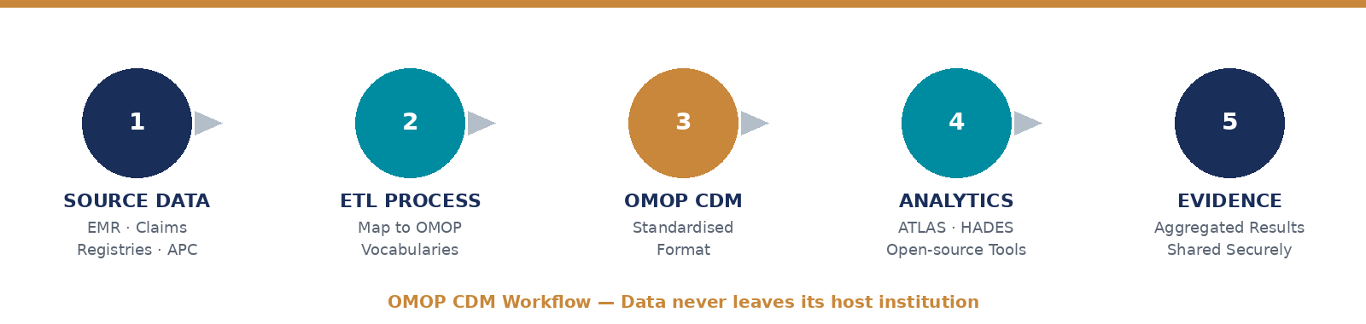
Figure 1: OMOP CDM Workflow — data never leaves its host institution

Traditional Approach
In non-standardised observational research, data processing and analysis scripts must be recreated for each study, often requiring site-specific implementation. This leads to slow, non-transparent workflows that are difficult to reproduce and challenging to scale across Australian institutions.

OHDSI Approach
All participating sites map their local data to the OMOP Common Data Model. Once mapped, data is structured in a shared format and terminology, allowing a single analysis script to run without modification across all sites. Federated research with shared code and local execution makes the process transparent, reproducible, and scalable.

Why the OHDSI Approach Works for Australia
- Large-scale evidence generation – OHDSI enables federated analyses across Australian health databases without sharing patient-level data — supporting robust evidence across states, health systems, and care settings.
- Rapid response to clinical questions – Standardised data and reusable analytical pipelines reduce the time to answer new clinical and regulatory questions — critical for the TGA, PBAC, and other Australian health bodies.
- Scalable and reproducible research – Open-source tools built around a common data model allow studies to be replicated across multiple Australian databases — improving transparency and long-term scientific value.

The Key Building Blocks of OHDSI Australia

Standardised Data
The OMOP CDM harmonises diverse Australian sources such as electronic medical records, administrative claims, and clinical registries into a single, consistent structure. Standardised vocabularies and OMOP tables enable both semantic and syntactic interoperability.

Standardised Analytics
OHDSI provides a comprehensive suite of open-source tools — ATLAS for user-friendly analysis and HADES for advanced R-based workflows — supporting the full observational research lifecycle from ETL to population-level effect estimation.

A National Community
OHDSI Australia is powered by an active national community of researchers, clinicians, and data partners. Join a working group, attend our monthly community call, or connect via the OHDSI Asia-Pacific network.

© 2014–2026 Observational Health Data Sciences and Informatics

Mission & Vision

OHDSI Mission
To improve health by empowering a community to collaboratively generate evidence that promotes better health decisions and better care.

OHDSI Vision
A world in which observational research produces a comprehensive understanding of health and disease.

OHDSI Values
- Innovation – We actively seek and encourage fresh methodological approaches in our work.
- Reproducibility – Accurate, reproducible, and well-calibrated evidence is necessary for health improvement.
- Community – Everyone is welcome to actively participate in OHDSI Australia.
- Collaboration – We work collectively to prioritise and address real-world needs.
- Openness – We strive to make methods, tools, and evidence open and publicly accessible.
- Beneficence – We protect the rights of individuals and organisations within our community.

Why Australia Needs a National Node
Transparent and reproducible research depends on consistent data standardisation, high-quality implementations, and sustained coordination across states and institutions. The national node ensures that these efforts are aligned, efficient, and sustainable.

1. Coordinating Australia’s Diversity
Australia’s health data landscape is highly diverse, with state-based systems, multiple coding conventions — including ICD-10-AM, PBS, and MBS — and varied governance models. The national node helps align efforts, supports coordinated vocabulary maintenance, and ensures Australian data are fit for reuse in multinational studies.

2. Enabling Policy and Regulatory Engagement
OHDSI Australia provides a clear interface between the research community and national stakeholders such as the TGA, PBAC, AIHW, and the Australian Digital Health Agency, helping translate technical standards into practice and informing policy development.

3. Strengthening the Australian OHDSI Community
The national node connects hospitals, universities, registries, and government agencies, supports education and capacity building, and enables collaboration through shared initiatives, studies, and events such as the annual national symposium and monthly community calls.

Supporting Australian Health Data Infrastructure
OHDSI Australia supports the Australian Health Data Strategy by demonstrating the value of the OMOP CDM as a foundation for interoperable, reproducible, and scalable health research — while maintaining the highest standards of patient privacy and data governance.

© 2014–2026 Observational Health Data Sciences and Informatics

Standardising Australia’s Healthcare Data with the OMOP CDM
Source: Australian Research Data Commons (ARDC) — ardc.edu.au

How Can We Make the Most of Australia’s Healthcare Data?
Australia’s healthcare data holds untapped potential. Hospital and administrative healthcare records contain useful information on medical conditions, diagnostic tests, treatments, outcomes and patient demographics. This data can help reveal disease patterns, assess treatment effectiveness, and inform clinical guidelines to improve patient care. However, differences in how healthcare data are collected, recorded and stored across Australia make it difficult to compare and analyse.

What Is the OMOP CDM?
The Observational Medical Outcomes Partnership Common Data Model (OMOP CDM) is the international gold standard for standardising health data into a consistent format. Developed by the OHDSI initiative, the OMOP CDM enables data from different healthcare sites or jurisdictions to be more easily analysed and compared, without compromising security or patient confidentiality.

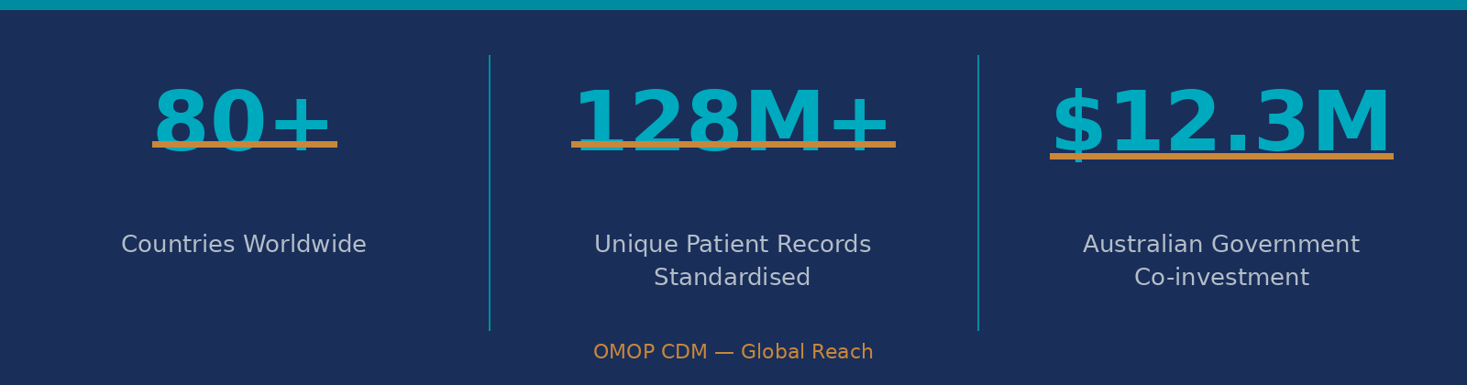
Figure 2: OMOP CDM Global Reach

Why Use the OMOP CDM?

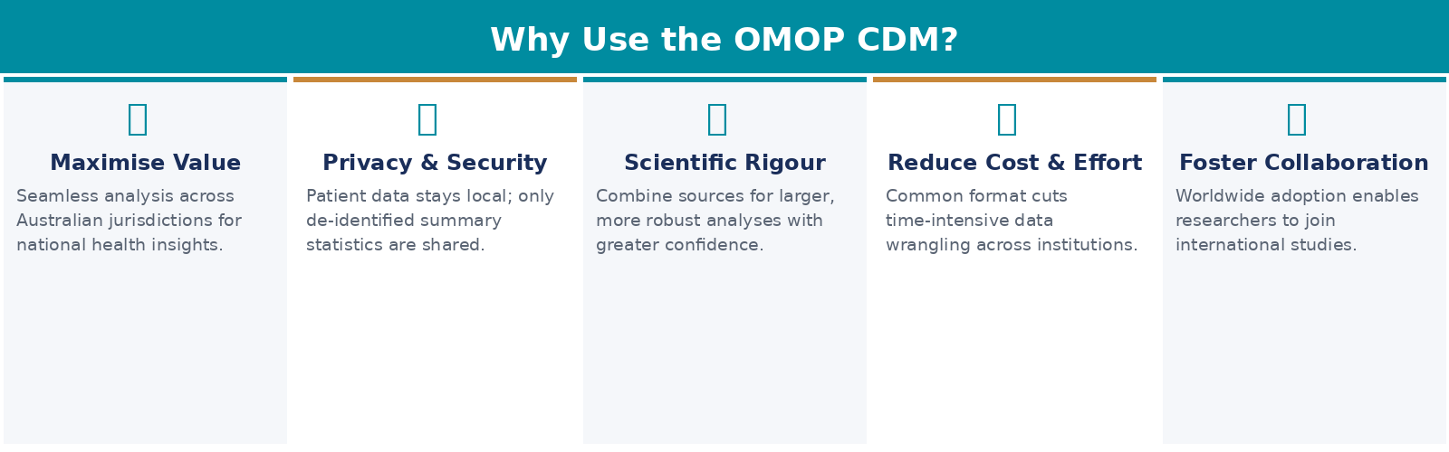
Figure 3: Five Key Benefits of the OMOP CDM

How Does the OMOP CDM Work?
The OMOP CDM transforms disparate data into a common format by using standard vocabularies, terminologies and coding schemes. The model can be implemented and used within existing database infrastructure, without the data ever leaving its host institution. Once in a common format, the database can be used to generate rigorous and reproducible evidence using standardised analytics tools.

The OMOP CDM in Action
Most medications rely on randomised clinical trials to test their safety and efficacy before approval for broader public use. However, clinical trials are often conducted on a small scale, making it difficult to detect rare and severe side effects that may only be visible at the population level.

The OMOP CDM standardises health data so researchers can compare datasets from around Australia and the world to use in large-scale studies, helping identify rare adverse effects and draw more robust conclusions. Researchers have already used the OMOP CDM to investigate the safety and effectiveness of medicines for heart failure, cardiovascular disease and asthma. The tool will also help the healthcare system respond more rapidly to major health threats such as future pandemics.

“When COVID-19 emerged in 2020, Australia’s healthcare data was not harmonised, unlike some other countries such as South Korea. This made it difficult to get an accurate picture of how the virus was spreading across the country and the effectiveness of treatments and vaccines, especially in vulnerable people. Once the AHDEN initiative is implemented, we will be able to identify and respond to future pandemics and major health threats much faster.”
— Professor Nicole Pratt, President of OHDSI Australia, Adelaide University

National Initiatives to Implement the OMOP CDM
The ARDC is partnering with universities, government and health services to implement the OMOP CDM through its People Research Data Commons (People RDC), which is delivering national-scale data infrastructure for health research and translation.

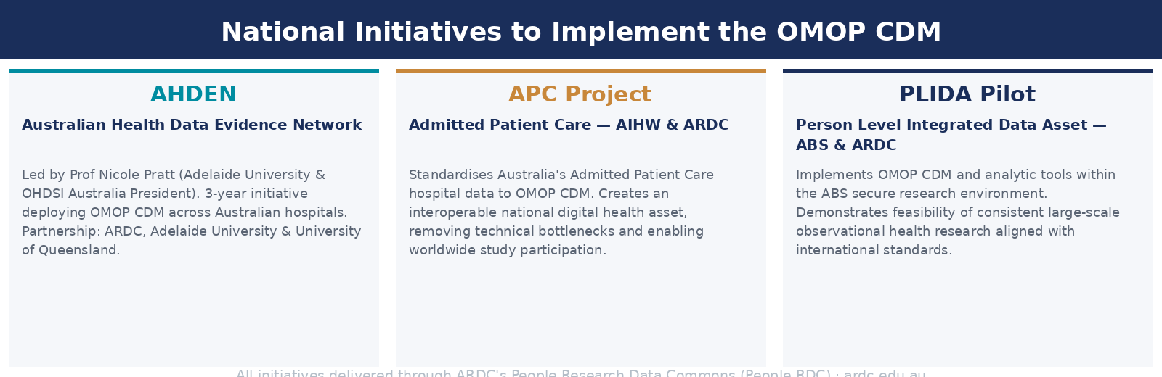
Figure 4: Three national ARDC-supported initiatives implementing the OMOP CDM in Australia

AHDEN — Australian Health Data Evidence Network
The OMOP CDM will be deployed across Australian hospitals by AHDEN through a 3-year national initiative. AHDEN is led by Professor Nicole Pratt (project lead), Adelaide University and President of OHDSI Australia. It is a national partnership between ARDC, Adelaide University and The University of Queensland, with more partners to be announced.

Standardising Australia’s Admitted Patient Care (APC) Hospital Data
The Australian Institute of Health and Welfare is partnering with the ARDC to standardise Australia’s Admitted Patient Care (APC) hospital data to the OMOP CDM. This conversion will establish an interoperable national digital health asset that removes technical bottlenecks, speeds up medical breakthroughs, and enables Australian participation in worldwide health studies.

Enhancing Person Level Integrated Data Asset (PLIDA) for Health Research
A pilot project between the Australian Bureau of Statistics (ABS) and ARDC will implement the OMOP CDM and analytic tools within the ABS secure research environment to demonstrate the feasibility of consistent large-scale observational health research aligned with international standards.

Harmonising Healthcare Standards: How FHIR and OMOP Work Together

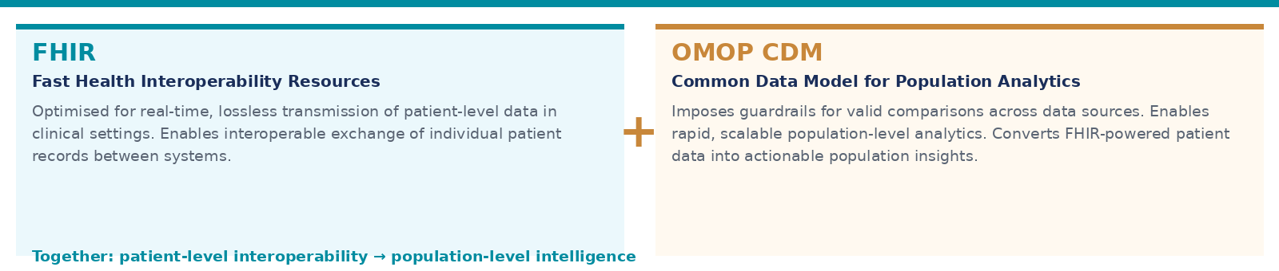
Figure 5: FHIR and OMOP CDM as complementary standards

FHIR (Fast Health Interoperability Resources) and OMOP are complementary standards that leverage each other. FHIR is optimised for the real-time, lossless transmission of patient-level data in clinical settings. To generate rapid and scalable population-level analytics, OMOP CDM provides the additional guardrails needed to make valid comparisons across different data sources. Harnessing FHIR-powered patient-level data into OMOP-powered population analytics is the logical next step to rapidly turn patient data into insights.

Learn More
- AHDEN Project: ardc.edu.au/project/australian-health-data-evidence-network-ahden
- APC OMOP Project: ardc.edu.au/project/converting-admitted-patient-care-data-to-omop-common-data-model
- PLIDA Project: ardc.edu.au/project/enhancing-person-level-integrated-data-asset-plida-for-health-research
- ARDC People Research Data Commons: ardc.edu.au/people-research-data-commons
- ARDC Connect Newsletter: ardc.edu.au/news-and-events/subscribe

The Australian Research Data Commons is enabled by NCRIS.

We acknowledge and celebrate the First Australians on whose traditional lands we live and work, and we pay our respects to their Elders past and present.

© 2014–2026 Observational Health Data Sciences and Informatics

