***LAND REGISTRY SYSTEM HELP***

***DUPLICATE BOOK***

***PAGE MENUE***

Description Page Number

**1). How do you open Land**

**Registry System** ………………………………………………………… **2 - 2**

**2). How does the Land Registry**

**System menu define** ………………………………………………………… **3 - 3**

**3). Master File**

1. **District File** ………………………………………………………… **4 - 5**
2. **Judicial Division File** ………………………………………………………… **6 - 7**
3. **Province File** ………………………………………………………… **8 - 8**
4. **Office File** ………………………………………………………… **9 - 10**
5. **Local Authority File** ………………………………………………………… **11 -12**
6. **Notary File** ………………………………………………………… **13 - 16**
7. **Nature of Deed File** ………………………………………………………… **17 - 18**
8. **Irregularity File** ………………………………………………………… **19 - 19**
9. **Bank file** ………………………………………………………… **20 - 21**
10. **Control File** ………………………………………………………… **22 - 22**

**4).** **Duplicate Book Entry**

i. **B-Edit** recordthe Duplicate Book Entry ………………………………………………………… **23** **- 24**

ii. **New record** add to the Duplicate Book Entry ………………………………………………………… **25 - 26**

**5).** **Duplicate Entry Reports**

1. **E- Report** ………………………………………………………… **27 - 27**
2. **Deed value Report** ………………………………………………………… **28 - 28**
3. **Notaries Certified copy** ………………………………………………………… **29 - 29**
4. **Irregularity report** ………………………………………………………… **30 - 30**
5. **Stamp scheduled Report**

**I. Provincial Council** ………………………………………………………… **31 - 32**

**Ii. Central Government** ………………………………………………………… **33 - 33**

1. **Notary’s Monthly List** ………………………………………………………… **34 - 35**

**6).Tools**

**A. Reindex**  ………………………………………………………… **36 - 36**

**B. System Backup**  ………………………………………………………… **37 - 37**

**C. Restore**  ………………………………………………………… **38 - 39**

**D. Password**

**i. User Maintain**  ………………………………………………………… **40 - 41**

**ii. Access Level** ………………………………………………………… **42 - 43**

**7). Help** ………………………………………………………… **44 – 44**

**8).** **Exit** ………………………………………………………… **44 - 44**

**9).** **Copy Write the Backup CD** ………………………………………………………… **45 – 51**

**10).** Re-Installation of the KC Land ………………………………………………………… **52 - 53**

Registry Setup CD

**( 1 ). How do you enter the Land Registry System ?**

a. Find the short cut icon in the desktop. .( open the computer and auto run the program )

b. Double left mouse click or select and enter the above icon.

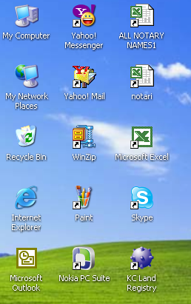

c. After next screen type the Login Name and Pass Word correctly and click the Enter button or ok.

( Your Login Name & Pass Word created by the user maintainer’s option )

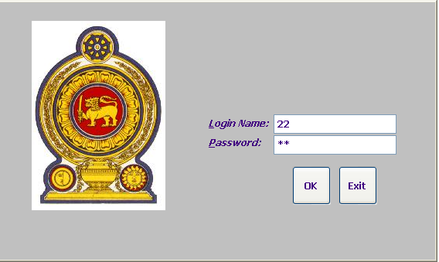

**( 2 ). How does the Land Registry System menu define ?**

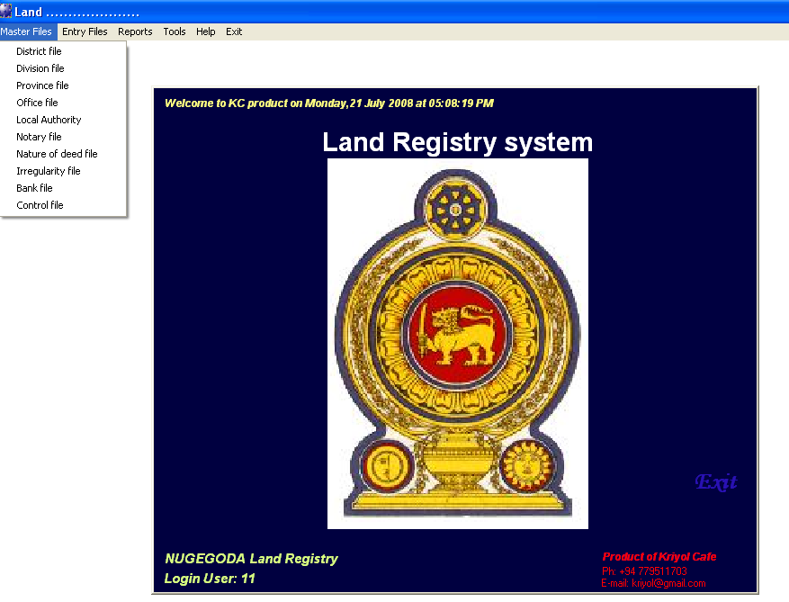

1. Master File You can Exit the programmed click exit button.
2. Entry File
3. Reports
4. Tools
5. Help
6. Exits

**3. Master File**

**( 1 ). How can you open the Master File?**

Please click the mouse point into the Master File Menu and open the file as flows.

1. District File
2. Judicial Division File
3. Province File
4. Office File
5. Local Authority File Master File
6. Notary File
7. Nature of Deed File
8. Irregularity File
9. Bank file
10. Control File

**A. District File**

1. **How do you enter the New record to District Master File?**
2. You must add new record click Add button. ( use enter or mouse click )
3. You must type the District Code
4. You must type the District Name.
5. Save the record to enter.

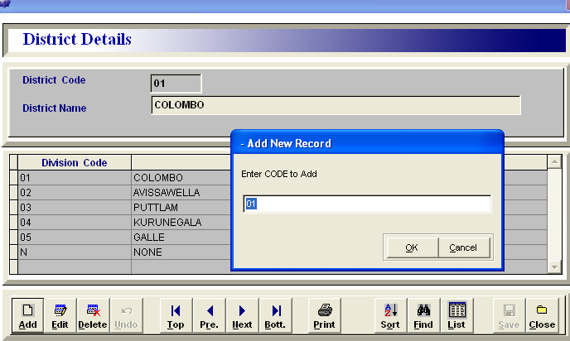

**II. How do you Edit the District Name?**

* 1. Find the edit code. ( use for Find option )
  2. After find the code click the Edit button
  3. You can change the District Name.
  4. Save the record.

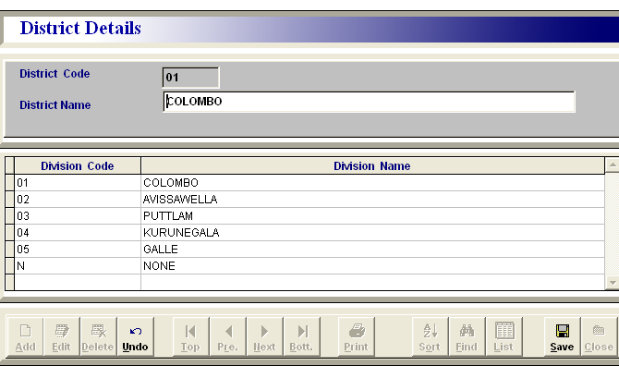

**Note** :

* 1. District Code can not be changed after the save.
  2. District record can not be delete, if use for anywhere.
  3. District master file included in whole Island wide district name.
  4. You can use other option (Undo, Top, Pre, Next, Bott. Print, Sort, List ) to handle the District Database.
  5. You can print the district list use to print button.

**B. Division File**

**I.** **How do you enter the New record to Judicial Division File?**

1. You must add new record click Add button. ( use enter or mouse click )

b. You must type the Judicial Division Code

c. You must type the Judicial DivisionName.

d. Save the record to enter.

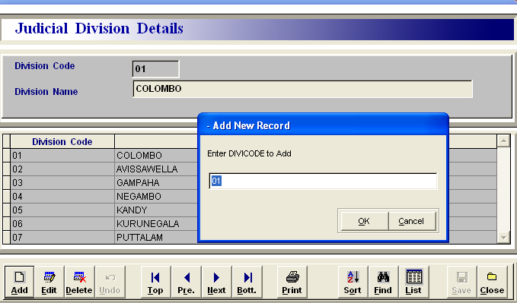

**II. How do you Edit the Judicial Division** **Name?**

1. Find the edit code. ( use for Find option )
2. After find the code click the Edit button.
3. You can change the Division Name.
4. Save the record.

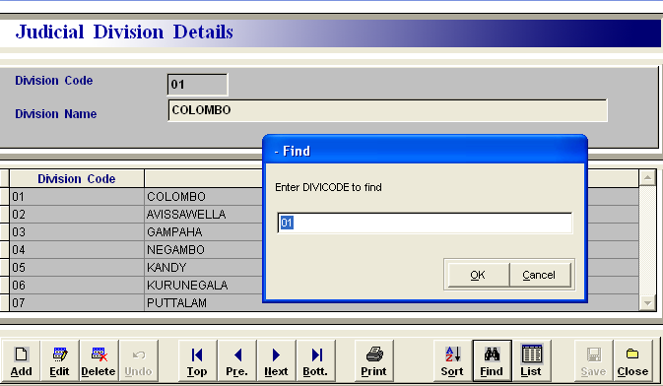

**Notice :**

1. Division Code can not be changed after the save.
2. Division record can not be delete, if use for anywhere.
3. Judicial Division master file included in whole Island wide Judicial Division name.
4. You can use other option (Undo, Top, Pre, Next, Bott. Print, Sort, List ) to handle the Division Database.
5. You can print the Judicial Division list use to print button.

**C. Province File**

**I. How do you create a new Province in the Province Master File?**

a. You must add new record click Add button. ( use enter or mouse click )

b. You must type the Province Code & Enter or Ok. ( use for numeric character )

c. You must type the Province Name.( use for short name of the province )

Ex: 01 – NWPC ( North Western Province )

Province Code 02 _ WPC ( Western Province )

d. Finally Save the record. ( use for Enter button or mouse click )

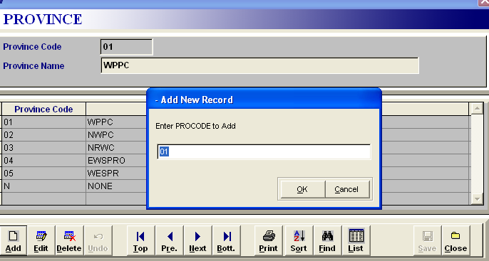

**II. How do you Edit the Province Name?**

a. You can find the Province details to Edit. ( use for Find option )

b. After find the record, next click the Edit button.

c. You can change the Province Name.

d. Finally to Save the record.

**Notice :**

a. Province Code can not be changed or deleted after the save.

b. Province Code Number define in a Numaric field or You can easy to use letter character to quickly

fine the name of Province

c. You can use other option ( Undo, Top, Pre, Next, Bott. Print, Sort, List ) to handle the Nature

of Deed Database.

d. You can print the Nature of Deed Name list use to print button

**D. Office File**

I. **How do you enter the New record to Office File?**

a. You must add new record click Add button. ( use enter or mouse click )

b. You must type the Office Code. ( use for two character in number )

c. You must type the Office Name.

e. You must select division & district into the relevant office. ( use for division & district combo box )

d. Save the record (use to enter.)

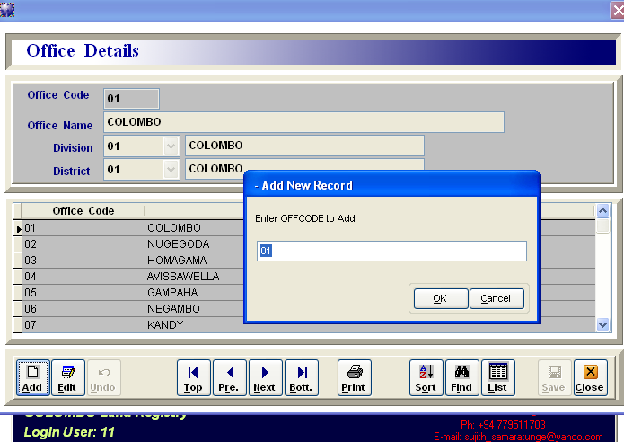

**II. How do you Edit the Office** **Name?**

a. Find the edit code. ( use for Find option )

1. After find the code click the Edit button.
2. You can change the relevant Judicial Division Code and District Code only.
3. Save the record.

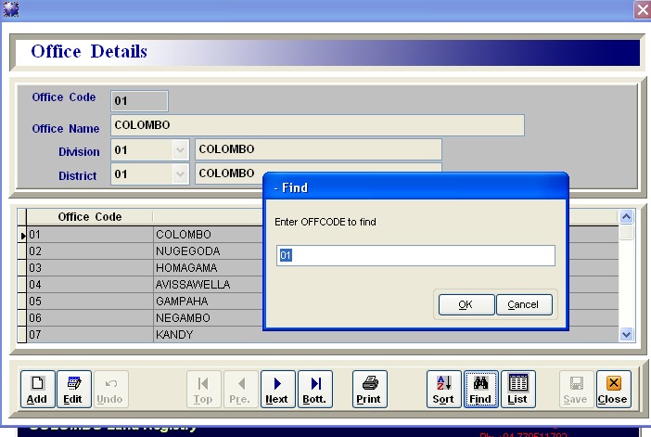

**Notice :**

a. Office Code or Name can not be changed and Edit for Division & District only.

b. Office record can not be delete, if use for anywhere.

c. Office Master File included in whole Island wide Office name.

d. You can use other option ( Undo, Top, Pre, Next, Bott. Print, Sort, List ) to handle the Office

Database.

e. You can print the Office Name list use to print button.

**E. Local Authority File**

**I. How do you create a new Local Authority Name?**

a. You must add new record click Add button. ( use enter or mouse click )

b. You must type the Local Authority Code & Enter/Ok. ( use for letter character )

c. You must type the Local Authority Name.( use for short name )

Ex: CMC – COLOMBO MC ( MC – MOUNCIPL COUNCIAL )

MPS _ MAHARAGAMA PS ( PS – PADESIYA SABA )

WUC _ WATTALA UC ( UC – URABAN COUNCIL )

d. Finally Save the record. ( use for Enter button or mouse click )

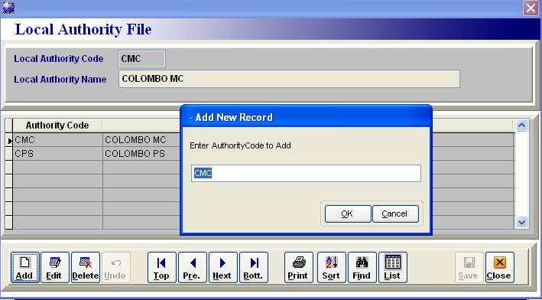

**II. How do you Edit the Local Authority Name?**

a. You can find the Local Authority Name details to Edit. ( use for Find option )

b. After find the record, next click the Edit button.

c. You can change the Local Authority Name.

d. Finally to Save the record.

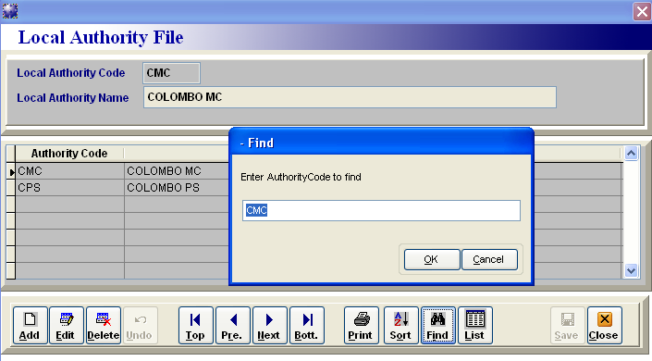

**Notice :**

a. Local Authority Code can not be changed or deleted after the save.

b. Local Authority Code Number define in a letter character field or numeric field.

c. You can easy to use letter character to quickly fine the name of Local Authority.

c. You can use other option ( Undo, Top, Pre, Next, Bott. Print, Sort, List ) to handle the Local

Authority Database.

d. You can print the Local Authority Name list use to print button

**F. Notary File**

**I. How do you create a Notary Code Number?**

1. Notary Code numbers are defines, according to the Notary surname first letter and four numeric number.

( Ex: A0212 - ABETRATHNA A.V.C. )

Two spaces

Notary Code Number Notary surname with initial

Notary Code number series as flows:

A0001 B0001 ……... ……... Z0001

A0002 B0002 ……... ……... Z0002

…….. …….. ……… .…….. .…….

…….. …….. ……... ……… .…….

A9999 B9999 Z9999

AA001 BA001 …….. ………. ZA001

AA002 BA002 ZA002

…….. ……… ………. .…….

…….. ……… ……… .……..

AA999 BA999 ………. ZA999

AB001 BB001 ZB001

……… ……... …….. ……… ……..

……… …….. …….. ……… ……..

……… ……... ……... ……..... ……..

b. You must add new record open the Notary Master File & click Add button. ( use enter or mouse click )

c. Type the New Notary Code number & enter.( Ex: A0004 , According to the code number series)

d. Open the Notary/Judge ect. Combo box **select N for Notary**.

( Do you want to select N- for Notary

Do you want to select J- for Judge/Ds. Division ect.

Do you want to select Z- for other )

.

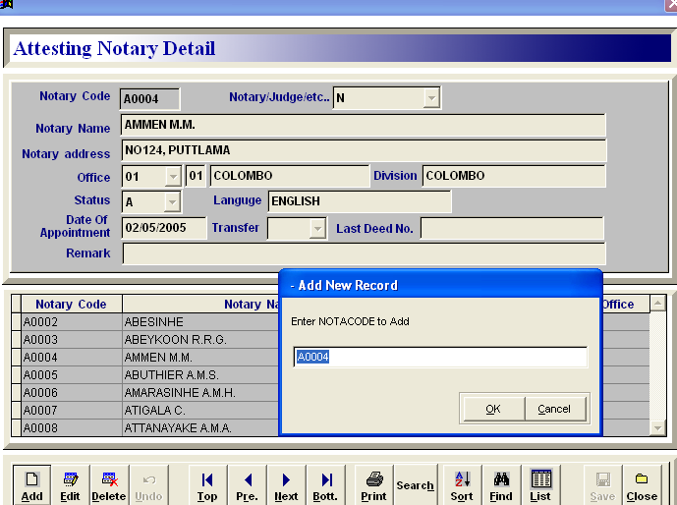

e. You must type the Notary Name & Address like above picture

f. Next select the Land Registry Office for the relevant Notary

g. Next select Status of the Notary – A **normally use for Active** ( A- Active , I – Inactive )

h. Next select the Language type & type the Appointment Date.( **see above picture** )

i. Save the record

**Note : (Notaries are transferred, death and suspend only)**

1. You can change the Status of notary in –> A – Active please flow the procedure

* 1. Next go to Transfer combo box and select the Y – Yes ( Notary is transferred to any other office in the island ) and ( change the office code )

Status of notary in –> I – Inactive, select the transfer combo box

* + 1. No ( Notary was death or suspends ).
  1. Go to the next field. ( **Last deed no** ) and type the notary last deed number & attested date.
  2. You can type the reason of Transferring or any other things in Remark column.

2. Finally Save the record.

**II. How do you Edit the Notary File?**

a. You can find the Notary Code details, select the Find option.

b. After find the code details click the Edit button.

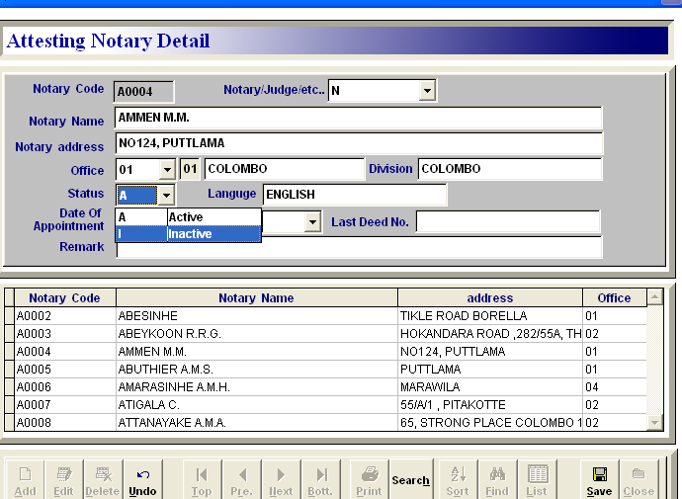

c. You can change the notary name or address as you wish

d. if any changes office, status, language, appointment date and remarks as you wish

e. Finally Save the record.

**Notice :**

a. Notary Code can not be changed or deleted after the save.

b. New Notary Code Number created and issued by the Head office only.

Type the notary name with initial same typing method.

c. Notary Master File will be included in whole Island wide Notary name & Code.

d. Following special Code Numbers are define as follow,

Ex:

Code no Name Address

XX001 - COLOMBO HC HIGH COURT, COL 11

XX002 - COLOMBO DC DISTRICT COURT, COL-02

DS001 - DS COLOMBO DS OFFICE COLOMBO

DS002 - DS WATTALA DS OFFICE WATTALA

…… ………………. …………..

…….. ………………. ………….

RG E. M. GUNASEKARA RGO BATTARAMULLA

RG1 NOT NOTARY -

Z OTHER OTHER

Office code number will be change in the above notary codes specially

e. You can use the search option to find the Notary details.

f. You can use other option ( Undo, Top, Pre, Next, Bott. Print, Search, Sort, List ) to handle the

Notary database.

g. You can print the Notary list use to print button.

**G. Nature of Deed File**

**I. How do you create a new Nature of Deed Name?**

a. You must add new record click Add button. ( use enter or mouse click )

b. You must type the Deed Code & Enter or Ok. ( use for letter character )

c. You must type the Nature of Deed Name & Registration Duty.

e. You must select I or M in the deed type comb box.

( I – Immovable , M – Movable )

d. Save the record. ( use to Enter button or mouse click )

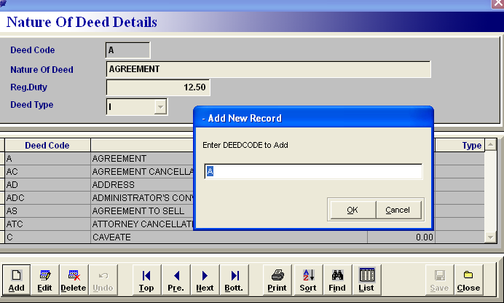

**II. How do you Edit the Nature of Deed Name?**

a. You can find the Nature of Deed details to Edit. ( use for Find option )

b. After find the record, next click the Edit button.

c. You can change the Nature of Deed Name , relevant Reg. Duty & Deed type.

d. Finally to Save the record.

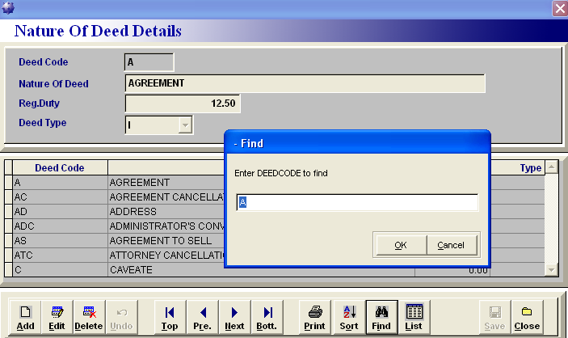

**Notice :**

a. Nature of Deed Code can not be changed or deleted after the save.

b. You can easy to use letter character to quickly fine the name of Nature.

c. You can use other option ( Undo, Top, Pre, Next, Bott. Print, Sort, List ) to handle the Nature

of Deed Database.

d. You can print the Nature of Deed Name list use to print button

**H. Irregularity File**

**I. How do you create a new Irregularity Name?**

a. You must add new record click Add button. ( use enter or mouse click )

b. You must type the Irregularity Code & Enter/Ok. ( use for letter/number character )

c. You must type the Irregularity Name

Ex: 01 – NO STAMP DUTY

02 – NO DEED NO.

d. Finally Save the record. ( use for Enter button or mouse click )

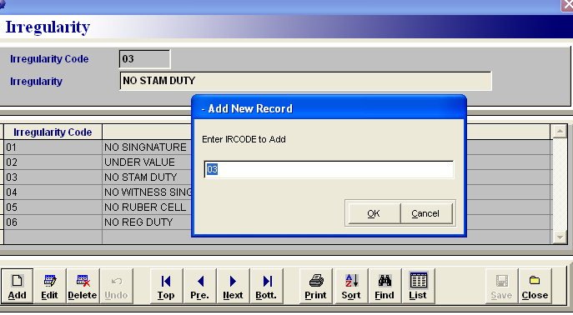

**II. How do you Edit the Irregularity Name?**

a. You can find the Irregularity Name details to Edit. ( use for Find option )

b. After find the record, next click the Edit button.

c. You can change the Irregularity Name.

d. Finally to Save the record

**Notice :**

a. Irregularity Code can not be changed or deleted after the save.

b. Irregularity Code Number define in a letter/number character field.

c. You can easy to use letter character to quickly fine the type of Irregularity.

d. You can use other option ( Undo, Top, Pre, Next, Bott. Print, Sort, List ) to handle the Bank

Database.

e. You can print the Irregularity Name list use to print button

**I. Bank file**

**I. How do you create a New Bank Name?**

a. You must add new record click Add button. ( use enter or mouse click )

b. You must type the Bank Code & Enter/Ok. ( use for letter/number character )

c. You must type the Bank short Name.

Ex: HNB10 - HNB COLOMBO-11

PBW - PB WATTALA ( People’s Bank Wattala )

d. Finally Save the record. ( use for Enter button or mouse click )

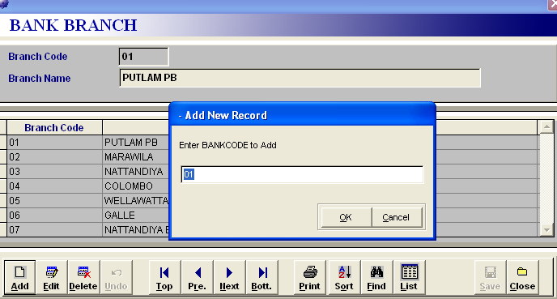

**II. How do you Edit the Bank Name?**

a. You can find the Bank Name details to Edit. ( use for Find option )

b. After find the record, next click the Edit button.

c. You can change the Bank Name.

d. Finally to Save the record

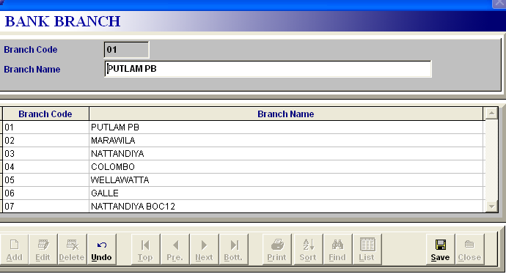

**Notice :**

a. Bank Code can not be changed or deleted after the save.

b. Bank Code Number define in a letter/number character field.

c. You can easy to use letter character to quickly fine the name of Bank

c. You can use other option ( Undo, Top, Pre, Next, Bott. Print, Sort, List ) to handle the Bank

Database.

d. You can print the Bank Name list use to print button

**J. Control File**

**I. Why do you use for Control File?**

1. To monitoring the **Office Name** , **Judicial Division** and **District** of the system.
2. You can not be change the Land registry Name and other details.
3. Starting of the every year of January first day, please change the Year as followers.

**Ex: Year - 08 , 09 , 10 ..ect.**

1. To provide a facility of change the Day Book Number( **General, Ldo**) and Duplicate Number.. etc, according to the every year of January first, then start the number in one( 1 & 0 ).

**Ex: General No - 1 Caveate No - 0**

**LDO No - 1 Address No - 0**

**Duplicate No – 1 Priority Notice No - 0**

**Deed Value - 500,000 or 1,000,000**

1. This Control File is using for **authorized user only**.( main user )
2. We can take a Notary attested deed details ( **Ex: Transfer & Gift only** ) then Deed Value Report defend in including of control file value.
3. Finally to **Update or Quit** the control file.

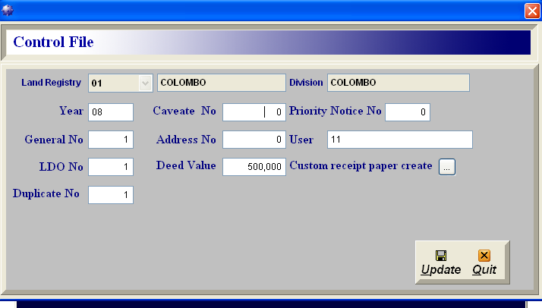

Click this button once after the installation and create the custom receipt paper

**3. Duplicate Book Entry**

**I. How do you Enter B-Edit record to the Duplicate Book Entry?**

1. Firstselect **Duplicate** Book Entry fromtheEntry File.

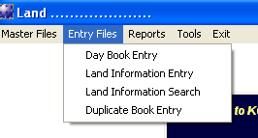

1. You can select the one Bundle of the Deeds according to the Notary.( Ex: one bundle ,one month and one Notary )
2. Next select the Bundle Edit( **B-Edit** ) and Click the bundle search option
3. Type the first Deed No. in search text box according to the selected bundle.
4. Find the above Deed No. in search prevue, and select it

B-Edit search option

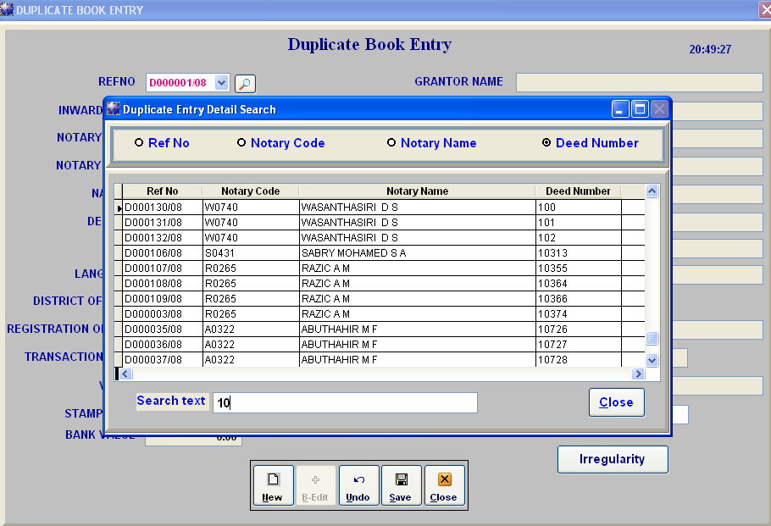

1. Check the duplicate book record according to the bundle of deeds and complete the other blank column details in selected deed after that save the duplicate record.

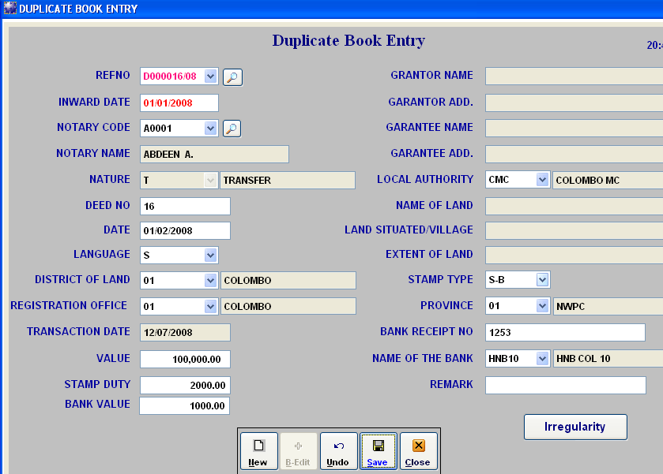

**Note** :

1. Bundle edit use for extra data records filling to the bundle of the Deeds one by one.
2. Transferred from the Day Book records and Edit or complete the records in Duplicate Book.
3. Find some Irregularity type of the deed, click Irregularity file and fill it.

**II. How do you Enter New record add to the Duplicate Book Entry?**

1. Type the **Inward Date** and select the Notary Code and Notary Name( By Type or search option )

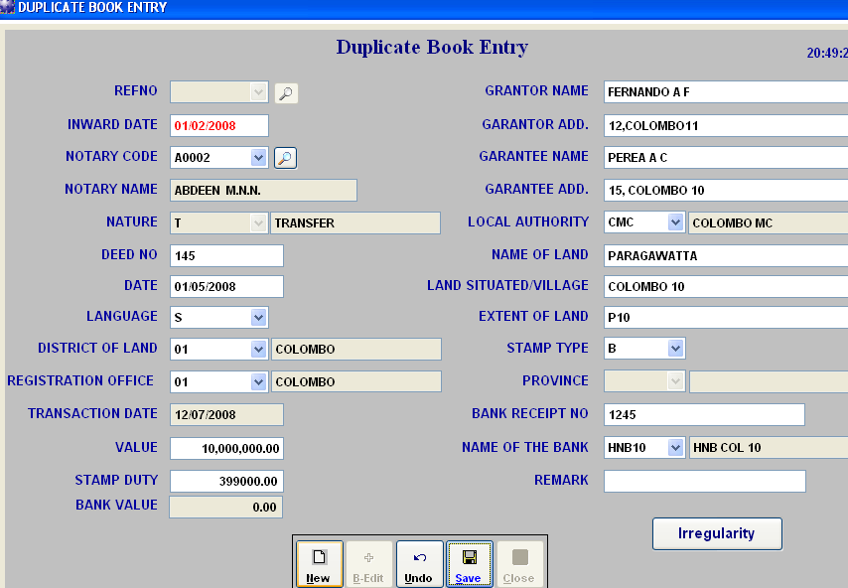

1. Fill the Nature, Deed No, Date, language, Distinct and Registration Office, type the value of deed
2. Other column from Grantor Name… to Extent of land details Enable to the value of **Transfer and Gift** deed from **equal or grater than Control File Deed value.**
3. Locale Authority ,Stamp Type, Province, Bank Receipt No and Name of Bank are **Enable to stamp duty grater than Zero.**
4. Select the **Stamp Type in *S-B ,*** please change the **Stamp Duty and Bank Value records** according to the stamps and Bank Receipt.value
5. You may include the Irregularity type, please select the Irregularity button and add the Irregularity type.

( Complete the Irregularity file enter **F12 or ok** exit the file. and Delete the Irregularity type please use the **Delete** button

1. Save the record

**Note :**

* 1. Select the Nature type in **Nil** - NIL MONTHLY LISTuse for Notary’s monthly summary report in

**NIL LIST**

* 1. Selected the nature type in **NIL (Nil monthly list),** then you have no deed number, language, district

of land, registration office, value and other details.

* 1. Selected the nature type in **LW (Last will)** , then you have type deed number, date and language

But district of land, registration office, value and other details are none.

4. There are registered deed in outstation office please change the district of land, registration office and

other details.

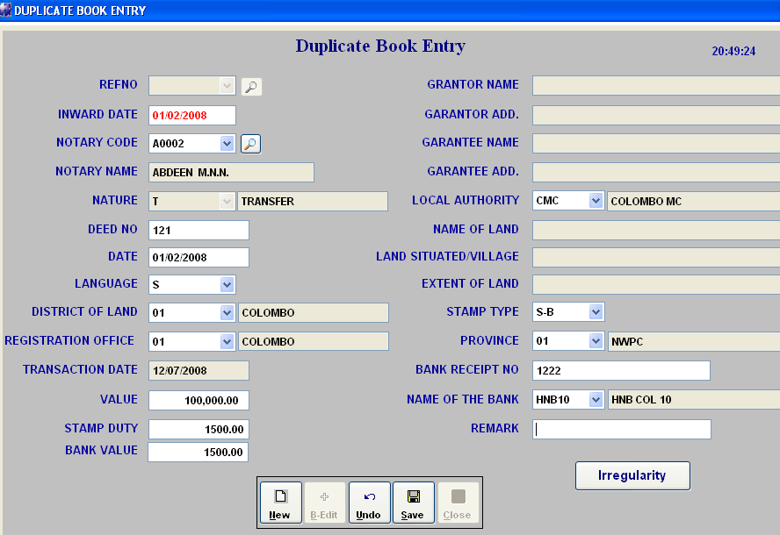

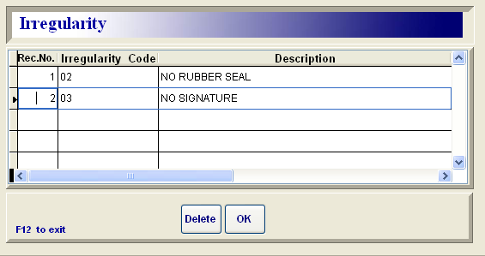

**4. Duplicate Entry Reports**

1. **E- Report**
2. **Deed value Report**
3. **Notaries Certified copy**
4. **Irregularity report**
5. **Stamp scheduled Report**
   * 1. **Provincial Council**
     2. **Central Government**
6. **Notary’s Monthly List**

**A. E - Report**

Reports select the Duplicate Book Entry Report and E -Report Select the

Notary/Judge..( N ) Type the Date range and Print Print preview and

Print the document

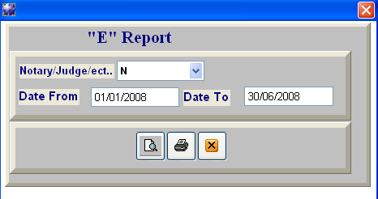

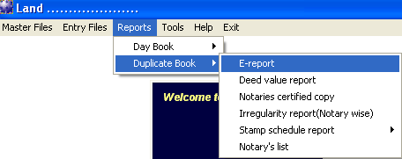

B. **Deed value Report**

Reports select the Duplicate Book and Deed value Report Select the

Date range and Print Print preview Print the document

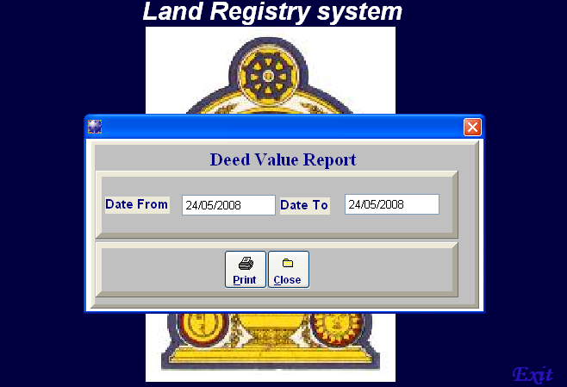

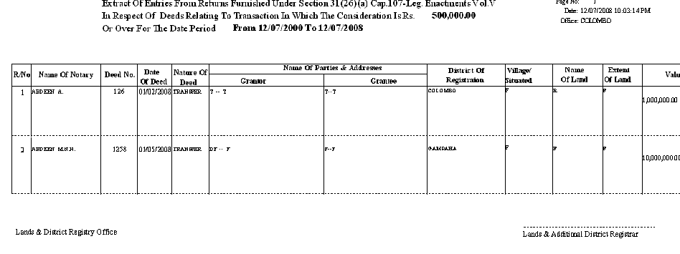

1. **Notaries Certified copies**

Reports select the Duplicate Book and Notaries Certified copies Select the

Outstation Office, Date range and Print Print preview Print the

document

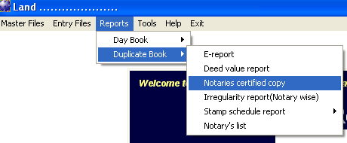

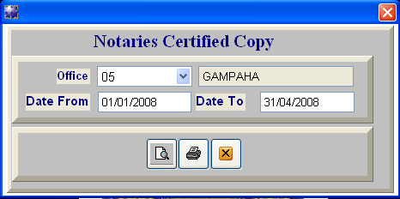

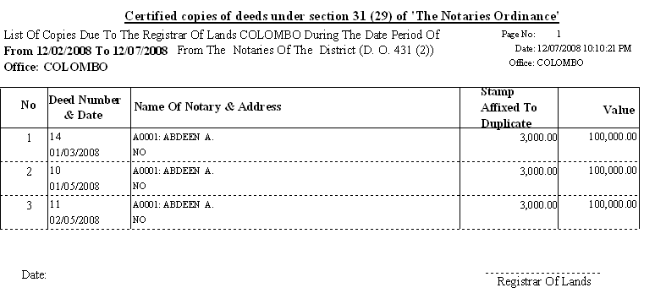

1. **Irregularity report**

Reports select the Duplicate Book and Irregularity Report ( Notary wise )

Select the Notary Code , Date Range and Print Print preview Print the

document

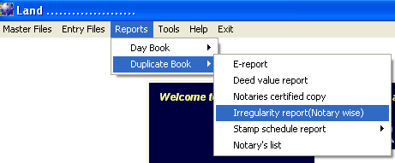

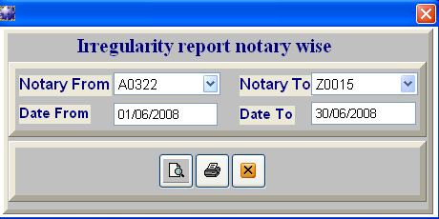

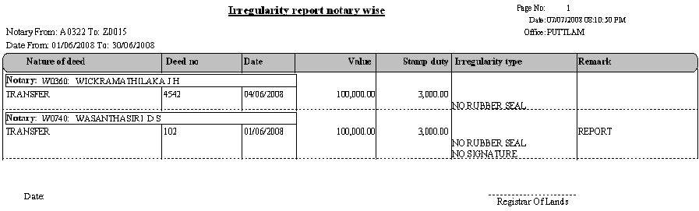

1. **Stamp scheduled Report**
   * 1. **Provincial Council Stamp schedule**

Reports select the Duplicate Book and Stamp Scheduled Report

Select the Provincial Council Stamp schedule Report select the Local authority

Name and Date range and Print Print preview Print the document

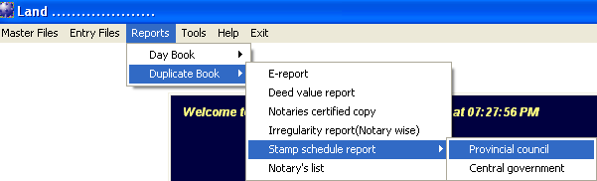

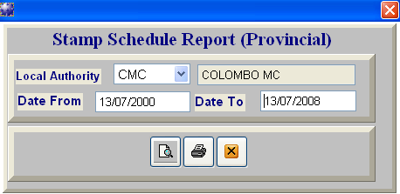

**Print button**

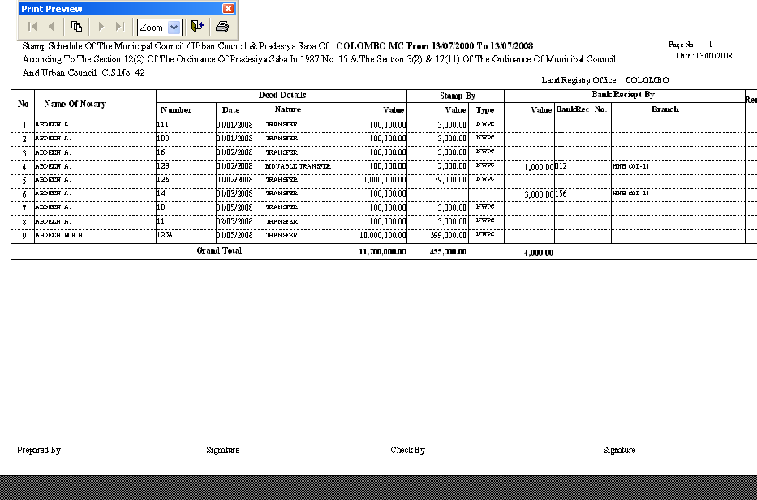

**ii. Central Gov. Stamp schedule**

Reports select the Duplicate Book and Stamp Scheduled Report

Select the Central Gov. Stamp schedule Report select the Local authority

Name ,Date Range and Print Print preview Print the document

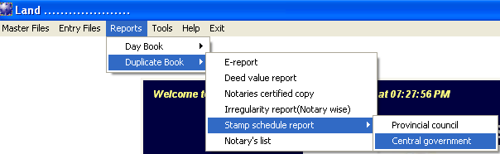

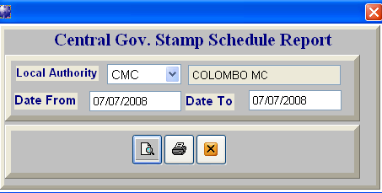

1. **Notary’s List**

Reports select the Duplicate Book and Notary’s List select the Notary Code,

Date Range and Print Print preview Print the document

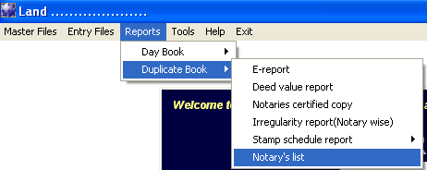

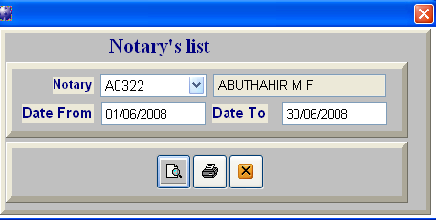

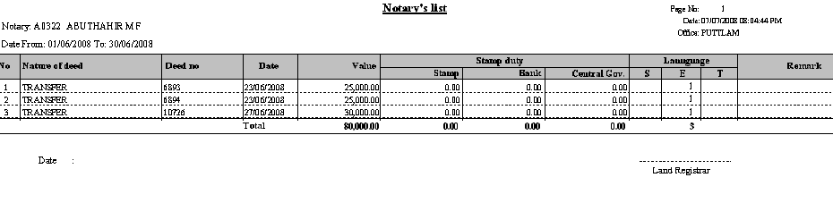

**5. Tools**

* + - 1. **Reindex**
      2. **System Backup**
      3. **Restore**
      4. **Password**

**i. User Maintain**

**ii. Access Level**

**A**. **Reindex**

Tools Select Reindex Reindex the system, click ok Completed

Reindex of Data File and ok

**Note :**

Please after the work of the system, Remember **Backup** the system before the Reindex in main computer

( **system will be open in one computer only** )

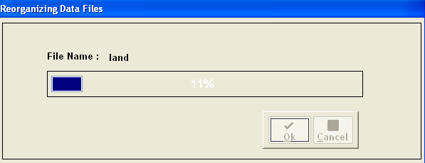

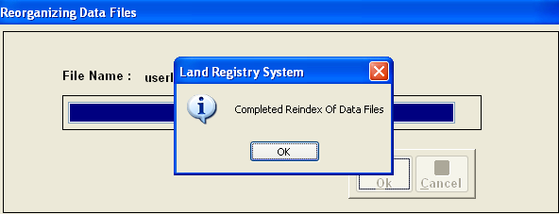

**B. System Backup**

Tools System Backup Select the Hard Dick C Click

Backup option ( After competed the Backup processing cancel the Backup Data File )

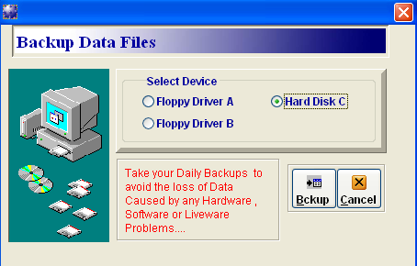

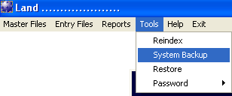

**Note :**

Please end of the day you must create the **Backup zip file** before the **Reindex**

**C. Restore**

Tools Restore Click the Browse button Select the

Backups file In backups folder Click the Restore Button ( System is generated by new

Data Backups )

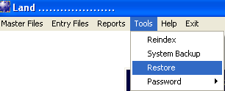

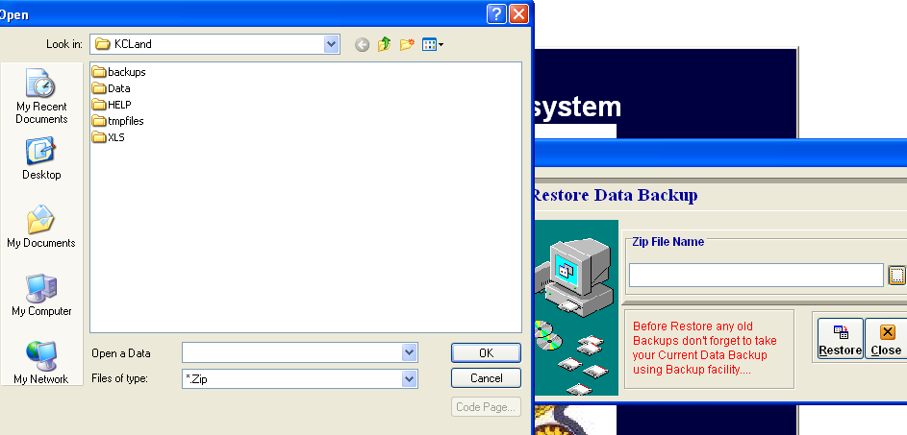

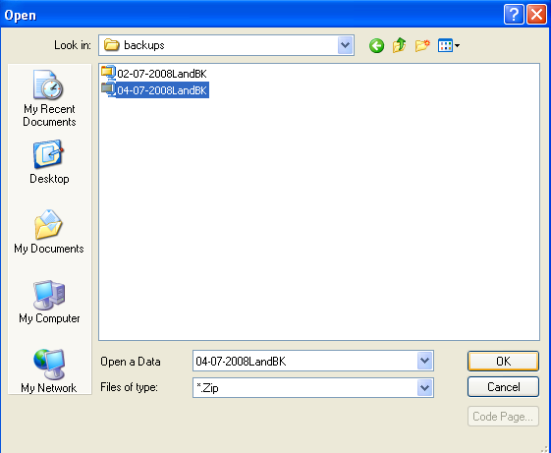

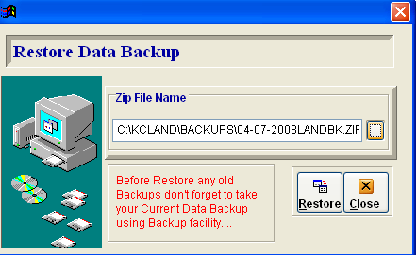

**D. Password**

**I. User Maintain**

Tools Pass Word & User Maintain Type the Login Name,

Full Name, Pass Word, Confirm Pass word and Inherits rights **Yes or No**

Save and Exit the user user updated successfully ( **ok** )

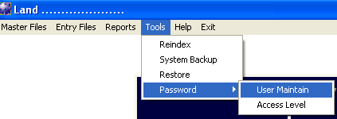

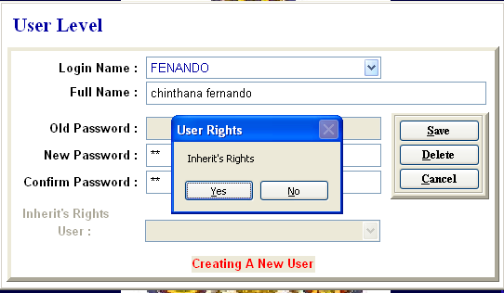

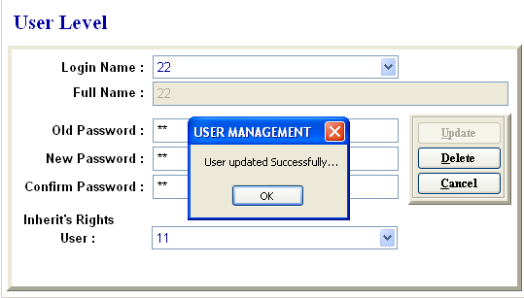

**Note :**

There is created pass word can be deleted by delete button.

**ii. Access Level**

Tools Password and Access Level Select the Login Name for Access

Access Level Update the User Access Select **Yes or No** for same

Access Level

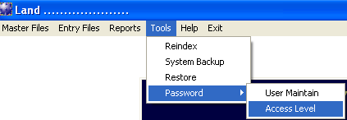

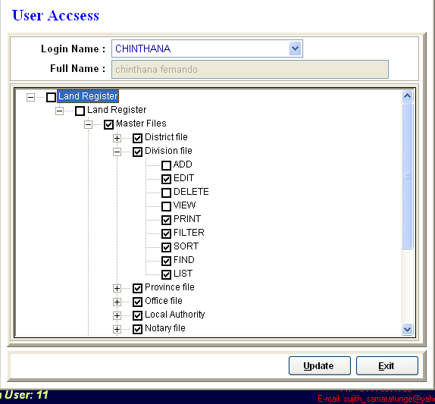

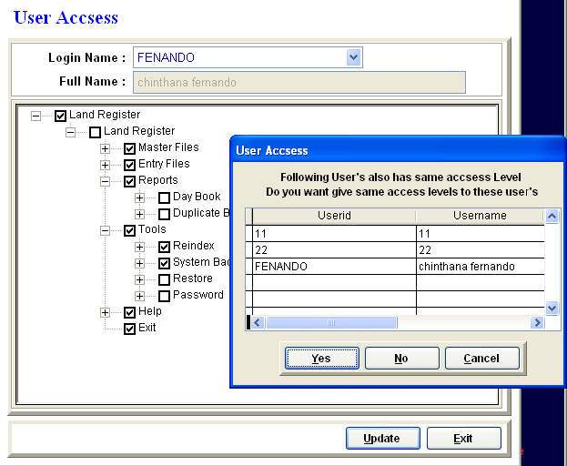

**Yes** change the user access level included other users

**No** change the access for same user only

**6. Help**

Help Select the About Land Registry select the Day Book Help or

Duplicate Book Help **( ? )** Ok, open the Word document and you can find the

Help item as you wish

**Note : You can go to quick view on page use for (Alt + F) goto ,type the page no**

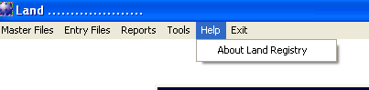

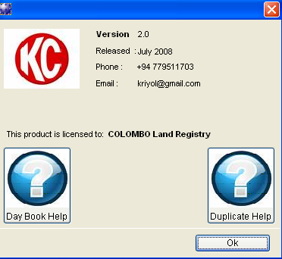

**7. Exit**

**Use for this button exit the Land Registry program**

**8. Copy Write The Backup CD**

* 1. Select the Tools and Backup transferred into Hard Disk C.

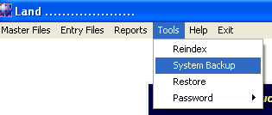

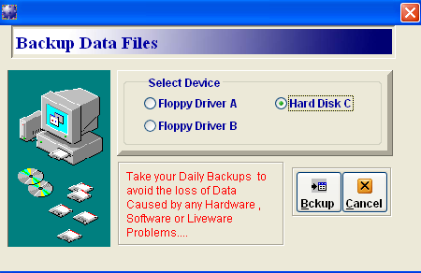

* 1. Select Hard Disk C and find the **KCLand** folder , open it and Backup Zip File selected into Backups folder.
  2. CD input into the Cd-Rom drive

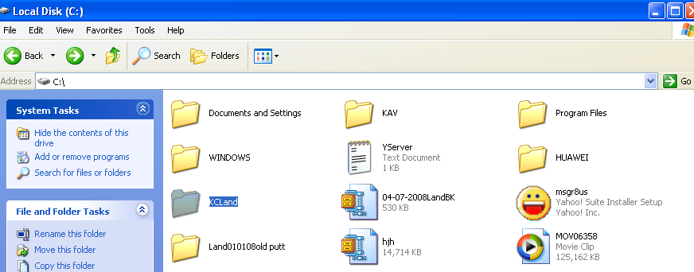

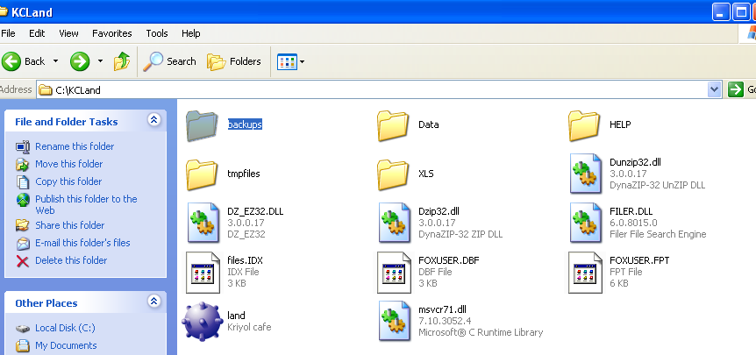

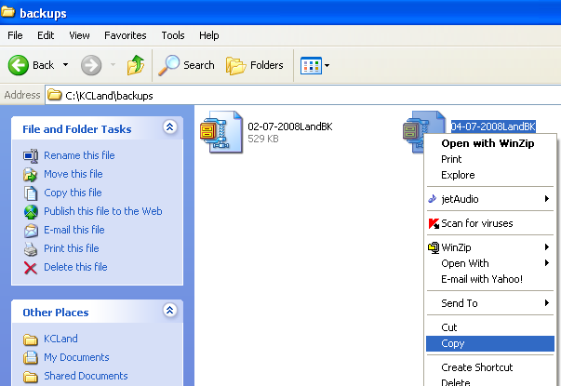

* 1. Backup Zip file copy into the **Hard Disk D or E** and select the Nero copy write software in the Desktop and double click to open.

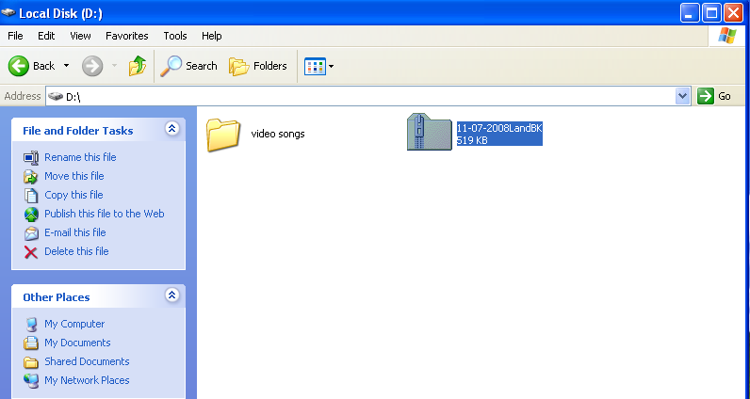

**Copied backup zip file**

**Nero copy writer**

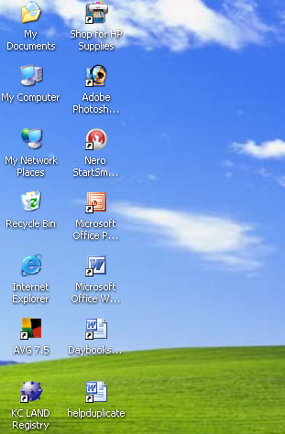

* 1. Select the **make Data CD** option and click **Add** button selected in Backup Zip file
  2. Next click **Add & Finished** button.

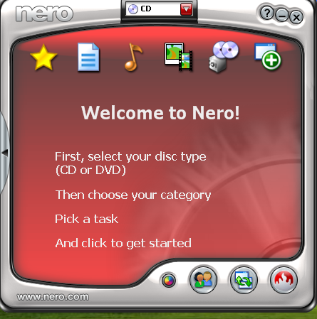

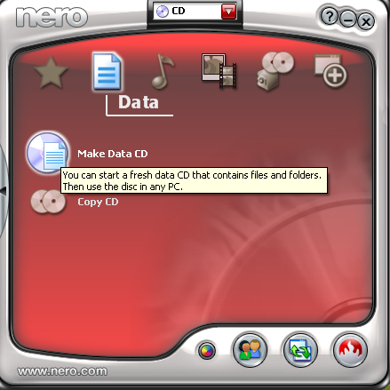

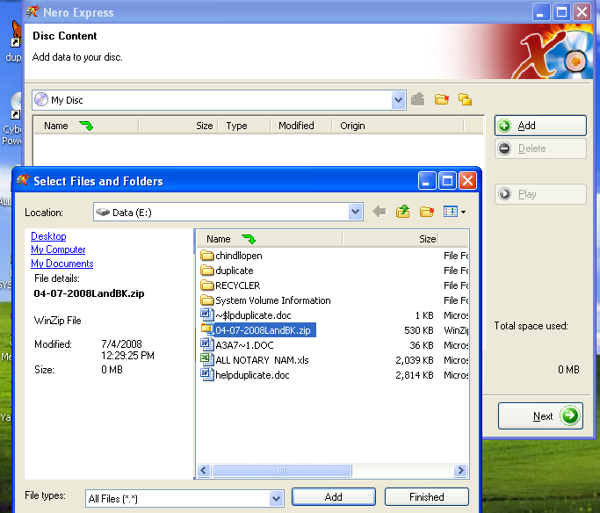

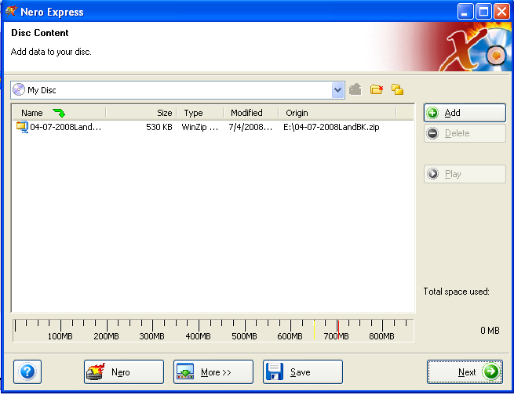

* 1. Click N**ext** button and select the writing speed (16* (2400 kb/s )
  2. Finally Burn the process click **Burn button**
  3. After Burn process completely to Exit the Nero System program

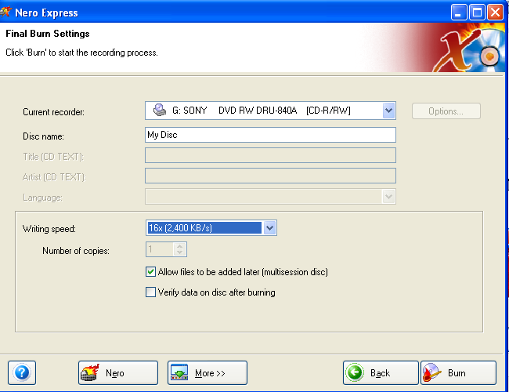

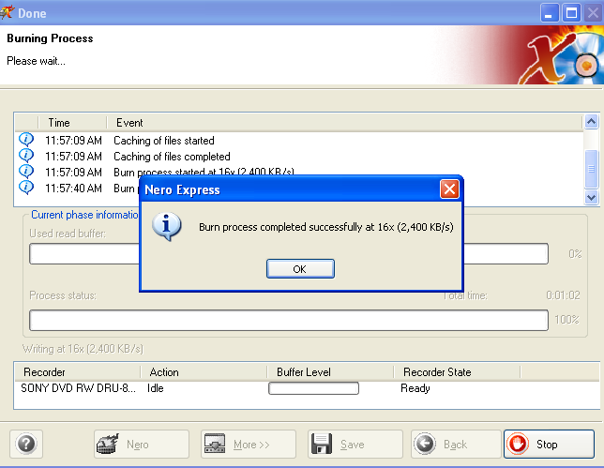

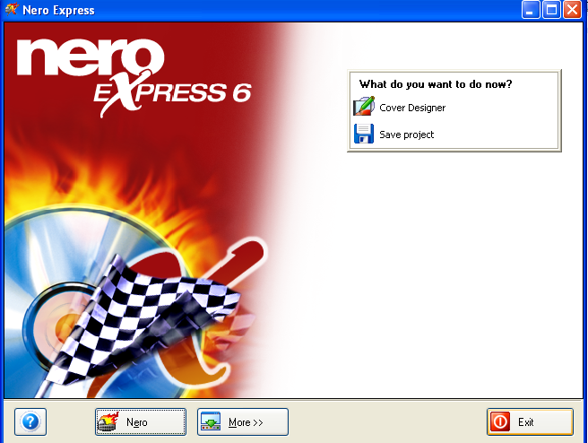

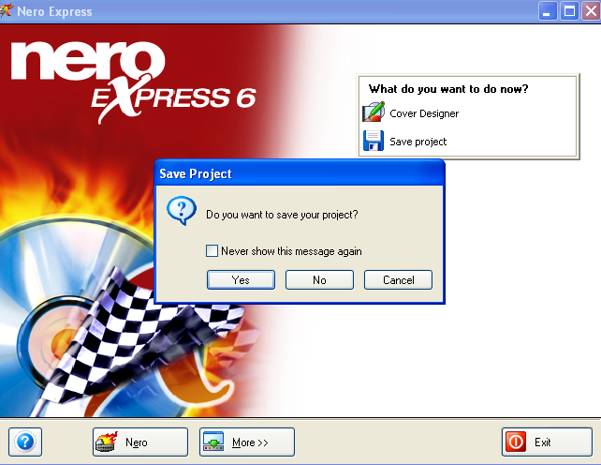

**10. Re-Installation of the KC Land Registry Setup CD**

1. Select the Control Panel and click the Add Remove File, Remove the KC Land Registry Setup File.

( Start Control panel Add. Or Remove Remove the kc land registry setup)

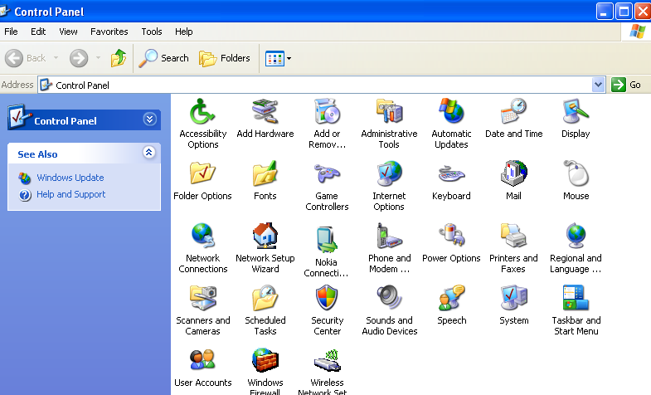

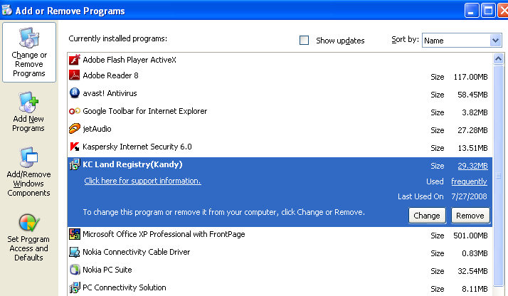

**Remove the KC Land Registry system**

1. Next select the Hard Disk C and Delete the **KCLAND** folder

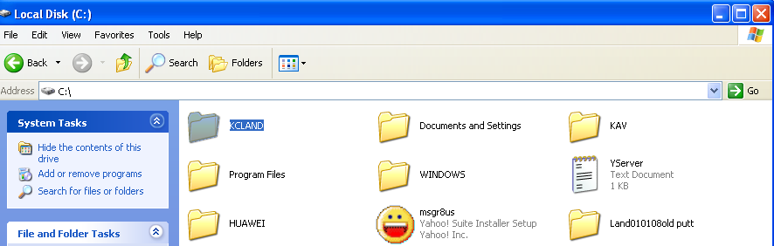

c. Finally new KC Land Registry setup CD Re-Install the Hard disk C.

**….. Finished …..**