**If Else Statement Examples**

Exmaple 1:

If value of a is greater than 10 , print “Big Number” , otherwise print “Small Number”

<html>

  <body>

    <script>

      let a = 12;

      if (a > 10) {

        console.log("Big Number");

      } else {

        console.log("Small Number");

      }

    </script>

  </body>

</html>

Output:

Big Number

Exmaple 2:

If Given name of Movie Is “Spider Man” print “Spider” , “Jurasic Park” then “Dinosaur” , or name is “Bat Man” print “Bat”, otherwise print “Rio”

<html>

  <body>

    <script>

      let movieName = "Jurasic Park";

      if (movieName == "Spider Man") {

        console.log("Spider");

      } else if (movieName == "Jurasic Park") {

        console.log("Dinosaur");

      } else if (movieName == "Bat Man") {

        console.log("Bat");

      } else {

        console.log("Rio");

      }

    </script>

  </body>

</html>

Output:

Dinosaur

Theory:

We can use Comparison and logical operators for condition in If statement

Example :

We use 3 conditions rounded in blue color >

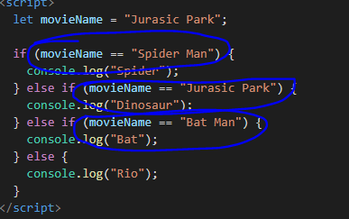

Comparison Operators

Comparison operators are used in logical statements to determine equality or difference between variables or values.

Given that **x = 5**, the table below explains the comparison operators:

|  |  |  |  |
| --- | --- | --- | --- |
| **Operator** | **Description** | **Comparing** | **Returns** |
| == | equal to | x == 8 | false |
| x == 5 | true |
| x == "5" | true |
| != | not equal | x != 8 | true |
| > | greater than | x > 8 | false |
| < | less than | x < 8 | true |
| >= | greater than or equal to | x >= 8 | false |
| <= | less than or equal to | x <= 8 | true |

**Logical Operators:**

**Examples**

Example 1:

<html>

  <body>

    <script>

      let name1 = "Tharindu";

      let name2 = "Wishwi";

      if (name1 == "Kasun" || name2 == "Wishwi") {

        console.log("One or more my friends");

      } else {

        console.log("Not any of my friends");

      }

    </script>

  </body>

</html>

Output:

One or more my friends

Logical operators are used to determine the logic between variables or values.

Given that **x = 6** and **y = 3**, the table below explains the logical operators:

|  |  |  |
| --- | --- | --- |
| **Operator** | **Description** | **Example** |
| && | and | (x < 10 && y > 1) is true |
| || | or | (x == 5 || y == 5) is false |
| ! | not | !(x == y) is true |