Anggota Kelompok :

1. Muhammad Dafa Prima Aji (1301174161)

Mengerjakan no 3

1. Imaduddin Qurrata Ayun (1301174207)

Mengerjakan no 1

1. Muhammad Faiq Ardyanto Putro (1301174401)

Mengerjakan no 1

1. Firhan Maulana Rusli (1301174086)

Mengerjakan no 2

Screenshot Hasil Running No 1 Paralel :

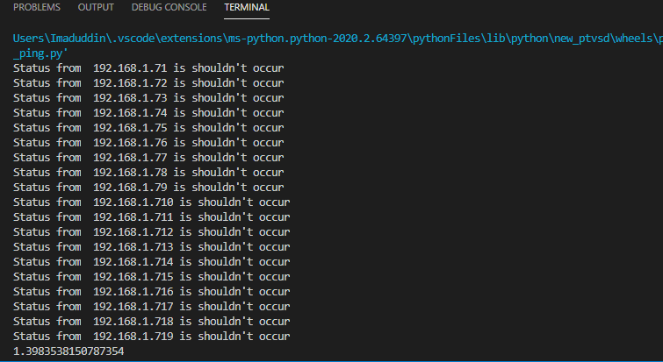

Screenshot Hasil Running No 1 Serial :

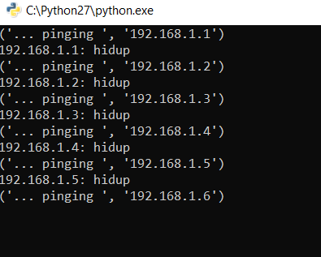

Screenshot Hasil Running no 2 Client:

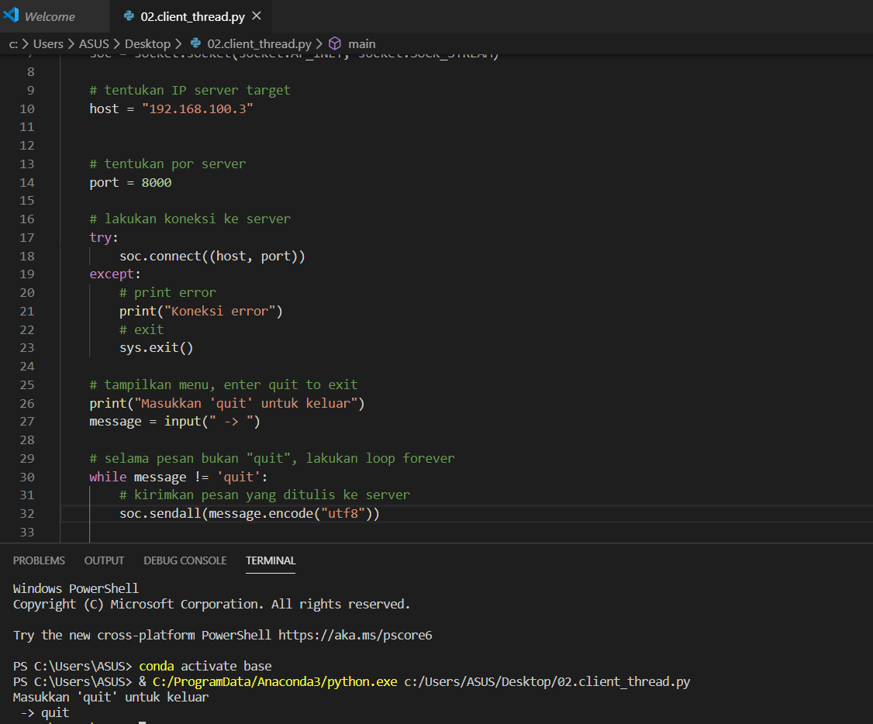

Screenshot Hasil Running no 2 Server:

