PYX TRACKER
Web-based Enterprise Operations Management System

An Information Technology Capstone Project
Presented to the Faculty of Information and Communication Technology
South East Asian Institute of Technology, Inc.
National Highway, Brgy. Crossing Ruber, Tupi, South Cotabato
In Partial Fulfillment of the Requirements for the Degree of
BACHELOR OF SCIENCE IN INFORMATION TECHNOLOGY
CAYUNDA, KLINT RUSSEL R.
DELOS SANTOS, BRENT R.
FIN, NOLI III M.
Adviser: [Name to be confirmed]
September 2026
TABLE OF CONTENTS
CHAPTER I 4
Background of the Study 4
Objectives of the Study 6
General Objective 6
Specific Objectives 7
Scope and Limitation of the Study 8
Scope of the Study 8
Limitation of the Study 9
Significance of the Study 10
IPO Model 12
Definition of Terms 13
CHAPTER II 15
Web-Based Inventory and Production Management for Food SMEs 15
Parcel Processing Barcode Scanning and Shipment Verification 16
Product Costing and Pricing Information Systems 17
Multi-Platform Order Processing and Waybill Management 18
Point of Sale Systems and Integrated Retail Transactions 19
Return-to-Sender Management and Reverse Logistics 21
Automation and Sustainable Development Alignment 22
Synthesis of the Literature and Research Gap 23
CHAPTER III 24
Environment 24
Software Engineering Technology 25
Build 1 Integrated Inventory Management System 26
Build 2 Product Costing and Pricing Calculator 26
Build 3 Multi-Platform Order Processing and Waybill Management 27
Build 4 Parcel Processing and Inventory Synchronization 27
Build 5 Point of Sale System 28
Build 6 Return-to-Sender Management 28
Planning and Conception Initiation Phase 30
Business Model Canvas 30
Gantt Chart 31
Functional Decomposition Diagram 32
Analysis and Design Phase 33
Use Case Diagrams 33
Use Case Matrix 36
Storyboard 39
Database Design 46
Entity Relationship Diagram 47
Data Dictionary 49
Network Design 70
Network Topology 71
Technology Stack Development 72
Software Specification 72
Hardware Specification 73
Program Specification 74
Testing and Evaluation Procedure 74
List of Modules 76
REFERENCES 77

CHAPTER I
INTRODUCTION

Background of the Study
This study presents Pyx Tracker: Web-based Enterprise Operations Management System, a centralized web application developed for Pyx Food Products. It connects inventory and production records with online order preparation, parcel documentation, product costing, retail sales, and Return-to-Sender management. The project provides authorized personnel with a common record of stock and transactions as goods move through production and selling channels. Enterprise operations management in this study refers to these defined functions rather than every administrative or accounting activity of the company.
Pyx Food Products is located at Zone 1, Prk. Vicente Fin, Brgy. Magsaysay, Polomolok, South Cotabato, Philippines. The proposal identifies honey, Paragis Tea, Black Rice Coffee, and Jar Cacao among the covered product lines. The business receives materials, prepares products, maintains finished goods, and serves online and walk-in customers. Honey passes through warehouse, production, and packaging stages; department products require monitoring of raw inputs and finished pouches or jars. Before integration, employees recorded inventory on paper and in disconnected spreadsheets. They manually organized orders from Shopee, the VIP website and Facebook channels, matched waybills to order lists, recorded retail sales, estimated costs, and maintained return records. Information therefore passed between staff responsible for materials, production, customer service, fulfillment, and sales. This description is based on the proposal, which does not provide timed observations or transaction volumes.
The proposal identifies six problems. (1) Manual parcel verification, inventory deduction, and packing-material monitoring increase the risk of stock discrepancies, dispatch delays, and incomplete shipment documentation. (2) Paper records and disconnected spreadsheets permit erasures, inconsistent entries, and counting errors, making physical stock difficult to reconcile with recorded balances. (3) Unstructured production and packaging cost calculations weaken the basis for selling-price decisions. (4) Manually organizing multi-channel orders and matching waybills increases verification work and the possibility of incorrect parcel contents. (5) Manual retail recording delays transactions and their inventory updates. (6) Unstructured return handling makes it difficult to preserve return history and distinguish physically received sellable goods from damaged goods or cancelled orders. These concerns limit the company's ability to trace an item from receipt to sale or return. They are documented problems rather than quantified error rates or measured business losses.
Pyx Tracker addresses these concerns through six connected modules. Integrated Inventory Management records receipts, production stages, finished goods, and stock movements. Product Costing and Pricing maintains product formulas separately from parcel recipes. Multi-Platform Order Processing and Waybill Management connects preparation, validation, stamping, and batch records. Parcel Processing and Inventory Synchronization maintains packing and related stock information, while the current Deliveries station separately captures before-shipment photos. The Point of Sale module records walk-in transactions, receipts, and stock changes. Return-to-Sender Management preserves case and condition records and confirms sellable stock restoration through reviewed barcode stock-in sessions. Role-based access supports the responsibilities of executives, HR personnel, production managers, customer service staff, and cashiers. The expected benefit is a consistent, traceable operational record; actual improvement must be demonstrated through documented tests and business-workflow comparisons.

Objectives of the Study

General Objective
This study aims to develop Pyx Tracker, a web-based enterprise operations management system for Pyx Food Products, to centralize inventory, fulfillment, costing, retail sales, and return records.

Specific Objectives
1. Develop an integrated inventory module that records raw materials, production movements, packaging materials, supplies, and finished-goods balances.
2. Implement a costing module that calculates product costs from configured formulas and maintains separate parcel-packaging cost recipes.
3. Develop a multi-platform order module that prepares order files, matches waybills, and produces stamped documents and finalized order batches.
4. Implement a parcel-processing module that maintains traceable packing records, stock-movement references, and before-shipment photo documentation.
5. Develop a POS module that records retail transactions, produces receipts, and deducts the selected inventory source.
6. Implement an RTS module that preserves return history and confirms sellable stock restoration through reviewed barcode stock-in sessions.
The module-specific tests in Chapter III evaluate these objectives through observable balances, cost calculations, generated documents, transaction records, and confirmed stock changes.

Scope and Limitation of the Study

Scope of the Study
The study covers a role-based web application for the internal operations of Pyx Food Products. Its users include executives, HR personnel, production managers, authorized customer service and operational staff, and POS cashiers. Customers benefit from the resulting processes but are not authenticated users of a public storefront. The six major modules are as follows.
- Integrated Inventory Management System — records raw materials, honey production stages, department finished goods, packaging materials, supplies, and stock movements.
- Product Costing and Pricing Calculator — maintains product formulas, material prices, parcel-packaging recipes, and selling prices under executive access.
- Multi-Platform Order Processing and Waybill Management — prepares supported order files, stamps waybills, generates master Excel files, and finalizes batches.
- Parcel Processing and Inventory Synchronization — maintains packing and parcel records with applicable stock movements and separate shipment-photo documentation.
- Point of Sale System — records walk-in sales, deducts the selected stock source, generates receipts, and preserves sales history.
- Return-to-Sender Management — records return cases, item condition, claim history, and reviewed barcode stock-in of physically received sellable goods.
Authentication, staff and supplier records, permissions, dashboards, settings, and activity records support these six modules. They are shared controls rather than additional independent research objectives. The same module names are used in Chapter III.

Limitation of the Study
The project is limited to the identified company's workflows and configured product catalogs. It is not a multi-tenant commercial service or a public shopping platform. File preparation and waybill processing support implemented formats; universal marketplace compatibility and continuous API synchronization with Shopee, Facebook, or couriers are not claimed.
Users need access to the application server through a working network and compatible browser. Scanning depends on readable codes and suitable hardware or a supported camera environment. Reliable records require correct starting balances, mappings, units, prices, and confirmation of physical movements. A saved photo is documentary evidence and does not establish that the correct items were packed or delivered.
The current Deliveries photo-saving workflow does not deduct product or packing-material stock and does not automatically mark a parcel as shipped. Stock movements occur through their designated inventory, packing, sales, or return operations. An RTS case does not itself increase sellable inventory; this requires a confirmed barcode stock-in session. Configured production settings also affect raw-material deduction, so automatic deduction is not assumed for every stock-in action.
The costing module depends on maintained formulas and prices. It is not a complete general ledger, payroll system, statutory accounting package, or autonomous pricing authority. The reviewed implementation does not substantiate predictive forecasting, a generative AI assistant, or an AI pricing engine. Completed usability scores, performance benchmarks, and quantified business improvement require separate evaluation evidence.

Significance of the Study
For executives, the system provides a basis for reviewing stock, sales, costs, and exceptions through connected records. It retains executive control over prices, permissions, and corrections.
For HR personnel, production managers, warehouse personnel, and customer service staff, role-specific workflows provide a consistent place to record receipts, production, packing, order preparation, shipment evidence, and returns. The expected benefit is less duplicate encoding and clearer responsibility for transactions.
For cashiers and customers, integrated POS records support organized transactions and retrievable receipts. Customers are indirect beneficiaries of consistent fulfillment and return documentation rather than assumed users of the internal application.
For future researchers, the project provides a Philippine food-enterprise case combining manufacturing-related inventory, online fulfillment, retail sales, and reverse flows. Its contribution can be evaluated through transaction traceability and documented implementation limits.

IPO Model
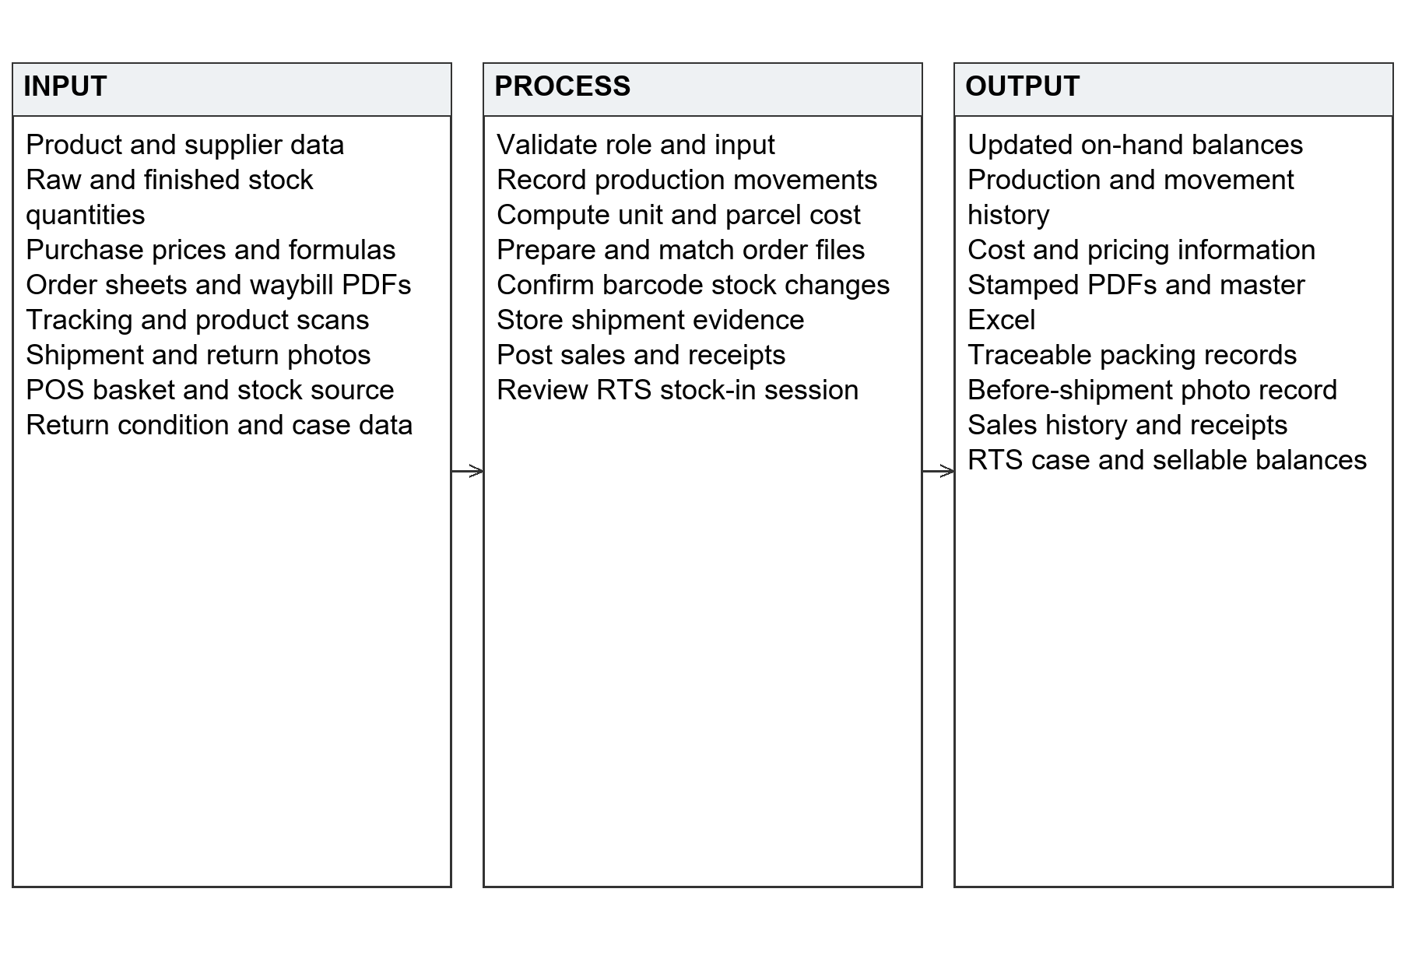
Figure 1.1 Input Process Output Model of Pyx Tracker
Inputs include product and supplier details, receipts, prices, order sheets, waybill PDFs, scans, photos, sales baskets, and return condition. The system validates access and input, records the relevant movement, calculates costs, prepares documents, and confirms reviewed stock changes. Outputs include balances, histories, stamped files, shipment evidence, receipts, and RTS records.
The model separates documentation from inventory posting. A tracking number and photo produce a shipment record through a save action; a scanned sellable return produces an inventory increase after confirmation. Each output is therefore tied to the action that creates it.

Definition of Terms
The following terms are defined operationally for this study.
Barcode — A machine-readable identifier used to locate a product or tracking record. A permanent SKU code identifies a product type; a legacy unique code identifies an individual issued unit.
Before-shipment photo — An image stored against a tracking number. Saving it does not post inventory deductions.
Bill of materials — Configured quantities of raw inputs or packaging associated with a product or production operation.
Black Rice Coffee — The department product referred to as BRC.
Cost of goods sold — The product-cost figure called COGS in the system, maintained separately from outbound parcel-packaging cost.
Customer service representative — A CSR staff member who handles supported order or return operations within assigned permissions.
Finished goods — Configured sellable bottles, pouches, jars, or other units available after confirmed stock-in.
Inventory pool — A defined stock source such as normal finished goods, sellable RTS goods, or damaged returns.
Jar Cacao — The cacao product tracked as finished jars in department inventory.
Parcel recipe — Material quantities used to estimate packaging cost for a matching parcel composition or tier.
Point of Sale — The POS workflow for recording walk-in sales, related stock deductions, and receipts.
Return-to-Sender — The RTS workflow for documenting returned parcels and processing their goods according to condition and confirmed receipt.
Role-based access — Rules allowing users to perform operations appropriate to their assigned role and department.
Stock-keeping unit — A SKU representing a product type or variant rather than one individual item.
VIP — The internal label for website and Facebook orders processed through the VIP preparation workflow.
Waybill — A shipment document containing tracking and delivery information, matched or stamped during order processing.

CHAPTER II
REVIEW OF RELATED LITERATURE AND STUDIES
This chapter develops the six themes in the supplied proposal's literature review. Philippine studies provide local workflow comparisons, while foreign studies contribute evidence on costing, identification, and logistics. The review distinguishes prototypes, reported evaluations, and industry guidance. Its gaps refer to the reviewed works rather than claiming that no comparable system exists elsewhere.

Web-Based Inventory and Production Management for Food SMEs
Lorzano et al. (2022) linked POS transactions with a bill of materials for True North Empanada, addressing delays and discrepancies associated with manual consolidation. Laping et al. (2023) used design thinking and user evaluation to develop inventory-interface alternatives for a Marikina convenience store handling perishable goods. Ercilla et al. (2024) described a proposed inventory and POS system for Bida Mart with stock visibility and replenishment information. Together, these Philippine studies connect inventory problems with both transaction structure and staff needs.
The studies have different emphases: ingredient requirements, user-centered interface selection, and intended retail integration. A proposal should not be treated as proof of a mature deployment. These distinctions suggest that inventory software needs a clear business-process model as well as usable screens.
Goedhart et al. (2023) extend the discussion to omni-channel retail, showing through numerical analysis that jointly considering replenishment and online allocation can improve inventory balance across stores. For Pyx Tracker, the relevant implication is shared stock visibility across channels, rather than adoption of their optimization model.
However, the reviewed studies do not document the same combination of honey production stages, department goods, packaging and supplies, packing, POS, and confirmed RTS stock-in. Pyx Tracker addresses this integration requirement while retaining physical counts and user confirmation as essential controls.

Parcel Processing Barcode Scanning and Shipment Verification
Chocholáč et al. (2022) compared RFID and barcode technologies in shipment consolidation through experiments and simulation. Their study concerns relative identification performance, not a general measured barcode-versus-manual improvement. Kamnardsiri et al. (2022) introduced barcode-detection datasets, including ParcelBar, and compared deep convolutional approaches. GS1 US (2026) discusses modern logistics data capture and two-dimensional identification.
These sources distinguish code detection, identifier interpretation, and the business action associated with a scan. A scan may locate a record without proving the contents or condition of a parcel. The local Bida Mart proposal identifies barcode integration as a future enhancement, not an established capability (Ercilla et al., 2024).
Pyx Tracker therefore treats scanning as an input mechanism supported by validation and confirmation. Tracking lookup supports documentary evidence; product scans support designated stock operations. Before-shipment photos provide a separate record for later return handling. The current Deliveries station preserves this distinction by saving photos without deducting stock.
However, the reviewed literature does not establish an evaluated Pyx-specific combination of packing records, product movements, material accountability, and shipment photos. The capstone must test these connections instead of transferring performance claims from RFID experiments or barcode-detection models.

Product Costing and Pricing Information Systems
Munifah et al. (2026) developed a web-based cost-of-goods-manufactured system for an Indonesian snack-food MSME using variable costing. Lorzano et al. (2022) connect material requirements with food-retail sales, while Divina et al. (2025) combine transactions, inventory, and analytics for Pastil sa Tabi. The latter Philippine studies contribute related evidence on input and transaction integration; they are not equivalent parcel-costing systems.
Costing depends on both the calculation and its inputs. Quantity, purchase price, unit, and conversion yield must be interpreted consistently. A price per roll cannot represent the cost of one cut piece without a defined yield. Manufacturing cost and outbound parcel packaging also serve different purposes, so separate formulas make the calculation easier to review.
Pyx Tracker applies this separation through product formulas and parcel recipes. Executives maintain the values and selling prices. The resulting information supports a traceable decision but does not guarantee a commercially optimal price or profit. Accuracy remains conditional on complete and correct inputs.
However, the reviewed works do not document Pyx's exact connection among formulas, material yields, parcel tiers, and retail prices. The project addresses that integration requirement and checks calculations against known examples rather than treating automation itself as proof of accuracy.

Multi-Platform Order Processing and Waybill Management
Goedhart et al. (2023) show that online fulfillment and inventory decisions interact across time and locations. Nanayakkara et al. (2022) address e-commerce returns through clustering, circular-network design, and optimization. Divina et al. (2025) illustrate transaction and inventory integration in a Philippine food enterprise. Although their settings differ, these works support examining how information remains connected through forward and reverse flows.
The Pyx proposal describes a file-oriented problem: staff organize supported channel orders and match them to waybills. This differs from selecting a fulfillment store or designing a regional returns network. The appropriate response is a controlled preparation workflow that permits review of names, items, variants, and tracking identifiers before parcel records are finalized.
The preparation tools and stamper perform distinct operations. VIP or SPX preparation produces an intermediate file; the PDF and Excel stamper is a separate step. Explicit stages help staff distinguish prepared input from generated output and finalized records. Duplicate-tracking validation also helps identify conflicting records before they are appended.
However, the reviewed studies do not document the same VIP and SPX preparation, PDF matching, master-file generation, and batch-finalization sequence. The project evaluates this organization-specific workflow using representative source files and expected output records.

Point of Sale Systems and Integrated Retail Transactions
Ercilla et al. (2024) present stock visibility and reporting as benefits intended by an integrated POS proposal. Lorzano et al. (2022) connect retail sales with ingredient inventory. Divina et al. (2025) report user and technical evaluation of a POS and inventory system for Pastil sa Tabi, including favorable assessments and remaining performance and reliability concerns. This local evidence supports integration while showing that evaluation must extend beyond the presence of a checkout screen.
For Pyx Tracker, a sale must maintain consistency among items, quantities, prices, stock source, receipt, and ending balance. An RTS item must be distinguished from normal stock. Authentication and approval rules also affect a cashier's permitted actions.
Checkout is therefore assessed as a coordinated transaction. A test compares initial stock, purchased quantity, receipt total, and ending stock. Repeated or interrupted requests are examined for duplicate effects. These are evaluation requirements for this project rather than results already demonstrated by the proposal.
However, the reviewed works do not demonstrate the full Pyx combination of PIN access, department catalogs, selected normal or RTS stock, and wider production and fulfillment records. This capstone evaluates that combination within an operations platform.

Return-to-Sender Management and Reverse Logistics
Nanayakkara et al. (2022) develop a circular returns framework validated in an electrical and electronic goods case. Bhatti and Bauirzhanovna (2023), using interviews with five experts, discuss intelligent inventory systems in Saudi manufacturing reverse logistics. Chocholáč et al. (2022) contribute complementary identification research at shipment-consolidation points. These foreign studies support structured return processes while differing from the food-enterprise setting.
A return record is not the same as usable stock. A case can contain photos, claims, and reusable or damaged item lines, while sellable inventory should represent goods physically received and accepted into the pool. A cancellation, expected return, and received sellable return are different events.
Pyx Tracker separates case recording from a reviewed barcode stock-in session. Scans build a draft; discarding the draft leaves stock unchanged; confirmation posts reviewed quantities. Damaged goods remain distinct. This establishes a testable requirement: entering a case must not itself create sellable inventory.
However, the reviewed sources do not provide a Philippine implementation study of this exact case-to-confirmed-stock process connected with Pyx's sales and packing workflows. That local evidence must come from the project's recorded return scenarios and inventory checks.

Automation and Sustainable Development Alignment
The proposal aligns the project with SDGs 8, 9, and 12. The United Nations identifies productivity and technological upgrading under Goal 8, industrial innovation under Goal 9, and resource efficiency and waste reduction under Goal 12 (United Nations Department of Economic and Social Affairs [UN DESA], n.d.-a, n.d.-b, n.d.-c). The project's intended contribution is operational: less repeated encoding, connected records, and greater visibility of materials and returns. It does not claim measured achievement of these targets.
AI methods in the barcode and intelligent-inventory literature do not establish that Pyx Tracker implements those methods. The supplied proposal and reviewed application support document processing, scanning, and configured business rules. This manuscript makes no claim of a trained forecasting model, autonomous decision engine, or generative AI feature.
However, an SDG alignment statement cannot replace evidence of reduced waste or improved productivity. Later impact claims should identify the measure, period, and business comparison used.

Synthesis of the Literature and Research Gap
The reviewed works share a concern with connections among material requirements, sales, inventory, orders, identification, and returns. Philippine studies offer local comparisons, while foreign logistics and costing studies explain additional dependencies. Their results remain specific to their settings and do not establish Pyx Tracker's effectiveness in advance.
The gap addressed here is the need for a coherent Pyx Food Products workflow connecting production-aware inventory, separate product and parcel costing, file-based orders, traceable shipment documentation, retail sales, and confirmed RTS stock-in. The contribution is integration and evaluation under the company's transaction and role rules, rather than a claim that every individual feature is novel.
Therefore, this study addresses these limitations by developing Pyx Tracker: Web-based Enterprise Operations Management System with six connected modules and a shared operational record. Chapter III explains the methodology, interactions, data structures, and verification procedure.

CHAPTER III
METHODOLOGY
This chapter describes the development approach, operating environment, functional design, data structure, and verification method for Pyx Tracker. It follows the supplied outline's environment, engineering technology, incremental builds, planning artifacts, analysis and design, database documentation, network design, specifications, and modules. Deployment at Pyx Food Products is acknowledged from the project team's account; dates, installed hardware, respondent counts, and measured results require supporting records.

Environment
The study is situated at Pyx Food Products, Zone 1, Prk. Vicente Fin, Brgy. Magsaysay, Polomolok, South Cotabato, Philippines. Its setting includes material receiving, production, online orders, packing, shipment documentation, retail sales, and return handling. Executives, HR personnel, production managers, customer service staff, and authorized warehouse and sales personnel participate in these workflows.
The proposal supplies the business scope. Reviewed project files and the local database schema supply implementation evidence for this chapter. These do not establish that every local change is installed identically on the company's server. Identifying the release used during evaluation is therefore part of deployment verification.

Software Engineering Technology
The study uses the Agile Software Development Model identified in the proposal. Agile principles emphasize working software, collaboration, responsiveness to requirements, and regular reflection (Beck et al., 2001). The methodology organizes work into six increments, each covering design and development, testing, and implementation or refinement. Shared authentication and data definitions support every increment.
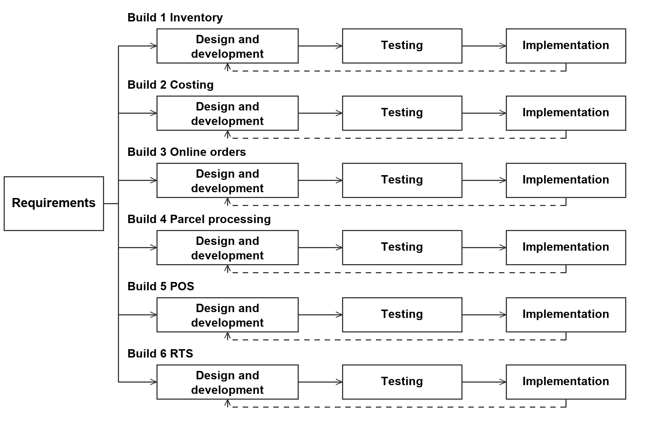
Figure 3.1 Incremental Agile Software Development Model
The diagram follows the sample's requirements-to-build structure, expanded to the six modules. Return arrows indicate feedback and revision. This sequence organizes the methodology and does not represent verified historical dates.

Build 1 Integrated Inventory Management System
Design and development define material categories, suppliers, products, measurement units, honey stage movements, and department finished goods. Separate stock structures preserve normal and returned sellable balances. Role rules determine who records receipts, performs production actions, and approves corrections.
Testing compares initial balances, recorded movements, and expected ending balances. Scenarios cover honey stages, department stock-in, configured raw deduction, repeated scans, and cancellation before confirmation. Raw kilograms must not be combined directly with finished pouches or bottles. Implementation review demonstrates receipt-to-finished-stock traceability and records the deduction settings used during evaluation.

Build 2 Product Costing and Pricing Calculator
Design and development establish formulas, material prices, yield conversions, custom costs, and parcel recipes. Manufacturing cost remains separate from fulfillment packaging. Executive permissions govern costing and selling-price changes.
Testing uses known inputs to verify line calculations and totals, including a roll cost converted to a usable-piece cost, a custom labor line, and a parcel matching one tier. It also checks unauthorized access and missing or inactive recipes. Implementation review records formula inputs and outputs without claiming that cost computation guarantees profit.

Build 3 Multi-Platform Order Processing and Waybill Management
Design and development organize supported VIP and SPX inputs into a common preparation workflow. Users review names, items, and variants, then operate the separate PDF and Excel stamper. Finalized batches provide master-file and parcel records.
Testing uses representative spreadsheets and PDFs to check matching, preserved descriptions, readable output, duplicate-tracking feedback, and finalization. Exceptions include missing columns, unmatched records, and repeated requests. Implementation review follows one batch from source files to final records and distinguishes preparation from stamping and finalization.

Build 4 Parcel Processing and Inventory Synchronization
Design and development connect packing activity and stock movements with product and parcel records. The current Deliveries station is documentary: staff scan or type a tracking number, capture or upload a photo, and save it for later lookup. Saving the photo is separate from stock deduction.
Testing checks the designated packing-confirmation workflow and its stock source. Photo scenarios cover tracking numbers with and without parcel records, duplicates, and later RTS lookup. Saving a photo alone must leave product and packing-material balances unchanged. Implementation review distinguishes packing, shipment-status actions, and documentary saves.

Build 5 Point of Sale System
Design and development provide cashier PIN access, item selection or scanning, normal or RTS stock selection, checkout, receipts, and history. Receipt items, prices, totals, and consumed inventory remain connected. Discount and receivable operations follow their configured permissions.
Testing covers normal-stock sales, RTS sales, totals, insufficient stock, unauthorized discounts, and repeated checkout requests. Each test records initial stock and the expected deduction. Implementation review demonstrates a complete sale and retrieves its receipt and history.

Build 6 Return-to-Sender Management
Design and development separate case documentation from sellable stock restoration. Staff locate the parcel, record condition and evidence, then scan accepted sellable goods into an owned draft session. Confirmation applies the reviewed stock-in; damaged goods remain outside the sellable balance.
Testing checks that case saving does not credit sellable stock, cancellation leaves balances unchanged, and confirmation posts the expected quantity once. Further scenarios cover invalid codes, repeated scans, mixed products, and later RTS sales. Implementation review traces a return from the case to confirmed stock while preserving its original history.

Planning and Conception Initiation Phase

Business Model Canvas
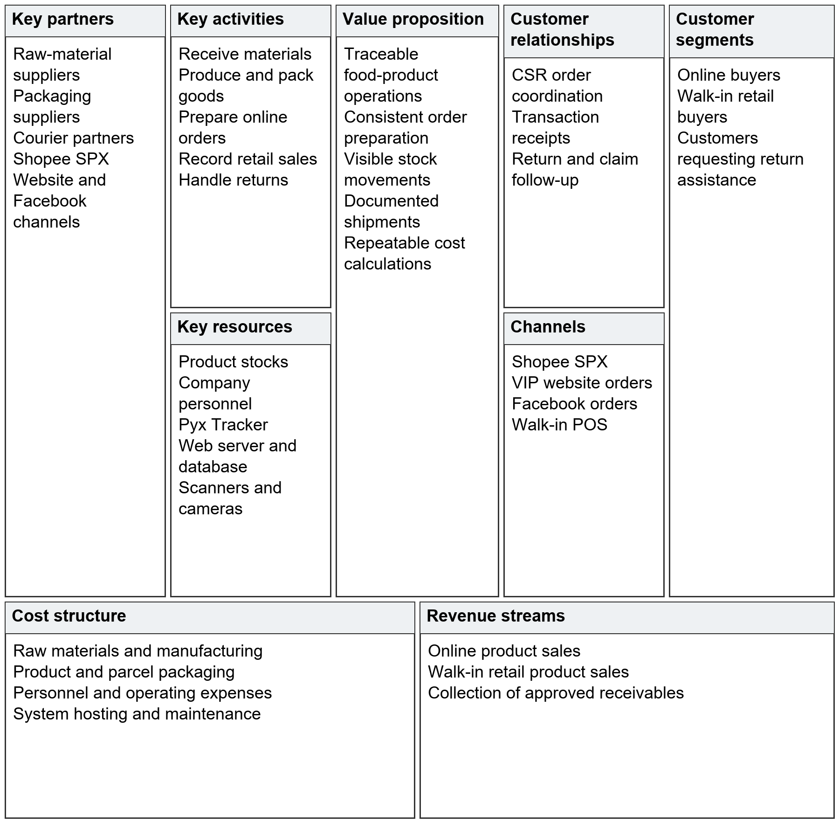
Figure 3.2 Business Model Canvas for Pyx Food Products and Pyx Tracker
The canvas follows the sample's nine blocks: partners, activities, resources, value proposition, customer relationships, channels, customer segments, cost structure, and revenue streams. It represents the food business supported by the system. Pyx Tracker is an internal resource; the canvas does not invent software-subscription income, market-size figures, or financial amounts.

Gantt Chart
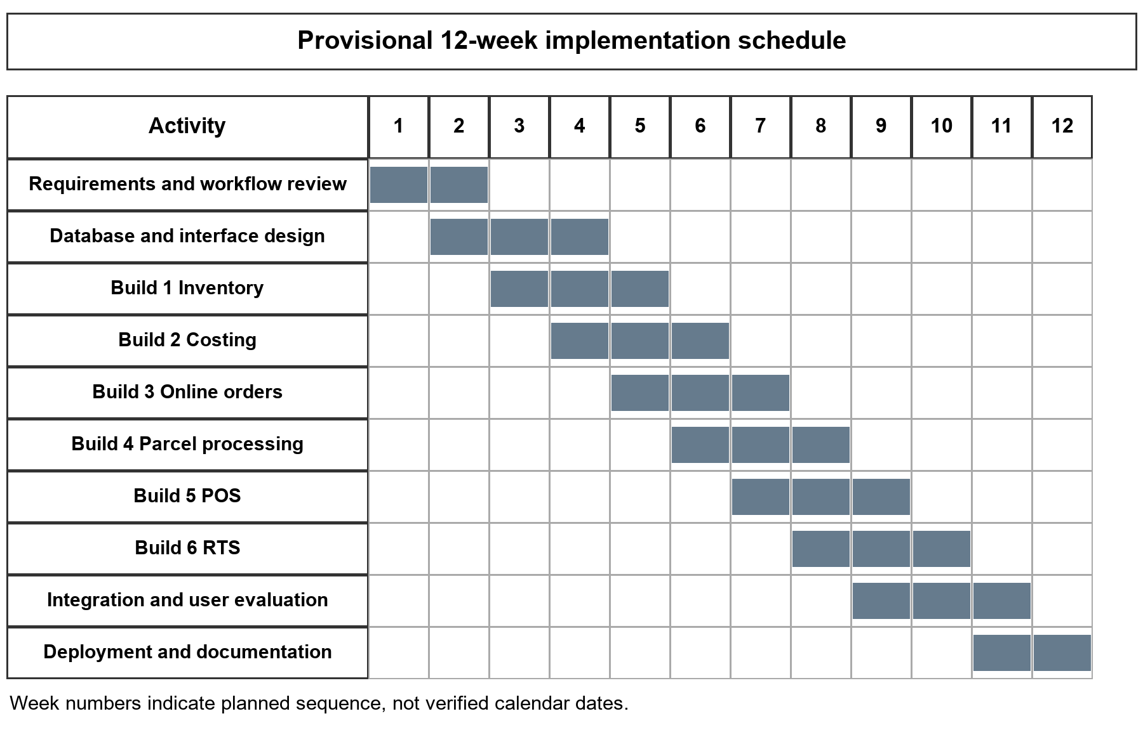
Figure 3.3 Provisional Development and Implementation Gantt Chart
The 12-week relative schedule shows requirements, design, six builds, integration, evaluation, and deployment documentation. Week numbers are provisional planning intervals. Actual start, milestone, testing, and deployment dates were not supplied and must replace these intervals before the chart is represented as historical. Testing and feedback accompany each build.

Functional Decomposition Diagram
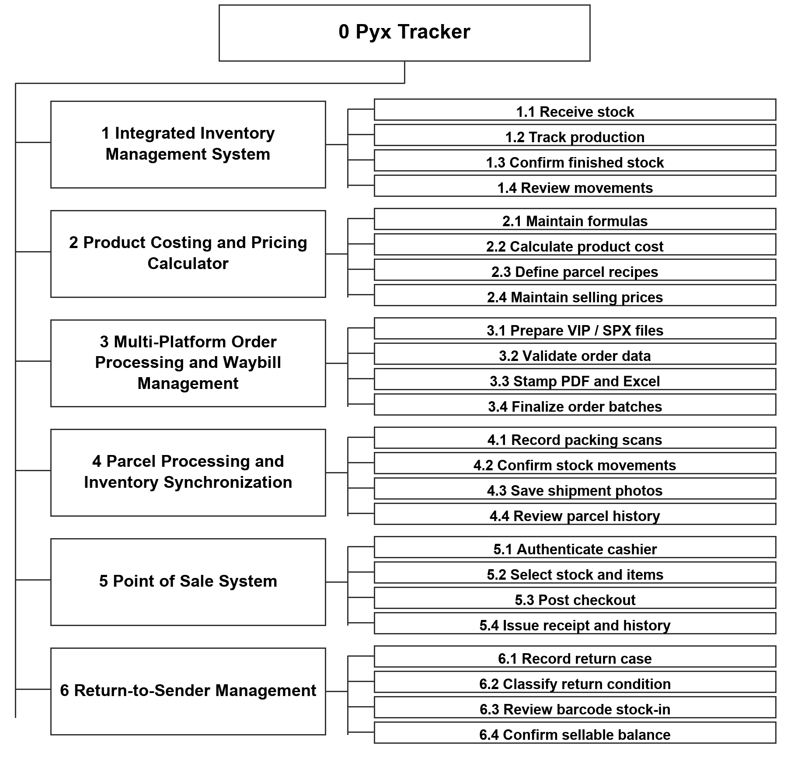
Figure 3.4 Functional Decomposition Diagram of Pyx Tracker
The FDD decomposes the root into six modules and their subfunctions, following the sample's system-to-function-to-subfunction hierarchy. It represents responsibility, not screen navigation or execution order. Shared authentication, permissions, and reporting support the branches.

Analysis and Design Phase

Use Case Diagrams
Human actors appear outside the system boundary, with use cases inside. Actors represent operational roles rather than named employees. Actual access remains subject to each workflow's role and department checks. The POS diagram uses an include relationship for required stock deduction and an extend relationship for an optional approved discount.
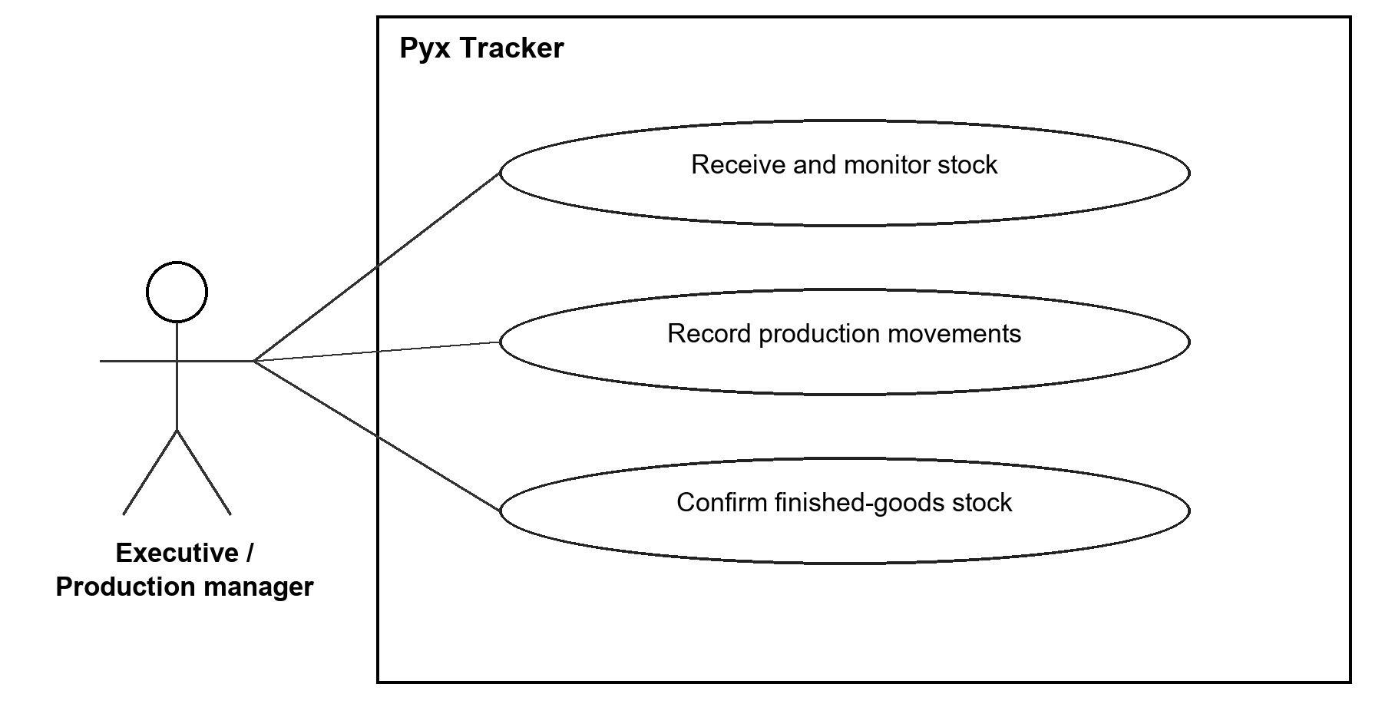
Figure 3.5 Use Cases for Inventory and Production
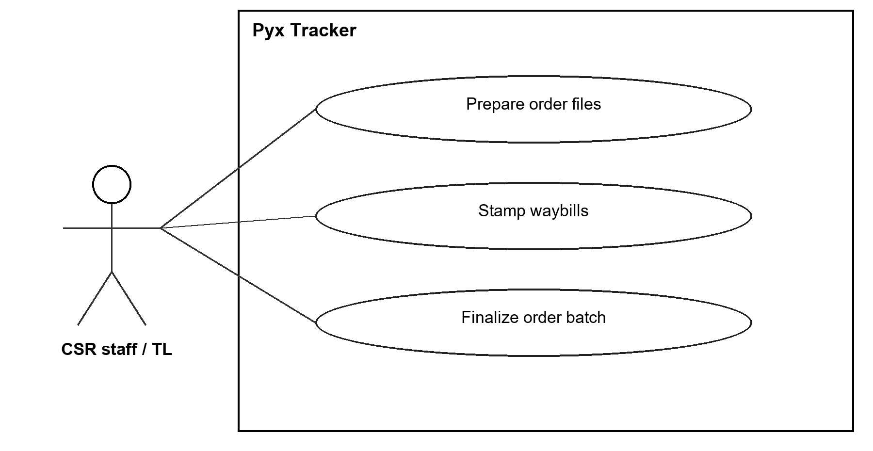
Figure 3.6 Use Cases for Online Orders
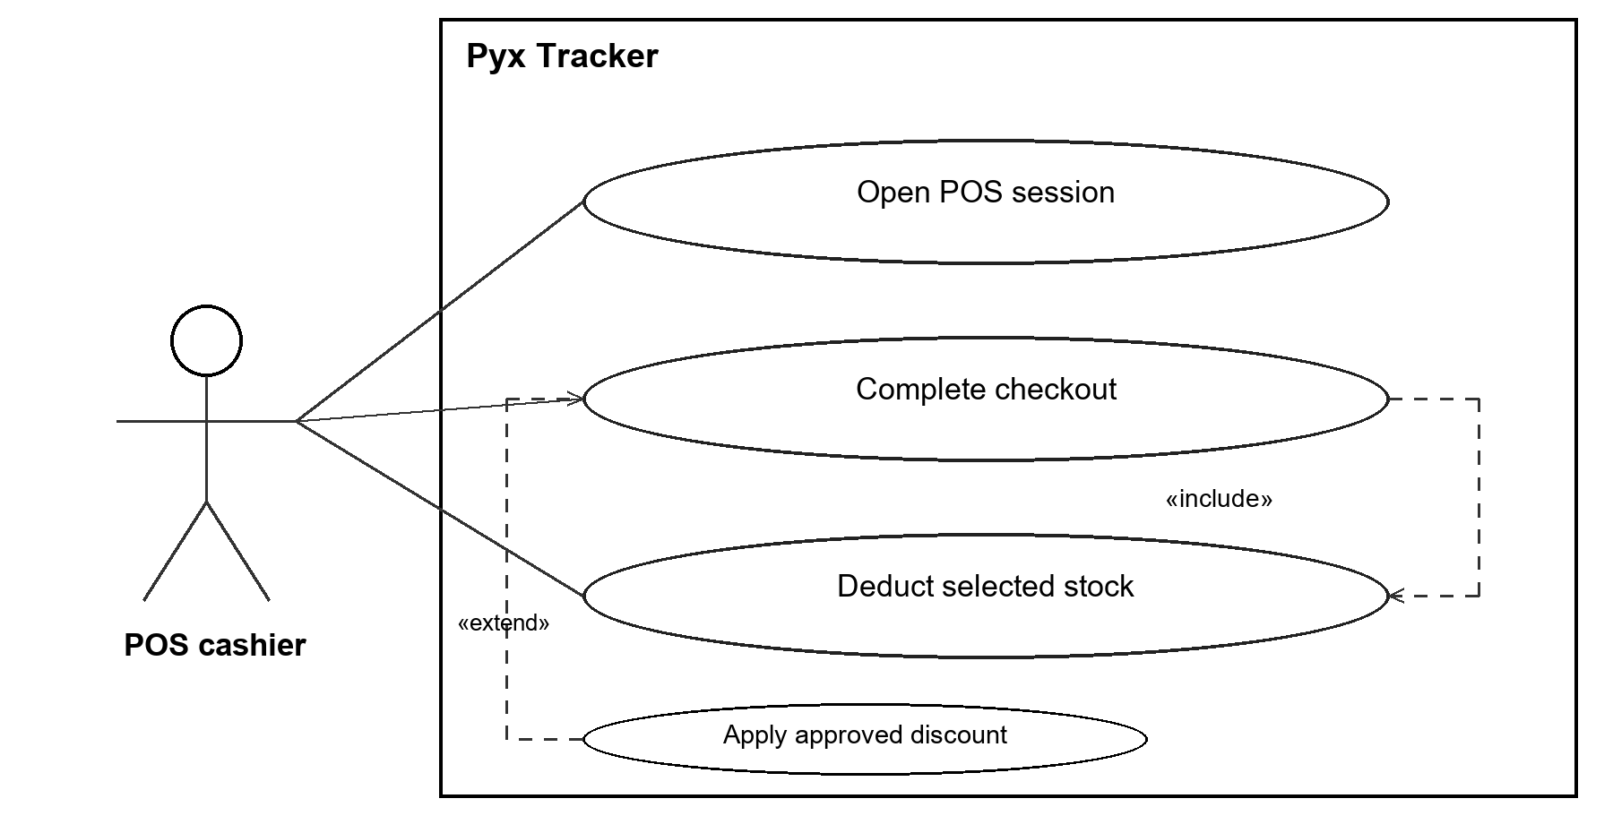
Figure 3.7 Use Cases for Point of Sale
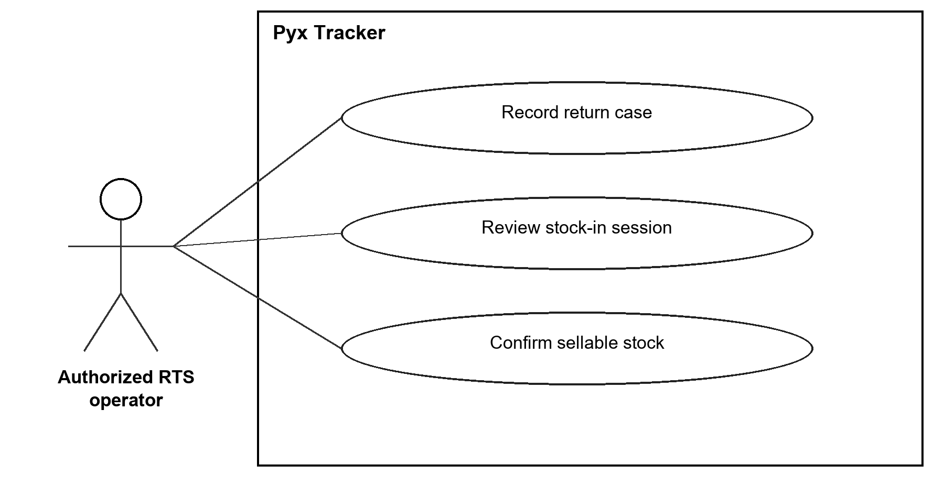
Figure 3.8 Use Cases for Return-to-Sender Management
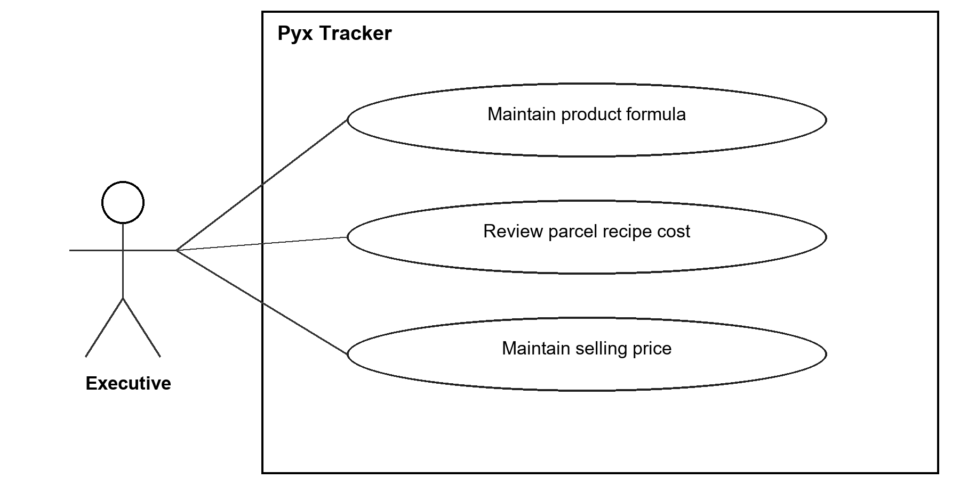
Figure 3.9 Use Cases for Product Costing
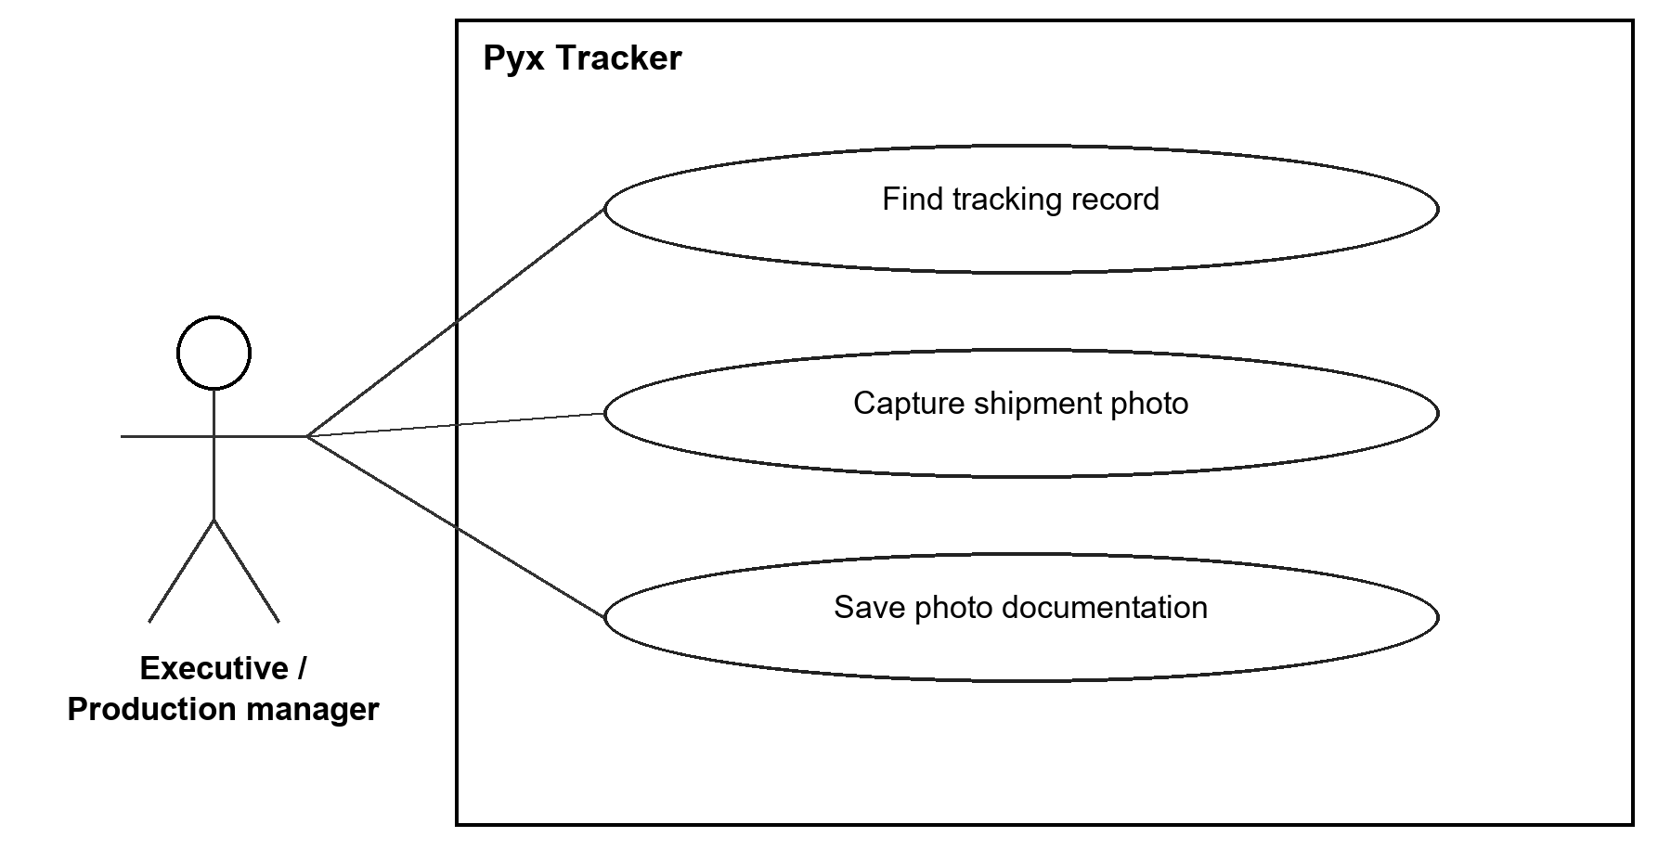
Figure 3.10 Use Cases for Parcel Documentation

Use Case Matrix
Table 3.1 Use Case Matrix for Inventory stock movement
Element | Specification
Use case | UC01 Inventory stock movement
Author | Cayunda, Klint Russel R.; Delos Santos, Brent R.; Fin, Noli III M.
Primary actor | Executive or authorized inventory operator
Trigger | Material receipt or finished-stock operation
Preconditions | Valid product, stock unit, permission and source record.
Basic flow | 1. Select category and product.  2. Enter or scan the movement.  3. Review quantity and source.  4. Confirm the allowed operation.
Postcondition | The relevant balance and movement record reflect the confirmed quantity.
Exceptions | Reject invalid input; preserve balances when an unconfirmed action is cancelled.

Table 3.2 Use Case Matrix for Product and parcel costing
Element | Specification
Use case | UC02 Product and parcel costing
Author | Cayunda, Klint Russel R.; Delos Santos, Brent R.; Fin, Noli III M.
Primary actor | Executive
Trigger | Review or update of product costs
Preconditions | Configured material prices, units and formulas.
Basic flow | 1. Select product or tier.  2. Review quantities, prices and yield.  3. Maintain formula lines.  4. Review calculated cost and price.
Postcondition | The cost is reproducible from the stored inputs.
Exceptions | Deny non-executive access; identify missing configuration before relying on the result.

Table 3.3 Use Case Matrix for Order preparation and finalization
Element | Specification
Use case | UC03 Order preparation and finalization
Author | Cayunda, Klint Russel R.; Delos Santos, Brent R.; Fin, Noli III M.
Primary actor | Authorized CSR staff or team leader
Trigger | Receipt of supported order files
Preconditions | Supported source files and an active processing batch.
Basic flow | 1. Choose preparation tool.  2. Upload and review data.  3. Run separate PDF/Excel stamper.  4. Download results and finalize batch.
Postcondition | Prepared outputs and finalized order/parcel records are available.
Exceptions | Report duplicates, unmatched records or missing fields; do not describe partial preparation as finalization.

Table 3.4 Use Case Matrix for Before-shipment documentation
Element | Specification
Use case | UC04 Before-shipment documentation
Author | Cayunda, Klint Russel R.; Delos Santos, Brent R.; Fin, Noli III M.
Primary actor | Executive or production manager
Trigger | Parcel presented for photo recording
Preconditions | Readable or manually entered tracking identifier and an image.
Basic flow | 1. Scan or type tracking.  2. Capture or upload photo.  3. Review and save.  4. Continue to next record.
Postcondition | Photo is retrievable by tracking number; stock is unchanged.
Exceptions | Provide duplicate feedback and request valid image/tracking input. A CSR parcel is not required.

Table 3.5 Use Case Matrix for Retail checkout
Element | Specification
Use case | UC05 Retail checkout
Author | Cayunda, Klint Russel R.; Delos Santos, Brent R.; Fin, Noli III M.
Primary actor | POS cashier
Trigger | Walk-in customer purchase
Preconditions | Valid POS access, product prices and available selected stock.
Basic flow | 1. Select or scan items.  2. Select normal or RTS stock.  3. Review total.  4. Confirm checkout and issue receipt.
Postcondition | Sale and receipt exist; the selected stock is deducted by the completed transaction.
Exceptions | Handle insufficient stock and invalid input; restrict discounts to the authorized workflow.

Table 3.6 Use Case Matrix for RTS case and sellable stock-in
Element | Specification
Use case | UC06 RTS case and sellable stock-in
Author | Cayunda, Klint Russel R.; Delos Santos, Brent R.; Fin, Noli III M.
Primary actor | Authorized RTS operator
Trigger | Returned parcel received
Preconditions | Tracking or case information, item condition and readable product codes.
Basic flow | 1. Record case and condition.  2. Open stock-in session.  3. Scan received sellable goods.  4. Review and confirm session.
Postcondition | Case history is retained; confirmed sellable quantity is credited once.
Exceptions | Case save alone adds no sellable stock; discarding a draft leaves inventory unchanged.

Storyboard
The following labeled wireframes explain the principal screens and interaction sequences. They are schematic drawings, not production screenshots. They follow the reference's screen-plus-explanation approach without copying its sample company's interface. Approved screenshots of the exact evaluated release can replace them if deployed-screen evidence is required.
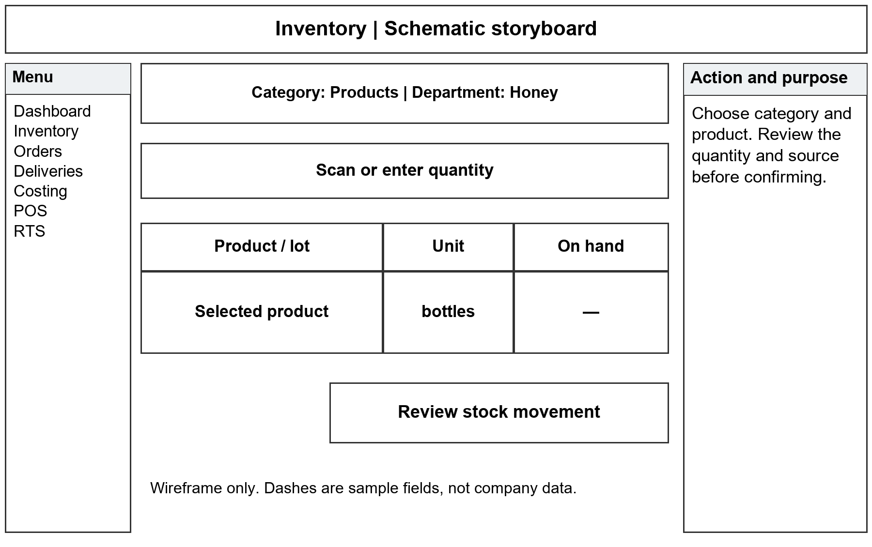
Figure 3.11 Inventory Storyboard
The user selects the category, product, and lot, enters or scans the movement, and reviews the action before confirmation. Quantities use the selected stock type's units. Available actions depend on the user's permissions.
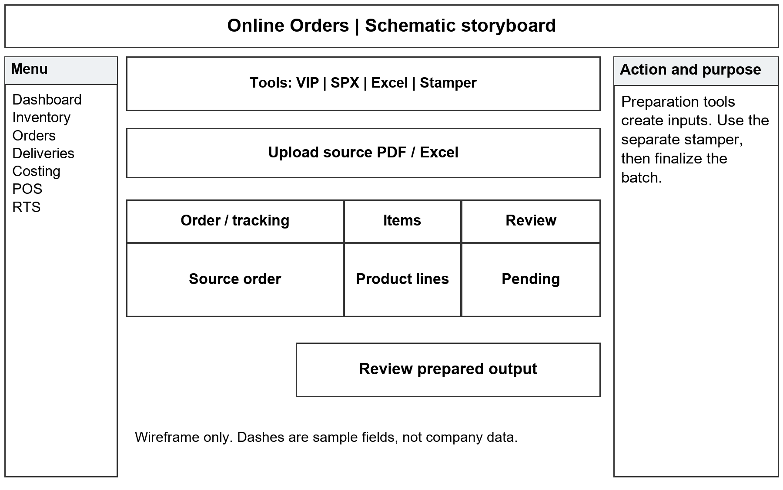
Figure 3.12 Online Orders Storyboard
CSR personnel select a source-specific preparation tool, review the information, then operate the separate stamper. Generated documents and finalized batch records are distinct outcomes.
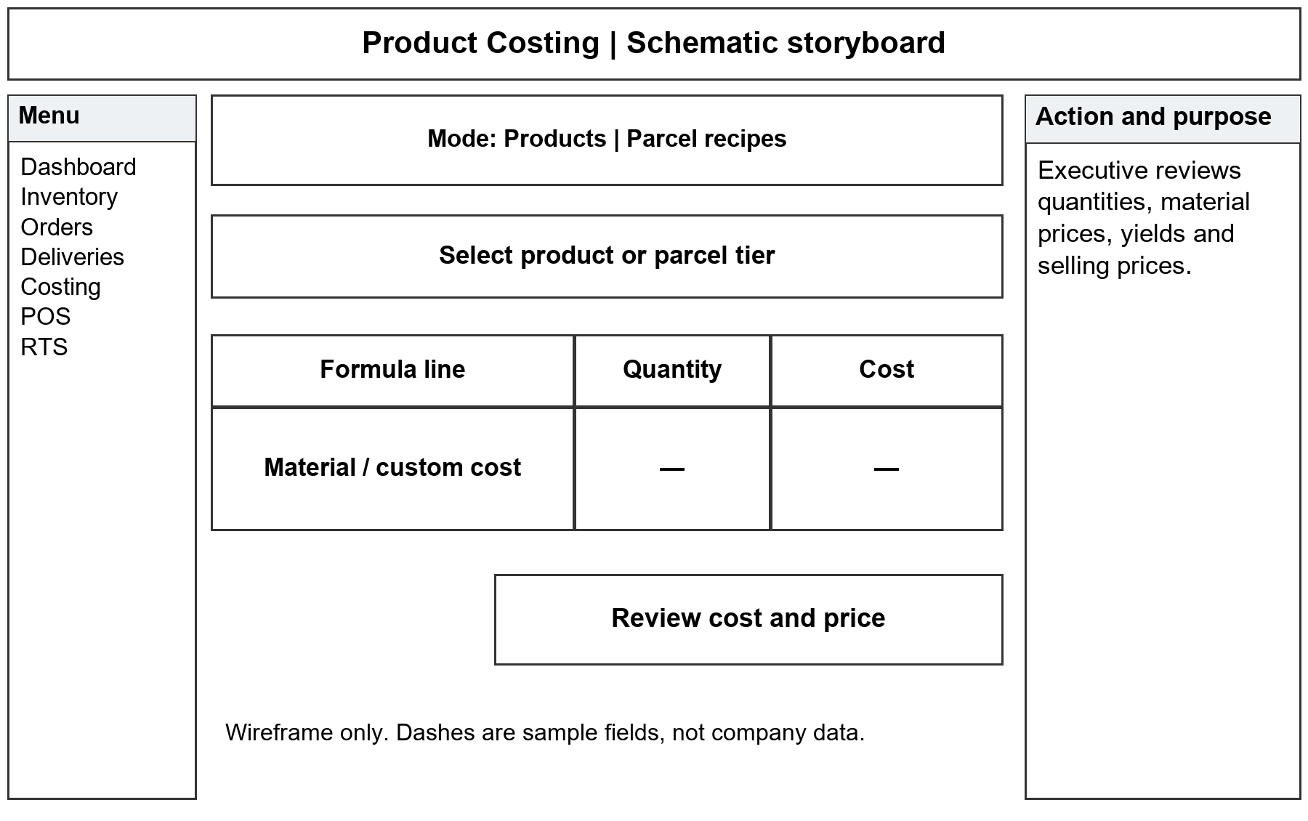
Figure 3.13 Product Costing Storyboard
An executive selects a product or parcel recipe, checks price and yield, and reviews formula or custom-cost lines. Product and parcel expenses remain separate.
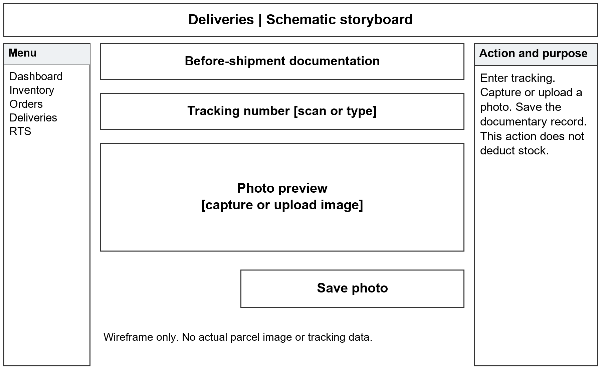
Figure 3.14 Parcel Documentation Storyboard
The operator enters the tracking number, captures or uploads the image, and saves the photo record. The storyboard does not depict stock deduction from this documentary action.
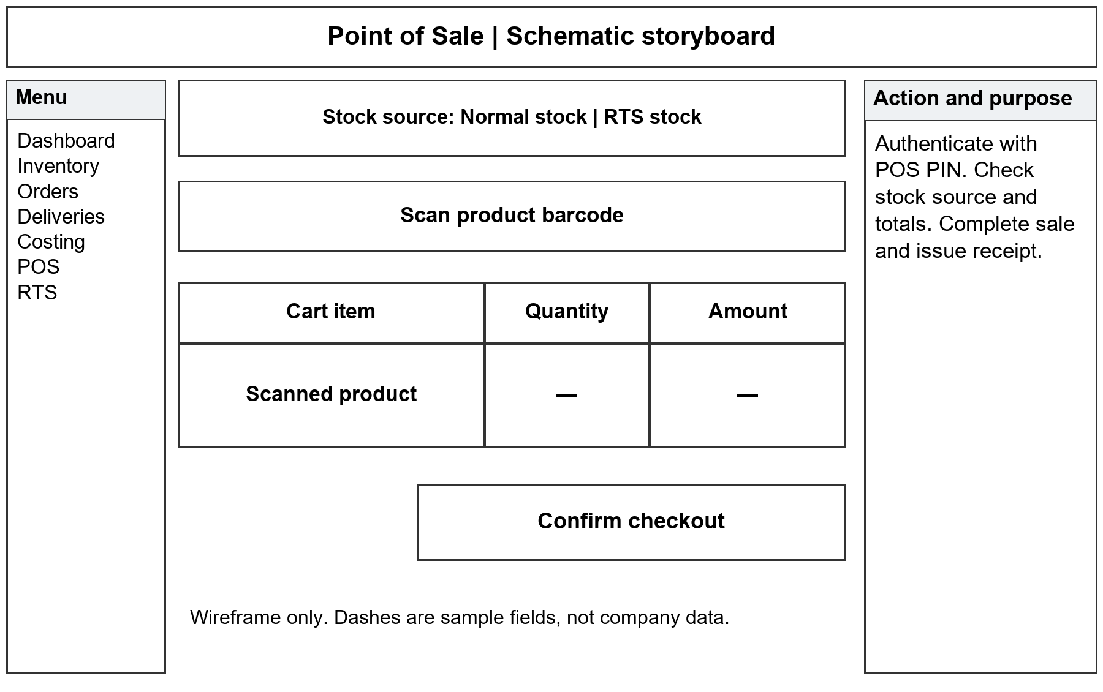
Figure 3.15 Point of Sale Storyboard
The cashier authenticates, chooses items and stock source, reviews the basket, and completes checkout. The receipt and ending stock provide evidence of the transaction.
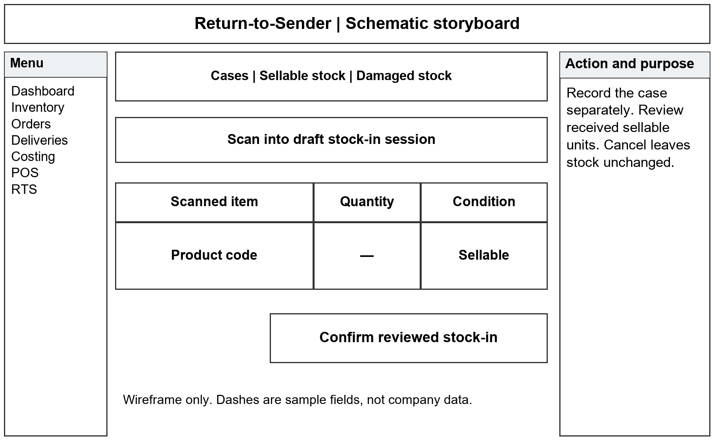
Figure 3.16 Return-to-Sender Storyboard
The operator records the case and condition, then reviews a separate stock-in session for received sellable units. Inventory is credited after confirmation.

Database Design
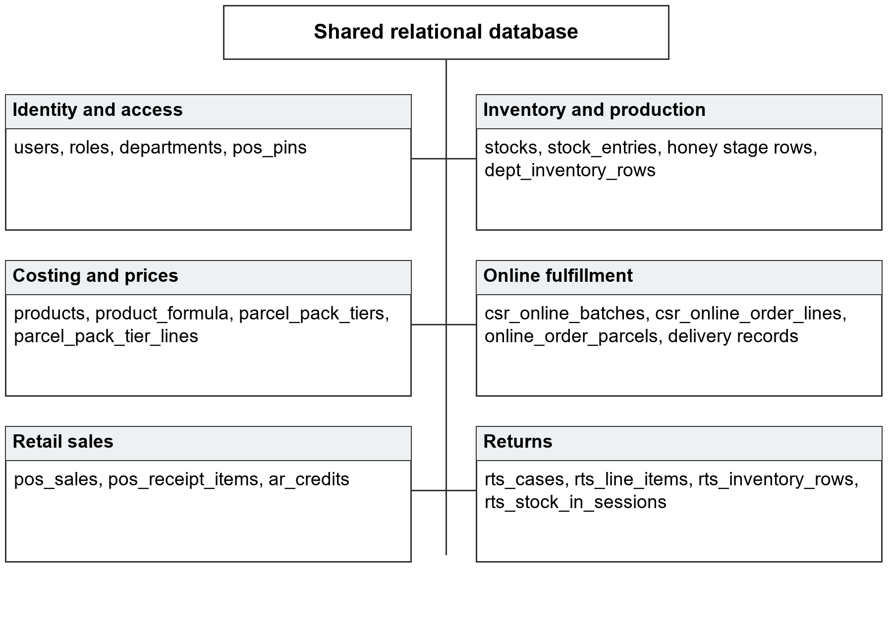
Figure 3.17 Database Design by Functional Area
The shared relational database contains identity, stock, production, order, costing, sales, and returns records. The areas shown are logical groupings, not independent databases. Dedicated tables preserve the different units and lifecycles of honey stages, department goods, material pools, and transactions.
Column and foreign-key metadata were inspected on 15 September 2026. Business records were not needed. The diagrams describe the reviewed local schema; deployment verification should confirm that the evaluated installation uses the same version.

Entity Relationship Diagram
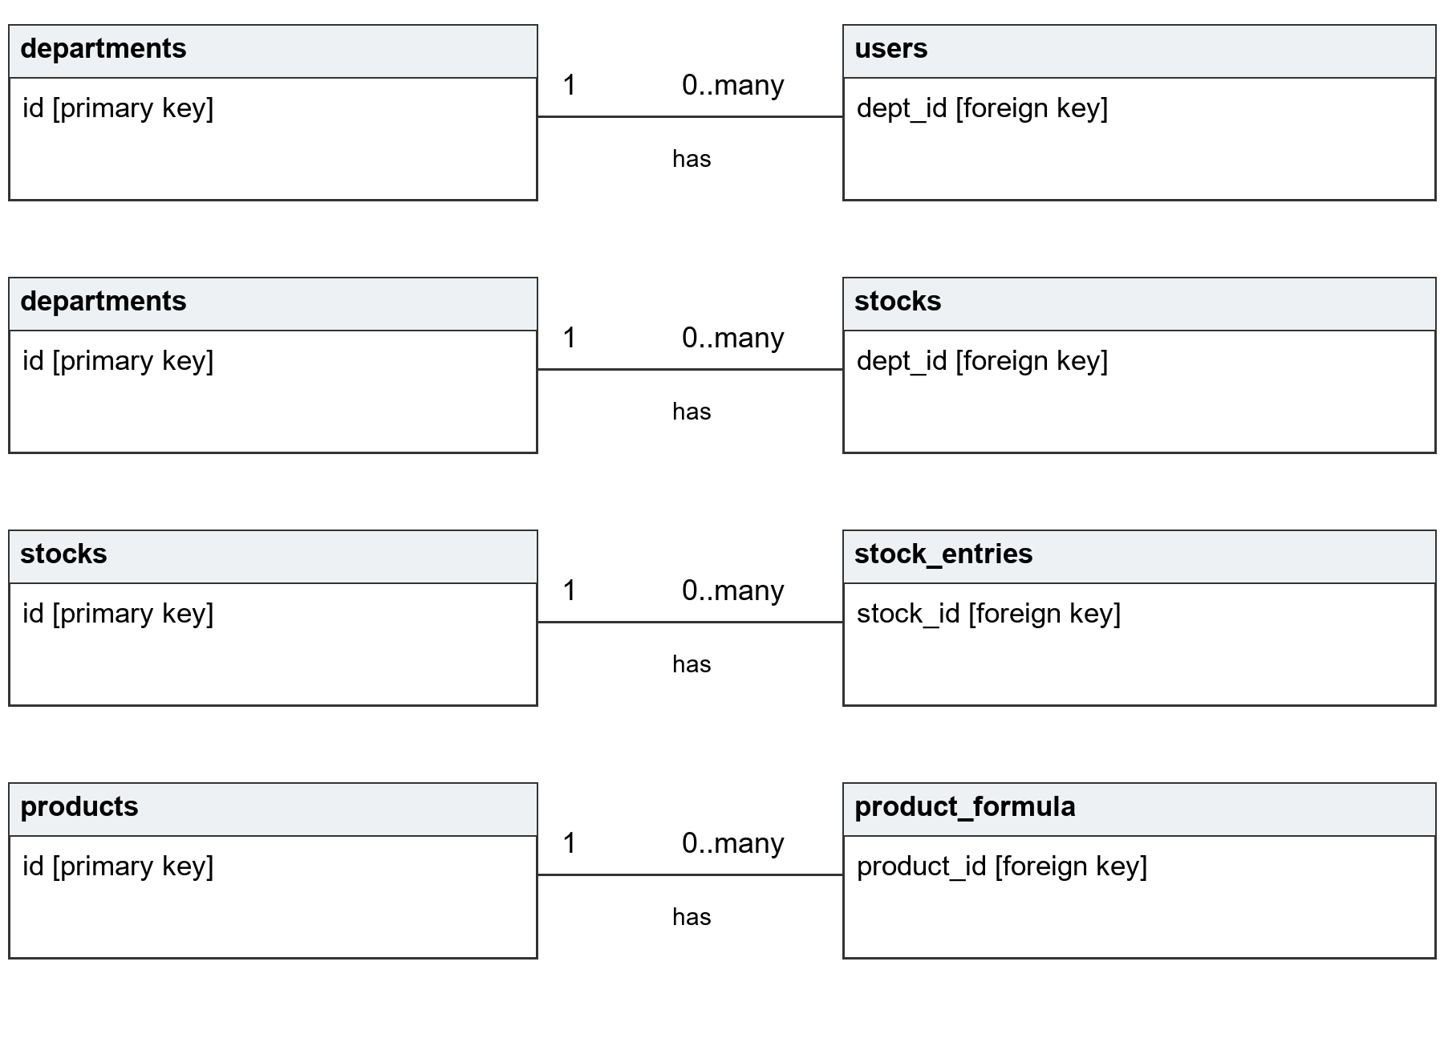
Figure 3.18 Inventory and Costing Entity Relationships
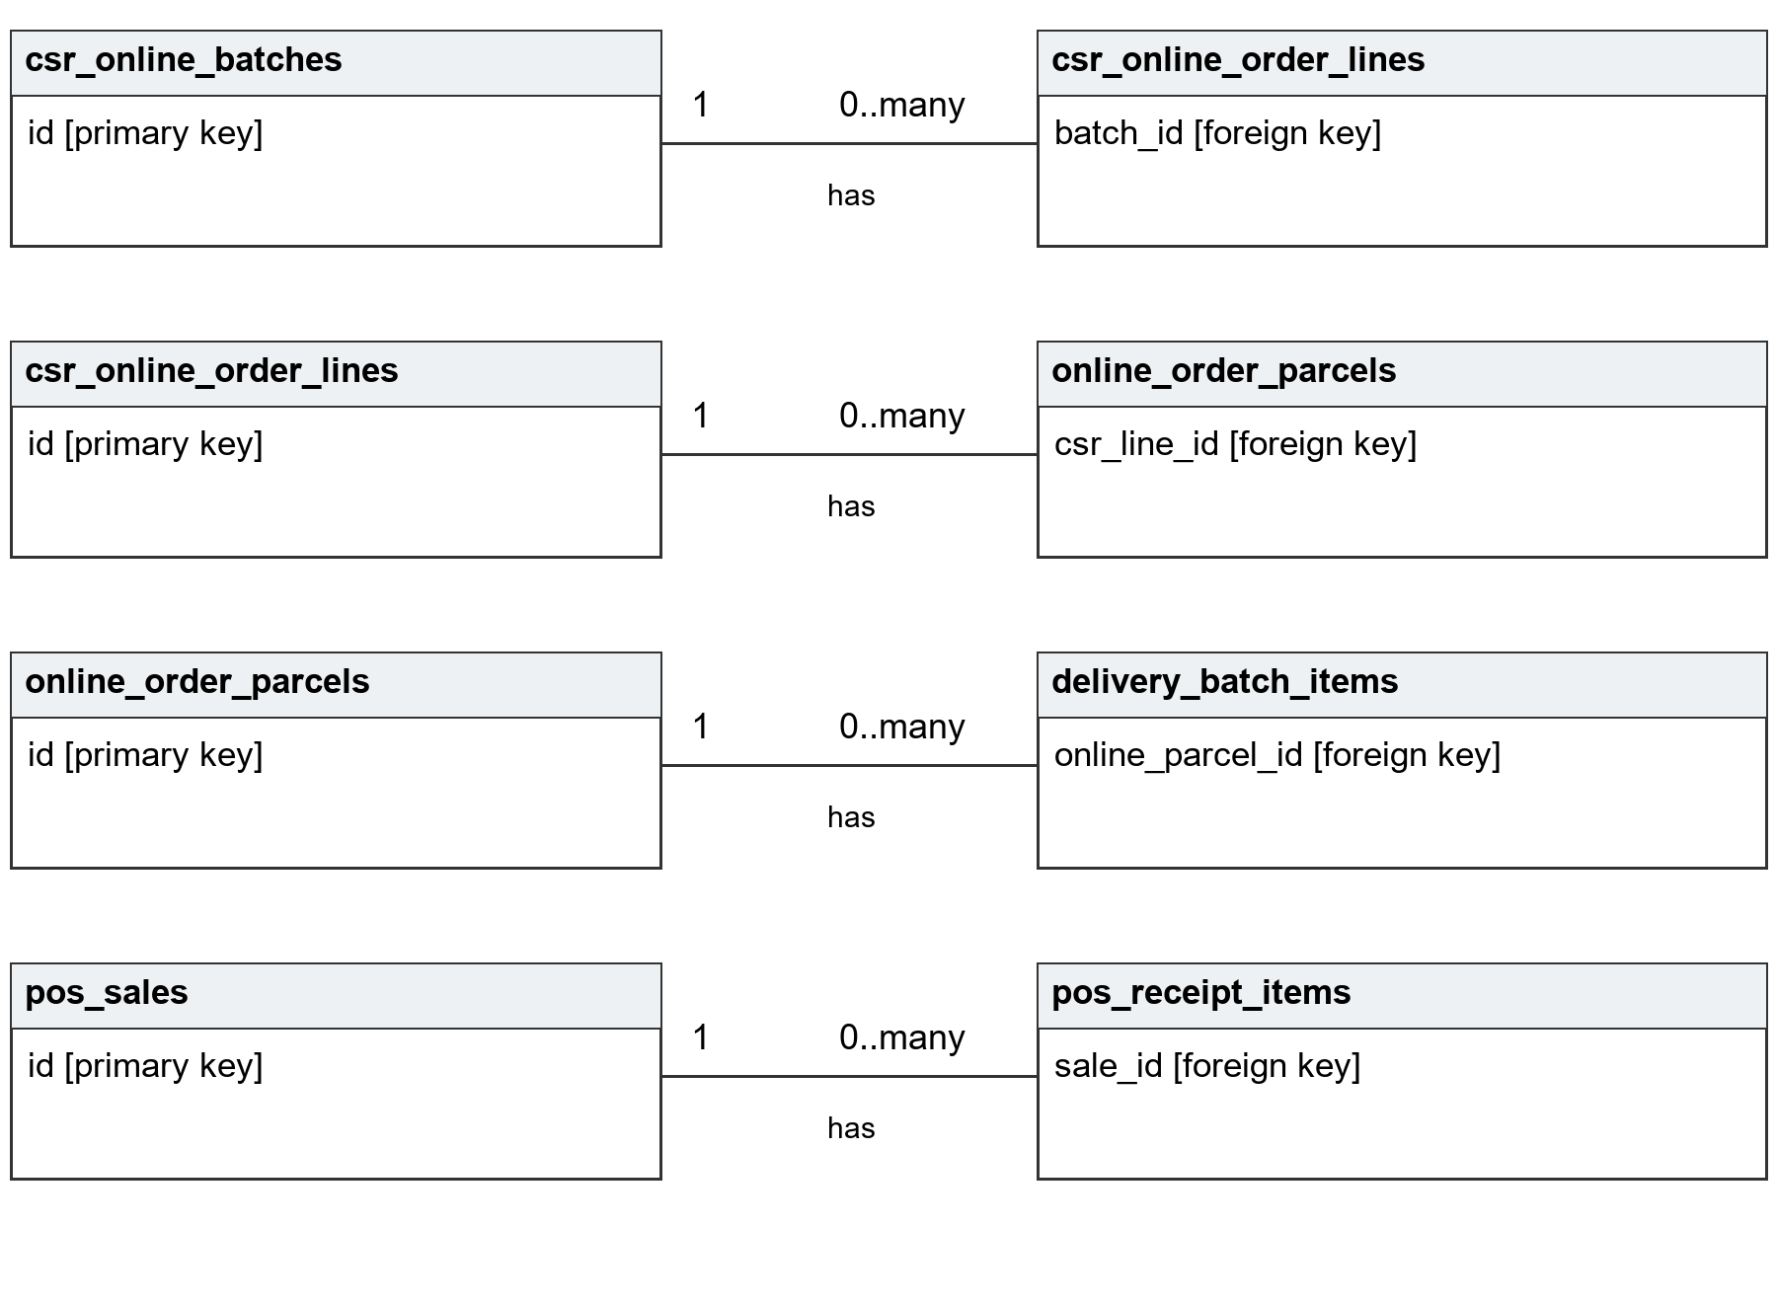
Figure 3.19 Order and Sales Entity Relationships
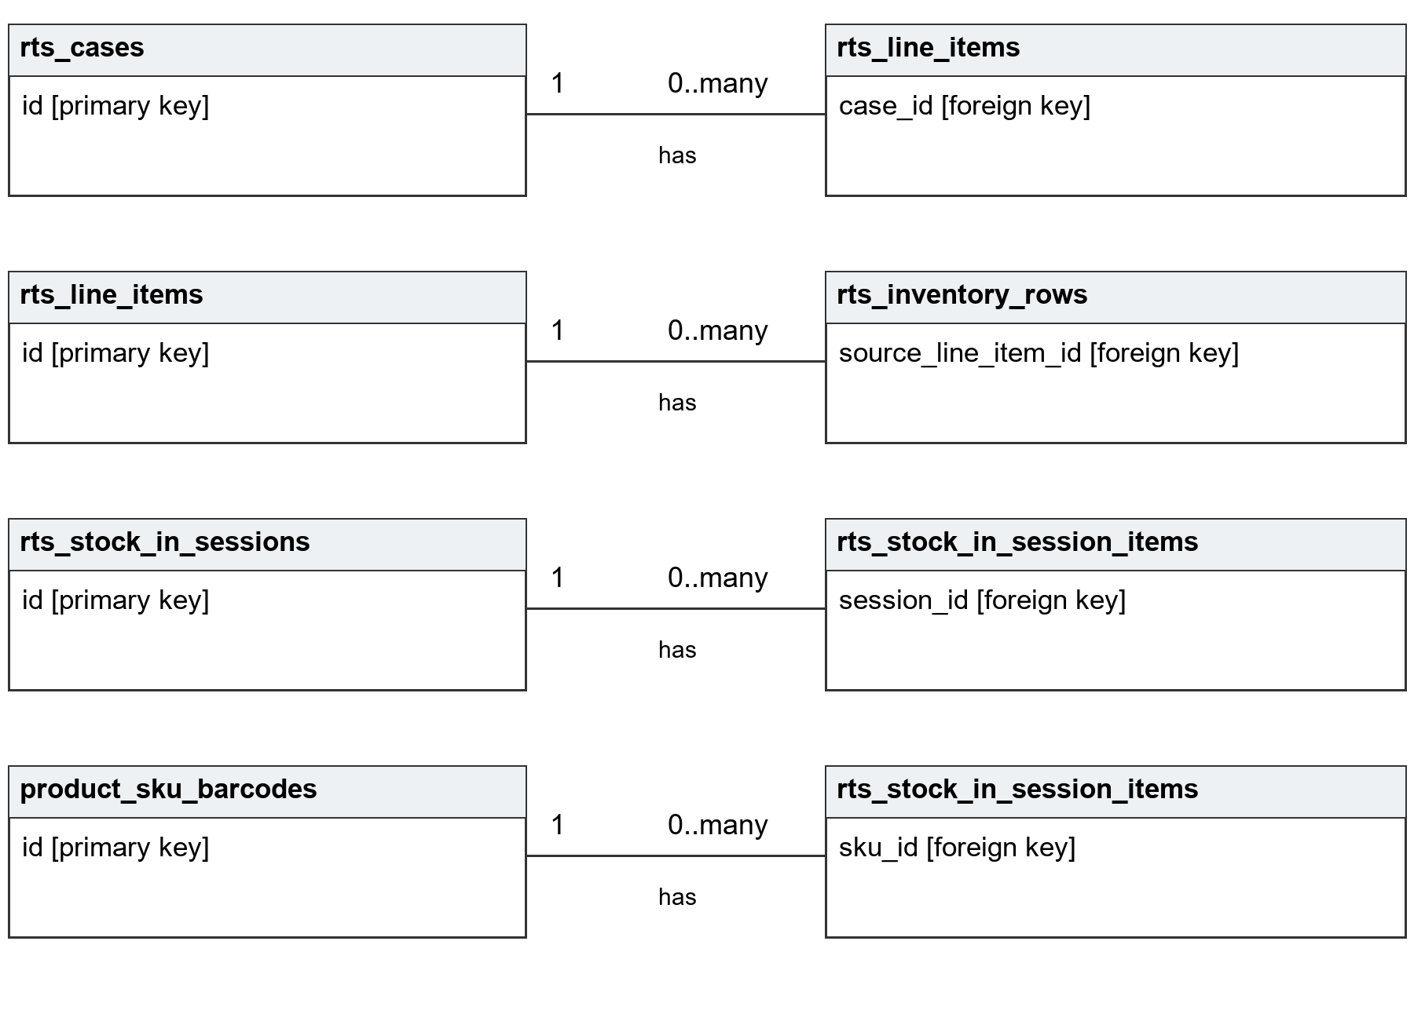
Figure 3.20 Return and Barcode Entity Relationships
These diagrams show selected declared foreign keys. A parent identifier may be referenced by many child records. The dictionary identifies whether a child reference permits NULL. Application-level relationships are not presented as database constraints. Repeated entity boxes keep each relationship readable.

Data Dictionary
The core dictionary records actual field names, types, nullability, defaults, and keys for the principal tables supporting the six modules. Descriptions explain operational purpose. A dash means no explicit default or a SQL NULL default reported by metadata, not a literal stored dash. PRI means primary key, UNI means unique index, and MUL means a non-unique indexed column. Index labels do not by themselves establish foreign keys.
Supporting request, history, permission, issued-code, unit-tracking, and correction tables are not all reproduced in this core dictionary. Permanent SKU codes identify product types; additional unit and event tables preserve movement detail.
Table 3.7 Data Dictionary for users
Attribute | Type | Null | Default | Description
id | int(10) unsigned | No | — | Row identifier. Index: PRI. auto_​increment.
username | varchar(64) | No | — | Username. Index: UNI.
name | varchar(120) | No | — | Name.
email | varchar(160) | Yes | NULL | Email. Index: UNI.
employee_​id | varchar(24) | No | — | Employee id. Index: UNI.
password_​hash | varchar(255) | No | — | Password verification hash.
role_​id | int(10) unsigned | No | — | Role id. FK to roles.id. Index: MUL.
dept_​id | int(10) unsigned | Yes | NULL | Dept id. FK to departments.id. Index: MUL.
is_​active | tinyint(1) | No | 1 | Whether the record is enabled. Index: MUL.
created_​at | datetime | No | current_​timestamp() | Created at.
updated_​at | datetime | No | current_​timestamp() | Updated at. on update current_​timestamp().

Table 3.8 Data Dictionary for roles
Attribute | Type | Null | Default | Description
id | int(10) unsigned | No | — | Row identifier. Index: PRI. auto_​increment.
name | varchar(32) | No | — | Name. Index: UNI.
created_​at | datetime | No | current_​timestamp() | Created at.

Table 3.9 Data Dictionary for departments
Attribute | Type | Null | Default | Description
id | int(10) unsigned | No | — | Row identifier. Index: PRI. auto_​increment.
name | varchar(32) | No | — | Name. Index: UNI.
created_​at | datetime | No | current_​timestamp() | Created at.

Table 3.10 Data Dictionary for suppliers
Attribute | Type | Null | Default | Description
id | int(10) unsigned | No | — | Row identifier. Index: PRI. auto_​increment.
first_​name | varchar(80) | No | — | First name.
last_​name | varchar(80) | No | — | Last name. Index: MUL.
contact_​number | varchar(32) | No | — | Contact number.
payment_​account | varchar(80) | No | — | Payment account.
payment_​account_​number | varchar(64) | No | — | Payment account number.
address | varchar(255) | No | — | Address.
valid_​id_​filename | varchar(190) | No | — | Valid id filename.
category | enum | No | — | Category. Index: MUL. Values: honey, paragis, black_​rice, cacao, honey_​comb.
is_​active | tinyint(1) | No | 1 | Whether the record is enabled.
created_​by | int(10) unsigned | No | — | Created by. FK to users.id. Index: MUL.
created_​at | datetime | No | current_​timestamp() | Created at.
updated_​at | datetime | No | current_​timestamp() | Updated at. on update current_​timestamp().

Table 3.11 Data Dictionary for stocks
Attribute | Type | Null | Default | Description
id | int(10) unsigned | No | — | Row identifier. Index: PRI. auto_​increment.
name | varchar(160) | No | — | Name.
dept_​id | int(10) unsigned | No | — | Dept id. FK to departments.id. Index: MUL.
supplier_​id | int(10) unsigned | Yes | NULL | Supplier id. FK to suppliers.id. Index: MUL.
unit | varchar(32) | No | 'pcs' | Unit.
category | enum | No | 'costing_​only' | Category. Values: raw_​material, packaging, supply, costing_​only.
production_​deduct | tinyint(1) | No | 1 | Whether configured production deduction applies.
pool_​yield_​qty | decimal(14,4) | Yes | NULL | Usable output per costing pool unit.
pool_​yield_​unit | varchar(32) | Yes | NULL | Pool yield unit.
on_​hand | decimal(12,2) | No | 0.00 | Operational material balance.
is_​active | tinyint(1) | No | 1 | Whether the record is enabled.
current_​price | decimal(14,6) | No | 0.000000 | Current unit price used in costing.
supplier_​name | varchar(160) | Yes | NULL | Supplier name.
supplier_​code | varchar(64) | Yes | NULL | Supplier code.
created_​by | int(10) unsigned | No | — | Created by. FK to users.id. Index: MUL.
created_​at | datetime | No | current_​timestamp() | Created at.

Table 3.12 Data Dictionary for stock_entries
Attribute | Type | Null | Default | Description
id | int(10) unsigned | No | — | Row identifier. Index: PRI. auto_​increment.
stock_​id | int(10) unsigned | No | — | Stock id. FK to stocks.id. Index: MUL.
dept_​id | int(10) unsigned | No | — | Dept id. FK to departments.id. Index: MUL.
qty | decimal(14,6) | No | — | Recorded quantity in the applicable unit.
batching_​date | datetime | No | — | Batching date.
supplier_​batch_​no | varchar(120) | Yes | NULL | Supplier batch no.
entered_​by | int(10) unsigned | No | — | Entered by. FK to users.id. Index: MUL.
created_​at | datetime | No | current_​timestamp() | Created at. Index: MUL.

Table 3.13 Data Dictionary for honey_warehouse_rows
Attribute | Type | Null | Default | Description
id | int(10) unsigned | No | — | Row identifier. Index: PRI. auto_​increment.
supplier_​name | varchar(160) | No | — | Supplier name.
supplier_​id | int(10) unsigned | Yes | NULL | Supplier id. FK to suppliers.id. Index: MUL.
supplier_​code | varchar(32) | No | — | Supplier code. Index: MUL.
arrival_​date | date | No | — | Arrival date. Index: MUL.
variant | enum | No | — | Variant. Index: MUL. Values: light, amber, dark, other.
current_​qty | decimal(12,2) | No | — | Current quantity in gallons.
initial_​qty | decimal(12,2) | No | — | Initial quantity in gallons.
unit_​cost_​per_​gallon | decimal(12,2) | Yes | NULL | Unit cost per gallon.
supplier_​price_​id | int(10) unsigned | Yes | NULL | Supplier price id. FK to supplier_​honey_​prices.id. Index: MUL.
cost_​override | tinyint(1) | No | 0 | Cost override.
created_​by | int(10) unsigned | No | — | Created by. FK to users.id. Index: MUL.
created_​at | datetime | No | current_​timestamp() | Created at.

Table 3.14 Data Dictionary for honey_production_rows
Attribute | Type | Null | Default | Description
id | int(10) unsigned | No | — | Row identifier. Index: PRI. auto_​increment.
warehouse_​row_​id | int(10) unsigned | No | — | Warehouse row id. FK to honey_​warehouse_​rows.id. Index: MUL.
supplier_​code | varchar(32) | No | — | Supplier code. Index: MUL.
arrival_​date | date | No | — | Arrival date.
stock_​out_​date | date | Yes | NULL | Stock out date. Index: MUL.
daily_​group_​key | varchar(128) | Yes | NULL | Daily group key. Index: UNI.
variant | enum | No | — | Variant. Values: light, amber, dark, other.
current_​qty | decimal(12,2) | No | — | Current quantity in gallons.
initial_​qty | decimal(12,2) | No | — | Initial quantity in gallons.
transferred_​at | datetime | No | current_​timestamp() | Transferred at.
created_​by | int(10) unsigned | No | — | Created by. FK to users.id. Index: MUL.
created_​at | datetime | No | current_​timestamp() | Created at.

Table 3.15 Data Dictionary for honey_packaging_rows
Attribute | Type | Null | Default | Description
id | int(10) unsigned | No | — | Row identifier. Index: PRI. auto_​increment.
production_​row_​id | int(10) unsigned | Yes | NULL | Production row id. FK to honey_​production_​rows.id. Index: MUL.
supplier_​code | varchar(32) | No | — | Supplier code.
batch_​no | varchar(48) | No | — | Batch no. Index: MUL.
bottling_​date | date | No | — | Bottling date. Index: MUL.
variant | enum | No | — | Variant. Values: light, amber, dark, other.
current_​liter | decimal(12,2) | No | 0.00 | Current count of 1 L bottles.
initial_​liter | decimal(12,2) | No | 0.00 | Initial count of 1 L bottles.
current_​250ml | decimal(12,2) | No | 0.00 | Current count of 250 mL bottles.
initial_​250ml | decimal(12,2) | No | 0.00 | Initial count of 250 mL bottles.
current_​350ml | decimal(12,2) | No | 0.00 | Current count of 350 mL bottles.
initial_​350ml | decimal(12,2) | No | 0.00 | Initial count of 350 mL bottles.
current_​gallon | decimal(12,2) | No | 0.00 | Current count of gallon units.
initial_​gallon | decimal(12,2) | No | 0.00 | Initial count of gallon units.
created_​by | int(10) unsigned | No | — | Created by. FK to users.id. Index: MUL.
created_​at | datetime | No | current_​timestamp() | Created at.

Table 3.16 Data Dictionary for dept_inventory_rows
Attribute | Type | Null | Default | Description
id | int(10) unsigned | No | — | Row identifier. Index: PRI. auto_​increment.
dept_​id | int(10) unsigned | No | — | Dept id. FK to departments.id. Index: MUL.
product_​key | varchar(32) | Yes | NULL | Product key.
product_​label | varchar(120) | No | — | Product label.
current_​qty | decimal(12,2) | No | — | Current quantity for the configured stock item.
initial_​qty | decimal(12,2) | No | — | Initial quantity for the configured stock item.
source_​note | varchar(255) | Yes | NULL | Source note.
last_​stock_​in_​at | datetime | Yes | NULL | Last stock in at.
created_​by | int(10) unsigned | Yes | NULL | Created by. FK to users.id. Index: MUL.
created_​at | datetime | No | current_​timestamp() | Created at.

Table 3.17 Data Dictionary for products
Attribute | Type | Null | Default | Description
id | int(10) unsigned | No | — | Row identifier. Index: PRI. auto_​increment.
name | varchar(160) | No | — | Name. Index: MUL.
dept_​product_​key | varchar(32) | Yes | NULL | Dept product key. Index: UNI.
dept_​id | int(10) unsigned | No | — | Dept id. FK to departments.id. Index: MUL.
size | enum | Yes | NULL | Size. Values: liter, 350ml, 250ml, gallon.
variant | enum | Yes | NULL | Variant. Values: light, amber, dark.
selling_​price | decimal(12,2) | No | 0.00 | Selling price.
baseline_​cost | decimal(12,2) | No | 0.00 | Baseline cost.
created_​by | int(10) unsigned | No | — | Created by. FK to users.id. Index: MUL.
created_​at | datetime | No | current_​timestamp() | Created at.

Table 3.18 Data Dictionary for product_formula
Attribute | Type | Null | Default | Description
id | int(10) unsigned | No | — | Row identifier. Index: PRI. auto_​increment.
product_​id | int(10) unsigned | No | — | Product id. FK to products.id. Index: MUL.
stock_​id | int(10) unsigned | Yes | NULL | Stock id. Index: MUL.
line_​label | varchar(160) | Yes | NULL | Description for a material or custom cost line.
qty_​per_​unit | decimal(16,8) | No | — | Formula quantity required per sellable unit.
price_​at_​creation | decimal(12,2) | No | — | Price at creation.
created_​at | datetime | No | current_​timestamp() | Created at.

Table 3.19 Data Dictionary for parcel_pack_tiers
Attribute | Type | Null | Default | Description
id | int(10) unsigned | No | — | Row identifier. Index: PRI. auto_​increment.
family | enum | No | — | Family. Index: MUL. Values: honey, dept_​pt_​brc, jar_​cacao.
tier_​key | varchar(64) | No | — | Tier key. Index: UNI.
label | varchar(128) | No | — | Label.
match_​rule | longtext | No | — | Configured parcel composition matching rule.
is_​active | tinyint(1) | No | 1 | Whether the record is enabled.
sort_​order | int(11) | No | 0 | Sort order.
created_​at | datetime | No | current_​timestamp() | Created at.
updated_​at | datetime | No | current_​timestamp() | Updated at. on update current_​timestamp().

Table 3.20 Data Dictionary for parcel_pack_tier_lines
Attribute | Type | Null | Default | Description
id | int(10) unsigned | No | — | Row identifier. Index: PRI. auto_​increment.
tier_​id | int(10) unsigned | No | — | Tier id. FK to parcel_​pack_​tiers.id. Index: MUL.
stock_​id | int(10) unsigned | Yes | NULL | Stock id. FK to stocks.id. Index: MUL.
line_​label | varchar(128) | Yes | NULL | Description for a material or custom cost line.
qty_​typical | decimal(12,4) | No | 0.0000 | Typical recipe quantity.
qty_​min | decimal(12,4) | Yes | NULL | Qty min.
qty_​max | decimal(12,4) | Yes | NULL | Qty max.
unit | varchar(32) | No | 'pcs' | Unit.
sort_​order | int(11) | No | 0 | Sort order.

Table 3.21 Data Dictionary for csr_online_batches
Attribute | Type | Null | Default | Description
id | int(10) unsigned | No | — | Row identifier. Index: PRI. auto_​increment.
user_​id | int(10) unsigned | No | — | User id. Index: MUL.
status | enum | No | 'active' | Current workflow state. Values: active, processed, cancelled.
created_​at | datetime | No | current_​timestamp() | Created at. Index: MUL.
completed_​at | datetime | Yes | NULL | Completed at.
master_​file_​token | varchar(64) | Yes | NULL | Master file token.
master_​filename | varchar(255) | Yes | NULL | Master filename.

Table 3.22 Data Dictionary for csr_online_order_lines
Attribute | Type | Null | Default | Description
id | int(10) unsigned | No | — | Row identifier. Index: PRI. auto_​increment.
batch_​id | int(10) unsigned | No | — | Batch id. FK to csr_​online_​batches.id. Index: MUL.
run_​id | int(10) unsigned | Yes | NULL | Run id. FK to csr_​online_​batch_​runs.id. Index: MUL.
order_​no | varchar(64) | Yes | NULL | Order no.
recipient_​name | varchar(255) | No | '' | Recipient name.
items | text | No | — | Items.
courier | varchar(191) | No | '' | Courier. Index: MUL.
tracking_​number | varchar(96) | No | '' | Tracking identifier used for lookup and matching. Index: MUL.
source_​pipeline | enum | No | — | Source pipeline. Index: MUL. Values: partner, vip, shopee_​spx, tiktok.
partner_​seller | enum | Yes | NULL | Partner seller. Index: MUL. Values: ian, jono, joven.
created_​at | datetime | No | current_​timestamp() | Created at.

Table 3.23 Data Dictionary for online_order_parcels
Attribute | Type | Null | Default | Description
id | int(10) unsigned | No | — | Row identifier. Index: PRI. auto_​increment.
csr_​batch_​id | int(10) unsigned | Yes | NULL | Csr batch id. FK to csr_​online_​batches.id. Index: MUL.
csr_​line_​id | int(10) unsigned | Yes | NULL | Csr line id. FK to csr_​online_​order_​lines.id. Index: MUL.
tracking_​number | varchar(96) | No | — | Tracking identifier used for lookup and matching. Index: UNI.
items_​raw | text | No | — | Original item description.
items_​parsed_​json | longtext | Yes | NULL | Parsed parcel item representation.
recipient_​name | varchar(255) | No | '' | Recipient name.
courier | varchar(191) | No | '' | Courier. Index: MUL.
order_​no | varchar(64) | Yes | NULL | Order no.
source_​pipeline | enum | No | — | Source pipeline. Index: MUL. Values: partner, vip, shopee_​spx, tiktok.
partner_​seller | enum | Yes | NULL | Partner seller. Index: MUL. Values: ian, jono, joven.
status | enum | No | 'packing' | Current workflow state. Index: MUL. Values: packing, shipped, on_​hold, cancelled, returned, rts.
ship_​date | date | Yes | NULL | Ship date. Index: MUL.
return_​date | date | Yes | NULL | Return date.
shipped_​by_​user_​id | int(10) unsigned | Yes | NULL | Shipped by user id. FK to users.id. Index: MUL.
deducted_​at | datetime | Yes | NULL | Timestamp recording parcel deduction.
rts_​case_​id | int(10) unsigned | Yes | NULL | Rts case id. Index: MUL.
status_​before_​rts | enum | Yes | NULL | Status before rts. Values: packing, shipped, on_​hold, cancelled, returned.
rts_​recorded_​at | datetime | Yes | NULL | Rts recorded at.
created_​at | datetime | No | current_​timestamp() | Created at.

Table 3.24 Data Dictionary for delivery_batches
Attribute | Type | Null | Default | Description
id | int(10) unsigned | No | — | Row identifier. Index: PRI. auto_​increment.
submitted_​by_​user_​id | int(10) unsigned | No | — | Submitted by user id. FK to app_​users.id. Index: MUL.
delivery_​date | date | No | — | Delivery date. Index: MUL.
submitted_​at | datetime | No | current_​timestamp() | Submitted at. Index: MUL.

Table 3.25 Data Dictionary for delivery_batch_items
Attribute | Type | Null | Default | Description
id | int(10) unsigned | No | — | Row identifier. Index: PRI. auto_​increment.
batch_​id | int(10) unsigned | No | — | Batch id. FK to delivery_​batches.id. Index: MUL.
photo_​filename | varchar(190) | No | — | Stored photo file reference.
tracking_​number | varchar(96) | Yes | NULL | Tracking identifier used for lookup and matching. Index: MUL.
raw_​qr_​text | varchar(512) | Yes | NULL | Raw qr text.
item_​status | enum | No | 'needs_​manual' | Item status. Index: MUL. Values: decoded_​ok, needs_​manual, ambiguous, resolved.
online_​parcel_​id | int(10) unsigned | Yes | NULL | Optional related parcel identifier. FK to online_​order_​parcels.id. Index: MUL.
voided_​at | datetime | Yes | NULL | Voided at.
resolved_​at | datetime | Yes | NULL | Resolved at.
resolved_​by_​user_​id | int(10) unsigned | Yes | NULL | Resolved by user id. FK to app_​users.id. Index: MUL.
created_​at | datetime | No | current_​timestamp() | Created at.

Table 3.26 Data Dictionary for pos_sales
Attribute | Type | Null | Default | Description
id | int(10) unsigned | No | — | Row identifier. Index: PRI. auto_​increment.
receipt_​no | varchar(32) | No | — | Receipt no. Index: UNI.
buyer_​name | varchar(160) | No | 'Walk-in' | Buyer name.
buyer_​credentials | varchar(160) | Yes | NULL | Buyer credentials.
seller_​name | varchar(160) | Yes | NULL | Seller name.
subtotal_​amount | decimal(12,2) | No | 0.00 | Subtotal amount.
discount_​percent | tinyint(3) unsigned | Yes | NULL | Discount percent.
discount_​amount | decimal(12,2) | No | 0.00 | Discount amount.
total_​amount | decimal(12,2) | No | 0.00 | Total amount.
is_​ar | tinyint(1) | No | 0 | Is ar. Index: MUL.
sold_​by_​pin_​id | int(10) unsigned | Yes | NULL | Sold by pin id. FK to pos_​pins.id. Index: MUL.
sold_​by_​user_​id | int(10) unsigned | Yes | NULL | Sold by user id. FK to users.id. Index: MUL.
sale_​date | datetime | No | current_​timestamp() | Sale date. Index: MUL.
refunded_​at | datetime | Yes | NULL | Refunded at. Index: MUL.
refund_​reason | varchar(255) | Yes | NULL | Refund reason.
created_​at | datetime | No | current_​timestamp() | Created at.

Table 3.27 Data Dictionary for pos_receipt_items
Attribute | Type | Null | Default | Description
id | int(10) unsigned | No | — | Row identifier. Index: PRI. auto_​increment.
sale_​id | int(10) unsigned | No | — | Sale id. FK to pos_​sales.id. Index: MUL.
product_​id | int(10) unsigned | No | — | Product id. FK to products.id. Index: MUL.
qty | decimal(12,2) | No | — | Recorded quantity in the applicable unit.
unit_​price | decimal(12,2) | No | — | Unit price.
list_​unit_​price | decimal(12,2) | Yes | NULL | List unit price.
line_​total | decimal(12,2) | No | — | Line total.
discount_​percent | tinyint(3) unsigned | Yes | NULL | Discount percent.
variant | varchar(32) | Yes | NULL | Variant.
size | varchar(16) | Yes | NULL | Size.
created_​at | datetime | No | current_​timestamp() | Created at.

Table 3.28 Data Dictionary for rts_cases
Attribute | Type | Null | Default | Description
id | int(10) unsigned | No | — | Row identifier. Index: PRI. auto_​increment.
tracking_​number | varchar(96) | No | — | Tracking identifier used for lookup and matching. Index: UNI.
courier_​detected | varchar(16) | Yes | NULL | Courier detected.
courier_​final | varchar(16) | No | — | Courier final.
shop | varchar(24) | No | — | Shop. Index: MUL.
vip_​subsource | varchar(16) | Yes | NULL | Vip subsource.
date_​delivered | date | Yes | NULL | Date delivered. Index: MUL.
date_​opened | date | No | — | Date opened.
documentation_​photo | varchar(190) | Yes | NULL | Documentation photo.
documentation_​attachments | longtext | Yes | NULL | Documentation attachments.
damaged_​reason | enum | Yes | NULL | Damaged reason. Index: MUL. Values: leak, item_​replaced, packaging_​replaced.
damaged_​tag | varchar(128) | No | 'no' | Damaged tag.
case_​disposition | enum | No | 'standard' | Case disposition. Index: MUL. Values: standard, swapped, leak.
claim_​status | enum | No | 'for_​submission' | Claim status. Index: MUL. Values: for_​submission, denied_​claims, approved_​claims, submitted_​claims, on_​process.
claim_​status_​note | varchar(512) | No | '' | Claim status note.
delivery_​match_​item_​id | int(10) unsigned | Yes | NULL | Delivery match item id. FK to delivery_​batch_​items.id. Index: MUL.
before_​shipment_​photo_​filename | varchar(255) | Yes | NULL | Before shipment photo filename.
parcel_​info_​snapshot | text | Yes | NULL | Parcel info snapshot.
created_​at | datetime | No | current_​timestamp() | Created at.
updated_​at | datetime | No | current_​timestamp() | Updated at. on update current_​timestamp().
voided_​at | datetime | Yes | NULL | Voided at. Index: MUL.
voided_​by_​user_​id | int(10) unsigned | Yes | NULL | Voided by user id.

Table 3.29 Data Dictionary for rts_line_items
Attribute | Type | Null | Default | Description
id | int(10) unsigned | No | — | Row identifier. Index: PRI. auto_​increment.
case_​id | int(10) unsigned | No | — | Case id. FK to rts_​cases.id. Index: MUL.
product_​type | varchar(32) | No | — | Product type.
honey_​size | varchar(16) | Yes | NULL | Honey size.
honey_​variant | varchar(16) | Yes | NULL | Honey variant.
combo_​product | varchar(32) | Yes | NULL | Combo product.
combo_​quantity | decimal(10,2) | Yes | NULL | Combo quantity.
combo_​honey_​size | varchar(16) | Yes | NULL | Combo honey size.
combo_​honey_​variant | varchar(16) | Yes | NULL | Combo honey variant.
quantity | decimal(10,2) | No | — | Quantity.
is_​bonus | tinyint(1) | No | 0 | Is bonus.
bonus_​parent_​id | int(10) unsigned | Yes | NULL | Bonus parent id. Index: MUL.
line_​role | enum | No | 'reusable' | Classification as reusable or damaged. Index: MUL. Values: reusable, damaged.
created_​at | datetime | No | current_​timestamp() | Created at.

Table 3.30 Data Dictionary for rts_inventory_rows
Attribute | Type | Null | Default | Description
id | int(10) unsigned | No | — | Row identifier. Index: PRI. auto_​increment.
source_​line_​item_​id | int(10) unsigned | Yes | NULL | Originating return line, when applicable. FK to rts_​line_​items.id. Index: UNI.
category | enum | No | 'honey' | Category. Index: MUL. Values: honey, other.
inventory_​pool | enum | No | 'sellable' | Separates sellable and damaged inventory. Index: MUL. Values: sellable, damaged.
product_​label | varchar(120) | No | — | Product label.
variant | varchar(32) | Yes | NULL | Variant.
current_​liter | decimal(12,2) | No | 0.00 | Current count of 1 L bottles.
initial_​liter | decimal(12,2) | No | 0.00 | Initial count of 1 L bottles.
current_​250ml | decimal(12,2) | No | 0.00 | Current count of 250 mL bottles.
initial_​250ml | decimal(12,2) | No | 0.00 | Initial count of 250 mL bottles.
current_​350ml | decimal(12,2) | No | 0.00 | Current count of 350 mL bottles.
initial_​350ml | decimal(12,2) | No | 0.00 | Initial count of 350 mL bottles.
current_​gallon | decimal(12,2) | No | 0.00 | Current count of gallon units.
initial_​gallon | decimal(12,2) | No | 0.00 | Initial count of gallon units.
current_​qty | decimal(12,2) | No | 0.00 | Current quantity for the configured stock item.
initial_​qty | decimal(12,2) | No | 0.00 | Initial quantity for the configured stock item.
synced_​at | datetime | No | current_​timestamp() | Synced at.
created_​at | datetime | No | current_​timestamp() | Created at.

Table 3.31 Data Dictionary for rts_stock_in_sessions
Attribute | Type | Null | Default | Description
id | int(10) unsigned | No | — | Row identifier. Index: PRI. auto_​increment.
started_​by | int(10) unsigned | No | — | Started by. FK to users.id. Index: MUL.
status | enum | No | 'draft' | Current workflow state. Values: draft, confirmed, discarded.
confirmed_​at | datetime | Yes | NULL | Time the reviewed session was confirmed.
confirmed_​by | int(10) unsigned | Yes | NULL | Confirmed by. FK to users.id. Index: MUL.
discarded_​at | datetime | Yes | NULL | Time the draft session was discarded.
discarded_​by | int(10) unsigned | Yes | NULL | Discarded by. FK to users.id. Index: MUL.
created_​at | datetime | No | current_​timestamp() | Created at.
updated_​at | datetime | No | current_​timestamp() | Updated at. on update current_​timestamp().

Table 3.32 Data Dictionary for rts_stock_in_session_items
Attribute | Type | Null | Default | Description
id | int(10) unsigned | No | — | Row identifier. Index: PRI. auto_​increment.
session_​id | int(10) unsigned | No | — | Session id. FK to rts_​stock_​in_​sessions.id. Index: MUL.
kind | enum | No | — | Kind. Values: honey, dept.
lookup_​kind | enum | No | — | Whether the scanned code resolves as SKU or unique unit. Values: sku, unique_​honey, unique_​dept.
code | varchar(64) | No | — | Stored barcode identifier.
sku_​id | int(10) unsigned | Yes | NULL | Sku id. FK to product_​sku_​barcodes.id. Index: MUL.
honey_​barcode_​id | int(10) unsigned | Yes | NULL | Honey barcode id. FK to honey_​bottle_​barcodes.id. Index: MUL.
dept_​barcode_​id | int(10) unsigned | Yes | NULL | Dept barcode id. FK to dept_​pouch_​barcodes.id. Index: MUL.
variant | varchar(32) | Yes | NULL | Variant.
size | varchar(16) | Yes | NULL | Size.
product_​key | varchar(32) | Yes | NULL | Product key.
product_​label | varchar(96) | No | — | Product label.
qty | int(10) unsigned | No | 1 | Recorded quantity in the applicable unit.
created_​at | datetime | No | current_​timestamp() | Created at.
updated_​at | datetime | No | current_​timestamp() | Updated at. on update current_​timestamp().

Table 3.33 Data Dictionary for product_sku_barcodes
Attribute | Type | Null | Default | Description
id | int(10) unsigned | No | — | Row identifier. Index: PRI. auto_​increment.
kind | enum | No | — | Kind. Index: MUL. Values: honey, dept.
variant | varchar(32) | No | '' | Variant.
size | varchar(16) | No | '' | Size.
product_​key | varchar(32) | No | '' | Product key.
code | varchar(32) | No | — | Stored barcode identifier. Index: UNI.
updated_​by | int(10) unsigned | Yes | NULL | Updated by. FK to users.id. Index: MUL.
updated_​at | datetime | No | current_​timestamp() | Updated at. on update current_​timestamp().

Table 3.34 Data Dictionary for sku_barcode_stock_events
Attribute | Type | Null | Default | Description
id | int(10) unsigned | No | — | Row identifier. Index: PRI. auto_​increment.
kind | enum | No | — | Kind. Values: honey, dept.
sku_​id | int(10) unsigned | No | — | Sku id. FK to product_​sku_​barcodes.id. Index: MUL.
qty | int(10) unsigned | No | — | Recorded quantity in the applicable unit.
packaging_​row_​id | int(10) unsigned | Yes | NULL | Packaging row id.
honey_​request_​id | int(10) unsigned | Yes | NULL | Honey request id. Index: MUL.
dept_​request_​id | int(10) unsigned | Yes | NULL | Dept request id. Index: MUL.
scanned_​by | int(10) unsigned | No | — | Scanned by. FK to users.id. Index: MUL.
scanned_​at | datetime | No | current_​timestamp() | Scanned at. Index: MUL.

Network Design
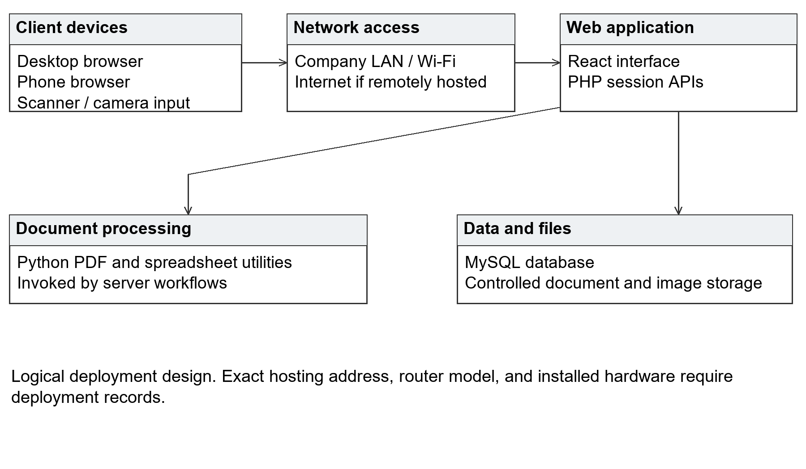
Figure 3.21 Logical Network Design of Pyx Tracker
Browser clients connect to the application server, PHP services, database, and controlled file storage. Server workflows invoke Python for document processing. Scanners and cameras provide input rather than connecting directly to the database. Session and permission checks apply through the application.
The diagram does not assert an unverified server address, hosting provider, router model, or equipment inventory. A local deployment requires company-network access; remote hosting also depends on an internet connection and appropriate secure browser access. Actual installation details require deployment records.

Network Topology
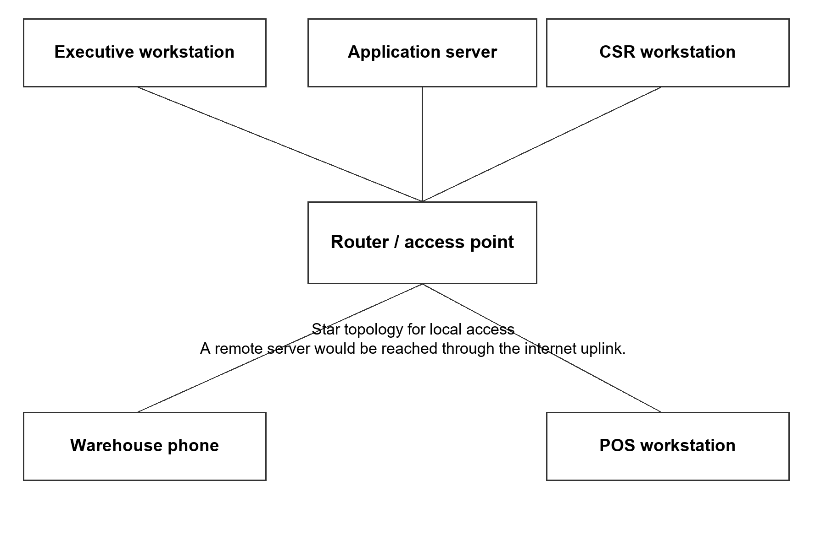
Figure 3.22 Star Topology for Local Access
Clients connect through a router or access point. A LAN server uses this local infrastructure; a remote server is reached through the internet uplink. This is a logical topology pending confirmation of the installed arrangement.

Technology Stack Development
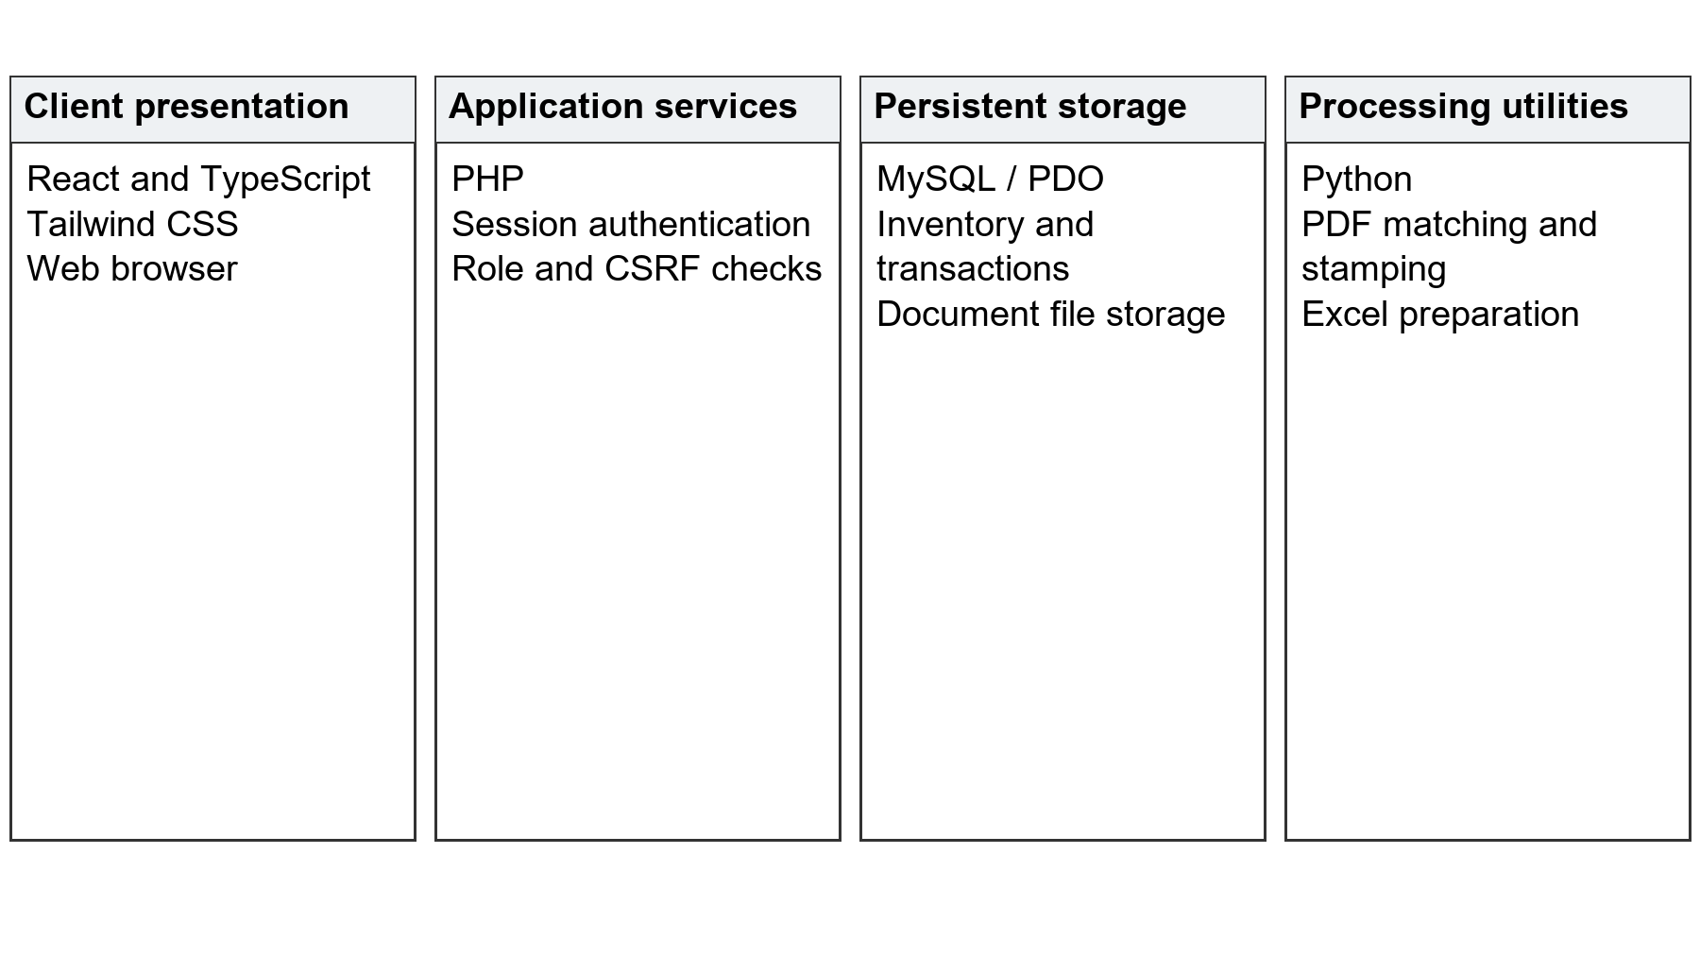
Figure 3.23 Technology Stack of Pyx Tracker
The stack follows the proposal and reviewed project: React and TypeScript for the interface, Tailwind CSS for presentation, PHP for business actions, MySQL for persistent records, and Python for document utilities. Vite supports frontend builds. Defined API actions connect these components.

Software Specification
Table 3.35 Software Specification
Component | Specification | Purpose
Client interface | React, TypeScript, Tailwind CSS | Browser screens and interactions.
Frontend build | Vite and project dependencies | Build the interface for deployment.
Server | PHP with session-based API actions | Validate access and execute business operations.
Database | MySQL accessed through PDO | Persist structured operational records.
Document utilities | Python and configured PDF/Excel libraries | Prepare and transform supported documents.
Development environment | Windows/XAMPP workspace; project editor | Local application development and maintenance.
Client browser | Compatible desktop or mobile browser | Access pages and supported scanning/camera workflows.

Hardware Specification
The sources do not identify exact deployed equipment. The table states functional requirements to be validated against the installed hardware rather than inventing machine specifications. Capacity must be tested against actual concurrent use and file sizes.
Table 3.36 Hardware Requirements to Confirm
Equipment | Functional requirement
Application server | Runs PHP, the database connection, and required Python utilities; storage sized for retained files and backups.
User workstation | Browser-capable computer with dependable network access.
Mobile device | Compatible browser and camera where camera scanning or photos are used.
Barcode scanner | Supported keyboard-wedge or equivalent input for the implemented scanning fields.
Printer | Receipt or barcode printer where printed output is used.
Network equipment | Router/access point and internet uplink where required by the hosting arrangement.
Backup storage | Separate capacity for the database and retained document/image files.

Program Specification
Table 3.37 Program Specification
Layer | Program responsibility
Presentation | React and TypeScript pages display role-appropriate workflows.
Authentication | PHP sessions, role/department checks, and POS authentication govern access.
Business processing | PHP handlers validate input, run the relevant stock or transaction action, and return a structured response.
Database access | PDO queries and transaction handling maintain persistent records.
File processing | Python utilities process supported PDF and Excel inputs; application storage controls their outputs.
Integrity controls | Validation, confirmation, duplicate checks, and history records protect the documented workflows.

Testing and Evaluation Procedure
Testing follows the six objectives. Each scenario records the initial state, permitted role, input, expected result, observed result, and evidence such as a receipt, generated file, or stock movement. Representative approved test records permit consistent comparisons.
Table 3.38 Functional Verification Plan
ID | Scenario | Expected evidence
T01 | Inventory receipt and finished-stock confirmation | Correct units, movement record, and starting/ending balance.
T02 | Product formula and parcel recipe calculation | Reproducible line values and totals; access denied to an unauthorized role.
T03 | Prepare, stamp, and finalize an order batch | Correct generated files and records, with duplicate/unmatched input feedback.
T04 | Packing and separate photo save | Expected packing movement; photo save alone leaves stock unchanged.
T05 | POS checkout using normal and RTS stock | Correct receipt, sales entry, and deduction from the selected source.
T06 | RTS case, draft cancellation, and confirmation | Case alone adds no sellable stock; cancelled draft has no effect; confirmation applies reviewed quantity once.

Integration tests follow receipt-to-finished-stock, source-file-to-parcel, POS-to-receipt, and return-to-confirmed-stock paths. Permission tests use authorized and unauthorized roles. Exceptions include invalid codes, duplicates, incomplete files, insufficient stock, interruption, and cancellation of drafts.
User evaluation should involve representatives of the actual operational roles performing defined tasks. Records should identify the selection method, number of participants, instrument, date, and system release. Any comparison of task time or stock accuracy must use comparable conditions and explain the measurements. No respondent count, rating, or improvement percentage is claimed without those records.
Deployment verification identifies the release date, installed schema, application version, roles, input devices, and backup and restoration procedure. An acceptance record should identify the evaluated installation. The provisional Gantt and logical network diagrams must be reconciled with these records before final submission.

List of Modules
Table 3.39 List of Modules
Module | Functions | Obj.
Integrated Inventory Management System | Stock categories, production stages, finished-goods stock-in, movements and review. | 1
Product Costing and Pricing Calculator | Product formulas, material prices and yields, parcel recipes and selling prices. | 2
Multi-Platform Order Processing and Waybill Management | VIP/SPX preparation, validation, PDF/Excel stamping and batch finalization. | 3
Parcel Processing and Inventory Synchronization | Packing records, applicable stock movements, parcel history and separate photo documentation. | 4
Point of Sale System | PIN access, selected stock source, checkout, receipts and sales history. | 5
Return-to-Sender Management | Return cases, condition records, reviewed barcode stock-in and sellable balances. | 6

REFERENCES
Beck, K., Beedle, M., van Bennekum, A., Cockburn, A., Cunningham, W., Fowler, M., Grenning, J., Highsmith, J., Hunt, A., Jeffries, R., Kern, J., Marick, B., Martin, R. C., Mellor, S., Schwaber, K., Sutherland, J., & Thomas, D. (2001). Principles behind the Agile Manifesto. https://agilemanifesto.org/principles.html
Bhatti, M. A., & Bauirzhanovna, B. A. (2023). Impact of intelligent inventory system on improvement of reverse logistics: A case of Saudi manufacturing industry. Operational Research in Engineering Sciences: Theory and Applications, 6(1). https://oresta.org/menu-script/index.php/oresta/article/view/512
Chocholáč, J., Hruška, R., & Sommerauerová, D. (2022). Effectiveness of automatic identification technologies in shipment consolidation. Proceedings of the 10th Carpathian Logistics Congress (pp. 53–58). https://doi.org/10.37904/clc.2022.4565
Divina, J., Olan, A., Perez, N. C., Sarmiento, M., & Acepcion, R. (2025). Data-driven point-of-sale and inventory system for Pastil sa Tabi: Integrating sales forecasting algorithms and predictive analytics. International Journal of Research and Innovation in Applied Science, 10(10), 826–838. https://doi.org/10.51584/IJRIAS.2025.1010000066
Ercilla, L., Garcia, J., Gonzales, A., & Relano, K. (2024). A research proposal of inventory and POS system for Bida Mart in the City of San Jose Del Monte, Bulacan. Ascendens Asia Singapore – Bestlink College of the Philippines Journal of Multidisciplinary Research, 4(1). https://ojs.aaresearchindex.com/index.php/aasgbcpjmra/article/view/13558
Goedhart, J., Haijema, R., Akkerman, R., & de Leeuw, S. (2023). Replenishment and fulfilment decisions for stores in an omni-channel retail network. European Journal of Operational Research, 311(3), 1009–1022. https://doi.org/10.1016/j.ejor.2023.06.018
GS1 US. (2026). Advancing intelligent data capture in modern logistics operations. https://documents.gs1us.org/adobe/assets/deliver/urn:aaid:aem:389a6053-bb10-454c-ac16-1c19ea2950f9/GS1-US-Advancing-Intelligent-Data-Capture-in-Modern-Logistics-Operations.pdf
Kamnardsiri, T., Charoenkwan, P., Malang, C., & Wudhikarn, R. (2022). 1D barcode detection: Novel benchmark datasets and comprehensive comparison of deep convolutional neural network approaches. Sensors, 22(22), 8788. https://doi.org/10.3390/s22228788
Laping, A. K. T., Mendoza, C. A. R., Tiulentino, K. N. L., Villaraza, R. M., Bucu, G. C., & Ngo, J. K. (2023). Designing an inventory management system for Convenience Store X using design thinking approach. Proceedings of the International Conference on Industrial Engineering and Operations Management (pp. 1703–1715). https://ieomsociety.org/proceedings/2023manila/480.pdf
Lorzano, E. R. B., Roda, I. G. S., Paulo, S. B. T., & Gabriel, A. D. (2022). Food retail company web-based POS with inventory and stock management. WCSE 2022 Spring Event Proceedings (pp. 371–385). https://doi.org/10.18178/wcse.2022.04.045
Munifah, Henny, & Aqham, A. A. (2026). Digitalization of production cost calculations using the variable costing method in food industry SMEs. Jurnal Ilmiah Sistem Informasi, 5(1). https://doi.org/10.51903/ydwg6m74
Nanayakkara, P. R., Jayalath, M. M., Thibbotuwawa, A., & Perera, H. N. (2022). A circular reverse logistics framework for handling e-commerce returns. Cleaner Logistics and Supply Chain, 5, 100080. https://doi.org/10.1016/j.clscn.2022.100080
United Nations Department of Economic and Social Affairs. (n.d.-a). Goal 8. https://sdgs.un.org/goals/goal8
United Nations Department of Economic and Social Affairs. (n.d.-b). Goal 9. https://sdgs.un.org/goals/goal9
United Nations Department of Economic and Social Affairs. (n.d.-c). Goal 12. https://sdgs.un.org/goals/goal12

