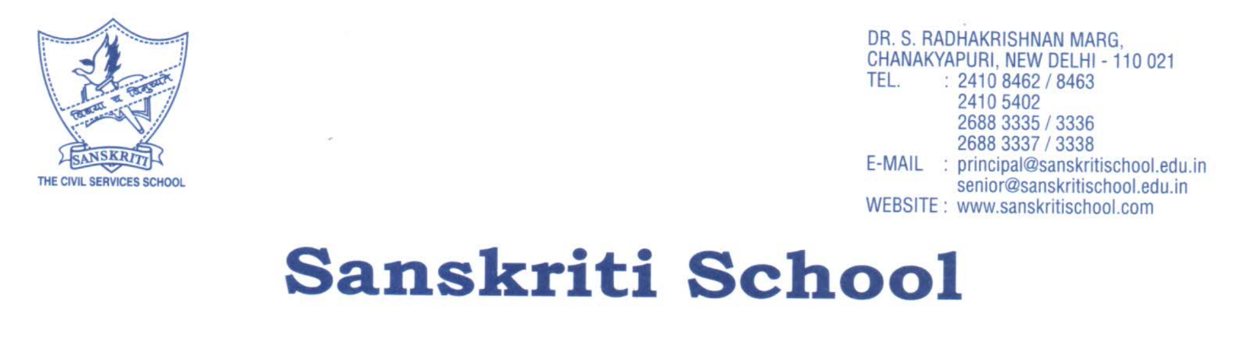

**September 30, 2022**

**TRANSCRIPT FOR 11 ADITYA DHA**

Sanskriti School is a private high school in New Delhi, India. We have students in the age group of 3 years to 17 years. Our total strength is approximately 2500 students, of these there are approximately 250 students in the graduating class.

In the academic system that we follow, we do not rank the students. The students usually take a Unit Test once a week and there are term end exams. The academic performance is based on the online assessment.

**Following is the final percentage for grade XI (Academic Session: 2021-22):**

|  |  |
| --- | --- |
| **Subjects** | **Grade XI** |
| English | 64% |
| 11grade subj | 74% |
| 11grade sub2 | 98% |
| Social Science | 78% |
| Science | 73% |



**Sana Kapur  
 Senior School Counselor**